* 1. PK parameters
  + 1.1. PK parameters for Raltegravir 10 mg (lactose formulation)
  + 1.2. PK parameters for Raltegravir 25 mg (lactose formulation)
  + 1.3. PK parameters for Raltegravir 50 mg (lactose formulation)
  + 1.4. PK parameters for Raltegravir 100 mg (lactose formulation)
  + 1.5. PK parameters for Raltegravir 200 mg (lactose formulation)
  + 1.6. PK parameters for Raltegravir 400mg (lactose formulation)
  + 1.7. PK parameters for Raltegravir 800 mg (lactose formulation)
  + 1.8. PK parameters for Raltegravir 1200 mg (lactose formulation)
  + 1.9. PK parameters for Raltegravir 1600 mg (lactose formulation)
  + 1.10. PK parameters for Raltegravir 100 mg filmcoated tablet md
  + 1.11. PK parameters for Raltegravir 200 mg filmcoated tablet md
  + 1.12. PK parameters for Filmcoated_tablet_400mg_sd
  + 1.13. PK parameters for Raltegravir 400 mg filmcoated tablet md
  + 1.14. PK parameters for Raltegravir 400mg chewable fasted
  + 1.15. PK parameters for Raltegravir 400mg chewable fed
  + 1.16. PK parameters for Raltegravir 400mg (granules in suspension)
* 2. Absorption
  + 2.1. Absorption for Raltegravir 10 mg (lactose formulation)
  + 2.2. Absorption for Raltegravir 25 mg (lactose formulation)
  + 2.3. Absorption for Raltegravir 50 mg (lactose formulation)
  + 2.4. Absorption for Raltegravir 100 mg (lactose formulation)
  + 2.5. Absorption for Raltegravir 200 mg (lactose formulation)
  + 2.6. Absorption for Raltegravir 400mg (lactose formulation)
  + 2.7. Absorption for Raltegravir 800 mg (lactose formulation)
  + 2.8. Absorption for Raltegravir 1200 mg (lactose formulation)
  + 2.9. Absorption for Raltegravir 1600 mg (lactose formulation)
  + 2.10. Absorption for Raltegravir 100 mg filmcoated tablet md
  + 2.11. Absorption for Raltegravir 200 mg filmcoated tablet md
  + 2.12. Absorption for Filmcoated_tablet_400mg_sd
  + 2.13. Absorption for Raltegravir 400 mg filmcoated tablet md
  + 2.14. Absorption for Raltegravir 400mg chewable fasted
  + 2.15. Absorption for Raltegravir 400mg chewable fed
  + 2.16. Absorption for Raltegravir 400mg (granules in suspension)
* 3. Mass Balance
  + 3.1. Mass Balance for Raltegravir 10 mg (lactose formulation)
  + 3.2. Mass Balance for Raltegravir 25 mg (lactose formulation)
  + 3.3. Mass Balance for Raltegravir 50 mg (lactose formulation)
  + 3.4. Mass Balance for Raltegravir 100 mg (lactose formulation)
  + 3.5. Mass Balance for Raltegravir 200 mg (lactose formulation)
  + 3.6. Mass Balance for Raltegravir 400mg (lactose formulation)
  + 3.7. Mass Balance for Raltegravir 800 mg (lactose formulation)
  + 3.8. Mass Balance for Raltegravir 1200 mg (lactose formulation)
  + 3.9. Mass Balance for Raltegravir 1600 mg (lactose formulation)
  + 3.10. Mass Balance for Raltegravir 100 mg filmcoated tablet md
  + 3.11. Mass Balance for Raltegravir 200 mg filmcoated tablet md
  + 3.12. Mass Balance for Filmcoated_tablet_400mg_sd
  + 3.13. Mass Balance for Raltegravir 400 mg filmcoated tablet md
  + 3.14. Mass Balance for Raltegravir 400mg chewable fasted
  + 3.15. Mass Balance for Raltegravir 400mg chewable fed
  + 3.16. Mass Balance for Raltegravir 400mg (granules in suspension)
* 4. Time profiles and residual plots
  + 4.1. Time profiles and residual plots for Raltegravir 10 mg (lactose formulation)
  + 4.2. Time profiles and residual plots for Raltegravir 25 mg (lactose formulation)
  + 4.3. Time profiles and residual plots for Raltegravir 50 mg (lactose formulation)
  + 4.4. Time profiles and residual plots for Raltegravir 100 mg (lactose formulation)
  + 4.5. Time profiles and residual plots for Raltegravir 200 mg (lactose formulation)
  + 4.6. Time profiles and residual plots for Raltegravir 400mg (lactose formulation)
  + 4.7. Time profiles and residual plots for Raltegravir 800 mg (lactose formulation)
  + 4.8. Time profiles and residual plots for Raltegravir 1200 mg (lactose formulation)
  + 4.9. Time profiles and residual plots for Raltegravir 1600 mg (lactose formulation)
  + 4.10. Time profiles and residual plots for Raltegravir 100 mg filmcoated tablet md
  + 4.10.1. For total simulation time range
  + 4.10.2. For first application range
  + 4.10.3. For last application range
  + 4.11. Time profiles and residual plots for Raltegravir 200 mg filmcoated tablet md
  + 4.11.1. For total simulation time range
  + 4.11.2. For first application range
  + 4.11.3. For last application range
  + 4.12. Time profiles and residual plots for Filmcoated_tablet_400mg_sd
  + 4.13. Time profiles and residual plots for Raltegravir 400 mg filmcoated tablet md
  + 4.13.1. For total simulation time range
  + 4.13.2. For first application range
  + 4.13.3. For last application range
  + 4.14. Time profiles and residual plots for Raltegravir 400mg chewable fasted
  + 4.15. Time profiles and residual plots for Raltegravir 400mg chewable fed
  + 4.16. Time profiles and residual plots for Raltegravir 400mg (granules in suspension)
  + 4.17. Residuals across all simulations

# 1. PK parameters

## 1.1. PK parameters for Raltegravir 10 mg (lactose formulation)

|  |  |  |  |
| --- | --- | --- | --- |
| Path | Parameter | Value | Unit |
| Raltegravir | C_max | 110.4938945 | µg/l |
| Raltegravir | C_max_norm | 0.8066055 | kg/l |
| Raltegravir | t_max | 0.7500000 | h |
| Raltegravir | C_tEnd | 1.9563139 | µg/l |
| Raltegravir | AUC | 241.6052506 | µg*h/l |
| Raltegravir | AUC_norm | 1.7637182 | kg*h/l |
| Raltegravir | AUC_inf | 255.1373571 | µg*h/l |
| Raltegravir | AUC_inf_norm | 1.8625028 | kg*h/l |
| Raltegravir | MRT | 3.3293592 | h |
| Raltegravir | Thalf | 4.7946014 | h |
| Raltegravir | CL | 8.9485329 | ml/min/kg |
| Raltegravir | Vss | 1787.5727415 | ml/kg |
| Raltegravir | Vd | 3713.8993740 | ml/kg |

## 1.2. PK parameters for Raltegravir 25 mg (lactose formulation)

|  |  |  |  |
| --- | --- | --- | --- |
| Path | Parameter | Value | Unit |
| Raltegravir | C_max | 276.849301 | µg/l |
| Raltegravir | C_max_norm | 0.808400 | kg/l |
| Raltegravir | t_max | 0.750000 | h |
| Raltegravir | C_tEnd | 4.894139 | µg/l |
| Raltegravir | AUC | 605.060435 | µg*h/l |
| Raltegravir | AUC_norm | 1.766776 | kg*h/l |
| Raltegravir | AUC_inf | 638.895505 | µg*h/l |
| Raltegravir | AUC_inf_norm | 1.865575 | kg*h/l |
| Raltegravir | MRT | 3.327076 | h |
| Raltegravir | Thalf | 4.791995 | h |
| Raltegravir | CL | 8.933796 | ml/min/kg |
| Raltegravir | Vss | 1783.405542 | ml/kg |
| Raltegravir | Vd | 3705.768108 | ml/kg |

## 1.3. PK parameters for Raltegravir 50 mg (lactose formulation)

|  |  |  |  |
| --- | --- | --- | --- |
| Path | Parameter | Value | Unit |
| Raltegravir | C_max | 556.5958396 | µg/l |
| Raltegravir | C_max_norm | 0.8126299 | kg/l |
| Raltegravir | t_max | 0.7500000 | h |
| Raltegravir | C_tEnd | 1.5273094 | µg/l |
| Raltegravir | AUC | 1296.6526164 | µg*h/l |
| Raltegravir | AUC_norm | 1.8931128 | kg*h/l |
| Raltegravir | AUC_inf | 1317.0856667 | µg*h/l |
| Raltegravir | AUC_inf_norm | 1.9229450 | kg*h/l |
| Raltegravir | MRT | 4.1443489 | h |
| Raltegravir | Thalf | 9.2732239 | h |
| Raltegravir | CL | 8.6672613 | ml/min/kg |
| Raltegravir | Vss | 2155.2090645 | ml/kg |
| Raltegravir | Vd | 6957.2629929 | ml/kg |

## 1.4. PK parameters for Raltegravir 100 mg (lactose formulation)

|  |  |  |  |
| --- | --- | --- | --- |
| Path | Parameter | Value | Unit |
| Raltegravir | C_max | 1123.8968432 | µg/l |
| Raltegravir | C_max_norm | 0.8204447 | kg/l |
| Raltegravir | t_max | 0.7500000 | h |
| Raltegravir | C_tEnd | 2.8365190 | µg/l |
| Raltegravir | AUC | 2615.7731116 | µg*h/l |
| Raltegravir | AUC_norm | 1.9095144 | kg*h/l |
| Raltegravir | AUC_inf | 2654.0634656 | µg*h/l |
| Raltegravir | AUC_inf_norm | 1.9374663 | kg*h/l |
| Raltegravir | MRT | 4.1381223 | h |
| Raltegravir | Thalf | 9.3568461 | h |
| Raltegravir | CL | 8.6022997 | ml/min/kg |
| Raltegravir | Vss | 2135.8420849 | ml/kg |
| Raltegravir | Vd | 6967.3857689 | ml/kg |

## 1.5. PK parameters for Raltegravir 200 mg (lactose formulation)

|  |  |  |  |
| --- | --- | --- | --- |
| Path | Parameter | Value | Unit |
| Raltegravir | C_max | 2283.843895 | µg/l |
| Raltegravir | C_max_norm | 0.833603 | kg/l |
| Raltegravir | t_max | 0.750000 | h |
| Raltegravir | C_tEnd | 1.918062 | µg/l |
| Raltegravir | AUC | 5349.761122 | µg*h/l |
| Raltegravir | AUC_norm | 1.952663 | kg*h/l |
| Raltegravir | AUC_inf | 5376.252319 | µg*h/l |
| Raltegravir | AUC_inf_norm | 1.962332 | kg*h/l |
| Raltegravir | MRT | 4.134027 | h |
| Raltegravir | Thalf | 9.573441 | h |
| Raltegravir | CL | 8.493296 | ml/min/kg |
| Raltegravir | Vss | 2106.690645 | ml/kg |
| Raltegravir | Vd | 7038.337707 | ml/kg |

## 1.6. PK parameters for Raltegravir 400mg (lactose formulation)

|  |  |  |  |
| --- | --- | --- | --- |
| Path | Parameter | Value | Unit |
| Raltegravir | C_max | 4673.726268 | µg/l |
| Raltegravir | C_max_norm | 0.852955 | kg/l |
| Raltegravir | t_max | 0.750000 | h |
| Raltegravir | C_tEnd | 3.837874 | µg/l |
| Raltegravir | AUC | 10899.606324 | µg*h/l |
| Raltegravir | AUC_norm | 1.989178 | kg*h/l |
| Raltegravir | AUC_inf | 10952.620364 | µg*h/l |
| Raltegravir | AUC_inf_norm | 1.998853 | kg*h/l |
| Raltegravir | MRT | 4.109855 | h |
| Raltegravir | Thalf | 9.574743 | h |
| Raltegravir | CL | 8.338114 | ml/min/kg |
| Raltegravir | Vss | 2056.106567 | ml/kg |
| Raltegravir | Vd | 6910.678864 | ml/kg |

## 1.7. PK parameters for Raltegravir 800 mg (lactose formulation)

|  |  |  |  |
| --- | --- | --- | --- |
| Path | Parameter | Value | Unit |
| Raltegravir | C_max | 9.613040e+03 | µg/l |
| Raltegravir | C_max_norm | 8.771899e-01 | kg/l |
| Raltegravir | t_max | 7.500000e-01 | h |
| Raltegravir | C_tEnd | 6.643868e+00 | µg/l |
| Raltegravir | AUC | 2.234232e+04 | µg*h/l |
| Raltegravir | AUC_norm | 2.038736e+00 | kg*h/l |
| Raltegravir | AUC_inf | 2.243378e+04 | µg*h/l |
| Raltegravir | AUC_inf_norm | 2.047083e+00 | kg*h/l |
| Raltegravir | MRT | 4.084571e+00 | h |
| Raltegravir | Thalf | 9.542753e+00 | h |
| Raltegravir | CL | 8.141668e+00 | ml/min/kg |
| Raltegravir | Vss | 1.995313e+03 | ml/kg |
| Raltegravir | Vd | 6.725318e+03 | ml/kg |

## 1.8. PK parameters for Raltegravir 1200 mg (lactose formulation)

|  |  |  |  |
| --- | --- | --- | --- |
| Path | Parameter | Value | Unit |
| Raltegravir | C_max | 1.468291e+04 | µg/l |
| Raltegravir | C_max_norm | 8.932101e-01 | kg/l |
| Raltegravir | t_max | 7.500000e-01 | h |
| Raltegravir | C_tEnd | 1.997039e+00 | µg/l |
| Raltegravir | AUC | 3.417676e+04 | µg*h/l |
| Raltegravir | AUC_norm | 2.079086e+00 | kg*h/l |
| Raltegravir | AUC_inf | 3.420447e+04 | µg*h/l |
| Raltegravir | AUC_inf_norm | 2.080772e+00 | kg*h/l |
| Raltegravir | MRT | 4.095406e+00 | h |
| Raltegravir | Thalf | 9.617984e+00 | h |
| Raltegravir | CL | 8.009847e+00 | ml/min/kg |
| Raltegravir | Vss | 1.968214e+03 | ml/kg |
| Raltegravir | Vd | 6.668591e+03 | ml/kg |

## 1.9. PK parameters for Raltegravir 1600 mg (lactose formulation)

|  |  |  |  |
| --- | --- | --- | --- |
| Path | Parameter | Value | Unit |
| Raltegravir | C_max | 1.979954e+04 | µg/l |
| Raltegravir | C_max_norm | 9.033539e-01 | kg/l |
| Raltegravir | t_max | 7.500000e-01 | h |
| Raltegravir | C_tEnd | 2.665646e+00 | µg/l |
| Raltegravir | AUC | 4.607060e+04 | µg*h/l |
| Raltegravir | AUC_norm | 2.101971e+00 | kg*h/l |
| Raltegravir | AUC_inf | 4.610762e+04 | µg*h/l |
| Raltegravir | AUC_inf_norm | 2.103660e+00 | kg*h/l |
| Raltegravir | MRT | 4.125340e+00 | h |
| Raltegravir | Thalf | 9.626328e+00 | h |
| Raltegravir | CL | 7.922700e+00 | ml/min/kg |
| Raltegravir | Vss | 1.961030e+03 | ml/kg |
| Raltegravir | Vd | 6.601758e+03 | ml/kg |

## 1.10. PK parameters for Raltegravir 100 mg filmcoated tablet md

|  |  |  |  |
| --- | --- | --- | --- |
| Path | Parameter | Value | Unit |
| Raltegravir | C_max | 894.0838340 | µg/l |
| Raltegravir | C_max_norm | 0.0326341 | kg/l |
| Raltegravir | C_max_t1_t2 | 863.1595648 | µg/l |
| Raltegravir | C_max_t1_t2_norm | 0.6301065 | kg/l |
| Raltegravir | C_max_tLast_tEnd | 892.6719556 | µg/l |
| Raltegravir | C_max_tLast_tEnd_norm | 0.6516506 | kg/l |
| Raltegravir | t_max | 168.7500000 | h |
| Raltegravir | t_max_t1_t2 | 0.7500000 | h |
| Raltegravir | t_max_tLast_tEnd | 228.7500000 | h |
| Raltegravir | C_trough_t2 | 19.6617510 | µg/l |
| Raltegravir | C_trough_tLast | 31.9225175 | µg/l |
| Raltegravir | AUC_t1_t2 | 1978.7565232 | µg*h/l |
| Raltegravir | AUC_t1_t2_norm | 1.4444923 | kg*h/l |
| Raltegravir | AUC_tLast_minus_1_tLast | 2218.5627070 | µg*h/l |
| Raltegravir | AUC_tLast_minus_1_tLast_norm | 1.6195509 | kg*h/l |
| Raltegravir | AUC_inf_t1 | 2144.3461704 | µg*h/l |
| Raltegravir | AUC_inf_t1_norm | 1.5653726 | kg*h/l |
| Raltegravir | AUC_inf_tLast | 2536.5542696 | µg*h/l |
| Raltegravir | AUC_inf_tLast_norm | 1.8516847 | kg*h/l |
| Raltegravir | MRT | 3.9621429 | h |
| Raltegravir | Thalf | 5.8376226 | h |
| Raltegravir | Thalf_tLast_tEnd | 6.9001592 | h |

## 1.11. PK parameters for Raltegravir 200 mg filmcoated tablet md

|  |  |  |  |
| --- | --- | --- | --- |
| Path | Parameter | Value | Unit |
| Raltegravir | C_max | 1812.3013054 | µg/l |
| Raltegravir | C_max_norm | 0.0330745 | kg/l |
| Raltegravir | C_max_t1_t2 | 1748.6577478 | µg/l |
| Raltegravir | C_max_t1_t2_norm | 0.6382601 | kg/l |
| Raltegravir | C_max_tLast_tEnd | 1808.6423947 | µg/l |
| Raltegravir | C_max_tLast_tEnd_norm | 0.6601545 | kg/l |
| Raltegravir | t_max | 72.7500000 | h |
| Raltegravir | t_max_t1_t2 | 0.7500000 | h |
| Raltegravir | t_max_tLast_tEnd | 228.7500000 | h |
| Raltegravir | C_trough_t2 | 39.4742325 | µg/l |
| Raltegravir | C_trough_tLast | 64.0305196 | µg/l |
| Raltegravir | AUC_t1_t2 | 3998.1178427 | µg*h/l |
| Raltegravir | AUC_t1_t2_norm | 1.4593130 | kg*h/l |
| Raltegravir | AUC_tLast_minus_1_tLast | 4483.5973516 | µg*h/l |
| Raltegravir | AUC_tLast_minus_1_tLast_norm | 1.6365131 | kg*h/l |
| Raltegravir | AUC_inf_t1 | 4329.1330307 | µg*h/l |
| Raltegravir | AUC_inf_t1_norm | 1.5801335 | kg*h/l |
| Raltegravir | AUC_inf_tLast | 5115.6988866 | µg*h/l |
| Raltegravir | AUC_inf_tLast_norm | 1.8672301 | kg*h/l |
| Raltegravir | MRT | 3.9411664 | h |
| Raltegravir | Thalf | 5.8124568 | h |
| Raltegravir | Thalf_tLast_tEnd | 6.8734080 | h |

## 1.12. PK parameters for Filmcoated_tablet_400mg_sd

|  |  |  |  |
| --- | --- | --- | --- |
| Path | Parameter | Value | Unit |
| Raltegravir | C_max | 3568.5563894 | µg/l |
| Raltegravir | C_max_norm | 0.6512616 | kg/l |
| Raltegravir | t_max | 0.7500000 | h |
| Raltegravir | C_tEnd | 28.2685935 | µg/l |
| Raltegravir | AUC | 8703.6498337 | µg*h/l |
| Raltegravir | AUC_norm | 1.5884161 | kg*h/l |
| Raltegravir | AUC_inf | 9072.4244034 | µg*h/l |
| Raltegravir | AUC_inf_norm | 1.6557174 | kg*h/l |
| Raltegravir | MRT | 4.8922185 | h |
| Raltegravir | Thalf | 9.0423584 | h |
| Raltegravir | CL | 10.0661302 | ml/min/kg |
| Raltegravir | Vss | 2954.7424316 | ml/kg |
| Raltegravir | Vd | 7878.9811134 | ml/kg |

## 1.13. PK parameters for Raltegravir 400 mg filmcoated tablet md

|  |  |  |  |
| --- | --- | --- | --- |
| Path | Parameter | Value | Unit |
| Raltegravir | C_max | 3.696229e+03 | µg/l |
| Raltegravir | C_max_norm | 3.372810e-02 | kg/l |
| Raltegravir | C_max_t1_t2 | 3.569008e+03 | µg/l |
| Raltegravir | C_max_t1_t2_norm | 6.513440e-01 | kg/l |
| Raltegravir | C_max_tLast_tEnd | 3.689995e+03 | µg/l |
| Raltegravir | C_max_tLast_tEnd_norm | 6.734241e-01 | kg/l |
| Raltegravir | t_max | 8.475000e+01 | h |
| Raltegravir | t_max_t1_t2 | 7.500000e-01 | h |
| Raltegravir | t_max_tLast_tEnd | 2.287500e+02 | h |
| Raltegravir | C_trough_t2 | 7.975313e+01 | µg/l |
| Raltegravir | C_trough_tLast | 1.291935e+02 | µg/l |
| Raltegravir | AUC_t1_t2 | 8.128051e+03 | µg*h/l |
| Raltegravir | AUC_t1_t2_norm | 1.483369e+00 | kg*h/l |
| Raltegravir | AUC_tLast_minus_1_tLast | 9.098474e+03 | µg*h/l |
| Raltegravir | AUC_tLast_minus_1_tLast_norm | 1.660472e+00 | kg*h/l |
| Raltegravir | AUC_inf_t1 | 8.798719e+03 | µg*h/l |
| Raltegravir | AUC_inf_t1_norm | 1.605766e+00 | kg*h/l |
| Raltegravir | AUC_inf_tLast | 1.036592e+04 | µg*h/l |
| Raltegravir | AUC_inf_tLast_norm | 1.891780e+00 | kg*h/l |
| Raltegravir | MRT | 3.934582e+00 | h |
| Raltegravir | Thalf | 5.828885e+00 | h |
| Raltegravir | Thalf_tLast_tEnd | 6.799164e+00 | h |

## 1.14. PK parameters for Raltegravir 400mg chewable fasted

|  |  |  |  |
| --- | --- | --- | --- |
| Path | Parameter | Value | Unit |
| Raltegravir | C_max | 6330.518996 | µg/l |
| Raltegravir | C_max_norm | 1.155320 | kg/l |
| Raltegravir | t_max | 0.750000 | h |
| Raltegravir | C_tEnd | 35.836480 | µg/l |
| Raltegravir | AUC | 14694.827674 | µg*h/l |
| Raltegravir | AUC_norm | 2.681806 | kg*h/l |
| Raltegravir | AUC_inf | 15124.213097 | µg*h/l |
| Raltegravir | AUC_inf_norm | 2.760169 | kg*h/l |
| Raltegravir | MRT | 4.186335 | h |
| Raltegravir | Thalf | 8.305142 | h |
| Raltegravir | CL | 6.038278 | ml/min/kg |
| Raltegravir | Vss | 1516.695142 | ml/kg |
| Raltegravir | Vd | 4340.961456 | ml/kg |

## 1.15. PK parameters for Raltegravir 400mg chewable fed

|  |  |  |  |
| --- | --- | --- | --- |
| Path | Parameter | Value | Unit |
| Raltegravir | C_max | 2.580439e+03 | µg/l |
| Raltegravir | C_max_norm | 4.709301e-01 | kg/l |
| Raltegravir | t_max | 2.500000e+00 | h |
| Raltegravir | C_tEnd | 3.592768e+01 | µg/l |
| Raltegravir | AUC | 1.411909e+04 | µg*h/l |
| Raltegravir | AUC_norm | 2.576734e+00 | kg*h/l |
| Raltegravir | AUC_inf | 1.460635e+04 | µg*h/l |
| Raltegravir | AUC_inf_norm | 2.665660e+00 | kg*h/l |
| Raltegravir | MRT | 5.989332e+00 | h |
| Raltegravir | Thalf | 9.400702e+00 | h |
| Raltegravir | CL | 6.252361e+00 | ml/min/kg |
| Raltegravir | Vss | 2.246848e+03 | ml/kg |
| Raltegravir | Vd | 5.087801e+03 | ml/kg |

## 1.16. PK parameters for Raltegravir 400mg (granules in suspension)

|  |  |  |  |
| --- | --- | --- | --- |
| Path | Parameter | Value | Unit |
| Raltegravir | C_max | 8156.789686 | µg/l |
| Raltegravir | C_max_norm | 1.488614 | kg/l |
| Raltegravir | t_max | 0.700000 | h |
| Raltegravir | C_tEnd | 42.186887 | µg/l |
| Raltegravir | AUC | 18791.010143 | µg*h/l |
| Raltegravir | AUC_norm | 3.429359 | kg*h/l |
| Raltegravir | AUC_inf | 19278.707122 | µg*h/l |
| Raltegravir | AUC_inf_norm | 3.518364 | kg*h/l |
| Raltegravir | MRT | 4.020312 | h |
| Raltegravir | Thalf | 8.013054 | h |
| Raltegravir | CL | 4.737050 | ml/min/kg |
| Raltegravir | Vss | 1142.665029 | ml/kg |
| Raltegravir | Vd | 3285.730123 | ml/kg |

# 2. Absorption

## 2.1. Absorption for Raltegravir 10 mg (lactose formulation)

Figure 1: Absorption of Raltegravir

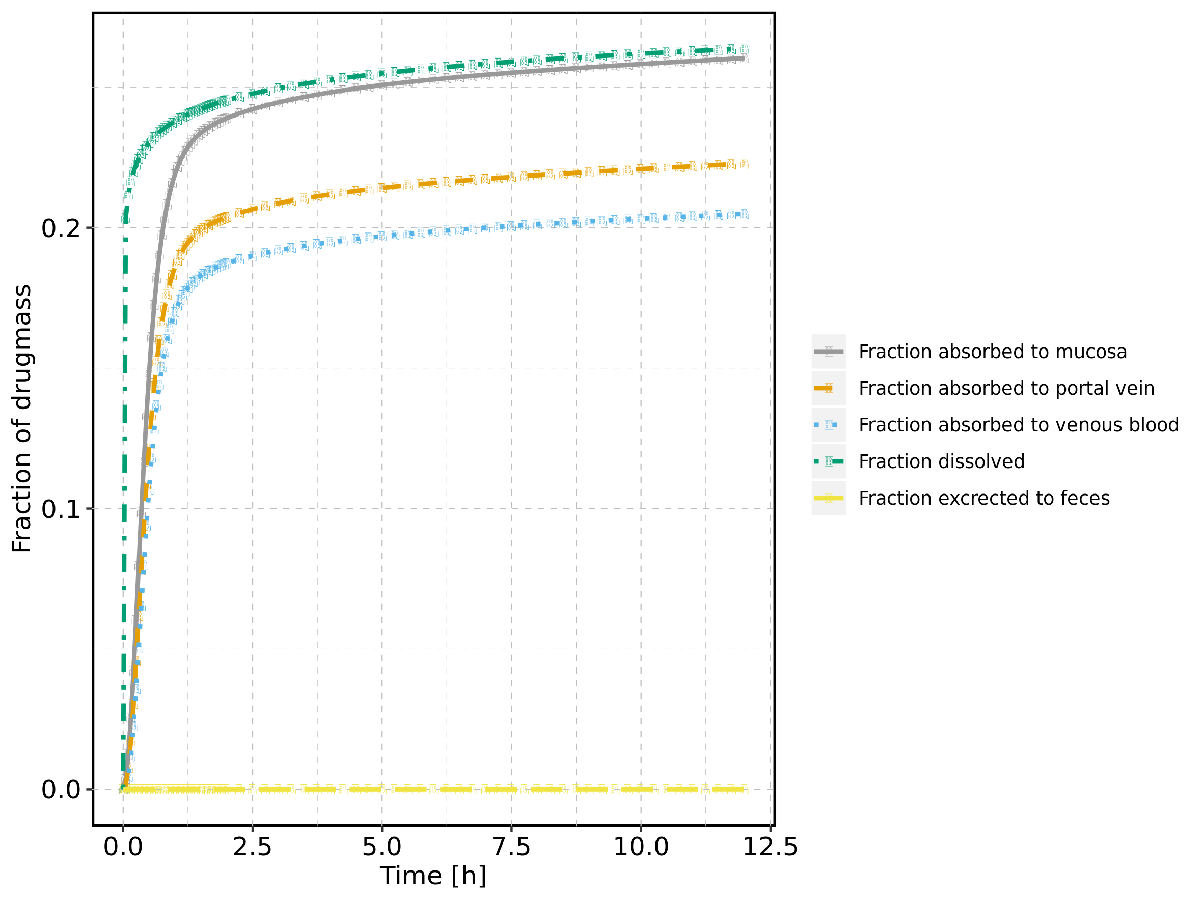

## 2.2. Absorption for Raltegravir 25 mg (lactose formulation)

Figure 2: Absorption of Raltegravir

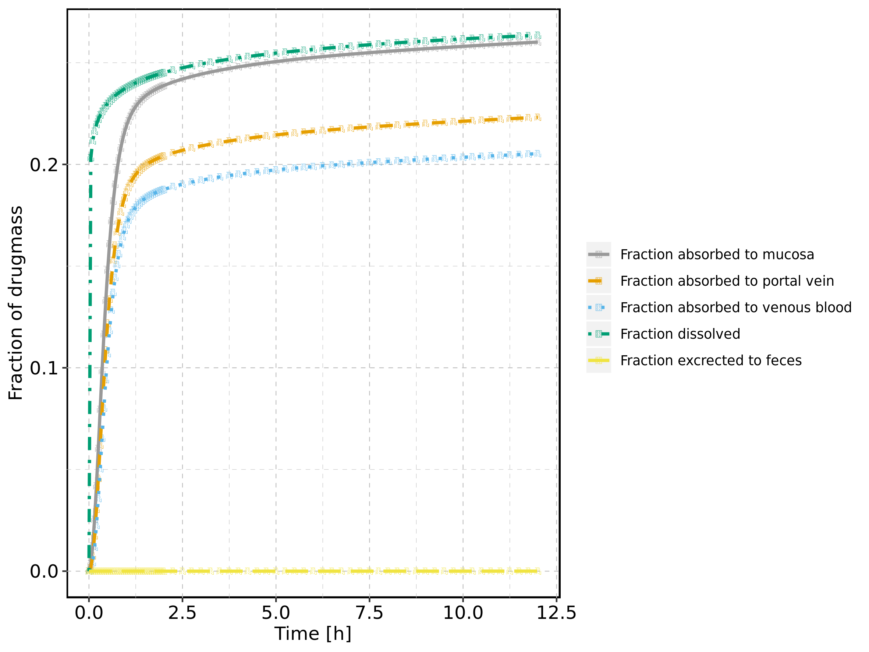

## 2.3. Absorption for Raltegravir 50 mg (lactose formulation)

Figure 3: Absorption of Raltegravir

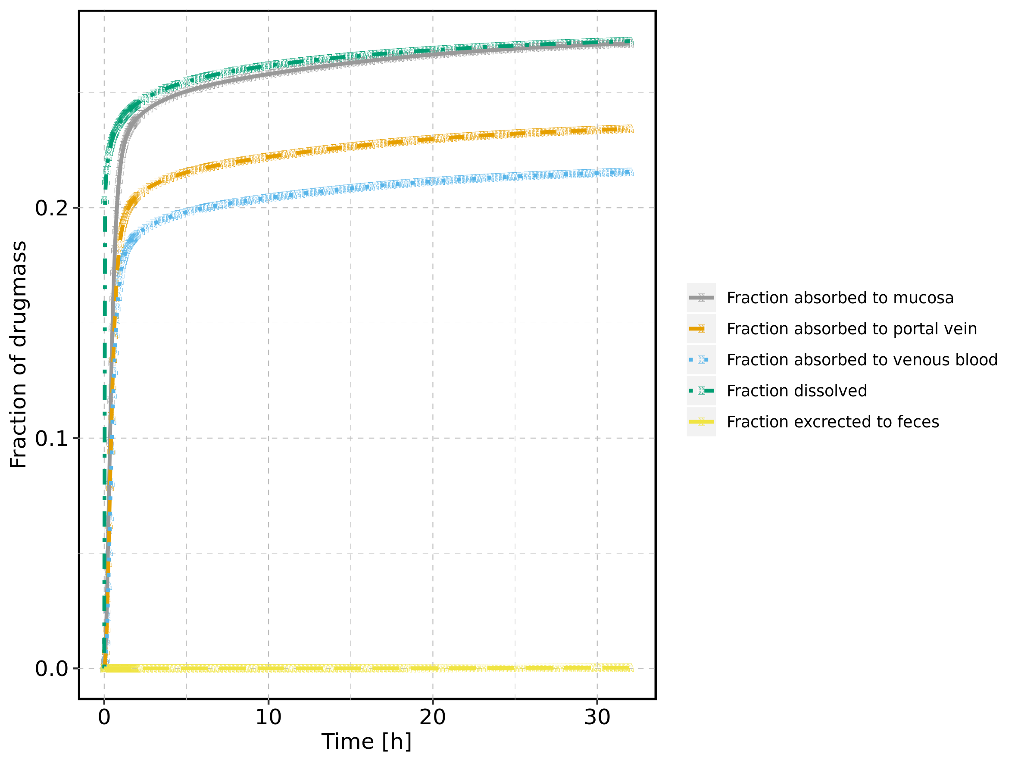

## 2.4. Absorption for Raltegravir 100 mg (lactose formulation)

Figure 4: Absorption of Raltegravir

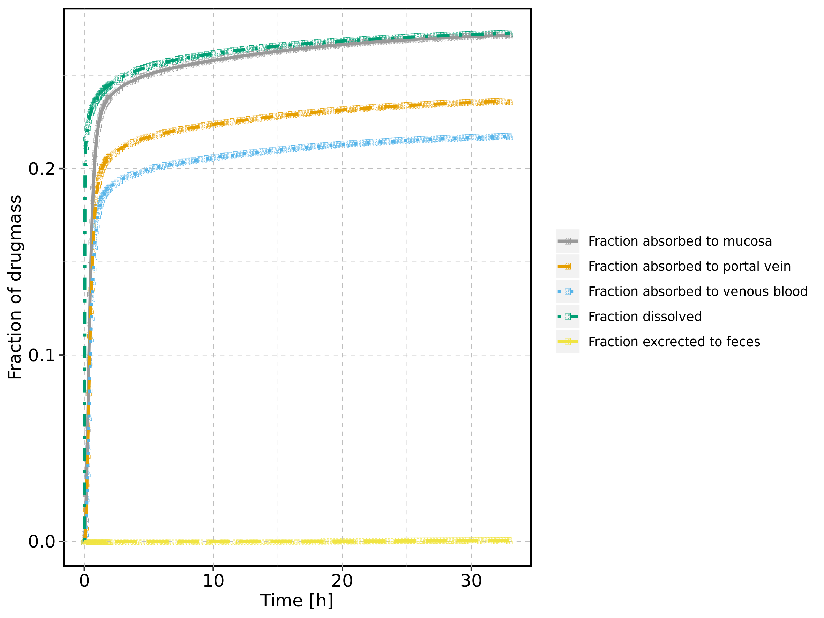

## 2.5. Absorption for Raltegravir 200 mg (lactose formulation)

Figure 5: Absorption of Raltegravir

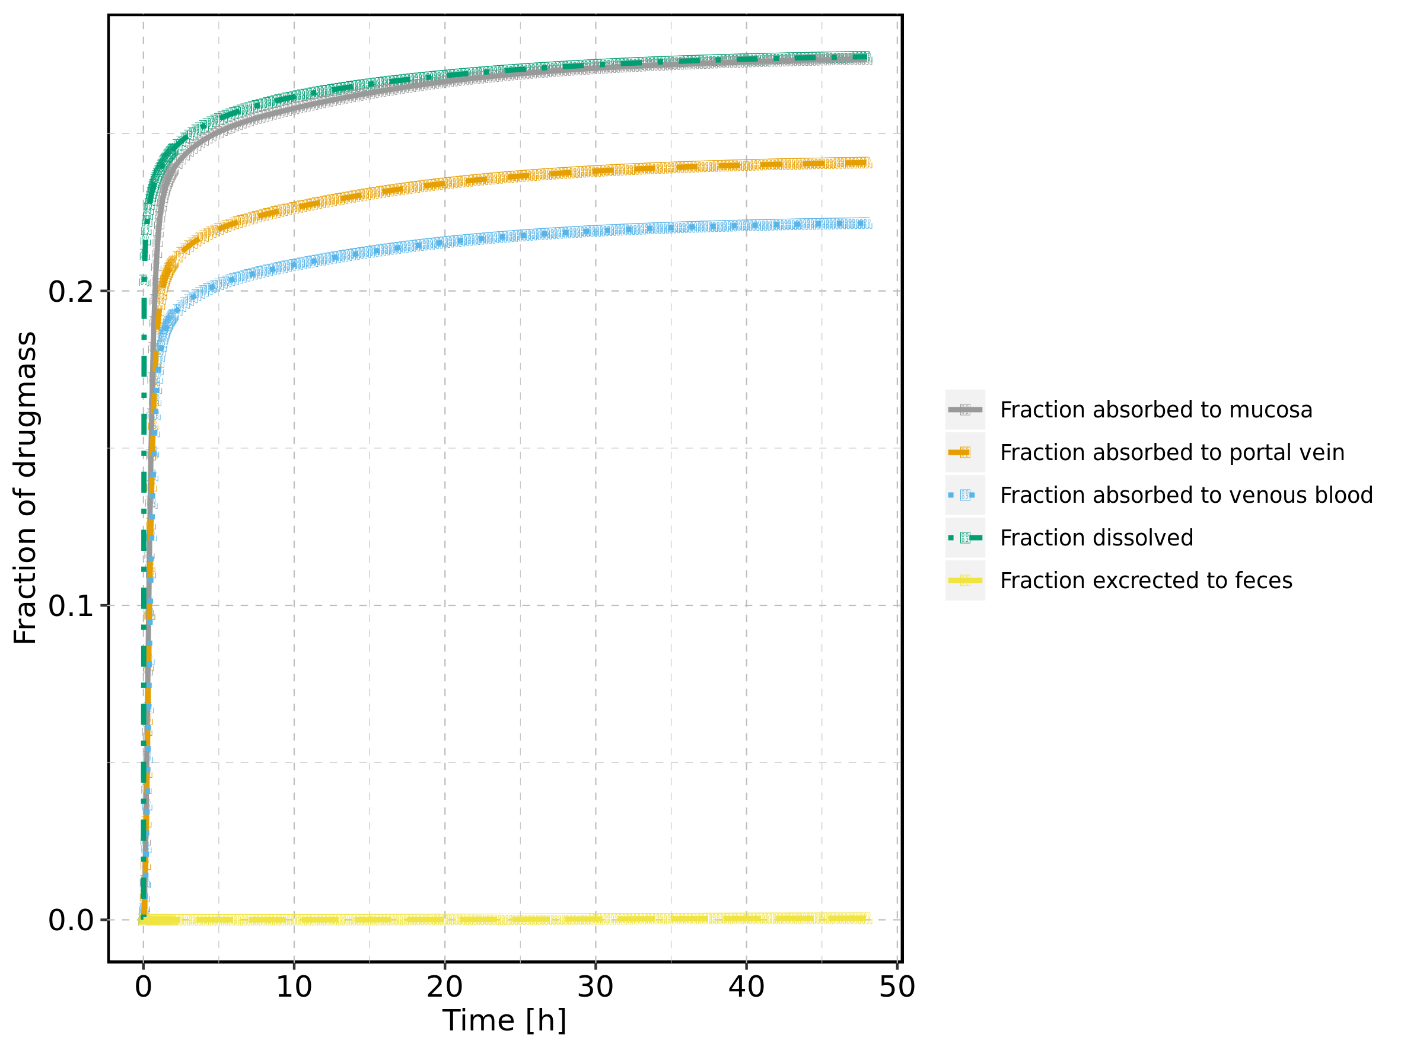

## 2.6. Absorption for Raltegravir 400mg (lactose formulation)

Figure 6: Absorption of Raltegravir

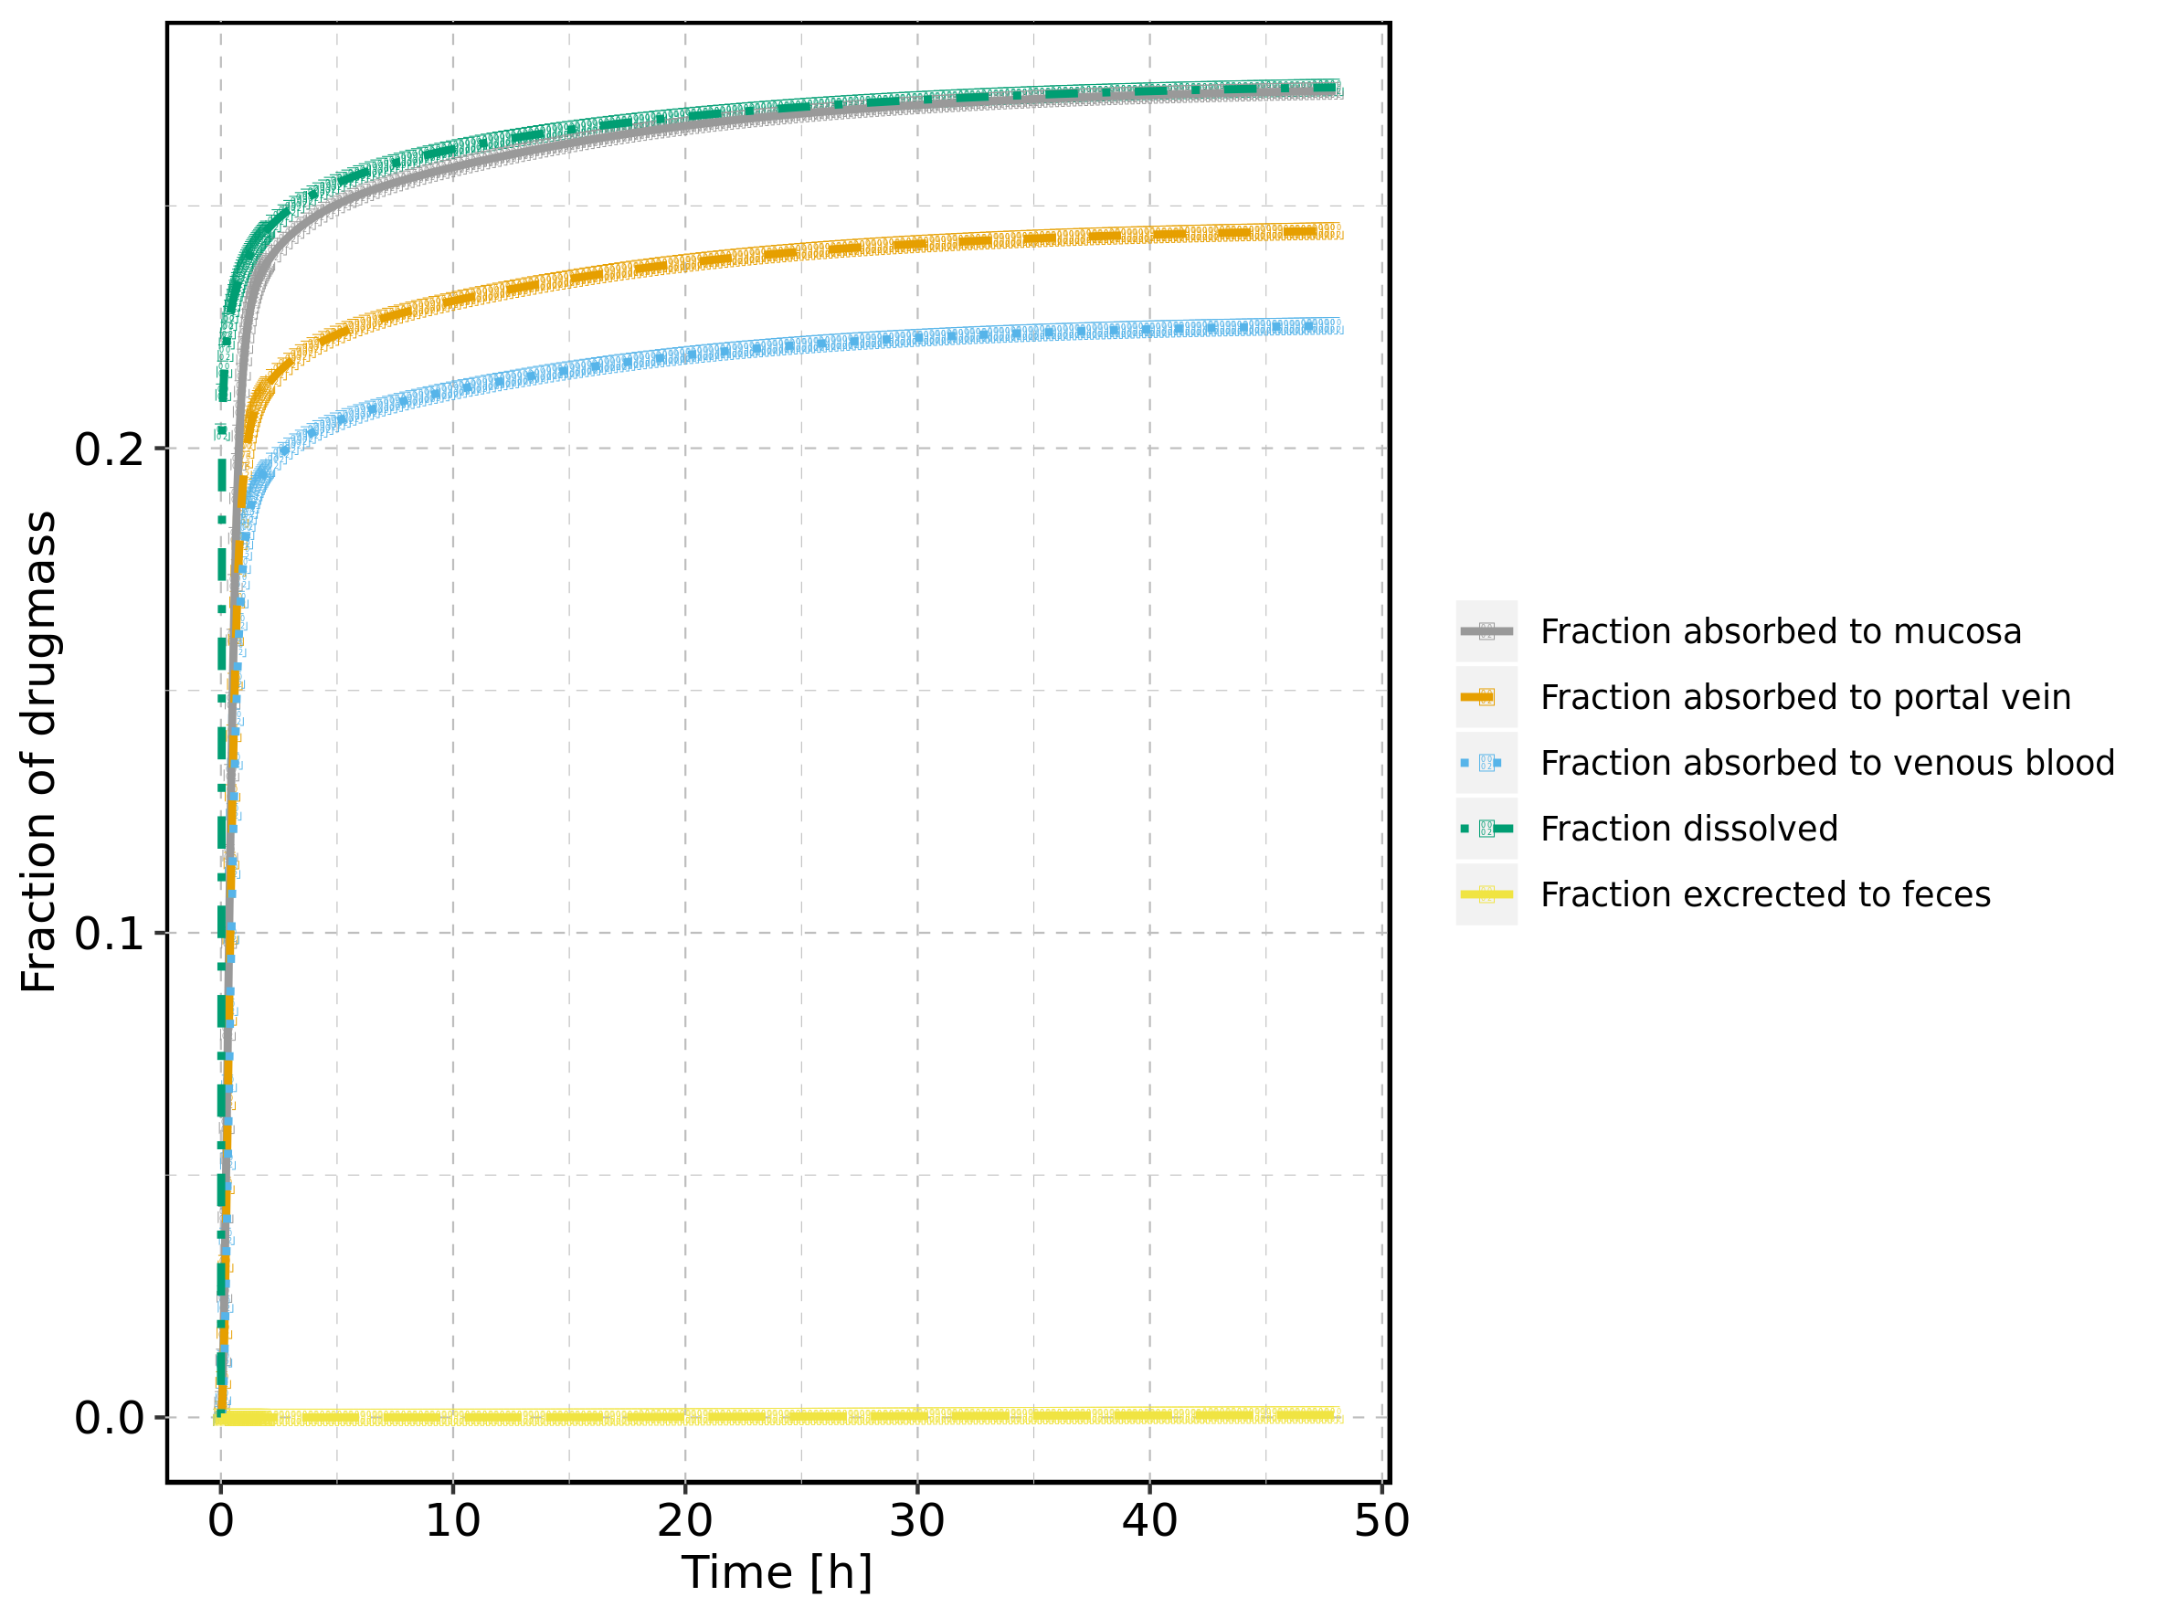

## 2.7. Absorption for Raltegravir 800 mg (lactose formulation)

Figure 7: Absorption of Raltegravir

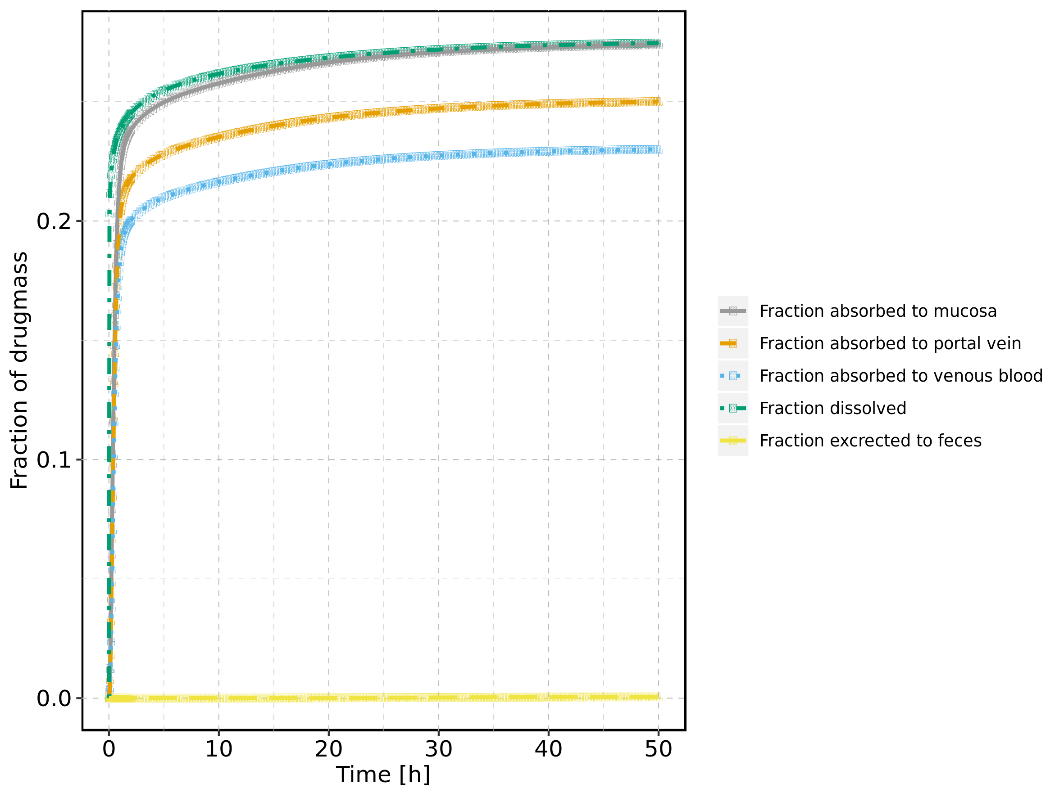

## 2.8. Absorption for Raltegravir 1200 mg (lactose formulation)

Figure 8: Absorption of Raltegravir

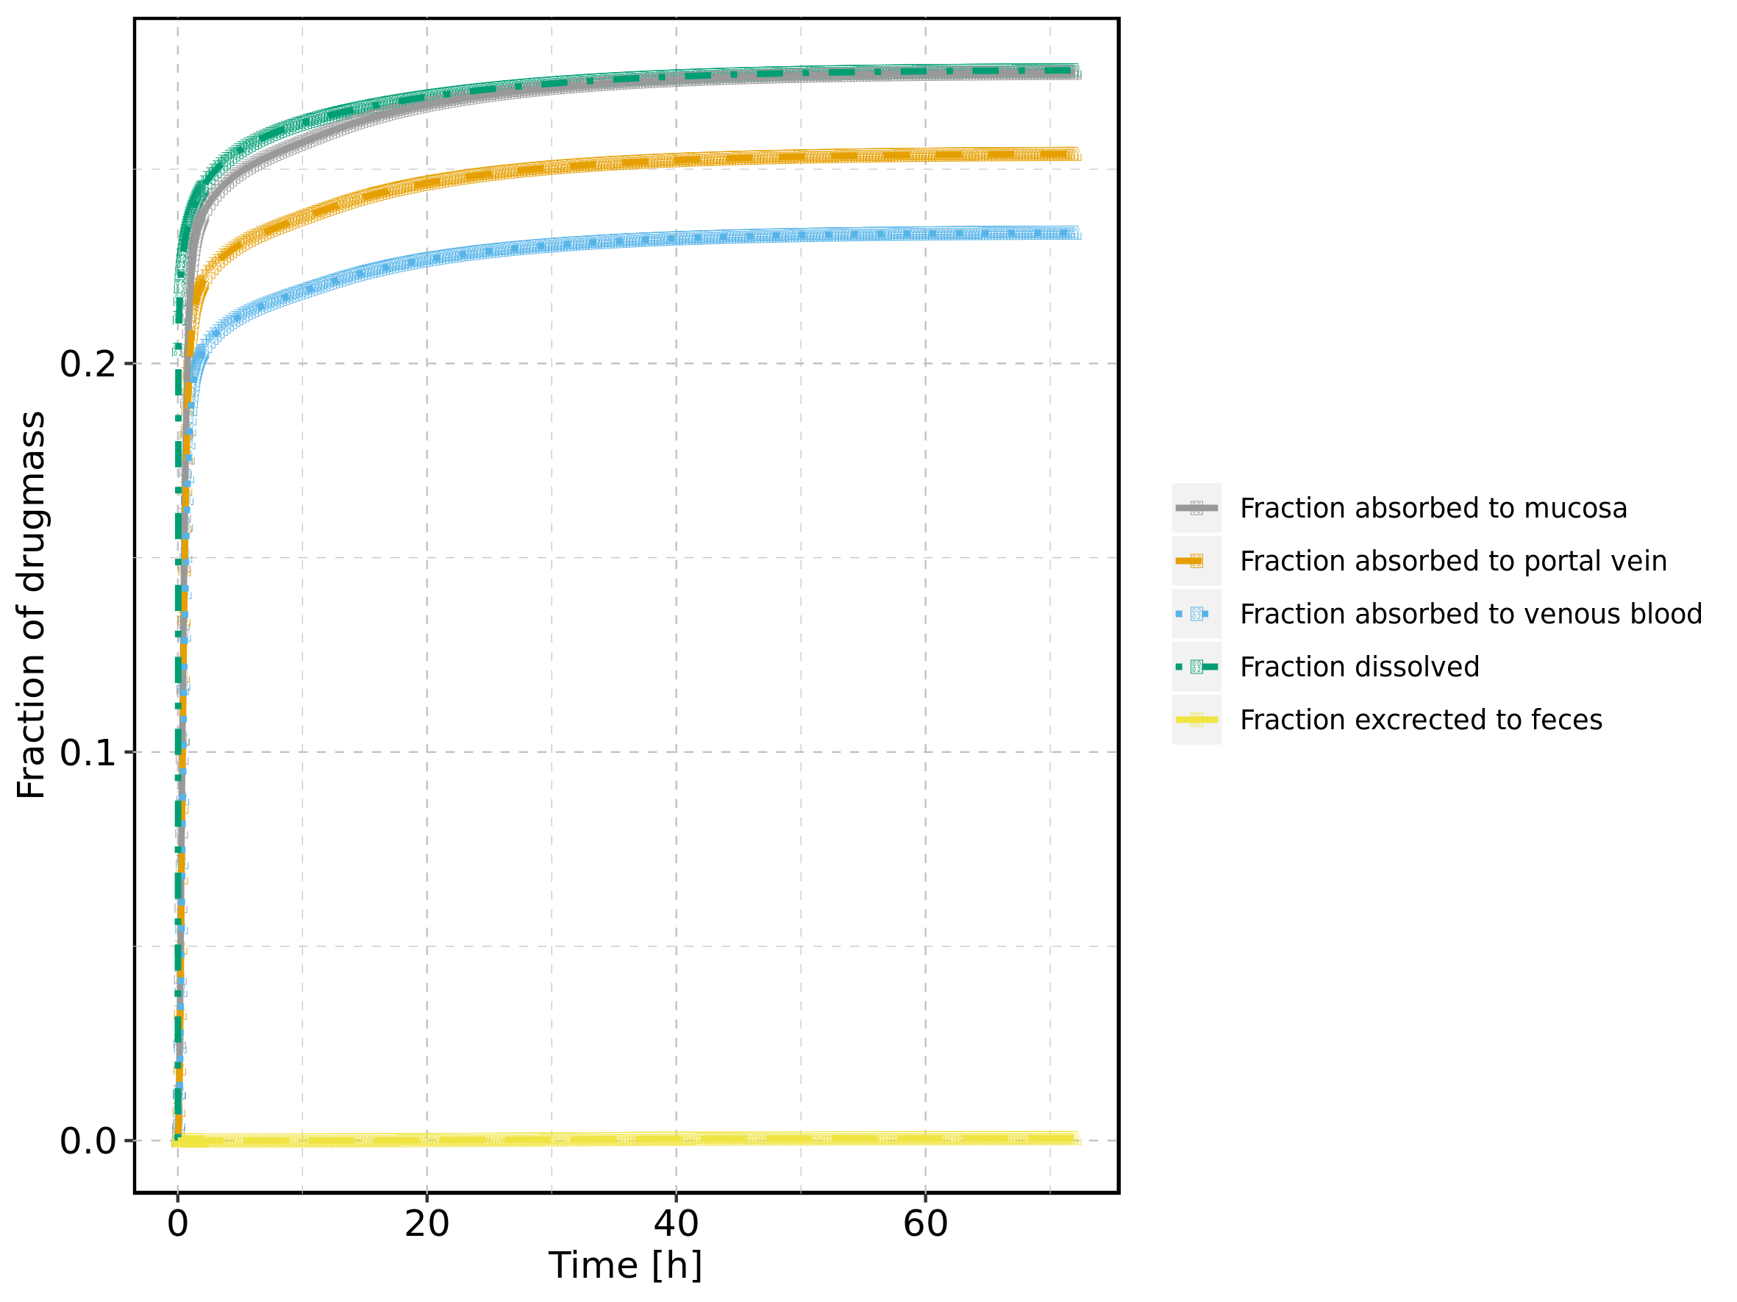

## 2.9. Absorption for Raltegravir 1600 mg (lactose formulation)

Figure 9: Absorption of Raltegravir

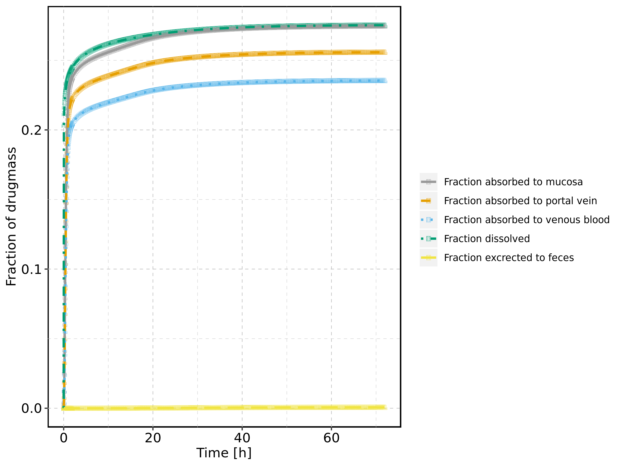

## 2.10. Absorption for Raltegravir 100 mg filmcoated tablet md

Figure 10: Absorption of Raltegravir

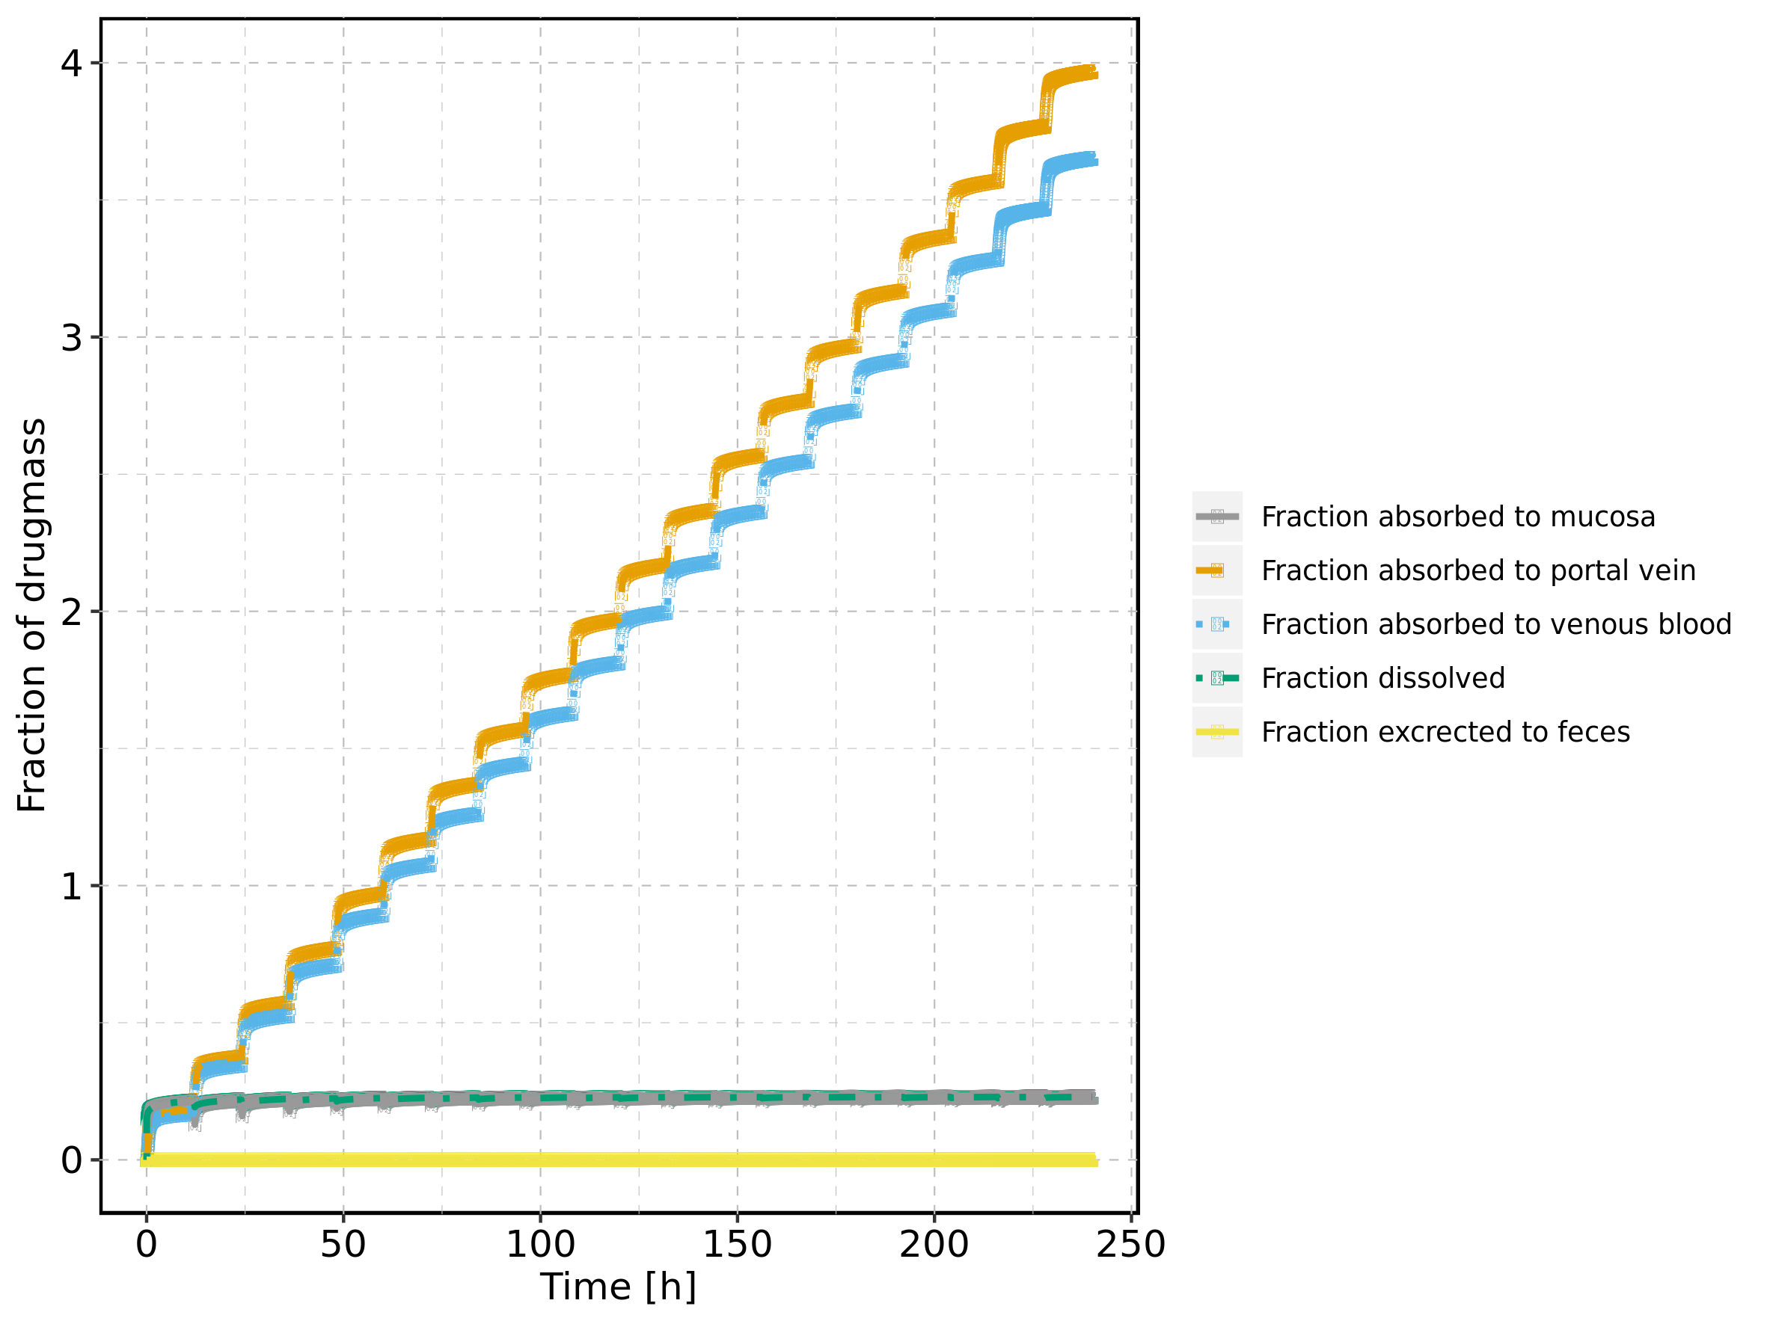

## 2.11. Absorption for Raltegravir 200 mg filmcoated tablet md

Figure 11: Absorption of Raltegravir

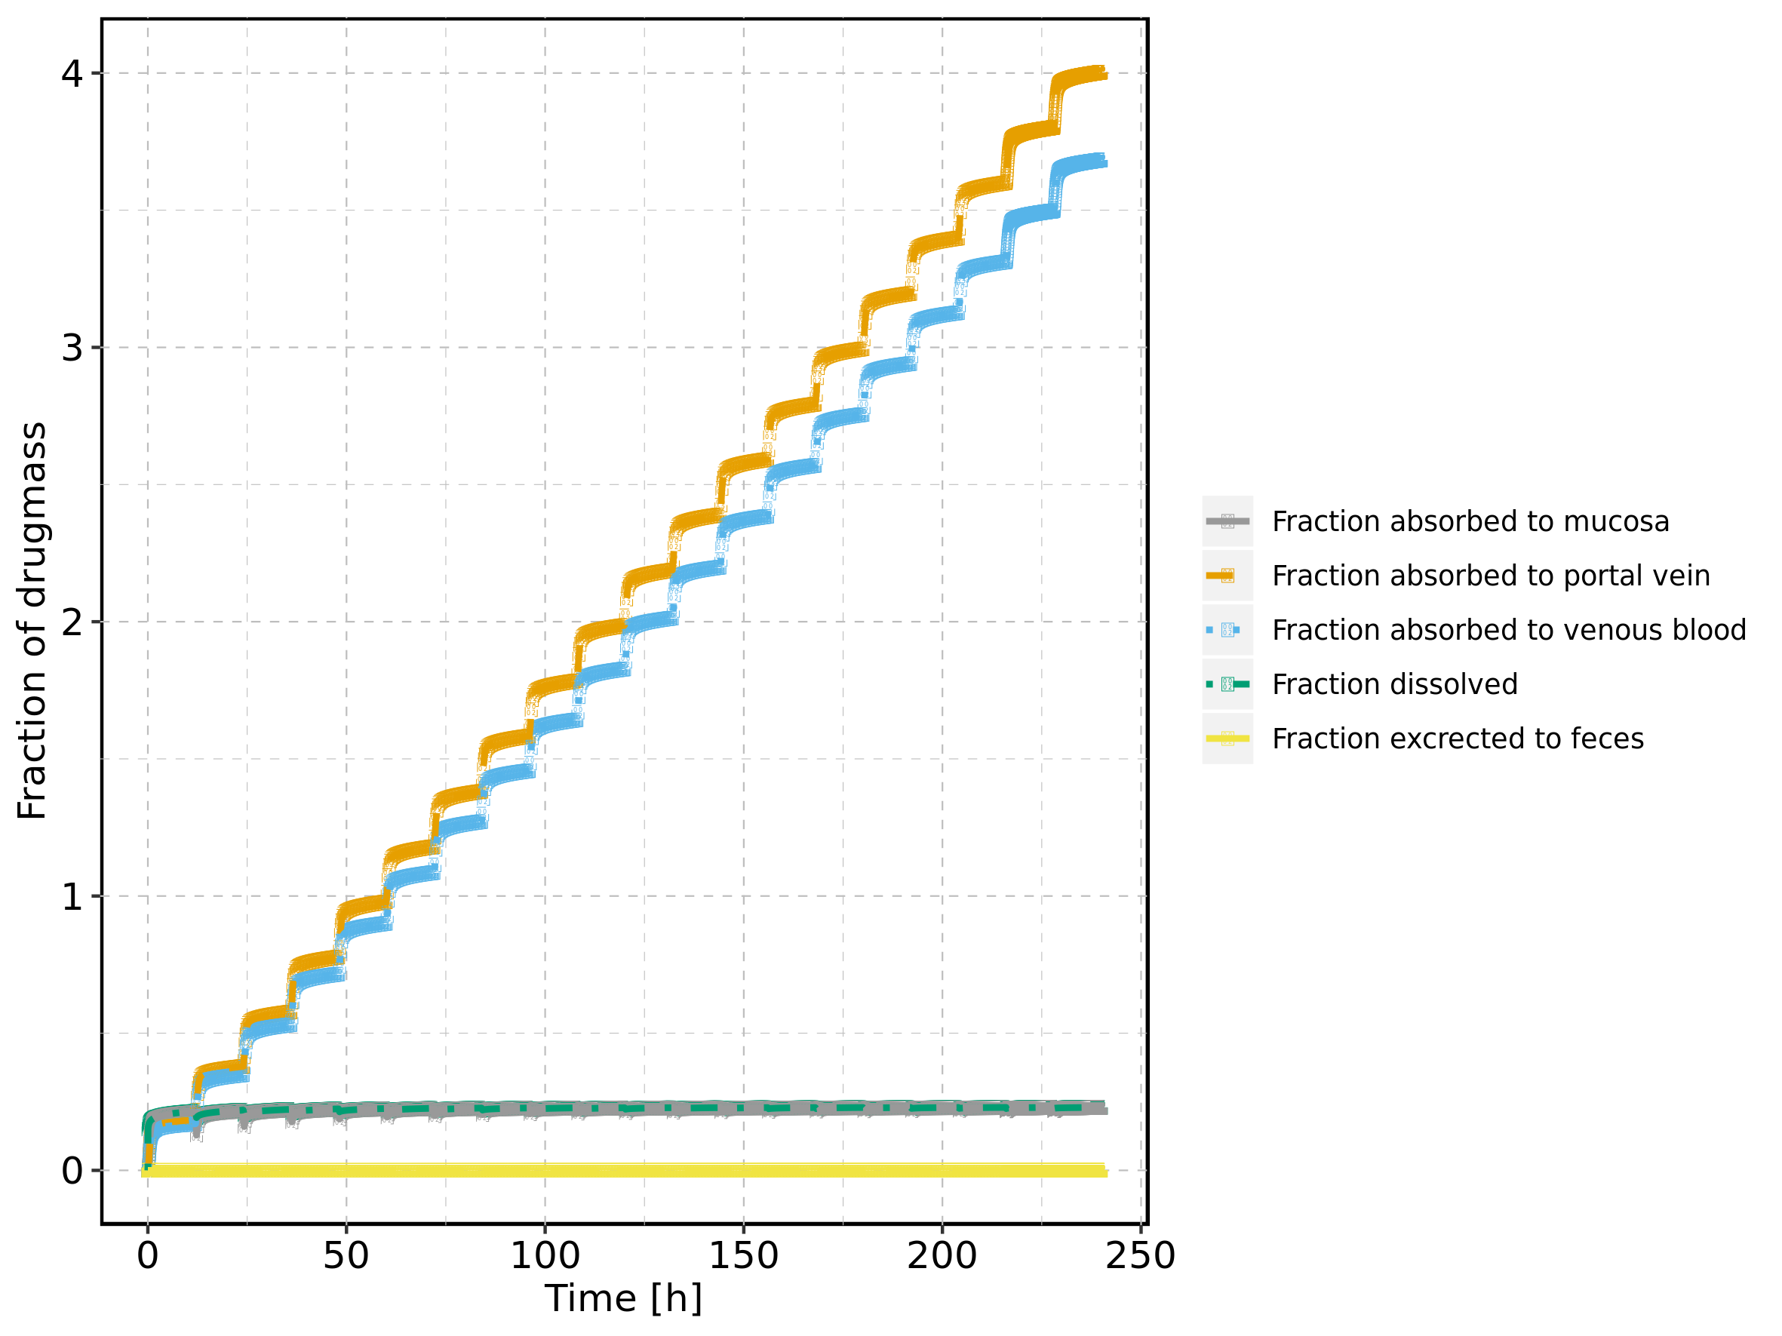

## 2.12. Absorption for Filmcoated_tablet_400mg_sd

Figure 12: Absorption of Raltegravir

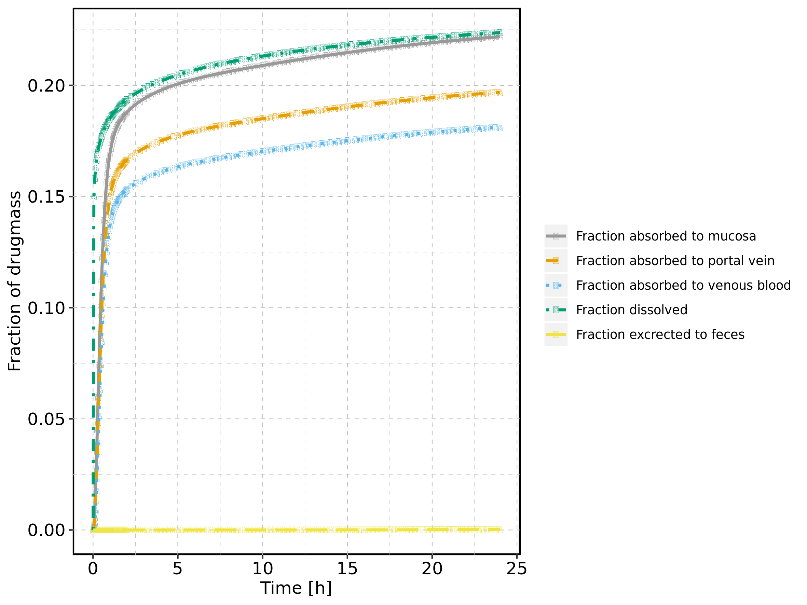

## 2.13. Absorption for Raltegravir 400 mg filmcoated tablet md

Figure 13: Absorption of Raltegravir

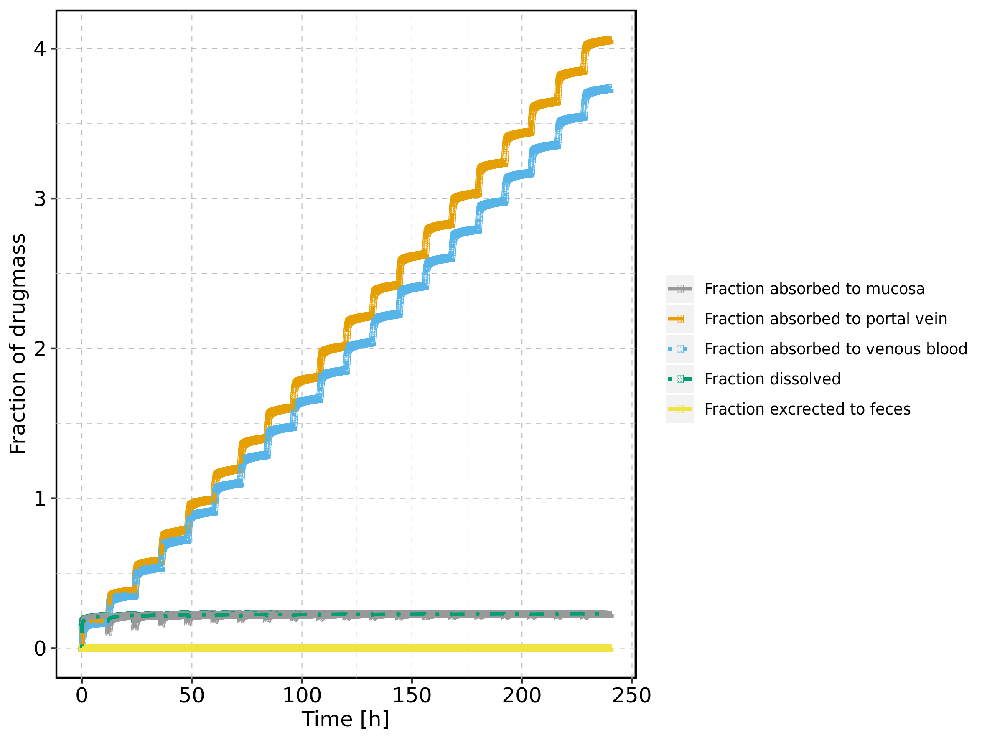

## 2.14. Absorption for Raltegravir 400mg chewable fasted

Figure 14: Absorption of Raltegravir

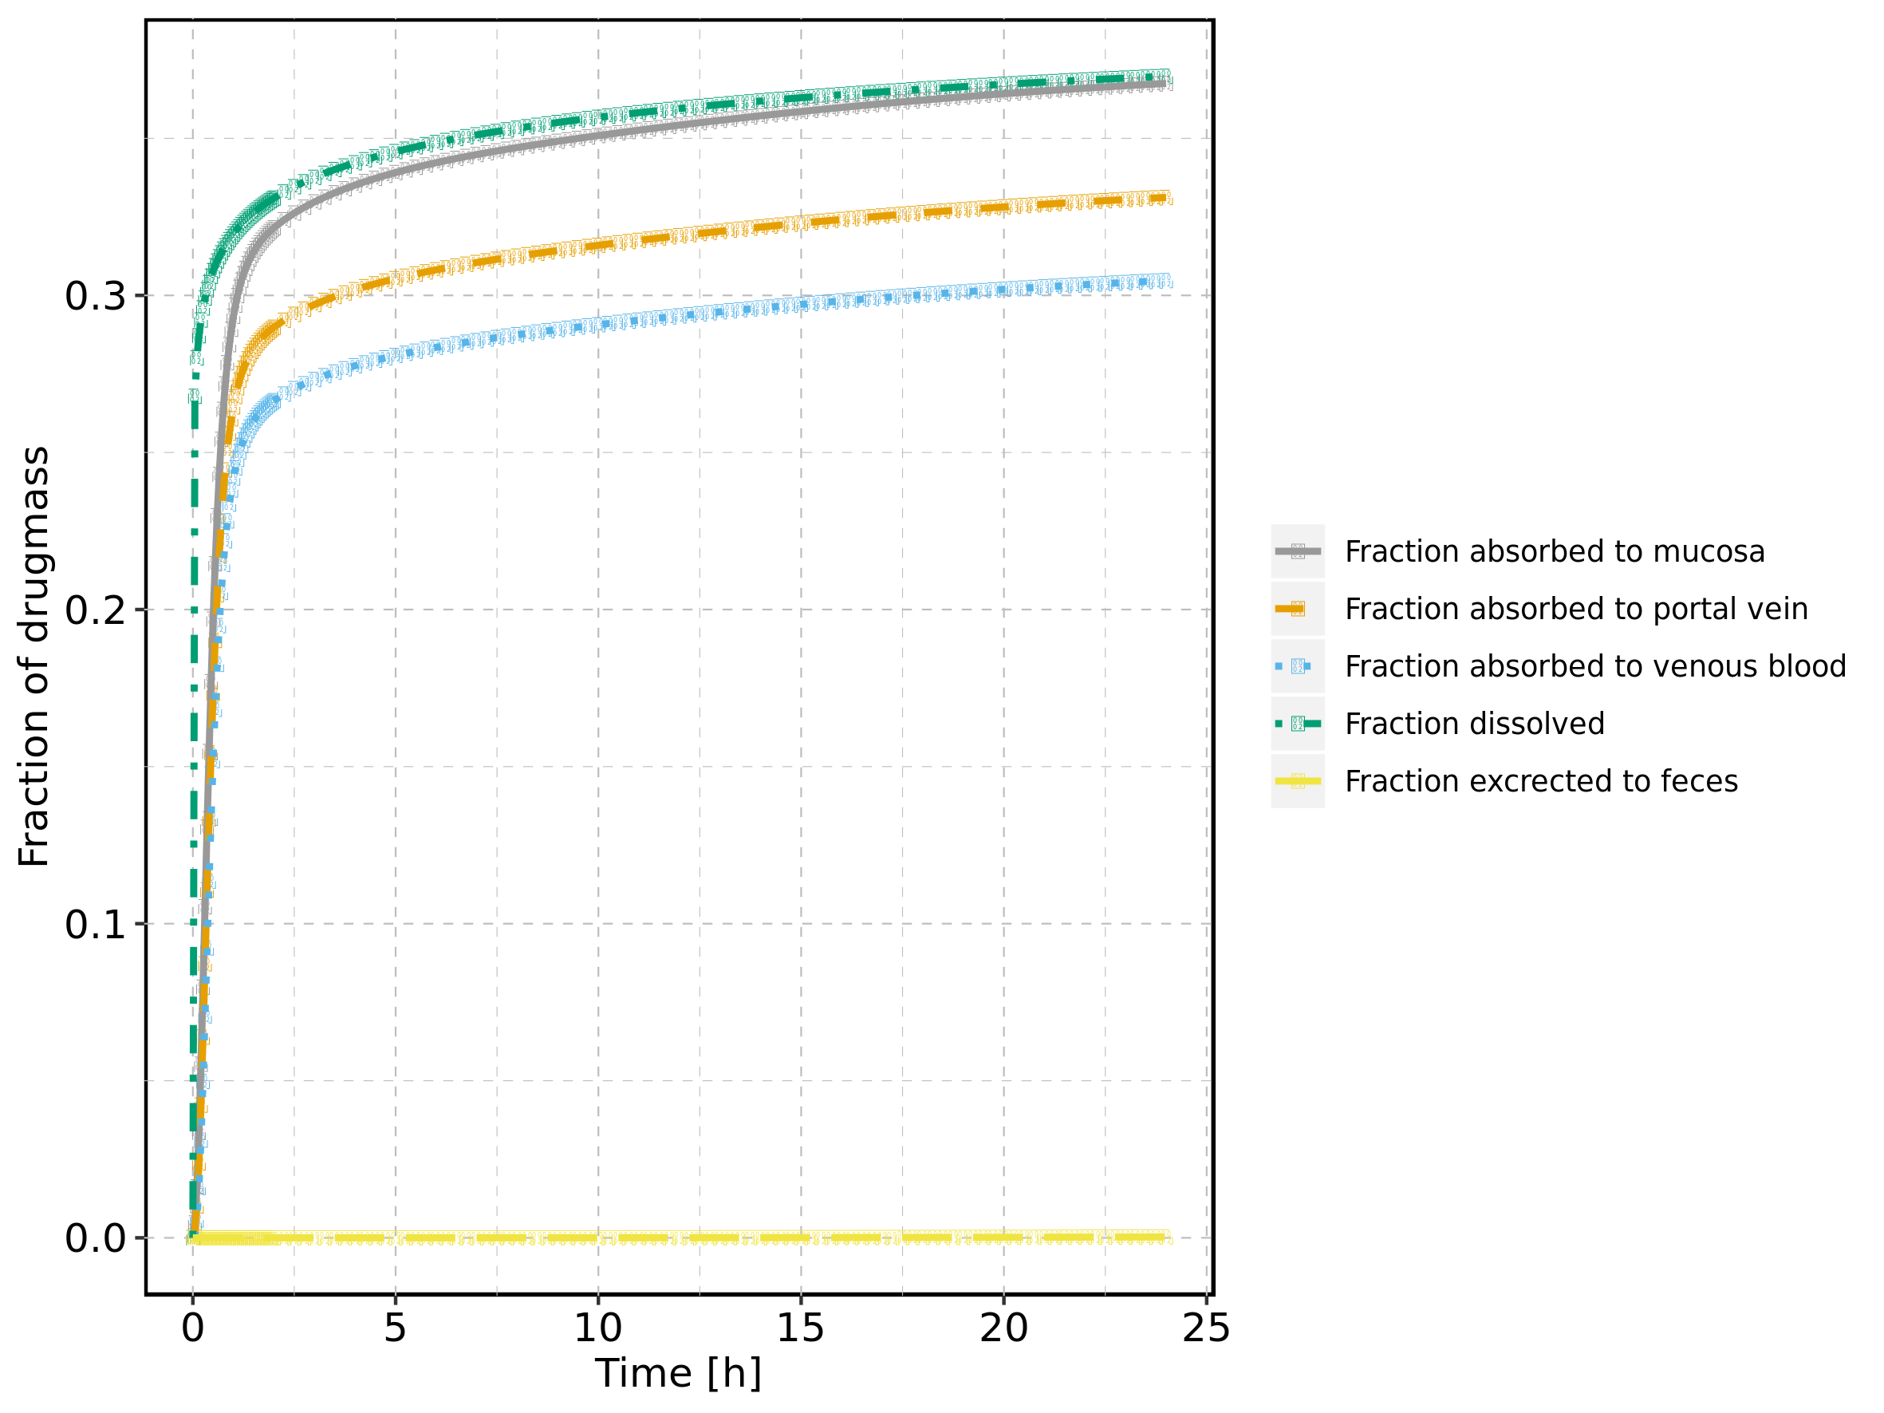

## 2.15. Absorption for Raltegravir 400mg chewable fed

Figure 15: Absorption of Raltegravir

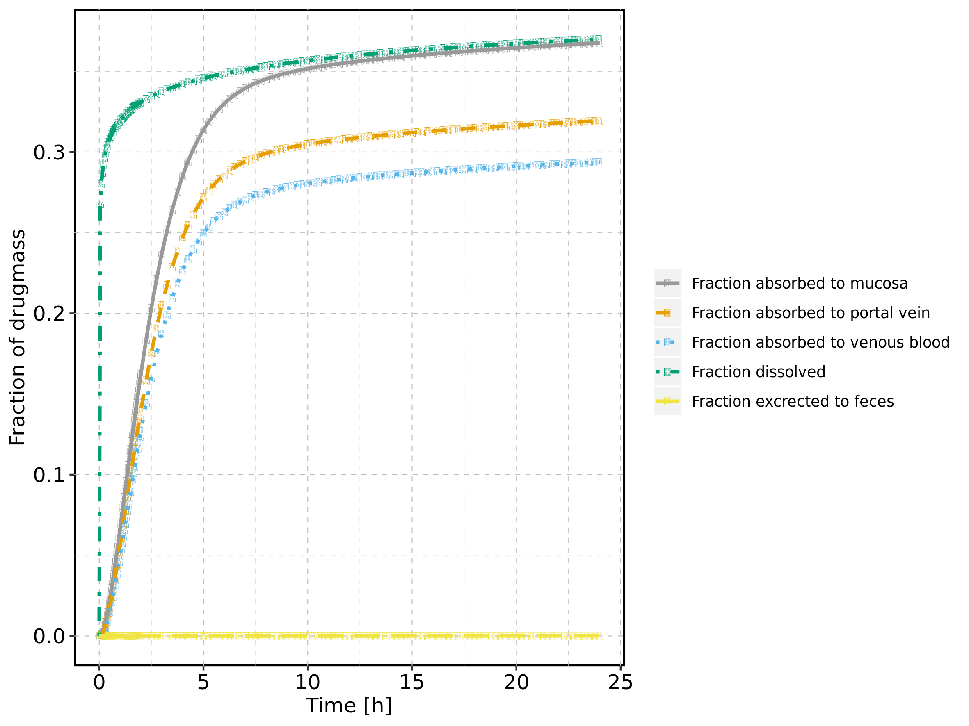

## 2.16. Absorption for Raltegravir 400mg (granules in suspension)

Figure 16: Absorption of Raltegravir

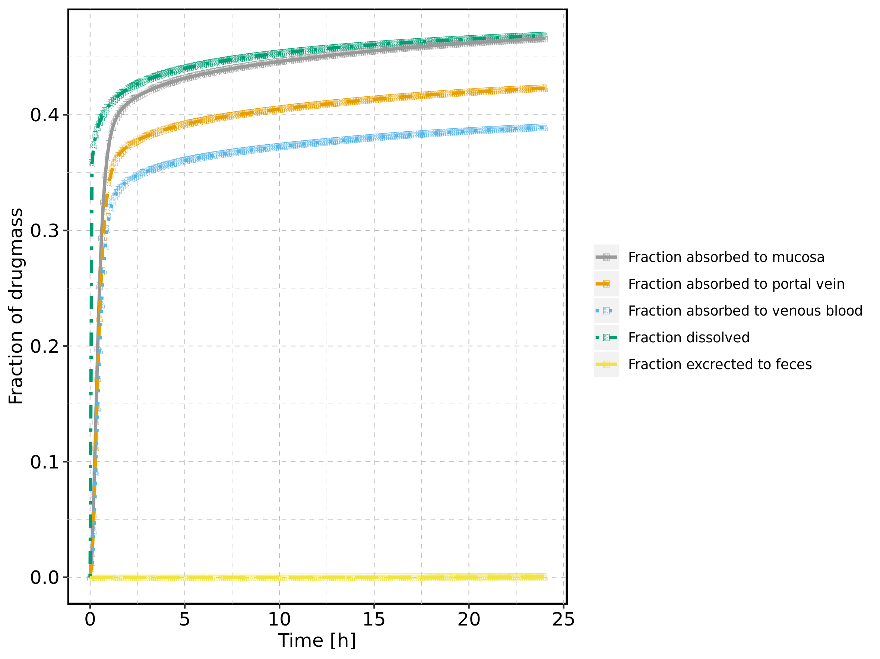

# 3. Mass Balance

## 3.1. Mass Balance for Raltegravir 10 mg (lactose formulation)

Figure 17: Amount of drug vs time within the different compartments.

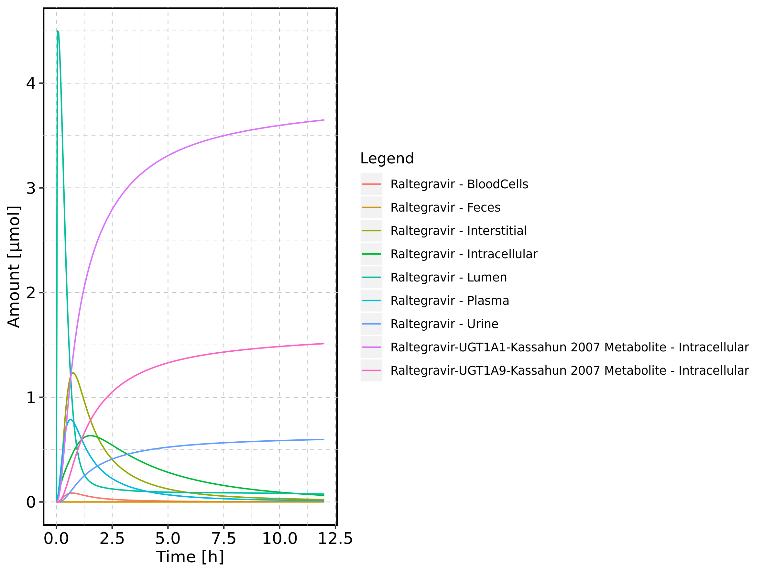

Figure 18: Cumulated amount of drug vs time within the different compartments

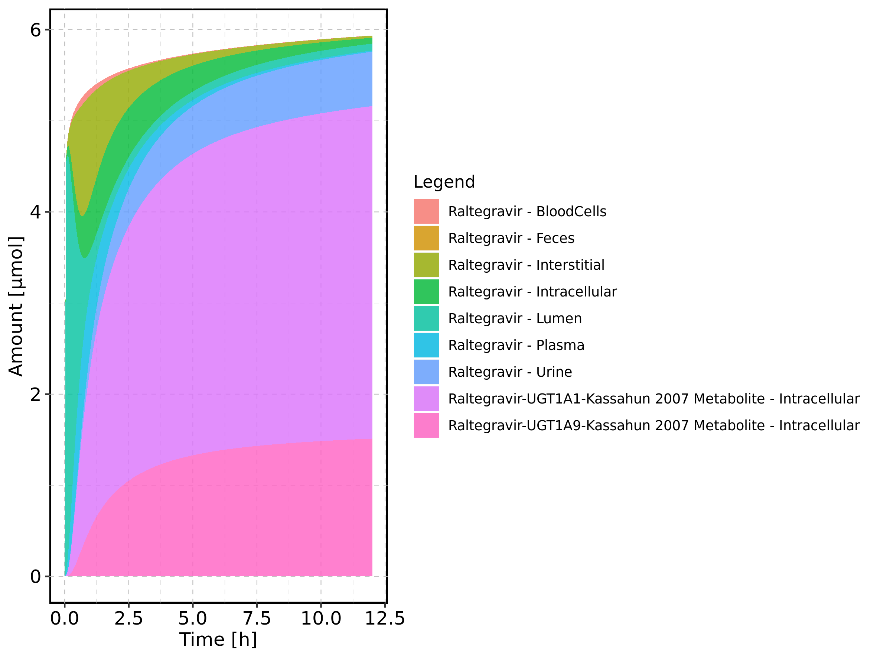

Figure 19: Amount of drug vs time within the different compartments normalized to applicated drugmass.

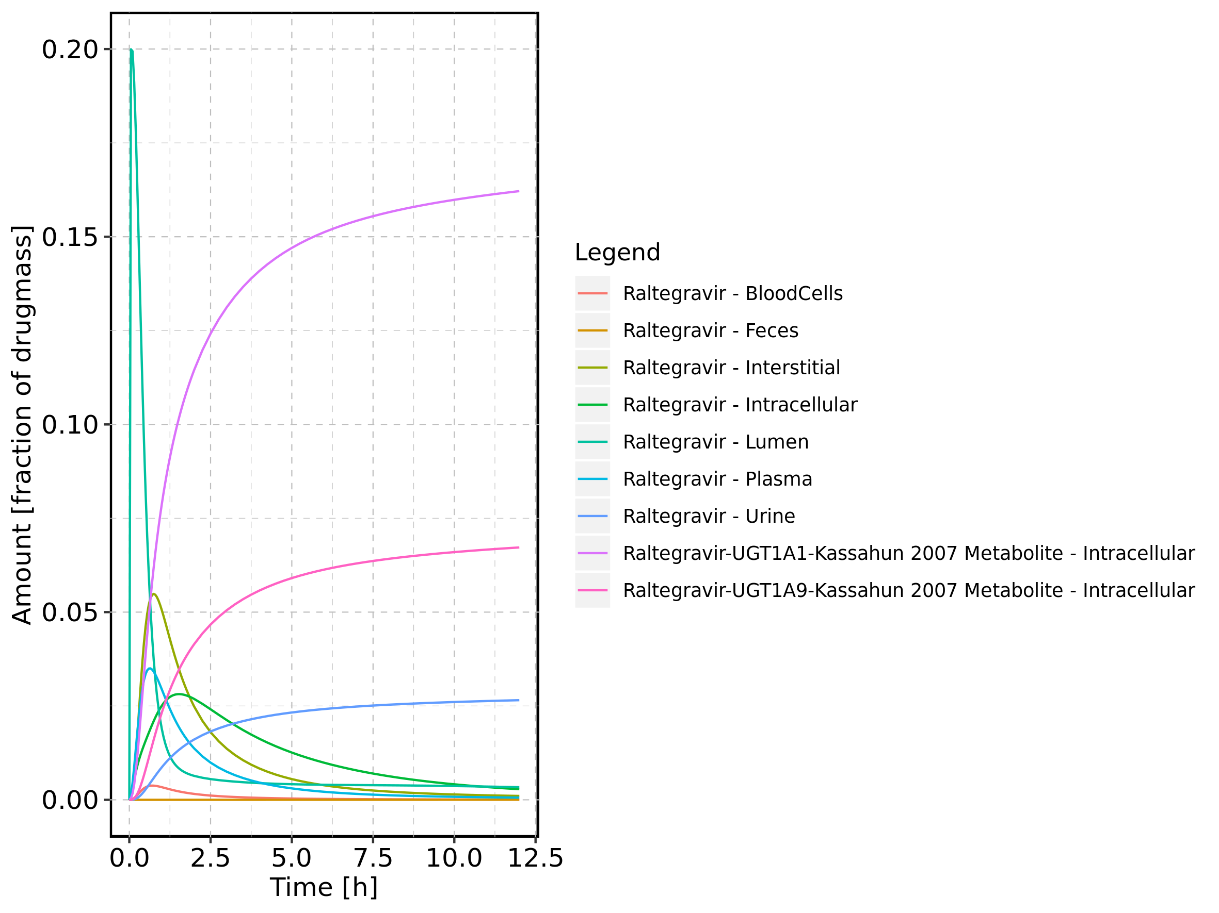

Figure 20: Cumulated amount of drug vs time within the different compartments normalized to applicated drugmass.

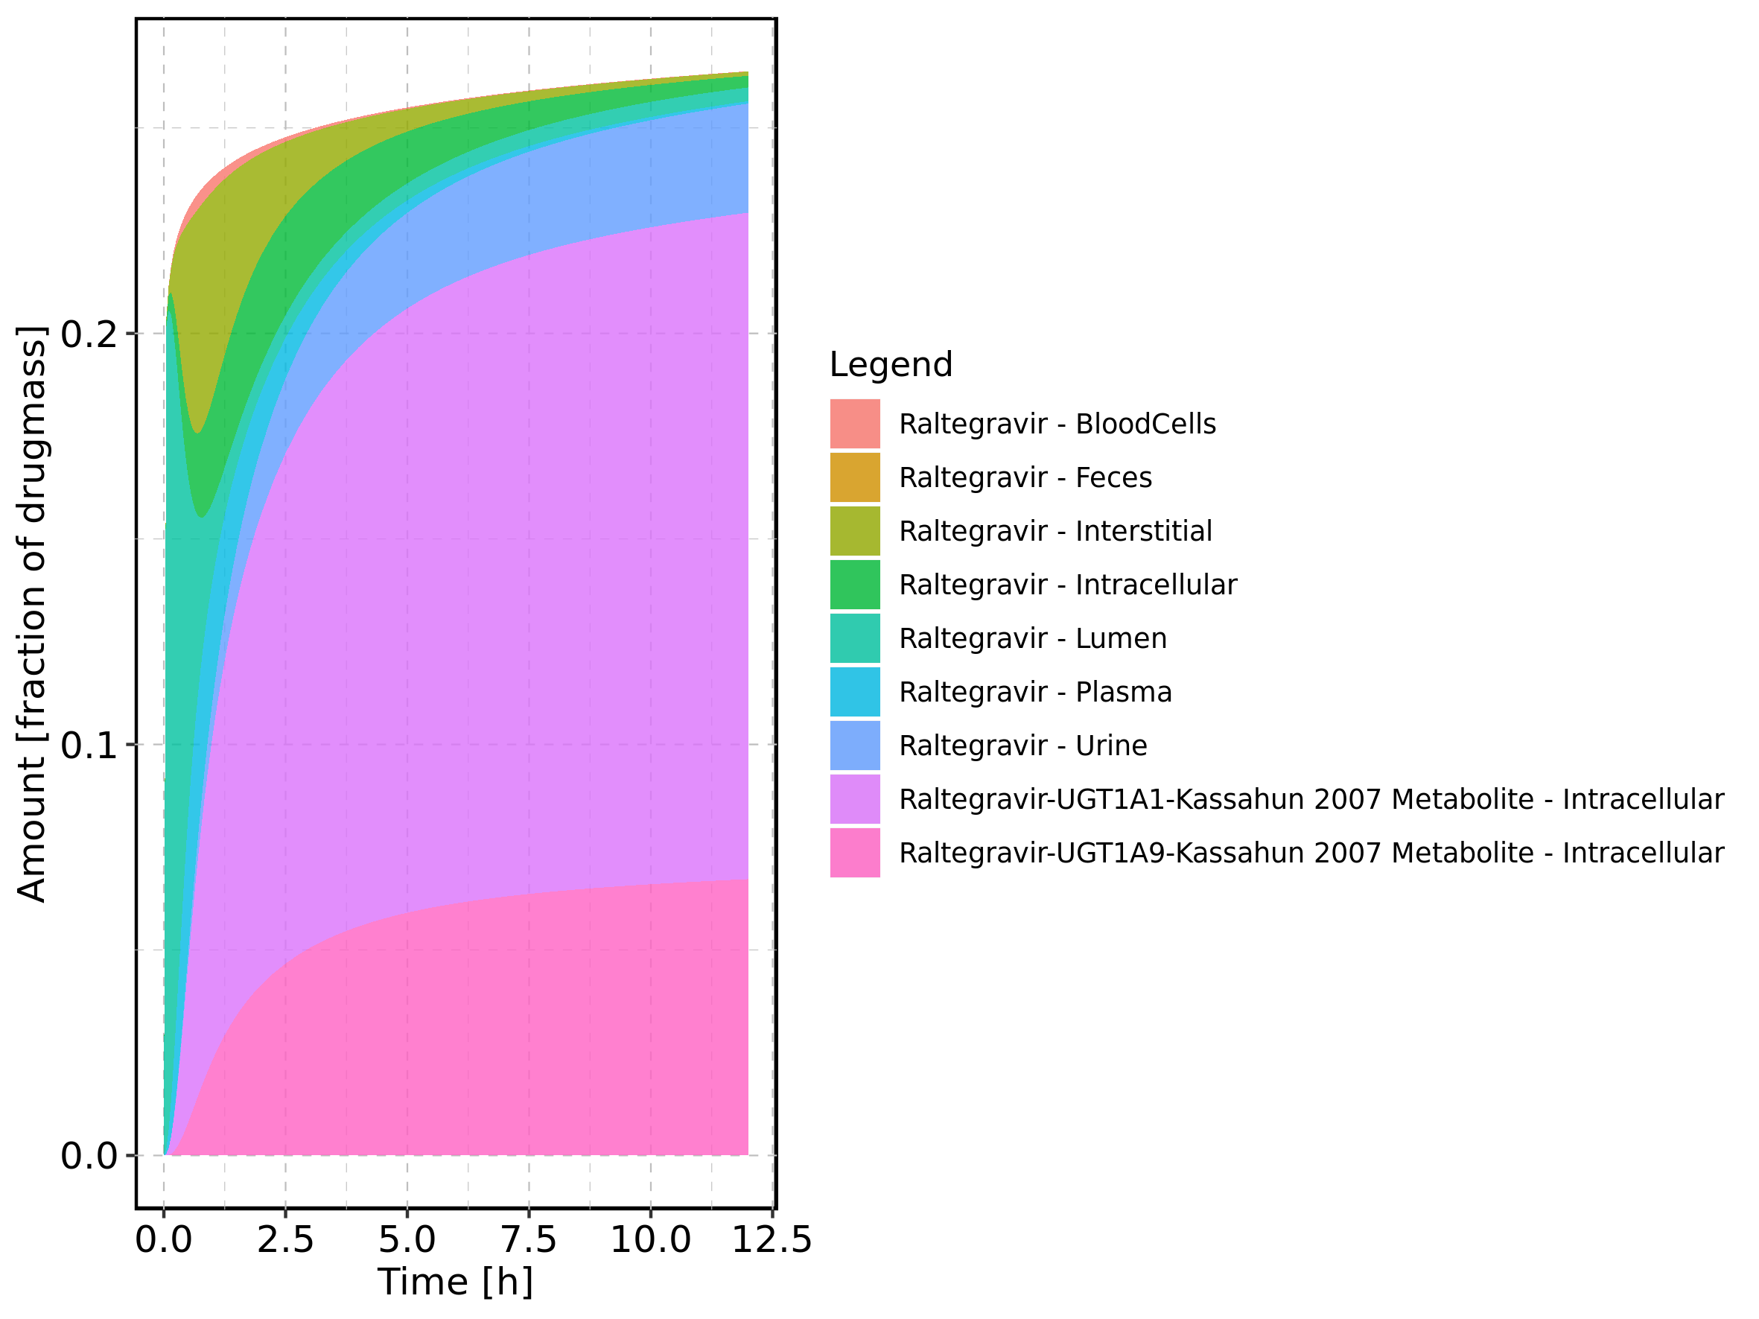

Figure 21: Fraction of drug within the different compartments at 12h.

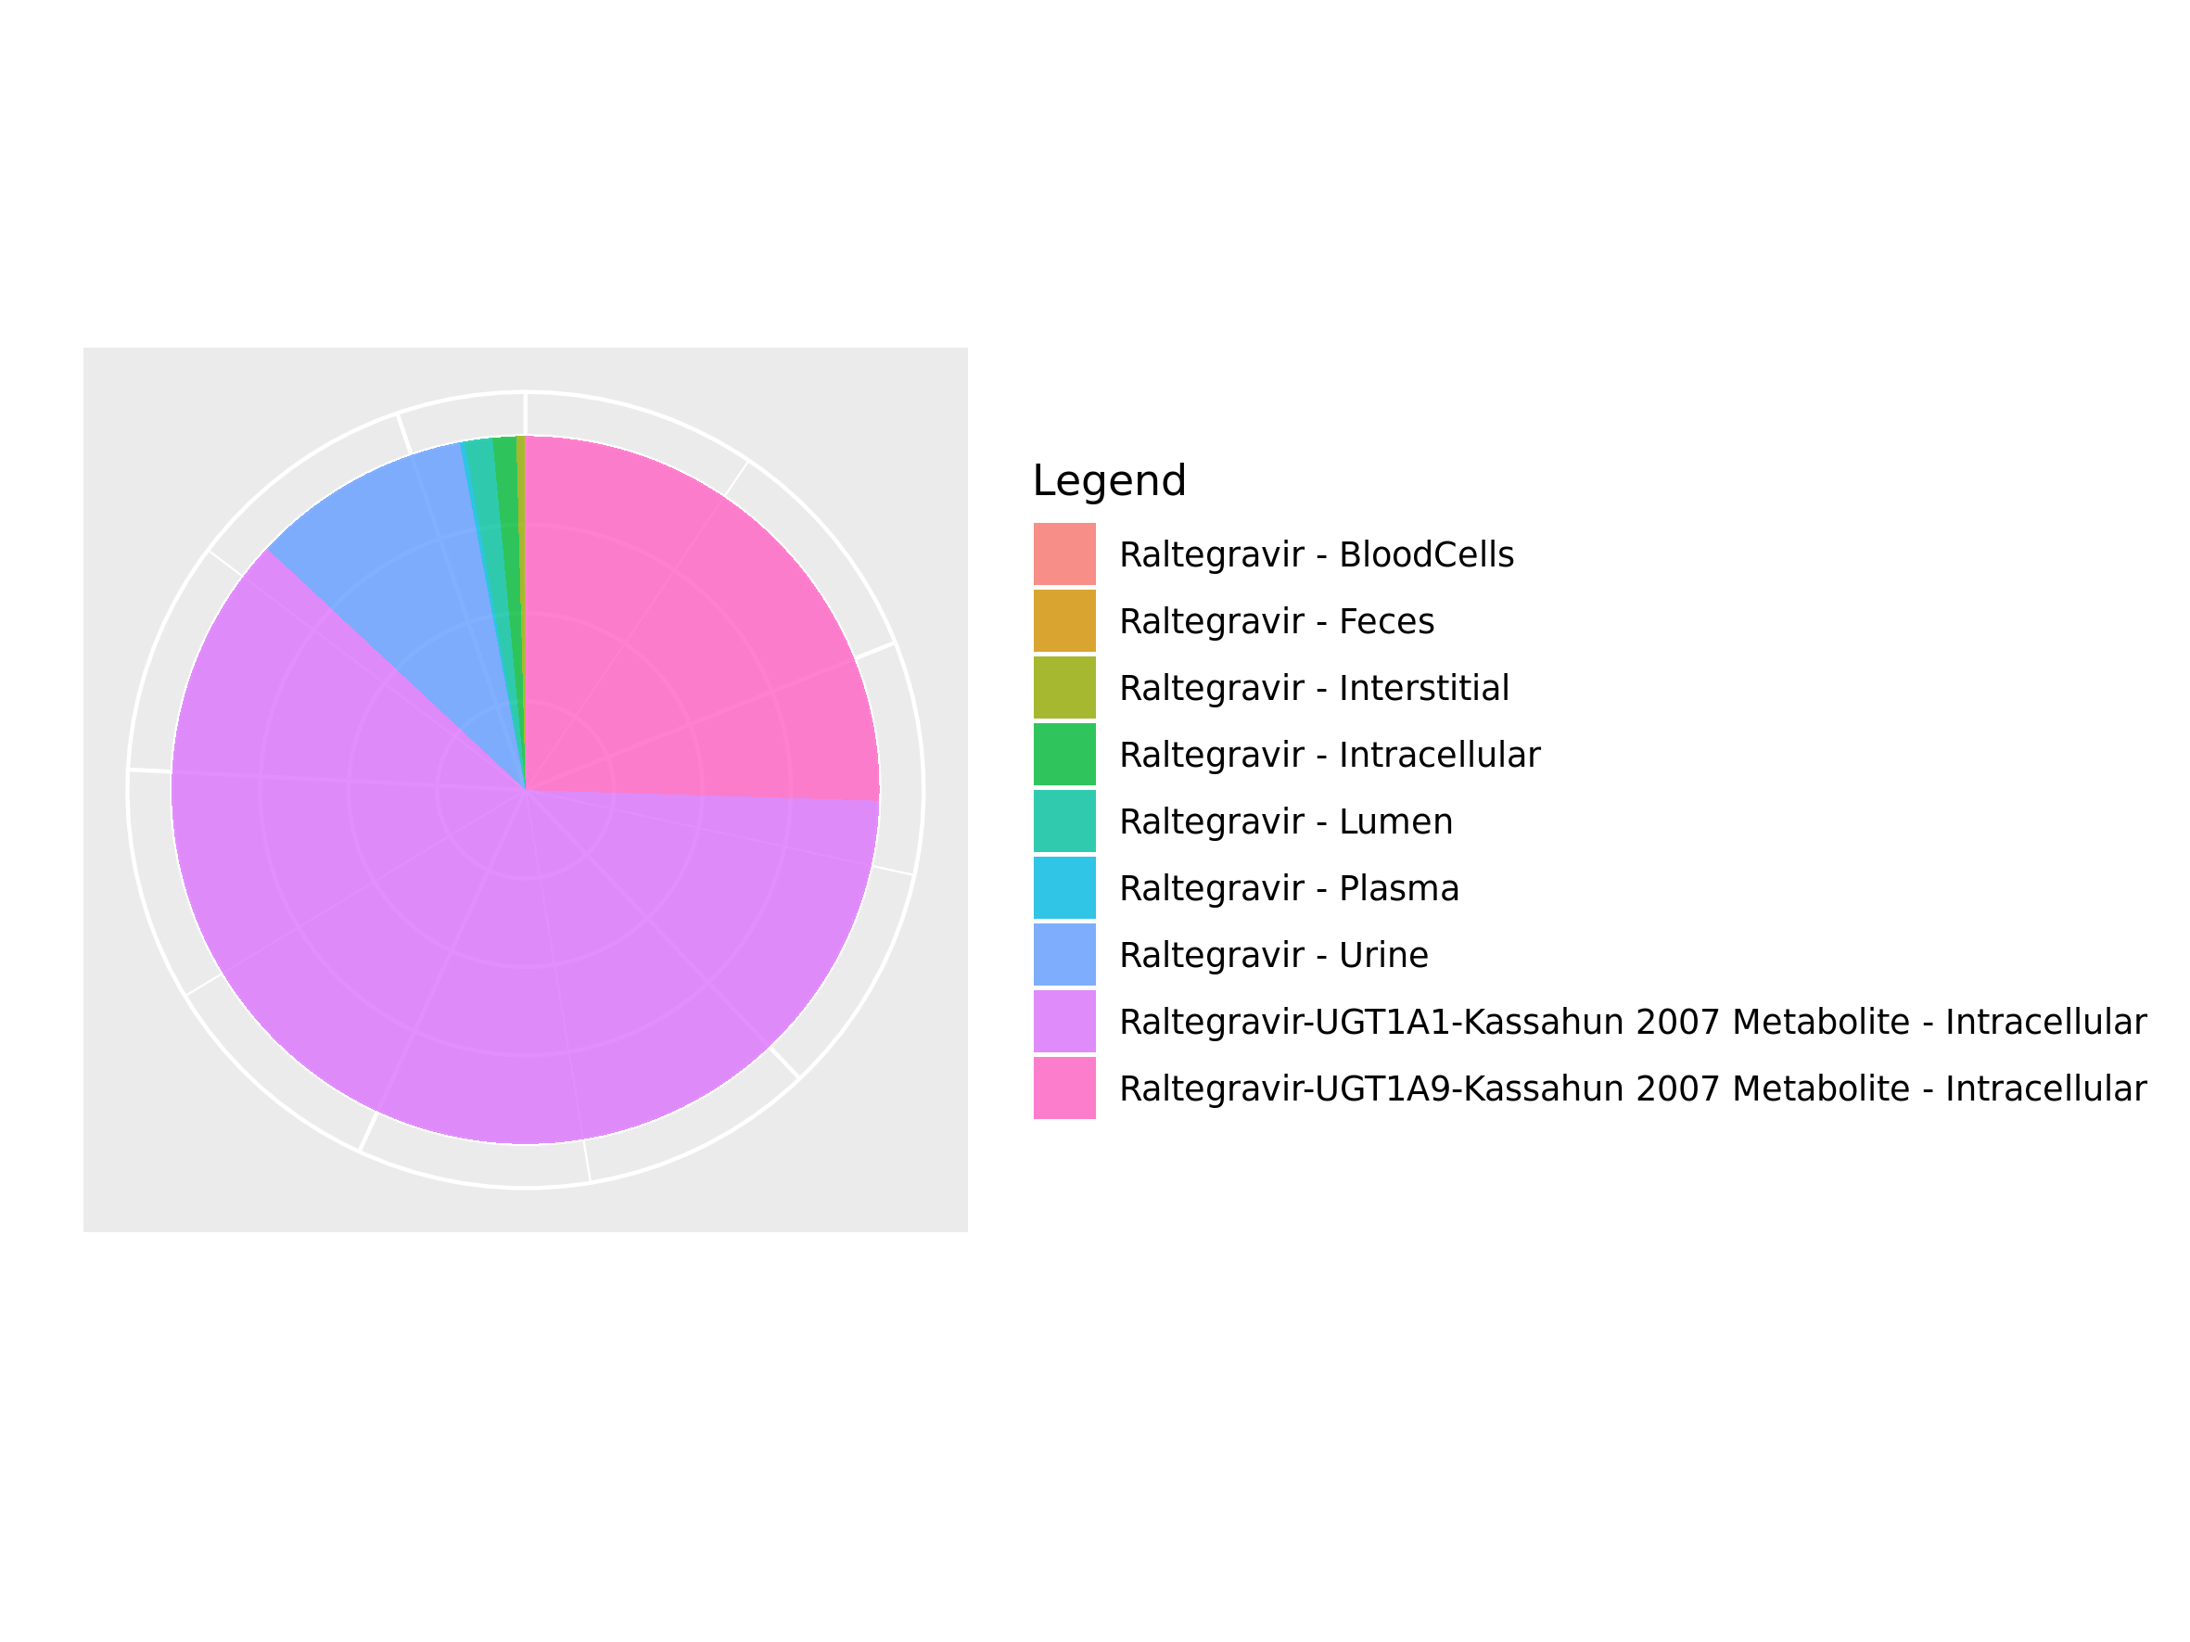

## 3.2. Mass Balance for Raltegravir 25 mg (lactose formulation)

Figure 22: Amount of drug vs time within the different compartments.

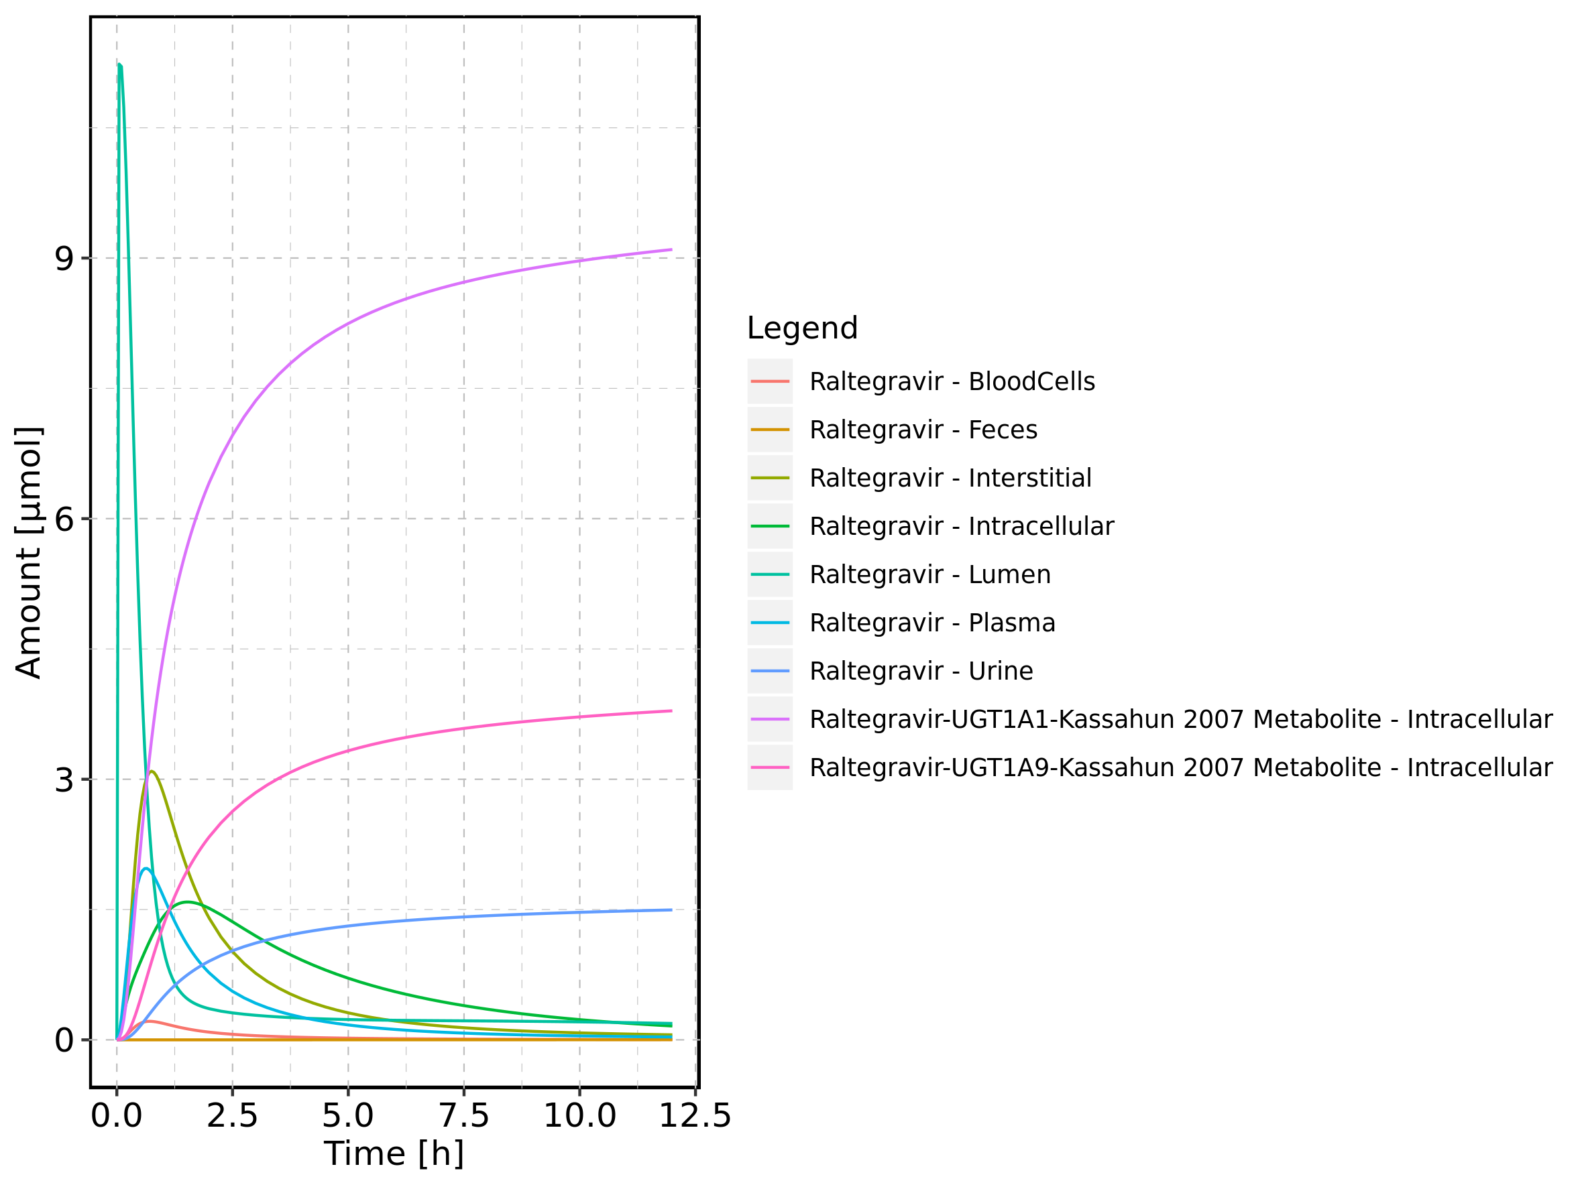

Figure 23: Cumulated amount of drug vs time within the different compartments

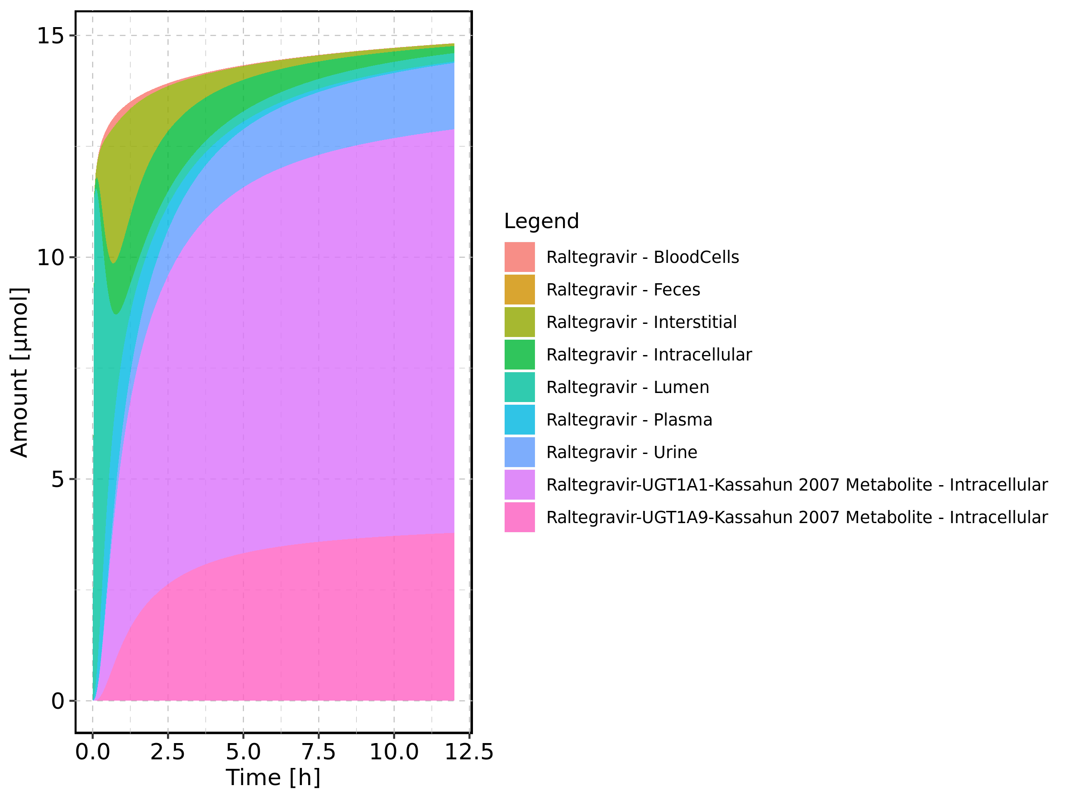

Figure 24: Amount of drug vs time within the different compartments normalized to applicated drugmass.

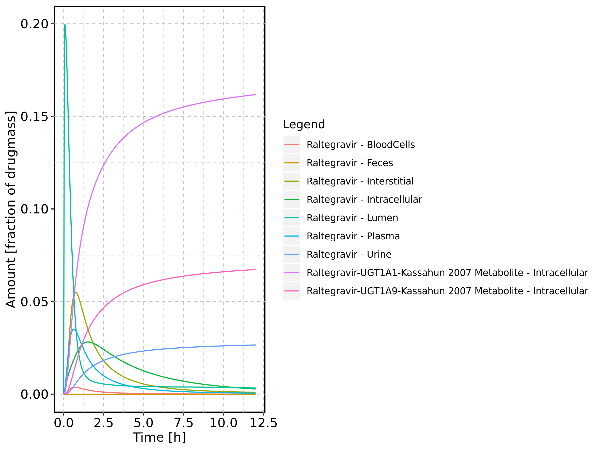

Figure 25: Cumulated amount of drug vs time within the different compartments normalized to applicated drugmass.

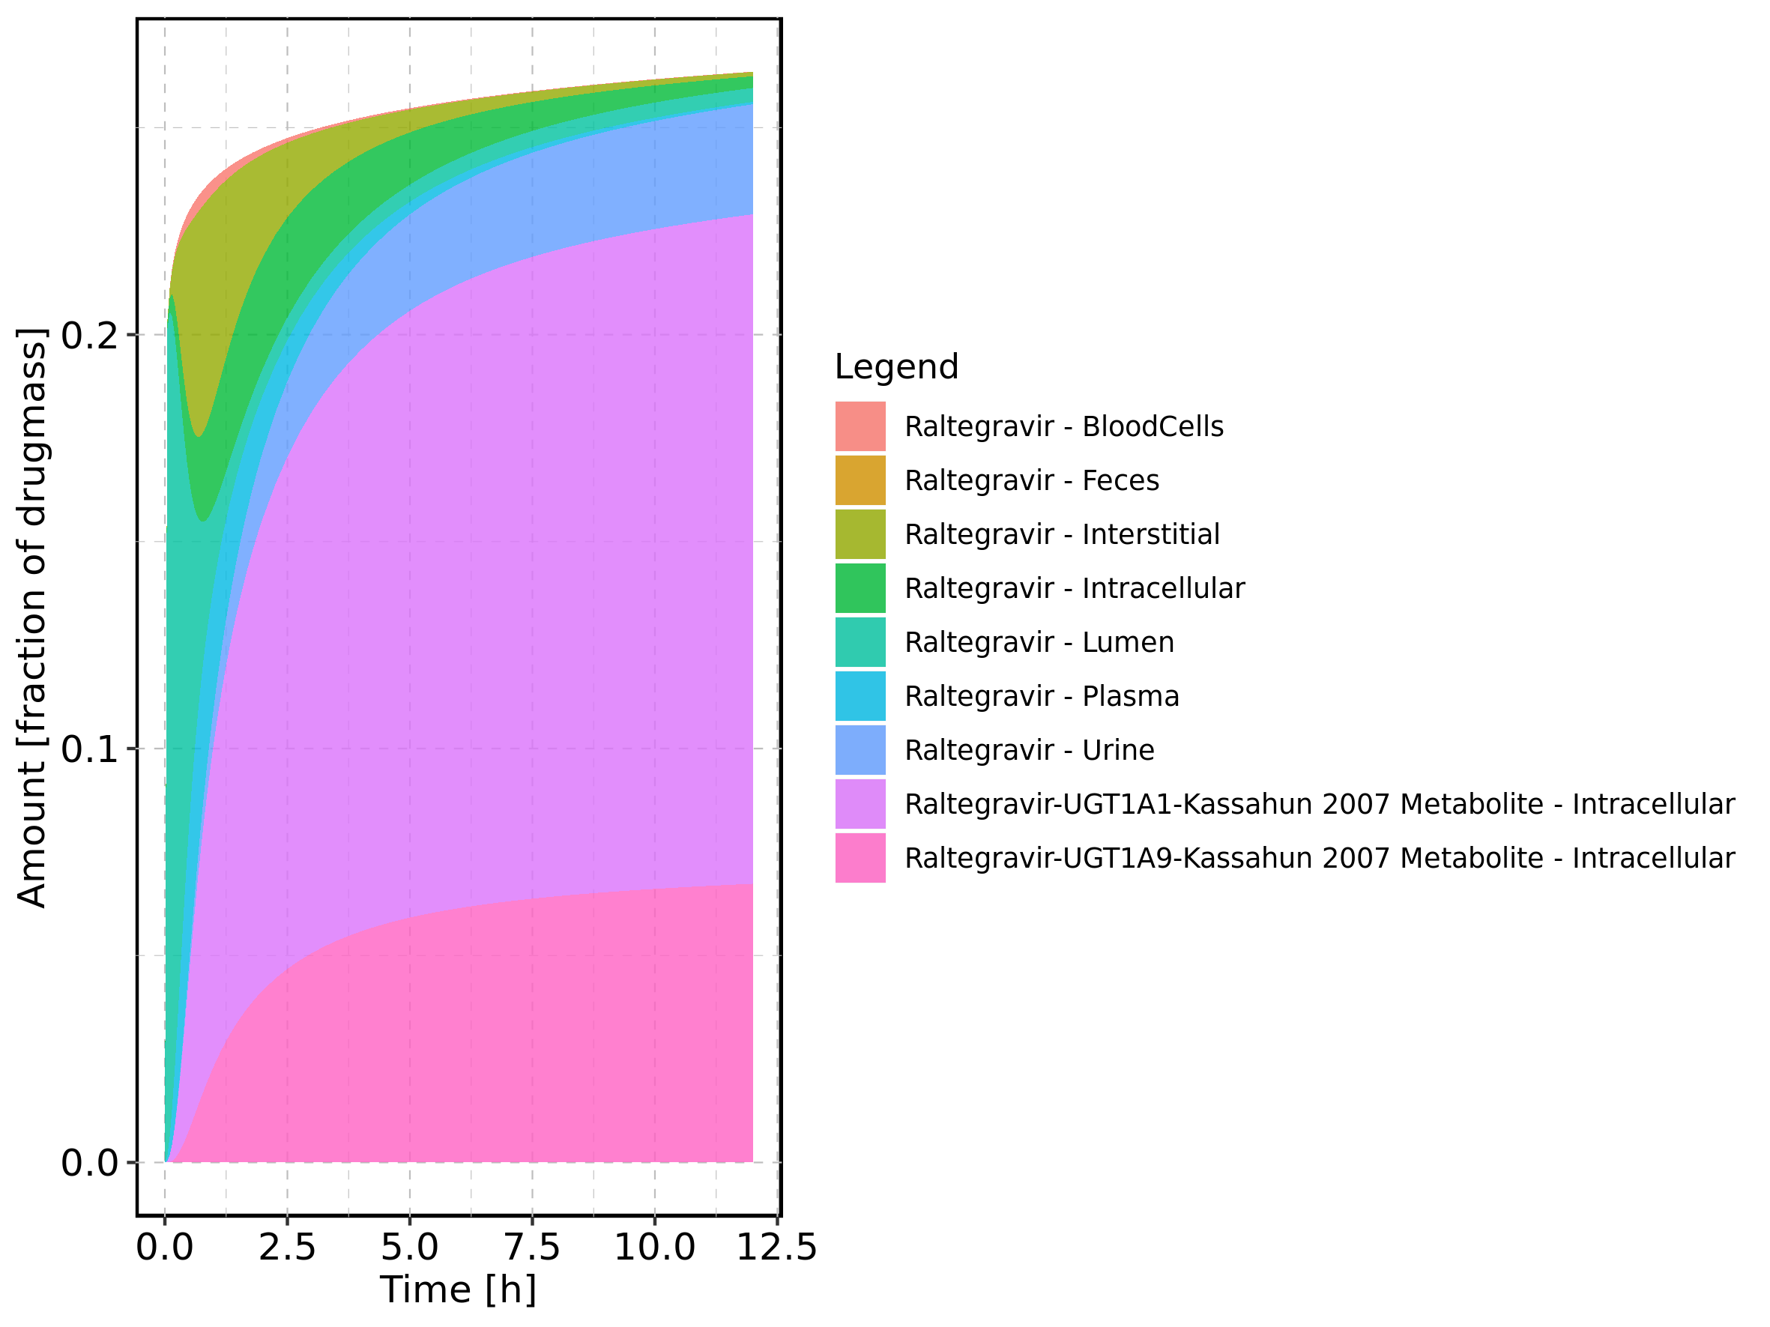

Figure 26: Fraction of drug within the different compartments at 12h.

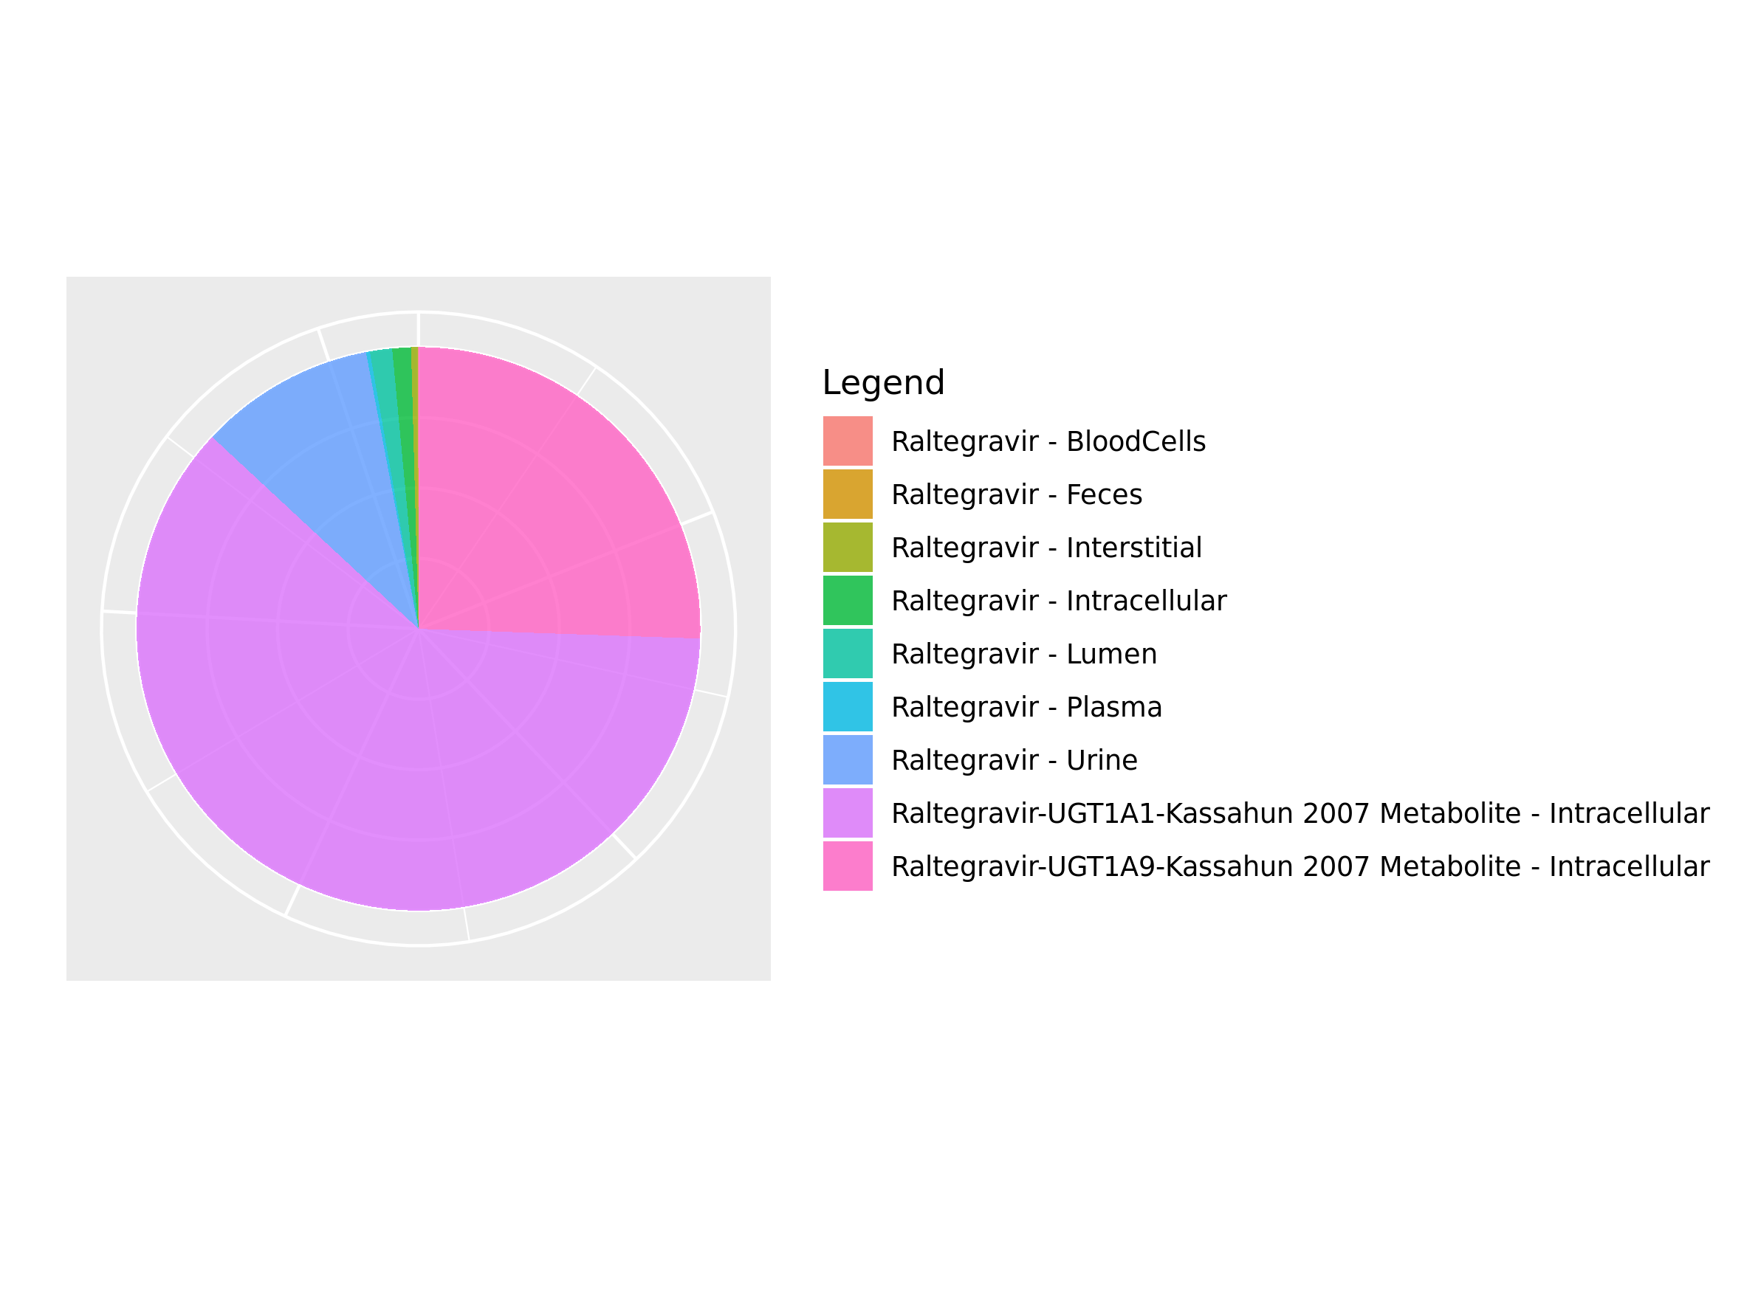

## 3.3. Mass Balance for Raltegravir 50 mg (lactose formulation)

Figure 27: Amount of drug vs time within the different compartments.

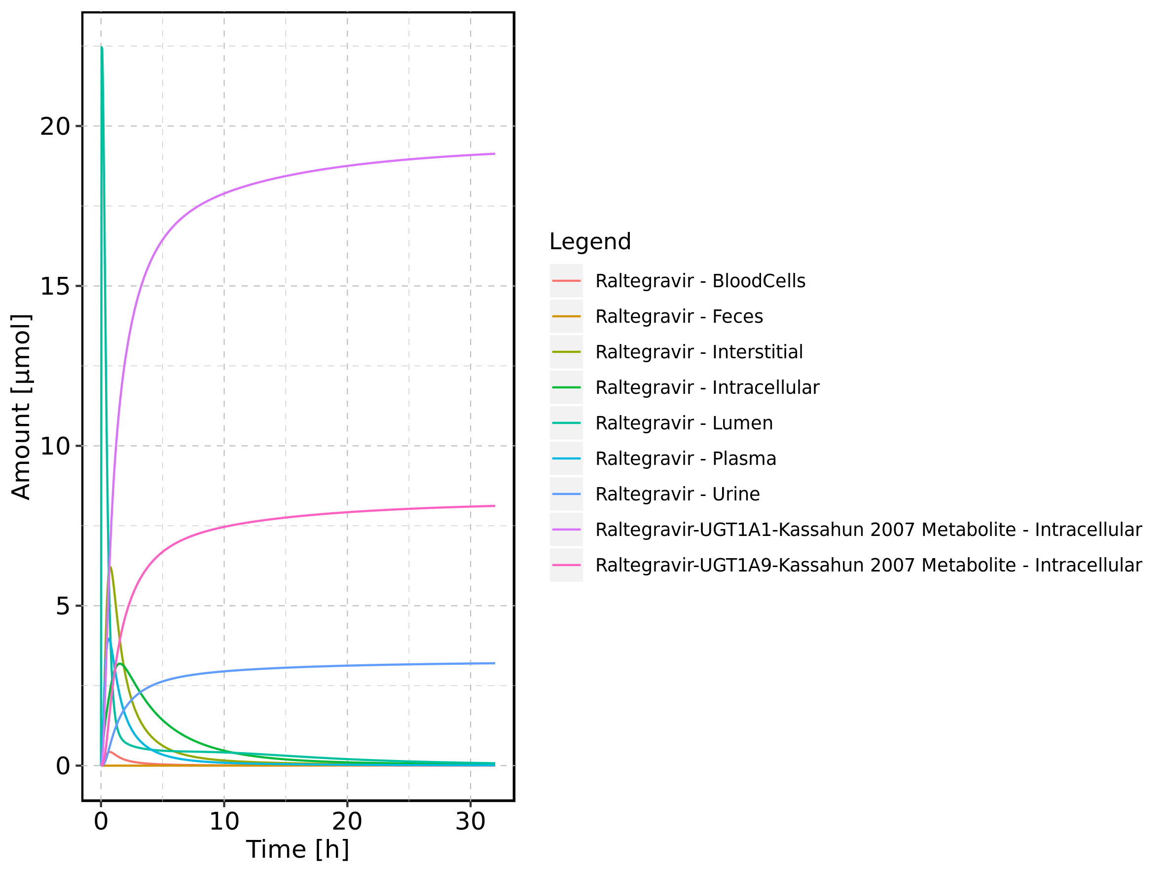

Figure 28: Cumulated amount of drug vs time within the different compartments

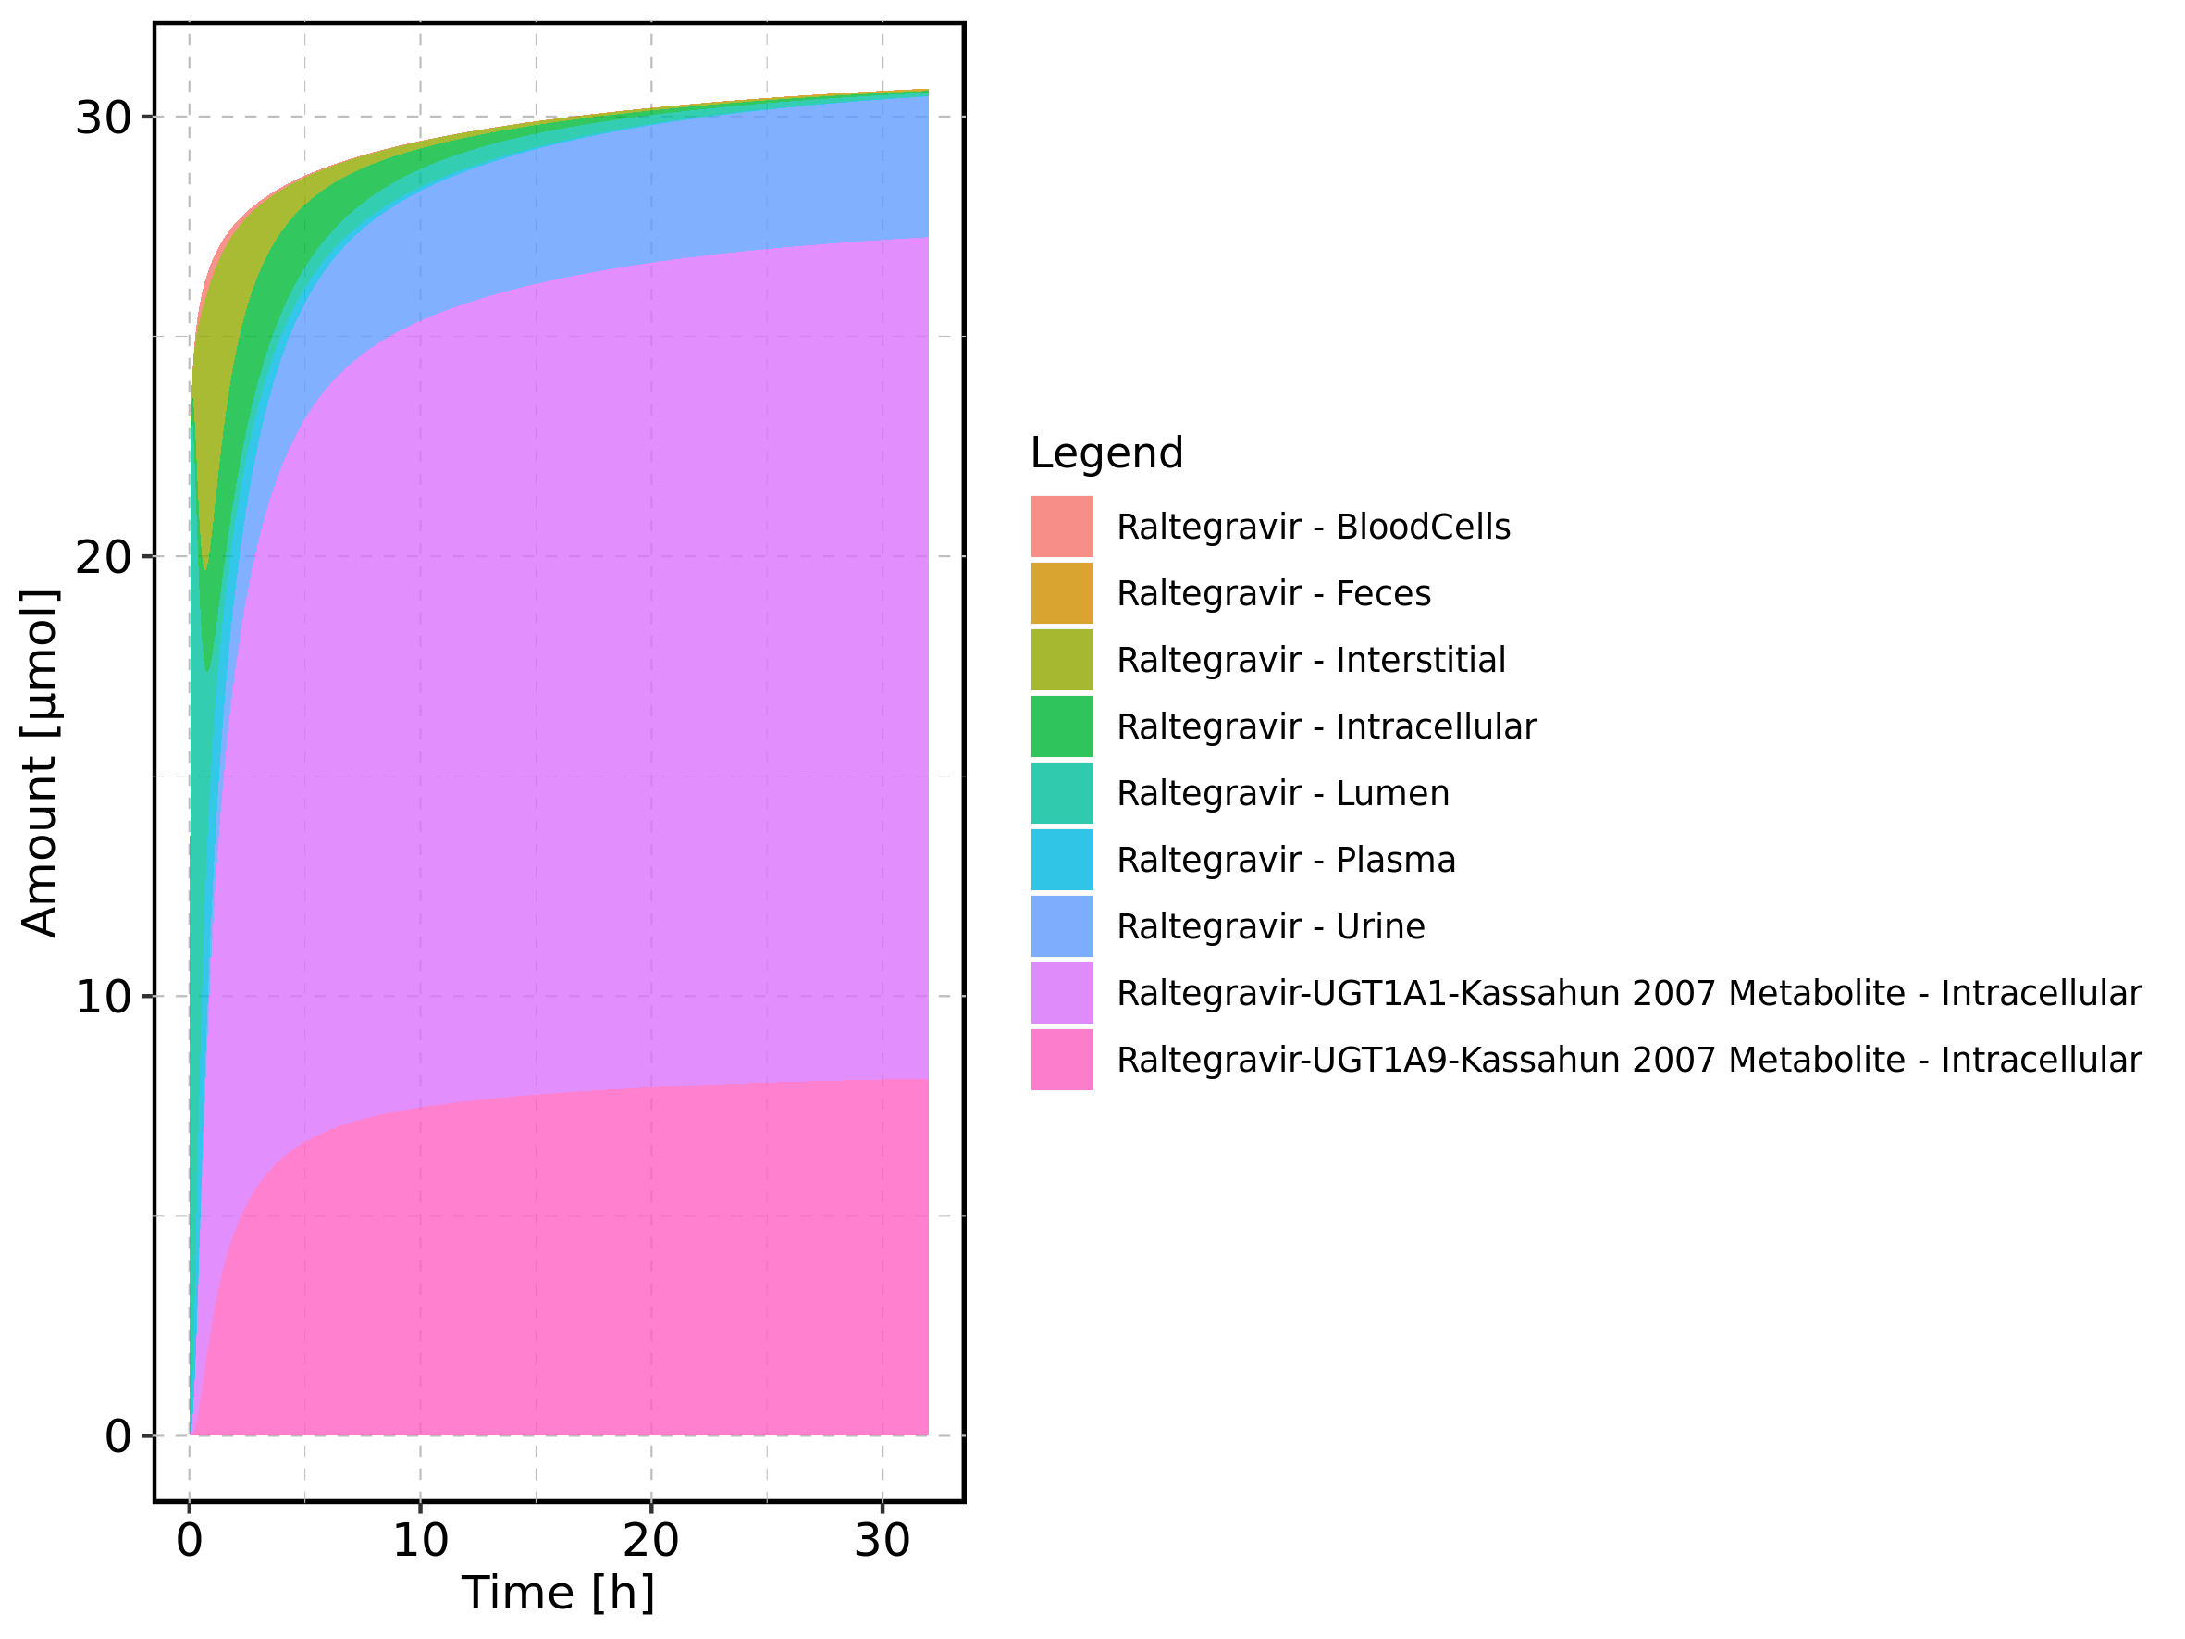

Figure 29: Amount of drug vs time within the different compartments normalized to applicated drugmass.

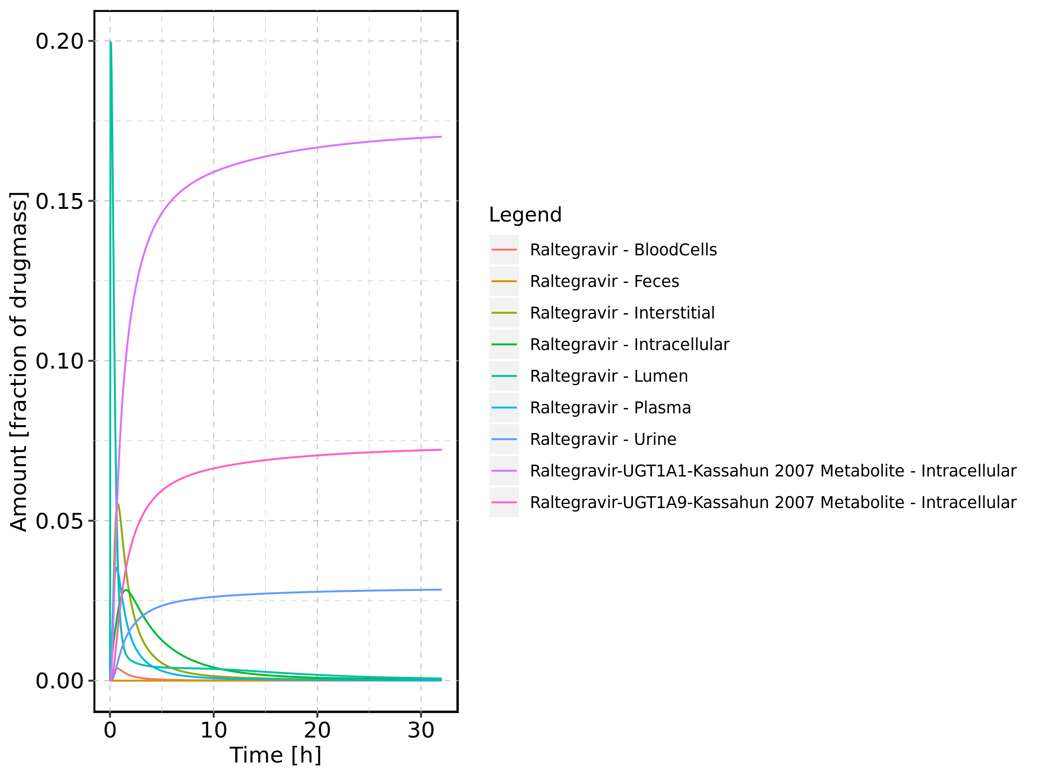

Figure 30: Cumulated amount of drug vs time within the different compartments normalized to applicated drugmass.

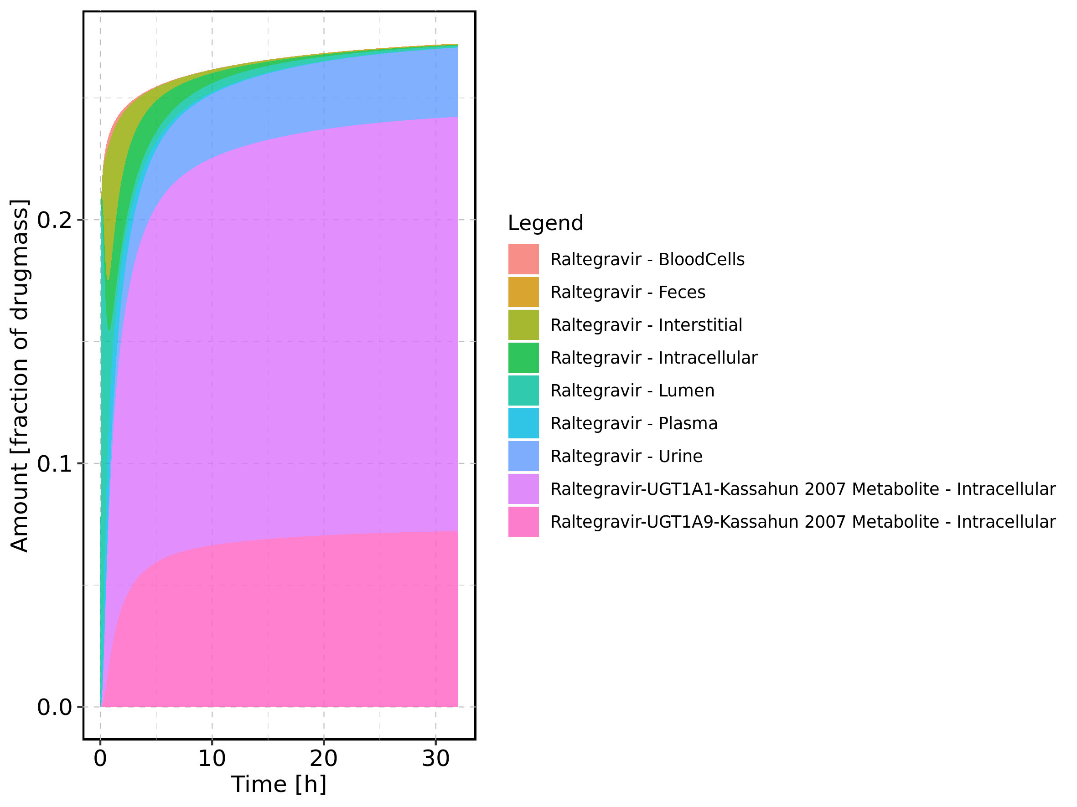

Figure 31: Fraction of drug within the different compartments at 32h.

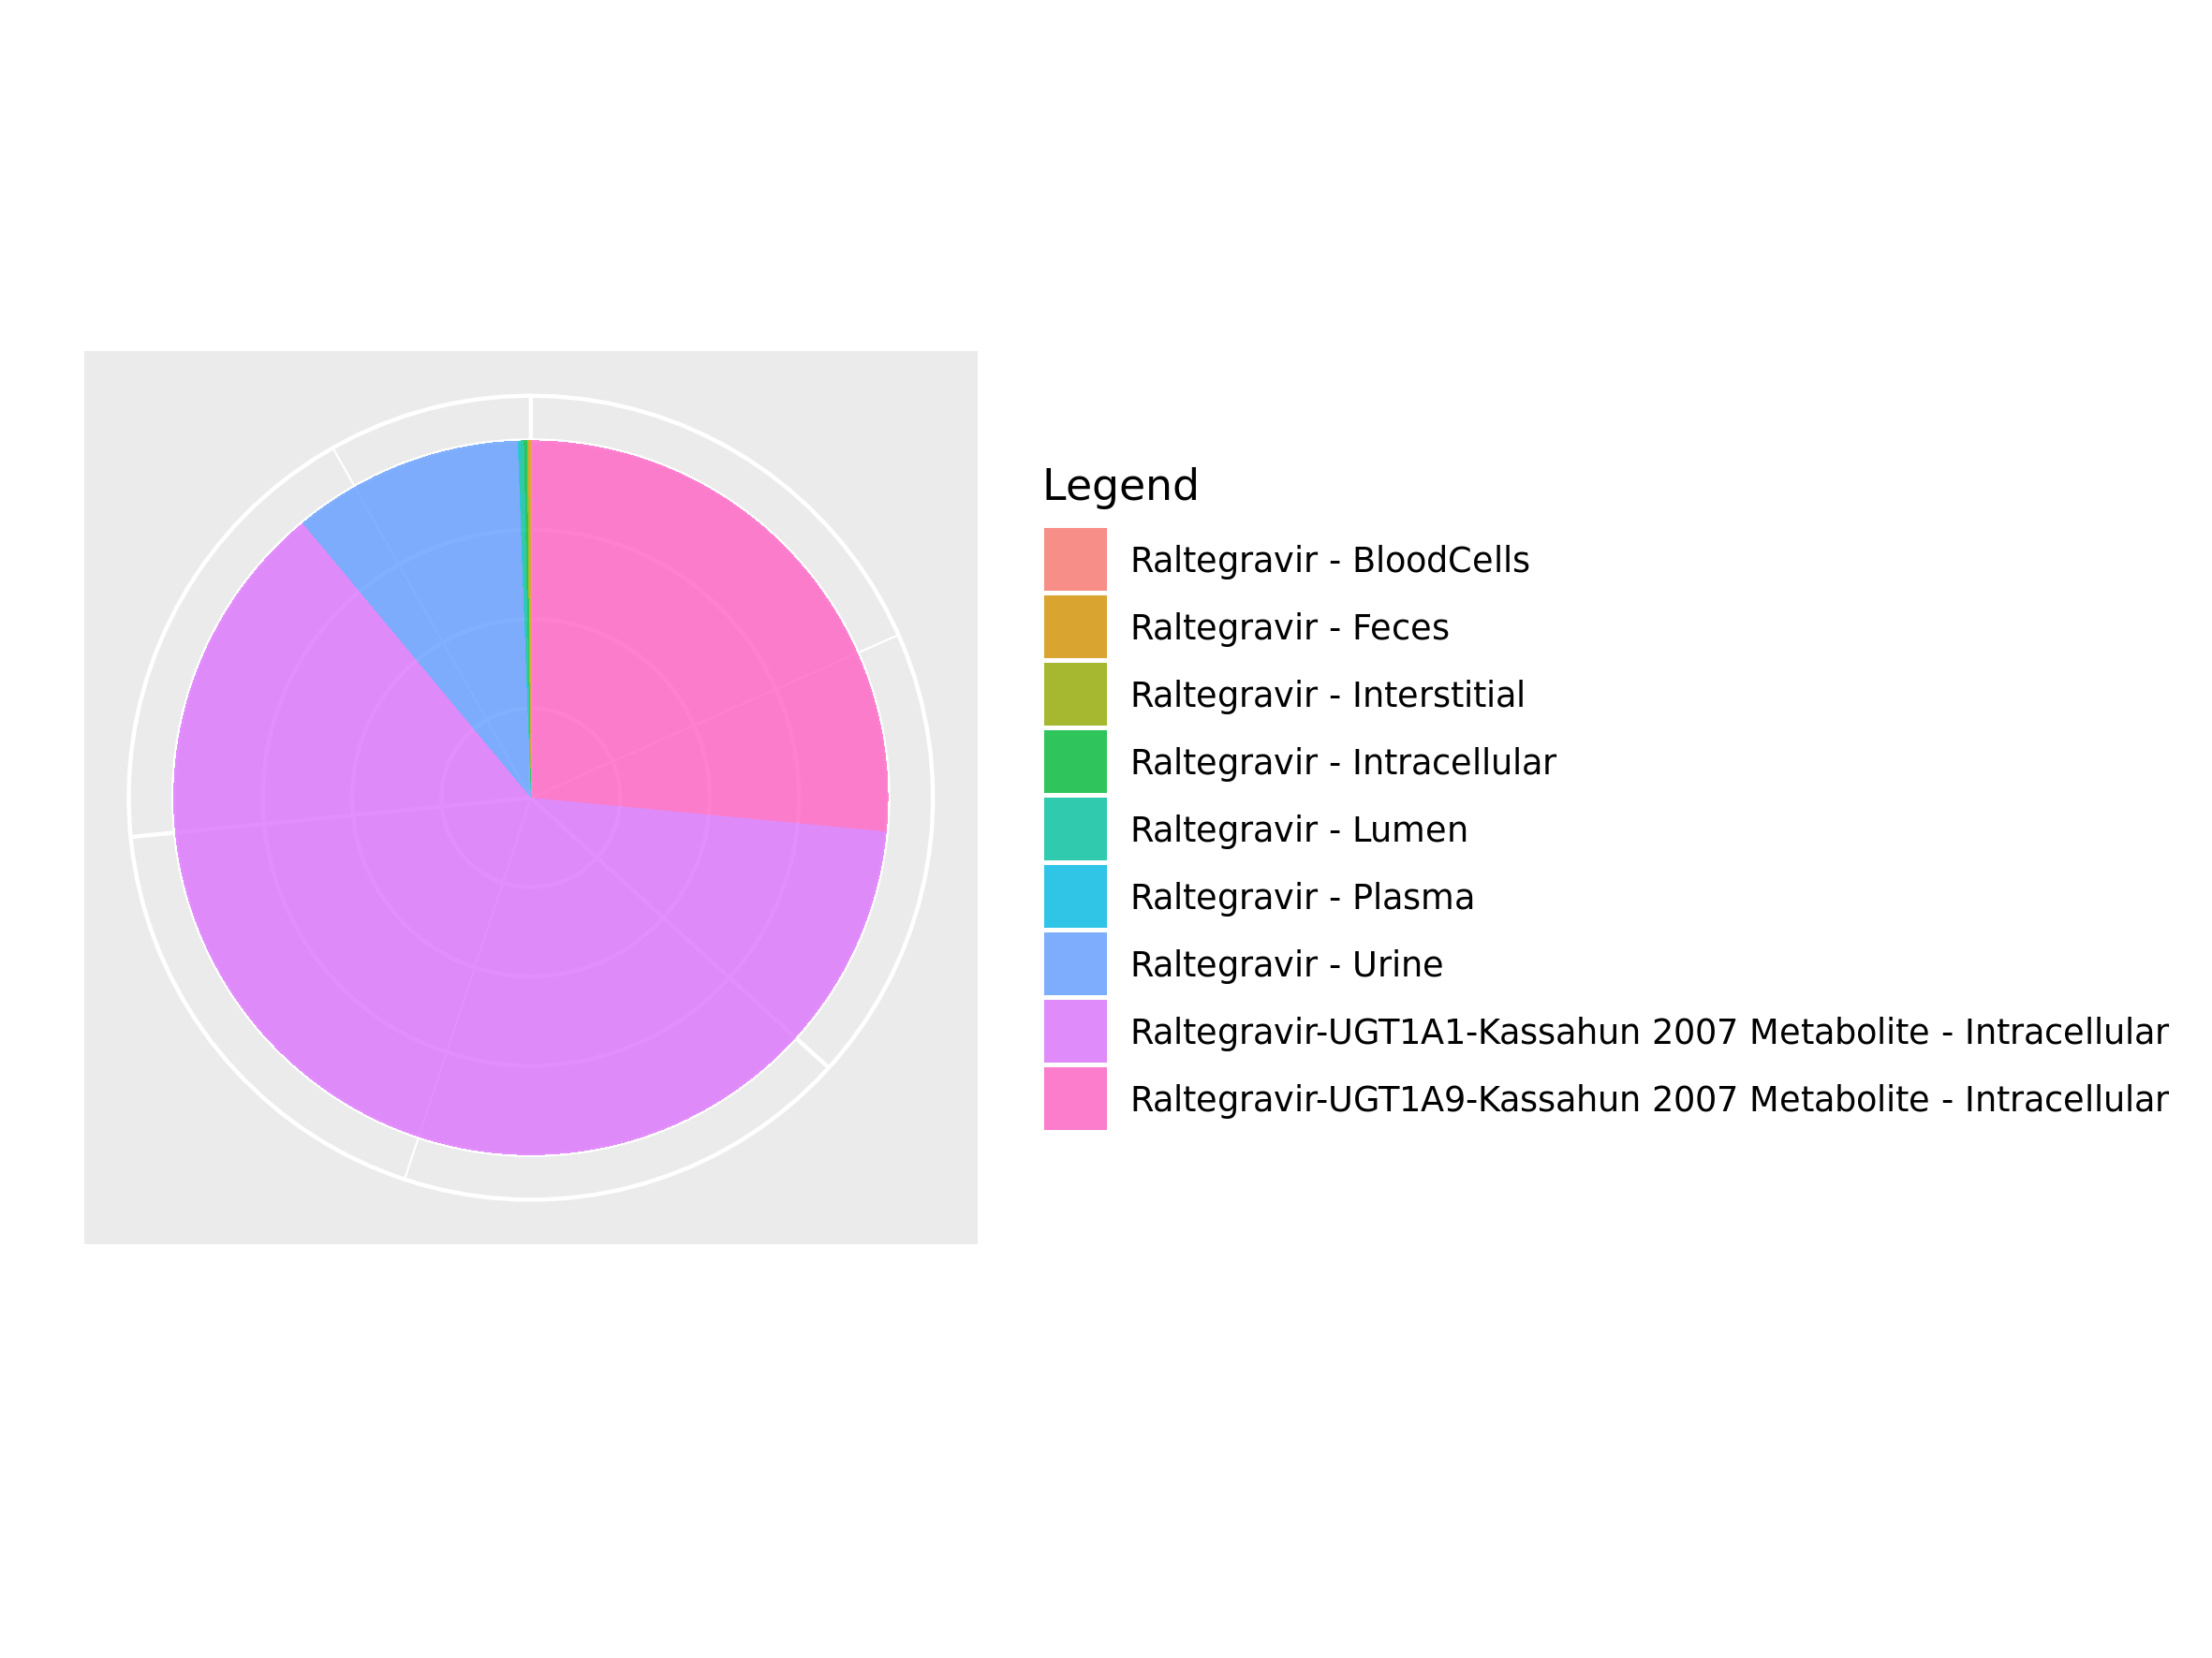

## 3.4. Mass Balance for Raltegravir 100 mg (lactose formulation)

Figure 32: Amount of drug vs time within the different compartments.

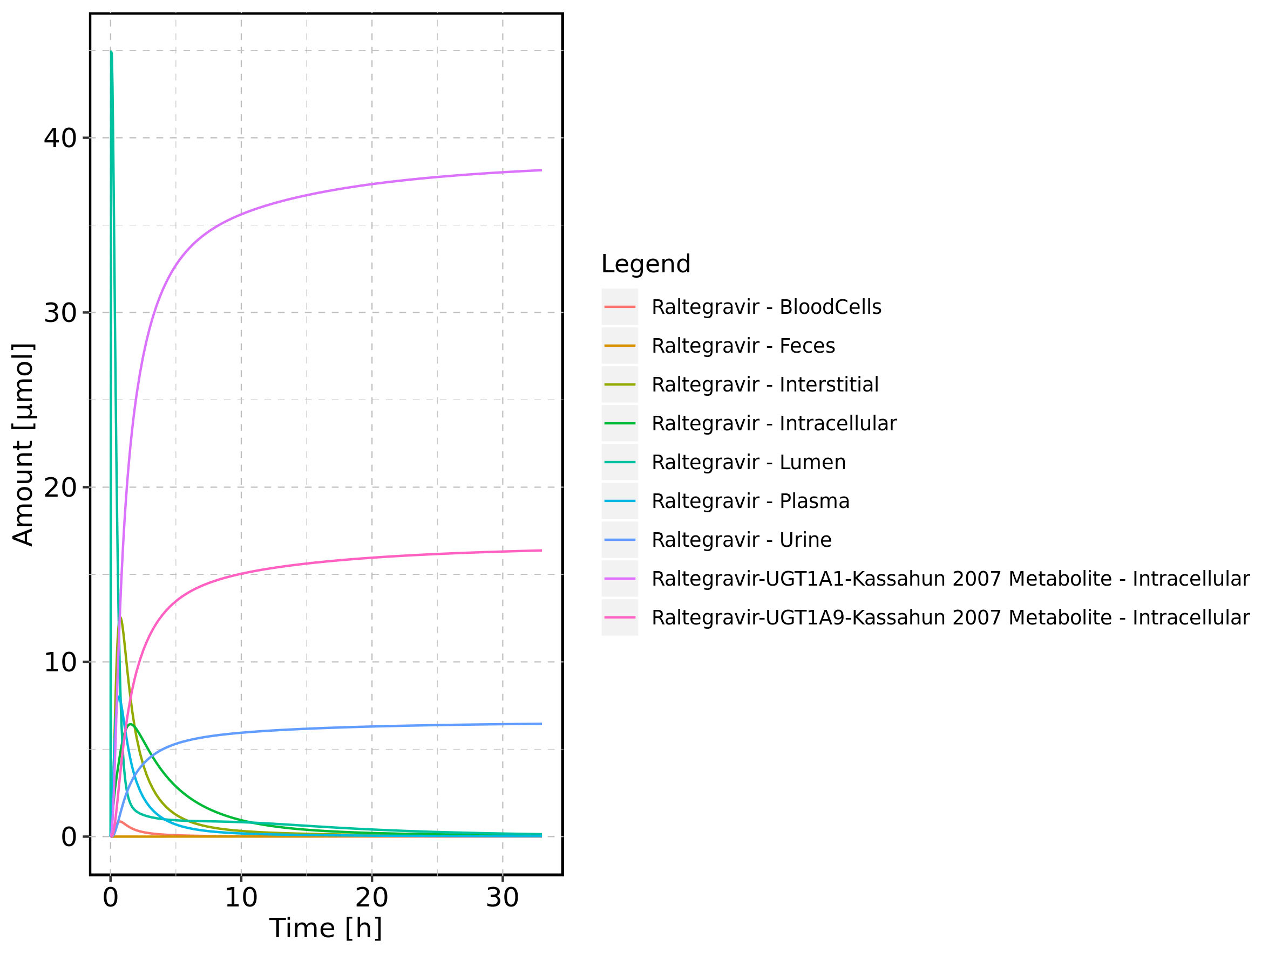

Figure 33: Cumulated amount of drug vs time within the different compartments

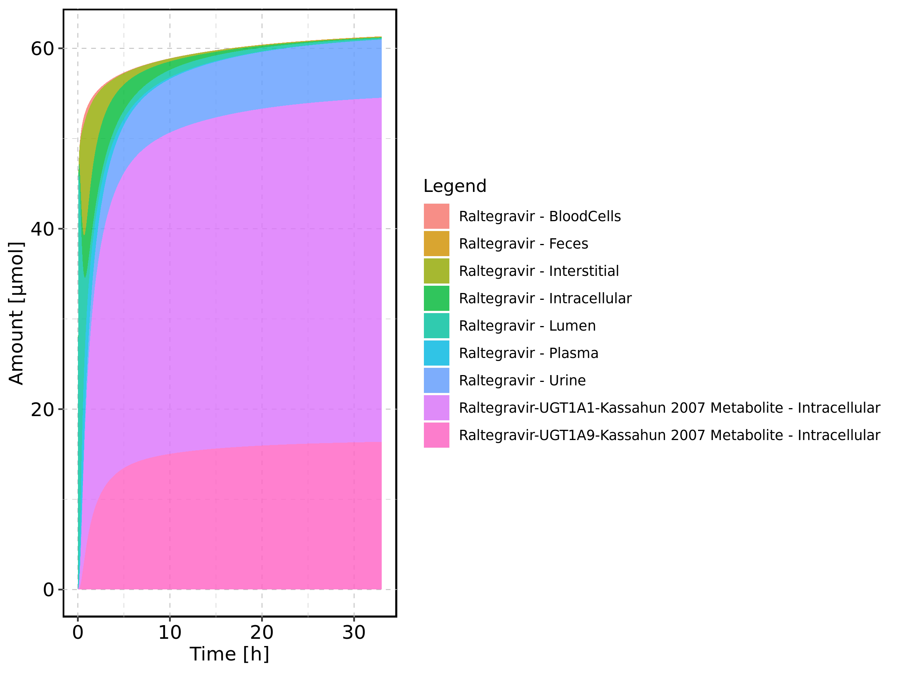

Figure 34: Amount of drug vs time within the different compartments normalized to applicated drugmass.

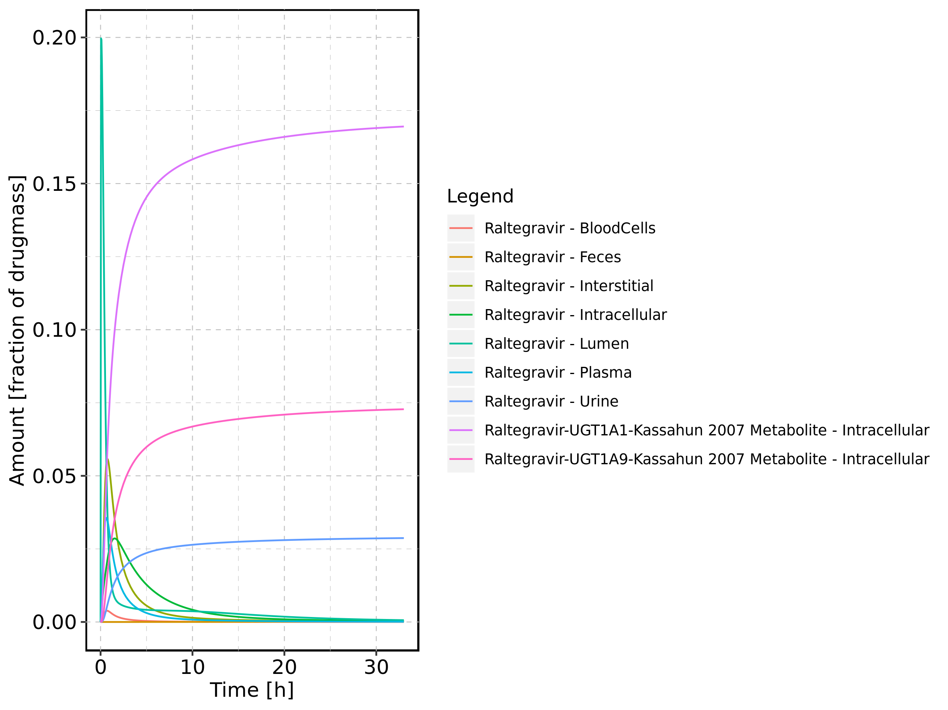

Figure 35: Cumulated amount of drug vs time within the different compartments normalized to applicated drugmass.

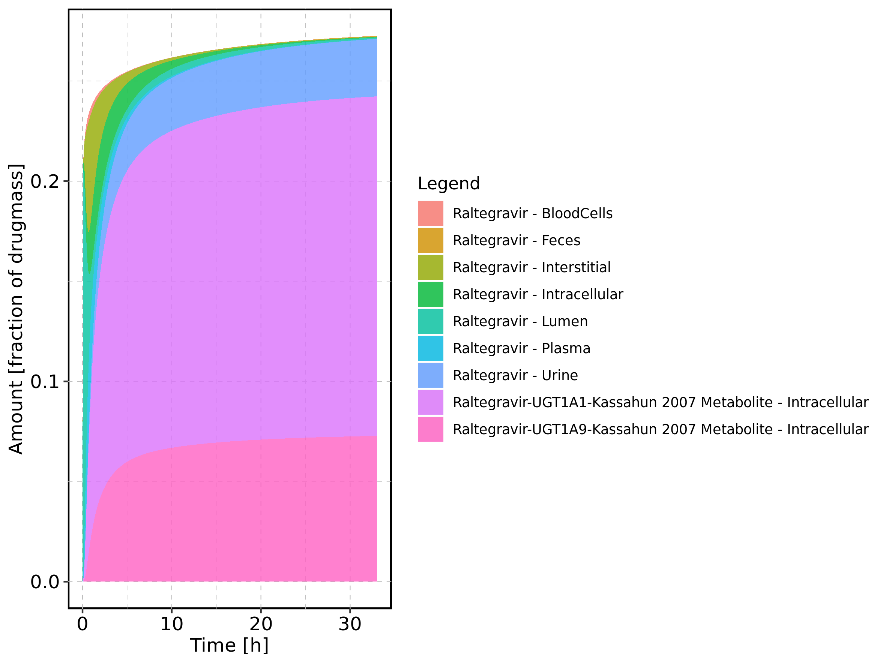

Figure 36: Fraction of drug within the different compartments at 33h.

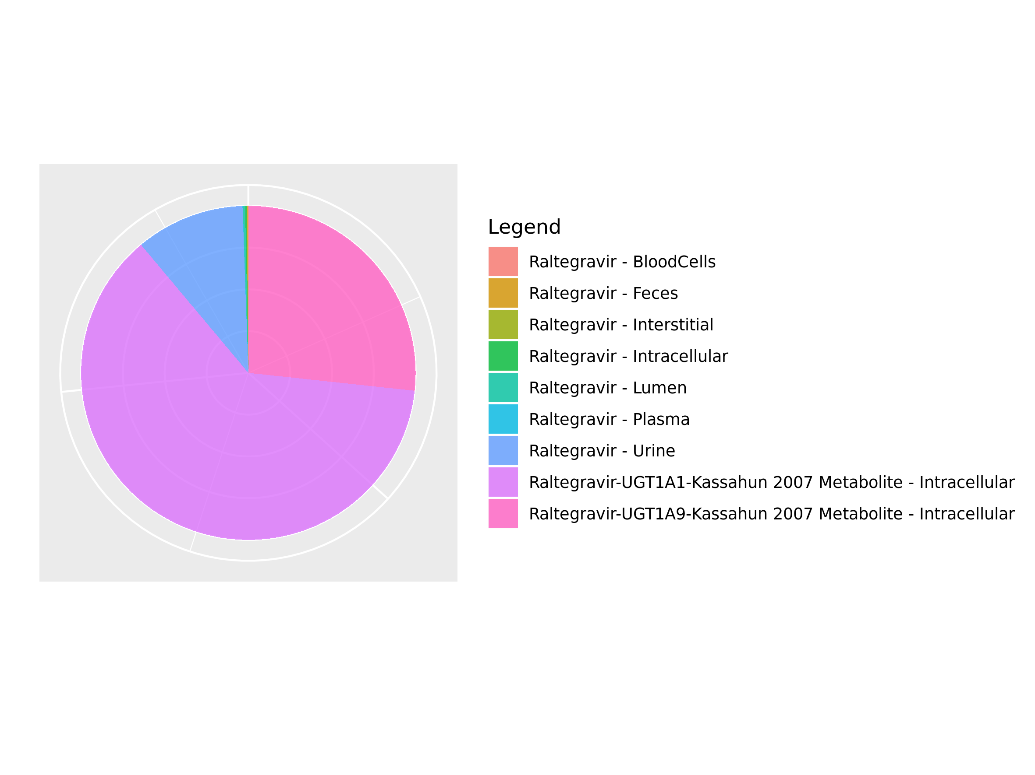

## 3.5. Mass Balance for Raltegravir 200 mg (lactose formulation)

Figure 37: Amount of drug vs time within the different compartments.

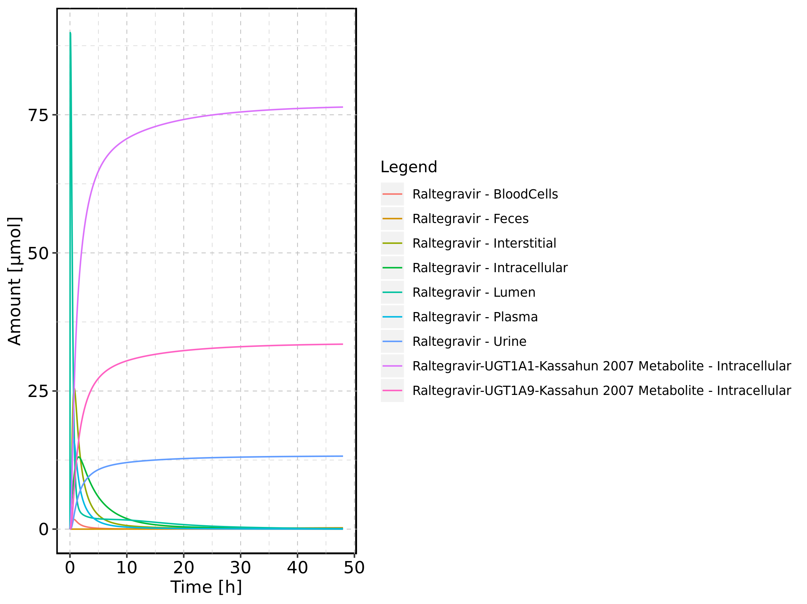

Figure 38: Cumulated amount of drug vs time within the different compartments

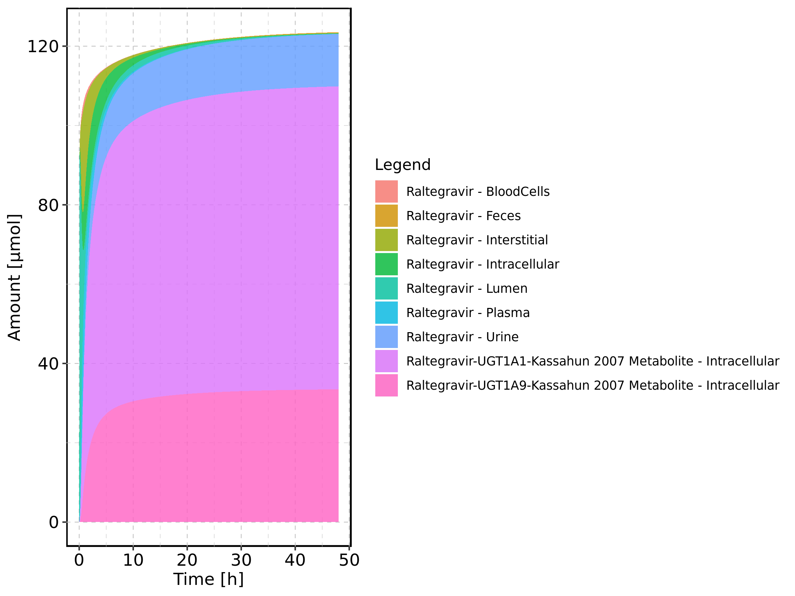

Figure 39: Amount of drug vs time within the different compartments normalized to applicated drugmass.

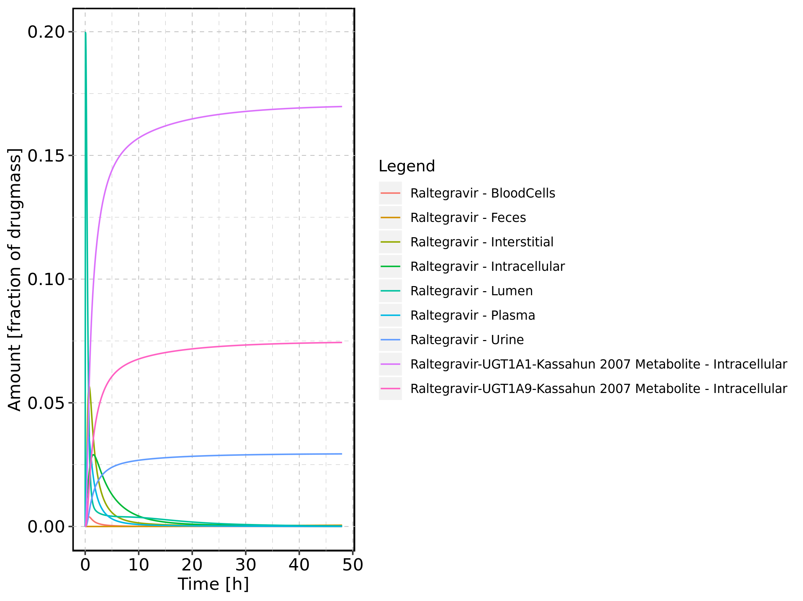

Figure 40: Cumulated amount of drug vs time within the different compartments normalized to applicated drugmass.

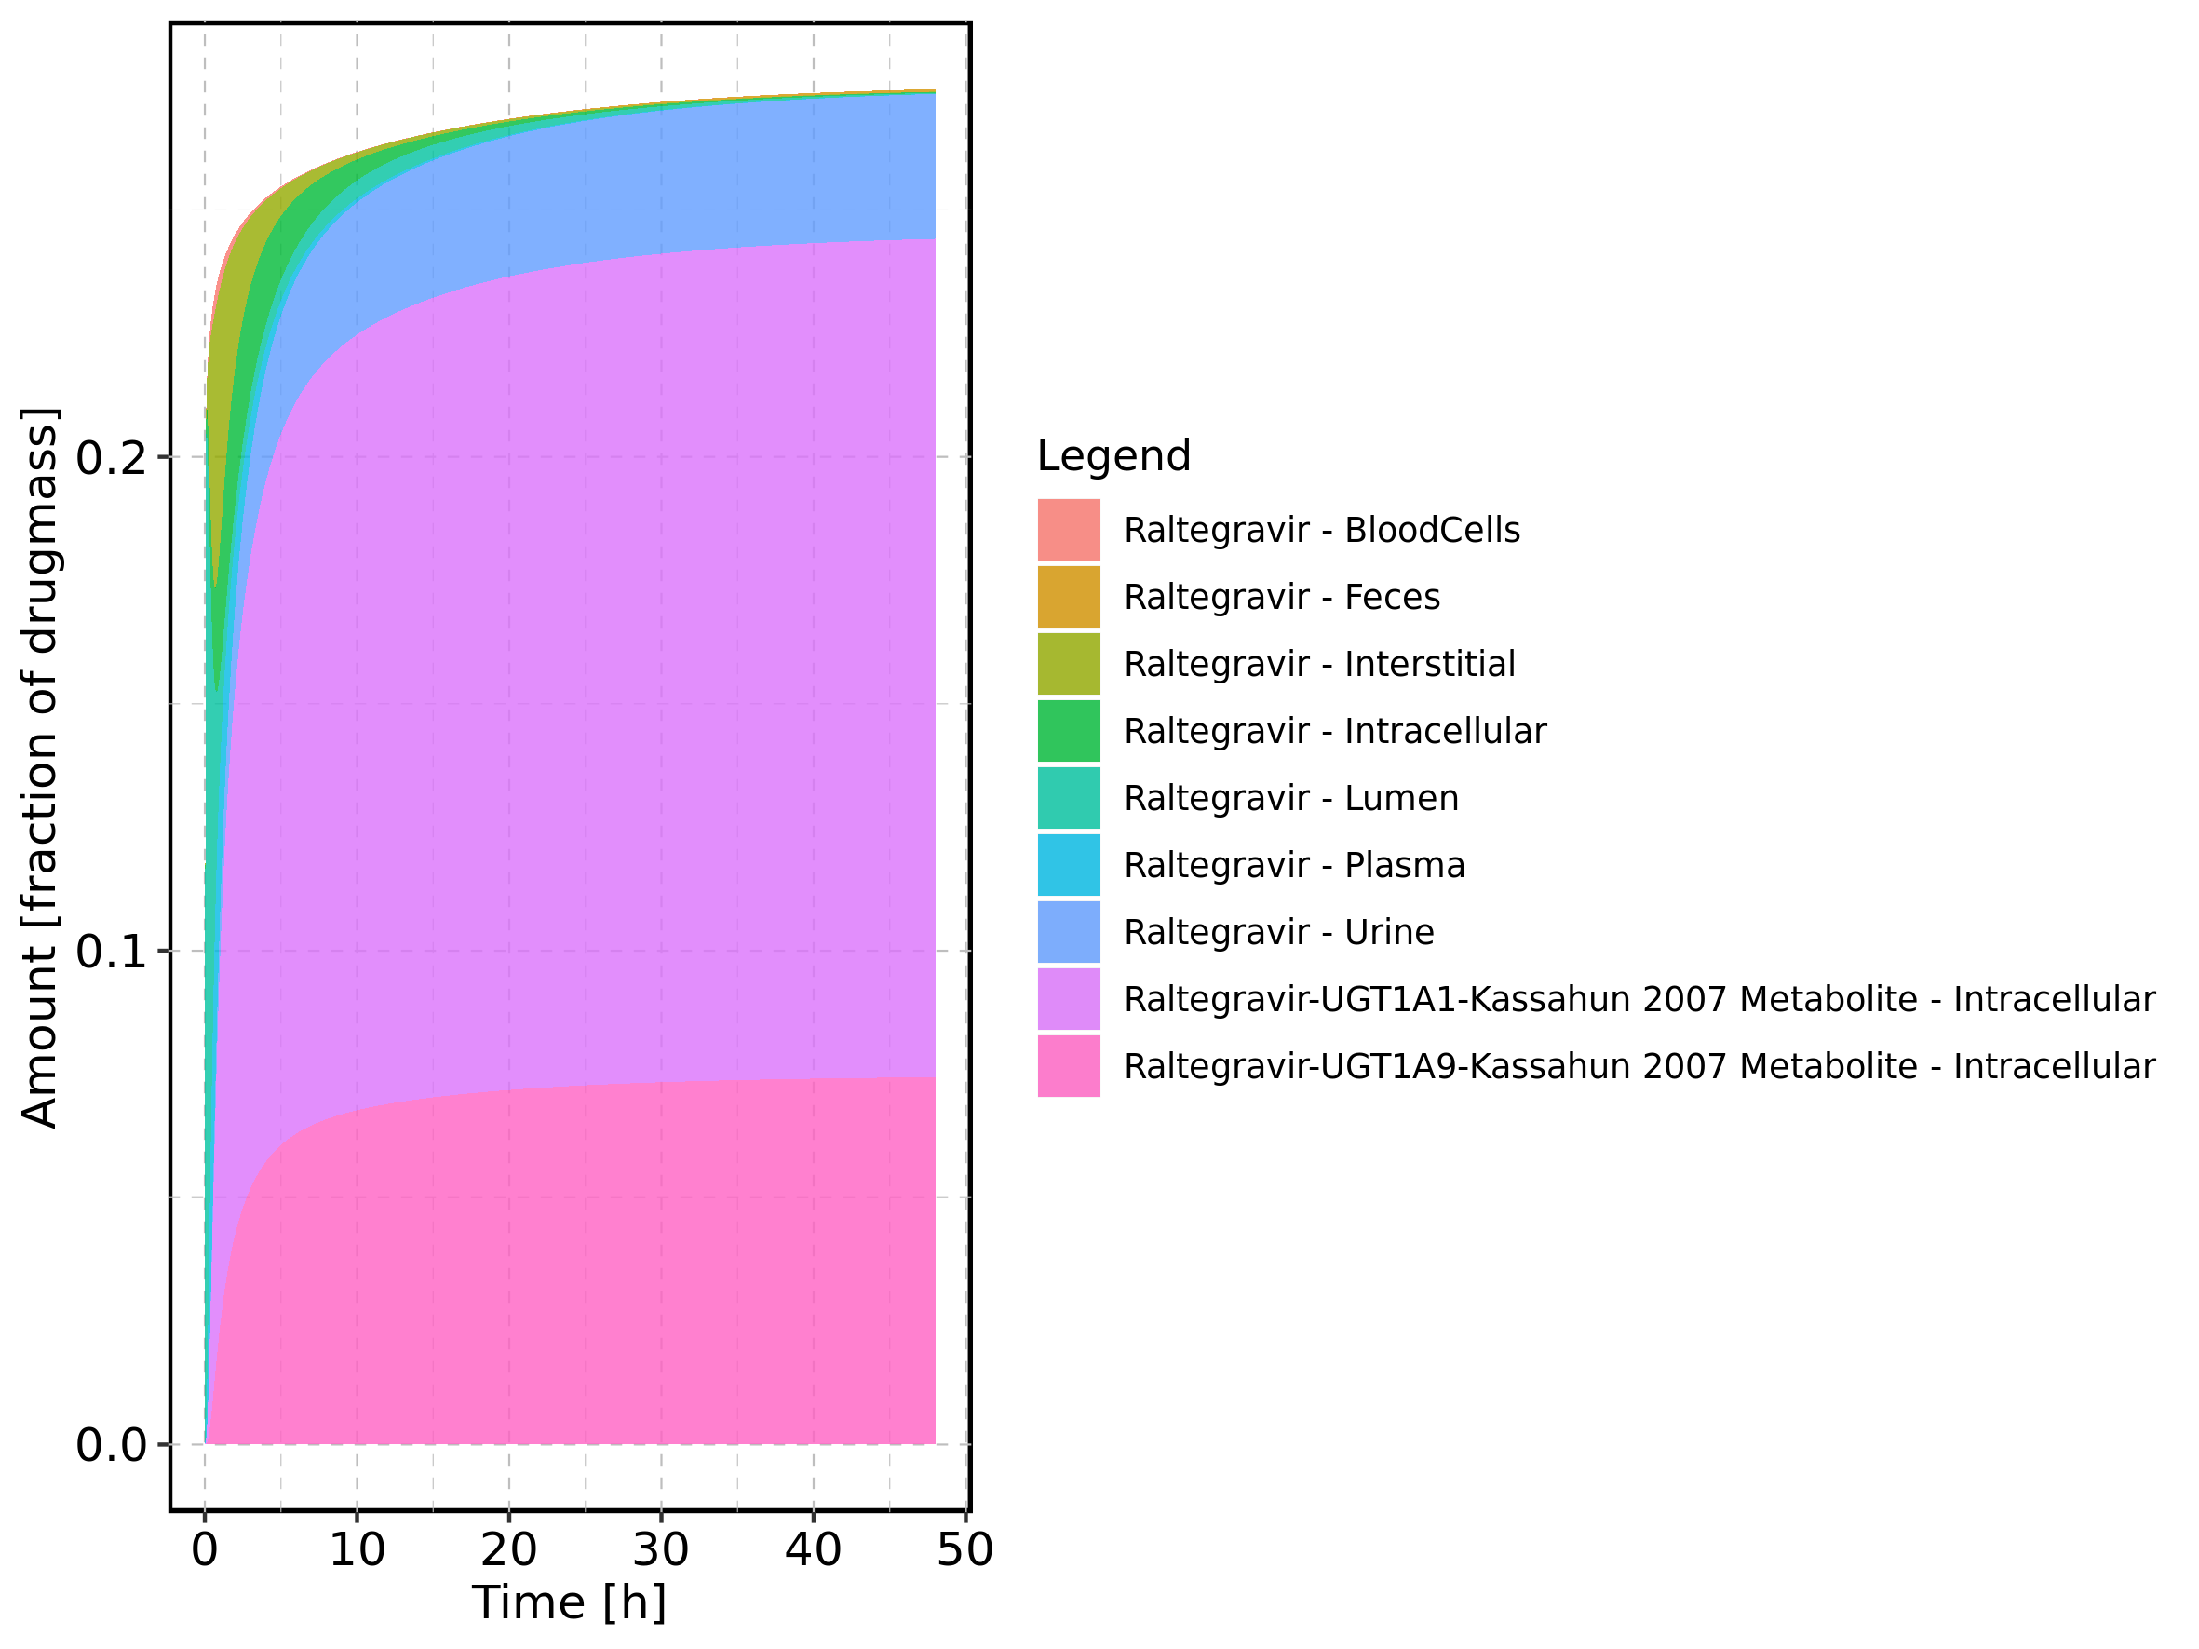

Figure 41: Fraction of drug within the different compartments at 48h.

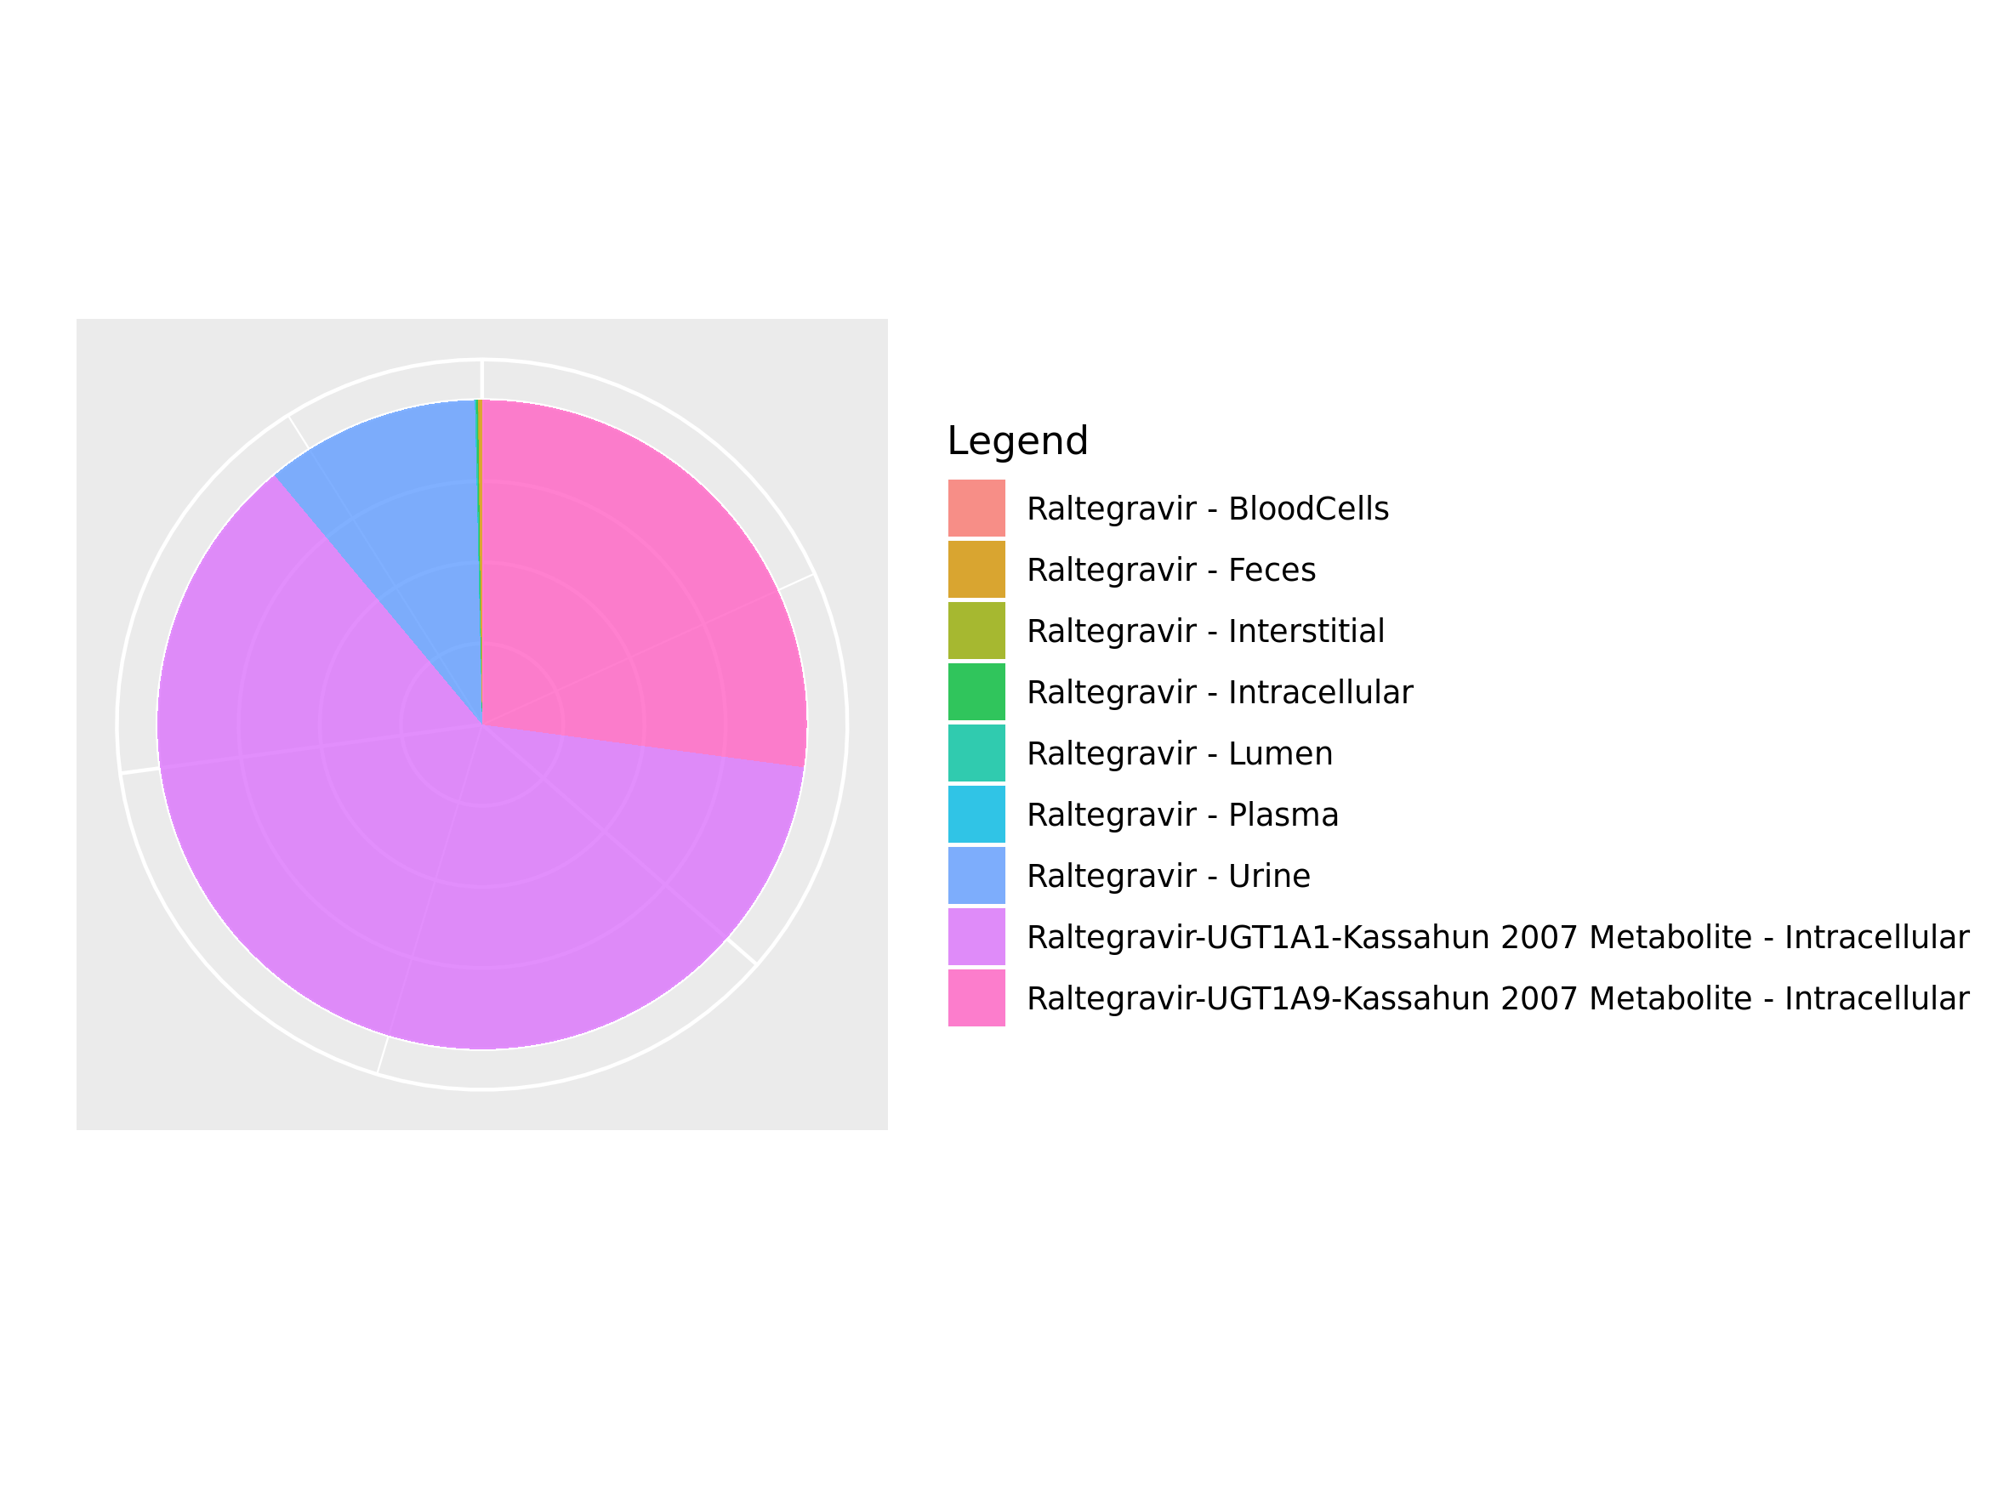

## 3.6. Mass Balance for Raltegravir 400mg (lactose formulation)

Figure 42: Amount of drug vs time within the different compartments.

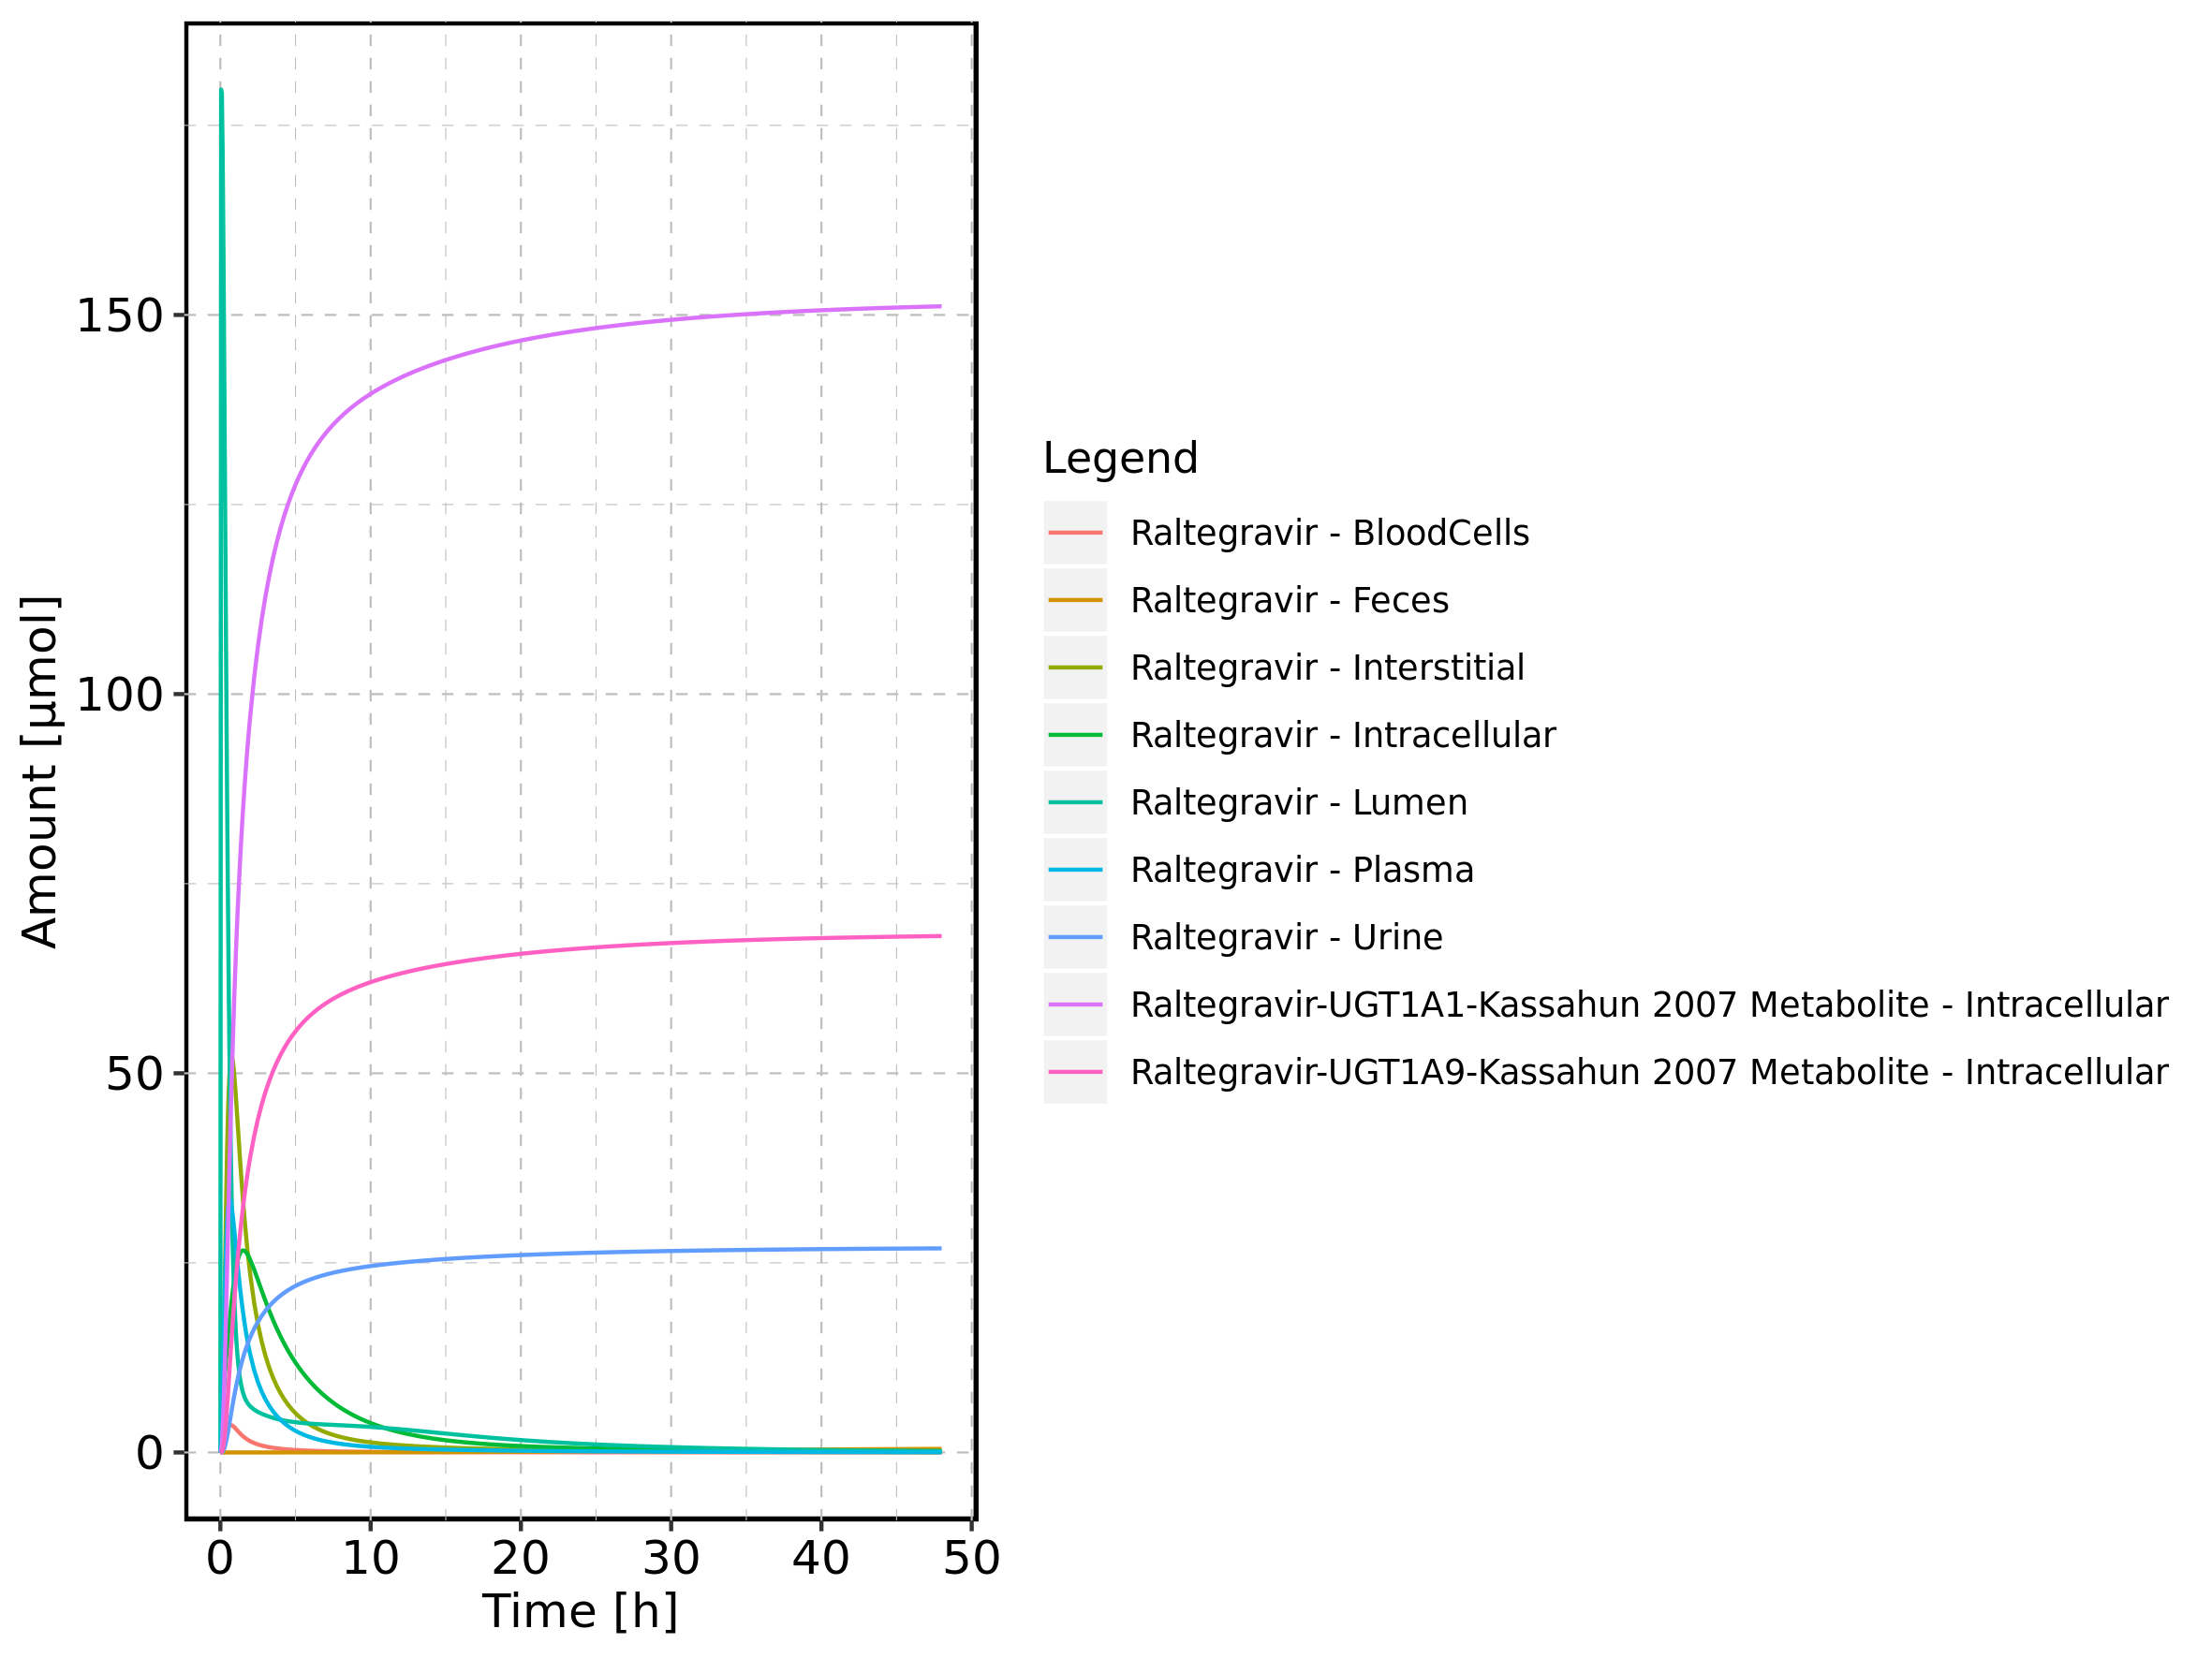

Figure 43: Cumulated amount of drug vs time within the different compartments

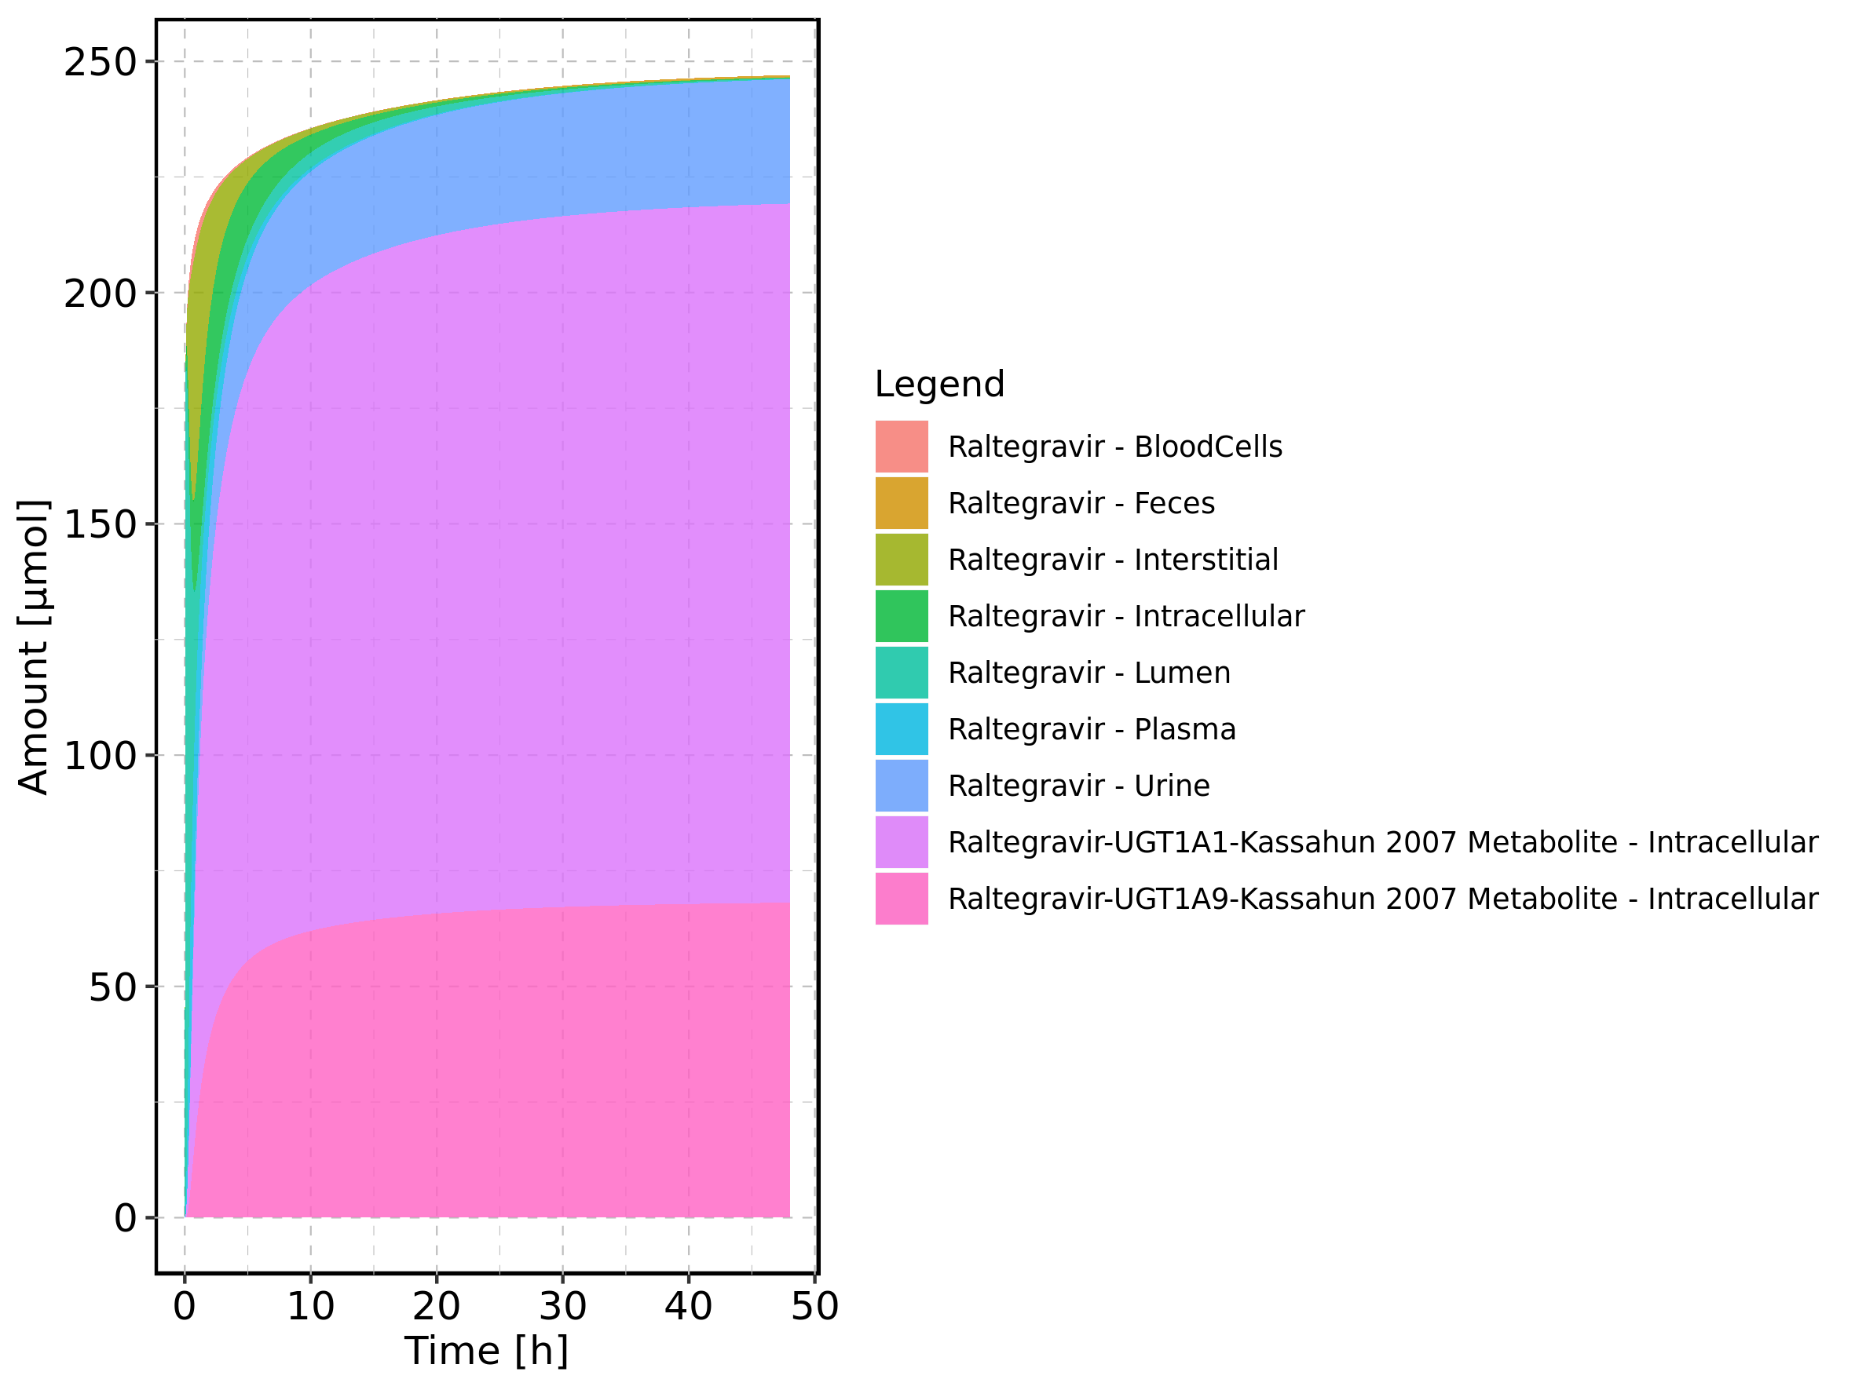

Figure 44: Amount of drug vs time within the different compartments normalized to applicated drugmass.

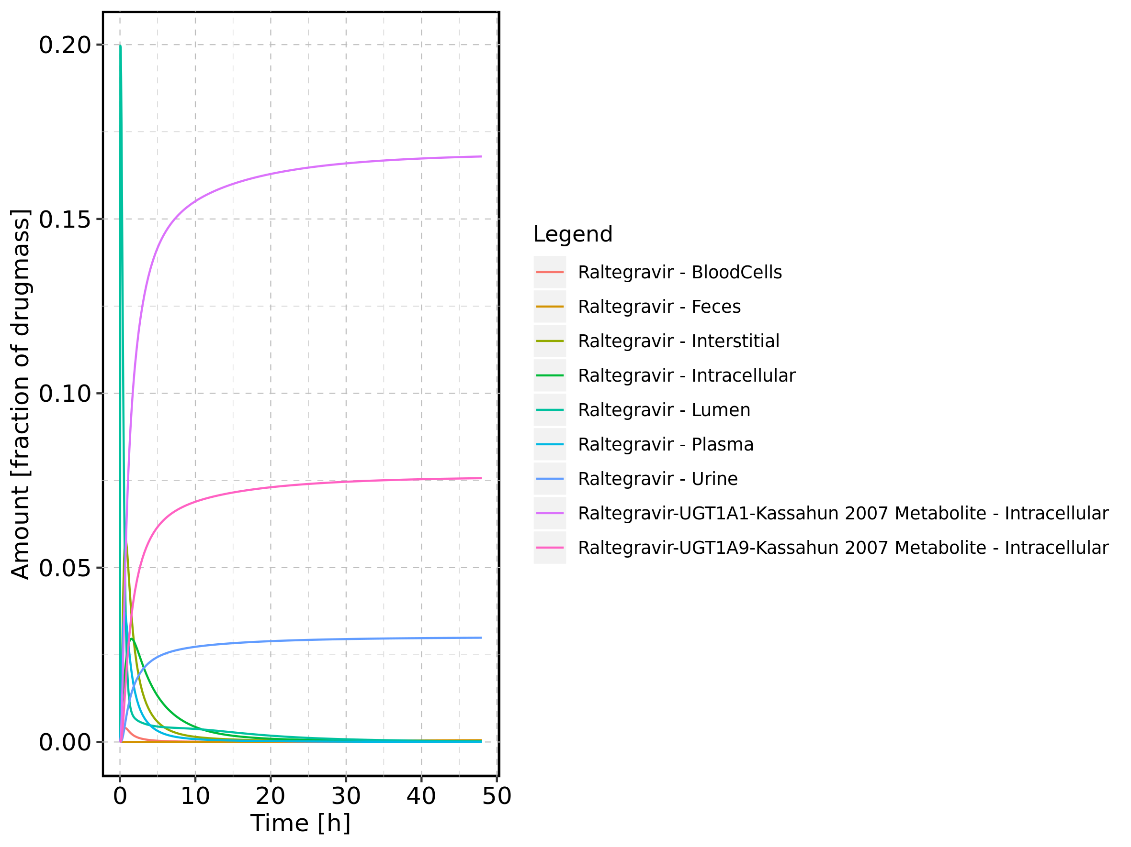

Figure 45: Cumulated amount of drug vs time within the different compartments normalized to applicated drugmass.

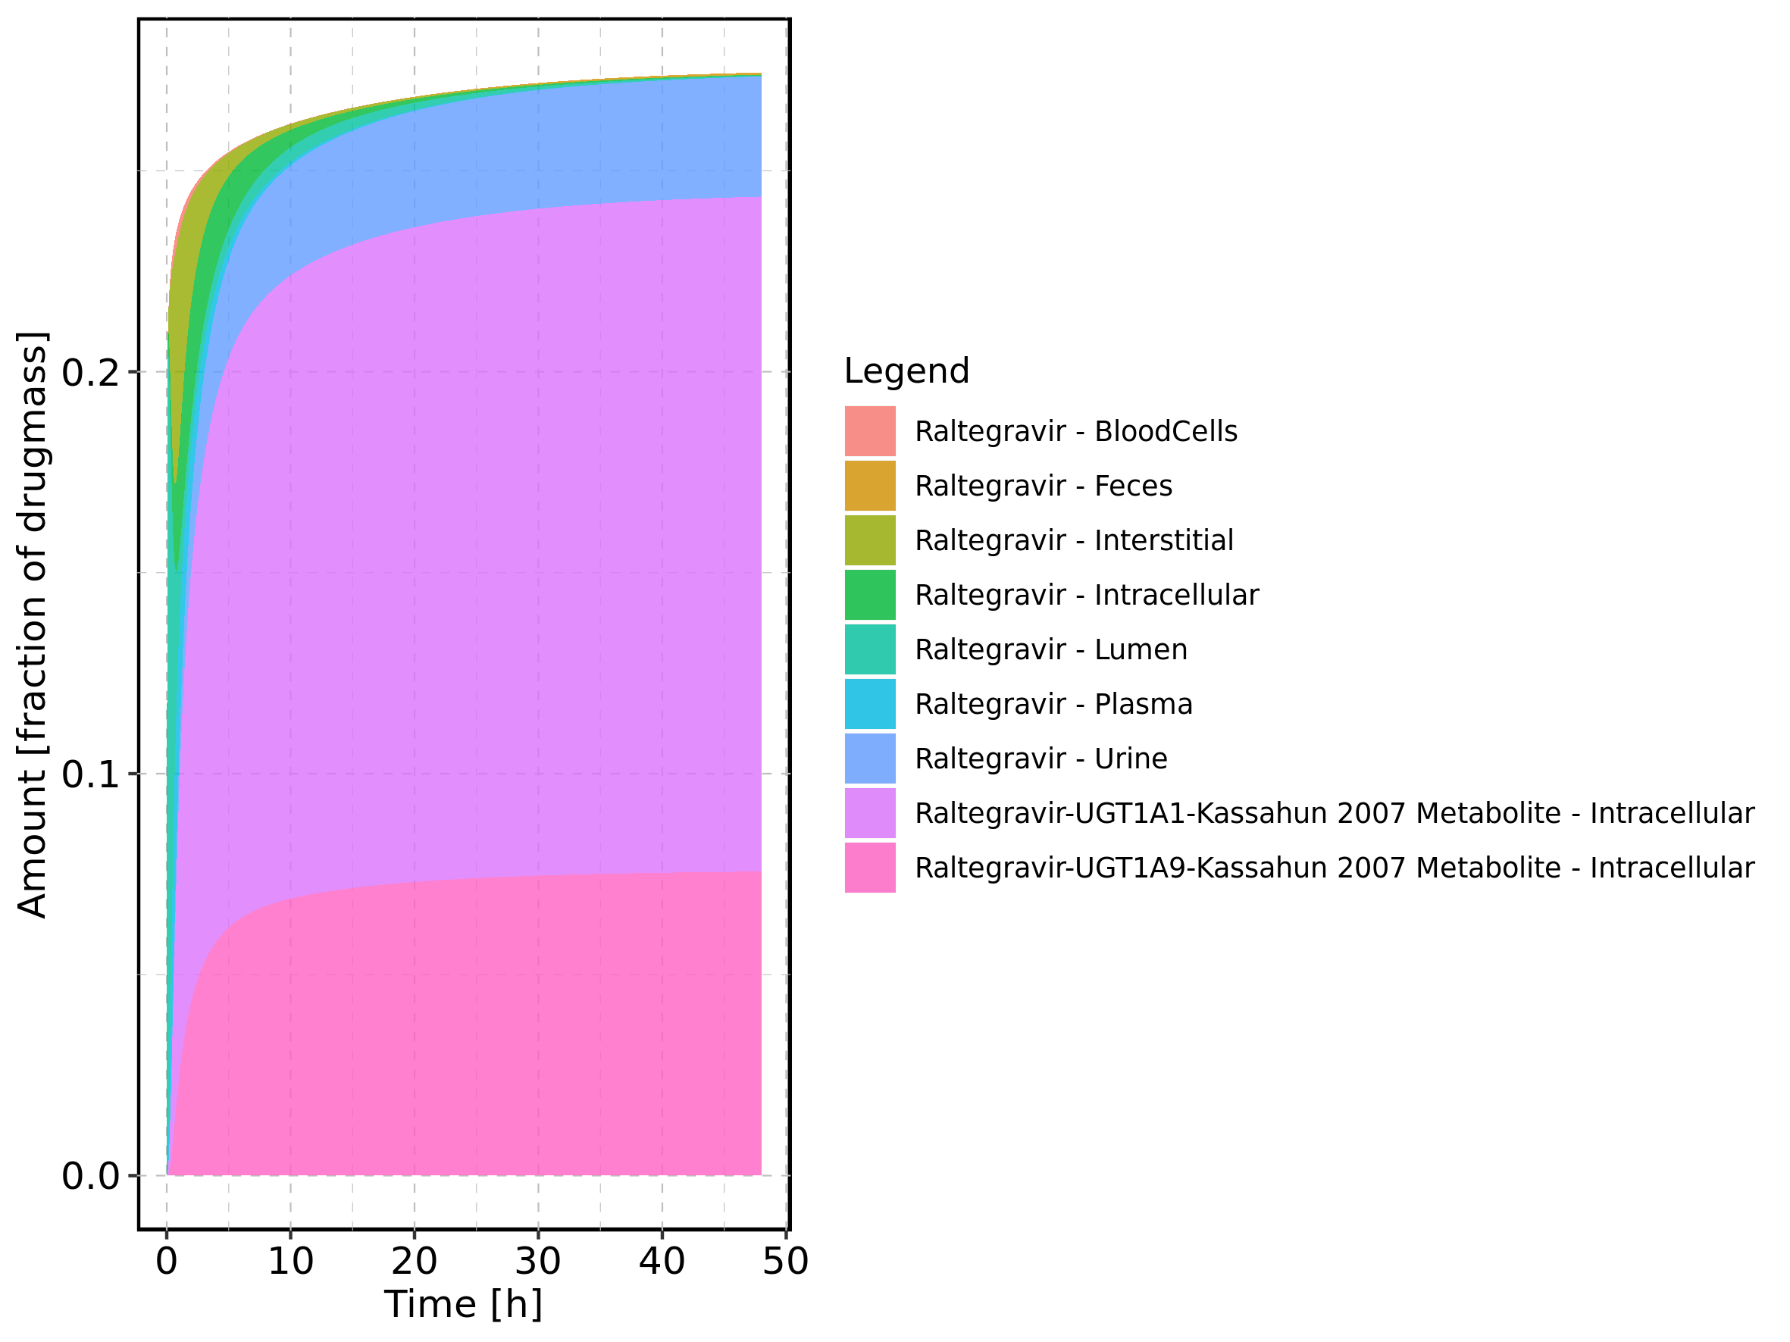

Figure 46: Fraction of drug within the different compartments at 48h.

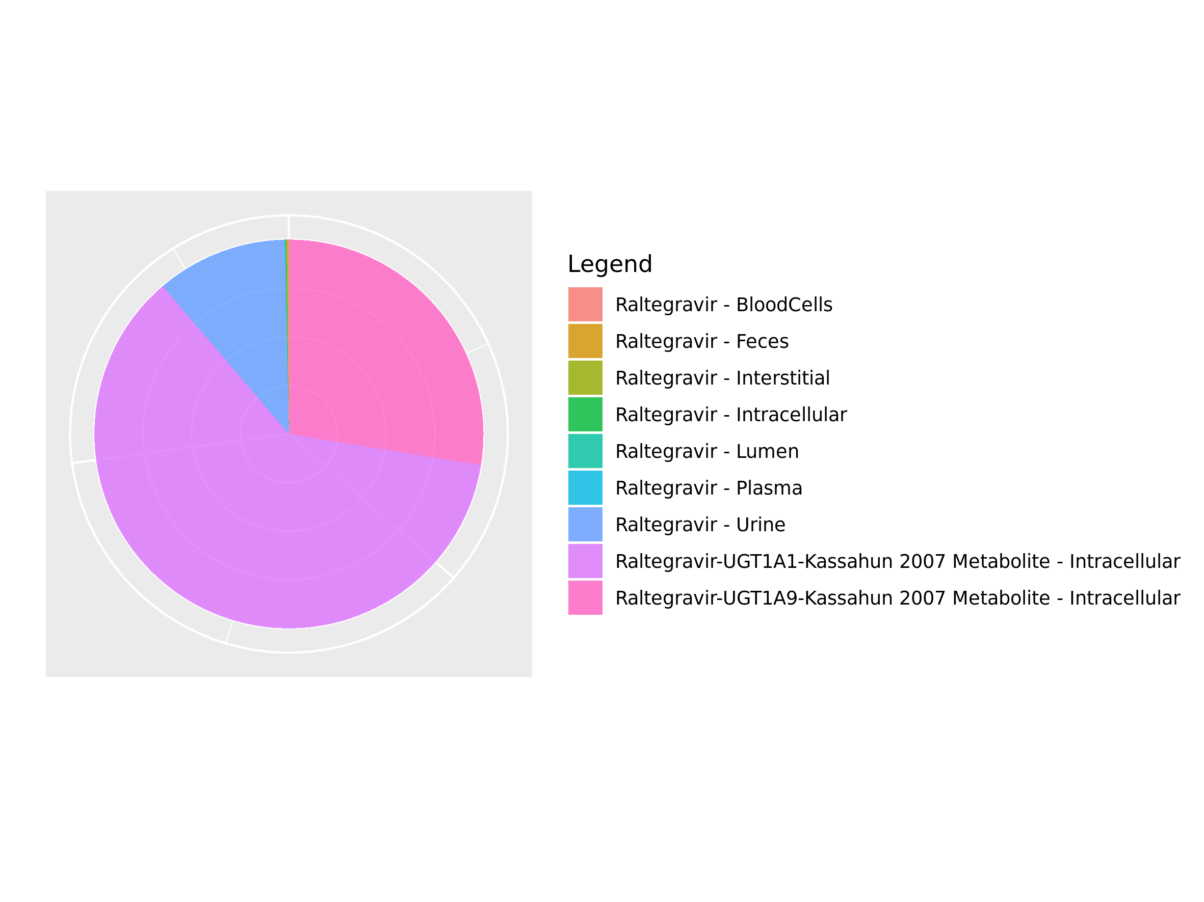

## 3.7. Mass Balance for Raltegravir 800 mg (lactose formulation)

Figure 47: Amount of drug vs time within the different compartments.

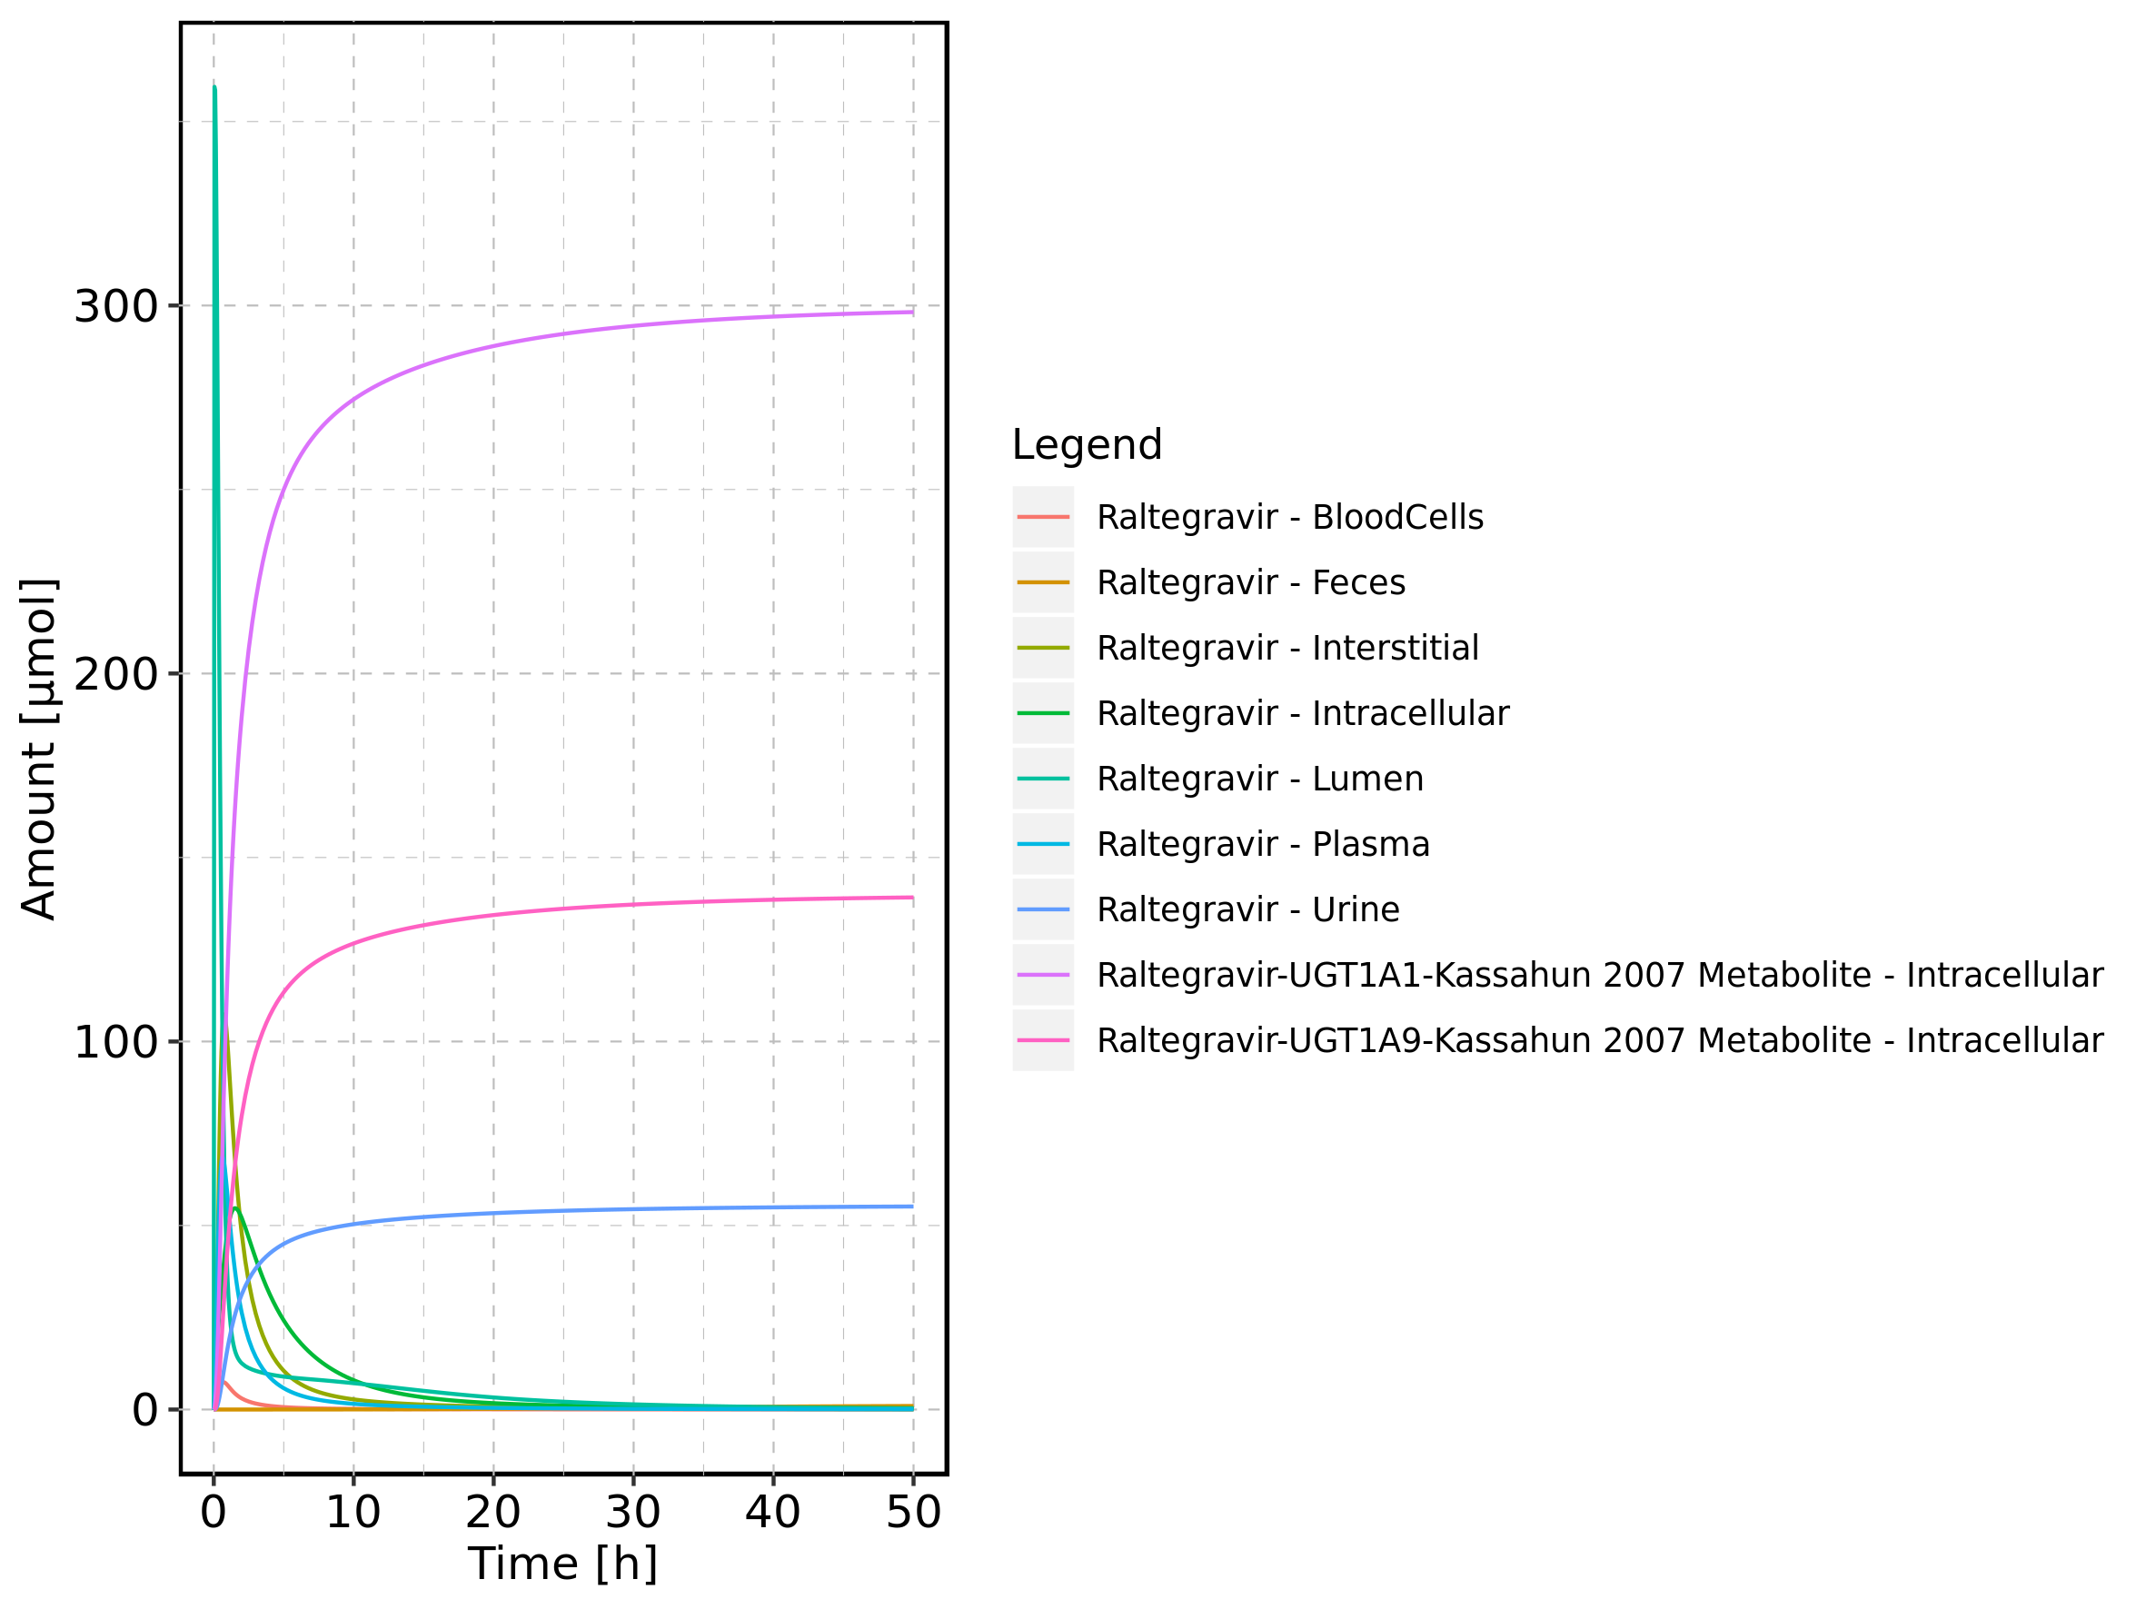

Figure 48: Cumulated amount of drug vs time within the different compartments

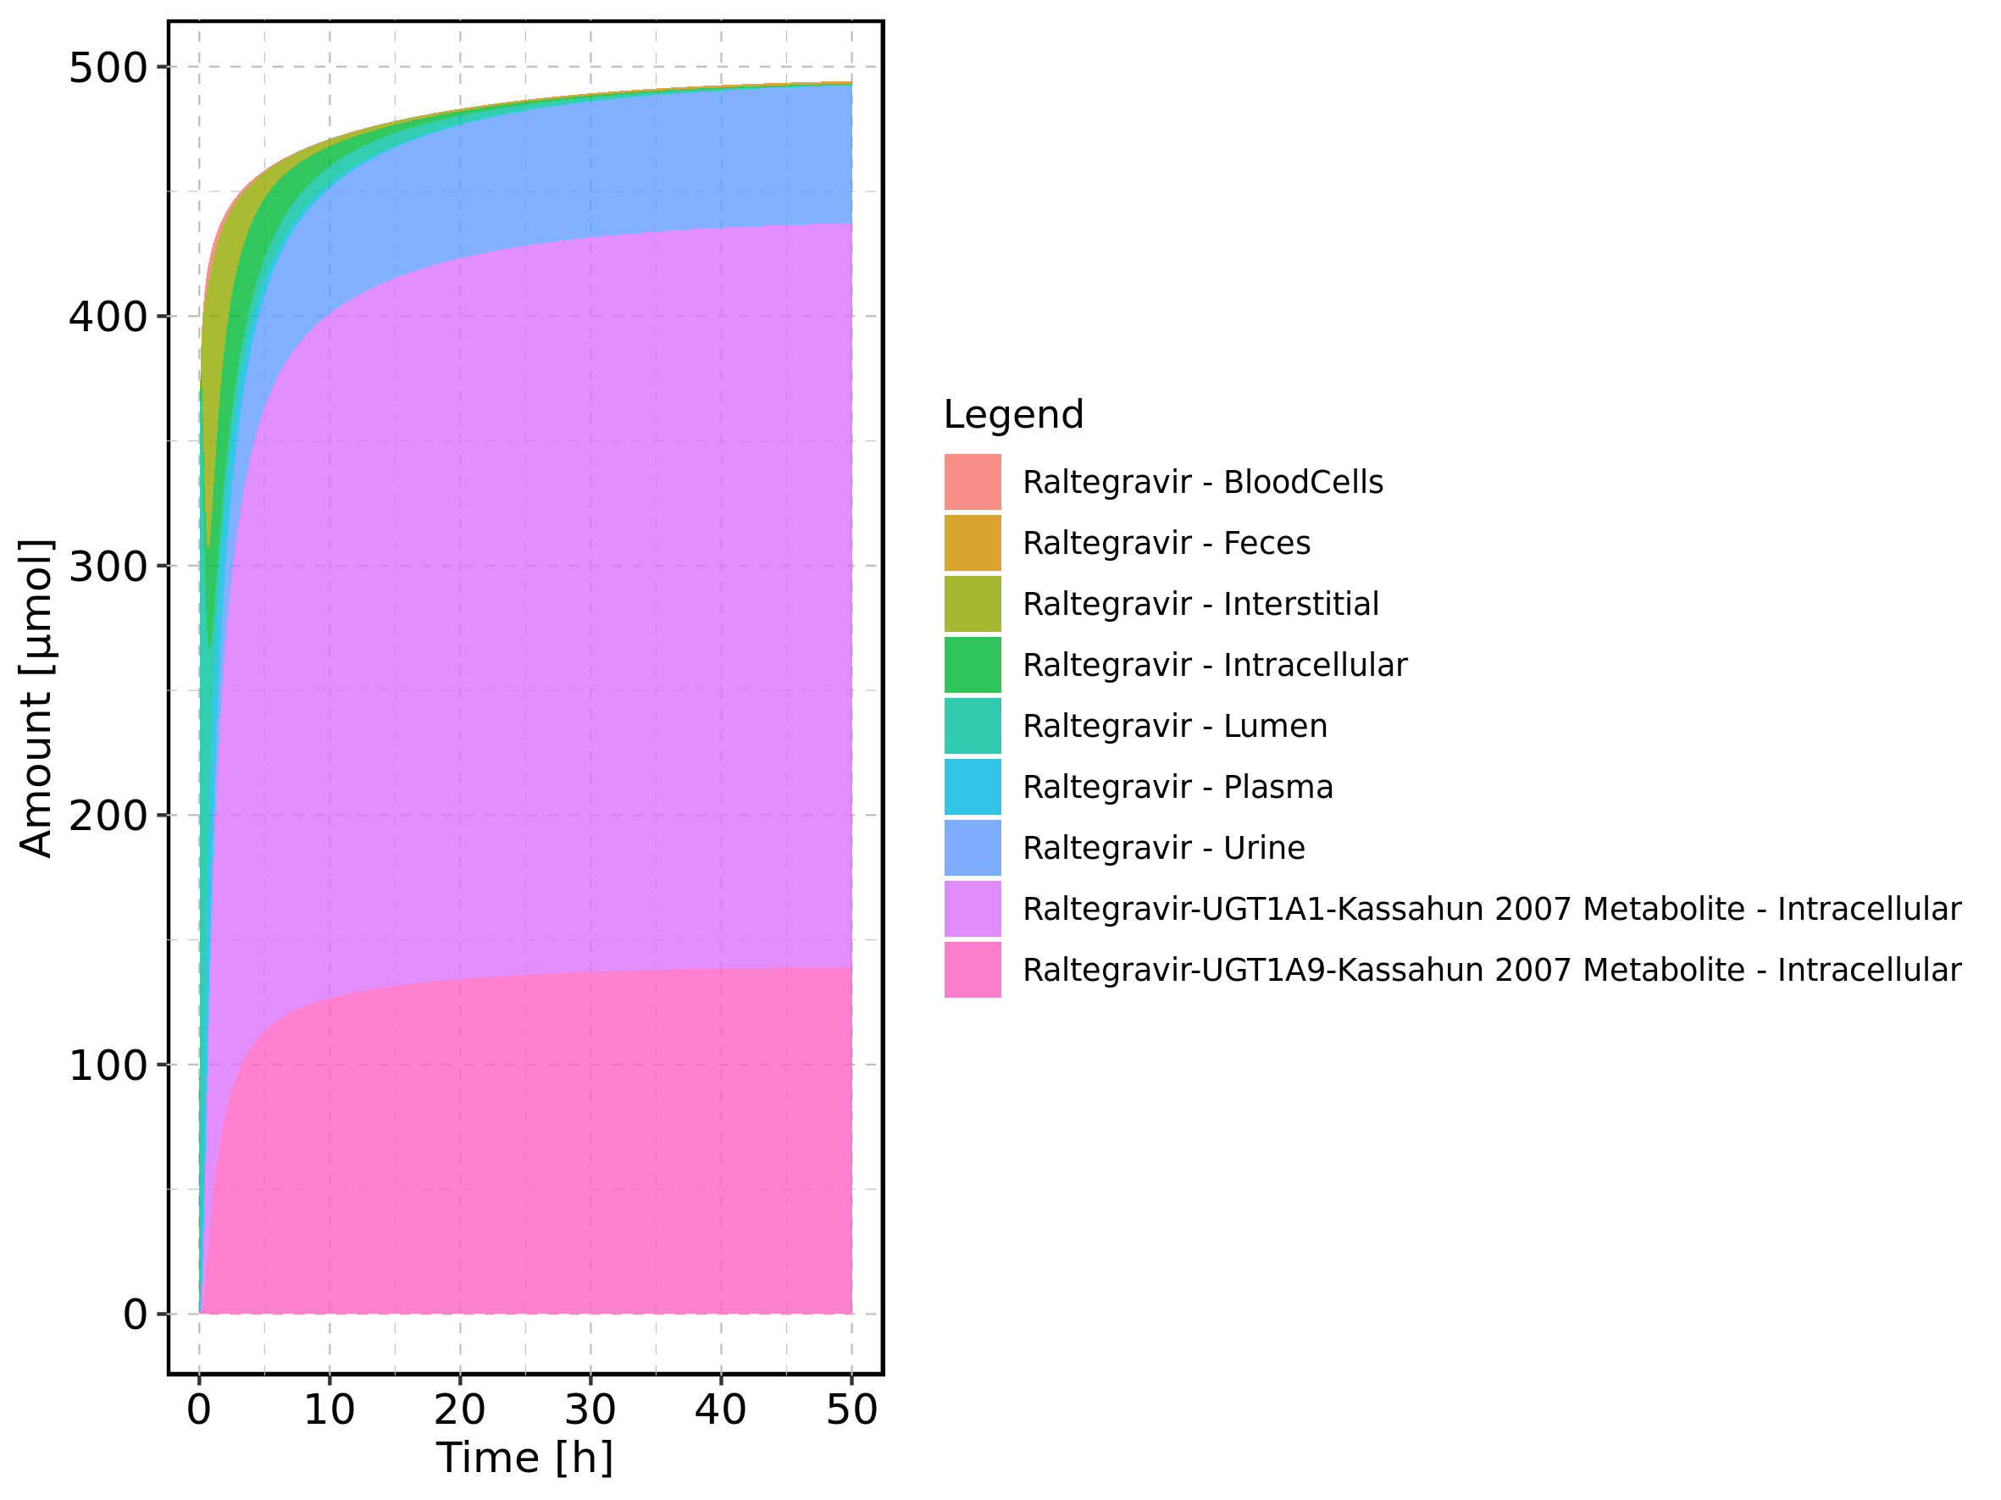

Figure 49: Amount of drug vs time within the different compartments normalized to applicated drugmass.

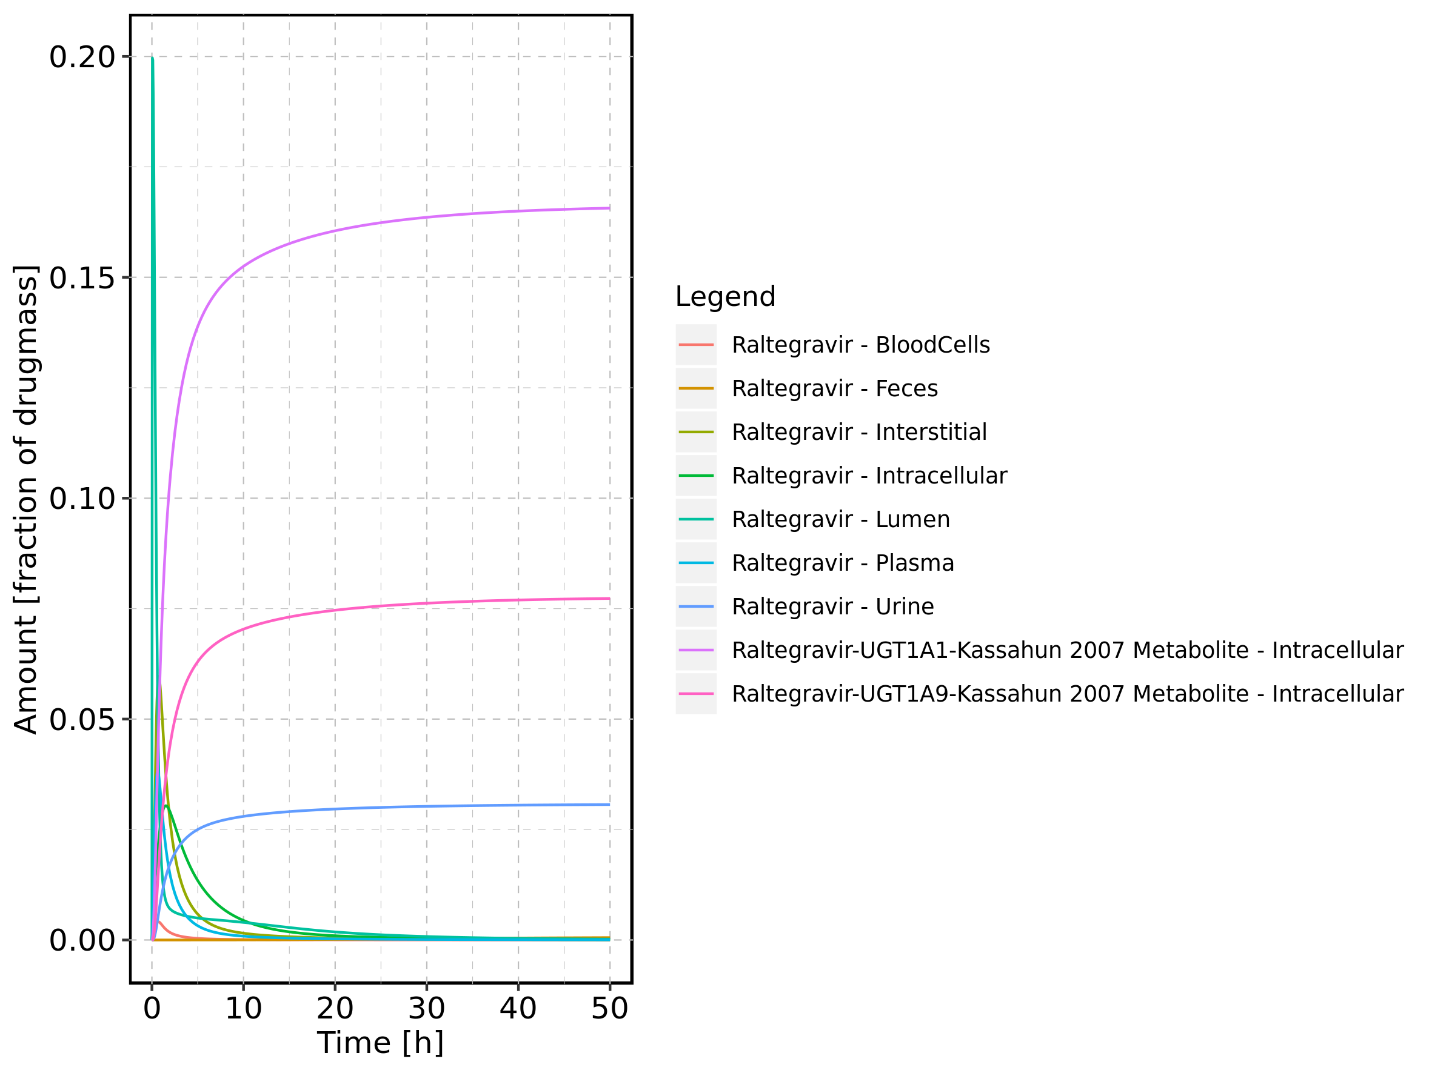

Figure 50: Cumulated amount of drug vs time within the different compartments normalized to applicated drugmass.

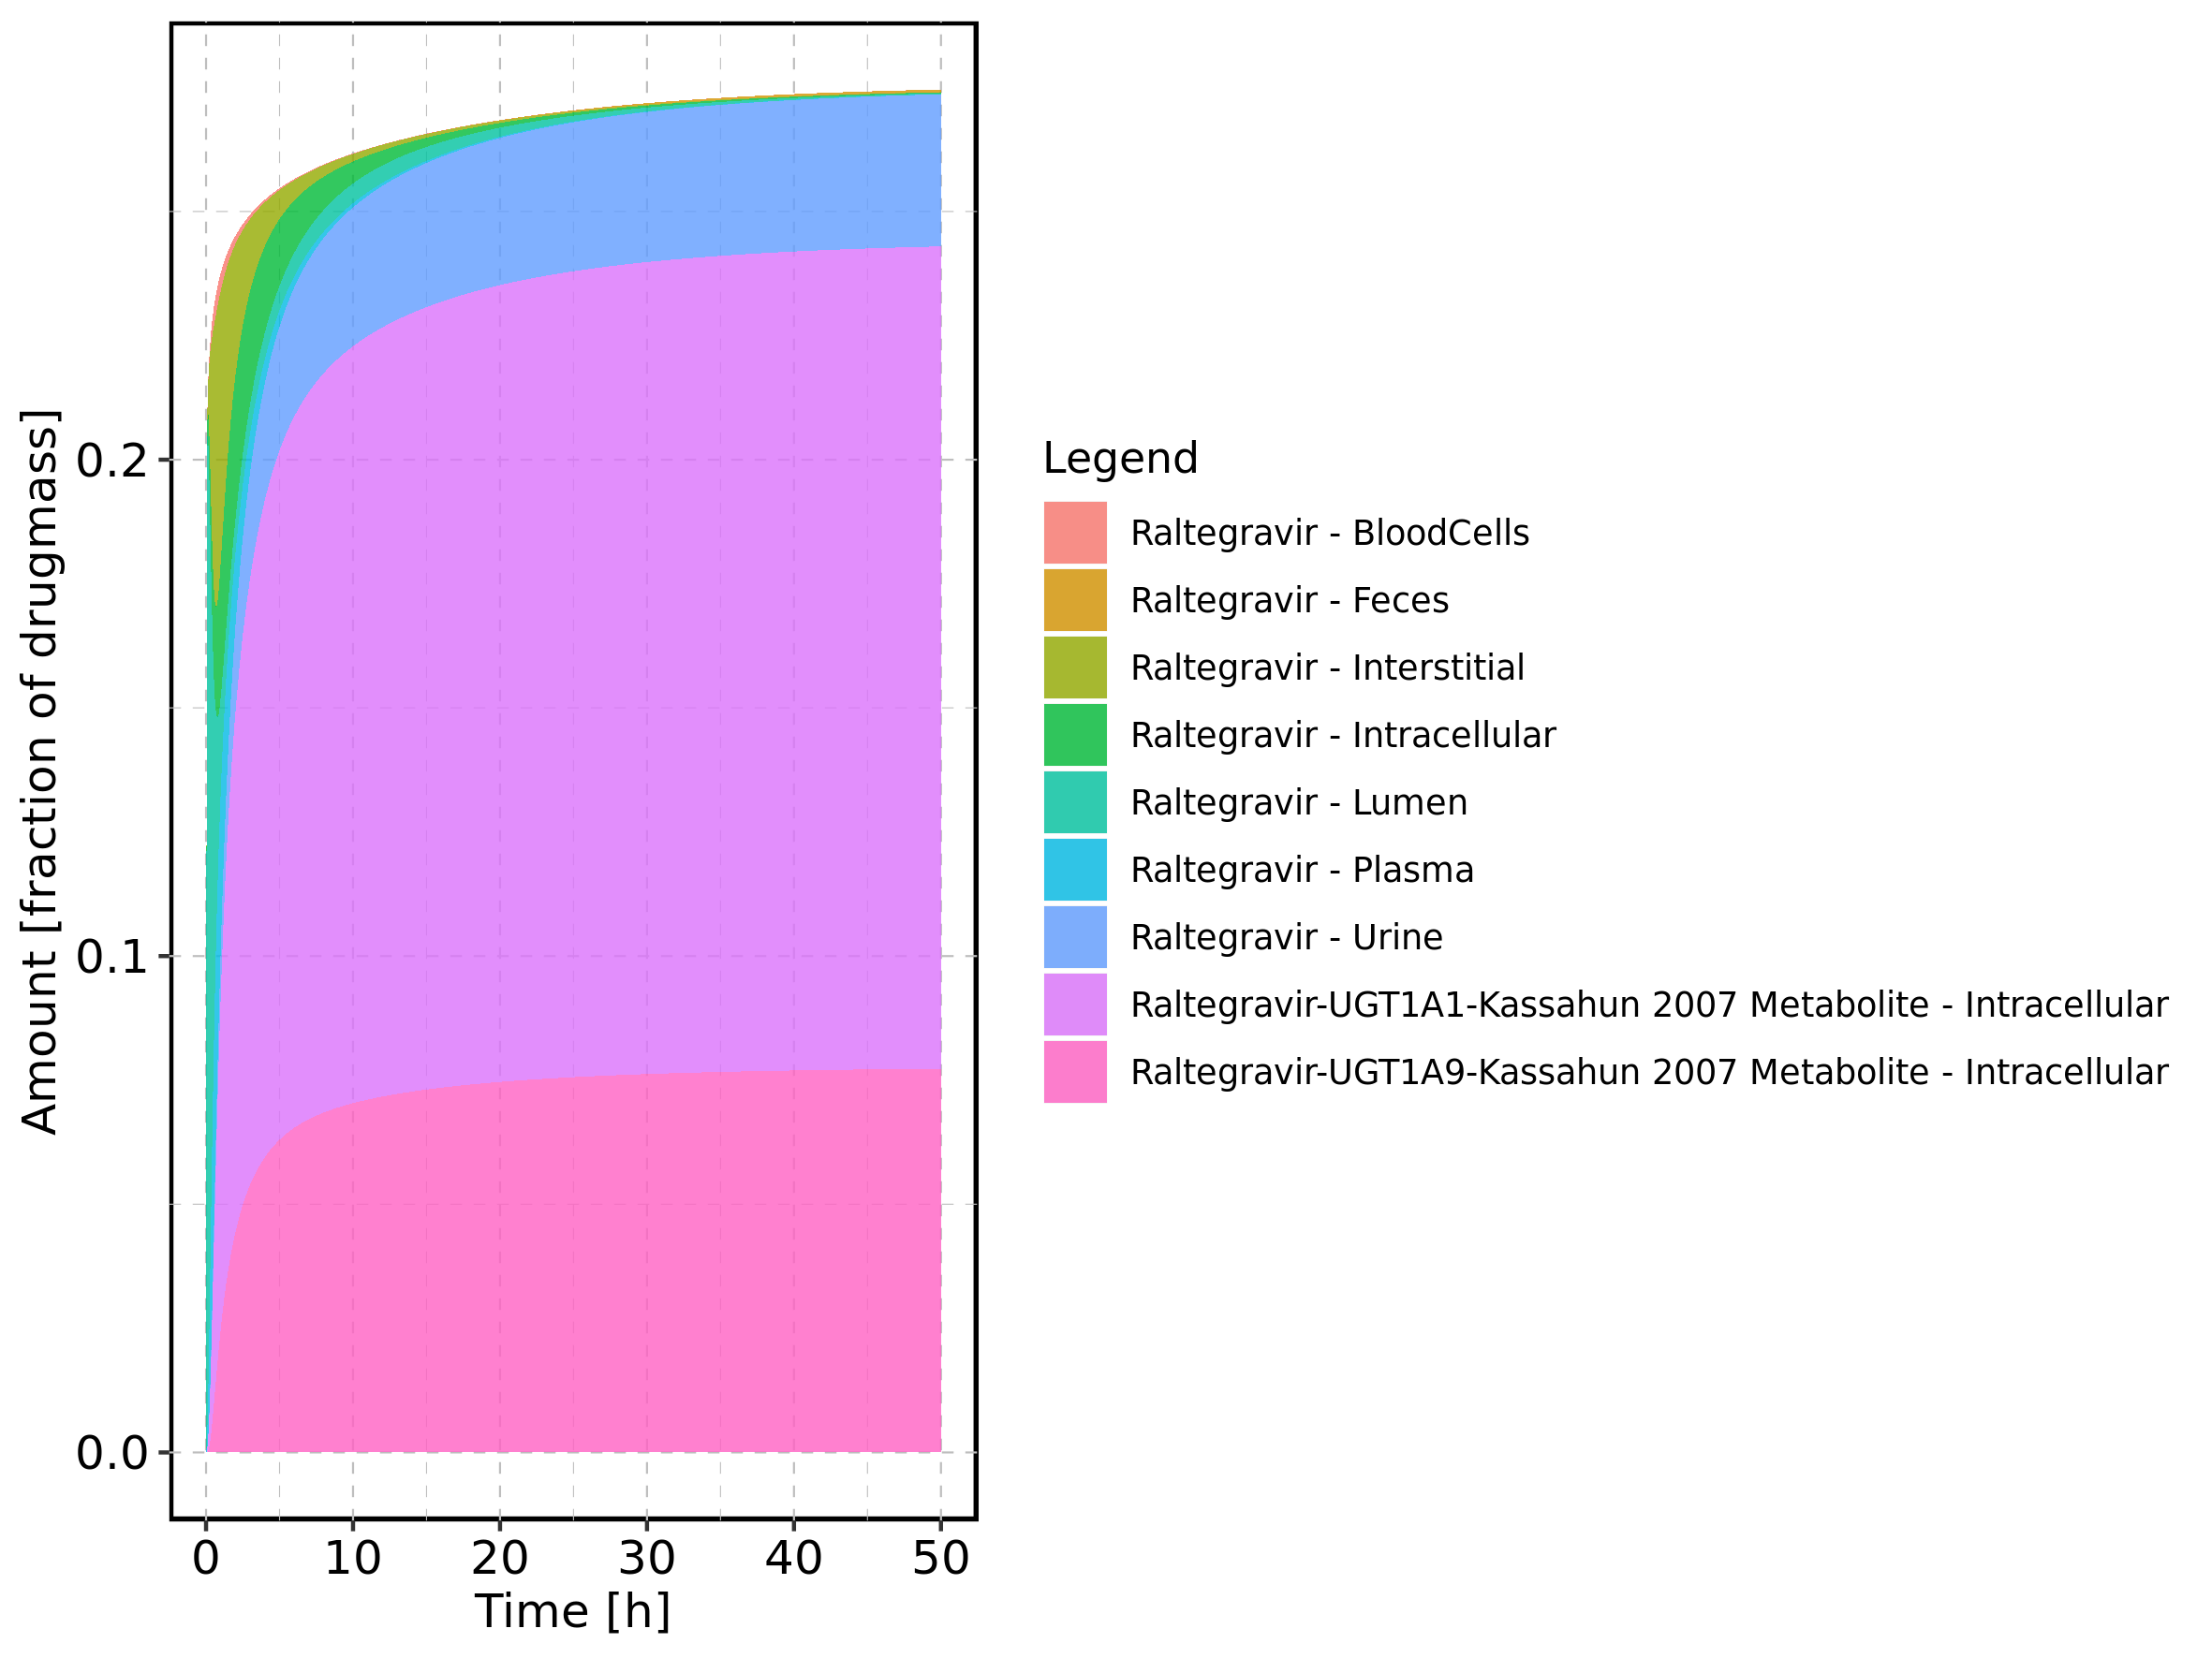

Figure 51: Fraction of drug within the different compartments at 50h.

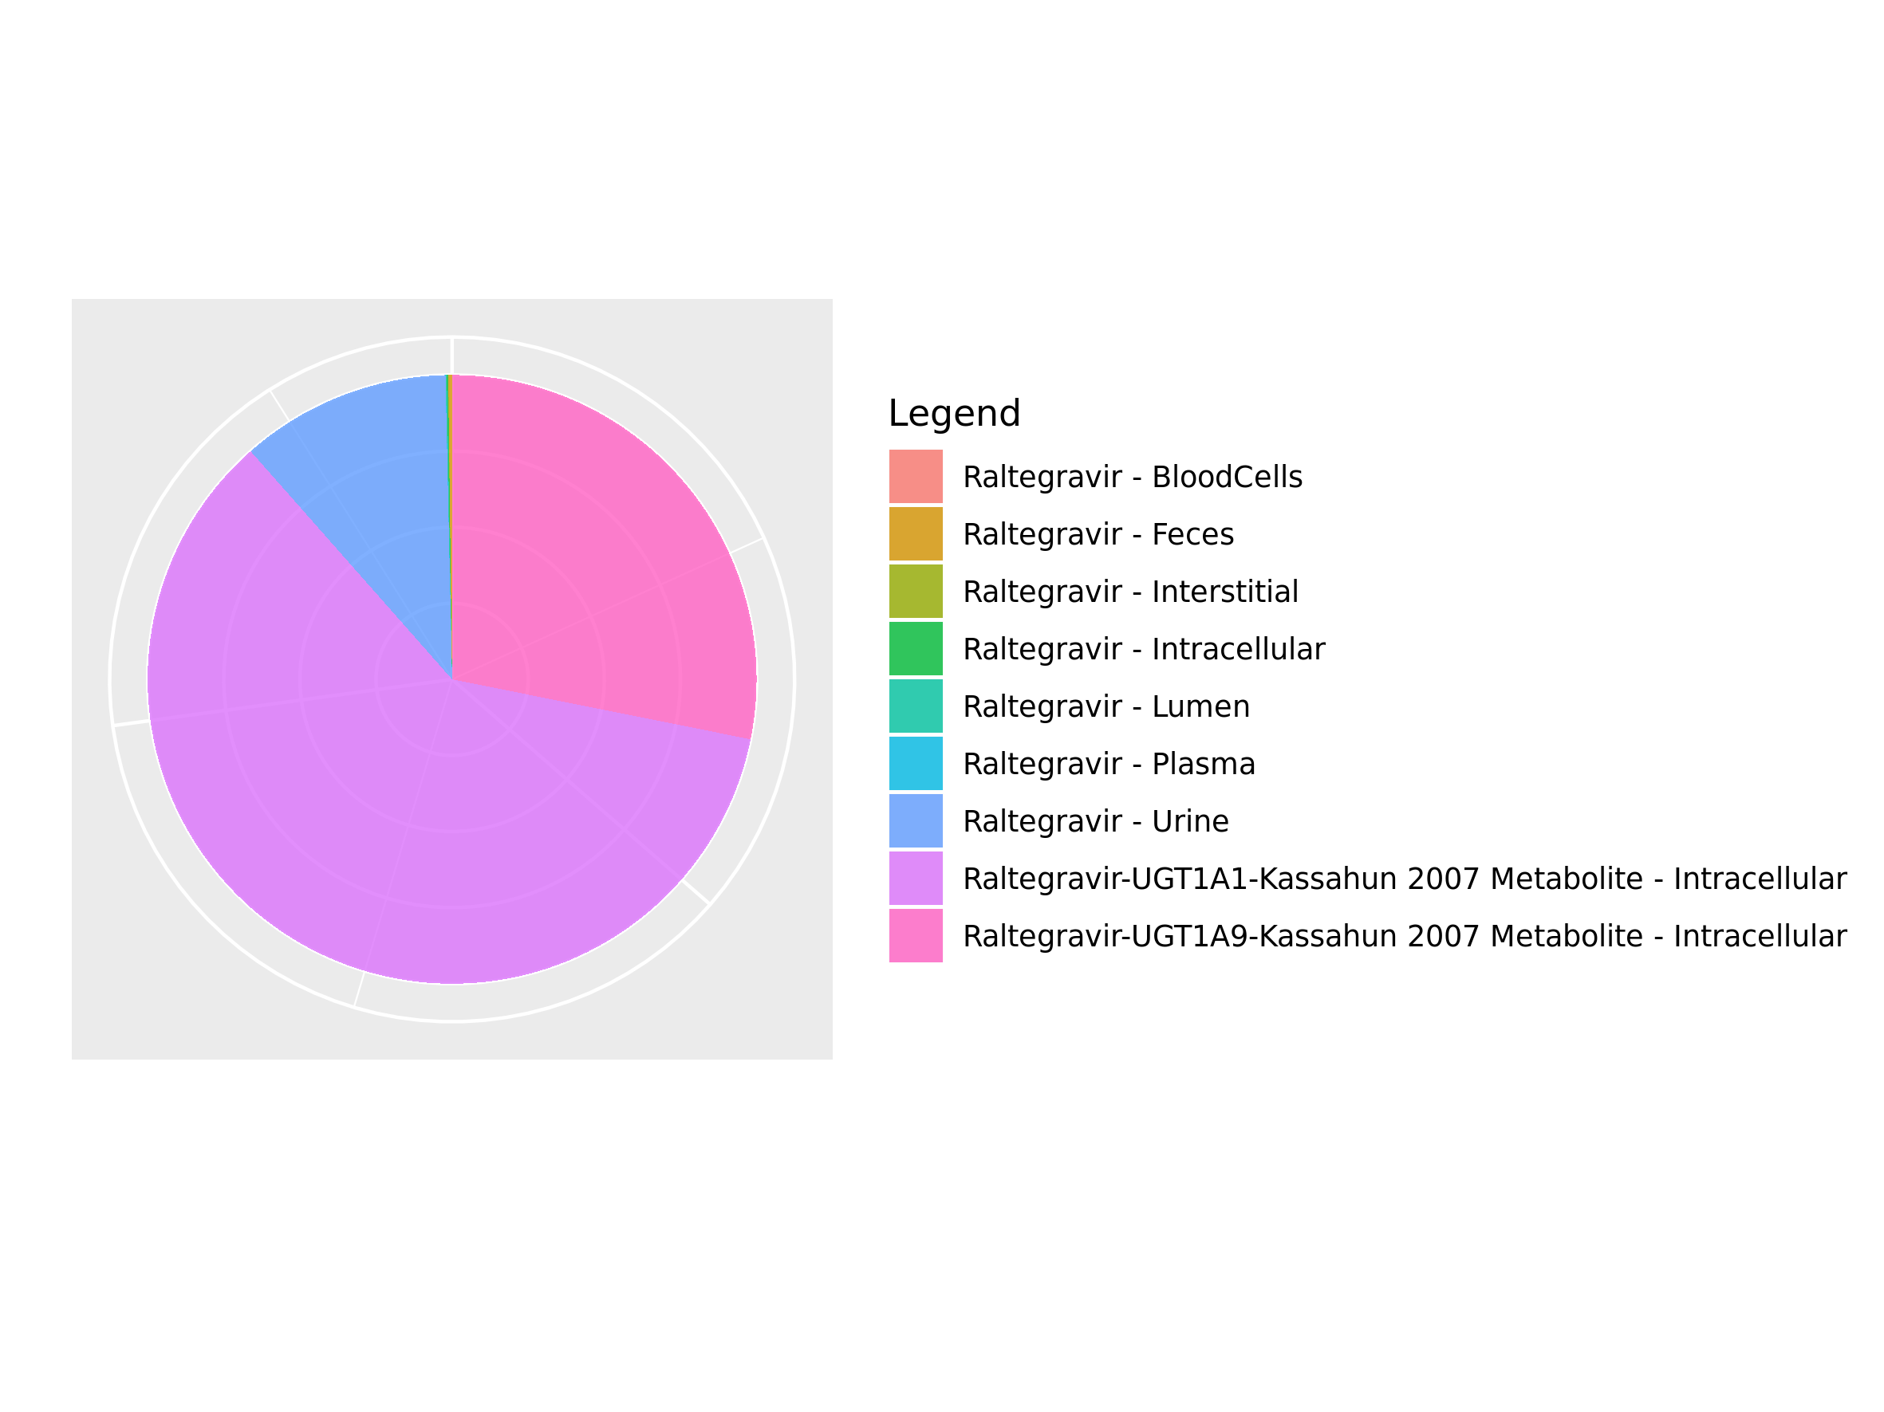

## 3.8. Mass Balance for Raltegravir 1200 mg (lactose formulation)

Figure 52: Amount of drug vs time within the different compartments.

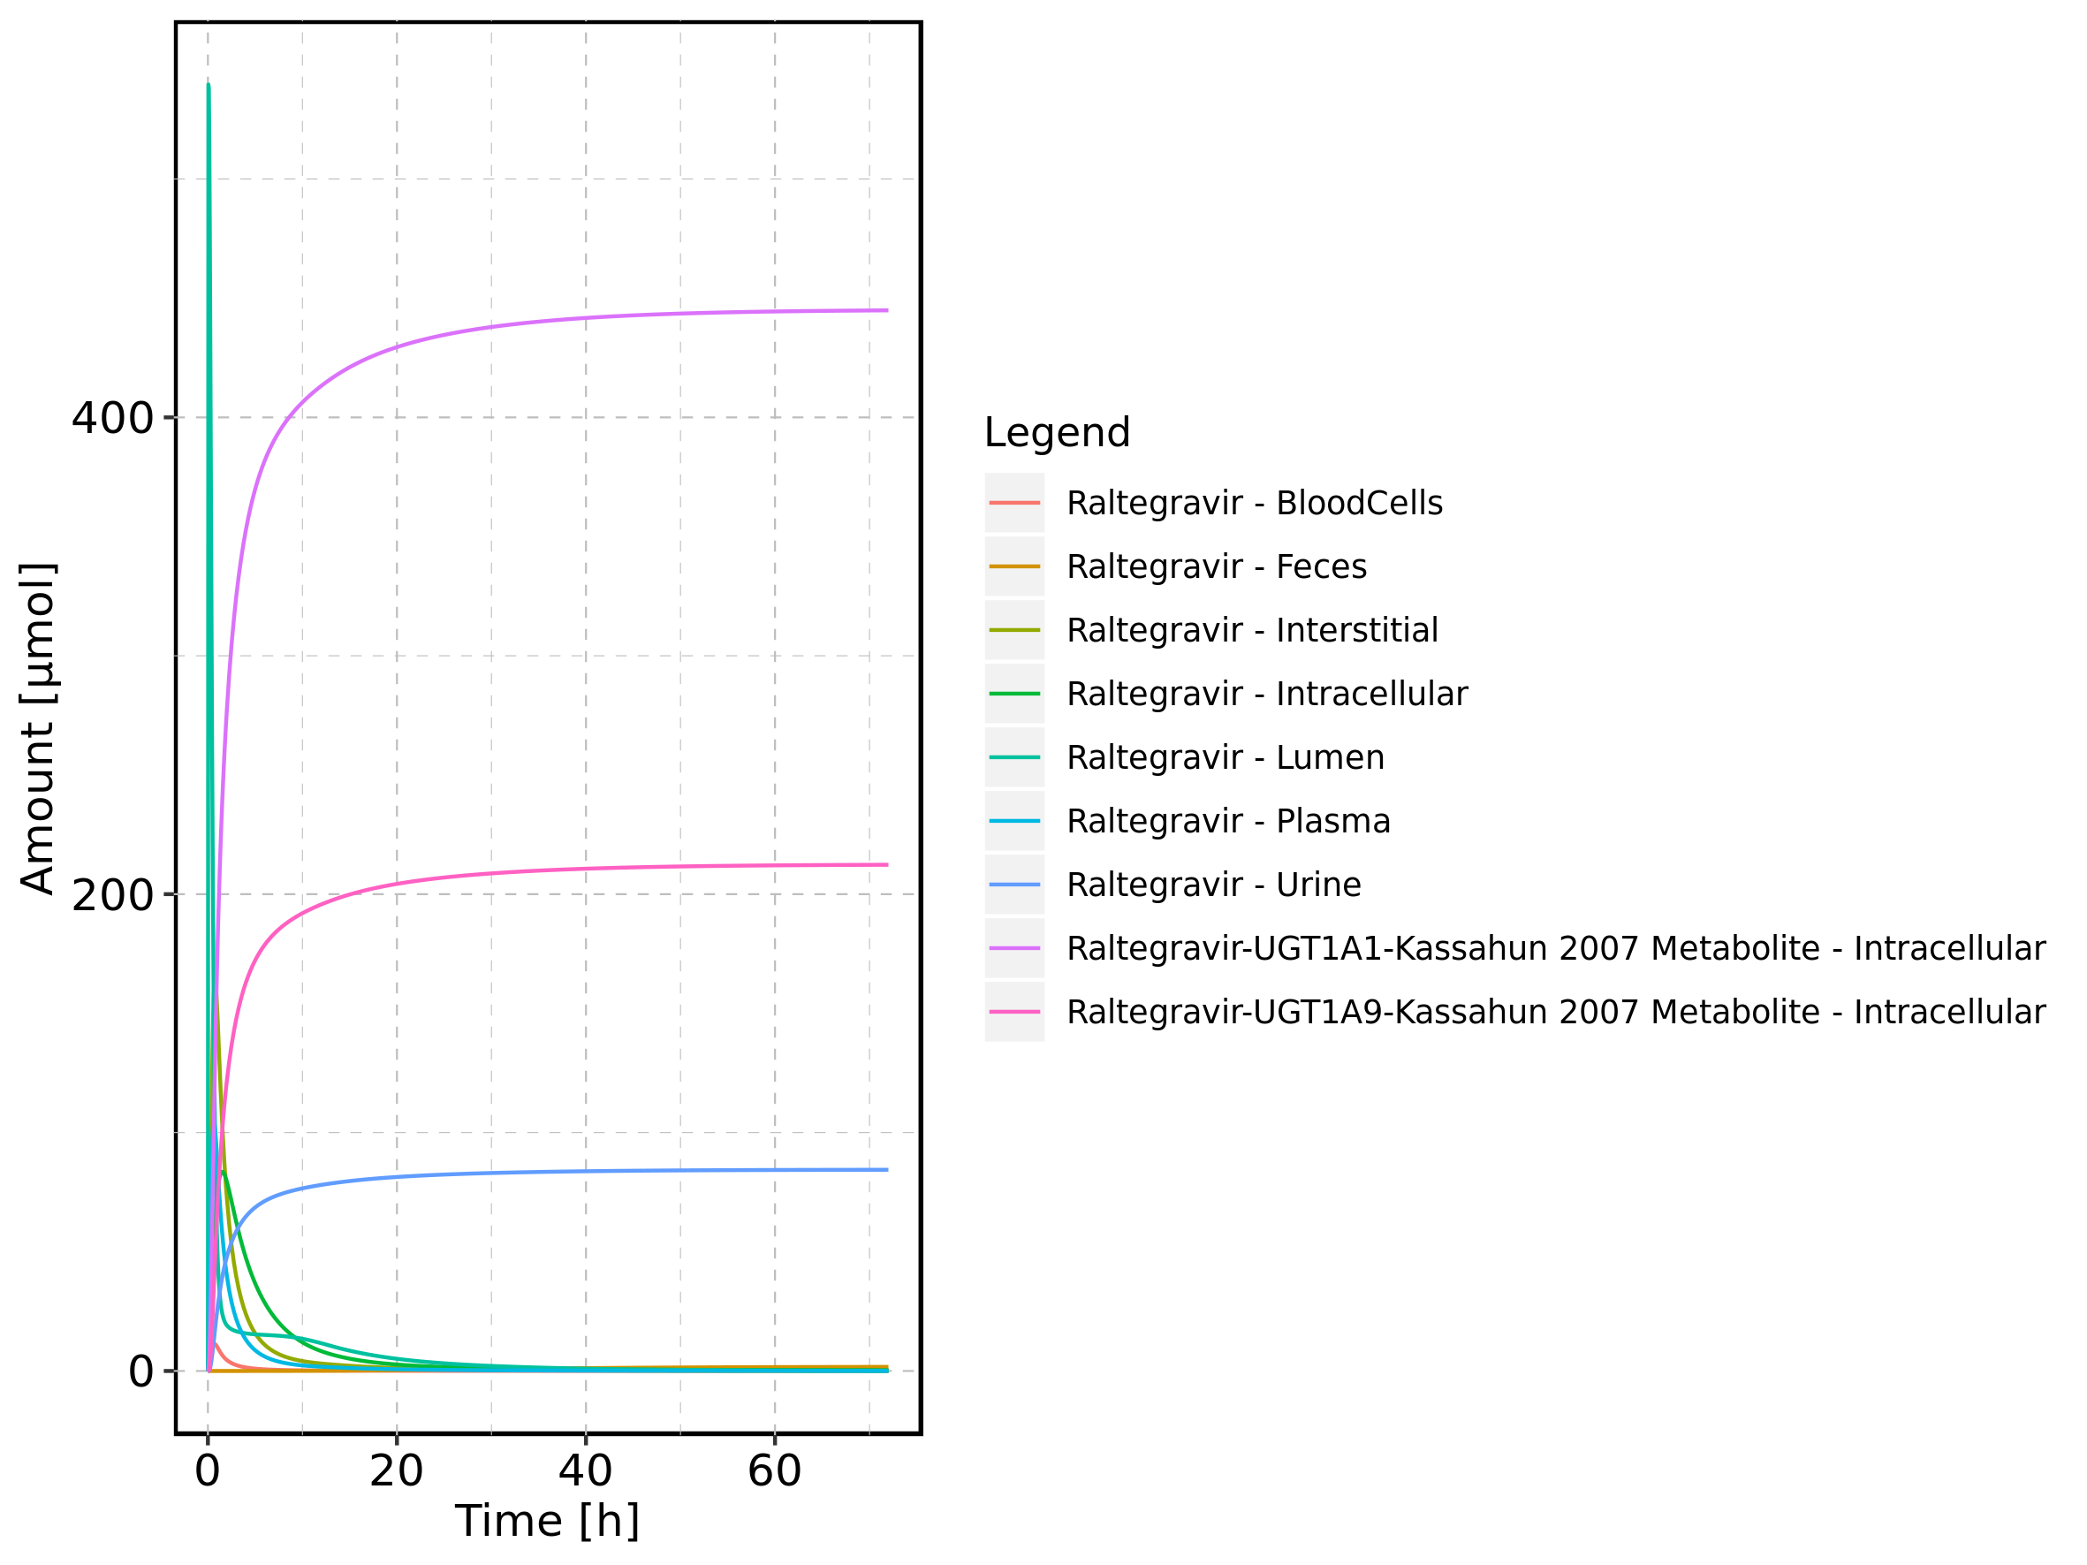

Figure 53: Cumulated amount of drug vs time within the different compartments

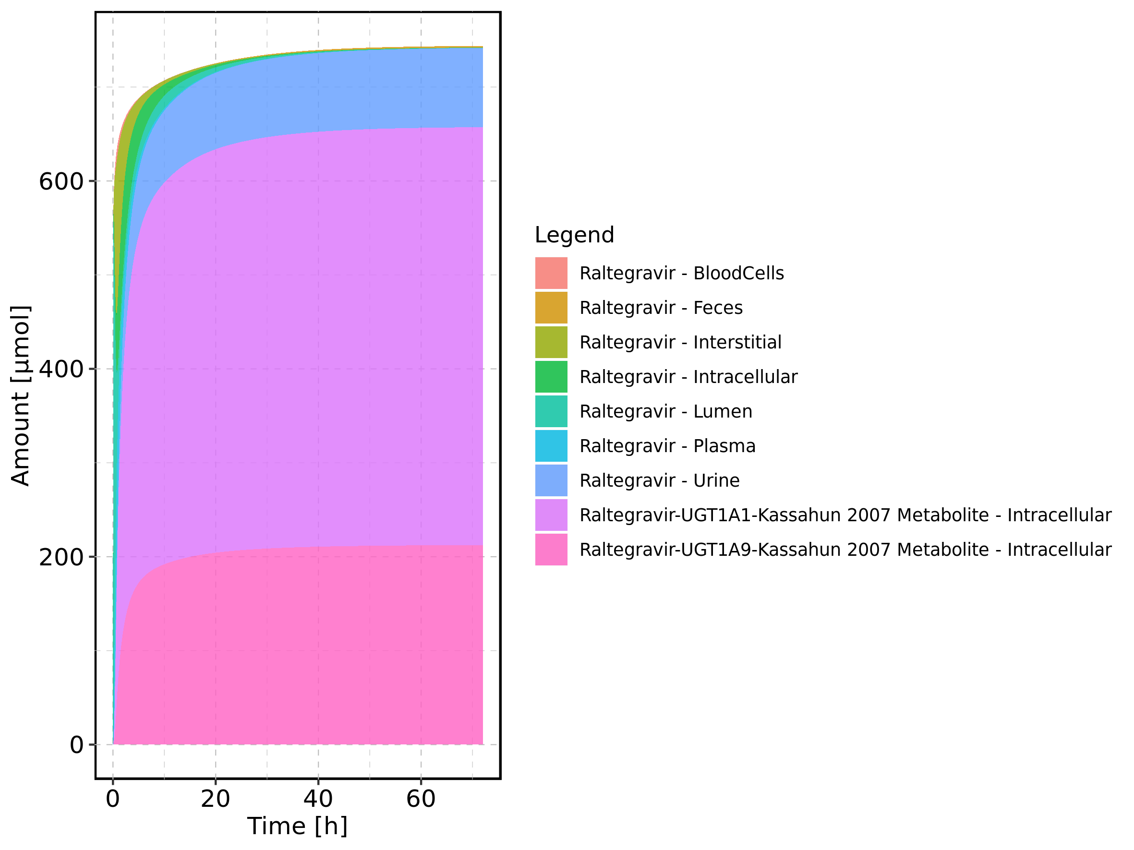

Figure 54: Amount of drug vs time within the different compartments normalized to applicated drugmass.

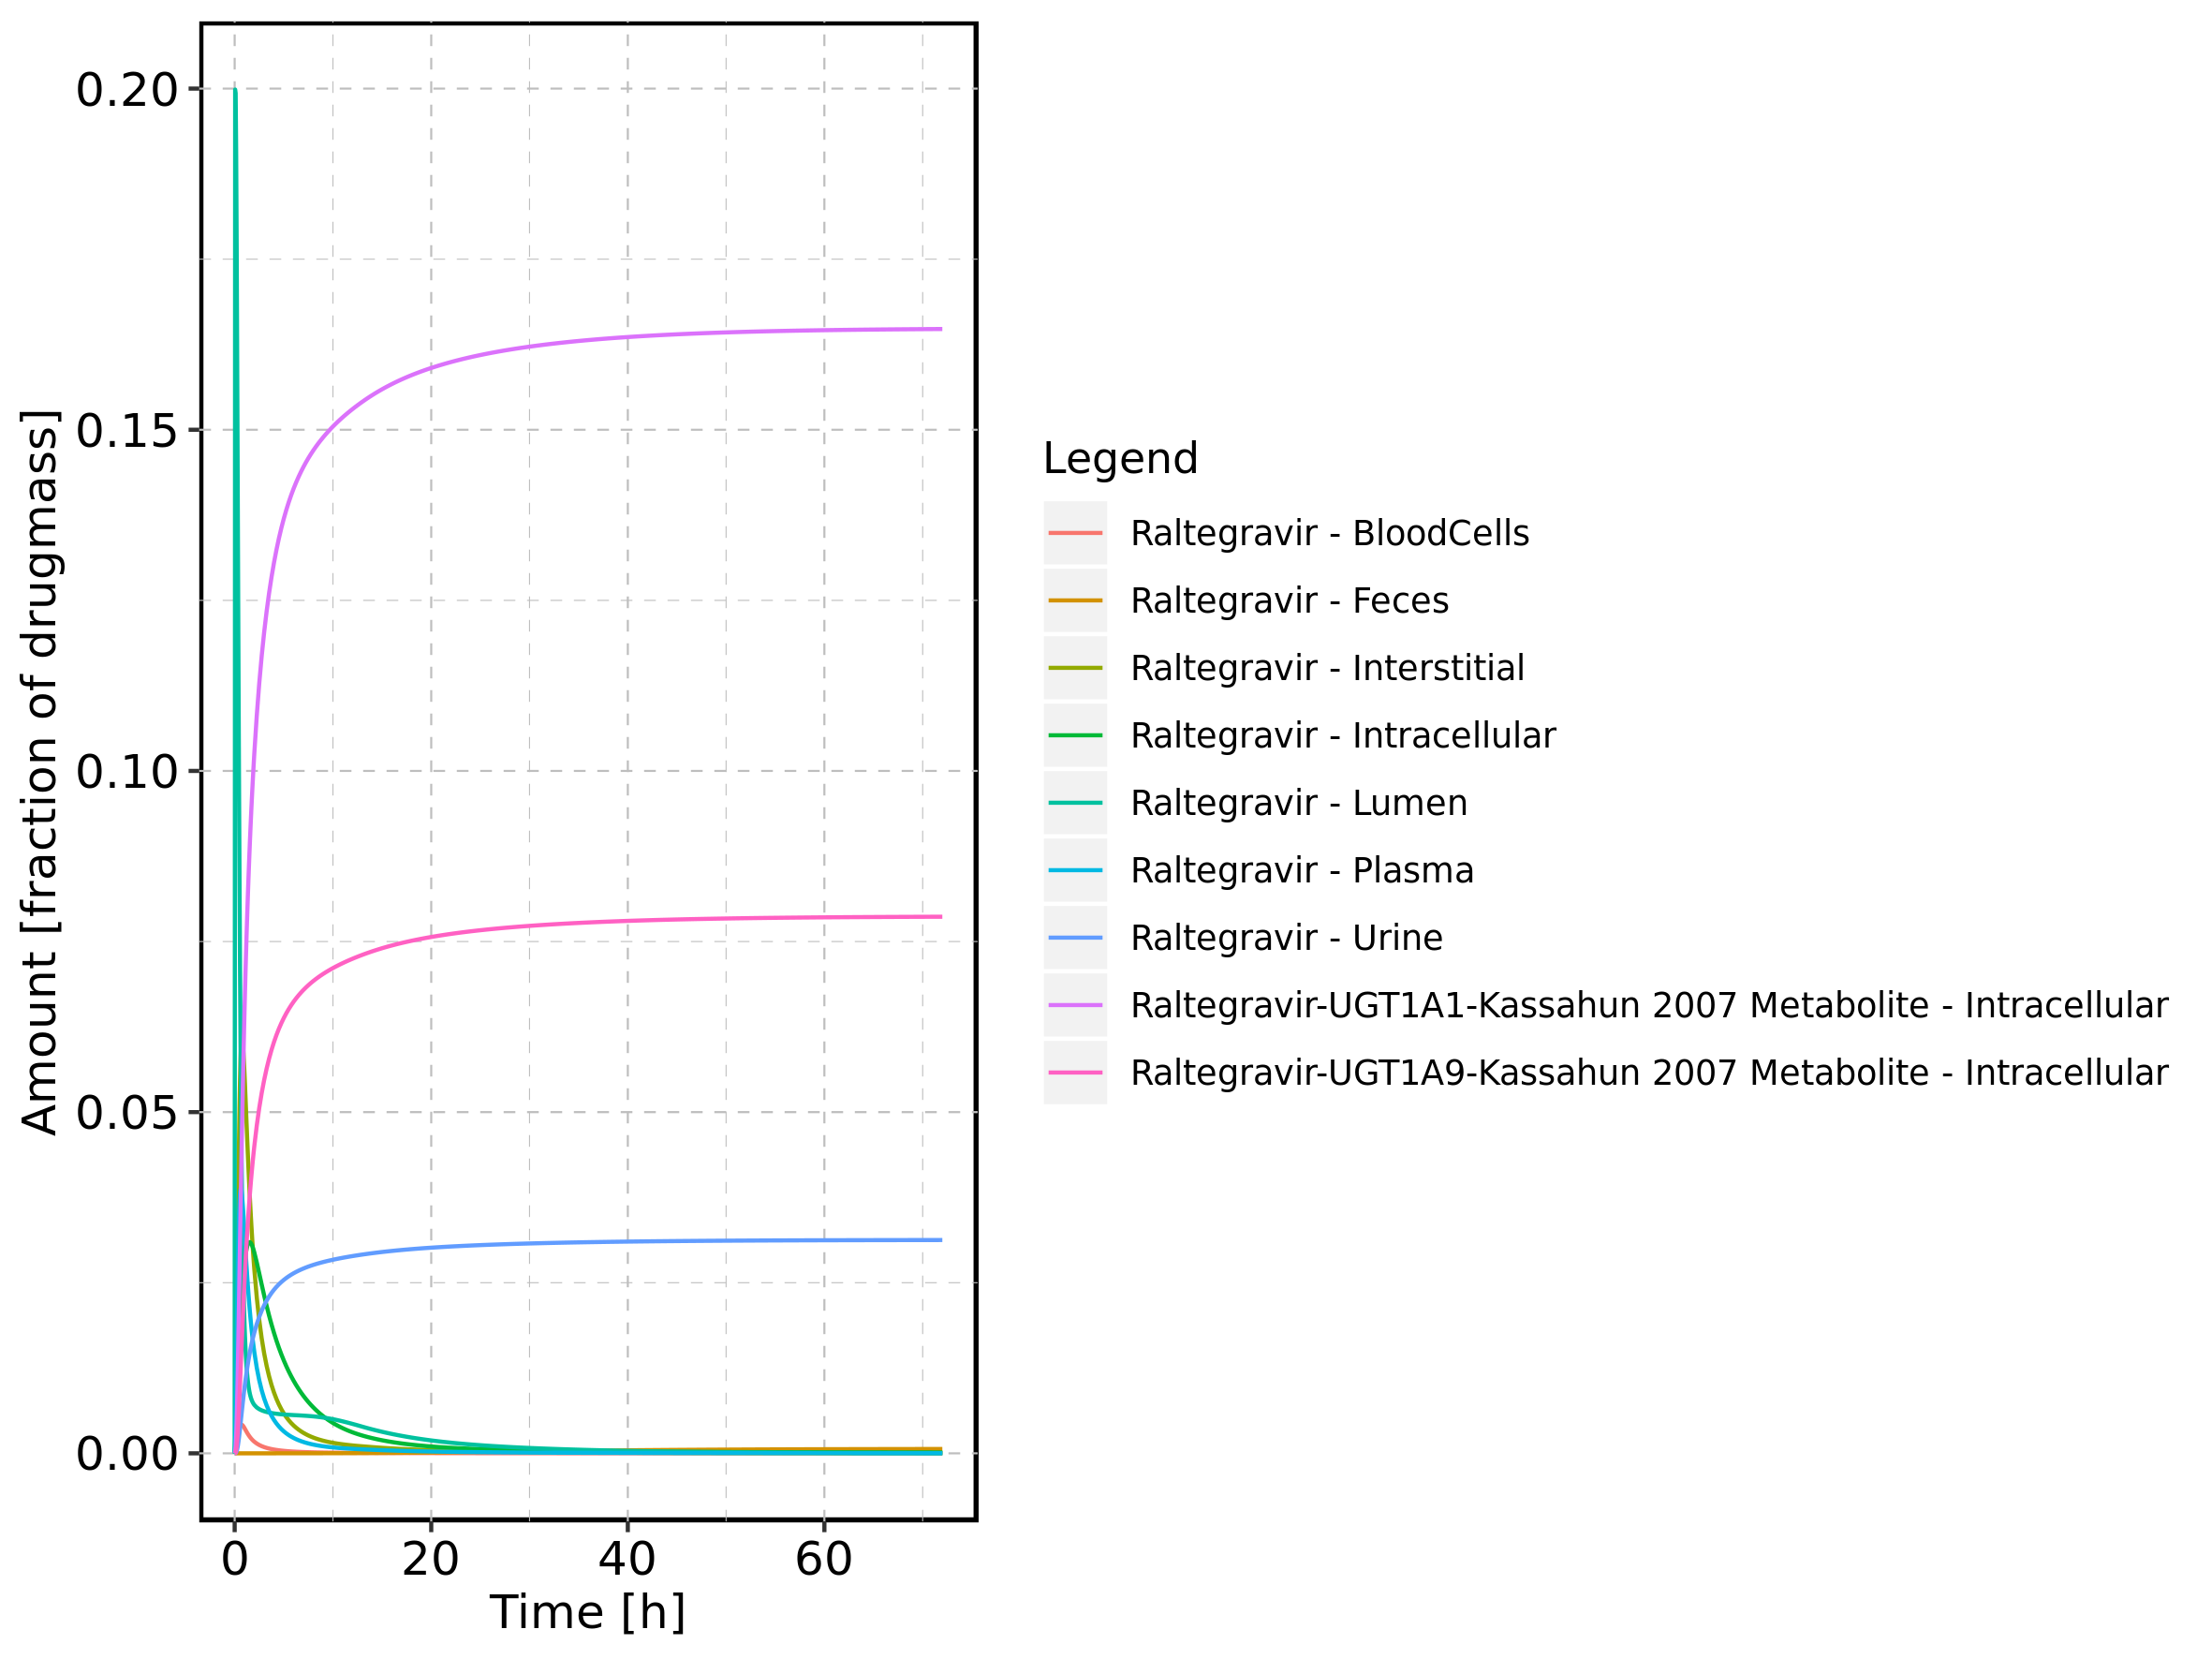

Figure 55: Cumulated amount of drug vs time within the different compartments normalized to applicated drugmass.

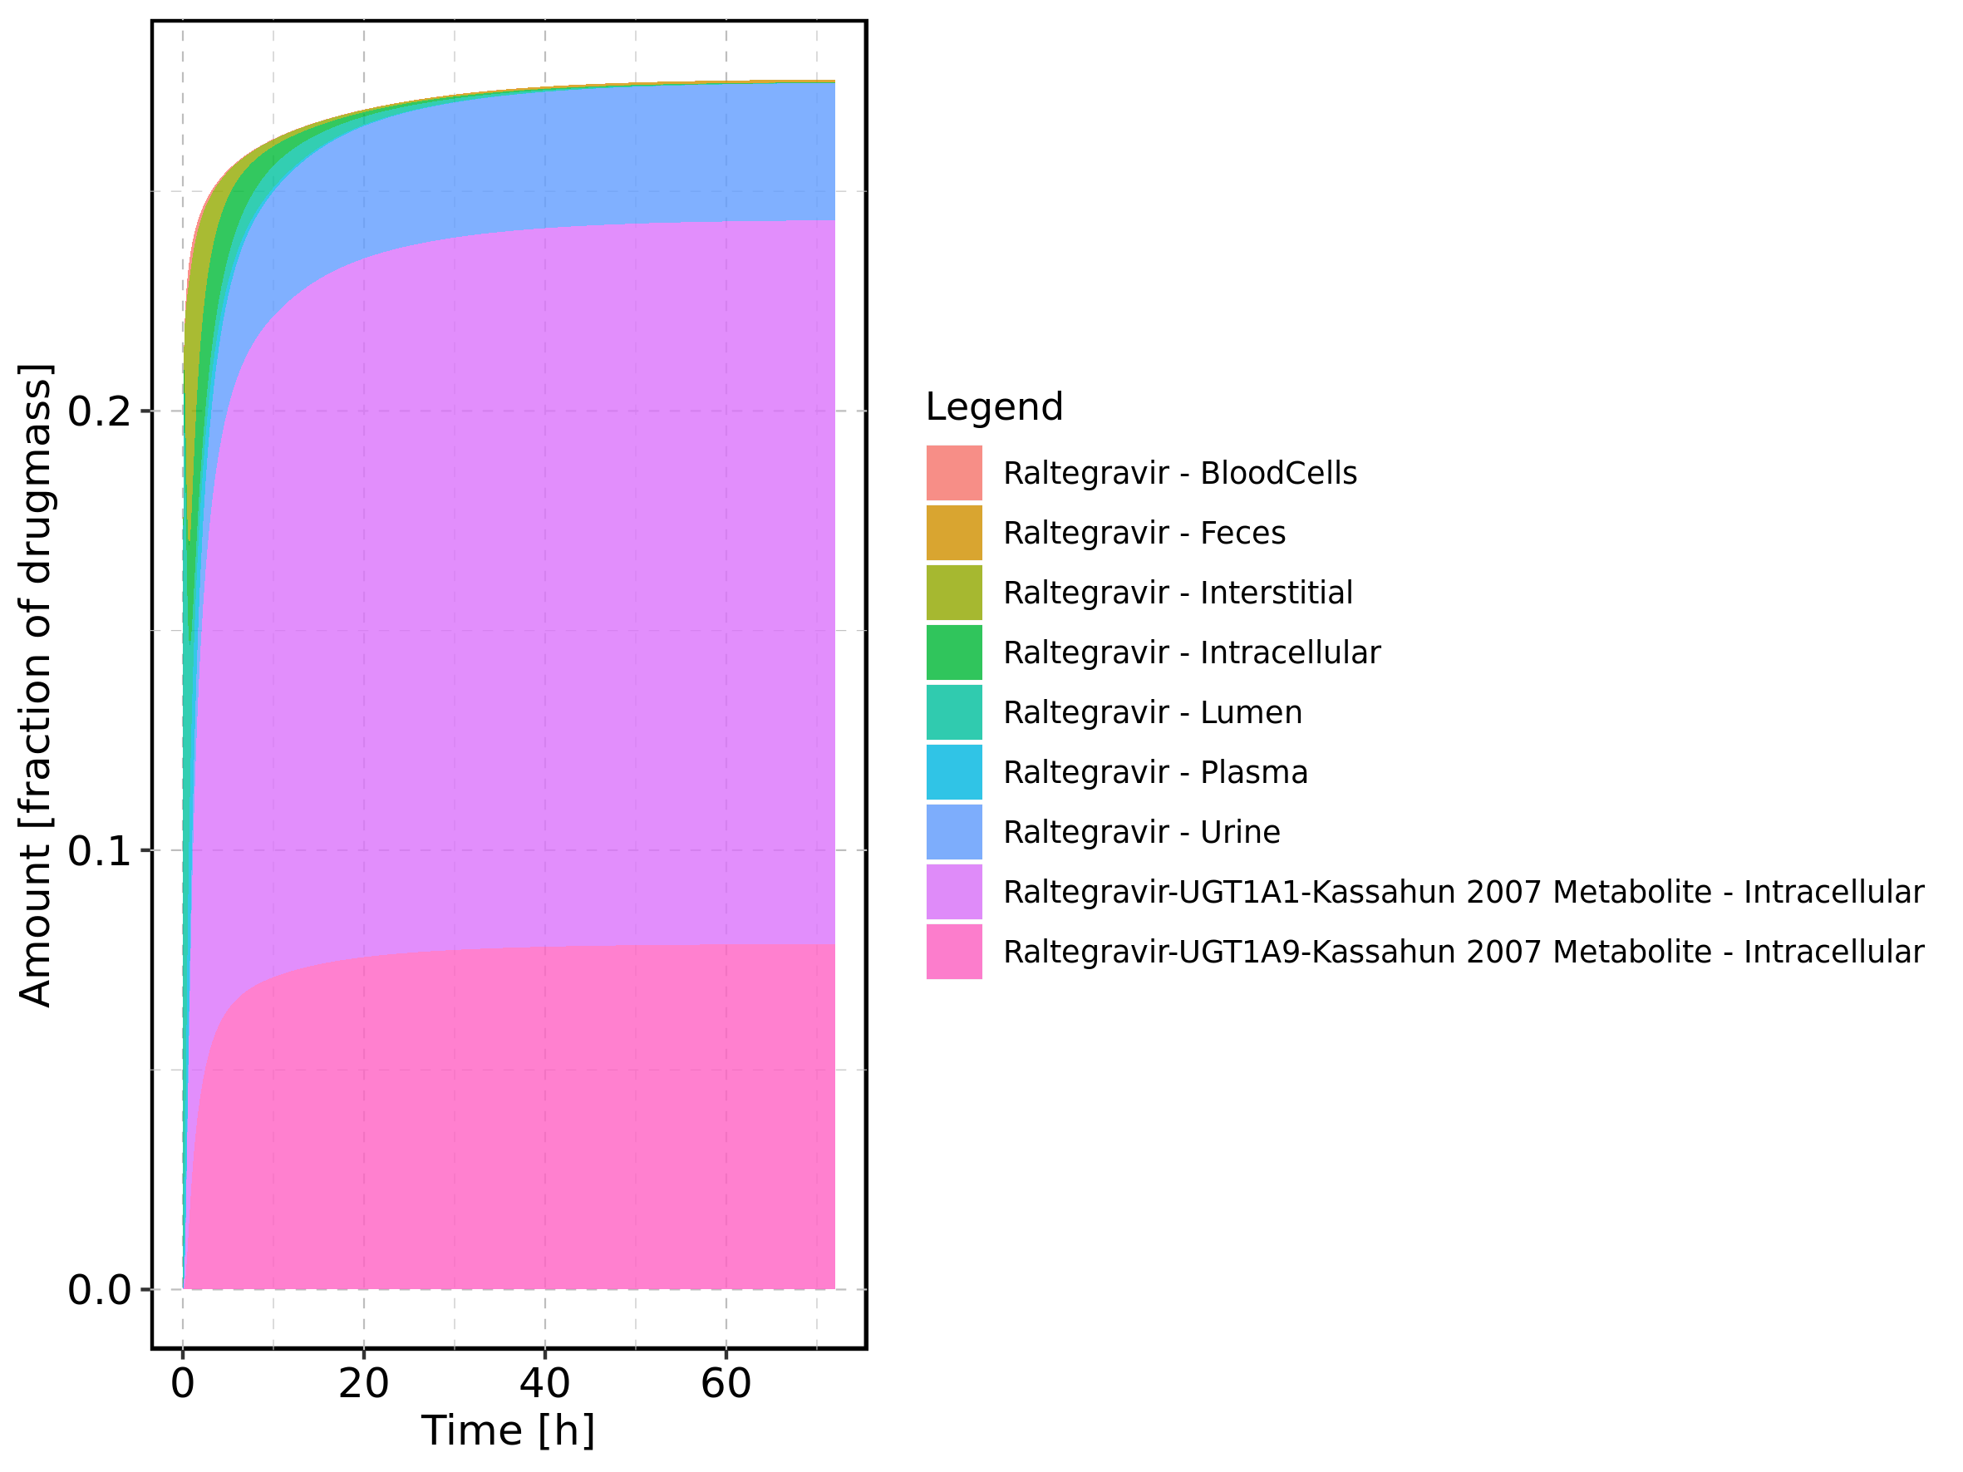

Figure 56: Fraction of drug within the different compartments at 72h.

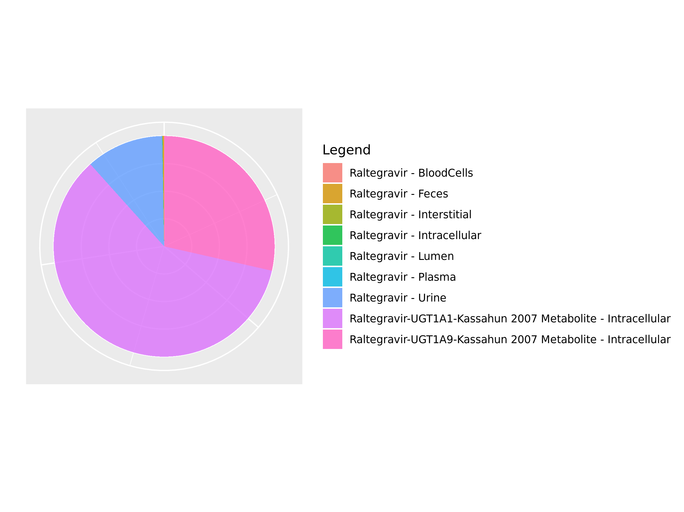

## 3.9. Mass Balance for Raltegravir 1600 mg (lactose formulation)

Figure 57: Amount of drug vs time within the different compartments.

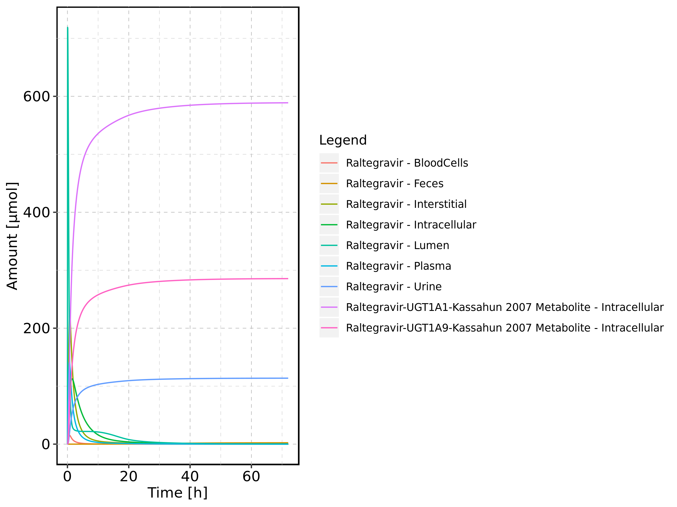

Figure 58: Cumulated amount of drug vs time within the different compartments

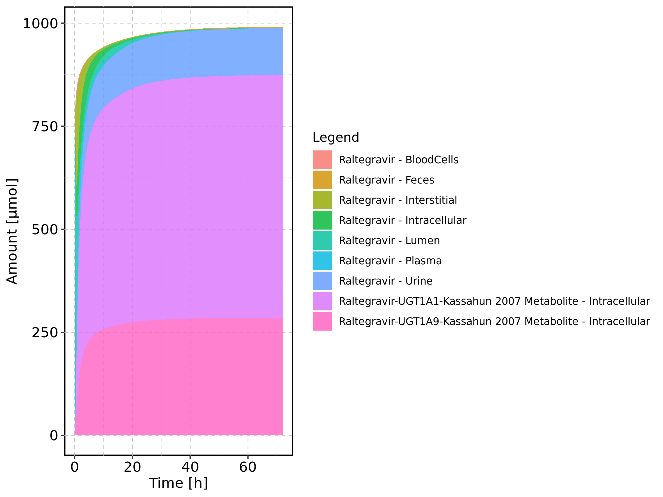

Figure 59: Amount of drug vs time within the different compartments normalized to applicated drugmass.

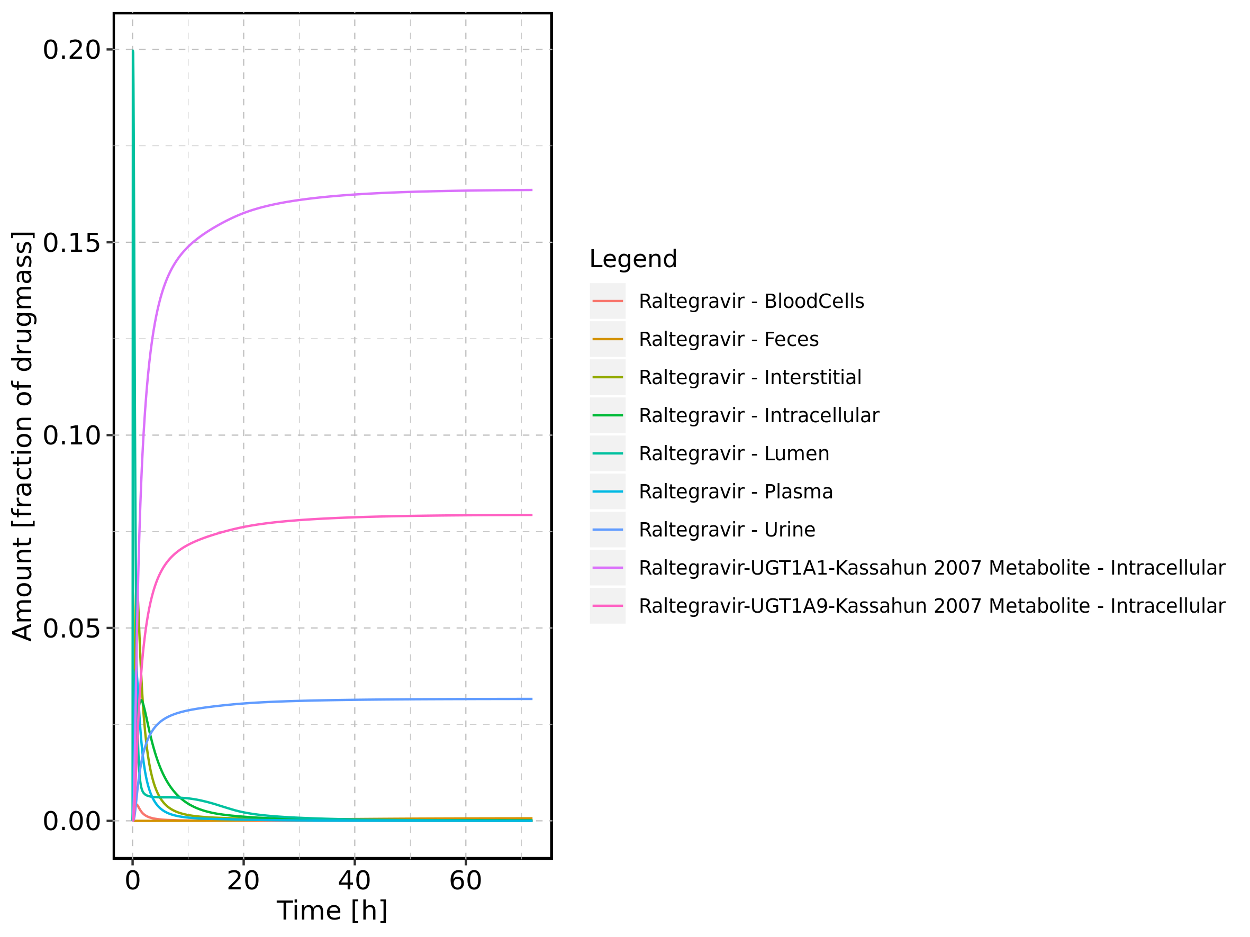

Figure 60: Cumulated amount of drug vs time within the different compartments normalized to applicated drugmass.

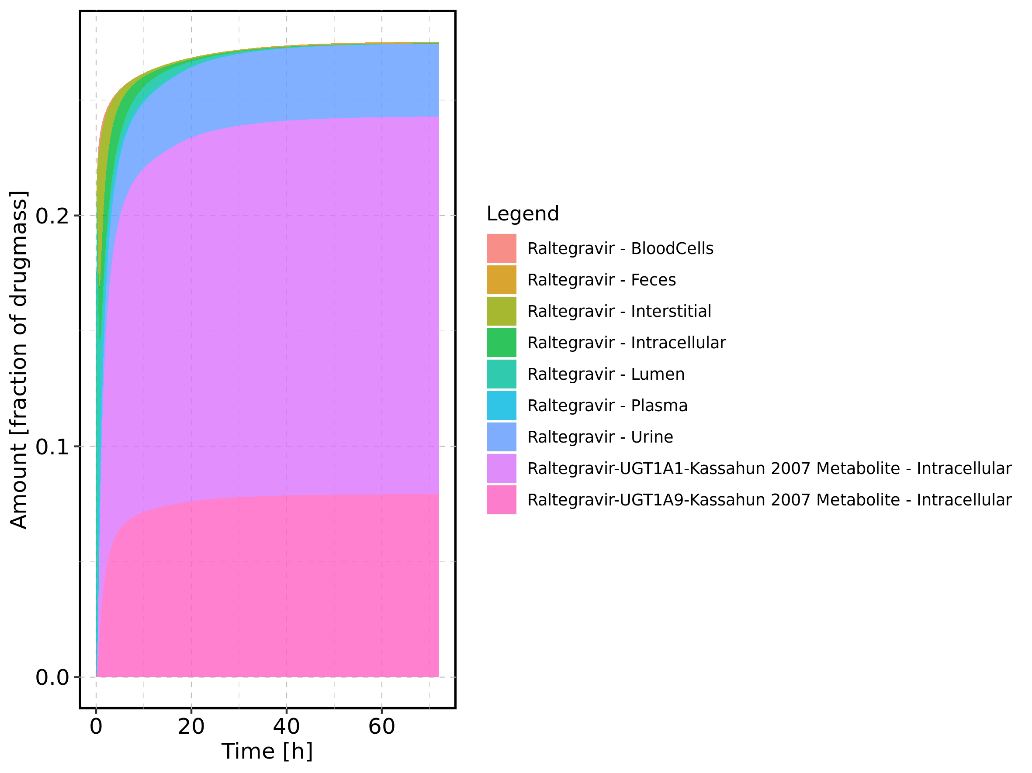

Figure 61: Fraction of drug within the different compartments at 72h.

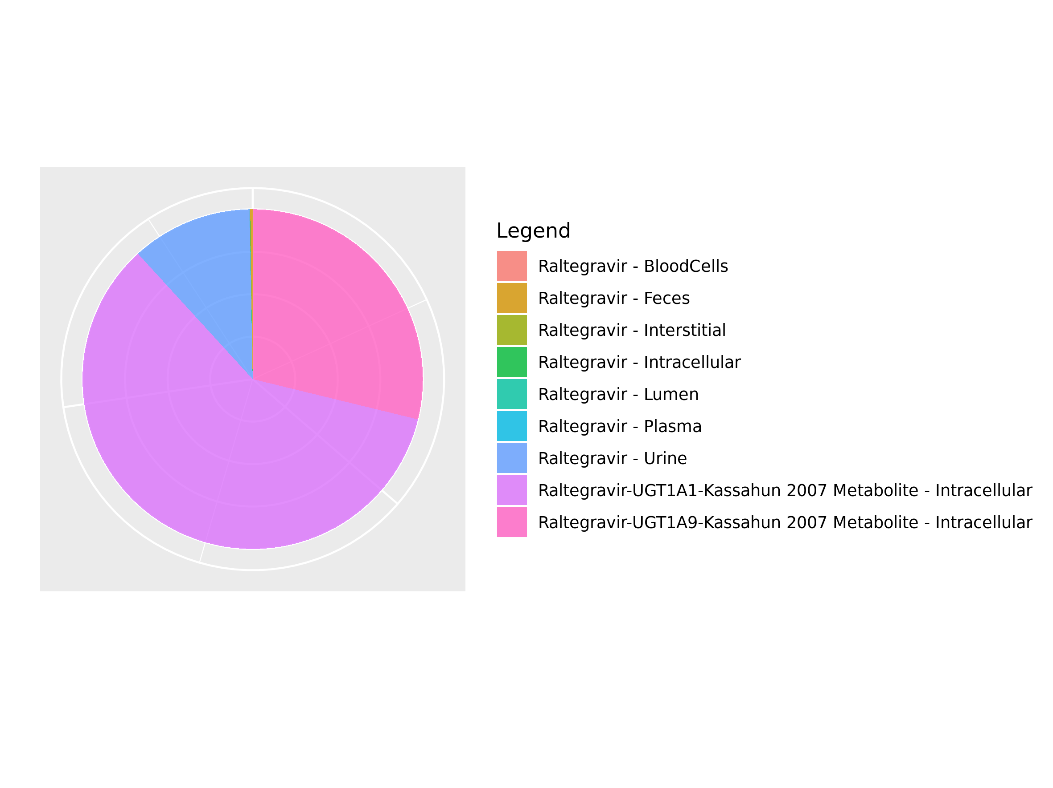

## 3.10. Mass Balance for Raltegravir 100 mg filmcoated tablet md

Figure 62: Amount of drug vs time within the different compartments.

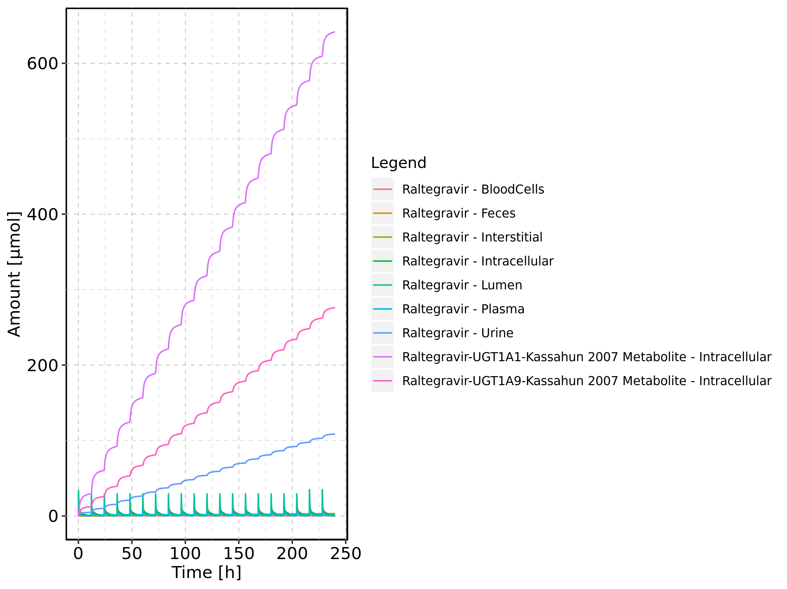

Figure 63: Cumulated amount of drug vs time within the different compartments

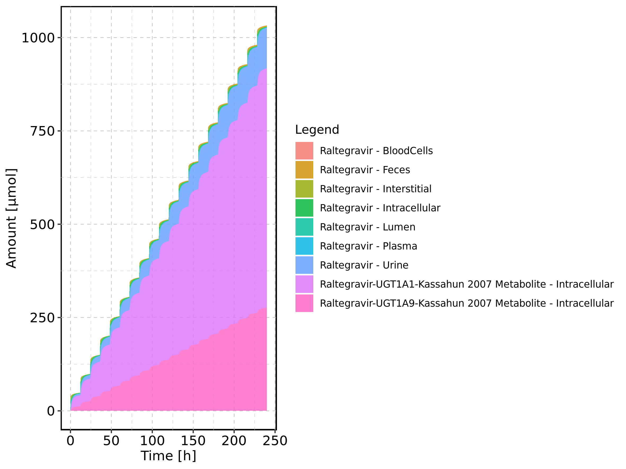

Figure 64: Amount of drug vs time within the different compartments normalized to applicated drugmass.

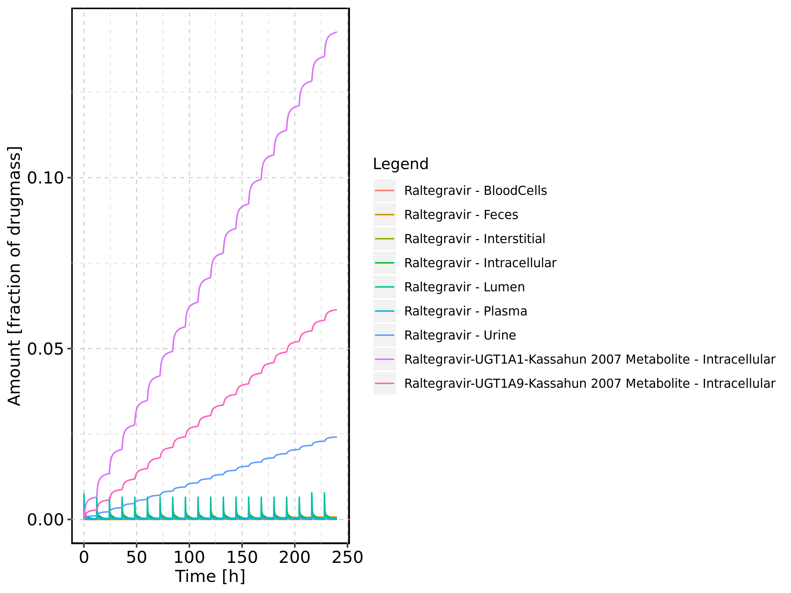

Figure 65: Cumulated amount of drug vs time within the different compartments normalized to applicated drugmass.

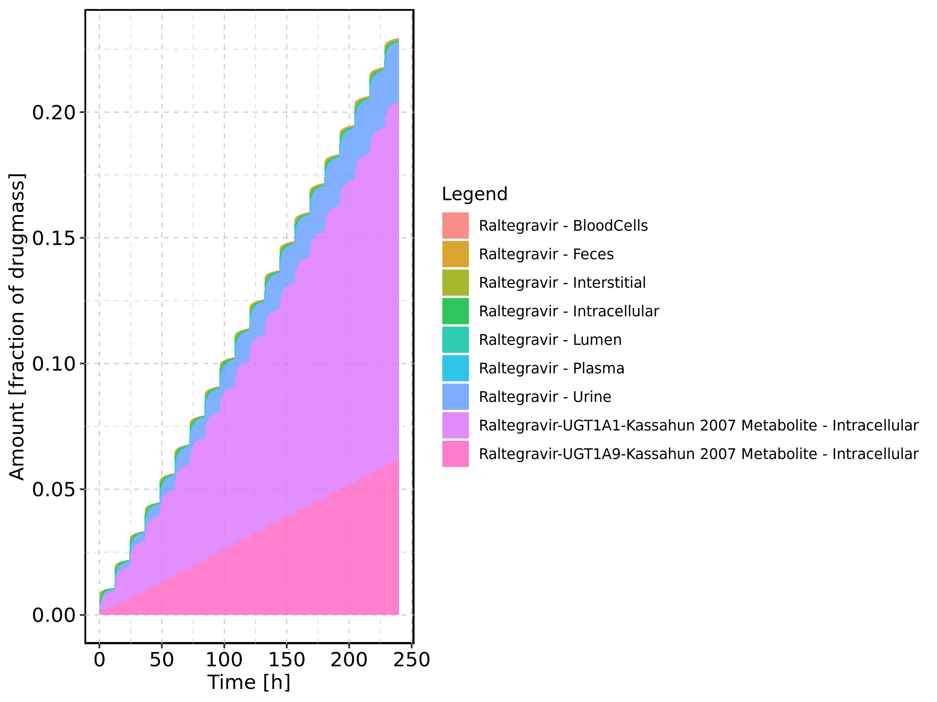

Figure 66: Fraction of drug within the different compartments at 240h.

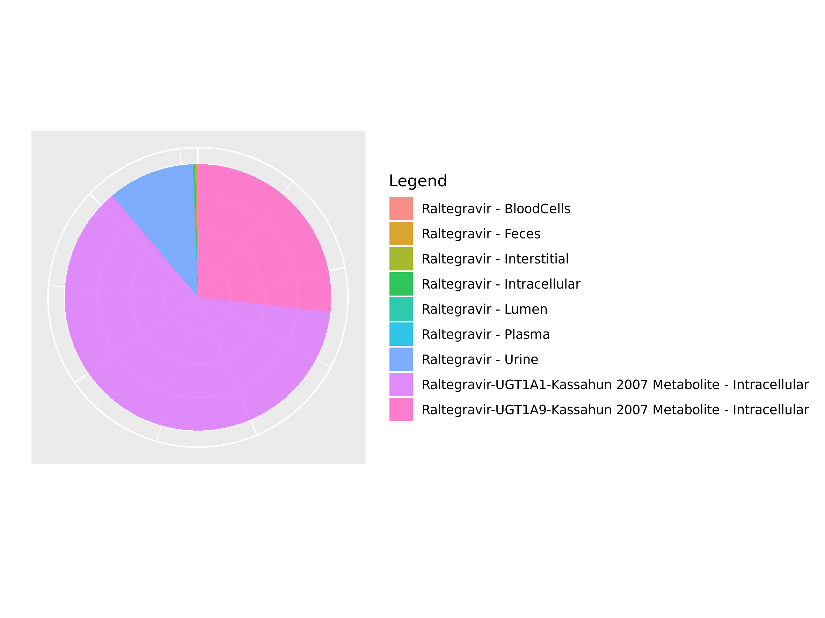

## 3.11. Mass Balance for Raltegravir 200 mg filmcoated tablet md

Figure 67: Amount of drug vs time within the different compartments.

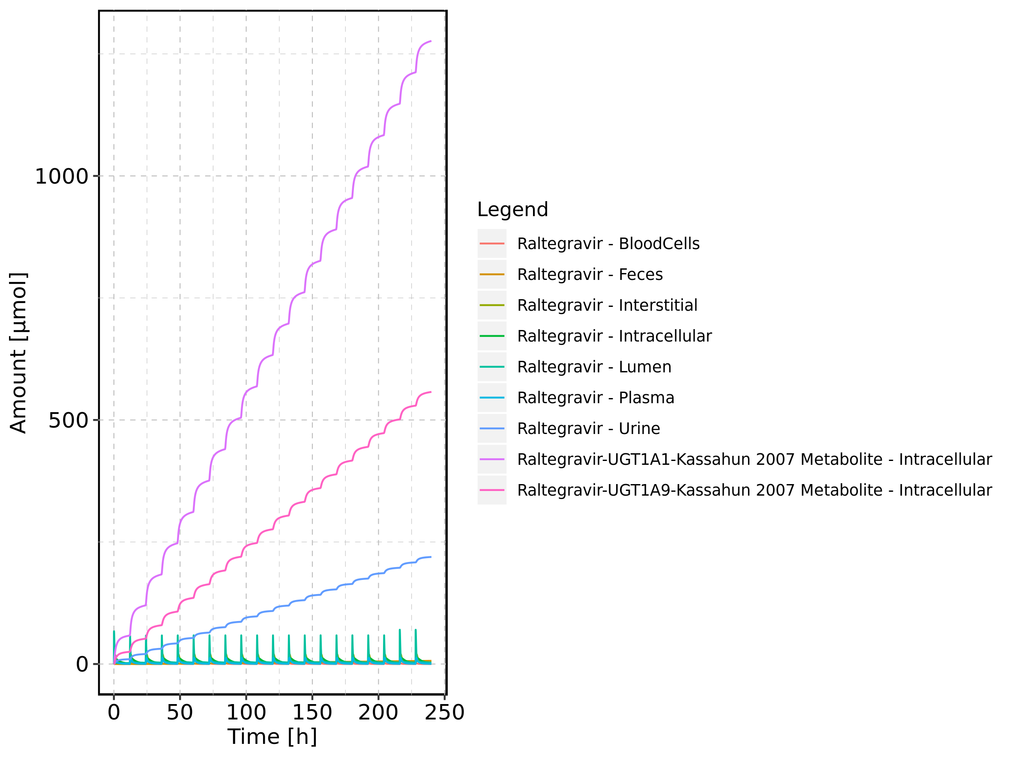

Figure 68: Cumulated amount of drug vs time within the different compartments

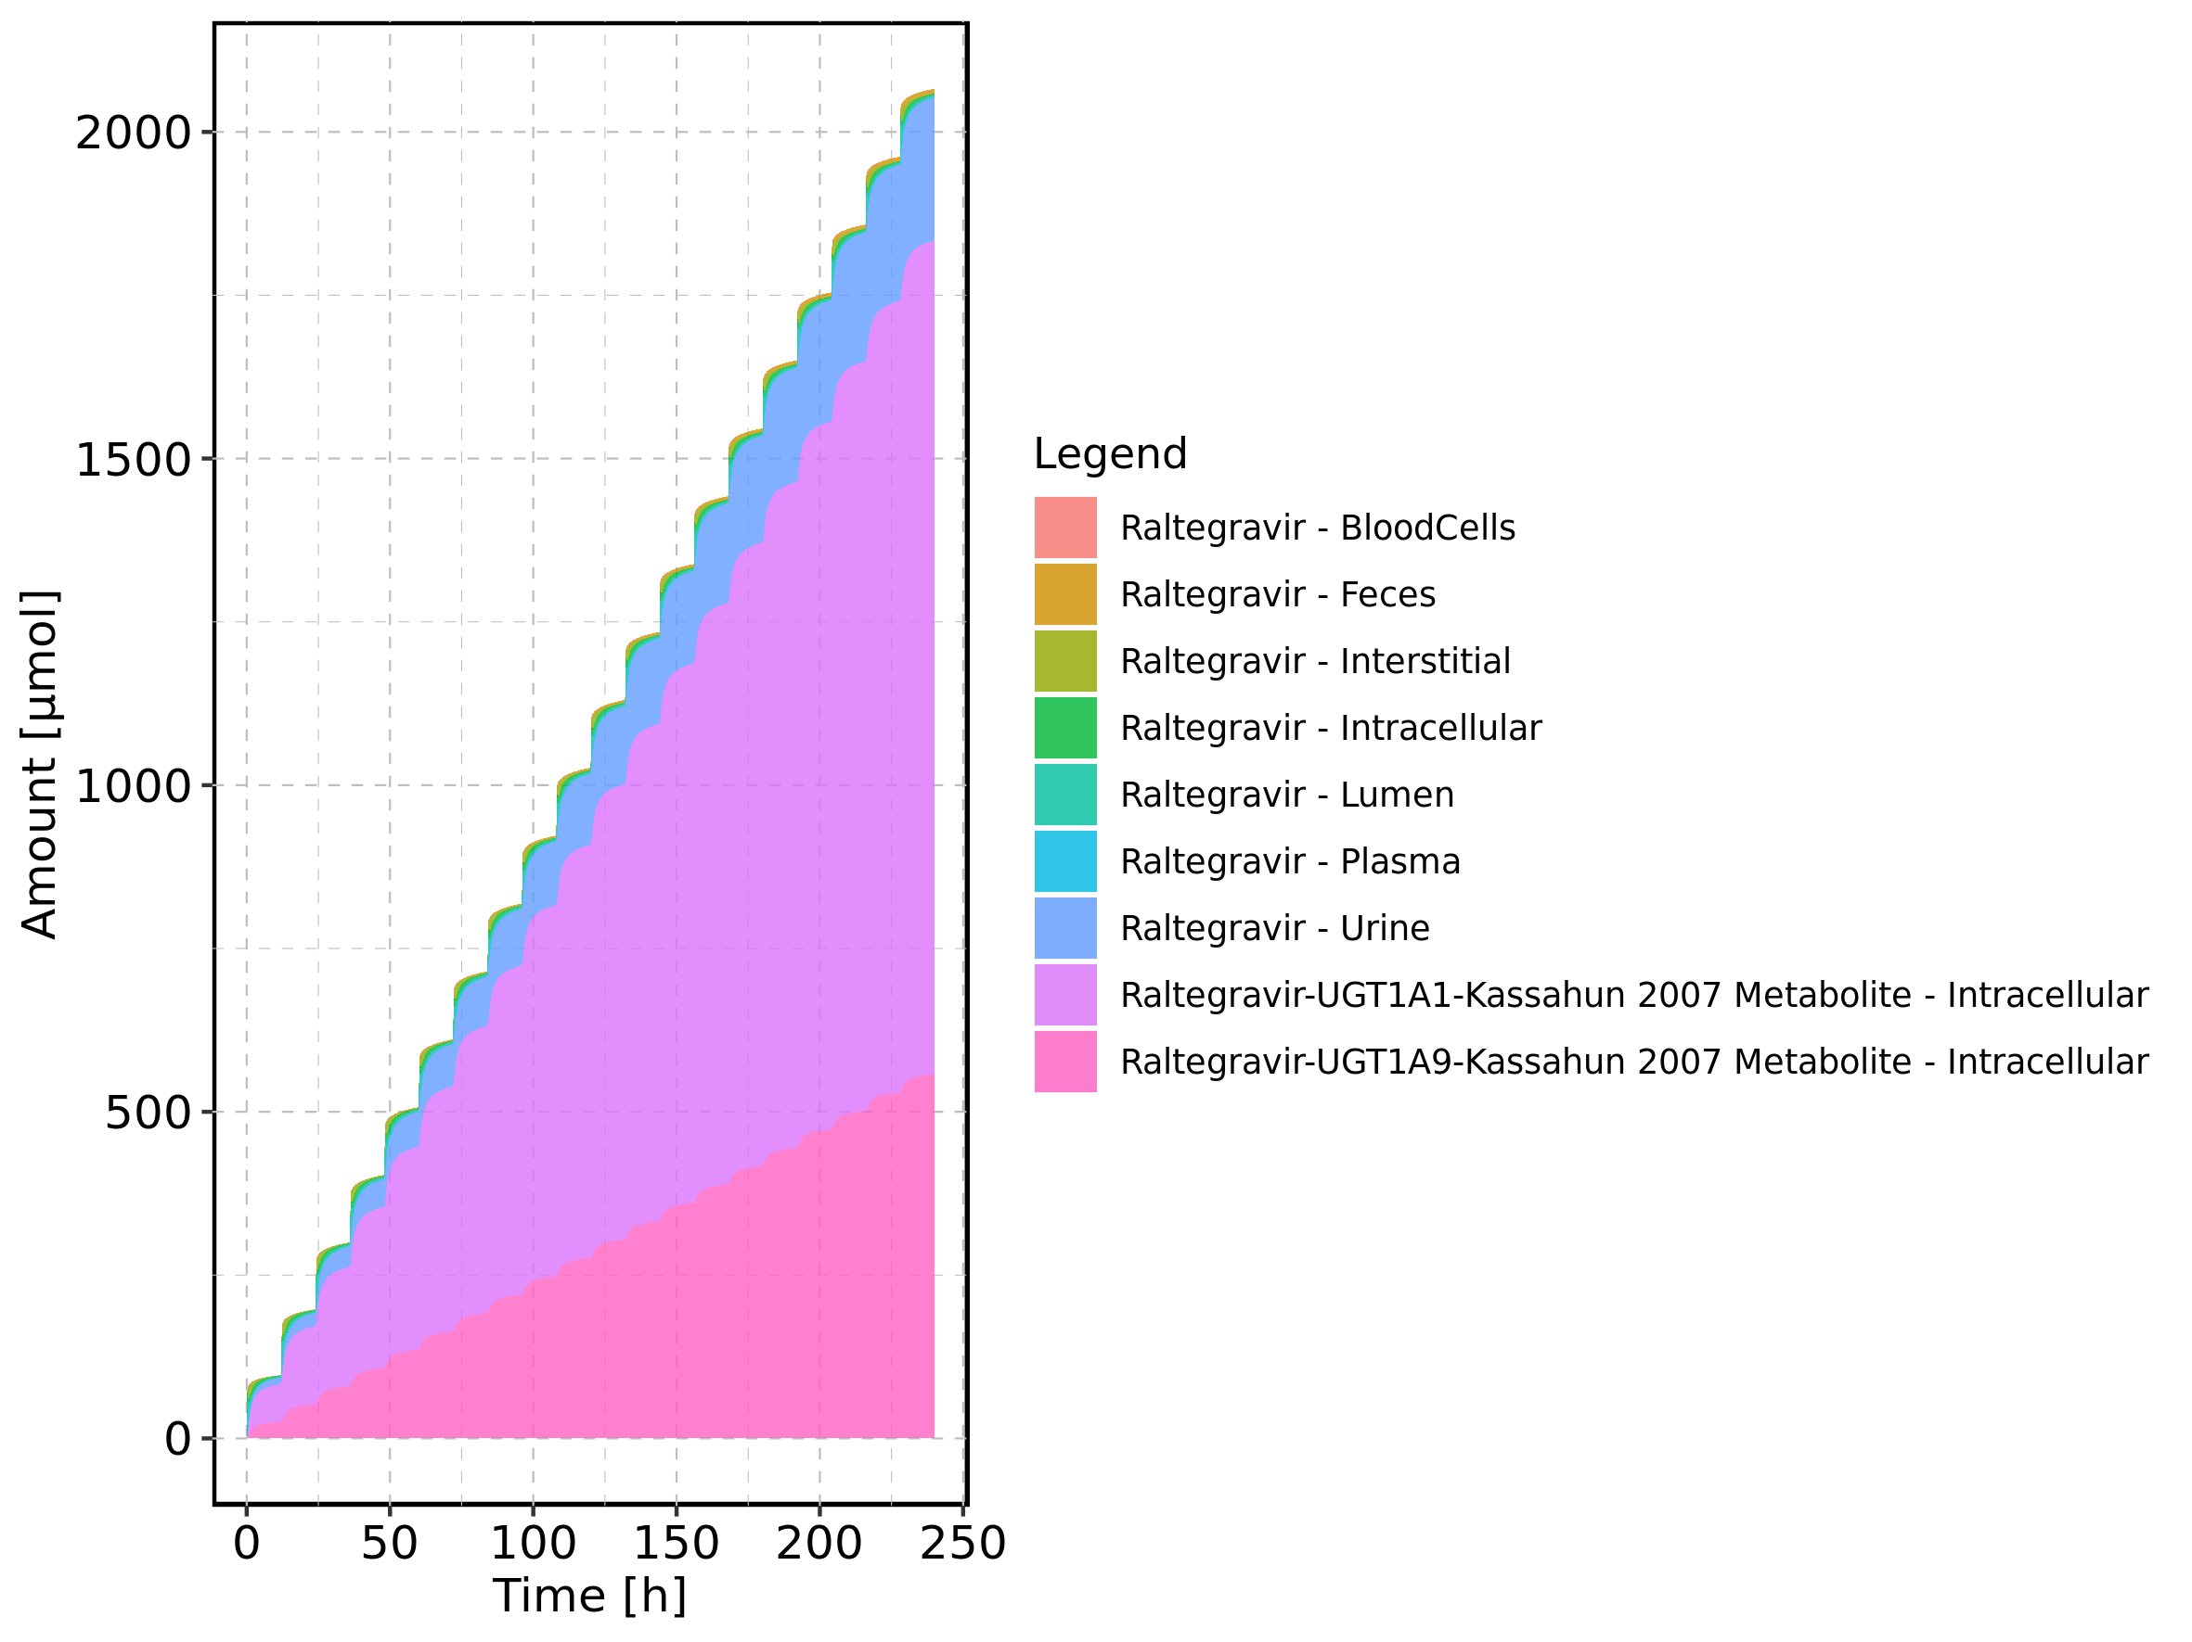

Figure 69: Amount of drug vs time within the different compartments normalized to applicated drugmass.

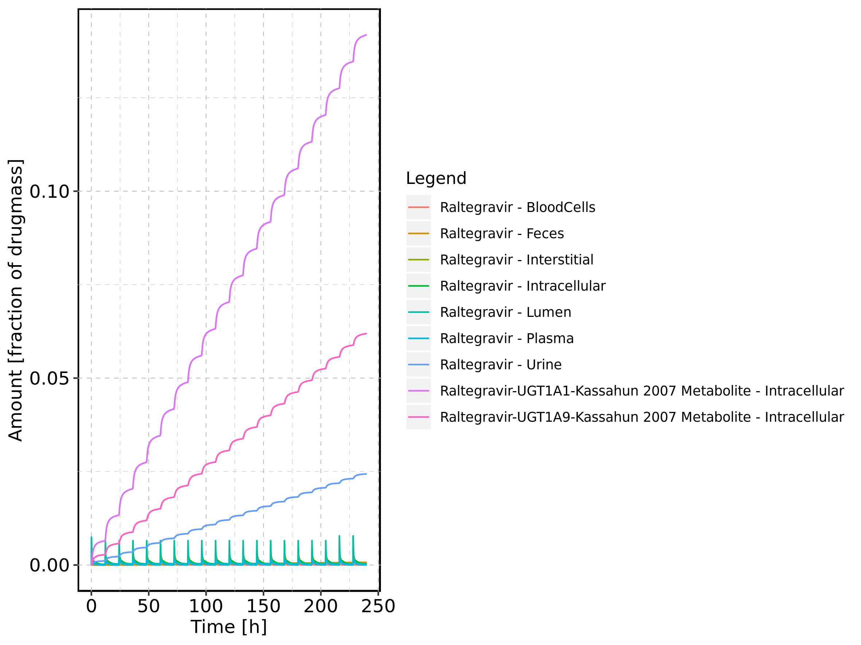

Figure 70: Cumulated amount of drug vs time within the different compartments normalized to applicated drugmass.

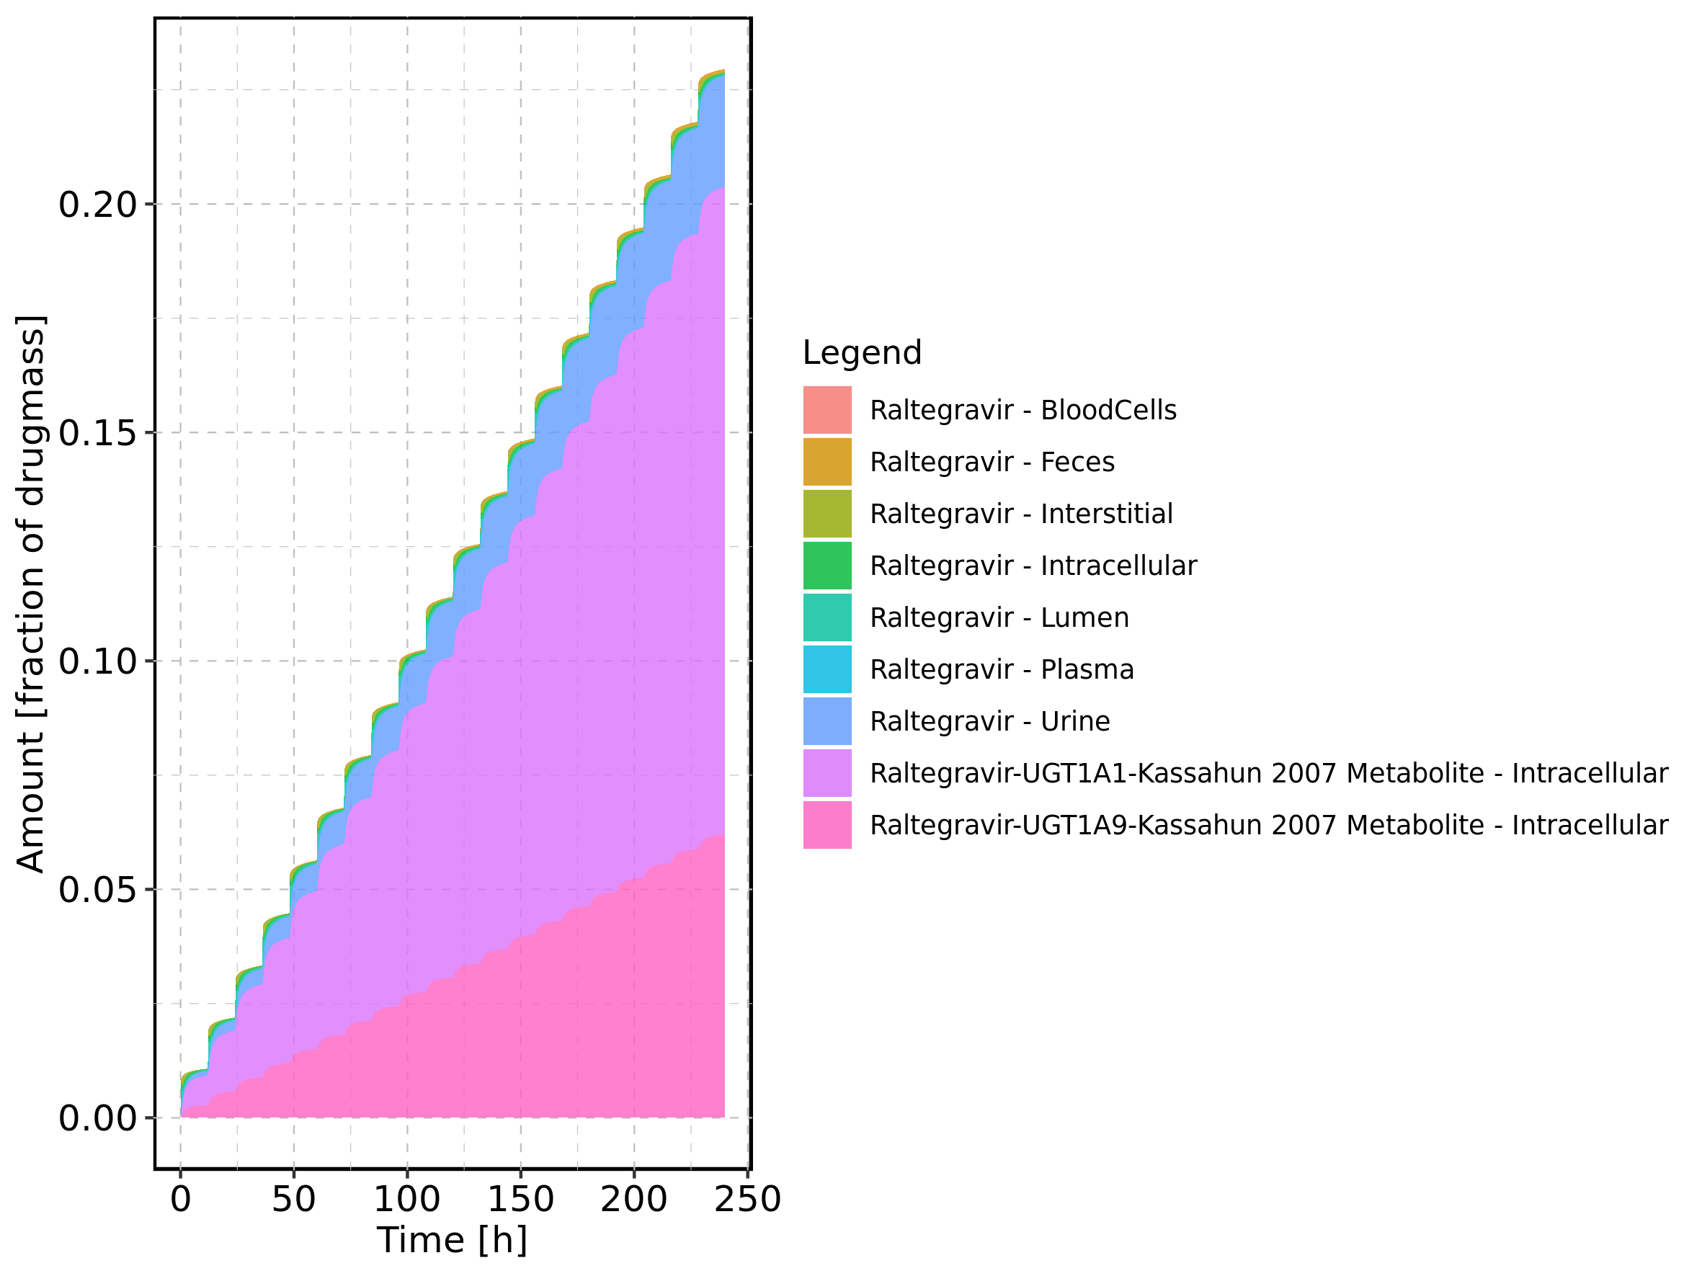

Figure 71: Fraction of drug within the different compartments at 240h.

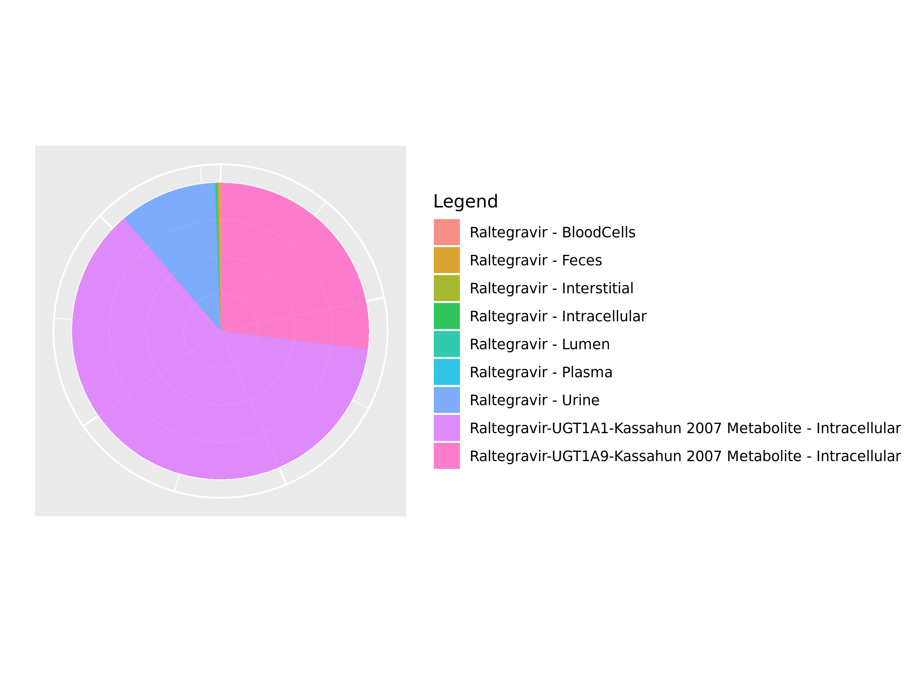

## 3.12. Mass Balance for Filmcoated_tablet_400mg_sd

Figure 72: Amount of drug vs time within the different compartments.

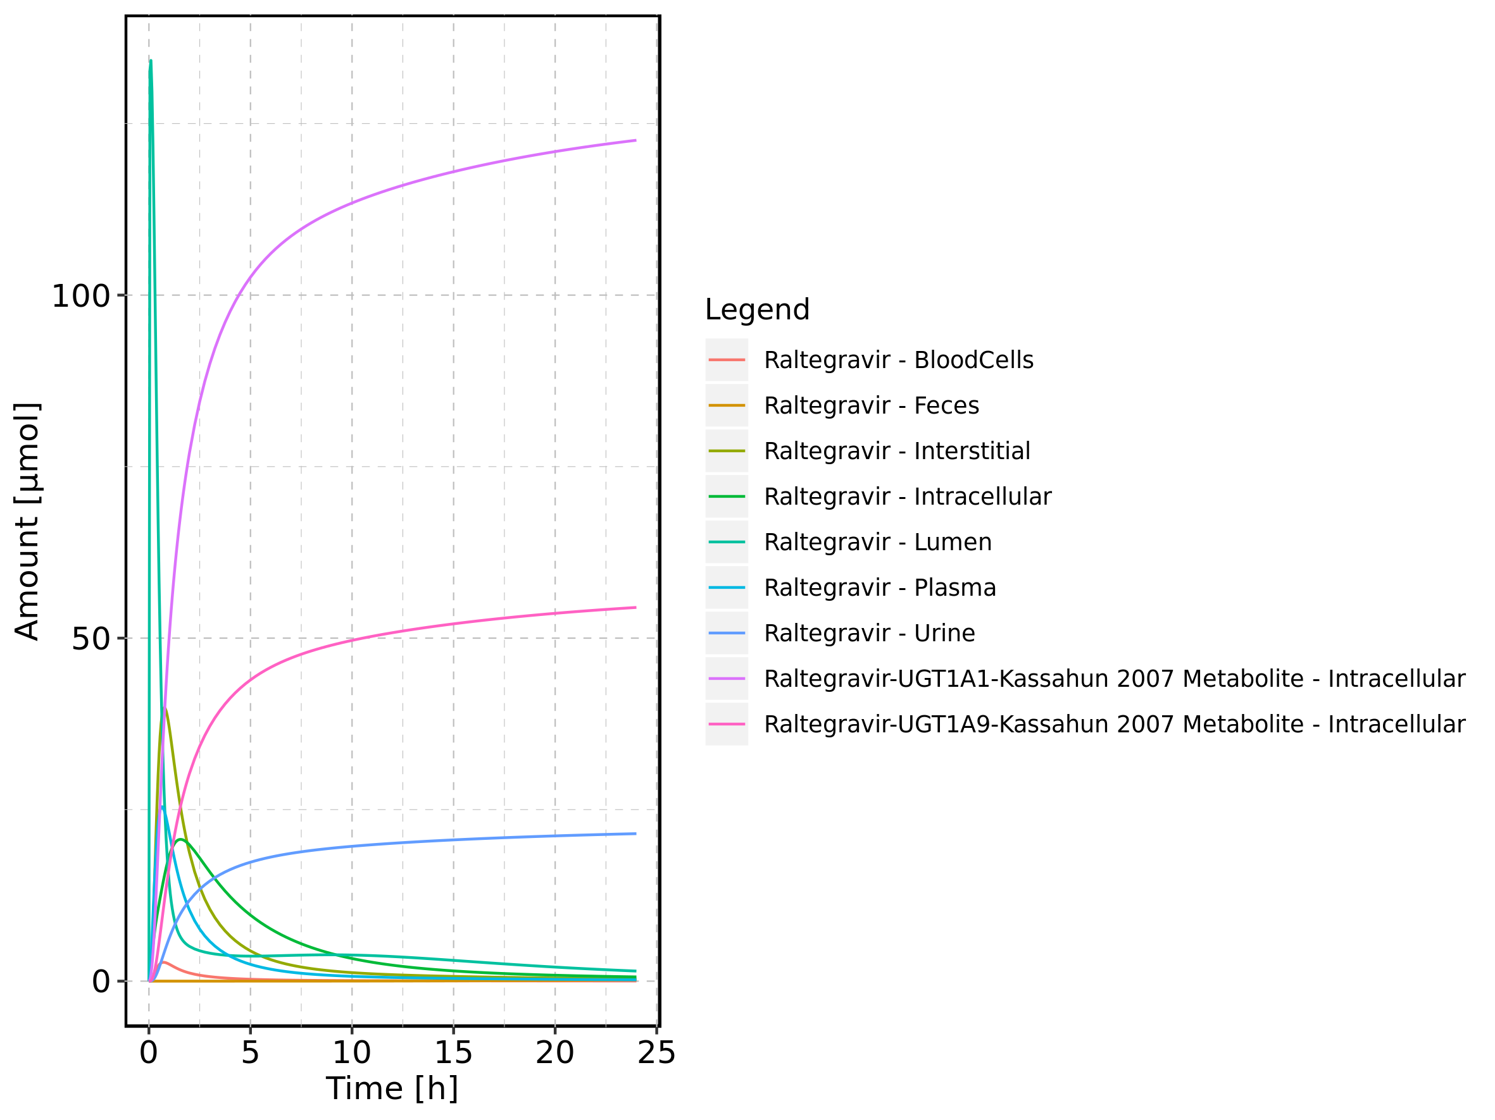

Figure 73: Cumulated amount of drug vs time within the different compartments

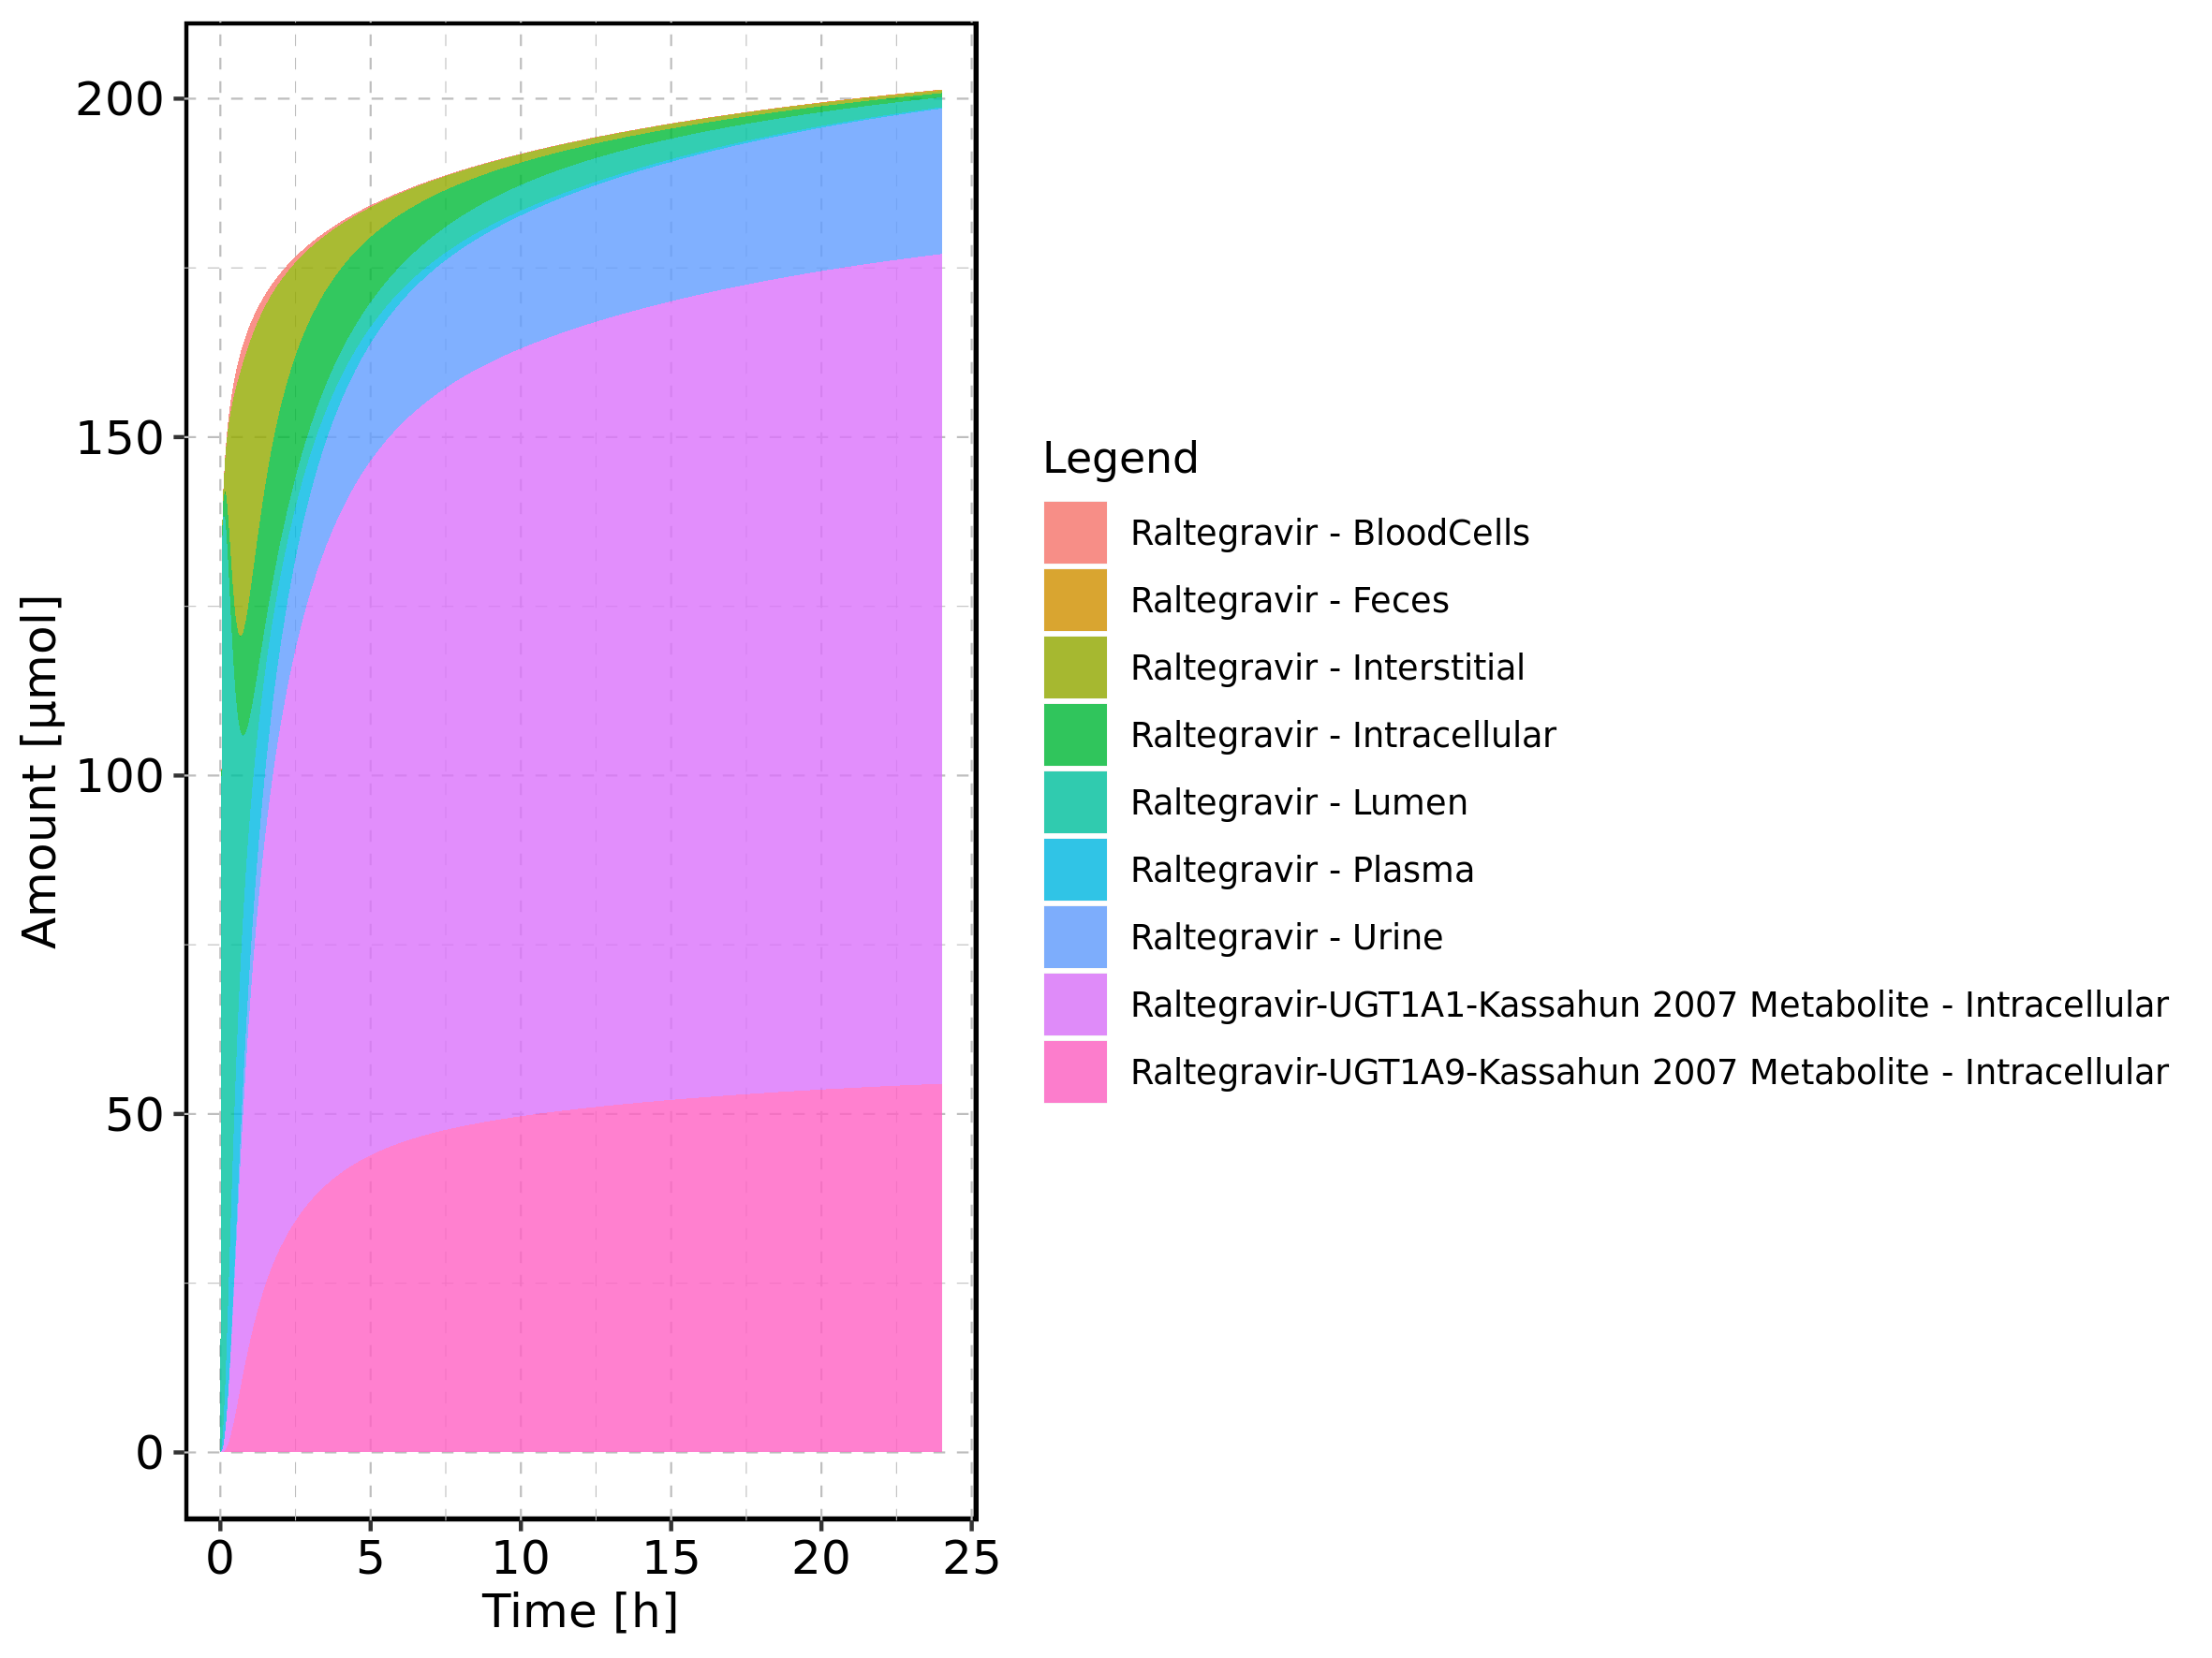

Figure 74: Amount of drug vs time within the different compartments normalized to applicated drugmass.

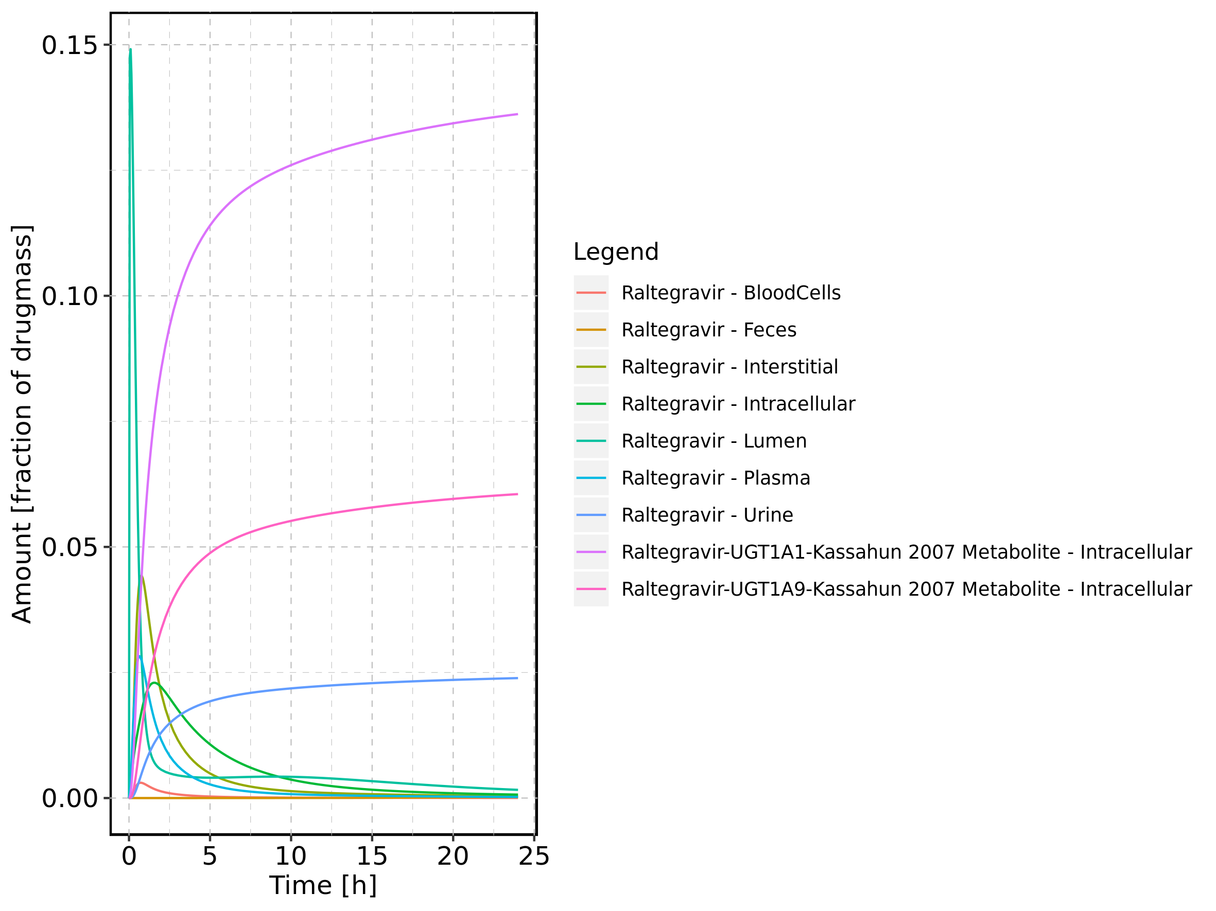

Figure 75: Cumulated amount of drug vs time within the different compartments normalized to applicated drugmass.

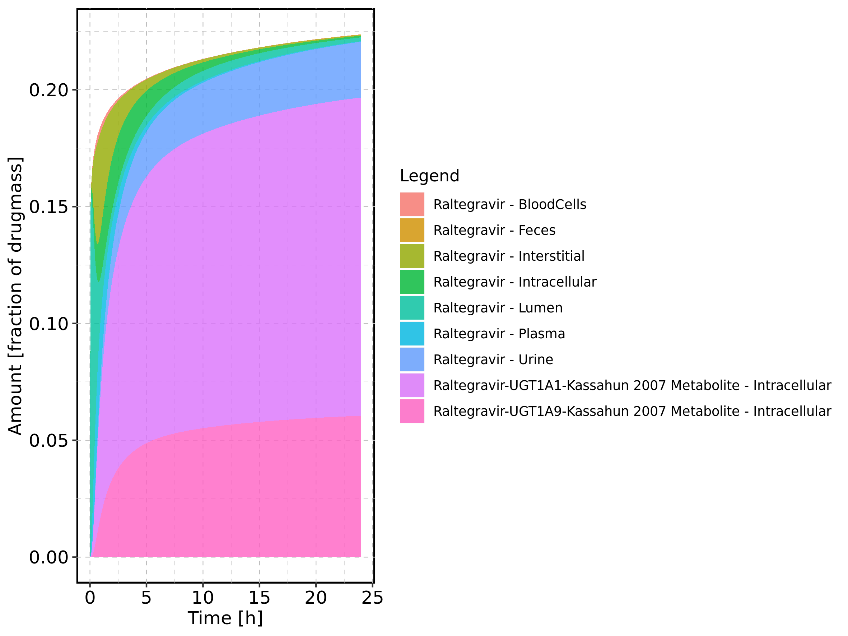

Figure 76: Fraction of drug within the different compartments at 24h.

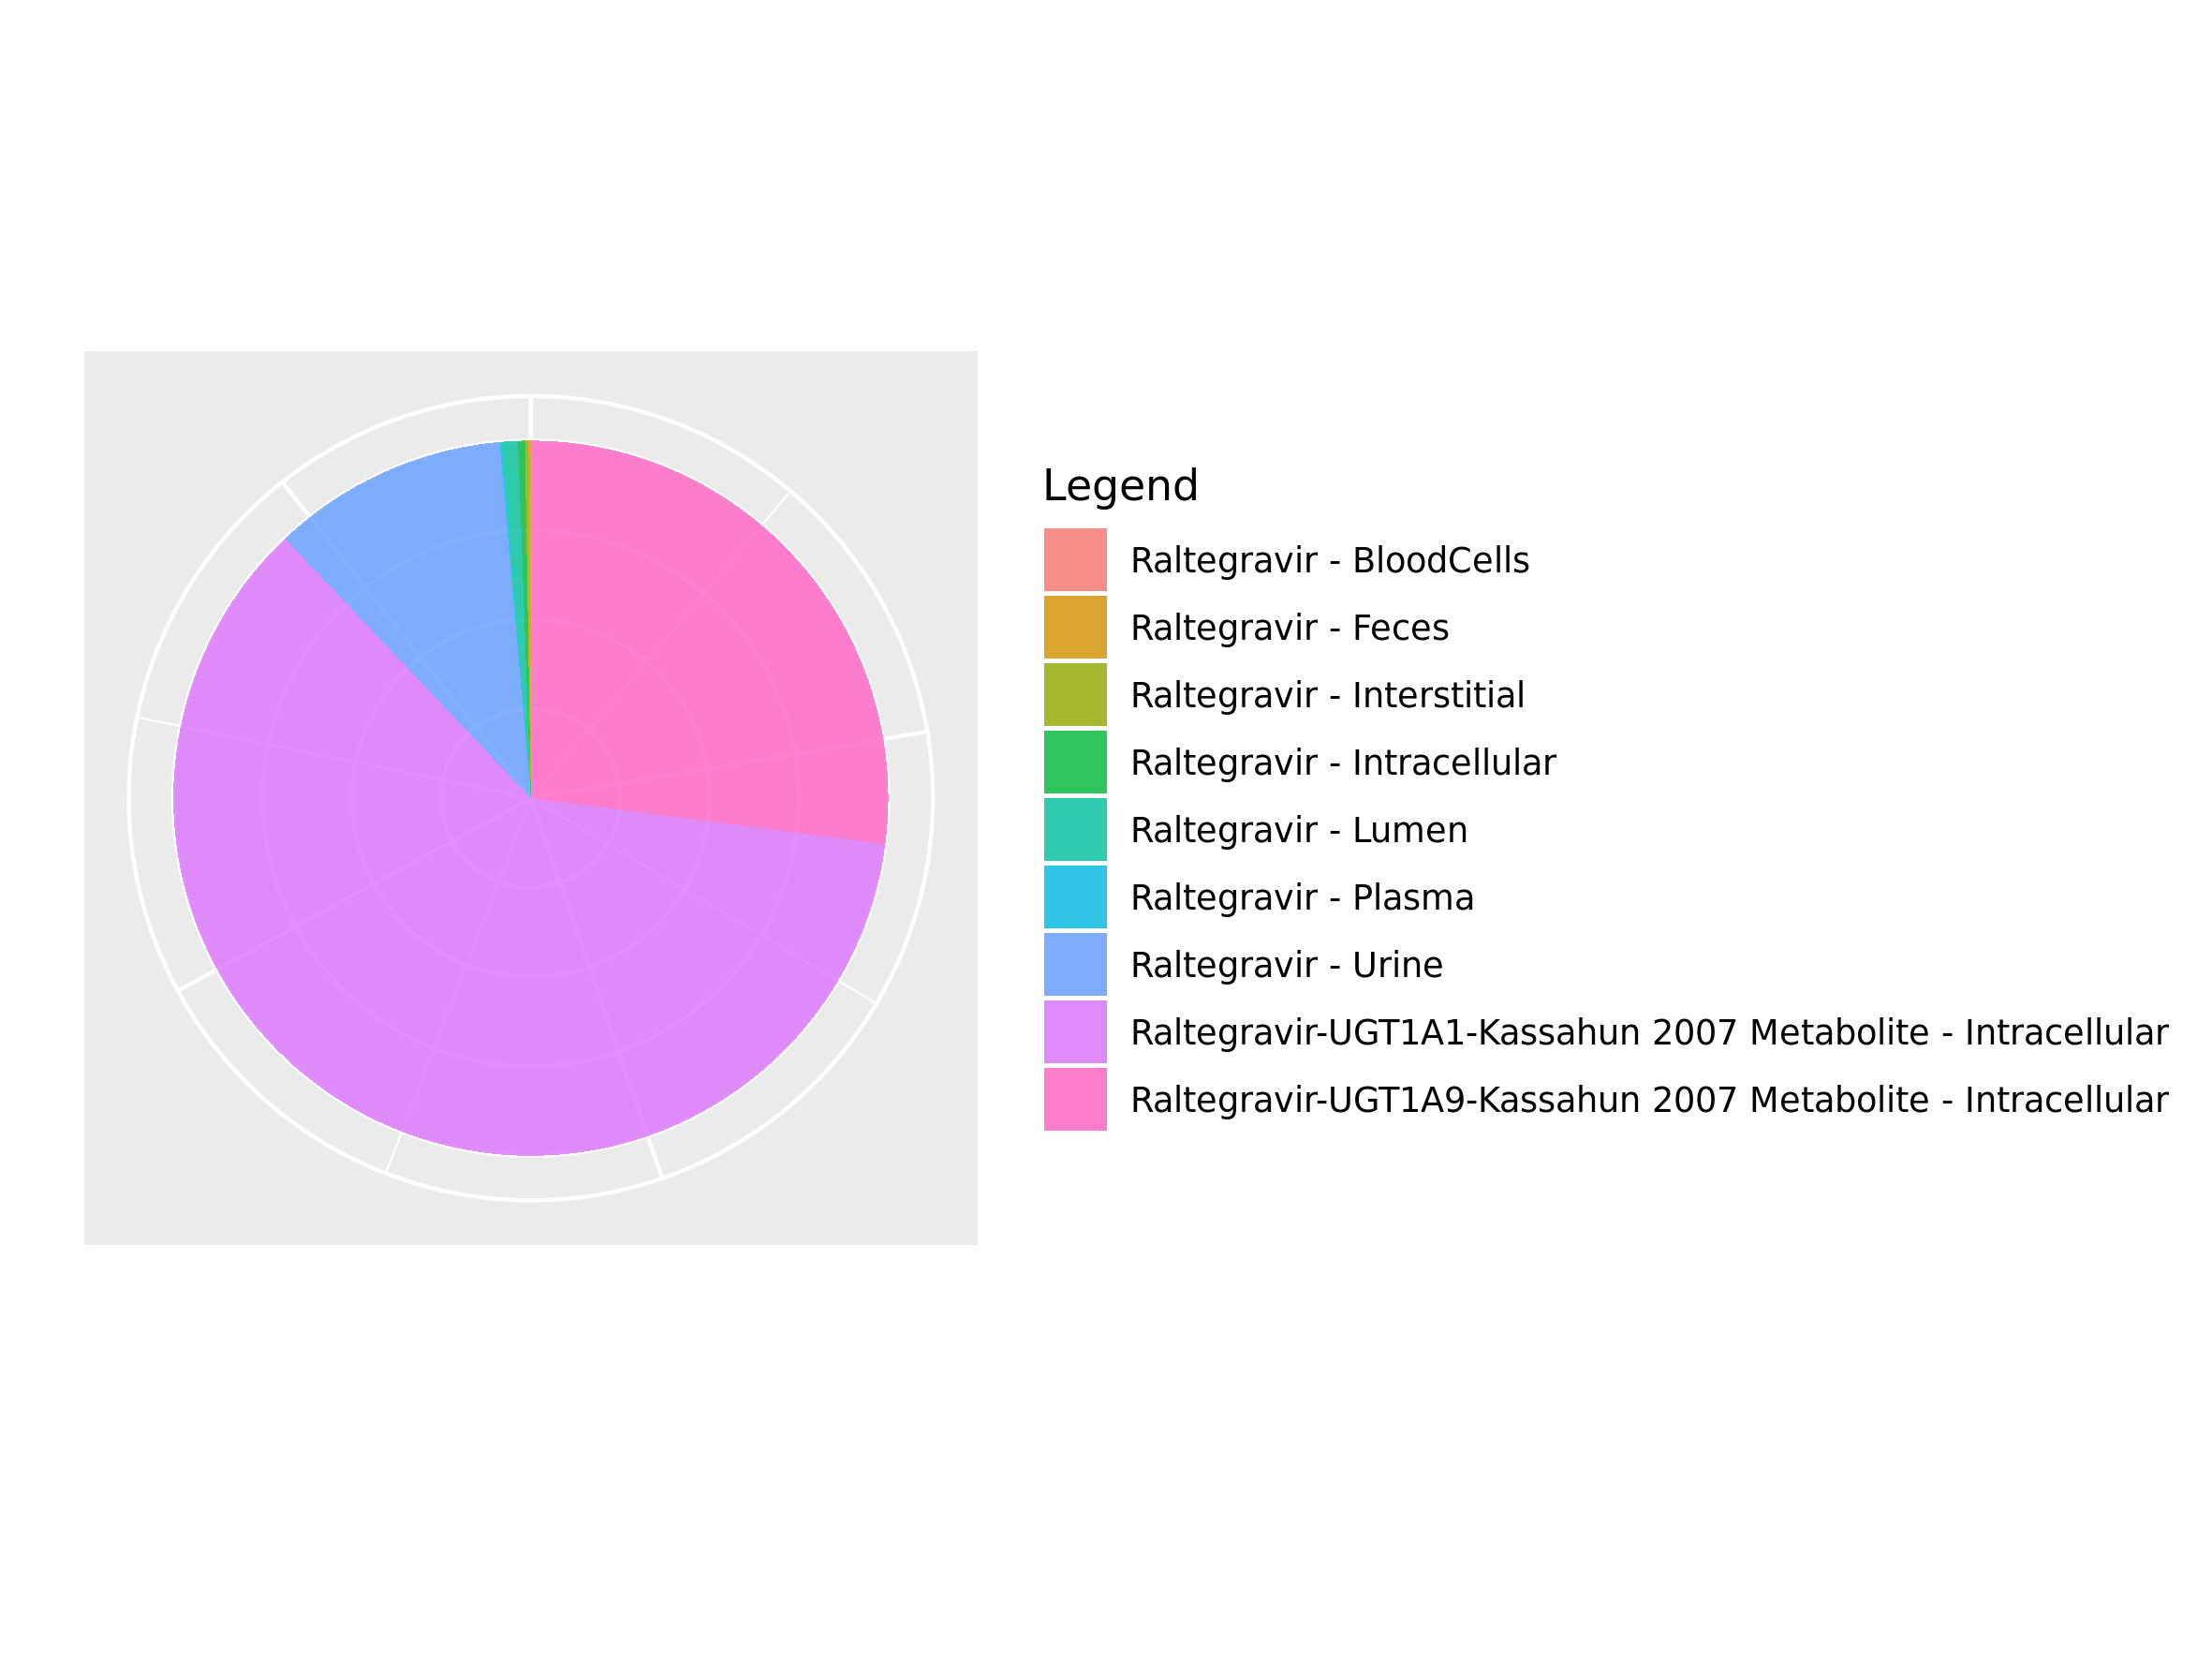

## 3.13. Mass Balance for Raltegravir 400 mg filmcoated tablet md

Figure 77: Amount of drug vs time within the different compartments.

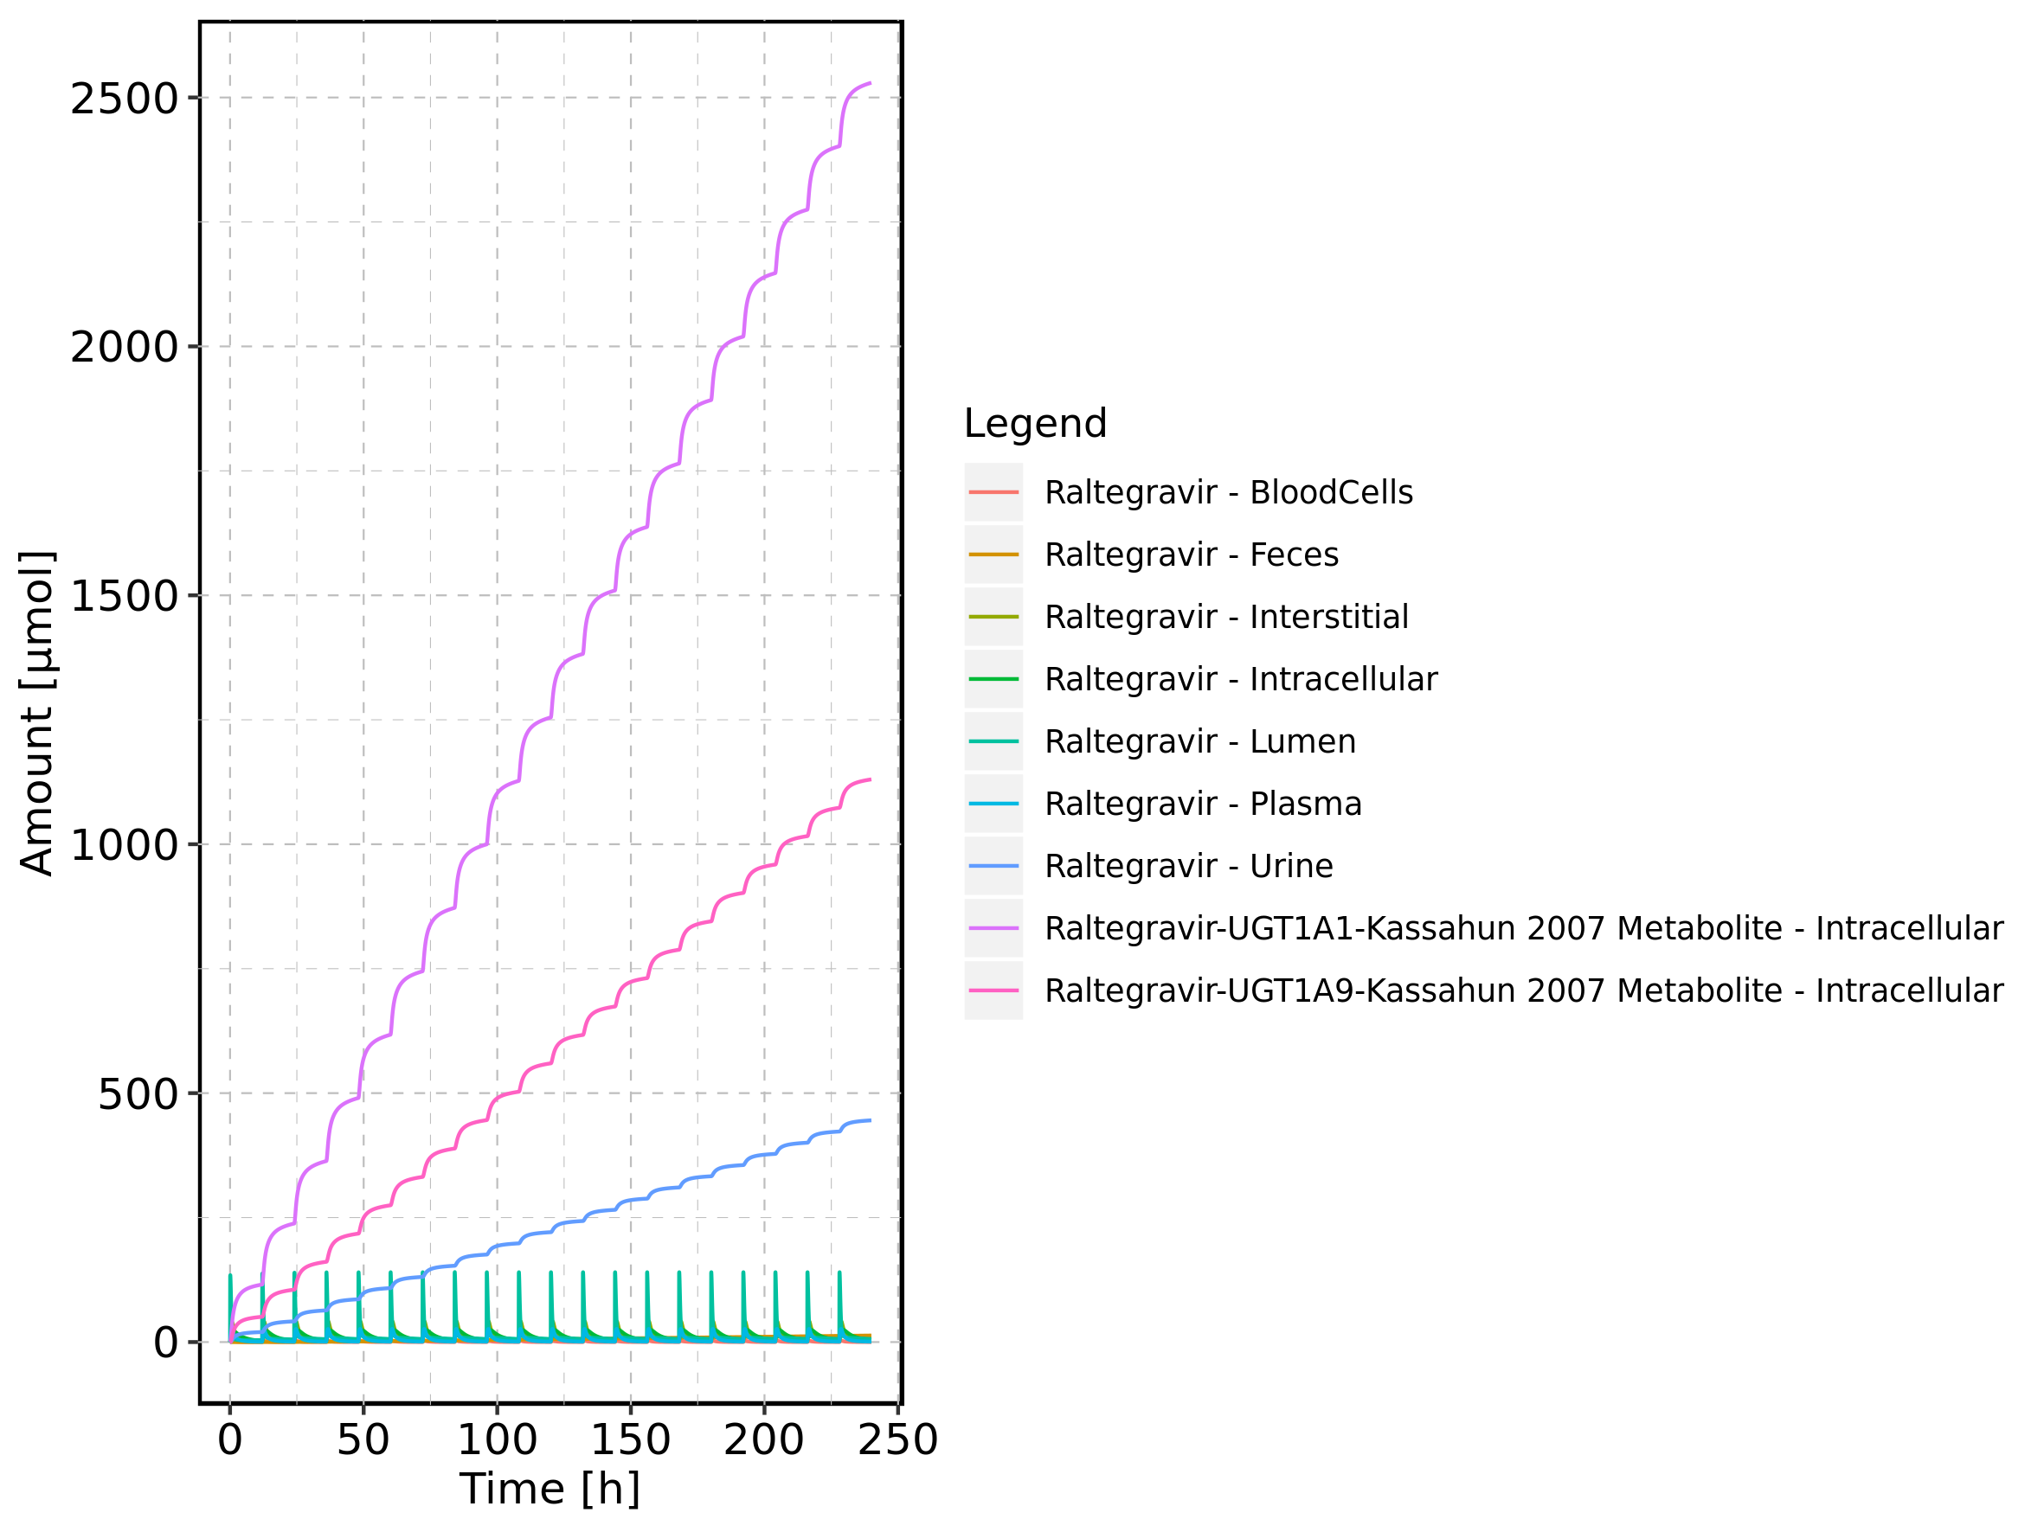

Figure 78: Cumulated amount of drug vs time within the different compartments

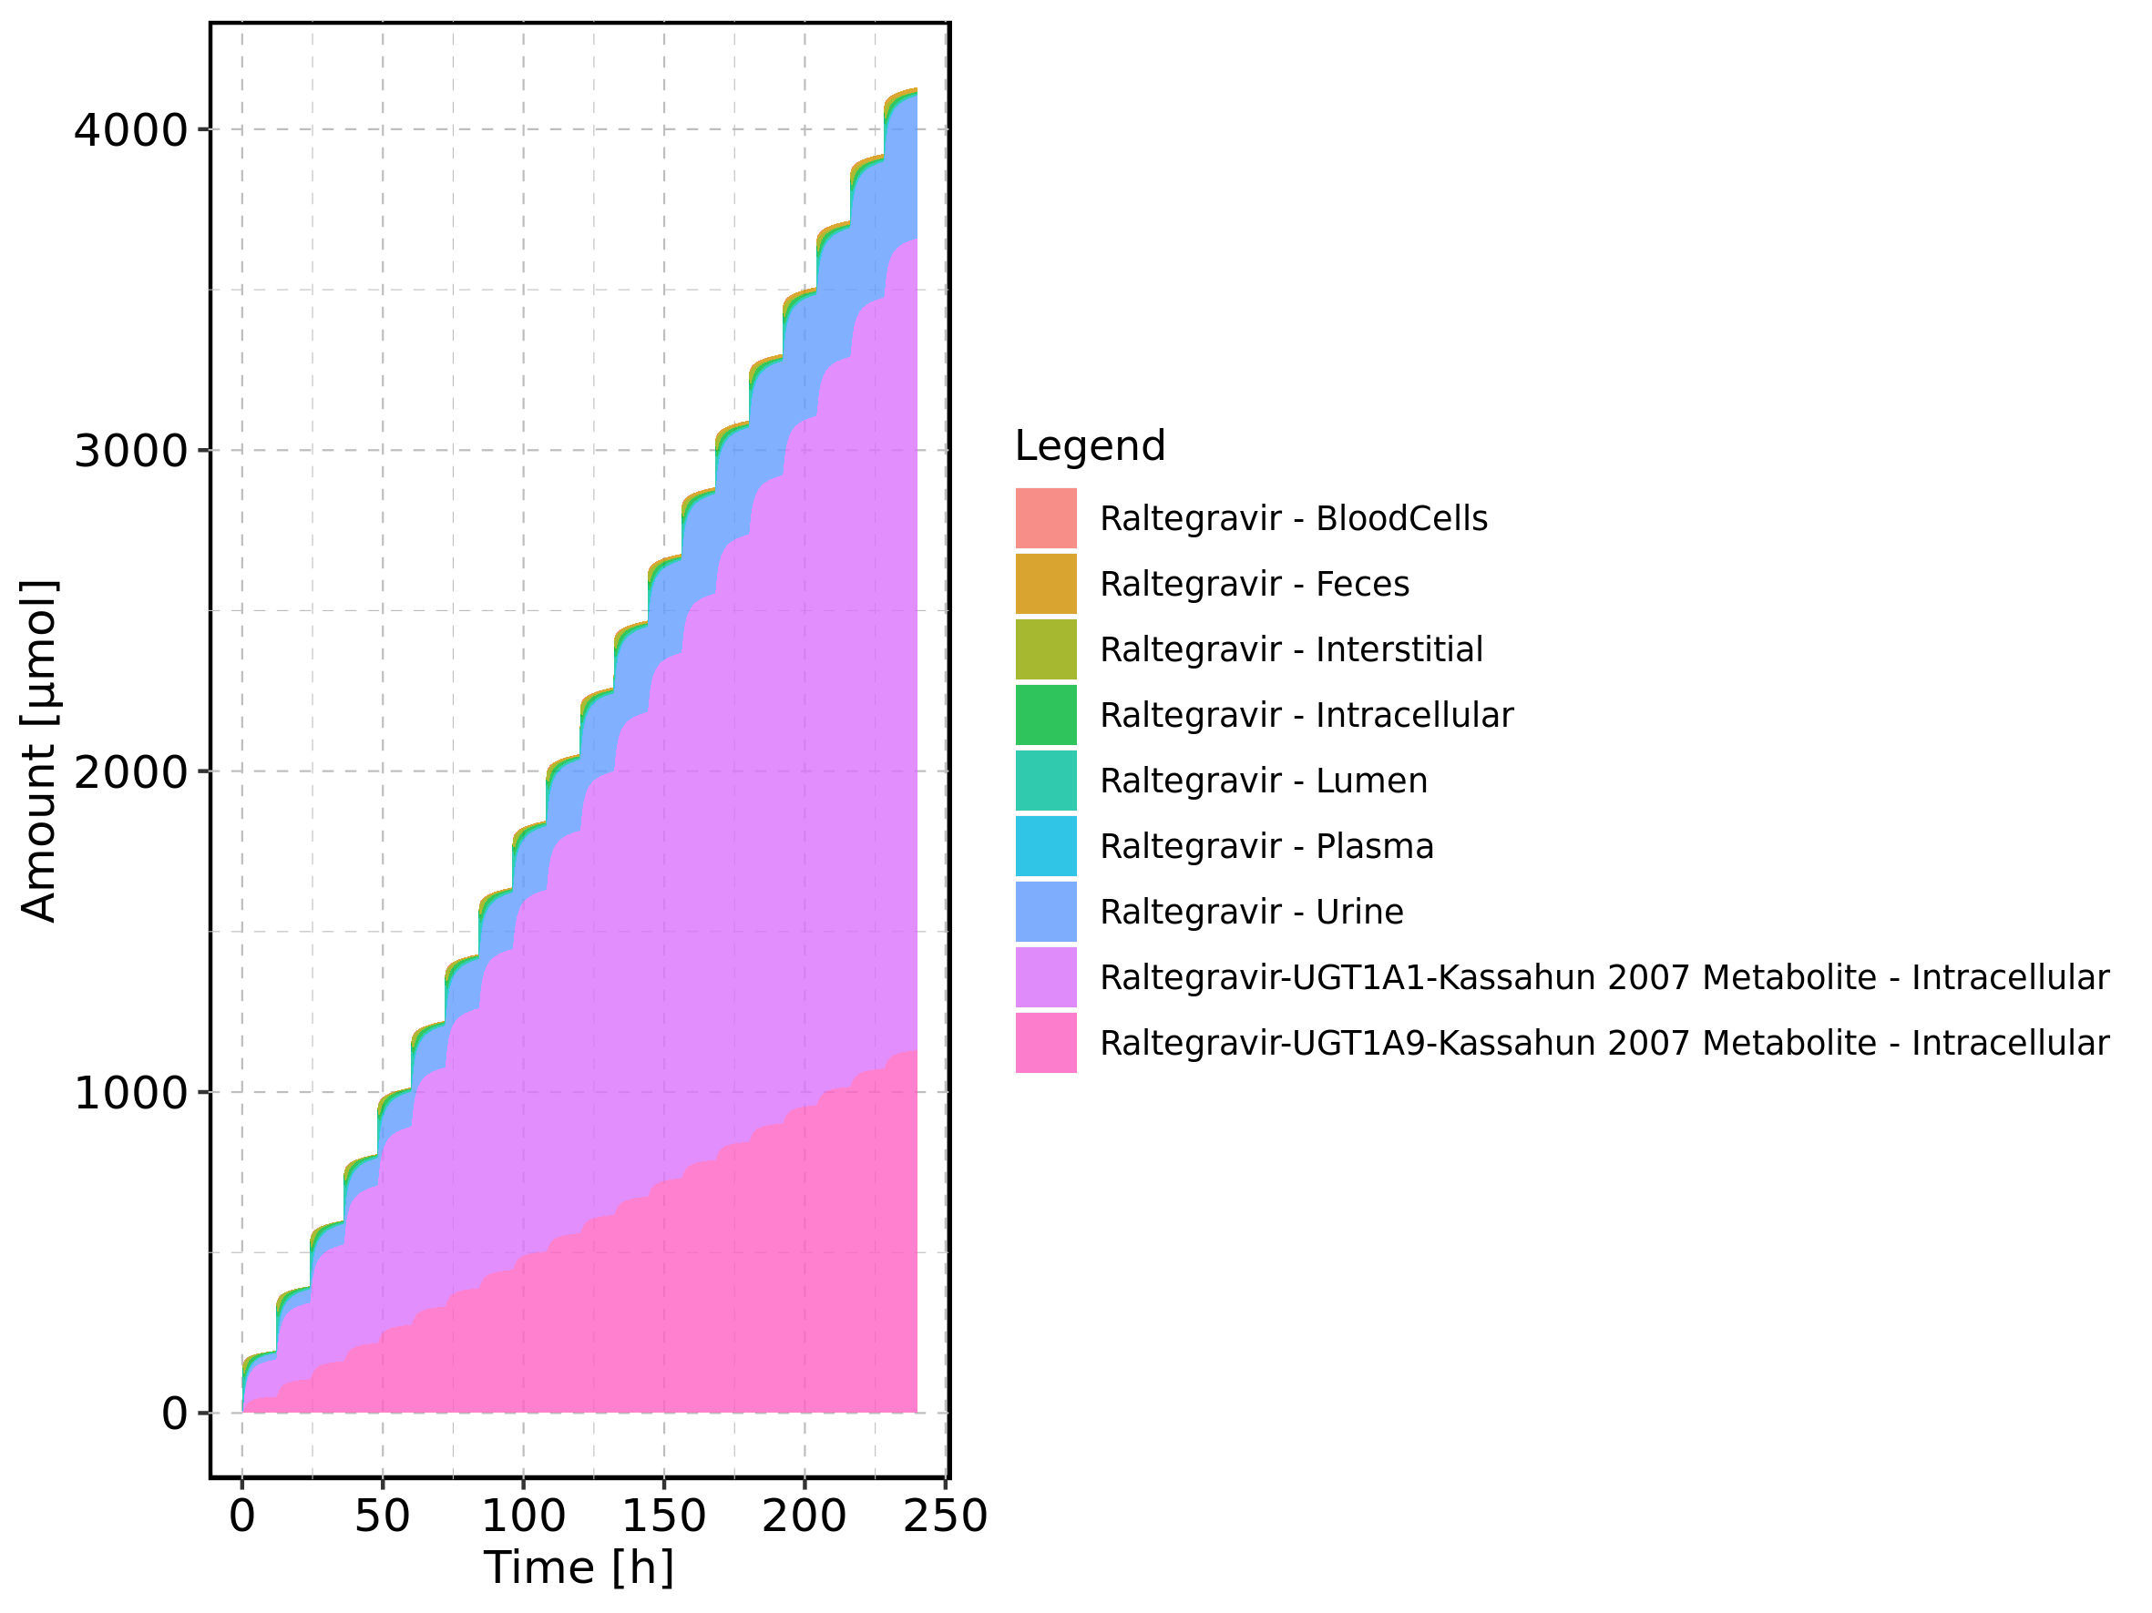

Figure 79: Amount of drug vs time within the different compartments normalized to applicated drugmass.

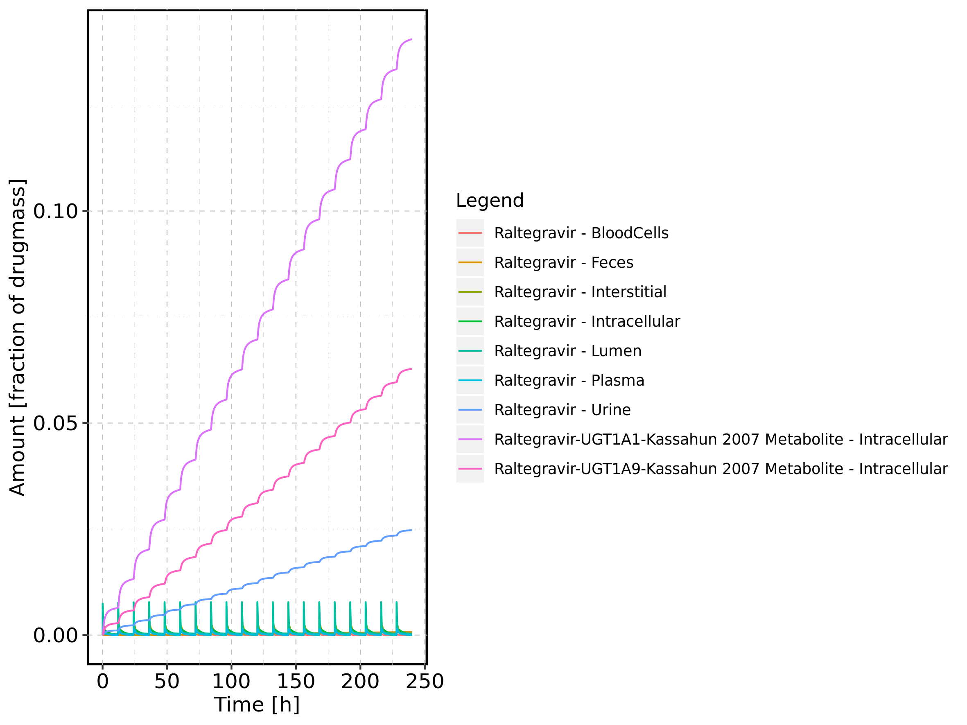

Figure 80: Cumulated amount of drug vs time within the different compartments normalized to applicated drugmass.

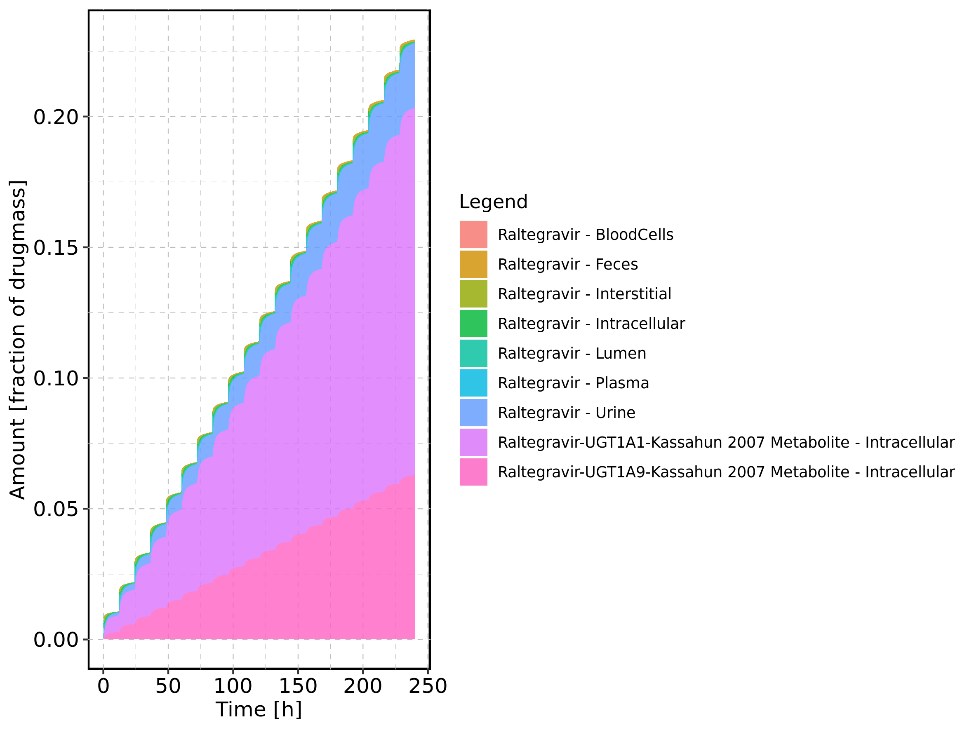

Figure 81: Fraction of drug within the different compartments at 240h.

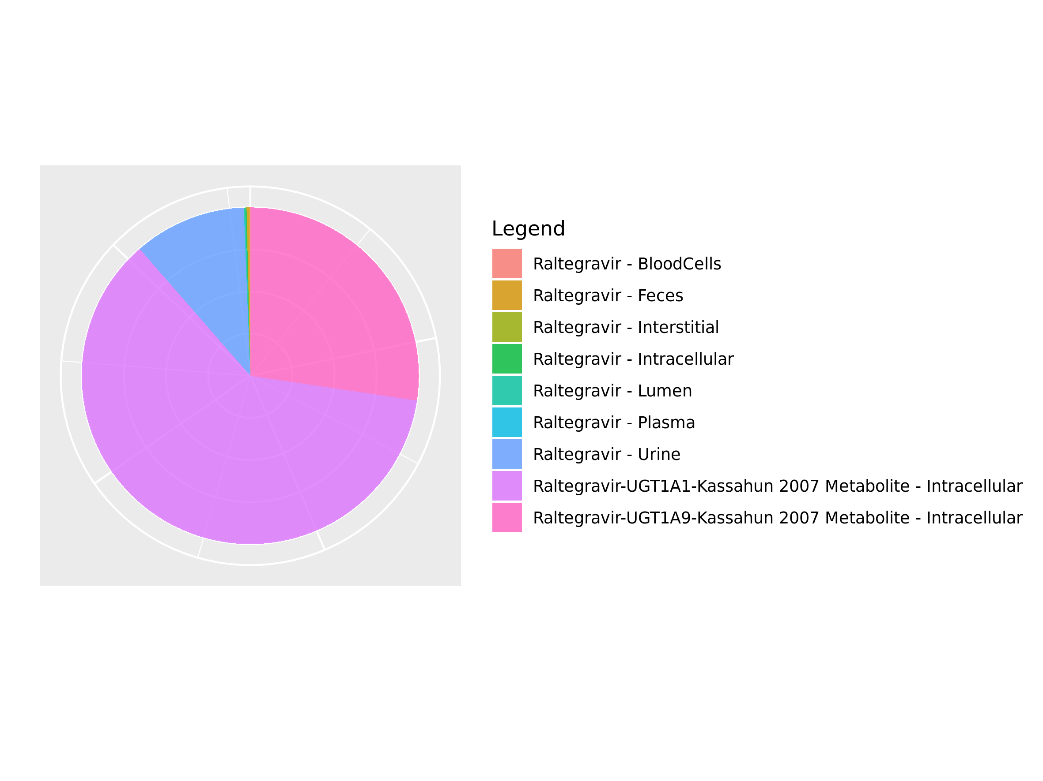

## 3.14. Mass Balance for Raltegravir 400mg chewable fasted

Figure 82: Amount of drug vs time within the different compartments.

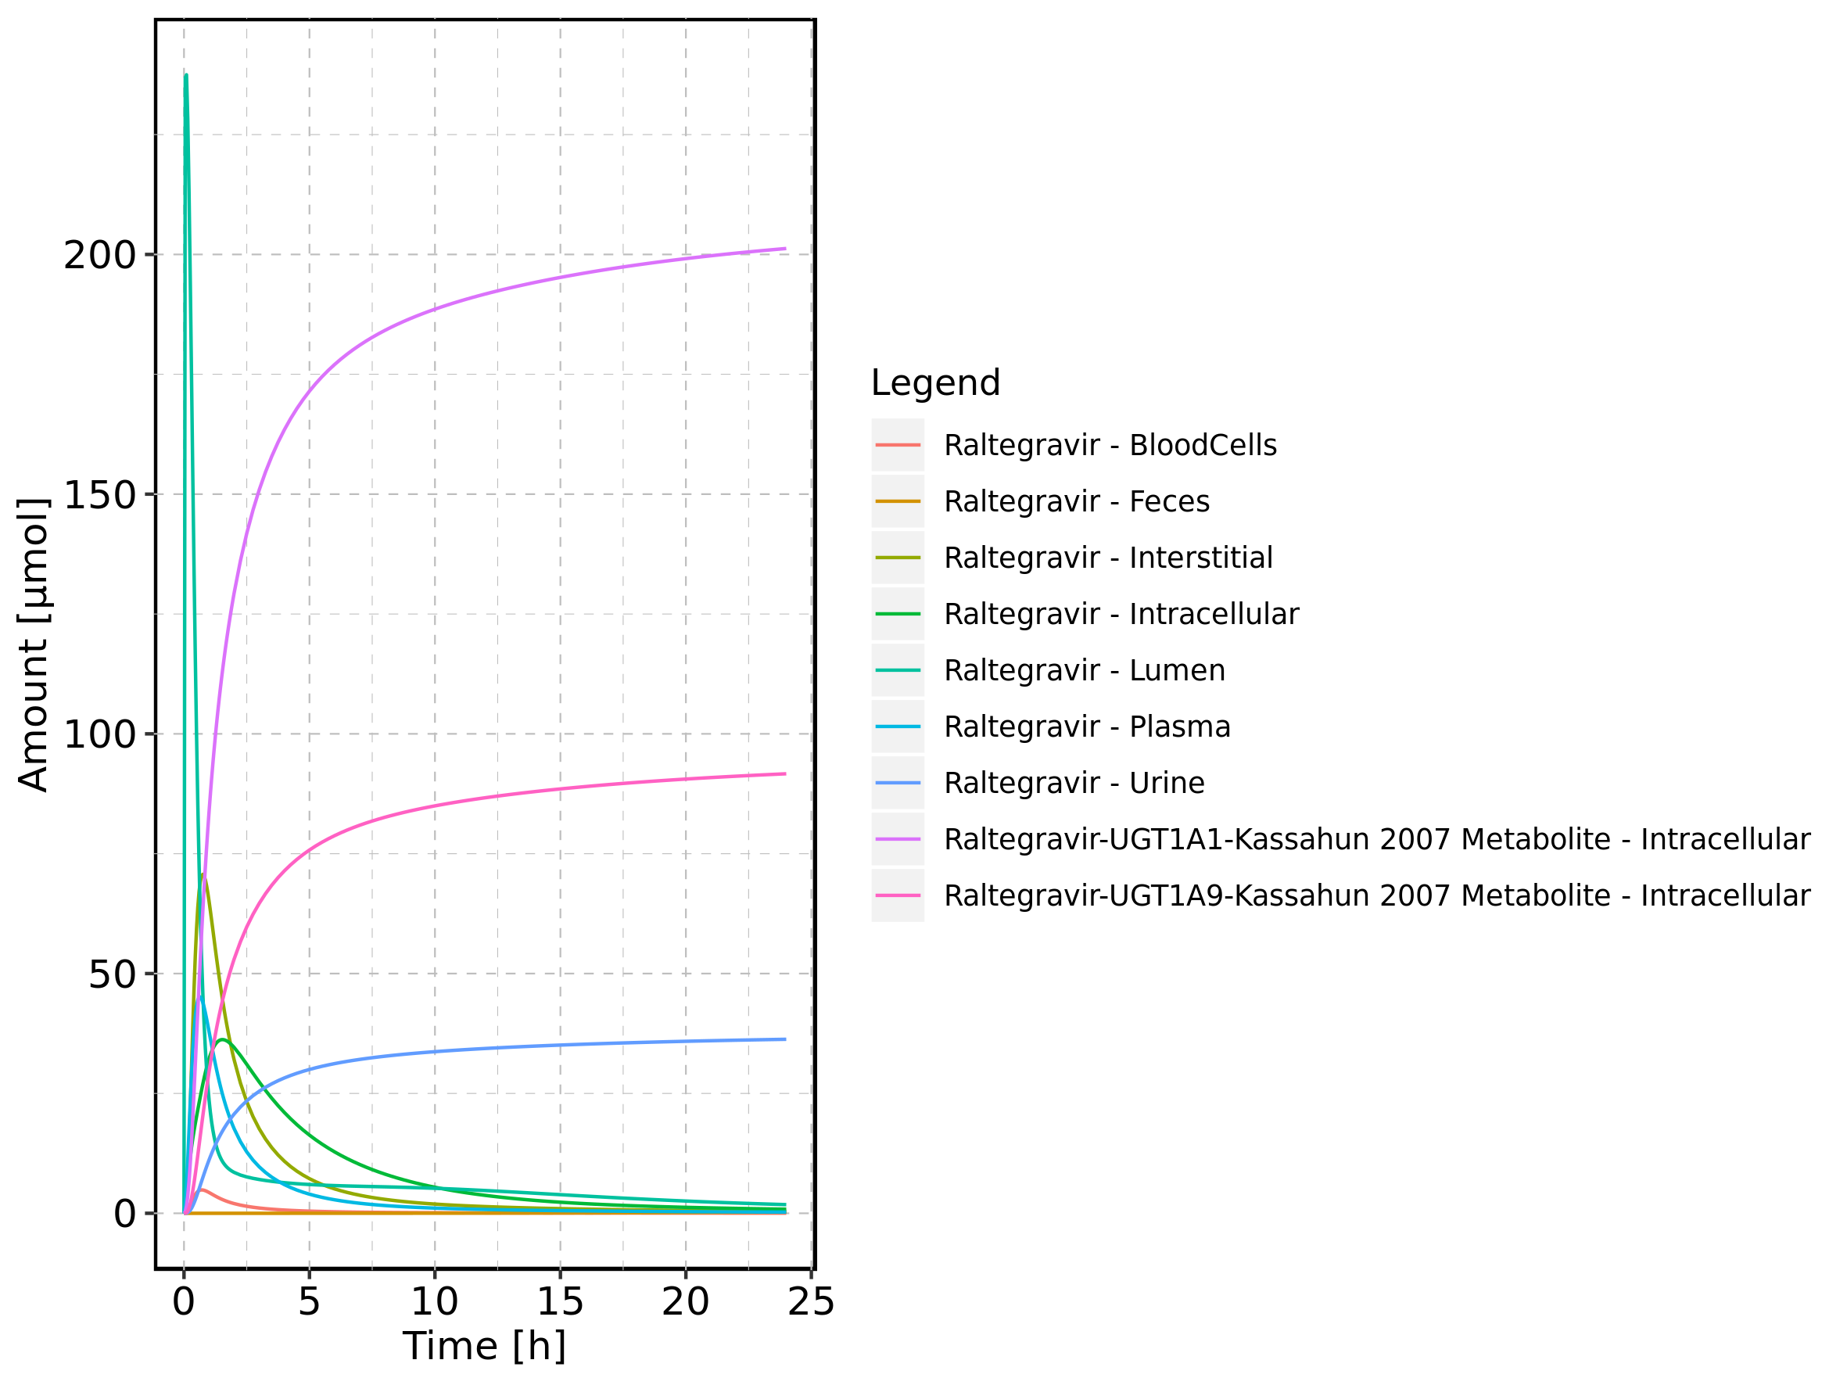

Figure 83: Cumulated amount of drug vs time within the different compartments

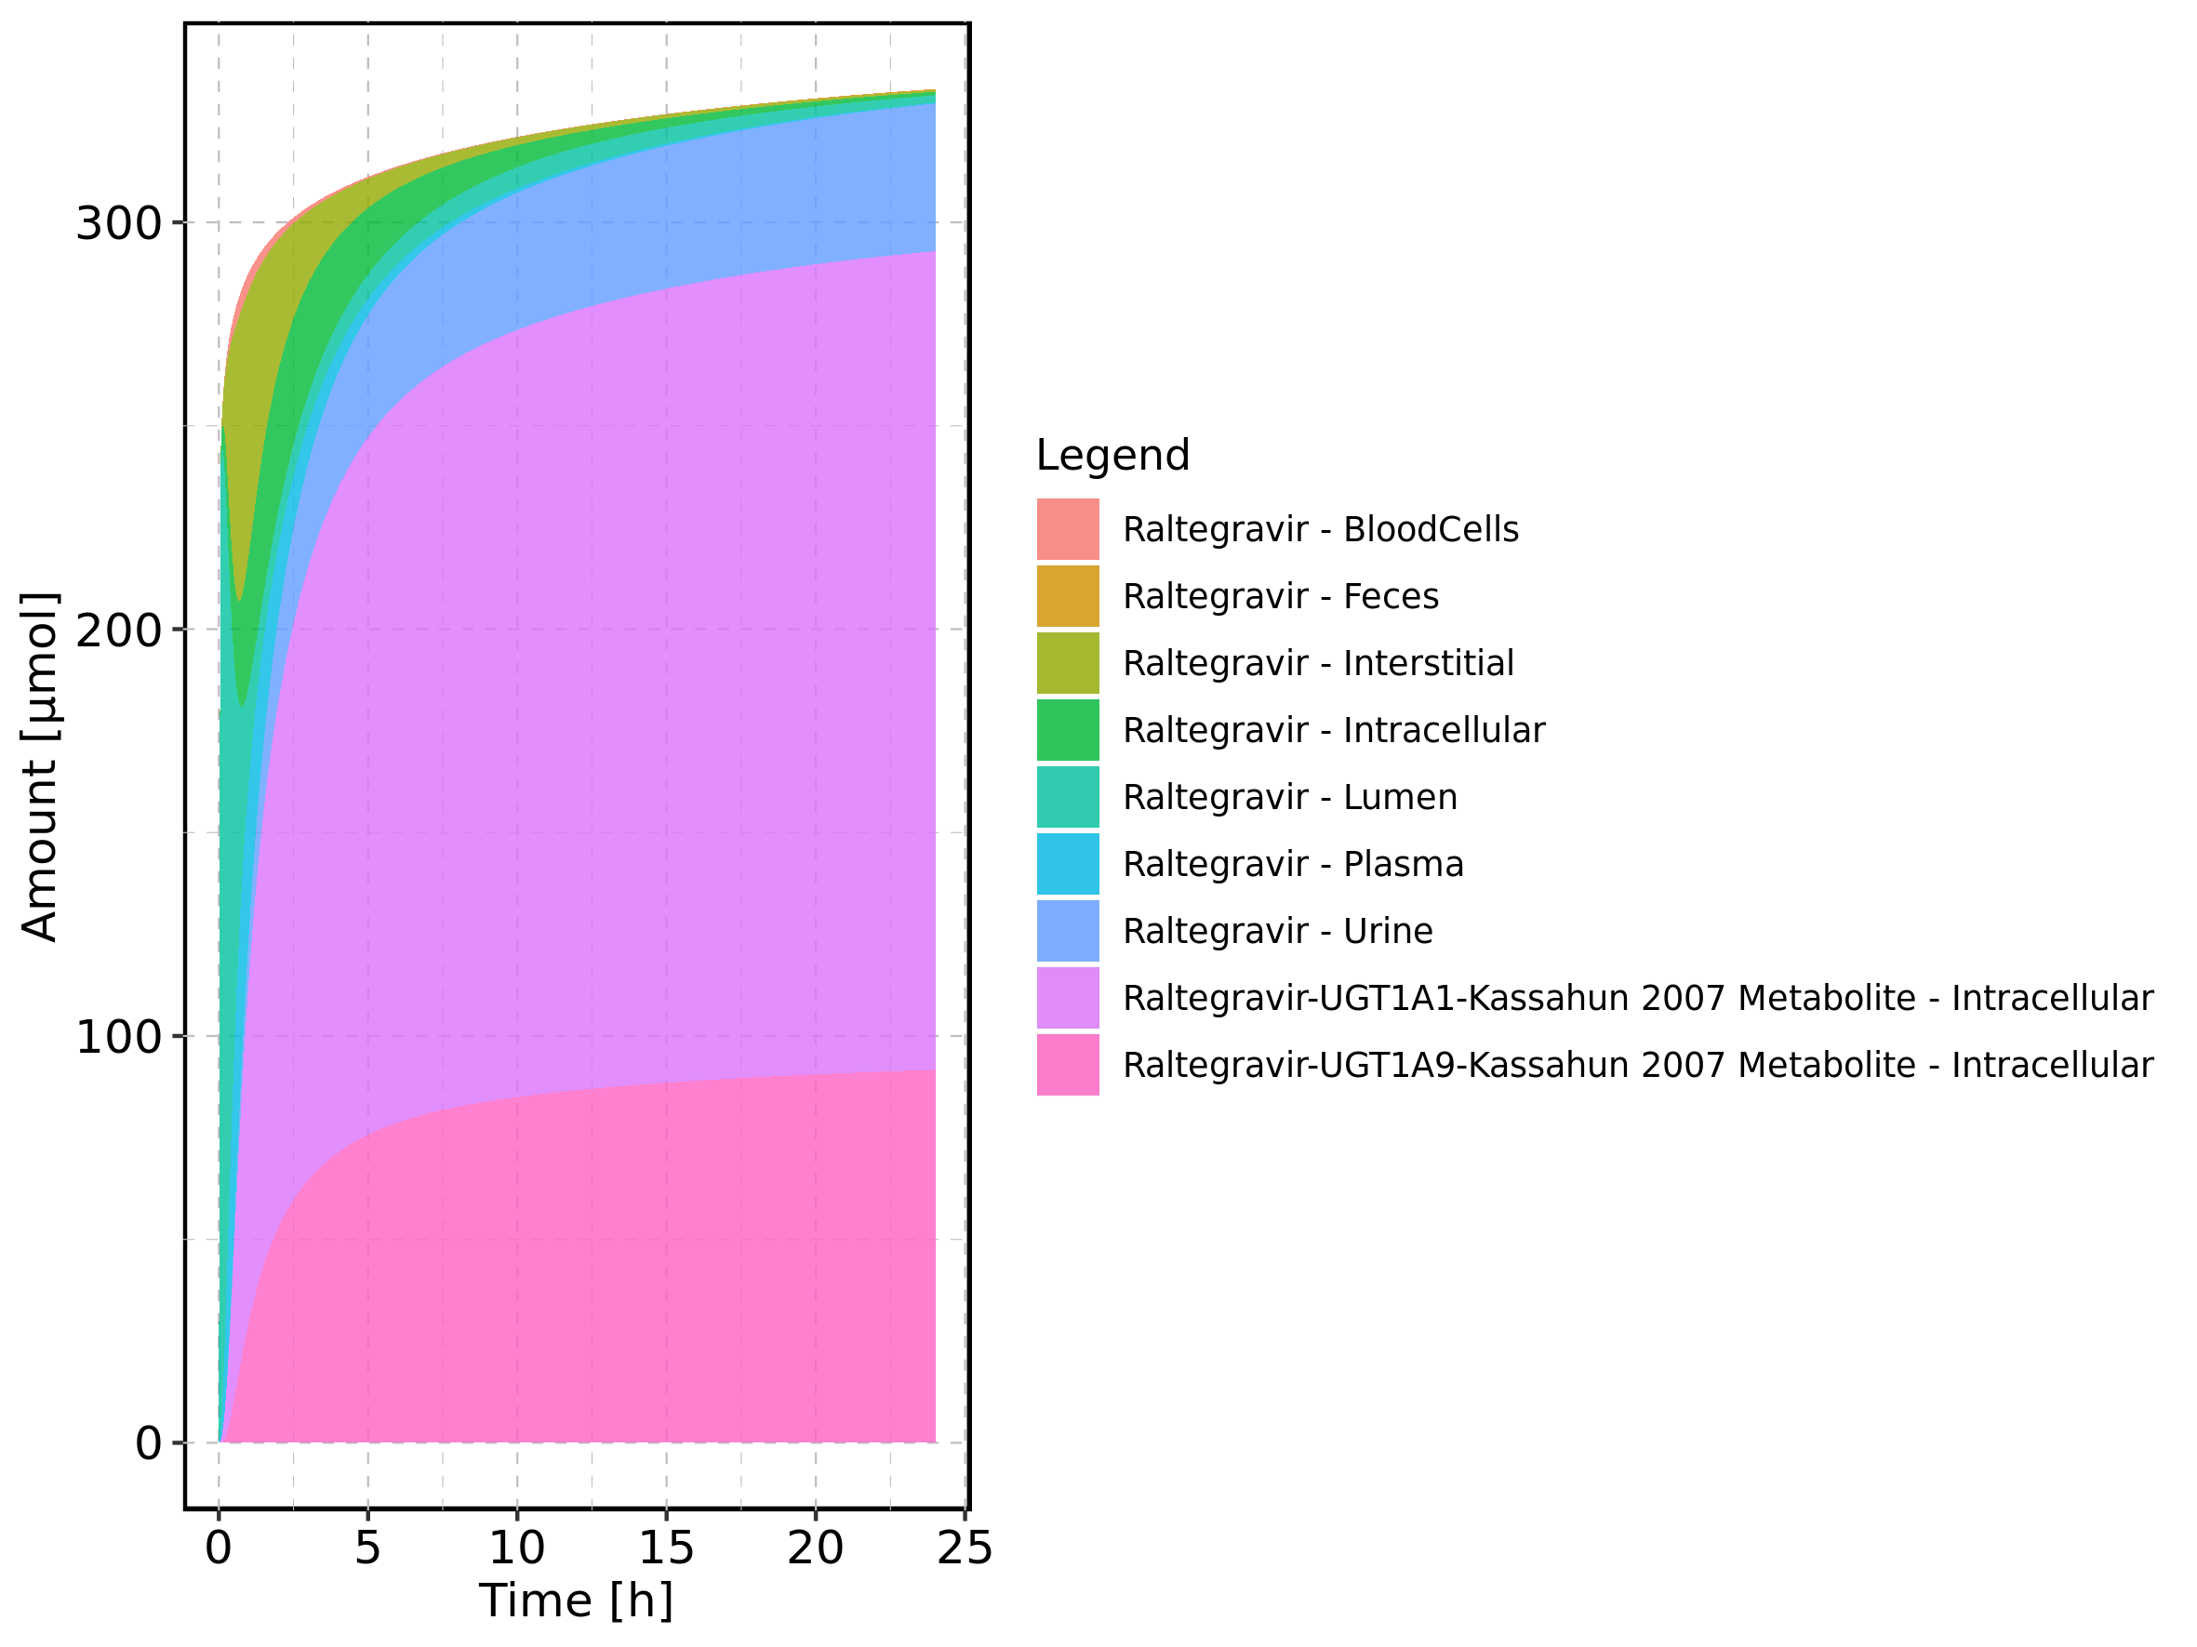

Figure 84: Amount of drug vs time within the different compartments normalized to applicated drugmass.

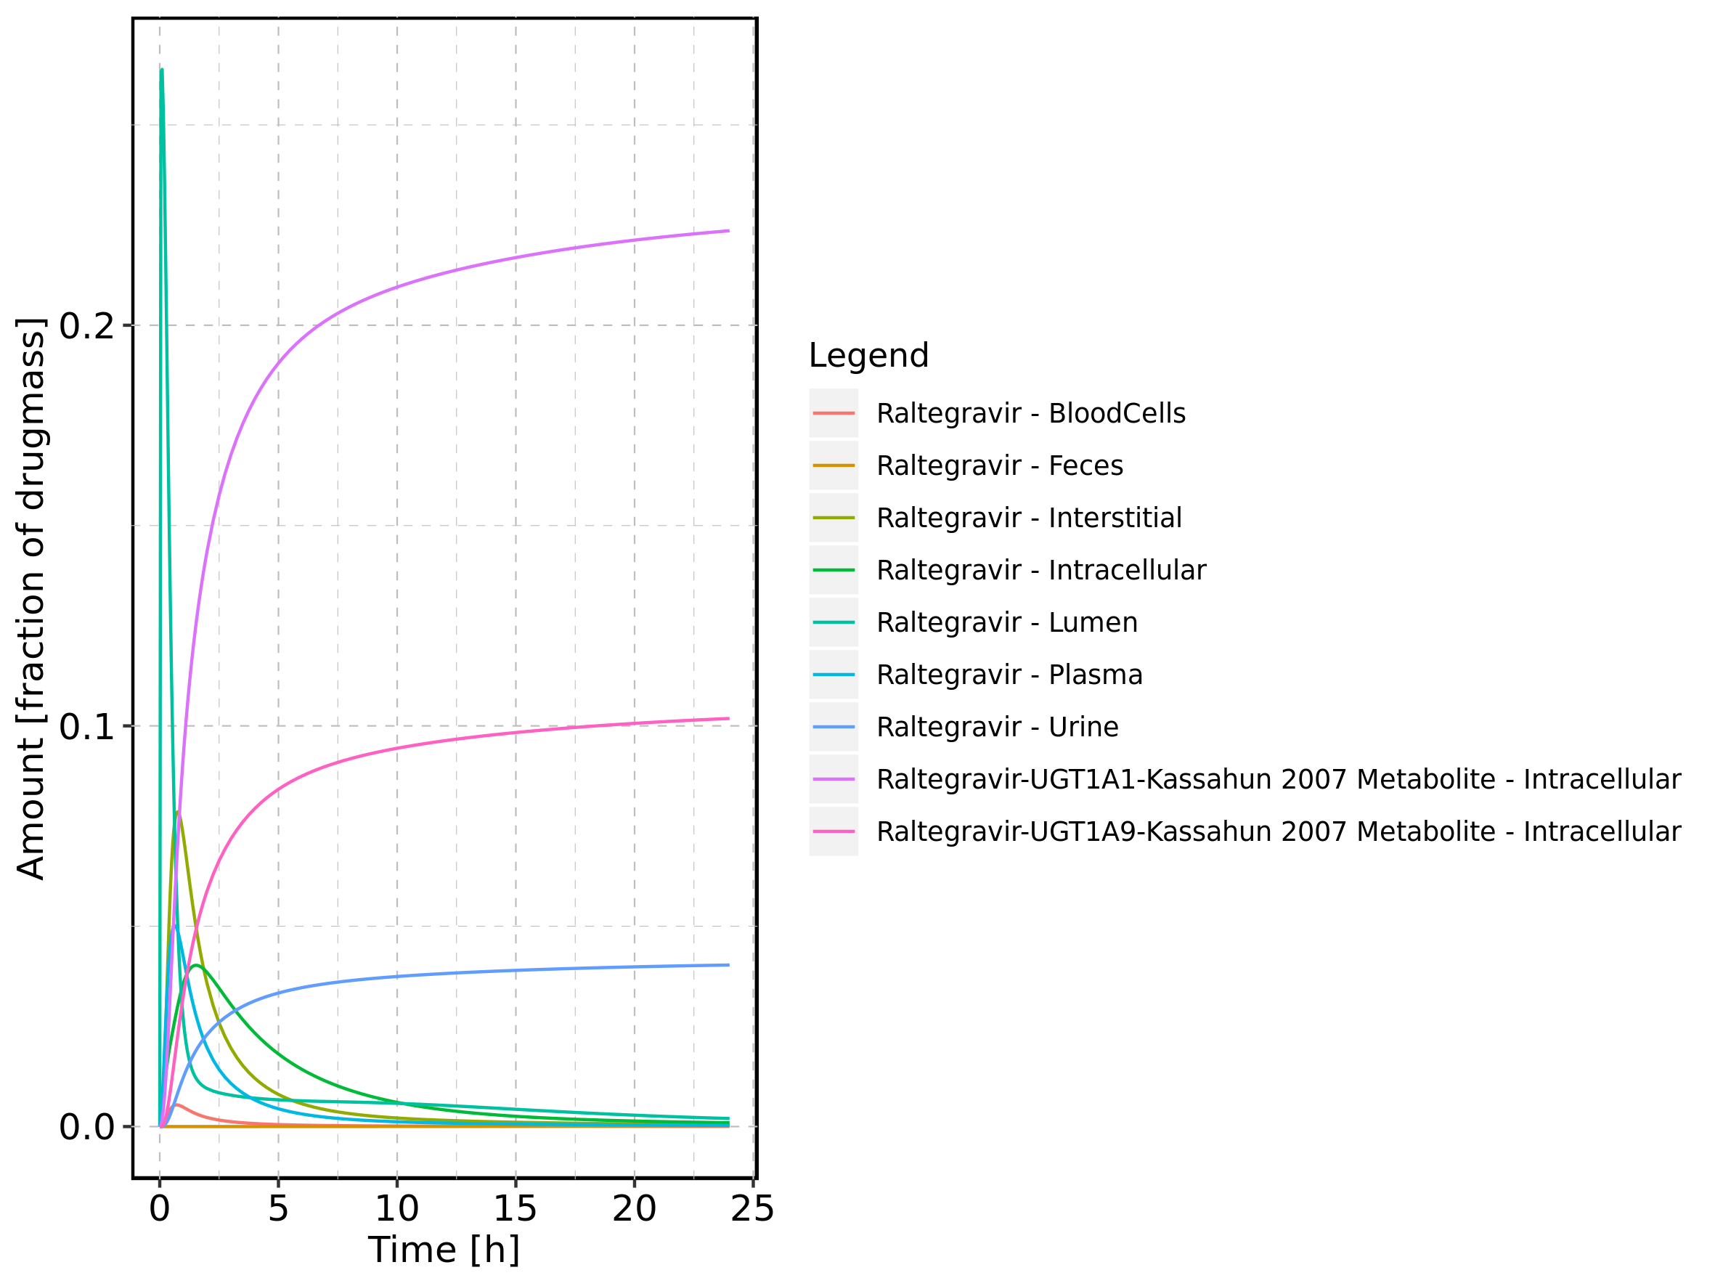

Figure 85: Cumulated amount of drug vs time within the different compartments normalized to applicated drugmass.

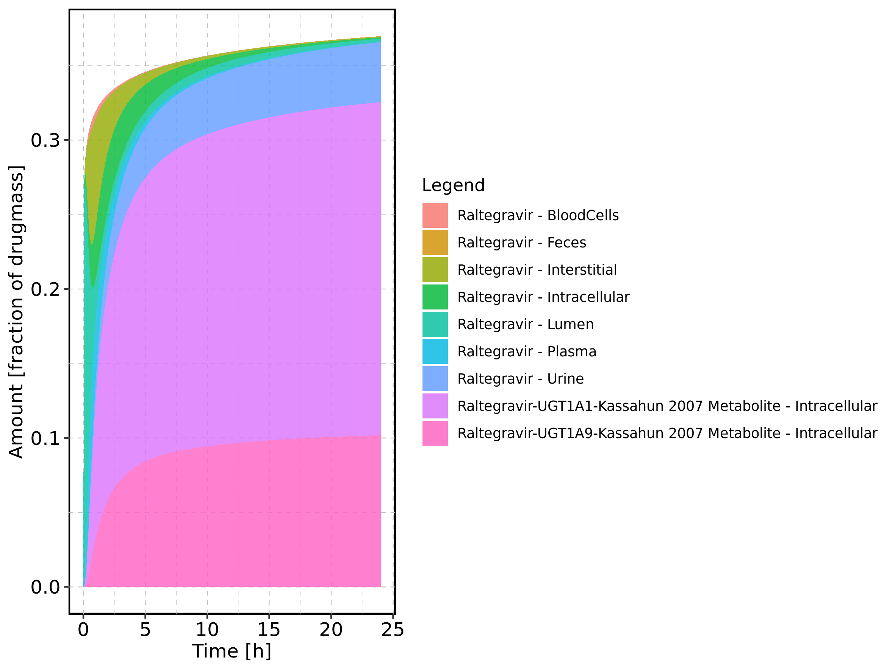

Figure 86: Fraction of drug within the different compartments at 24h.

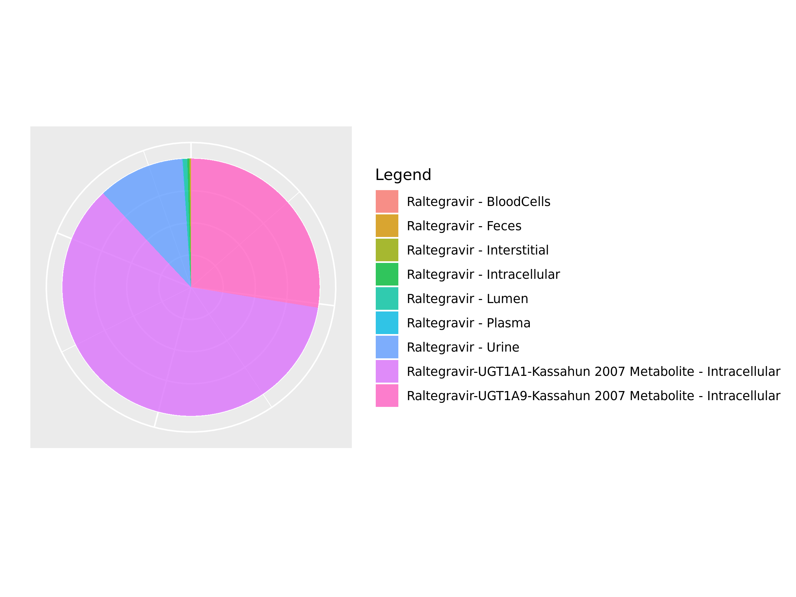

## 3.15. Mass Balance for Raltegravir 400mg chewable fed

Figure 87: Amount of drug vs time within the different compartments.

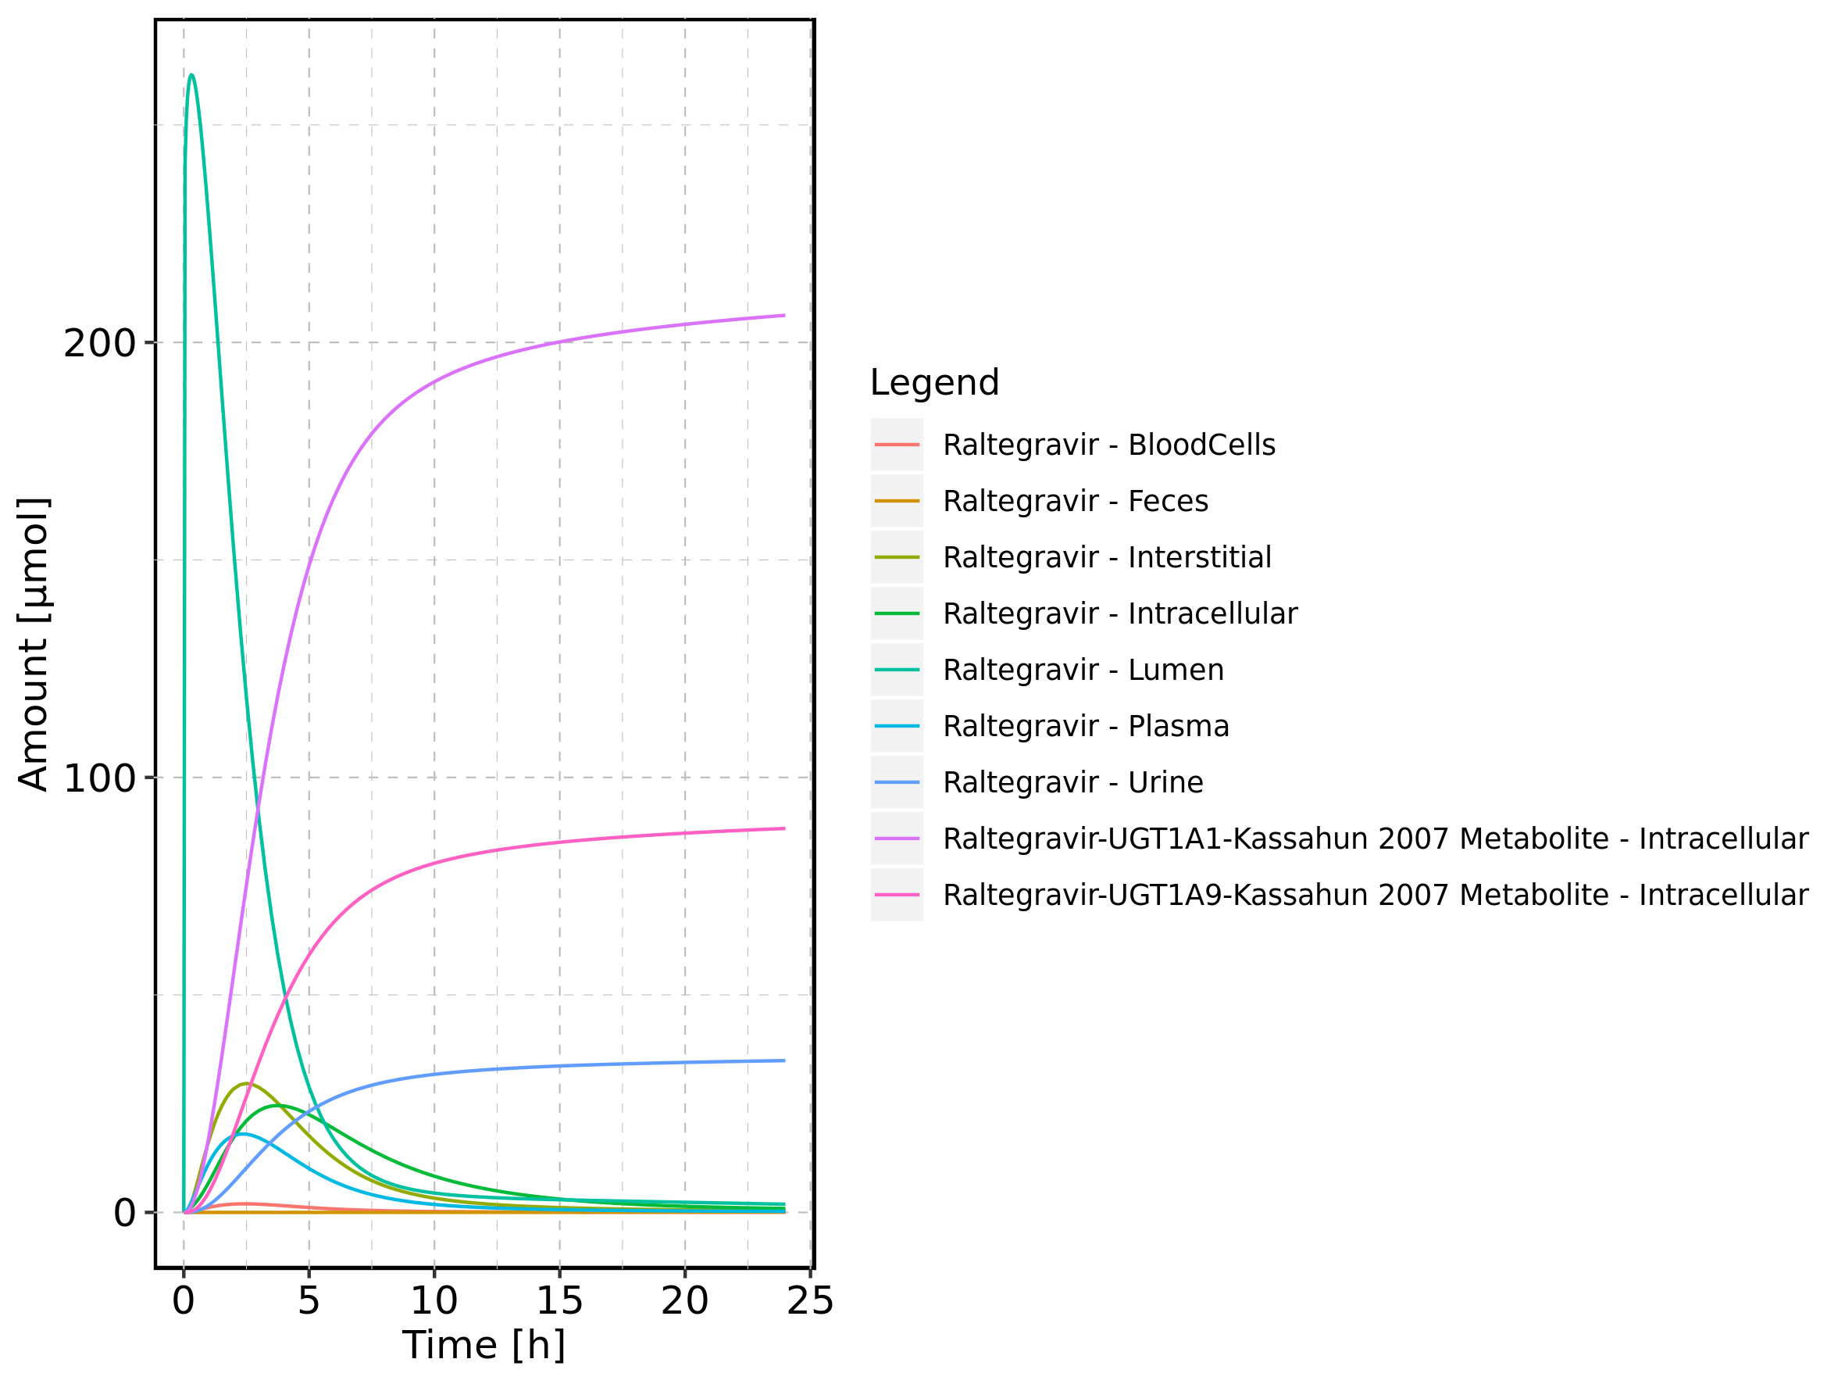

Figure 88: Cumulated amount of drug vs time within the different compartments

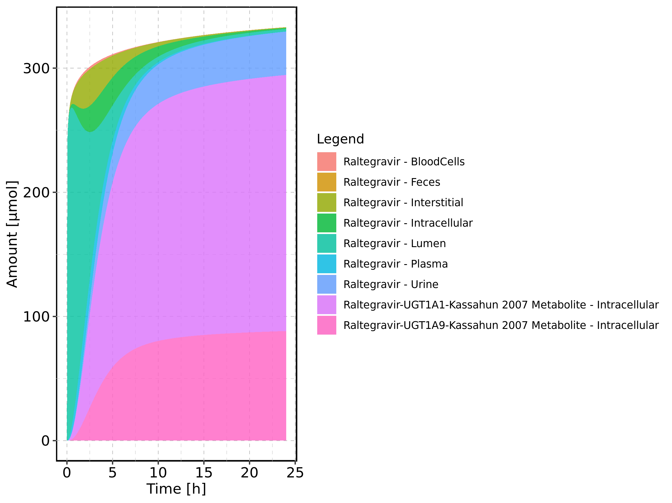

Figure 89: Amount of drug vs time within the different compartments normalized to applicated drugmass.

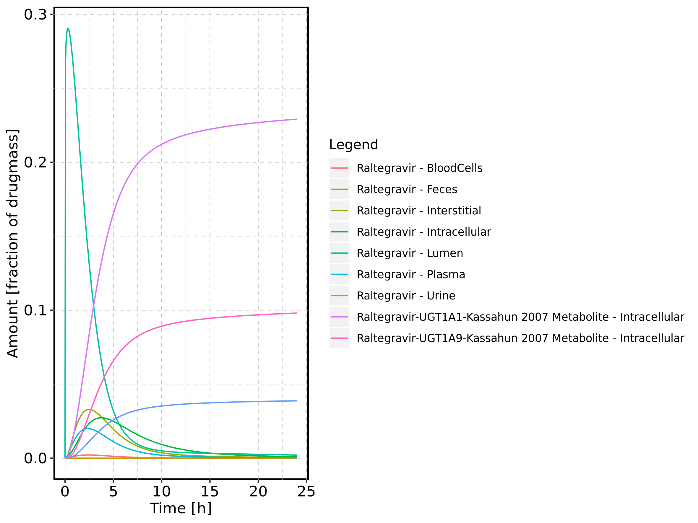

Figure 90: Cumulated amount of drug vs time within the different compartments normalized to applicated drugmass.

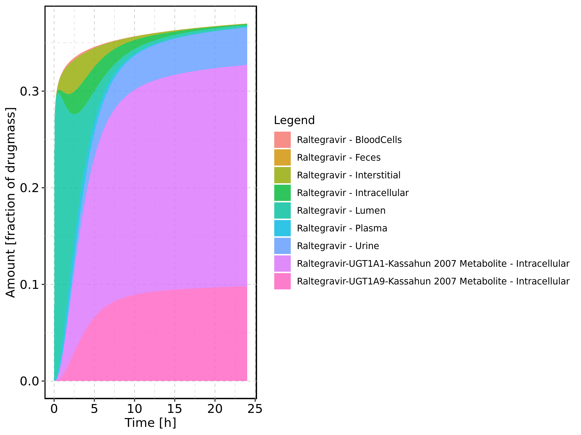

Figure 91: Fraction of drug within the different compartments at 24h.

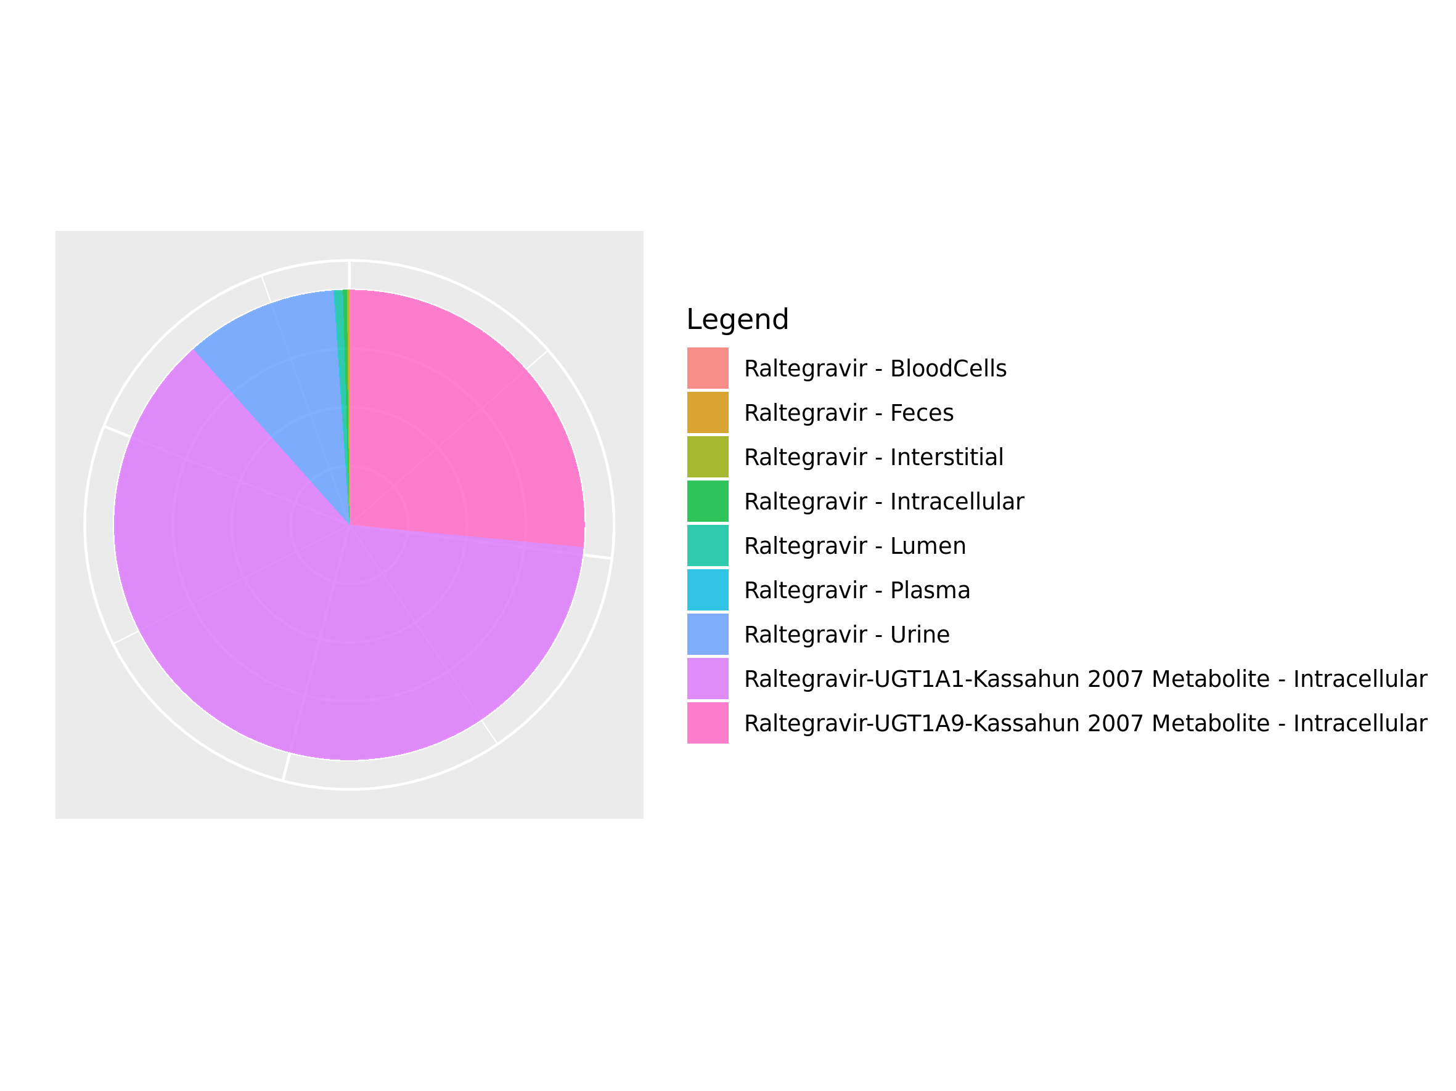

## 3.16. Mass Balance for Raltegravir 400mg (granules in suspension)

Figure 92: Amount of drug vs time within the different compartments.

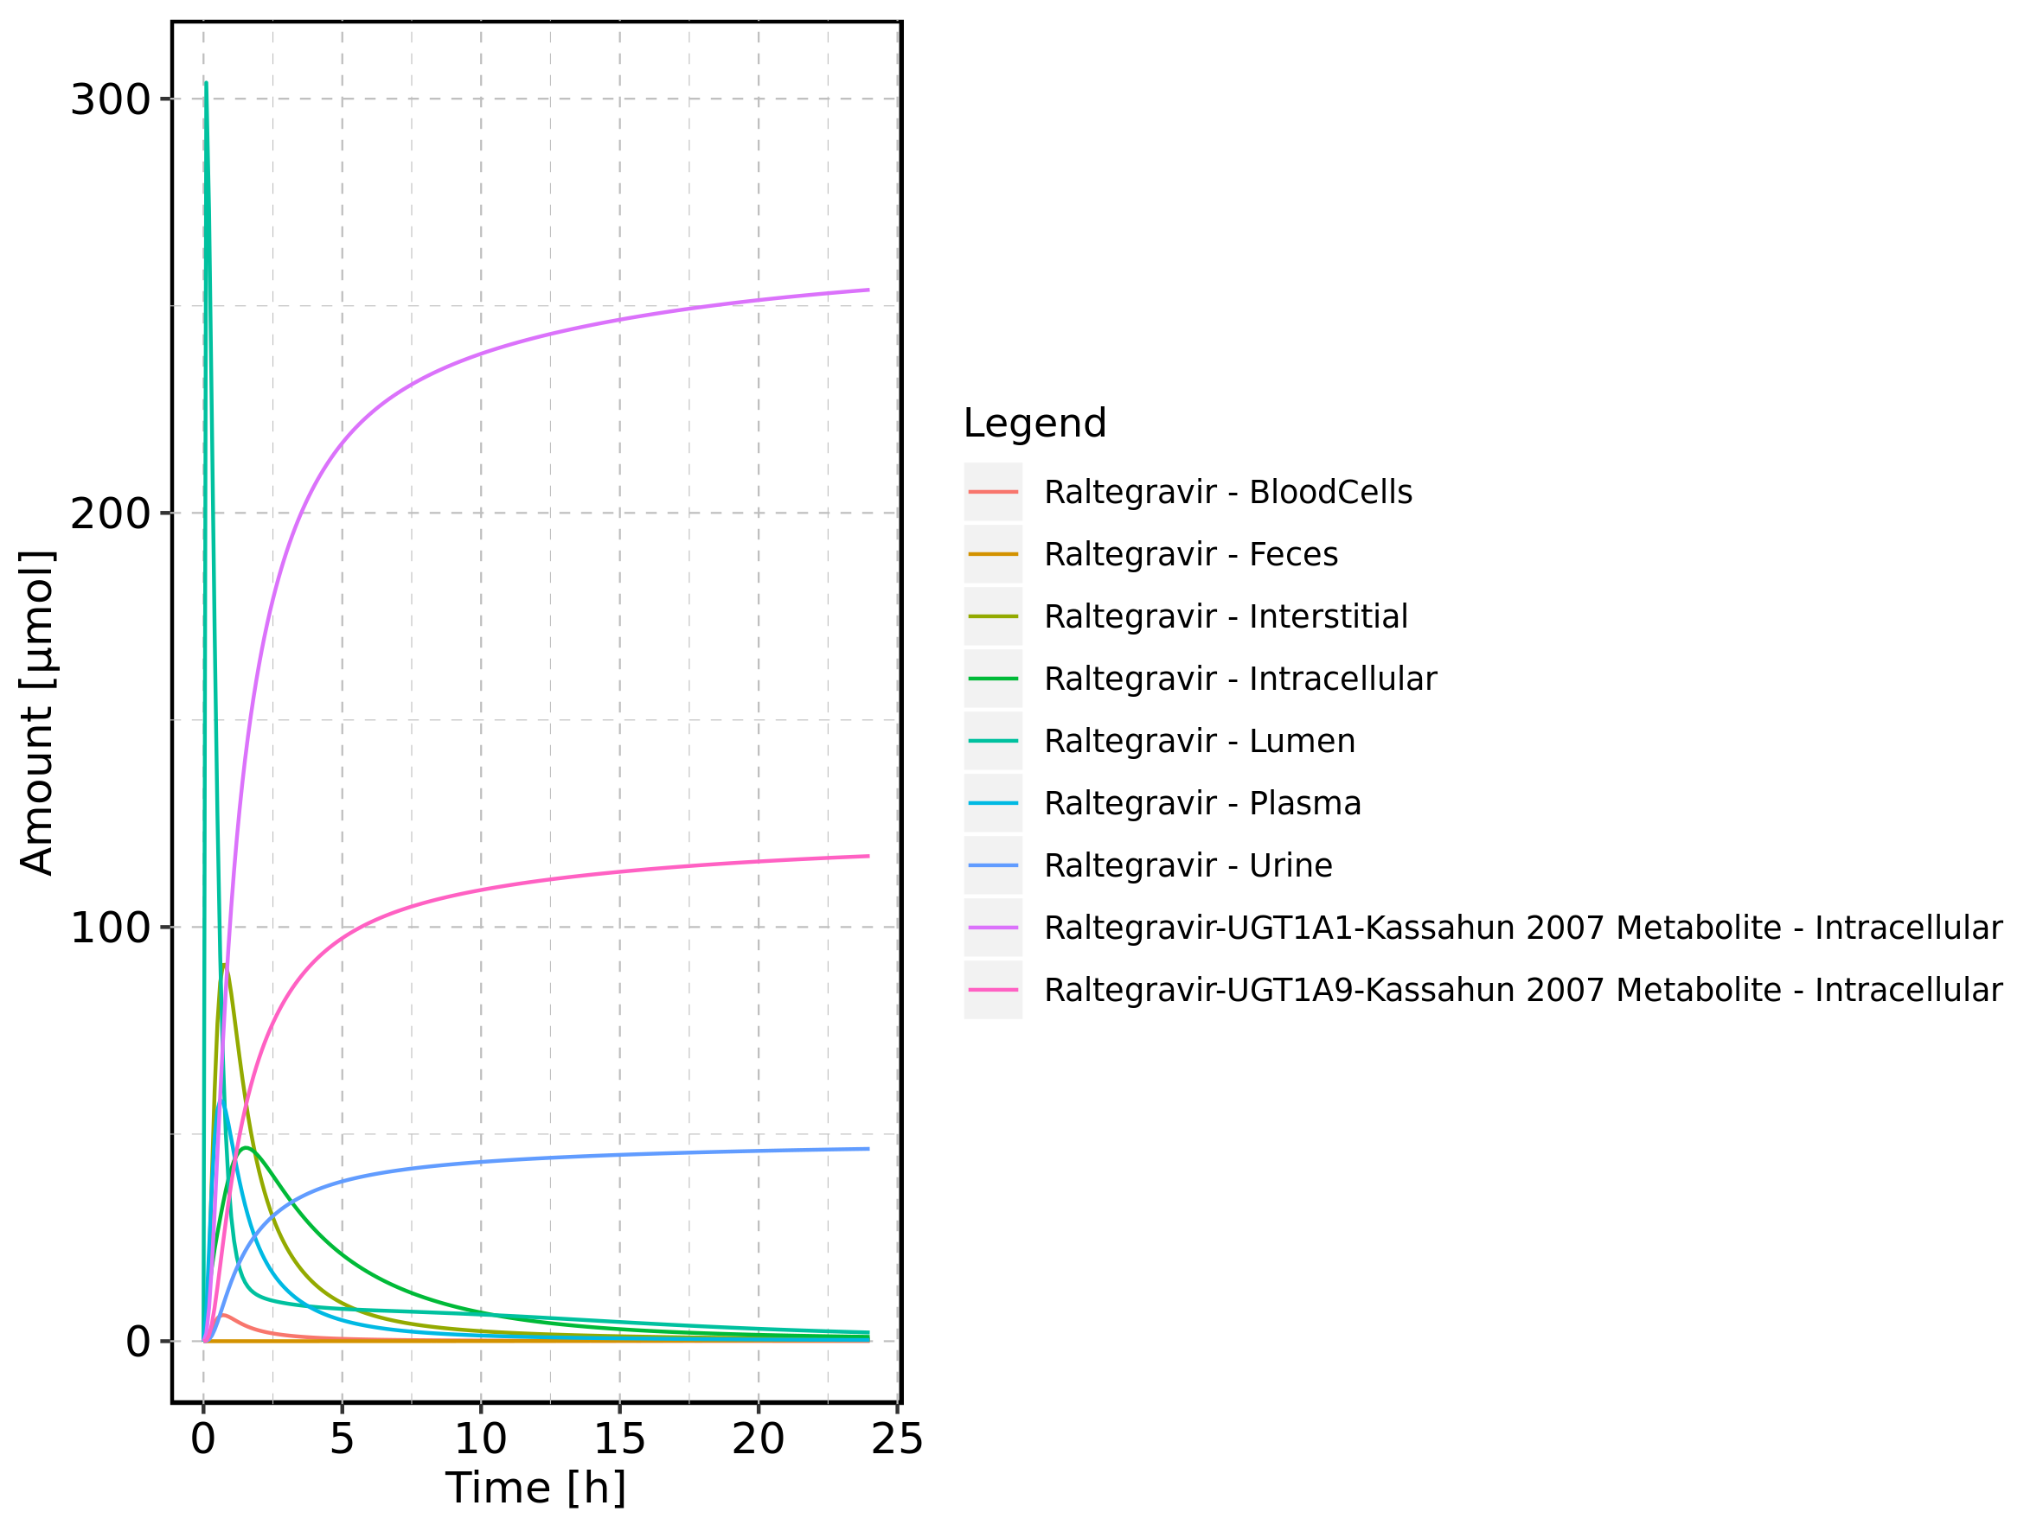

Figure 93: Cumulated amount of drug vs time within the different compartments

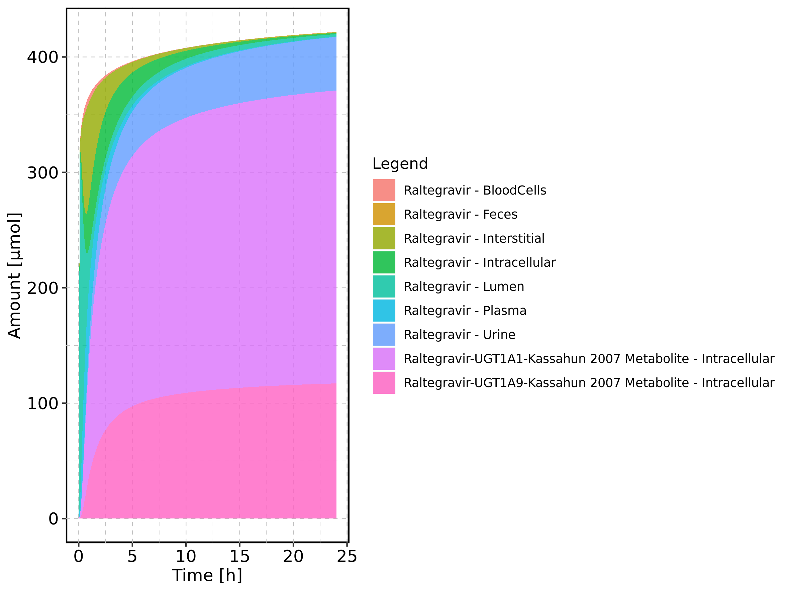

Figure 94: Amount of drug vs time within the different compartments normalized to applicated drugmass.

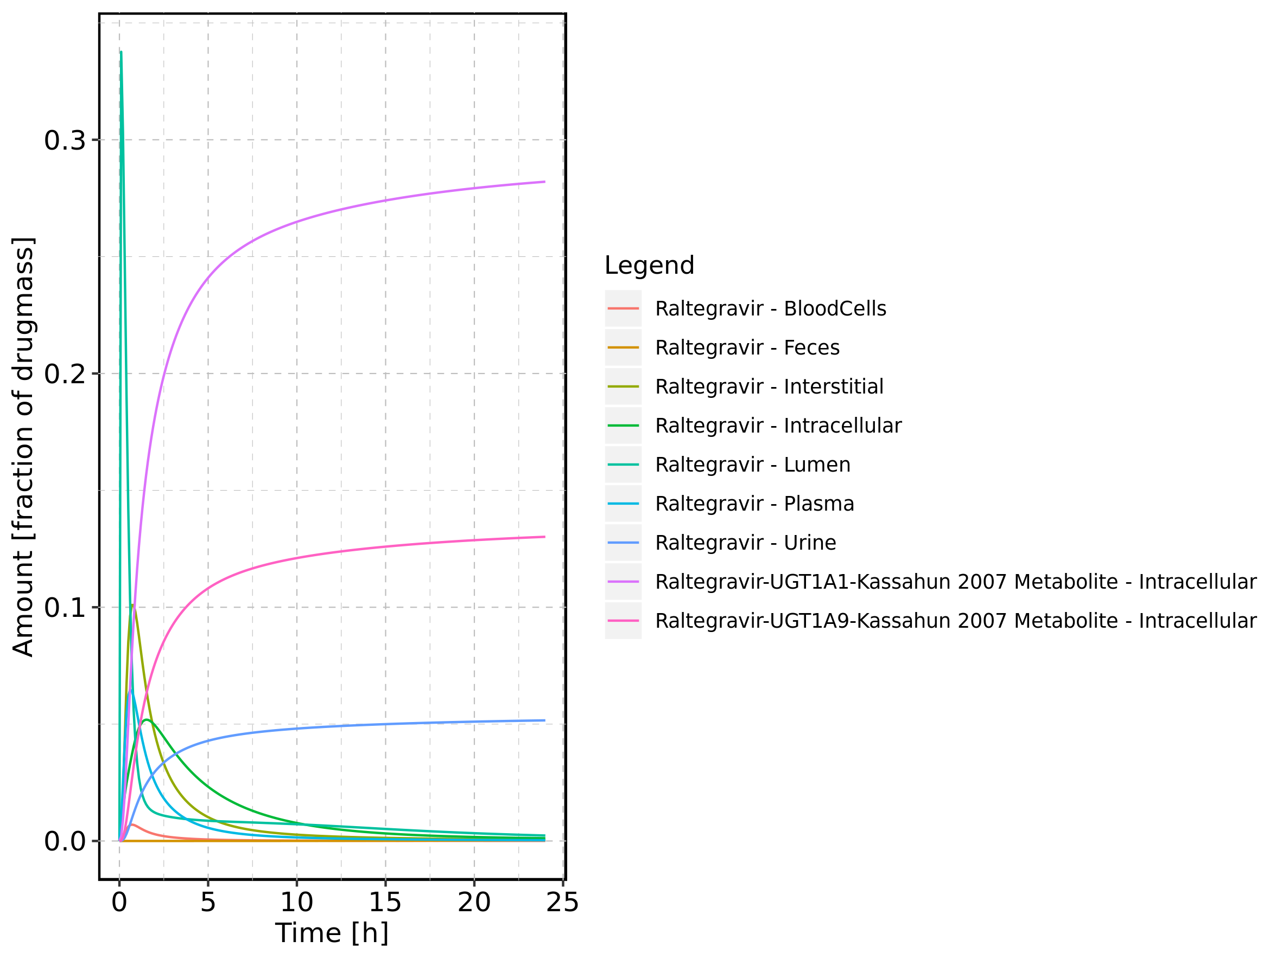

Figure 95: Cumulated amount of drug vs time within the different compartments normalized to applicated drugmass.

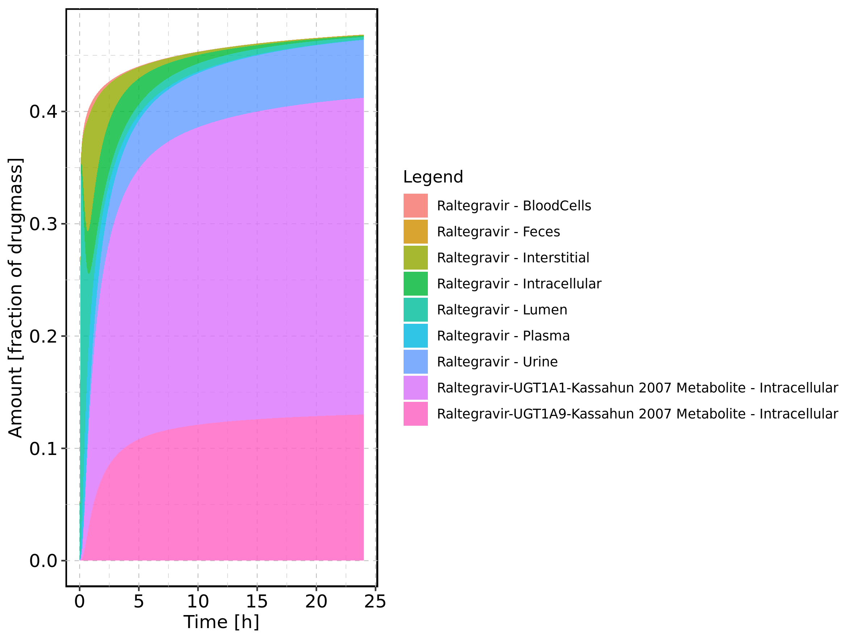

Figure 96: Fraction of drug within the different compartments at 24h.

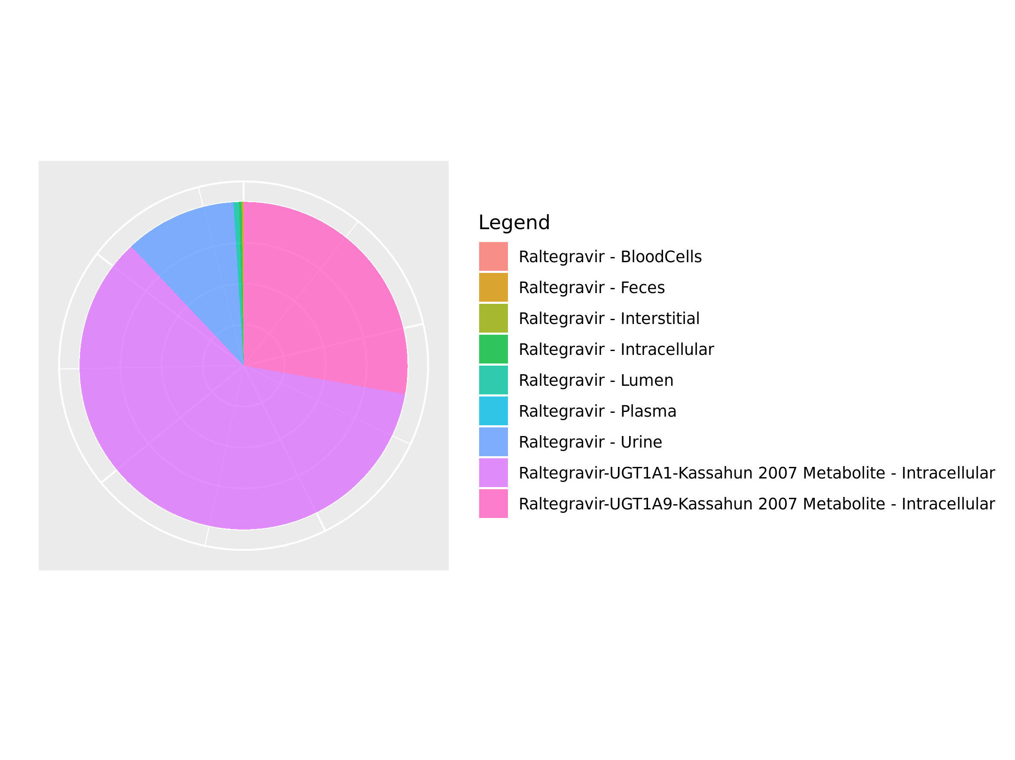

# 4. Time profiles and residual plots

## 4.1. Time profiles and residual plots for Raltegravir 10 mg (lactose formulation)

Figure 97: Time profiles of Raltegravir 10 mg (lactose formulation) for Raltegravir 10 mg (lactose formulation). Data source: Data/Raltegravir_PK.txt. Time profiles are plotted in a linear scale.

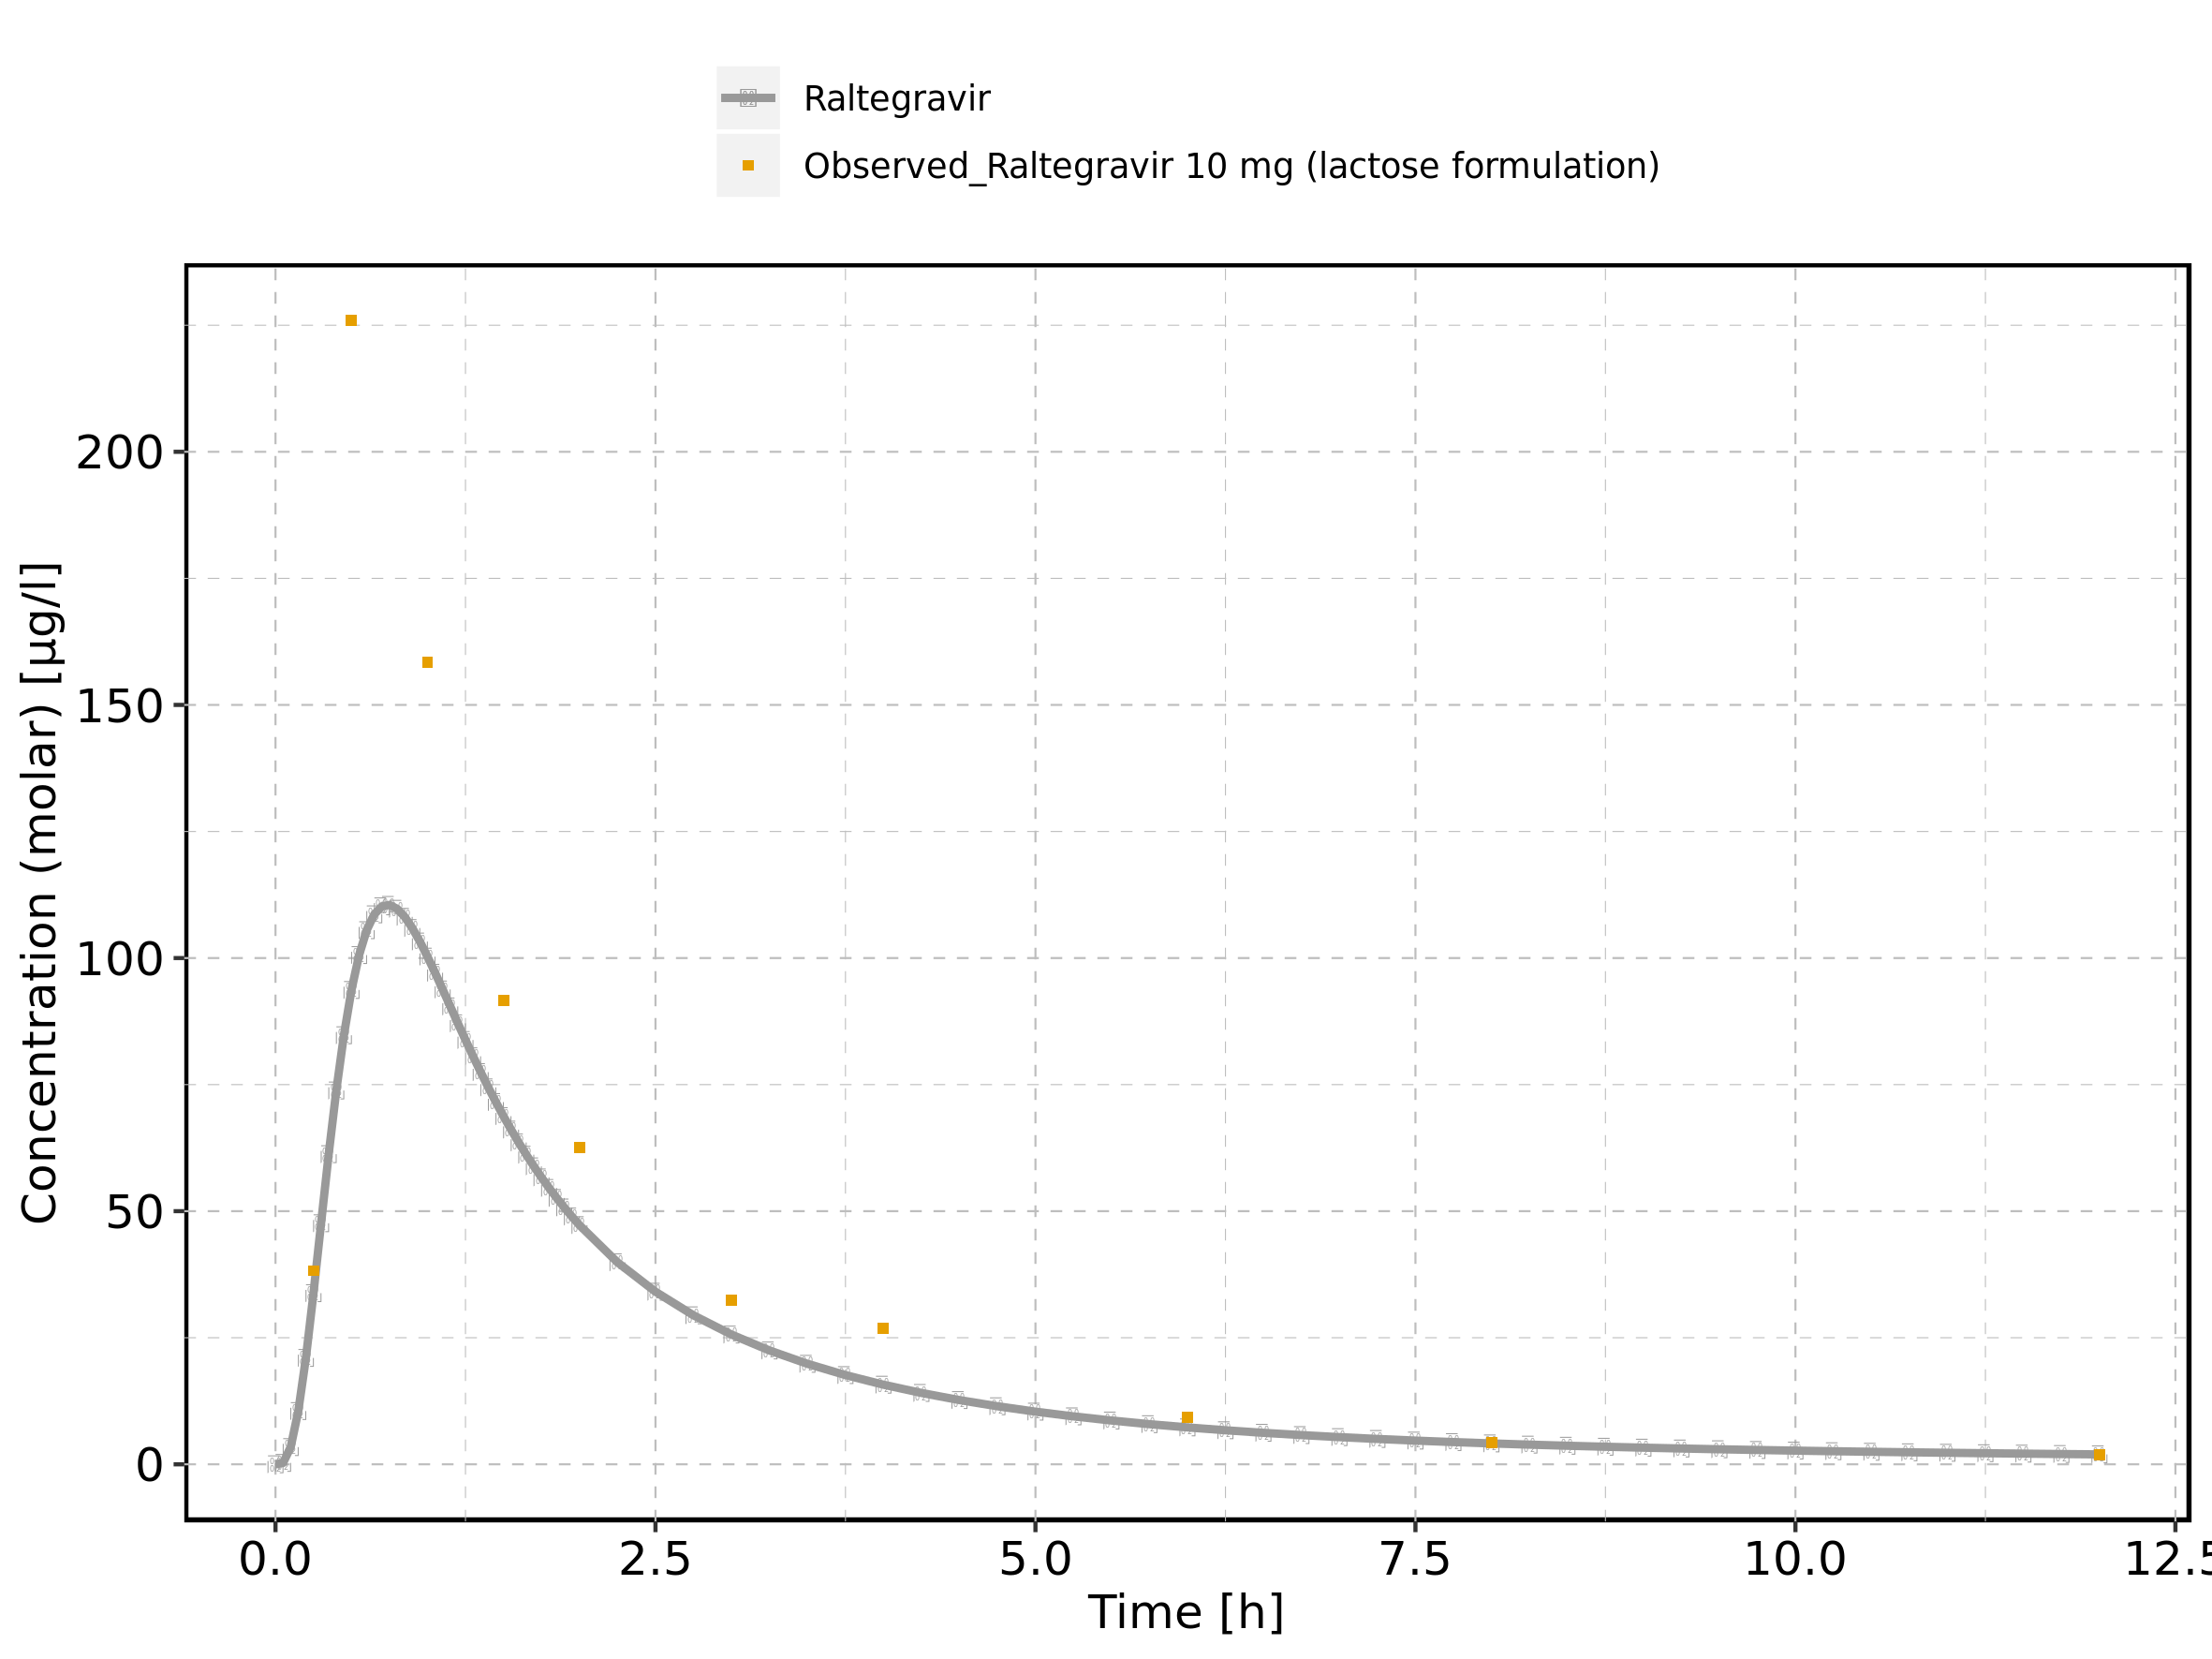

Figure 98: Time profiles of Raltegravir 10 mg (lactose formulation) for Raltegravir 10 mg (lactose formulation). Data source: Data/Raltegravir_PK.txt. Time profiles are plotted in a logarithmic scale.

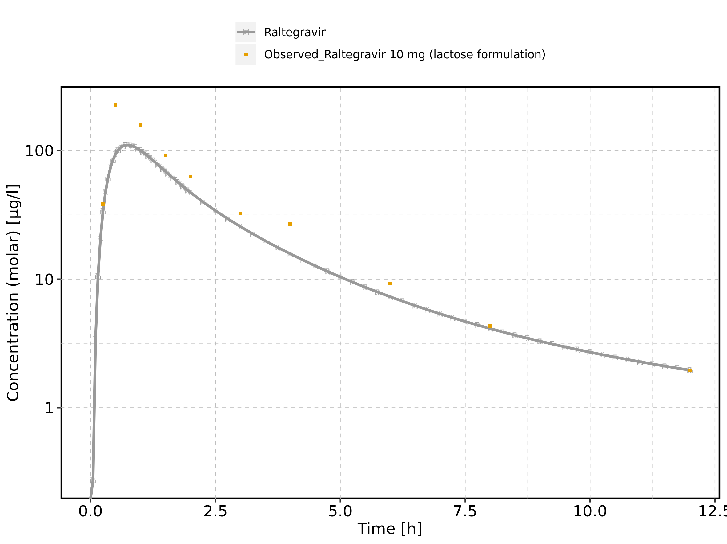

Figure 99: Predicted vs observed of Raltegravir 10 mg (lactose formulation) for Raltegravir 10 mg (lactose formulation). Data source: Data/Raltegravir_PK.txt. Predictions and observations are plotted in a linear scale.

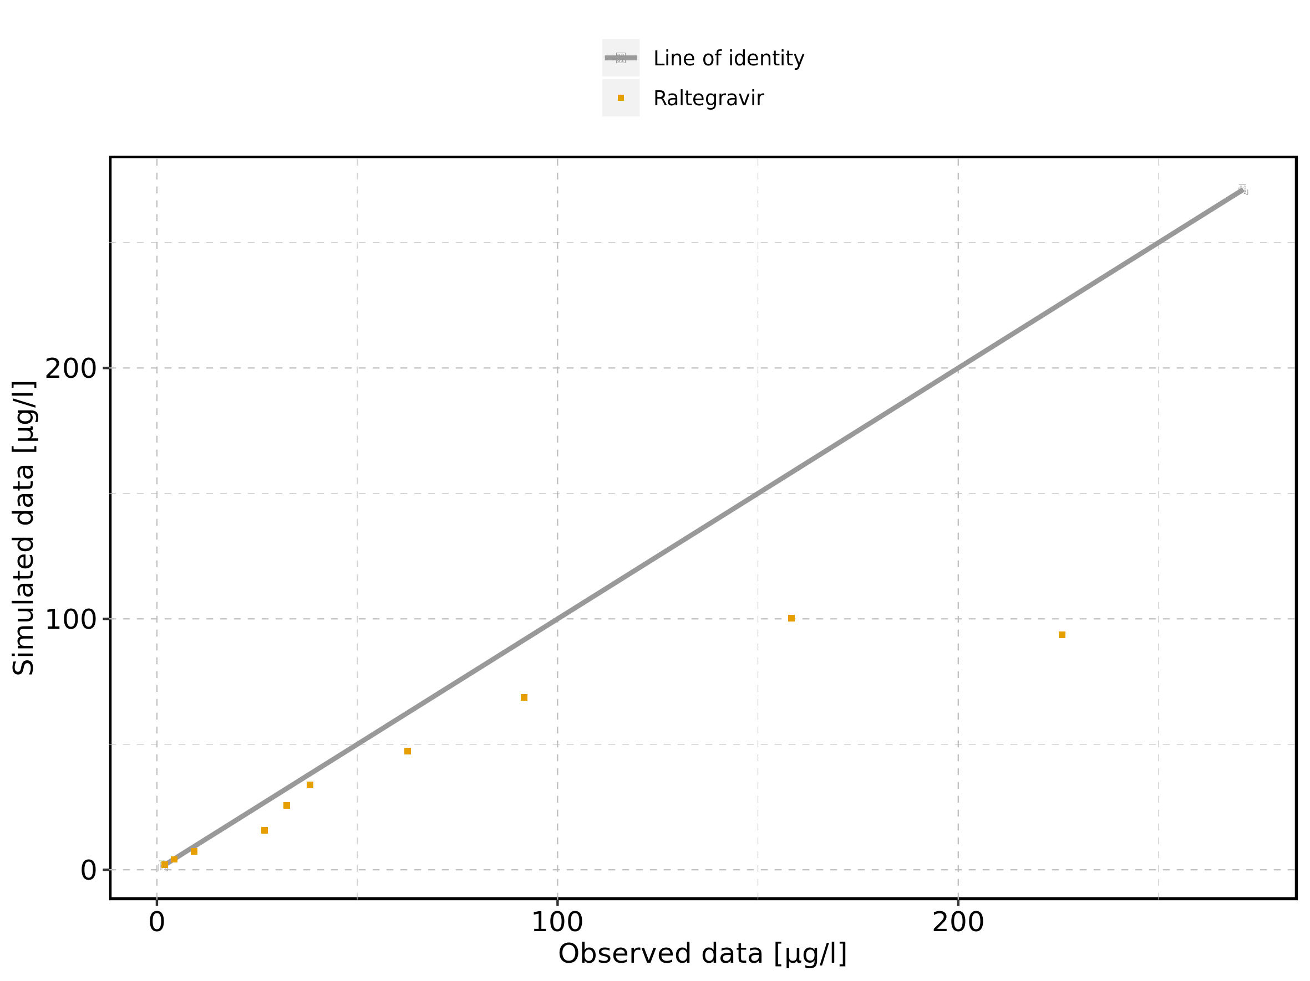

Figure 100: Predicted vs observed of Raltegravir 10 mg (lactose formulation) for Raltegravir 10 mg (lactose formulation). Data source: Data/Raltegravir_PK.txt. Predictions and observations are plotted in a logarithmic scale.

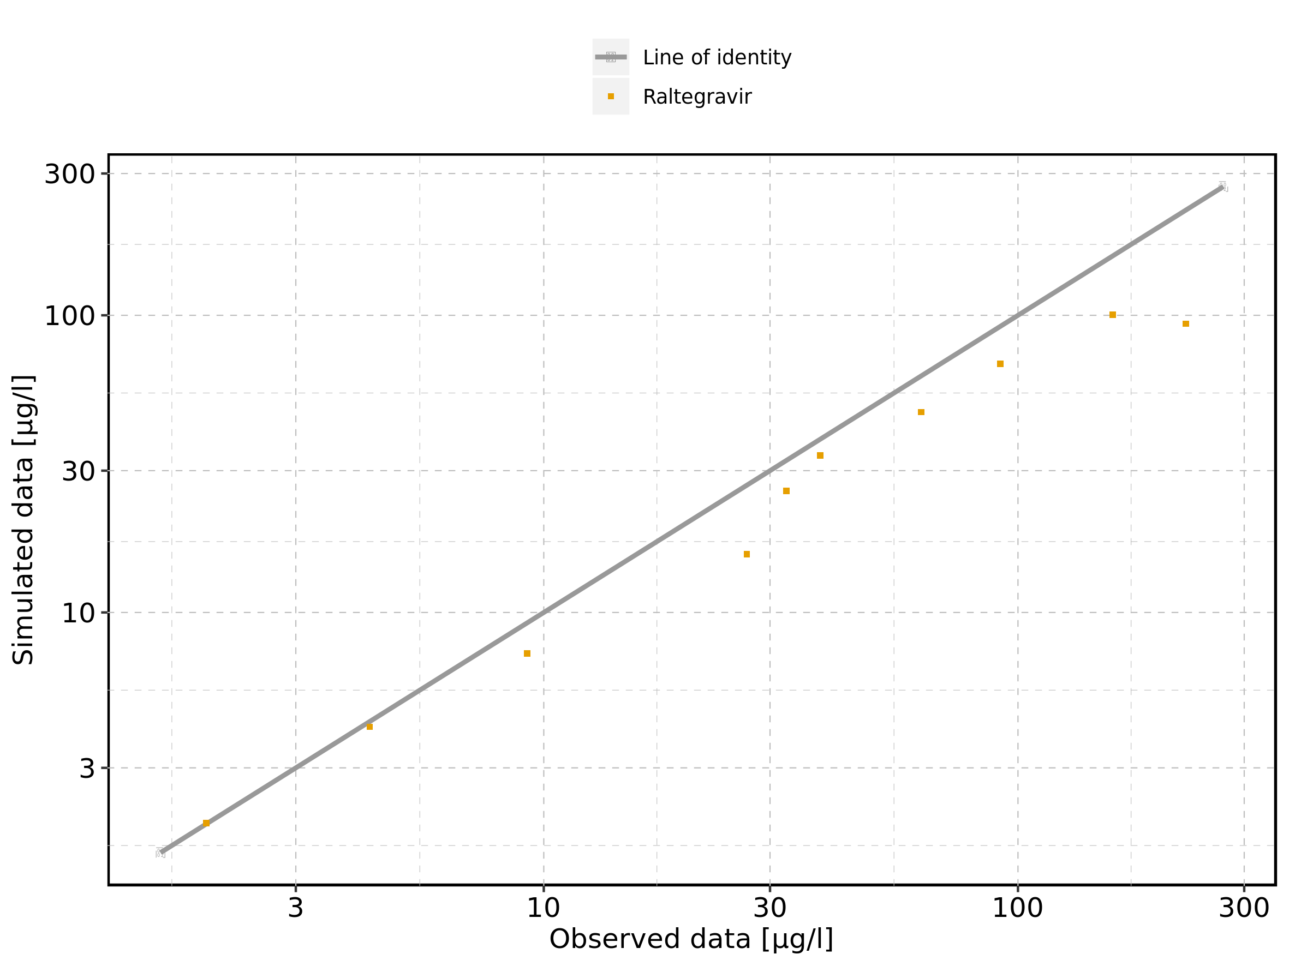

Figure 101: Logarithmic residuals vs predicted values of Raltegravir 10 mg (lactose formulation) for Raltegravir 10 mg (lactose formulation). Data source: Data/Raltegravir_PK.txt.

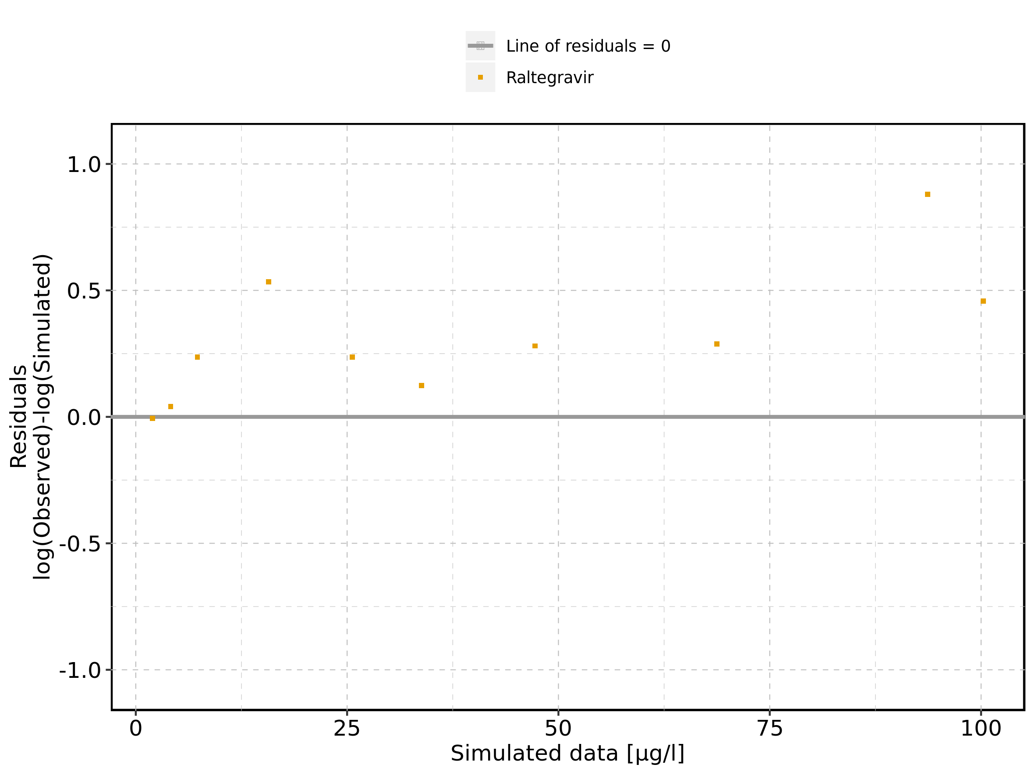

Figure 102: Logarithmic residuals vs time of Raltegravir 10 mg (lactose formulation) for Raltegravir 10 mg (lactose formulation). Data source: Data/Raltegravir_PK.txt.

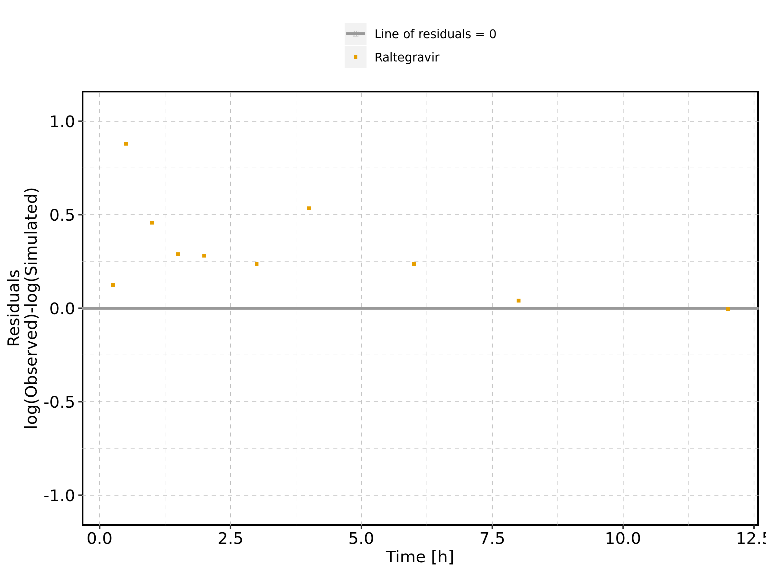

Figure 103: Logarithmic residuals distribution of Raltegravir 10 mg (lactose formulation) for Raltegravir 10 mg (lactose formulation). Data source: Data/Raltegravir_PK.txt.

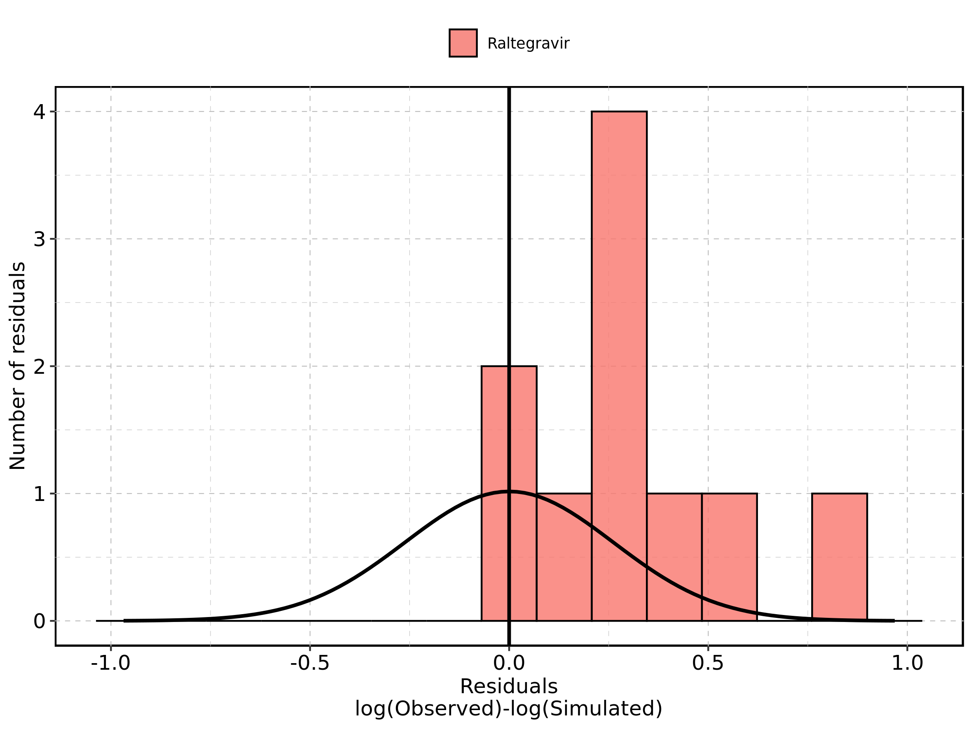

Figure 104: Logarithmic residuals of Raltegravir 10 mg (lactose formulation) for Raltegravir 10 mg (lactose formulation) as quantile-quantile plot. Data source: Data/Raltegravir_PK.txt.

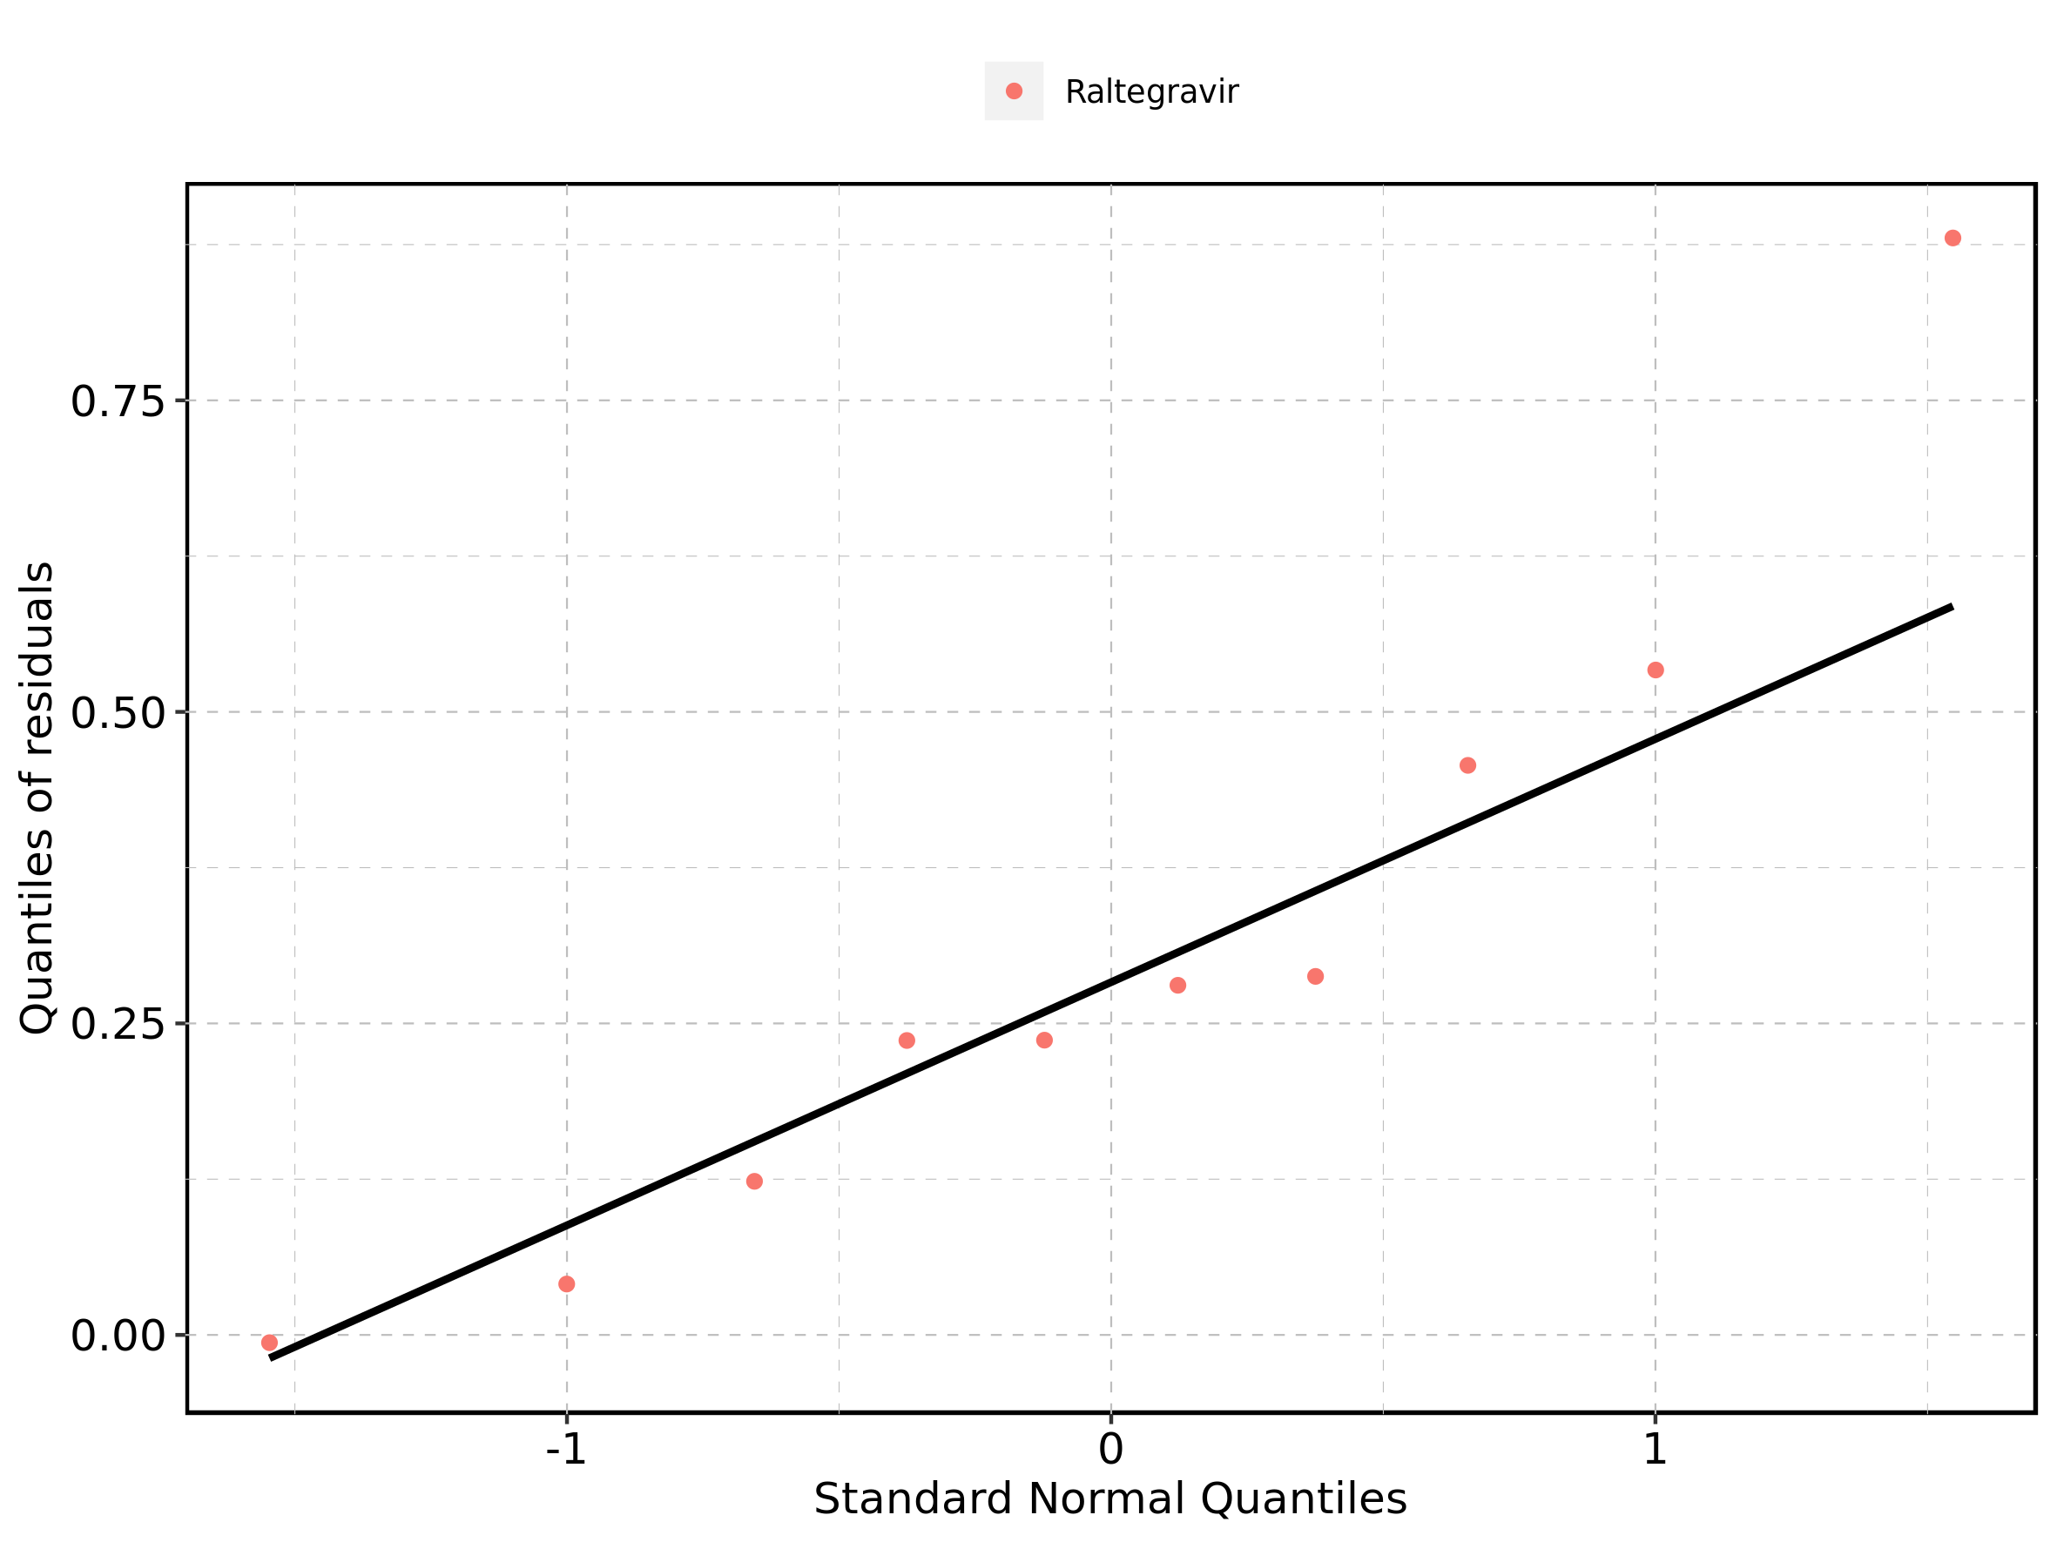

## 4.2. Time profiles and residual plots for Raltegravir 25 mg (lactose formulation)

Figure 105: Time profiles of Raltegravir 25 mg (lactose formulation) for Raltegravir 25 mg (lactose formulation). Data source: Data/Raltegravir_PK.txt. Time profiles are plotted in a linear scale.

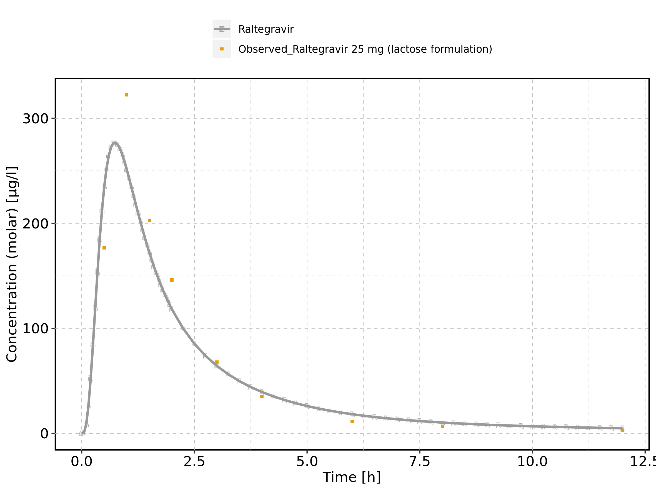

Figure 106: Time profiles of Raltegravir 25 mg (lactose formulation) for Raltegravir 25 mg (lactose formulation). Data source: Data/Raltegravir_PK.txt. Time profiles are plotted in a logarithmic scale.

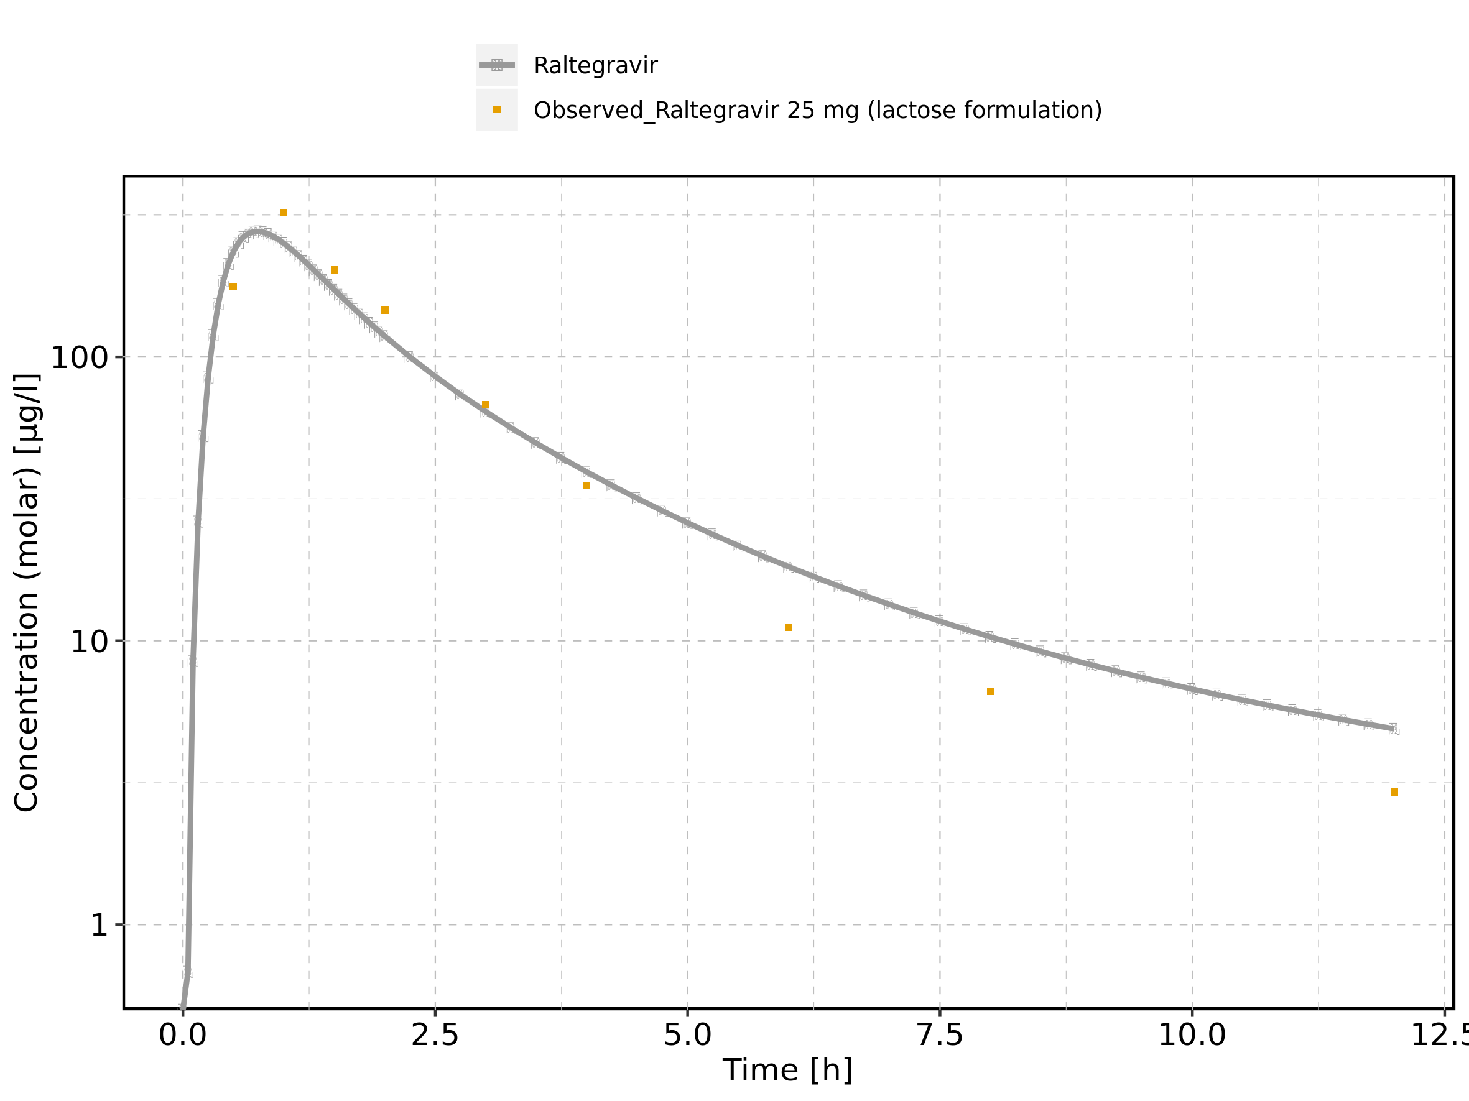

Figure 107: Predicted vs observed of Raltegravir 25 mg (lactose formulation) for Raltegravir 25 mg (lactose formulation). Data source: Data/Raltegravir_PK.txt. Predictions and observations are plotted in a linear scale.

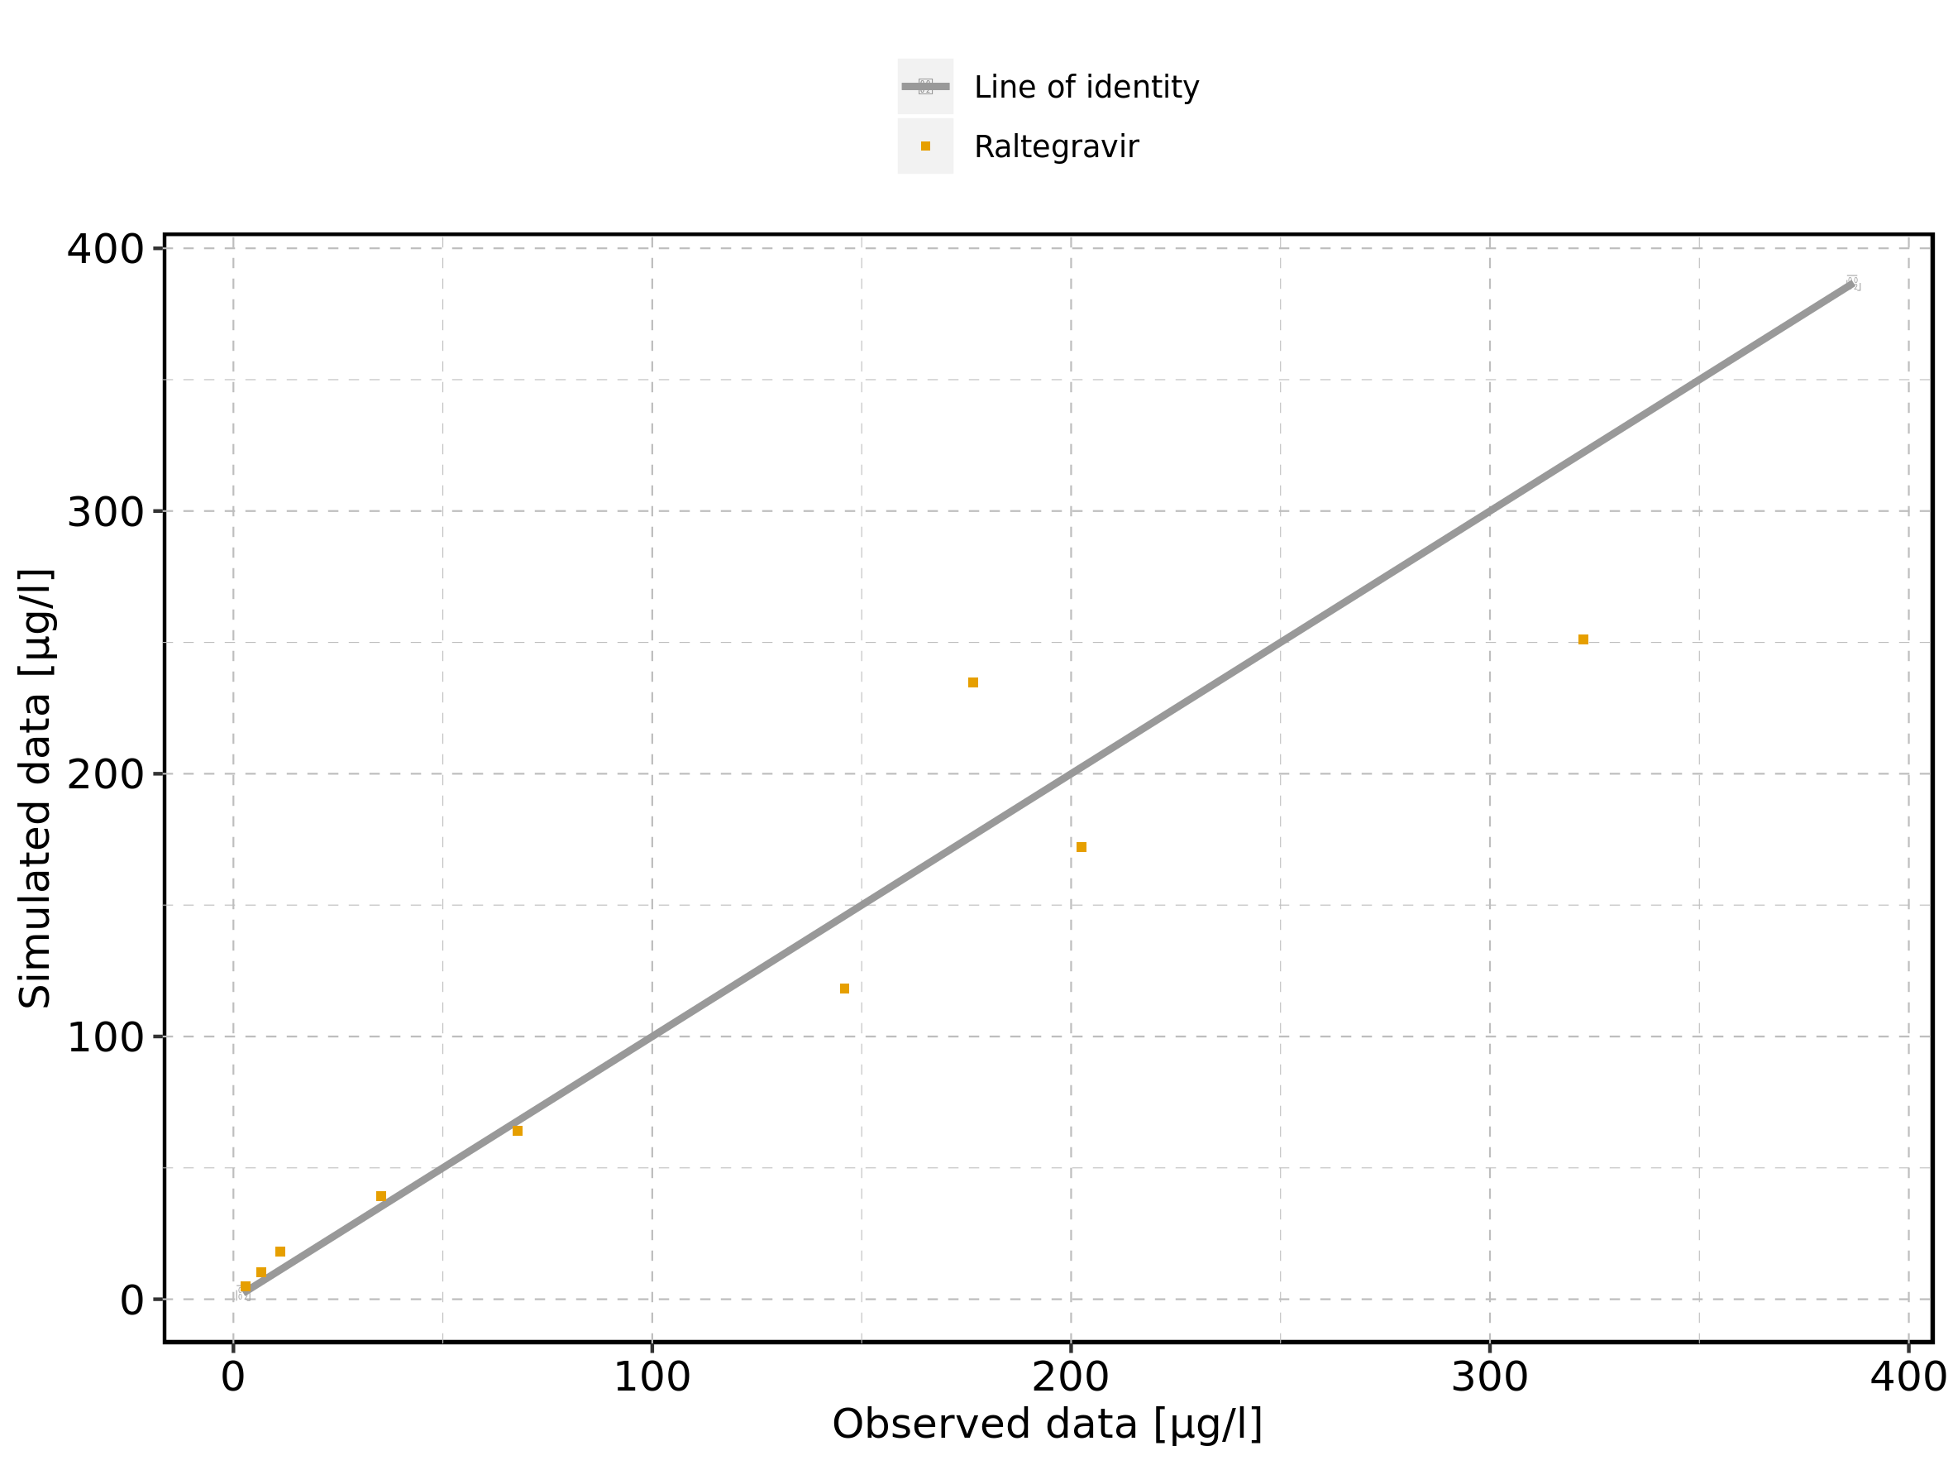

Figure 108: Predicted vs observed of Raltegravir 25 mg (lactose formulation) for Raltegravir 25 mg (lactose formulation). Data source: Data/Raltegravir_PK.txt. Predictions and observations are plotted in a logarithmic scale.

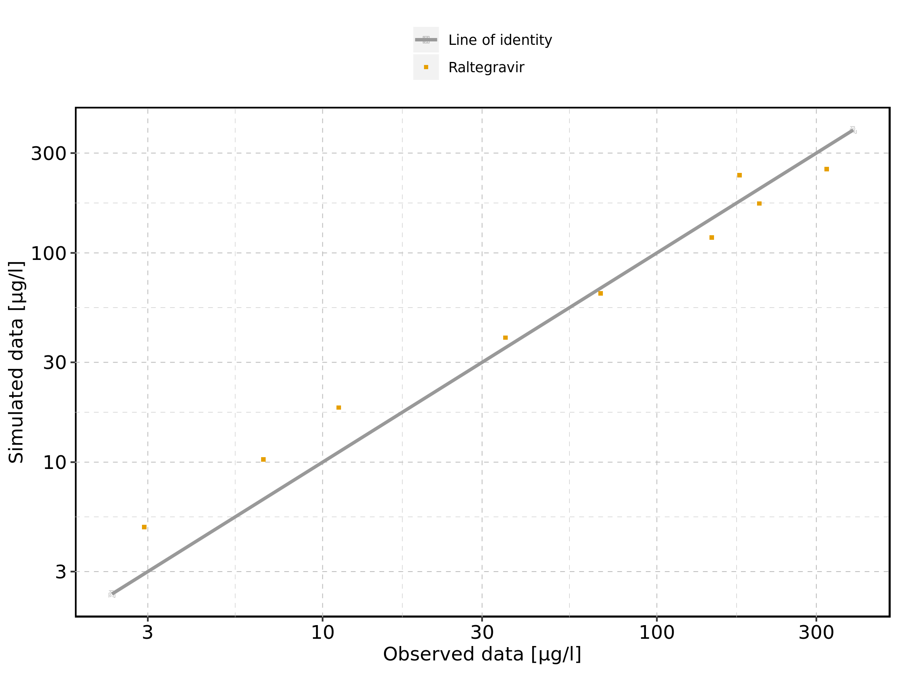

Figure 109: Logarithmic residuals vs predicted values of Raltegravir 25 mg (lactose formulation) for Raltegravir 25 mg (lactose formulation). Data source: Data/Raltegravir_PK.txt.

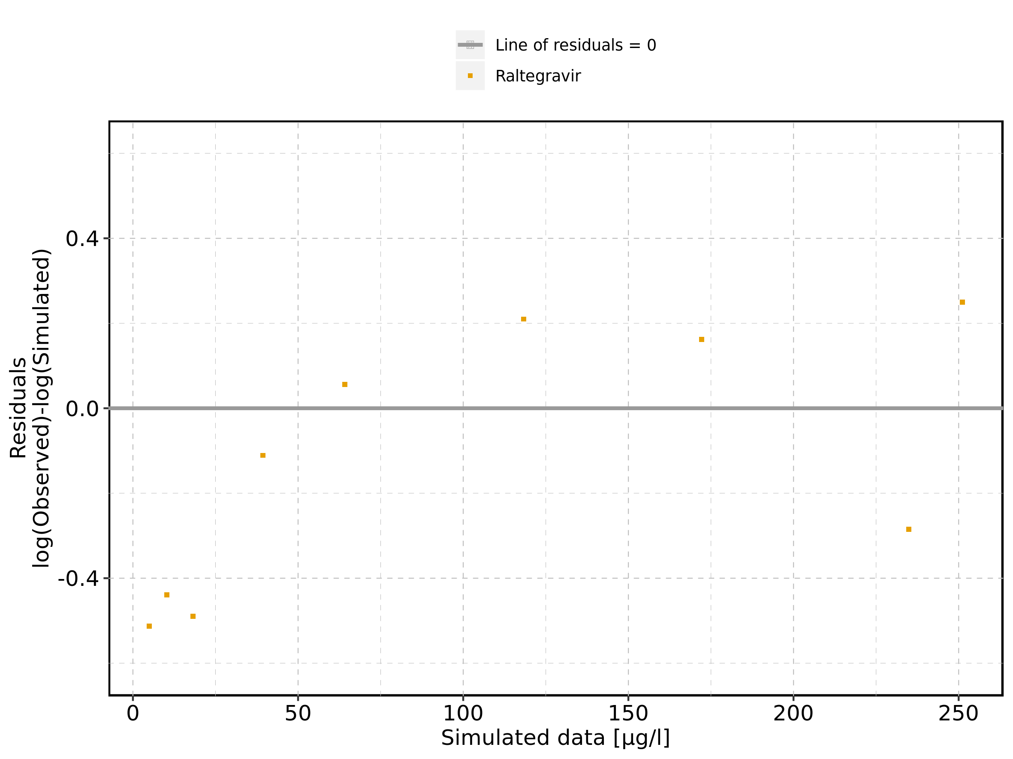

Figure 110: Logarithmic residuals vs time of Raltegravir 25 mg (lactose formulation) for Raltegravir 25 mg (lactose formulation). Data source: Data/Raltegravir_PK.txt.

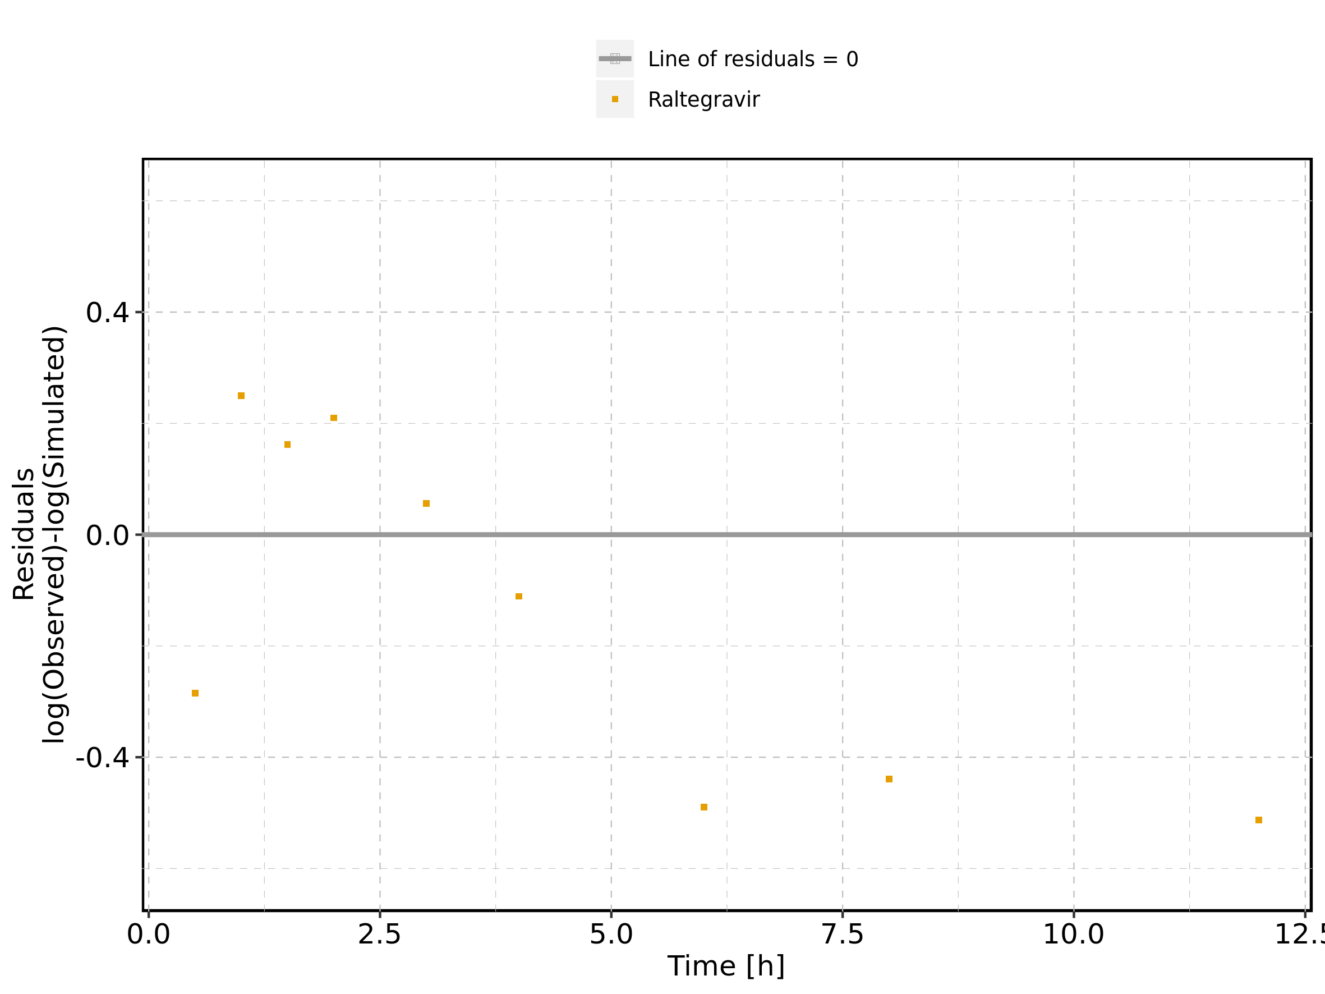

Figure 111: Logarithmic residuals distribution of Raltegravir 25 mg (lactose formulation) for Raltegravir 25 mg (lactose formulation). Data source: Data/Raltegravir_PK.txt.

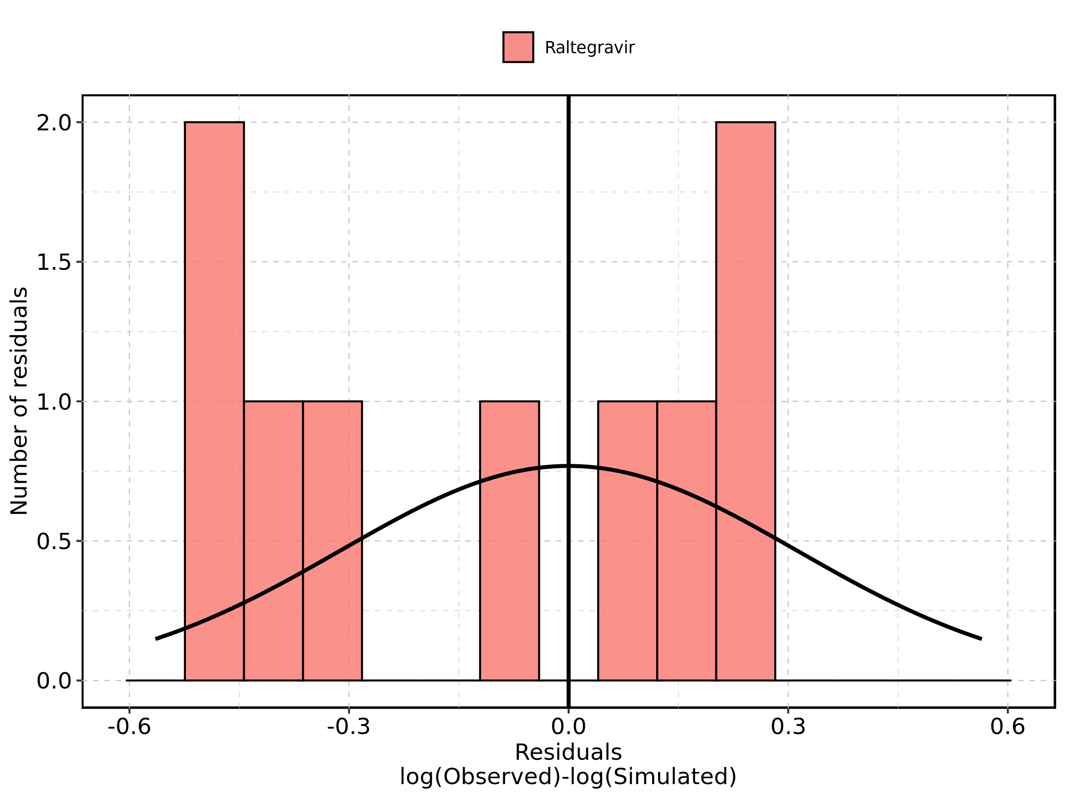

Figure 112: Logarithmic residuals of Raltegravir 25 mg (lactose formulation) for Raltegravir 25 mg (lactose formulation) as quantile-quantile plot. Data source: Data/Raltegravir_PK.txt.

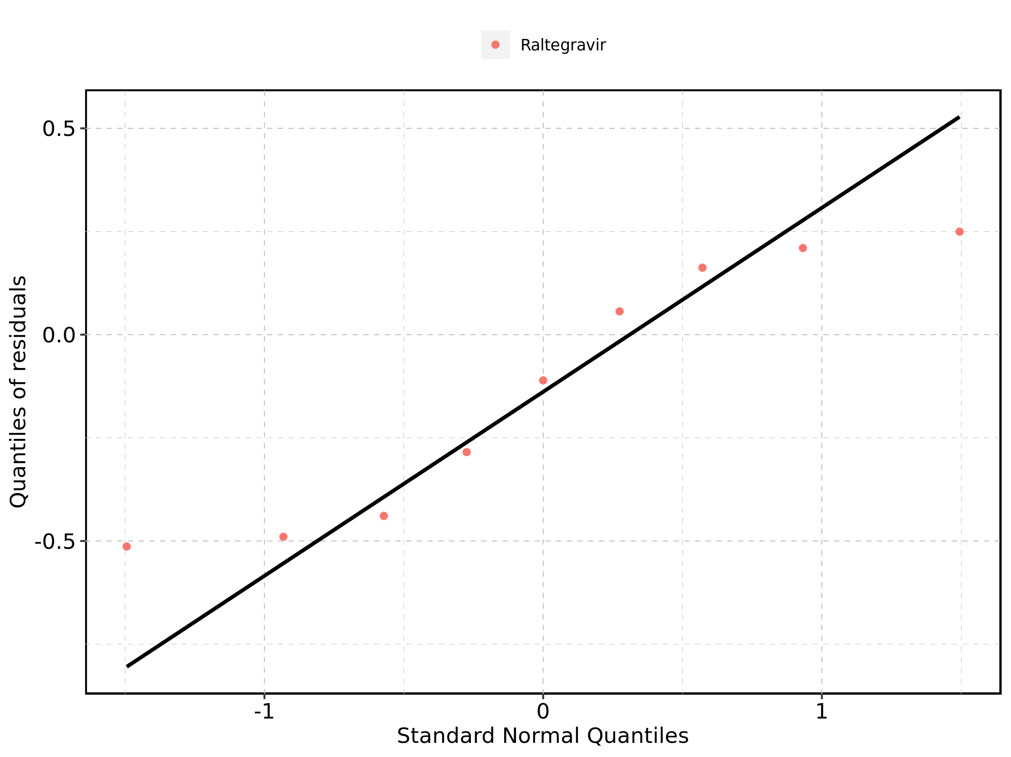

## 4.3. Time profiles and residual plots for Raltegravir 50 mg (lactose formulation)

Figure 113: Time profiles of Raltegravir 50 mg (lactose formulation) for Raltegravir 50 mg (lactose formulation). Data source: Data/Raltegravir_PK.txt. Time profiles are plotted in a linear scale.

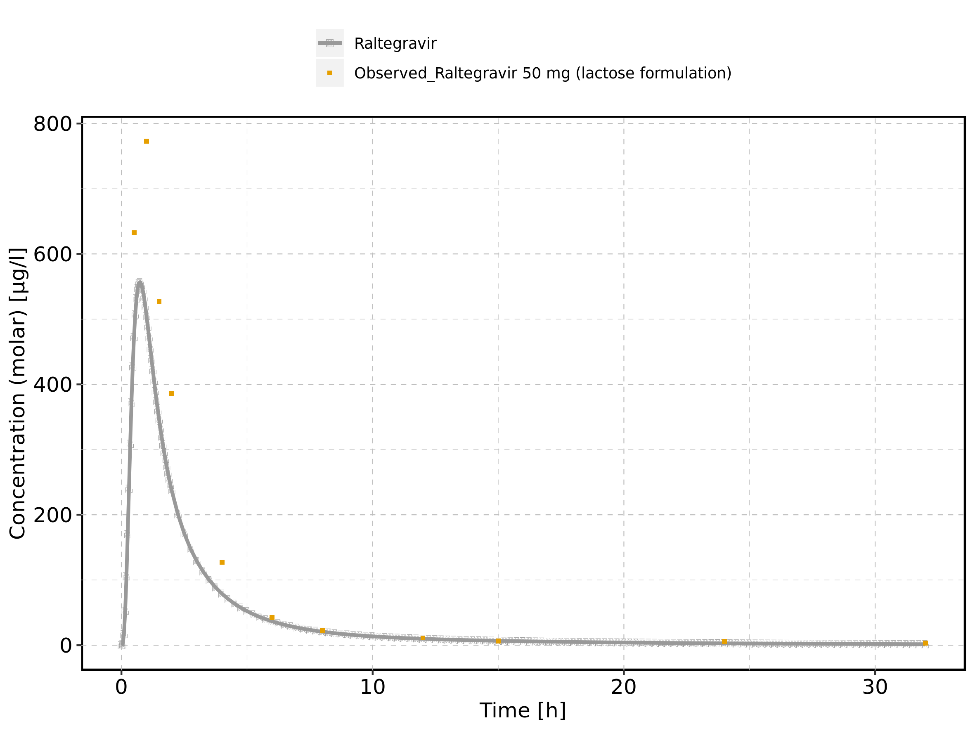

Figure 114: Time profiles of Raltegravir 50 mg (lactose formulation) for Raltegravir 50 mg (lactose formulation). Data source: Data/Raltegravir_PK.txt. Time profiles are plotted in a logarithmic scale.

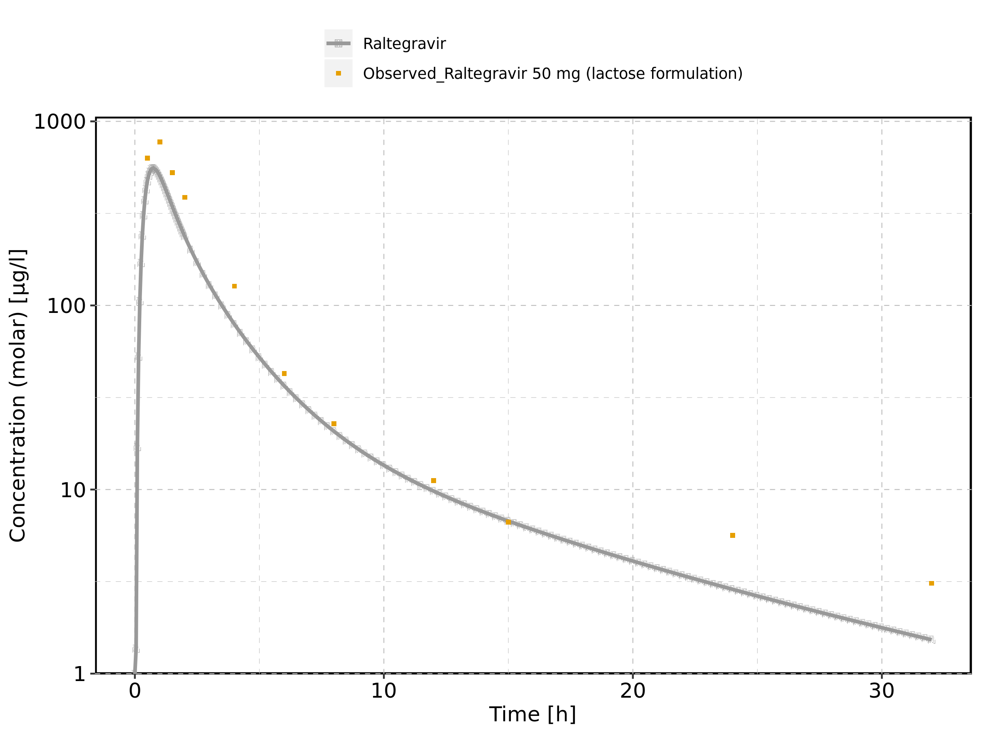

Figure 115: Predicted vs observed of Raltegravir 50 mg (lactose formulation) for Raltegravir 50 mg (lactose formulation). Data source: Data/Raltegravir_PK.txt. Predictions and observations are plotted in a linear scale.

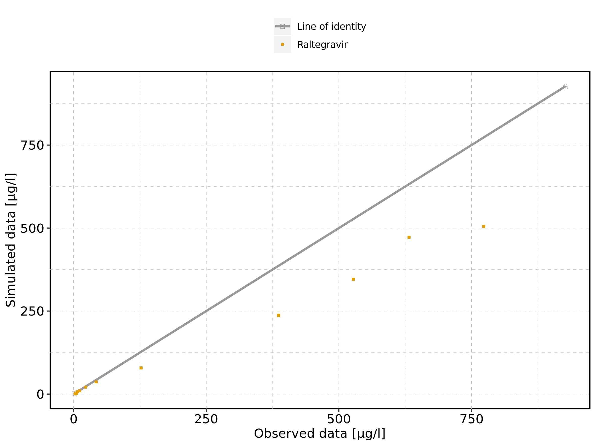

Figure 116: Predicted vs observed of Raltegravir 50 mg (lactose formulation) for Raltegravir 50 mg (lactose formulation). Data source: Data/Raltegravir_PK.txt. Predictions and observations are plotted in a logarithmic scale.

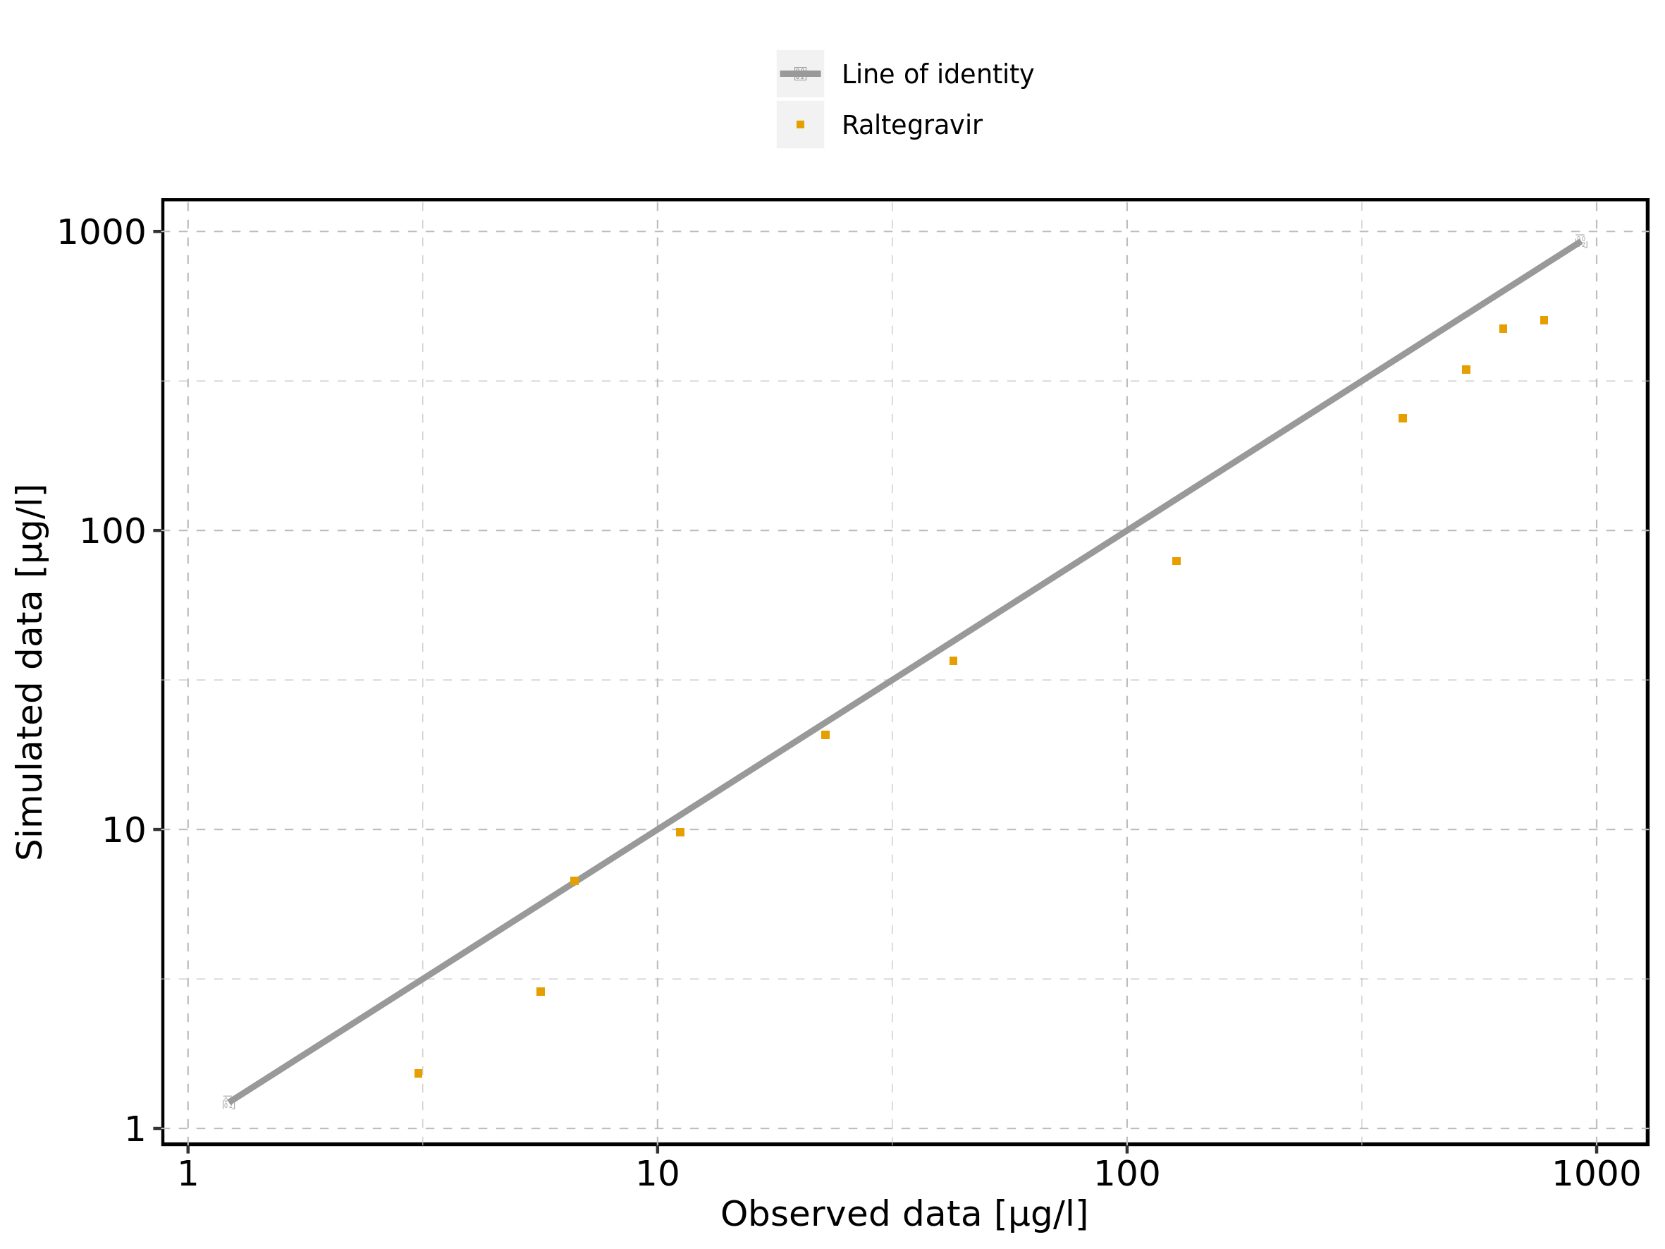

Figure 117: Logarithmic residuals vs predicted values of Raltegravir 50 mg (lactose formulation) for Raltegravir 50 mg (lactose formulation). Data source: Data/Raltegravir_PK.txt.

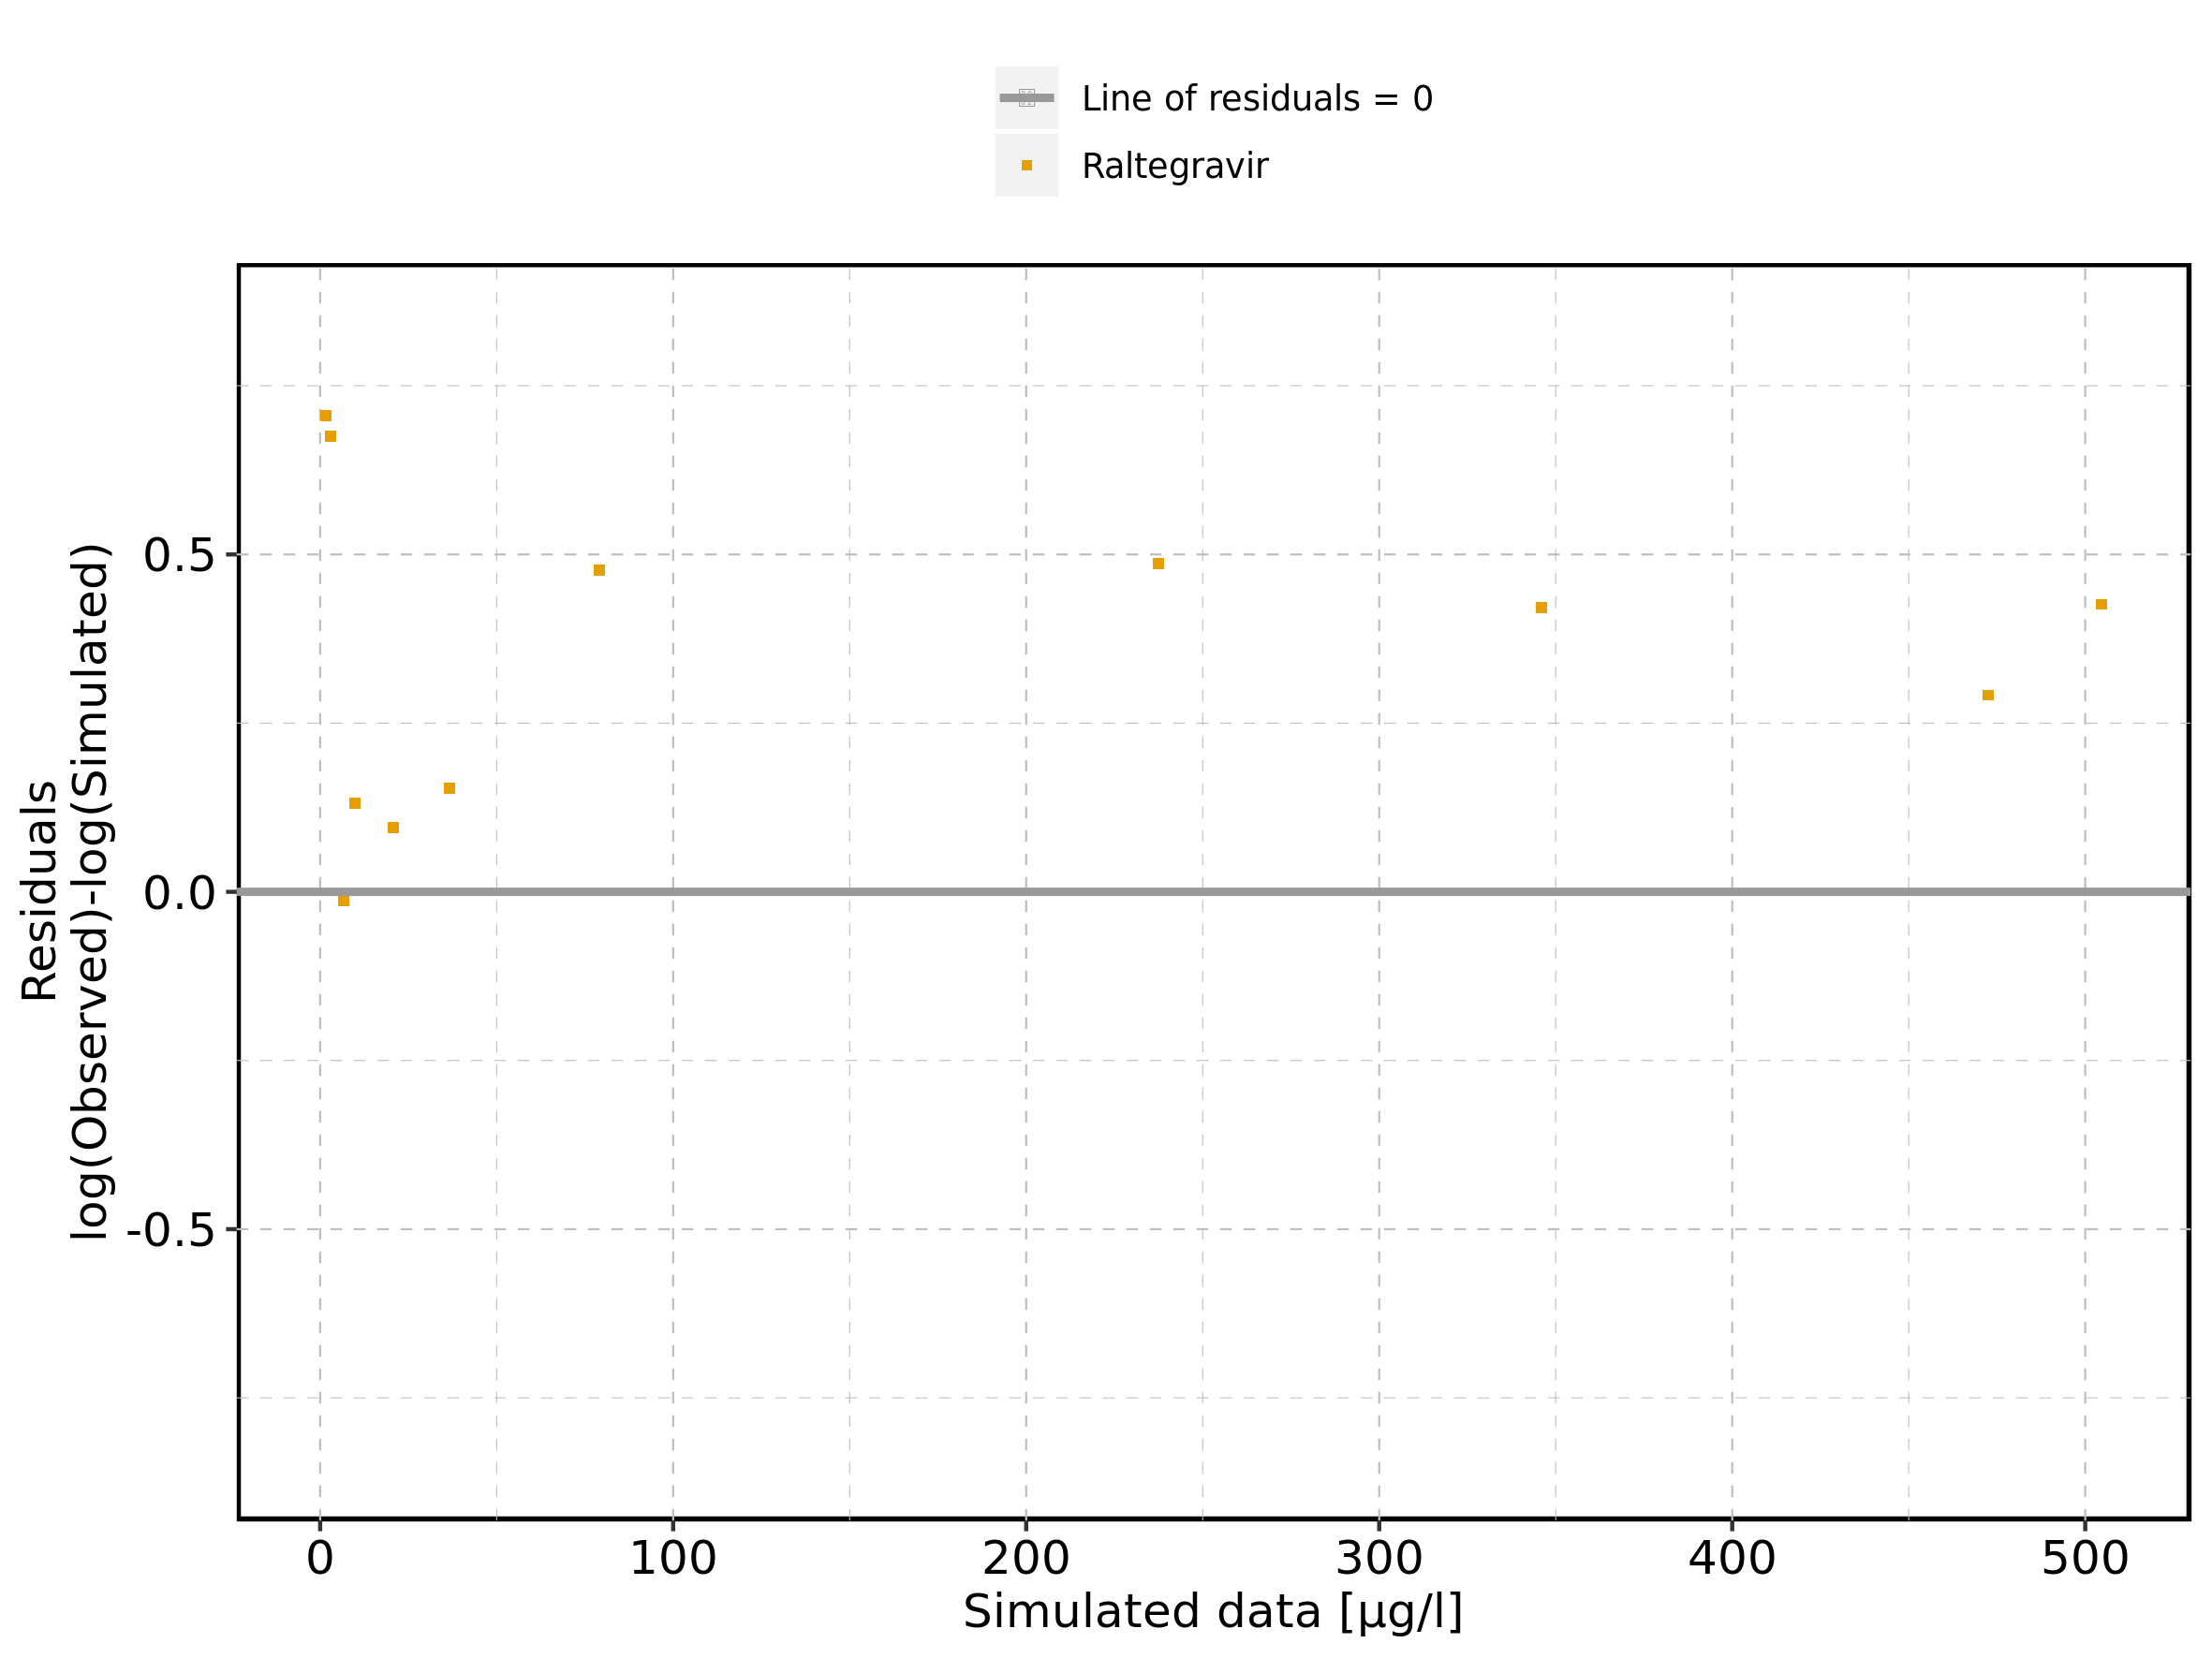

Figure 118: Logarithmic residuals vs time of Raltegravir 50 mg (lactose formulation) for Raltegravir 50 mg (lactose formulation). Data source: Data/Raltegravir_PK.txt.

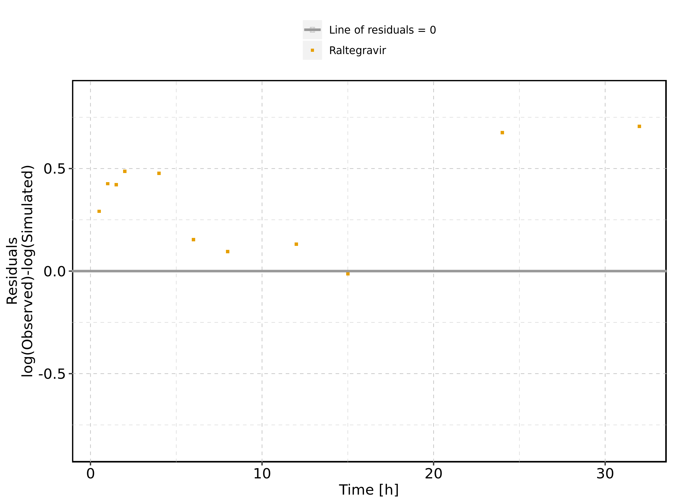

Figure 119: Logarithmic residuals distribution of Raltegravir 50 mg (lactose formulation) for Raltegravir 50 mg (lactose formulation). Data source: Data/Raltegravir_PK.txt.

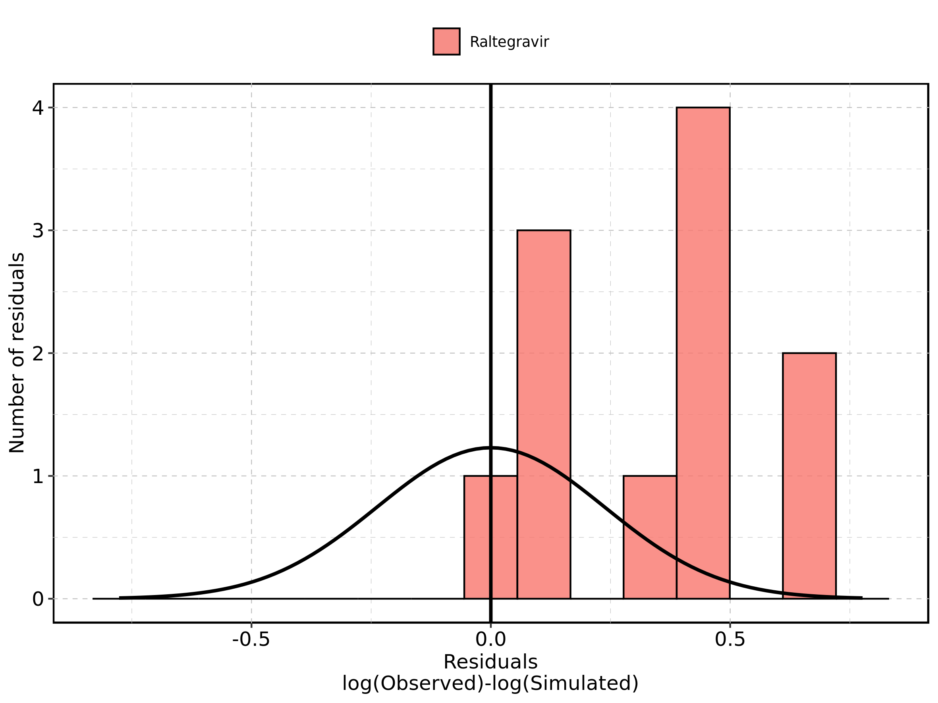

Figure 120: Logarithmic residuals of Raltegravir 50 mg (lactose formulation) for Raltegravir 50 mg (lactose formulation) as quantile-quantile plot. Data source: Data/Raltegravir_PK.txt.

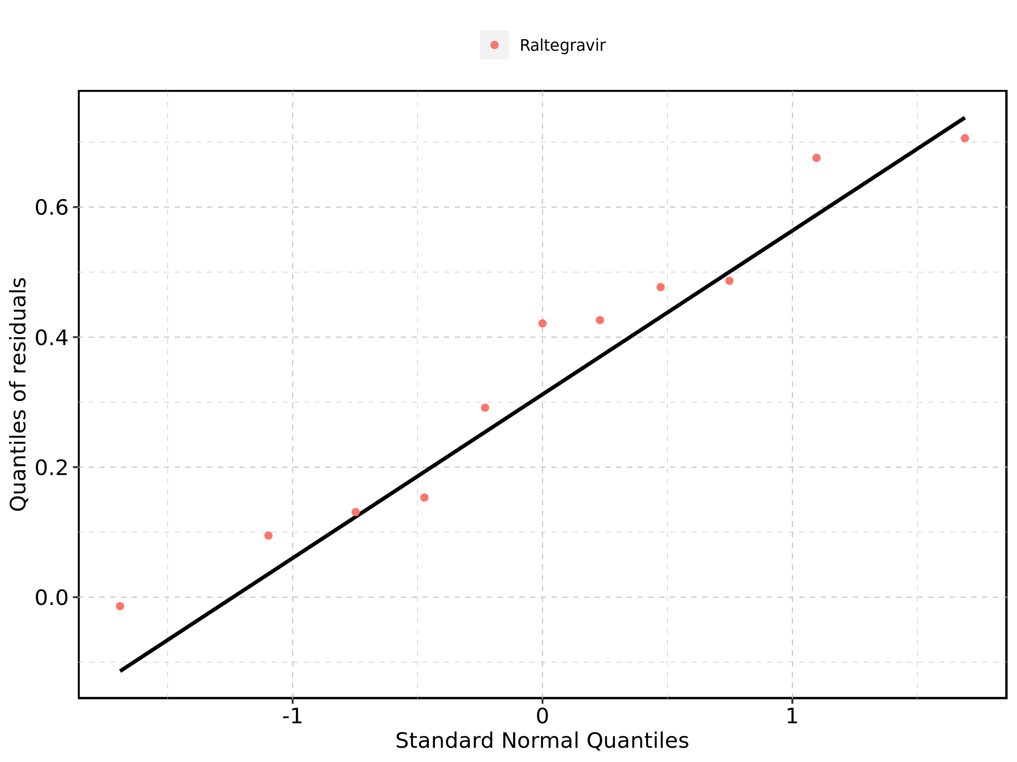

## 4.4. Time profiles and residual plots for Raltegravir 100 mg (lactose formulation)

Figure 121: Time profiles of Raltegravir 100 mg (lactose formulation) for Raltegravir 100 mg (lactose formulation). Data source: Data/Raltegravir_PK.txt. Time profiles are plotted in a linear scale.

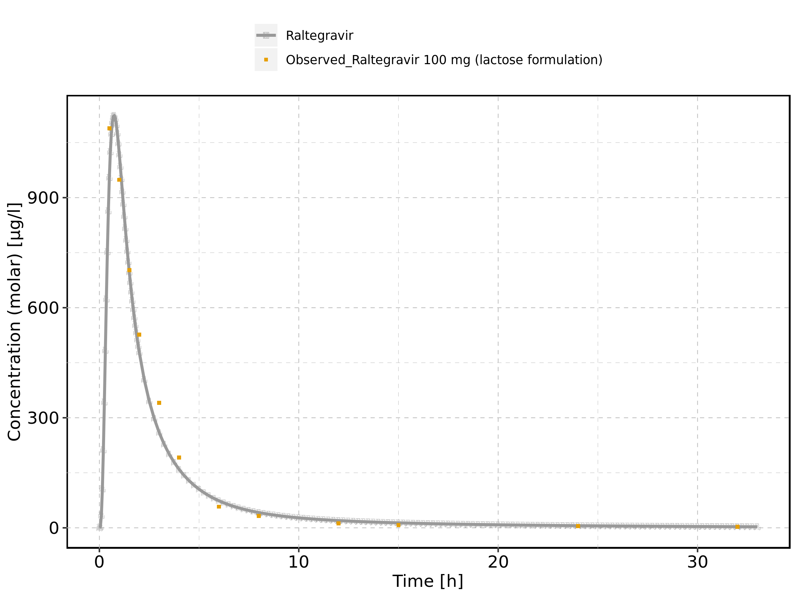

Figure 122: Time profiles of Raltegravir 100 mg (lactose formulation) for Raltegravir 100 mg (lactose formulation). Data source: Data/Raltegravir_PK.txt. Time profiles are plotted in a logarithmic scale.

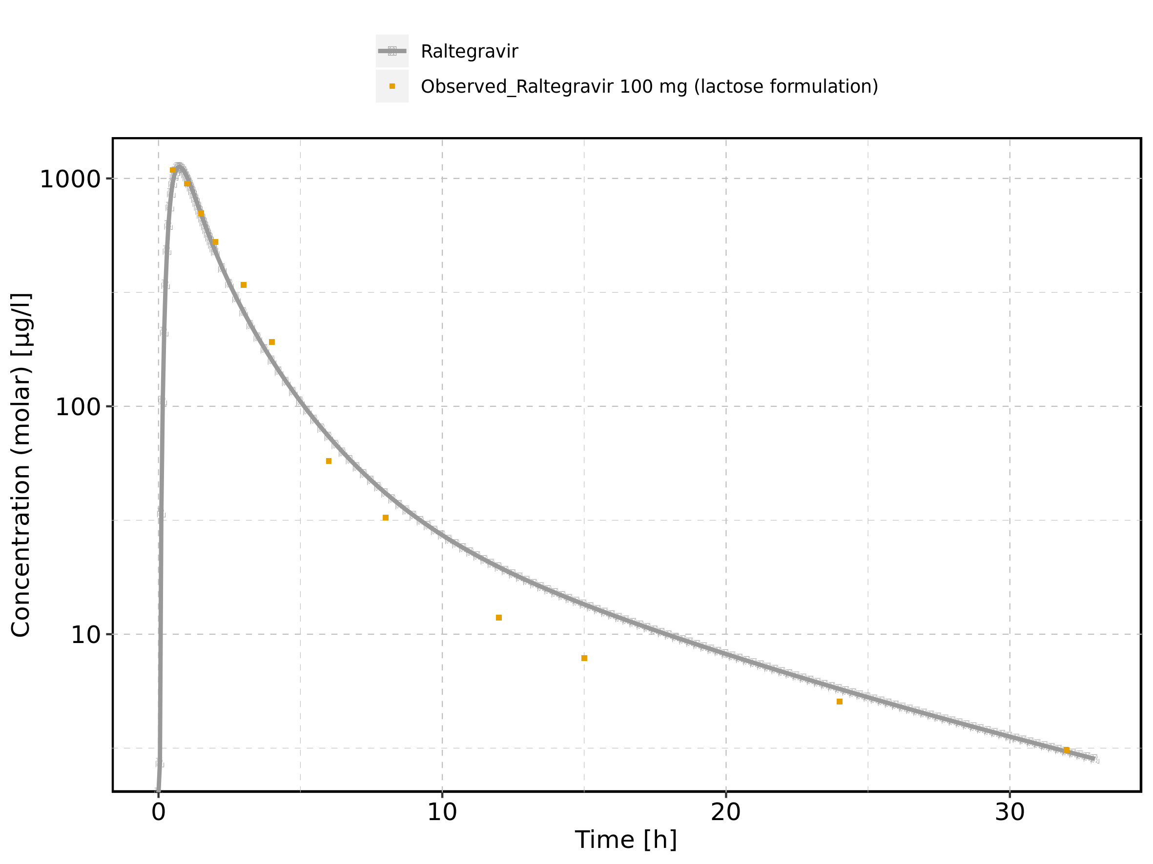

Figure 123: Predicted vs observed of Raltegravir 100 mg (lactose formulation) for Raltegravir 100 mg (lactose formulation). Data source: Data/Raltegravir_PK.txt. Predictions and observations are plotted in a linear scale.

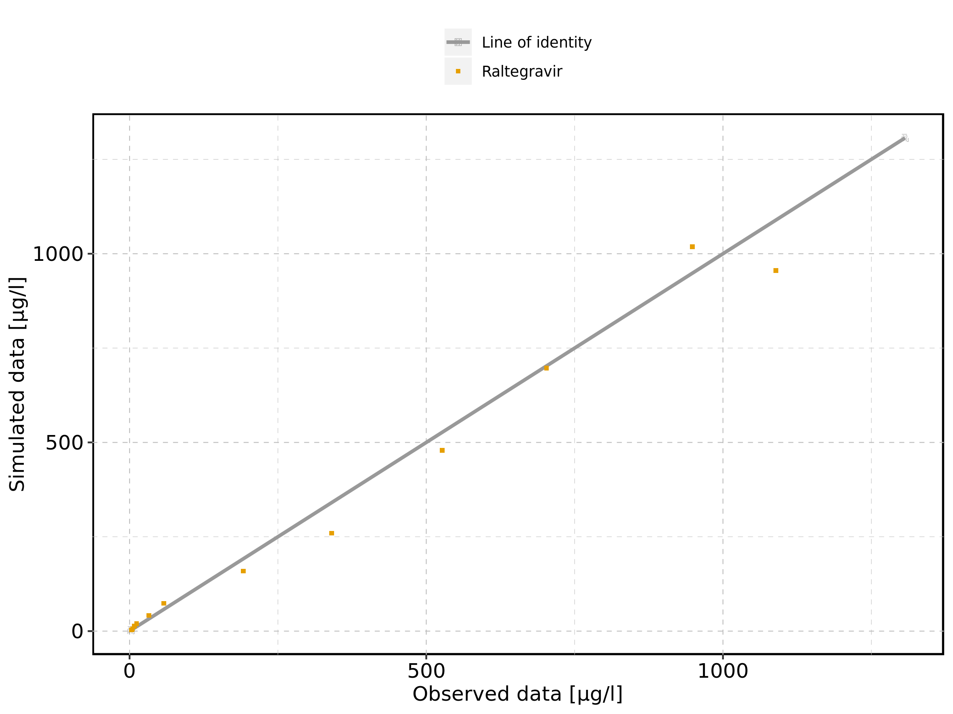

Figure 124: Predicted vs observed of Raltegravir 100 mg (lactose formulation) for Raltegravir 100 mg (lactose formulation). Data source: Data/Raltegravir_PK.txt. Predictions and observations are plotted in a logarithmic scale.

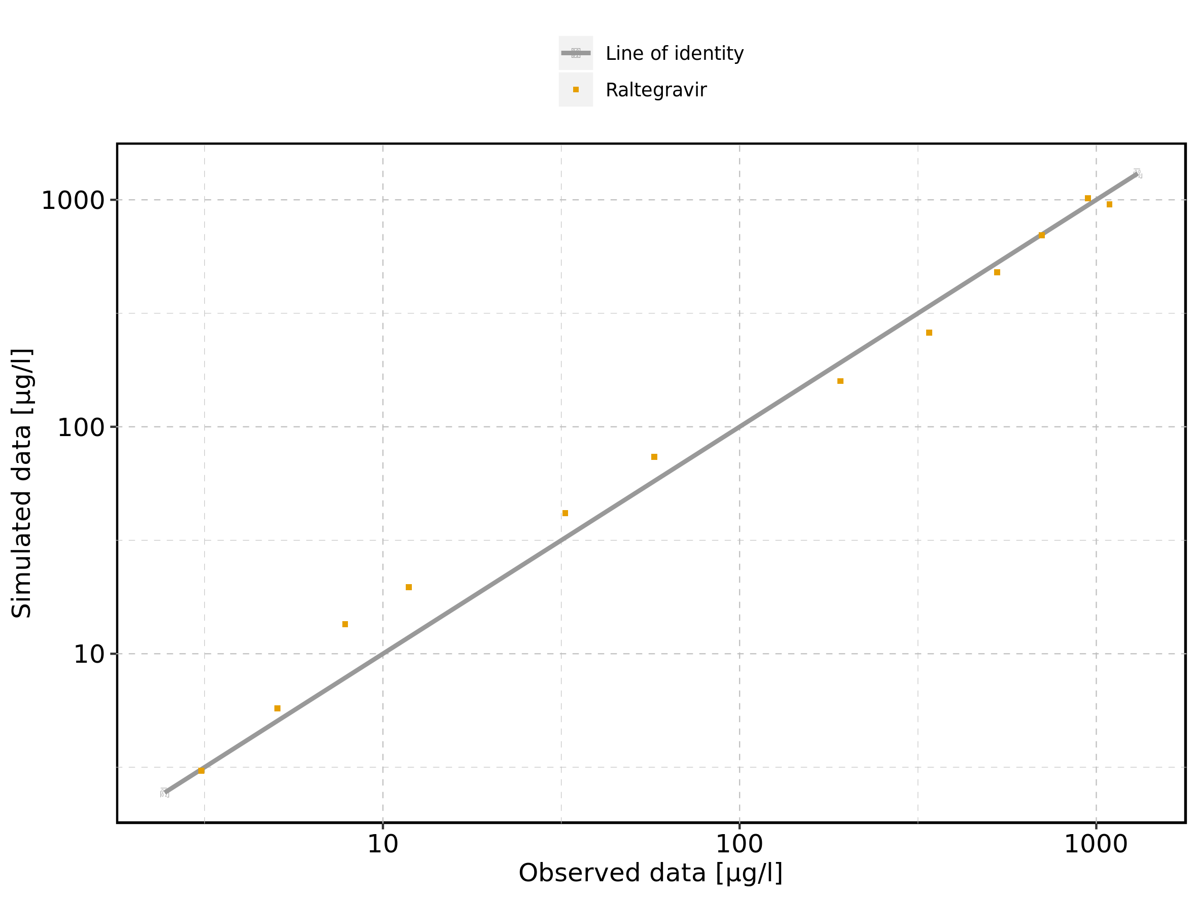

Figure 125: Logarithmic residuals vs predicted values of Raltegravir 100 mg (lactose formulation) for Raltegravir 100 mg (lactose formulation). Data source: Data/Raltegravir_PK.txt.

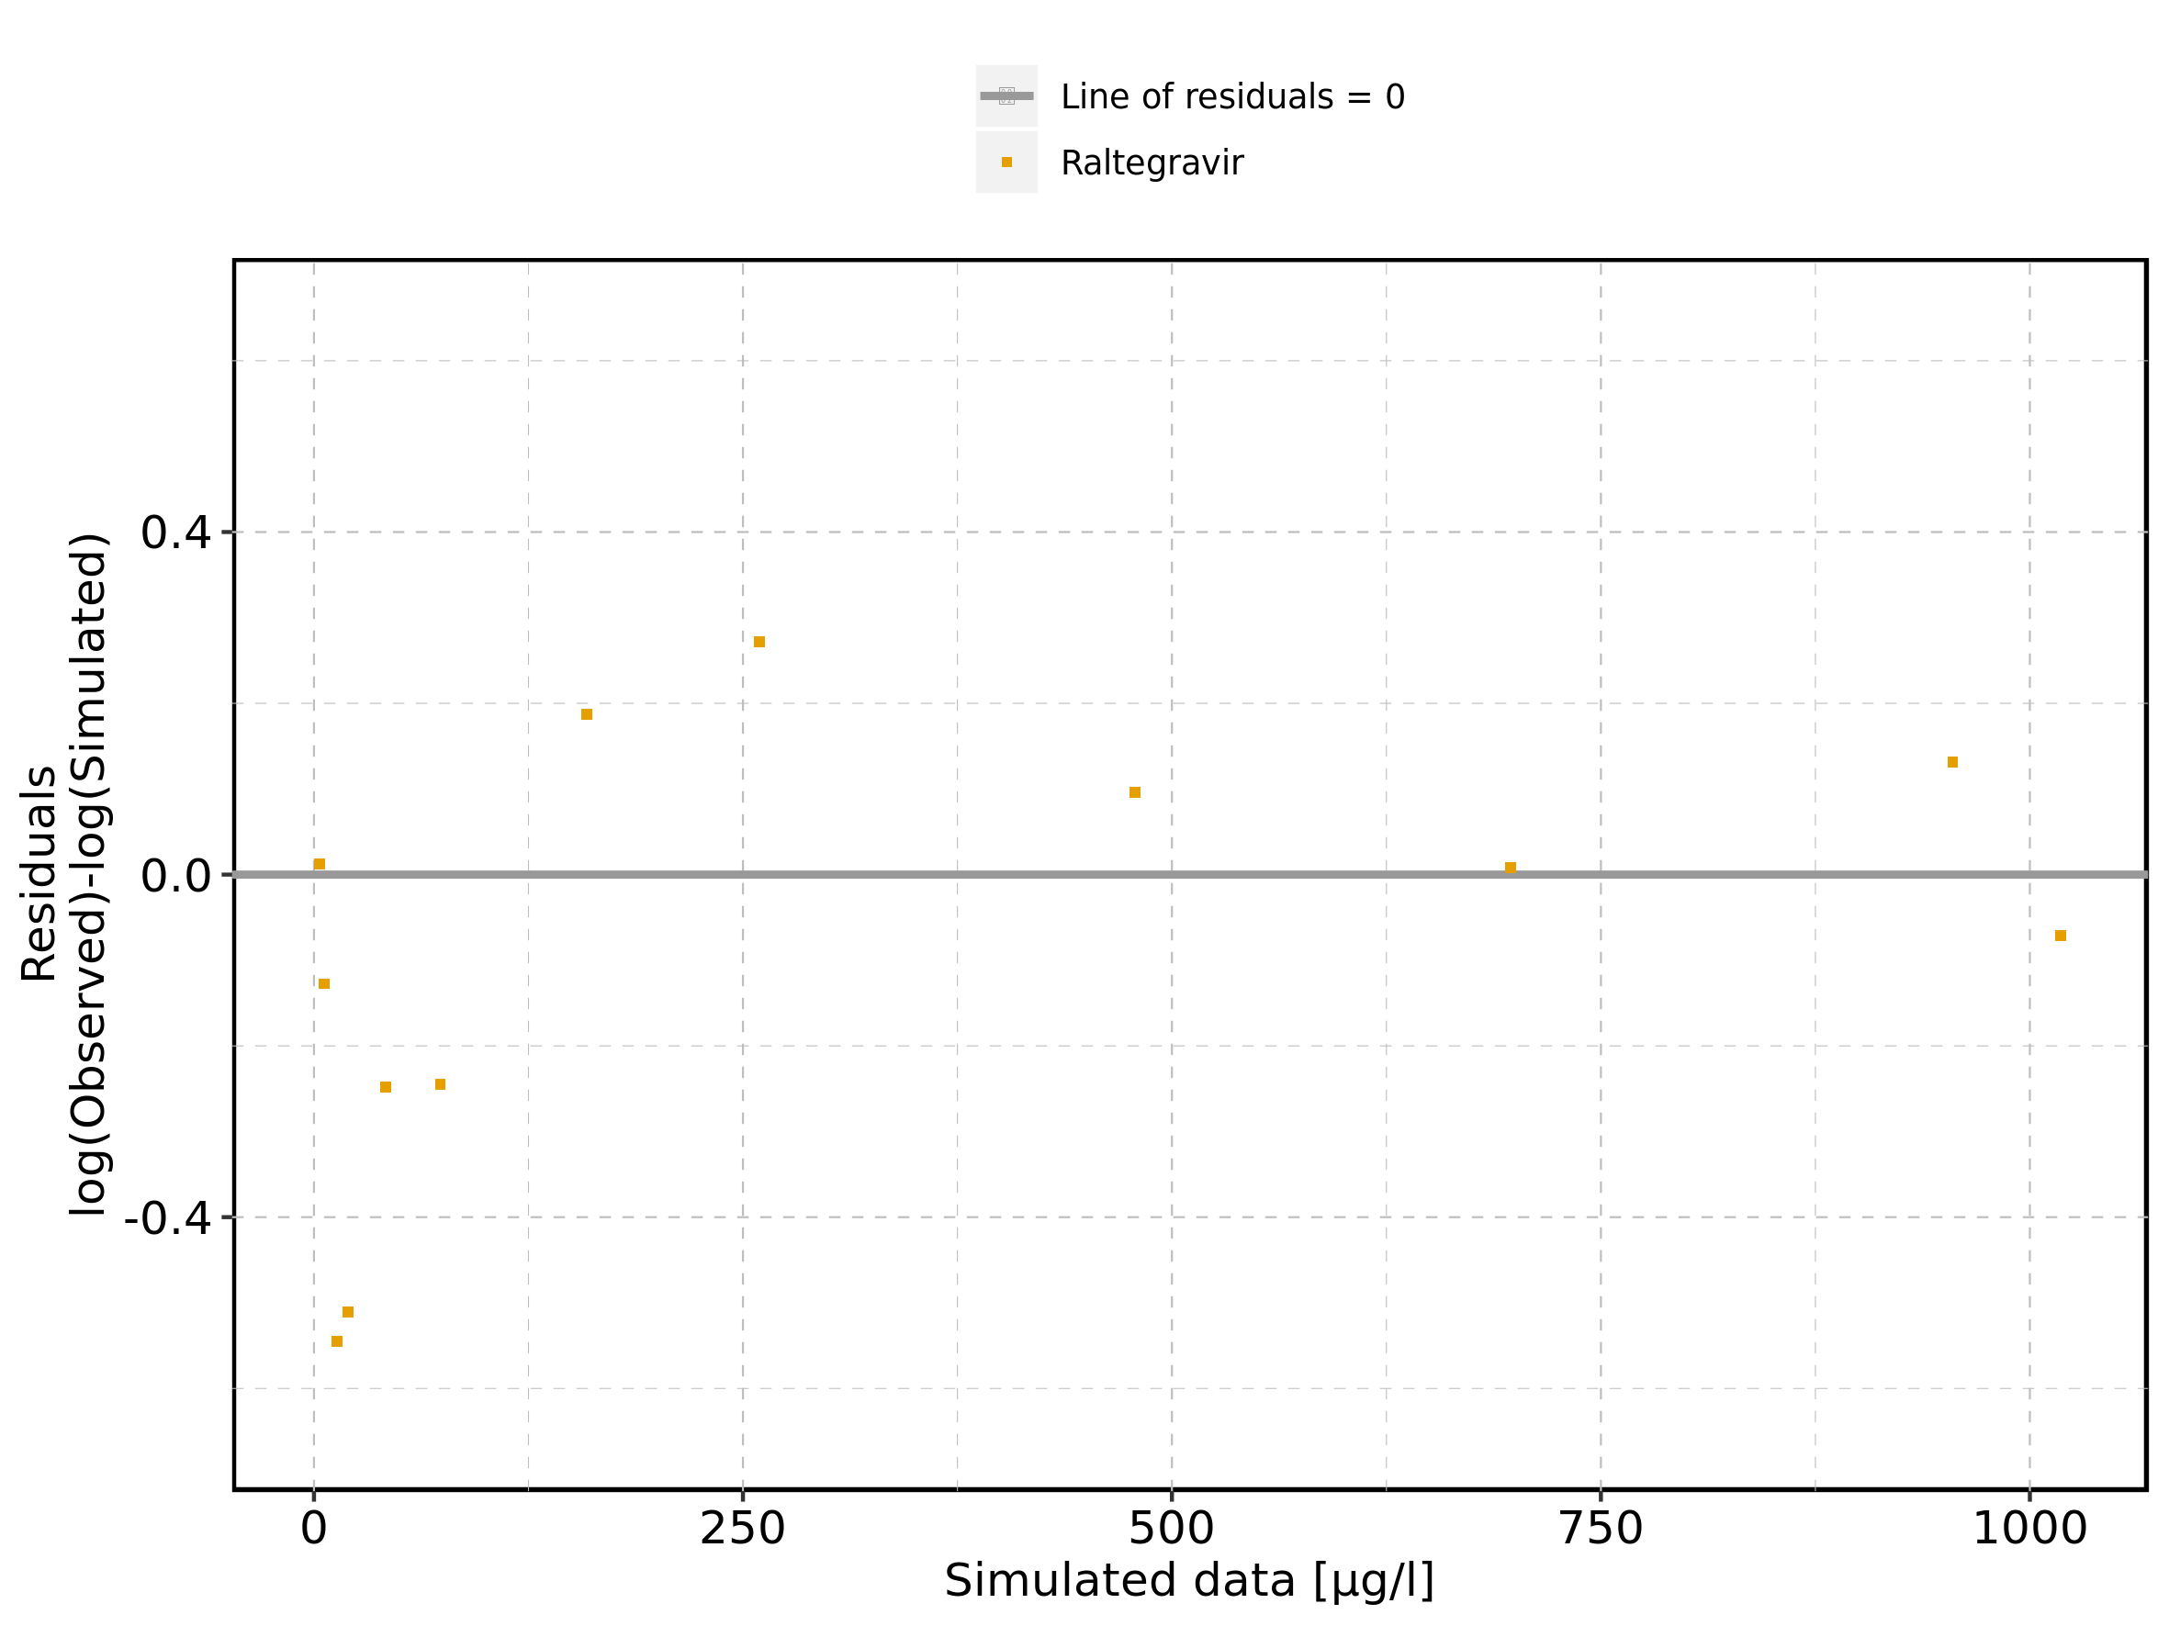

Figure 126: Logarithmic residuals vs time of Raltegravir 100 mg (lactose formulation) for Raltegravir 100 mg (lactose formulation). Data source: Data/Raltegravir_PK.txt.

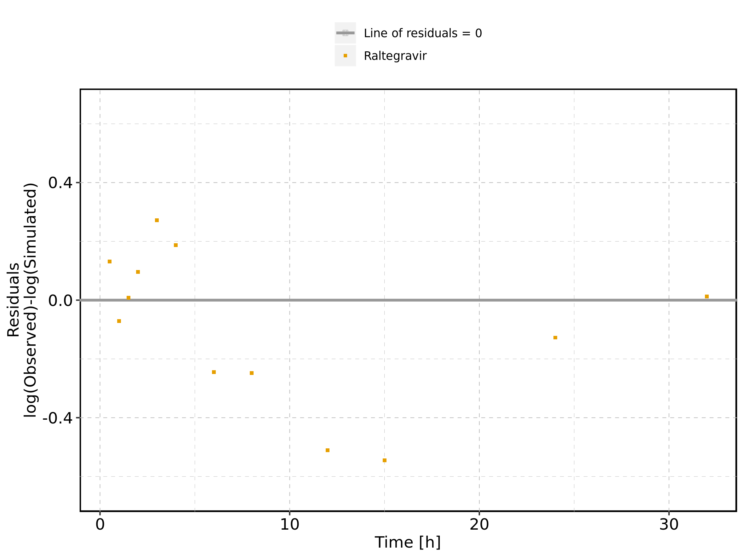

Figure 127: Logarithmic residuals distribution of Raltegravir 100 mg (lactose formulation) for Raltegravir 100 mg (lactose formulation). Data source: Data/Raltegravir_PK.txt.

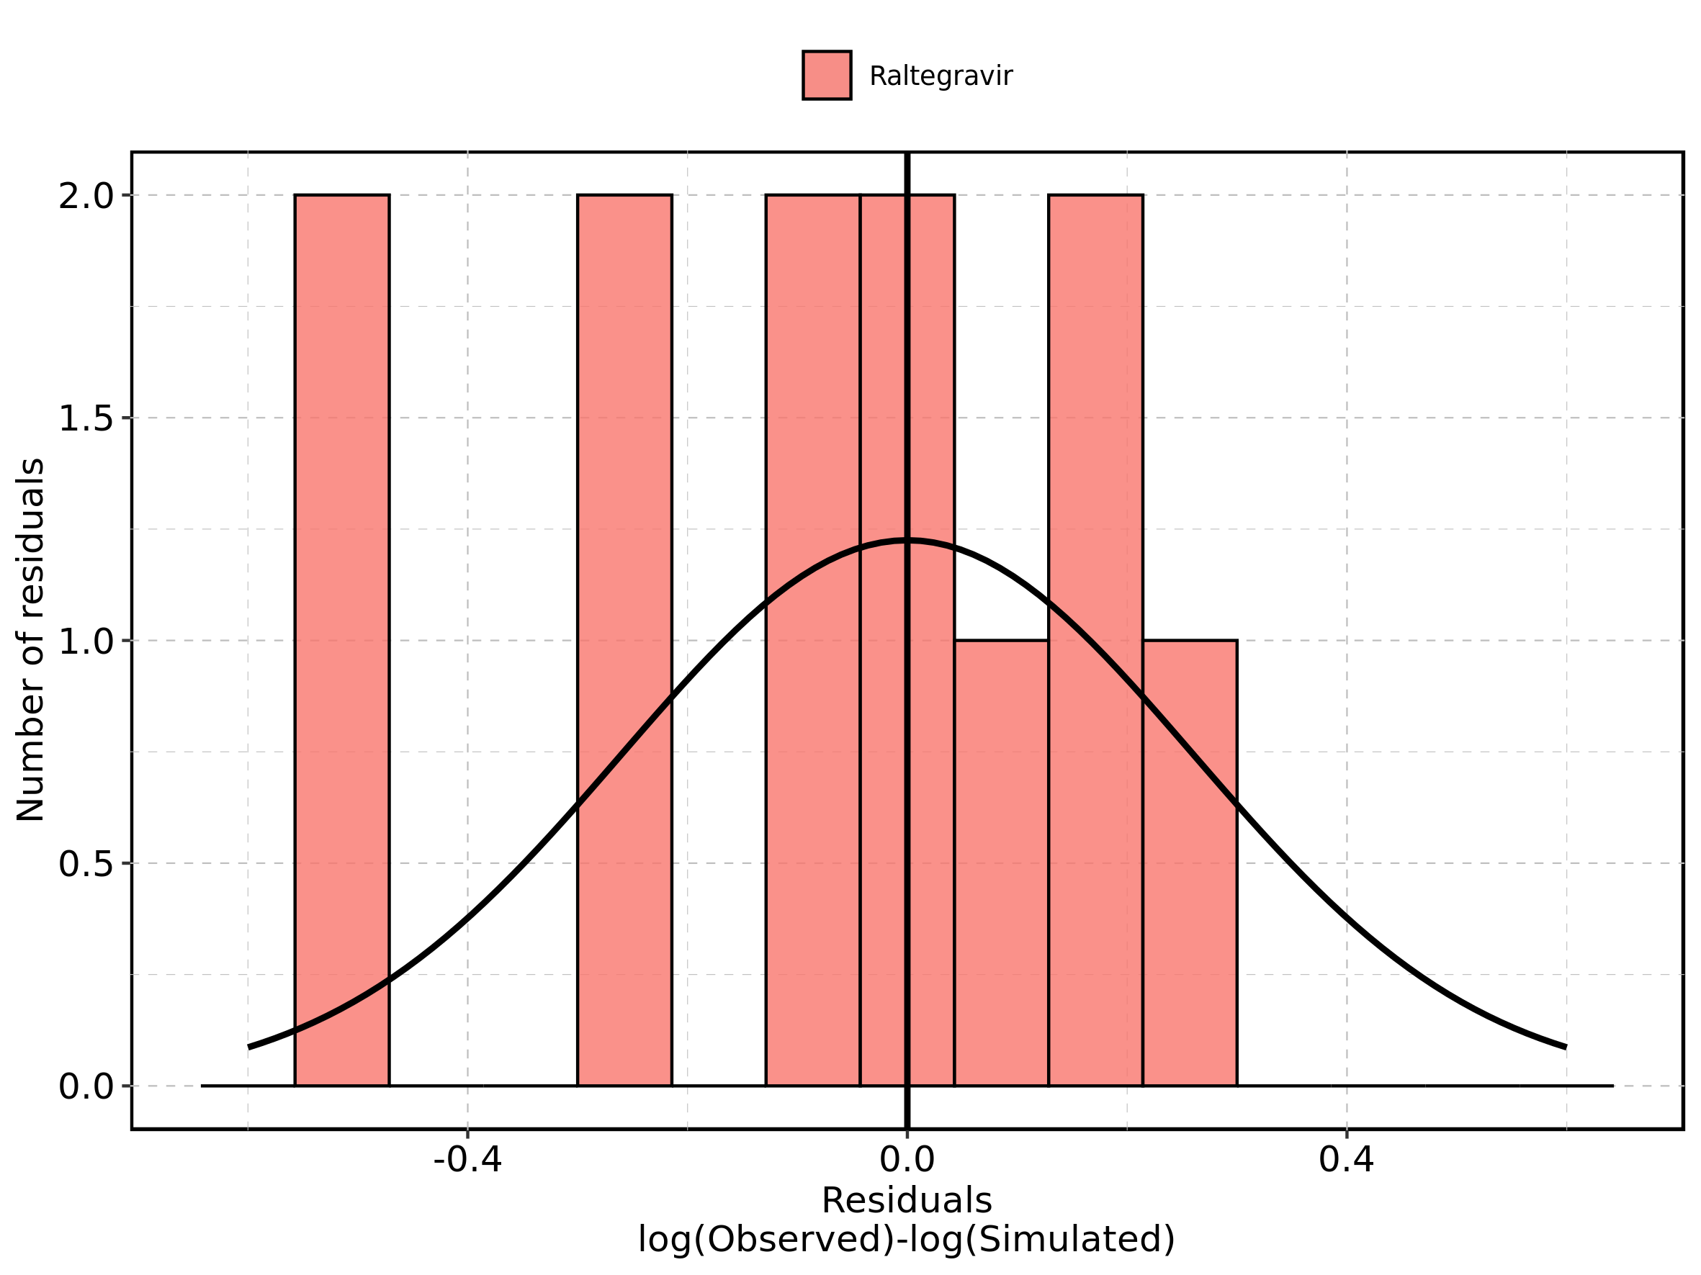

Figure 128: Logarithmic residuals of Raltegravir 100 mg (lactose formulation) for Raltegravir 100 mg (lactose formulation) as quantile-quantile plot. Data source: Data/Raltegravir_PK.txt.

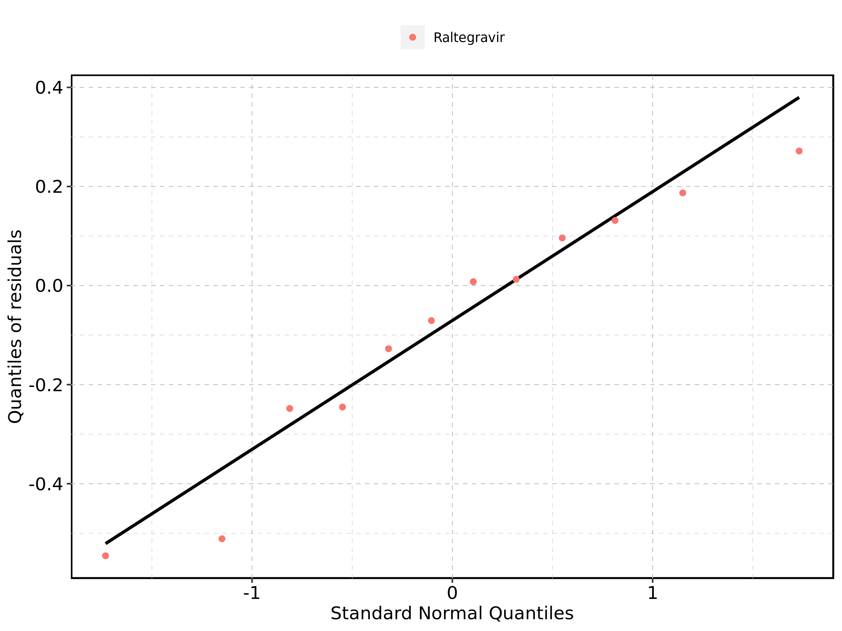

## 4.5. Time profiles and residual plots for Raltegravir 200 mg (lactose formulation)

Figure 129: Time profiles of Raltegravir 200 mg (lactose formulation) for Raltegravir 200 mg (lactose formulation). Data source: Data/Raltegravir_PK.txt. Time profiles are plotted in a linear scale.

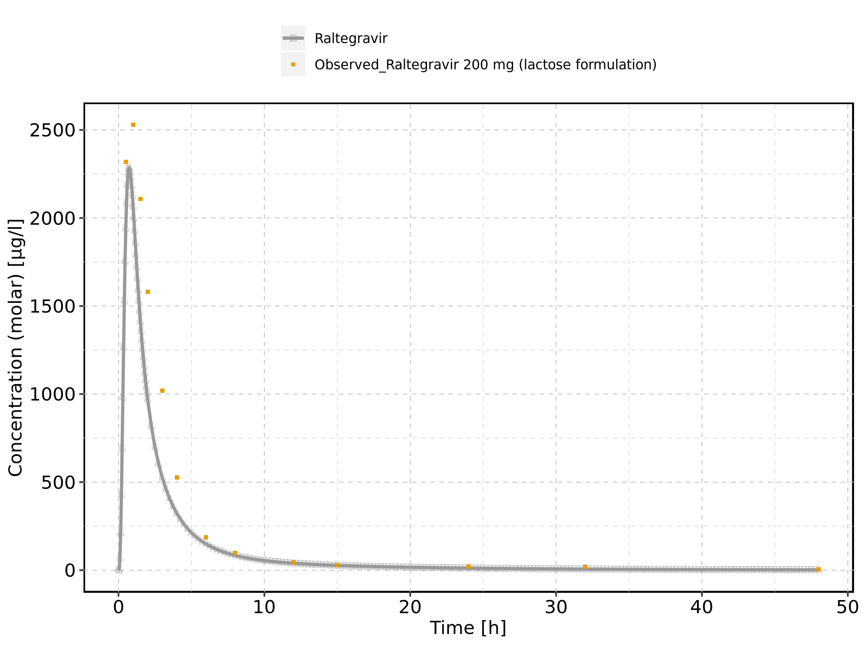

Figure 130: Time profiles of Raltegravir 200 mg (lactose formulation) for Raltegravir 200 mg (lactose formulation). Data source: Data/Raltegravir_PK.txt. Time profiles are plotted in a logarithmic scale.

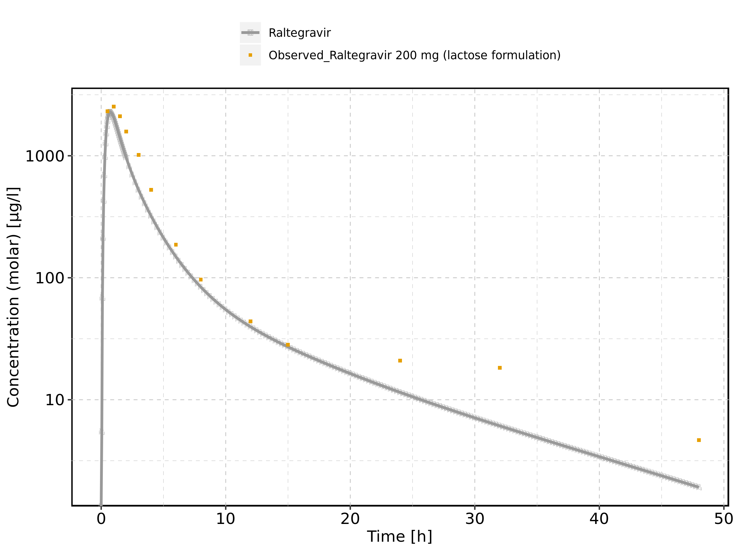

Figure 131: Predicted vs observed of Raltegravir 200 mg (lactose formulation) for Raltegravir 200 mg (lactose formulation). Data source: Data/Raltegravir_PK.txt. Predictions and observations are plotted in a linear scale.

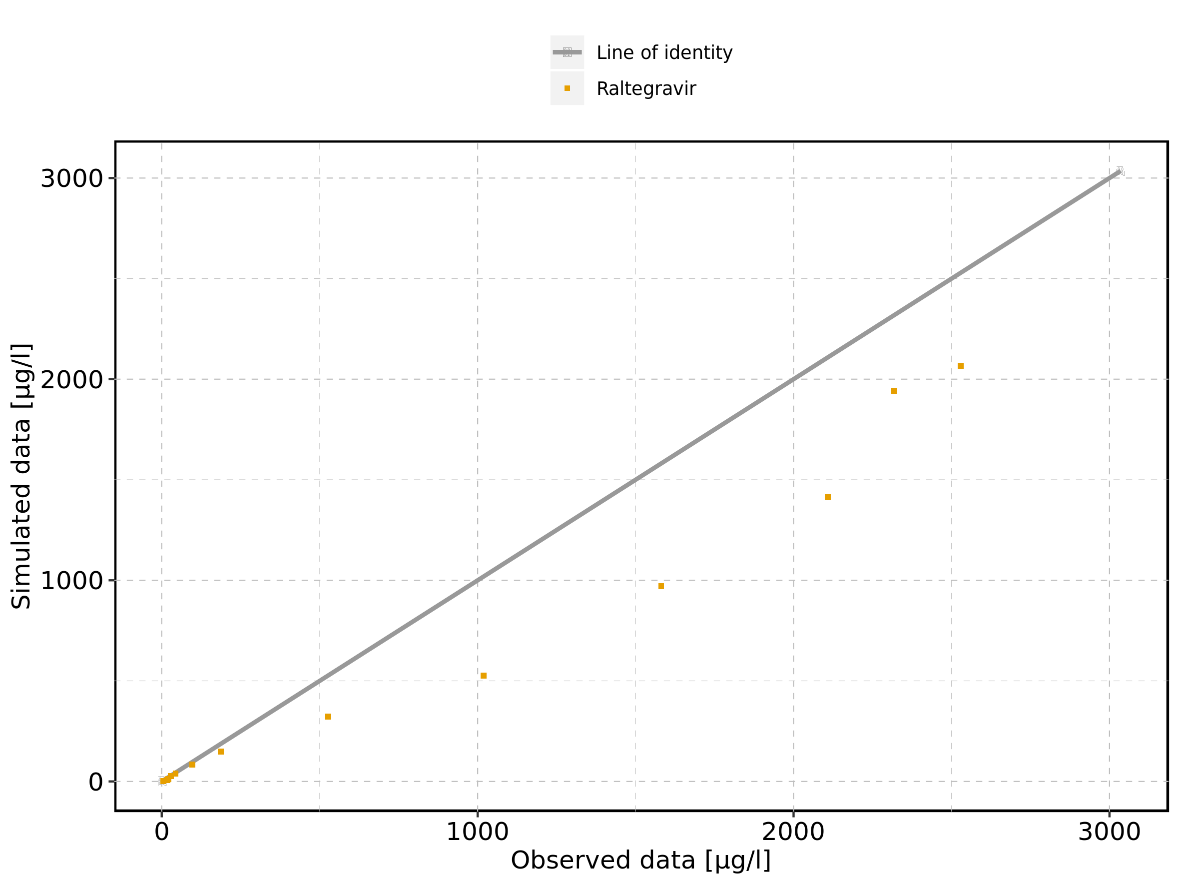

Figure 132: Predicted vs observed of Raltegravir 200 mg (lactose formulation) for Raltegravir 200 mg (lactose formulation). Data source: Data/Raltegravir_PK.txt. Predictions and observations are plotted in a logarithmic scale.

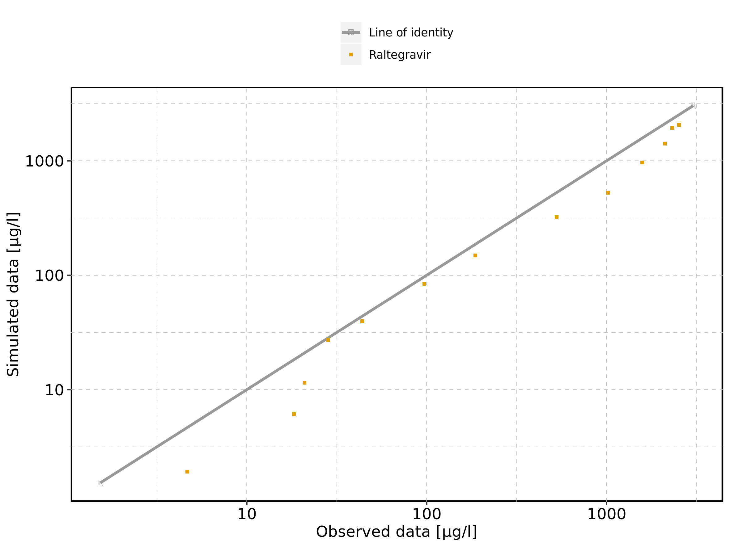

Figure 133: Logarithmic residuals vs predicted values of Raltegravir 200 mg (lactose formulation) for Raltegravir 200 mg (lactose formulation). Data source: Data/Raltegravir_PK.txt.

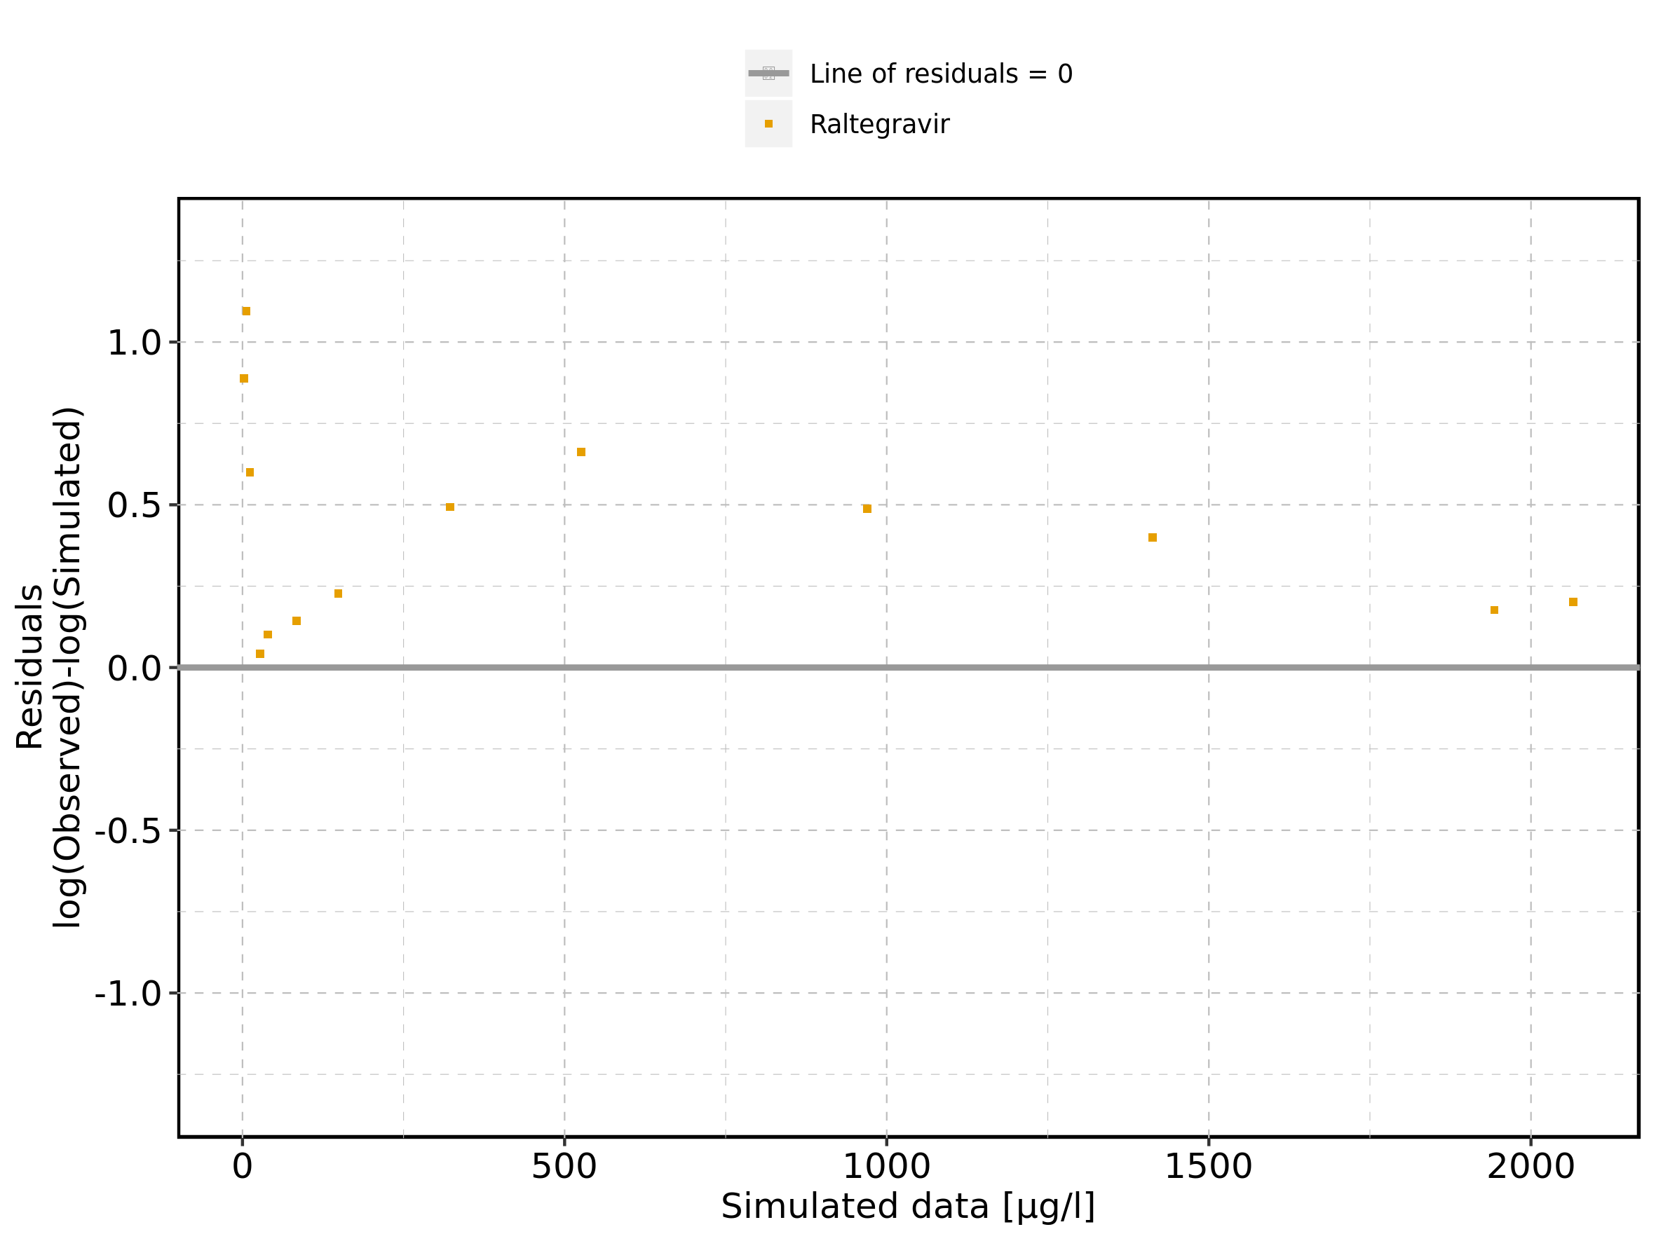

Figure 134: Logarithmic residuals vs time of Raltegravir 200 mg (lactose formulation) for Raltegravir 200 mg (lactose formulation). Data source: Data/Raltegravir_PK.txt.

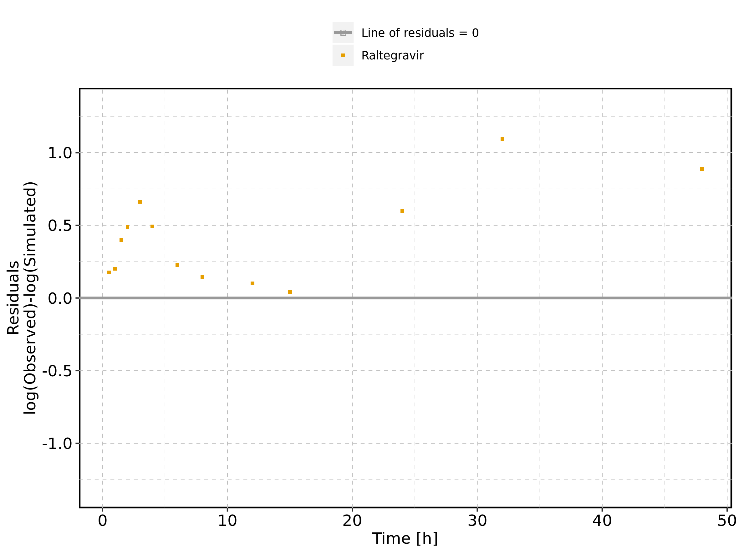

Figure 135: Logarithmic residuals distribution of Raltegravir 200 mg (lactose formulation) for Raltegravir 200 mg (lactose formulation). Data source: Data/Raltegravir_PK.txt.

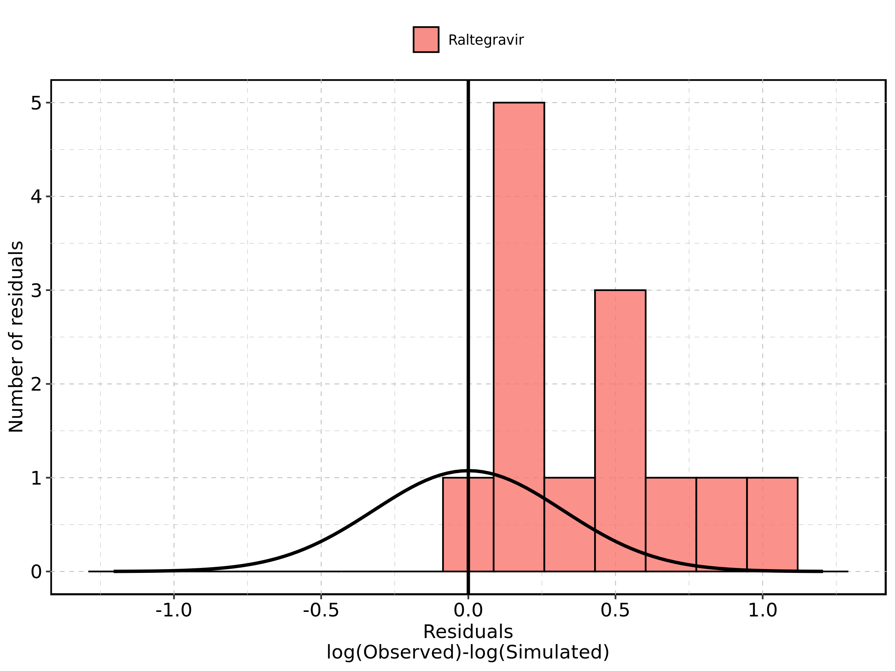

Figure 136: Logarithmic residuals of Raltegravir 200 mg (lactose formulation) for Raltegravir 200 mg (lactose formulation) as quantile-quantile plot. Data source: Data/Raltegravir_PK.txt.

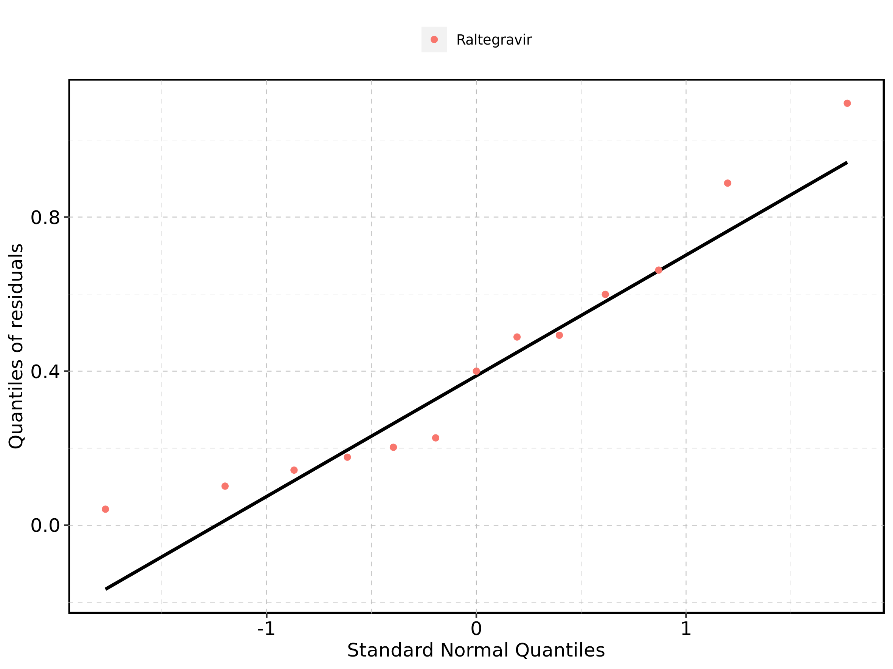

## 4.6. Time profiles and residual plots for Raltegravir 400mg (lactose formulation)

Figure 137: Time profiles of Raltegravir 400mg (lactose formulation) for Raltegravir 400mg (lactose formulation). Data source: Data/Raltegravir_PK.txt. Time profiles are plotted in a linear scale.

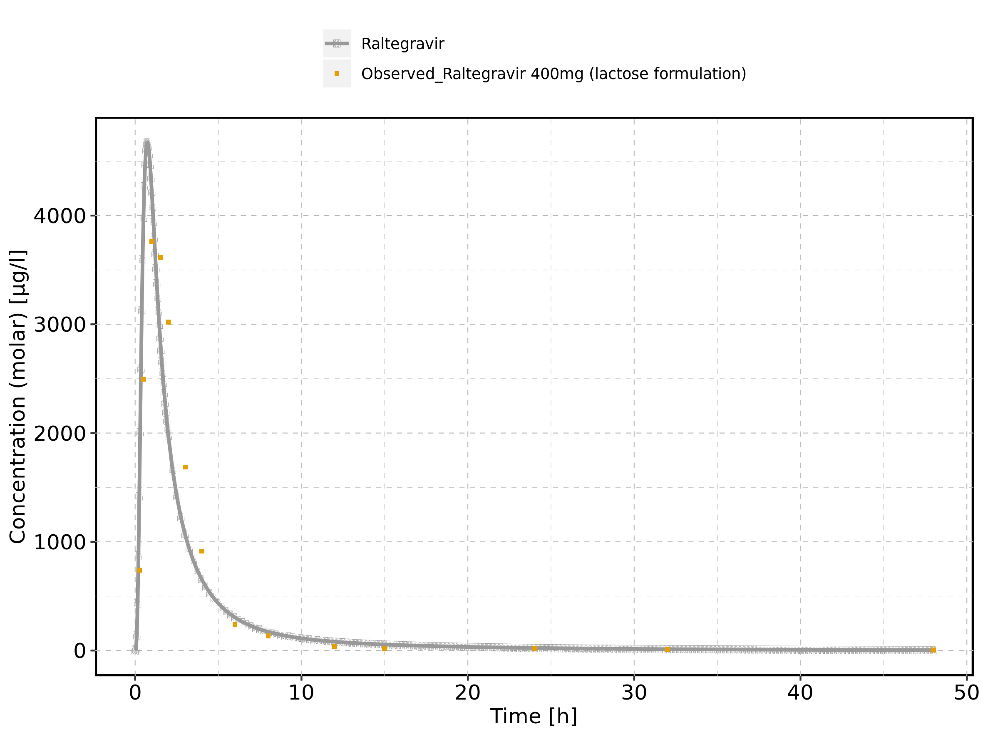

Figure 138: Time profiles of Raltegravir 400mg (lactose formulation) for Raltegravir 400mg (lactose formulation). Data source: Data/Raltegravir_PK.txt. Time profiles are plotted in a logarithmic scale.

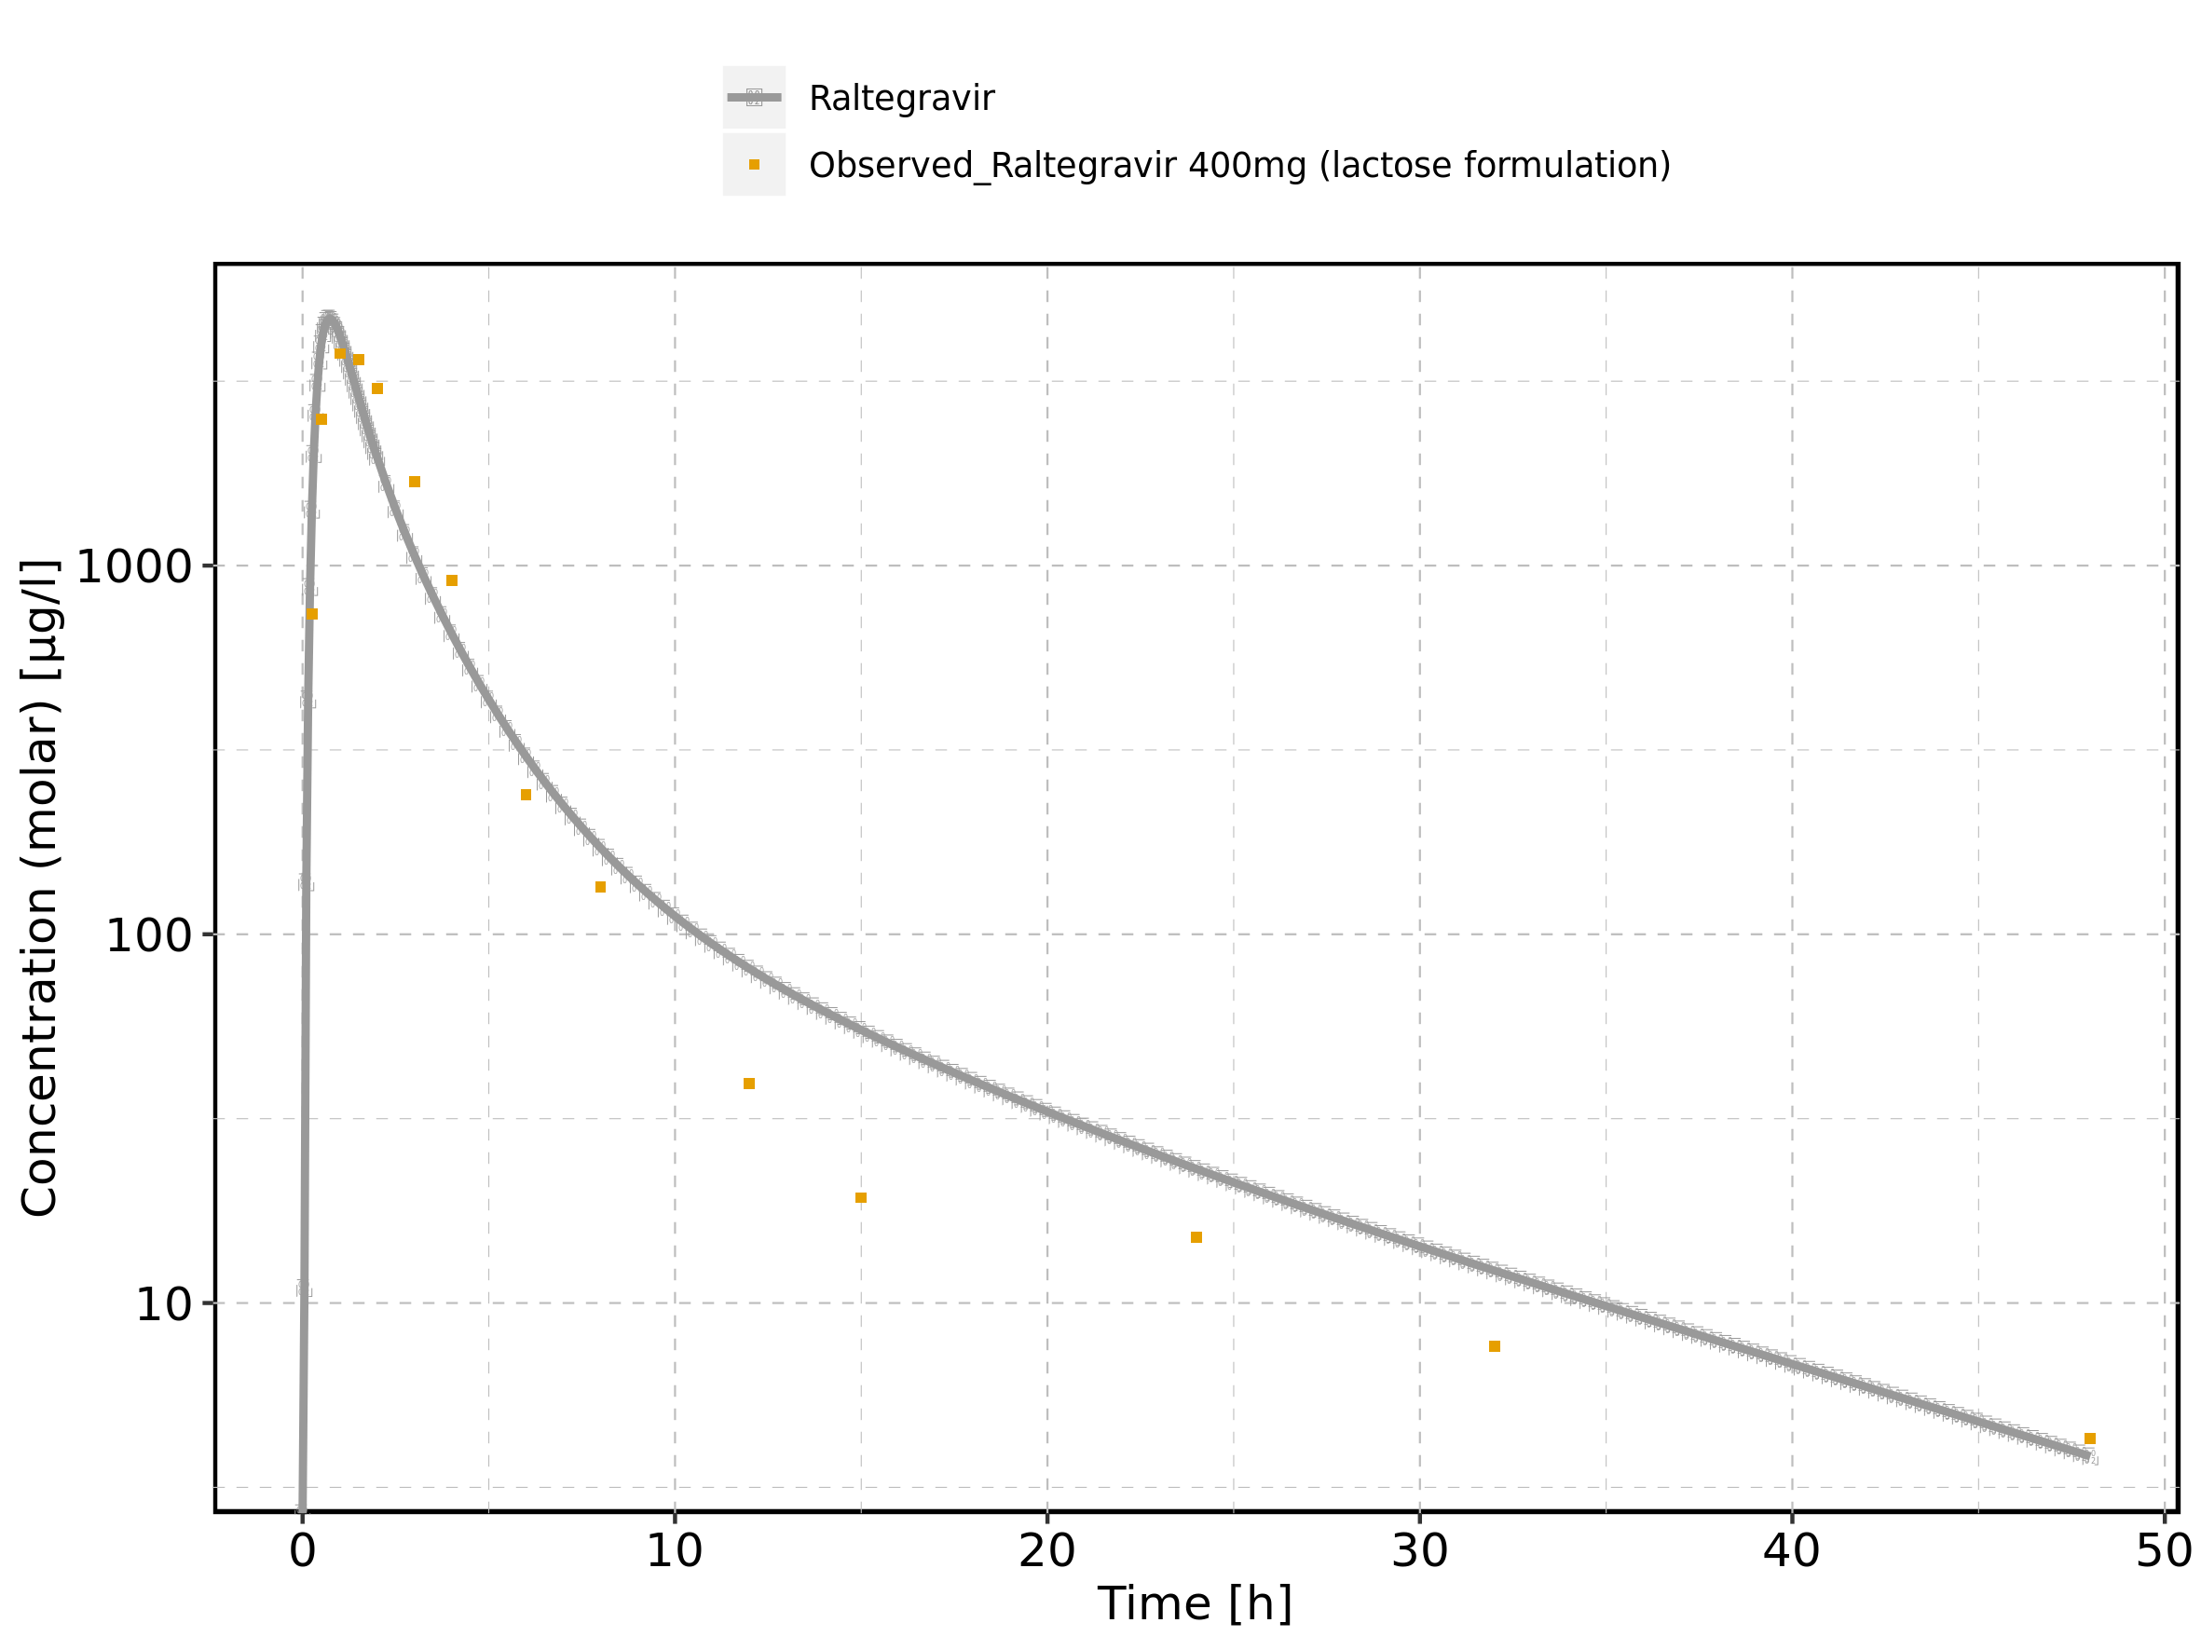

Figure 139: Predicted vs observed of Raltegravir 400mg (lactose formulation) for Raltegravir 400mg (lactose formulation). Data source: Data/Raltegravir_PK.txt. Predictions and observations are plotted in a linear scale.

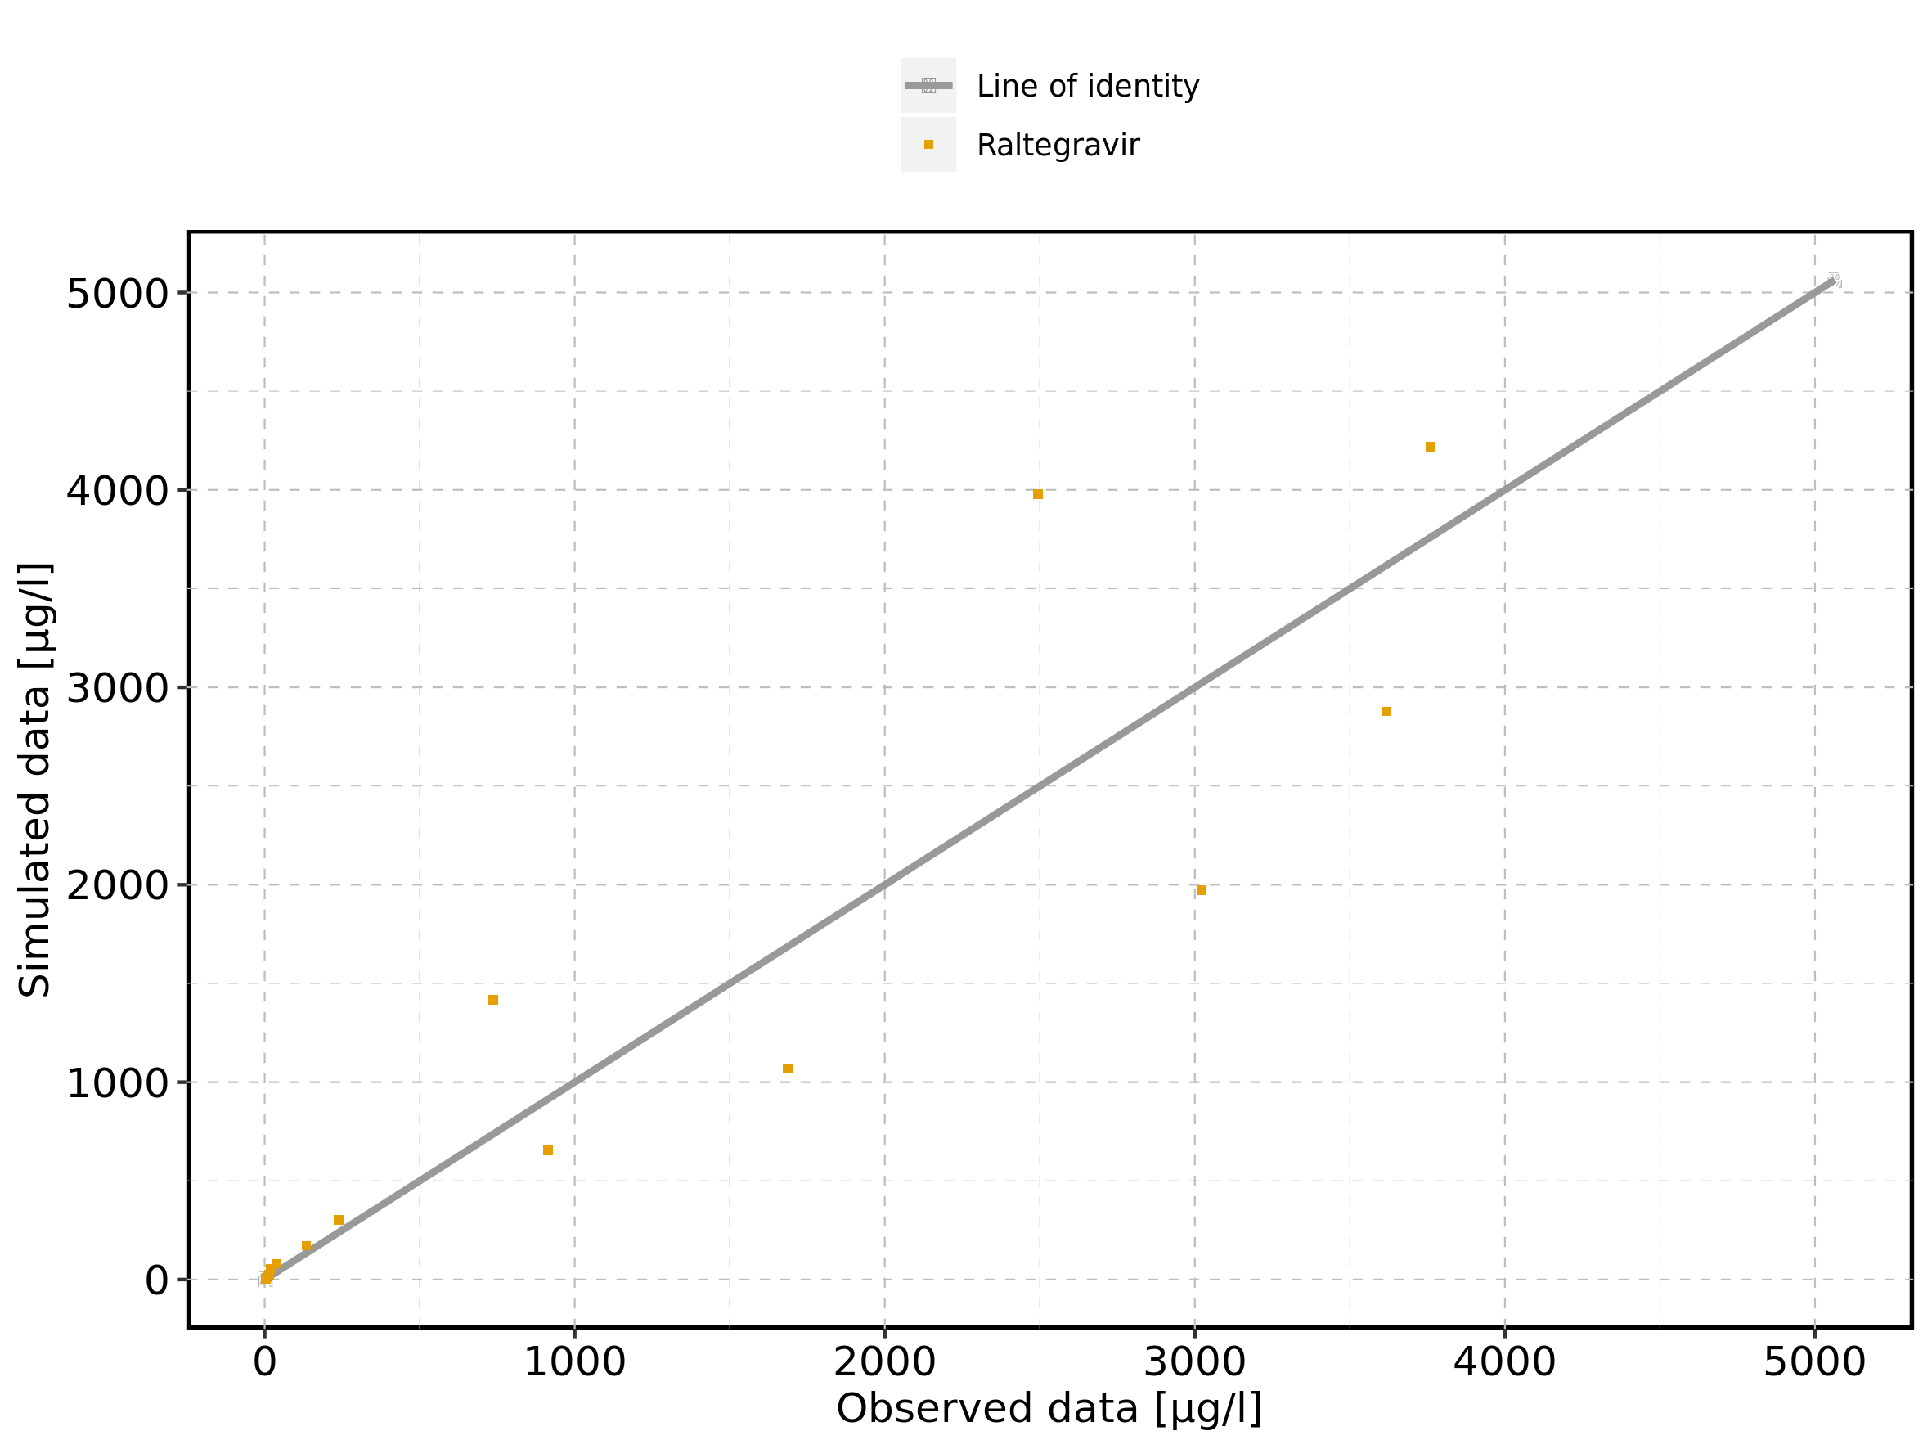

Figure 140: Predicted vs observed of Raltegravir 400mg (lactose formulation) for Raltegravir 400mg (lactose formulation). Data source: Data/Raltegravir_PK.txt. Predictions and observations are plotted in a logarithmic scale.

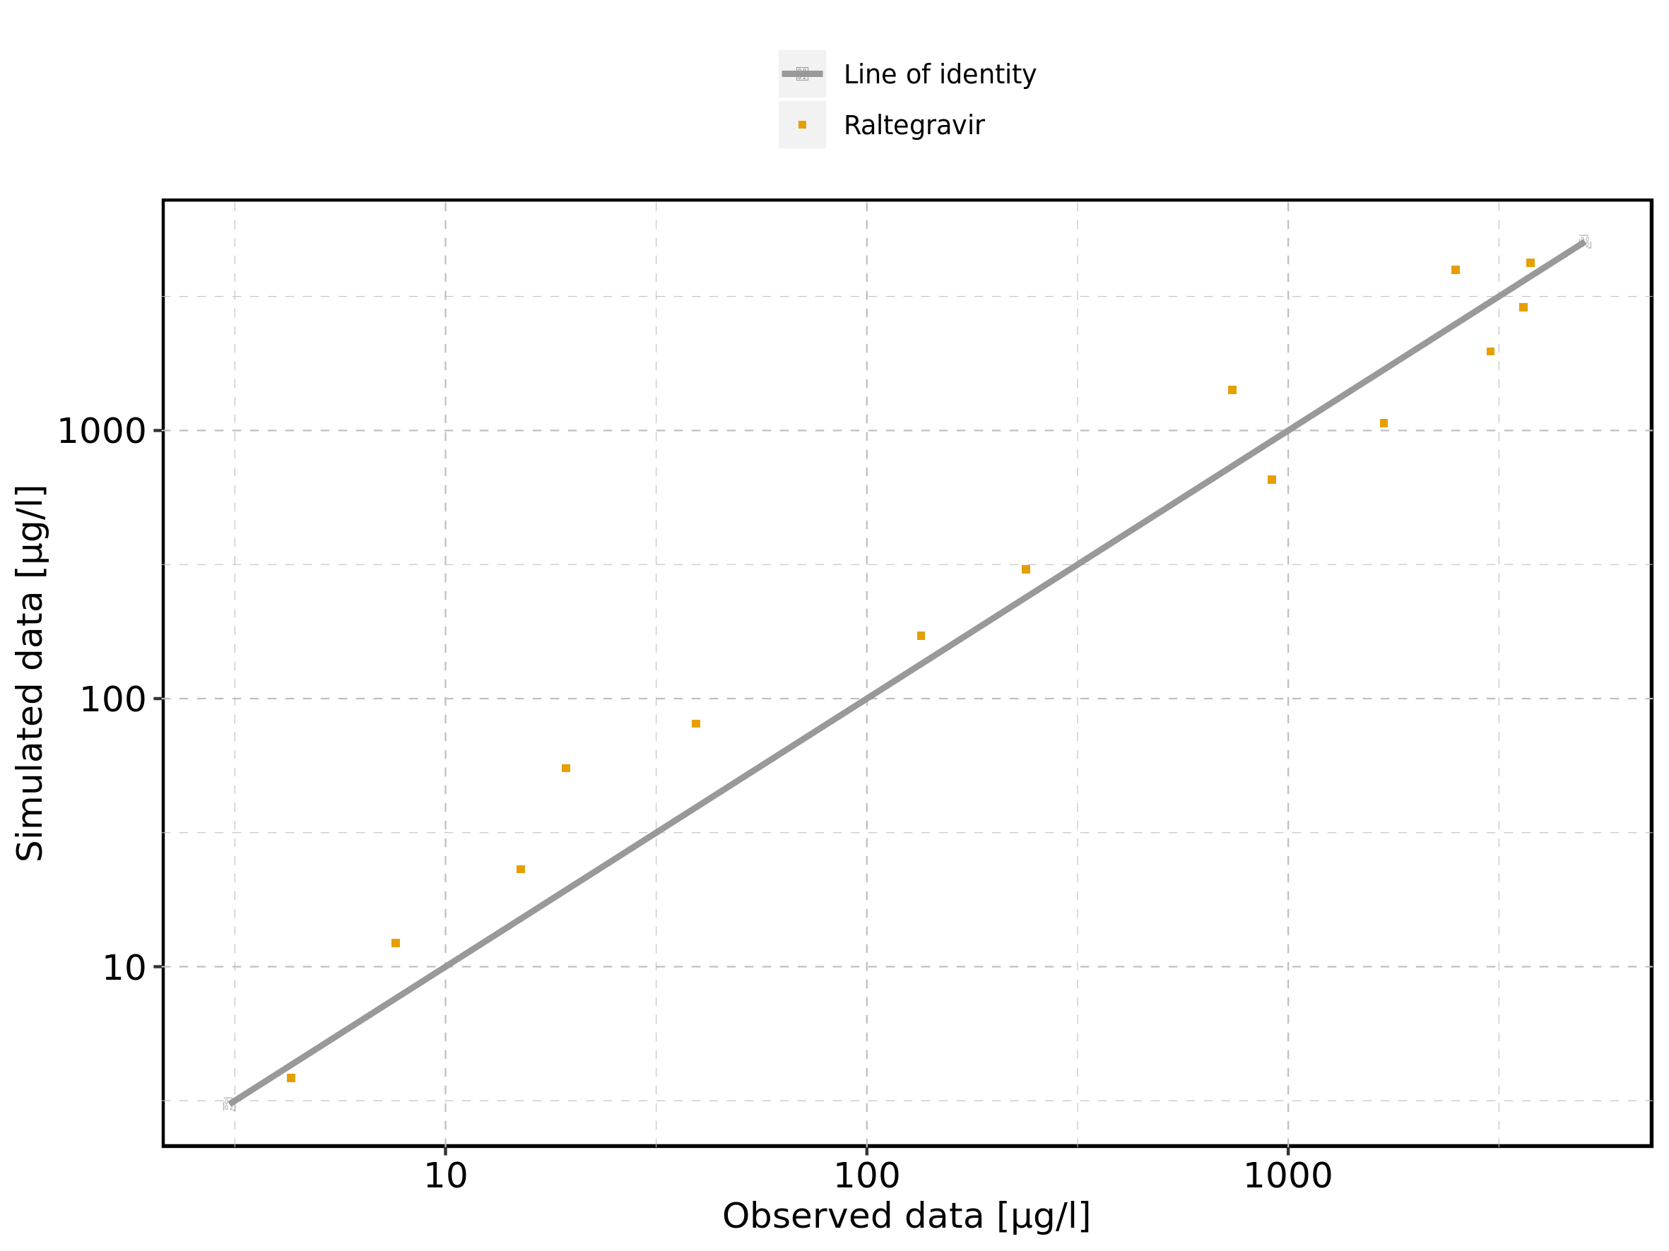

Figure 141: Logarithmic residuals vs predicted values of Raltegravir 400mg (lactose formulation) for Raltegravir 400mg (lactose formulation). Data source: Data/Raltegravir_PK.txt.

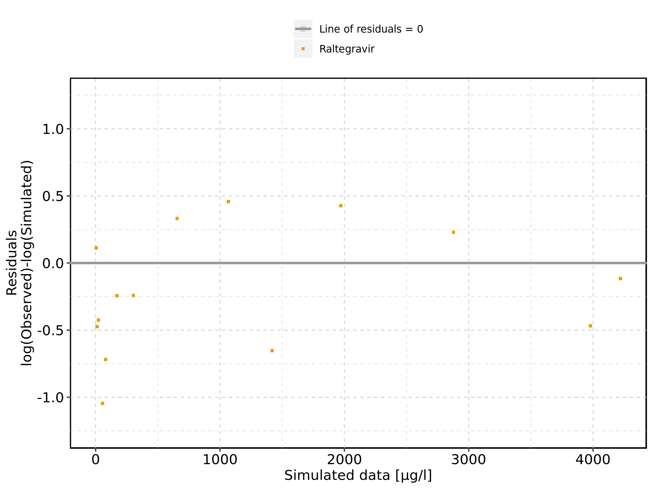

Figure 142: Logarithmic residuals vs time of Raltegravir 400mg (lactose formulation) for Raltegravir 400mg (lactose formulation). Data source: Data/Raltegravir_PK.txt.

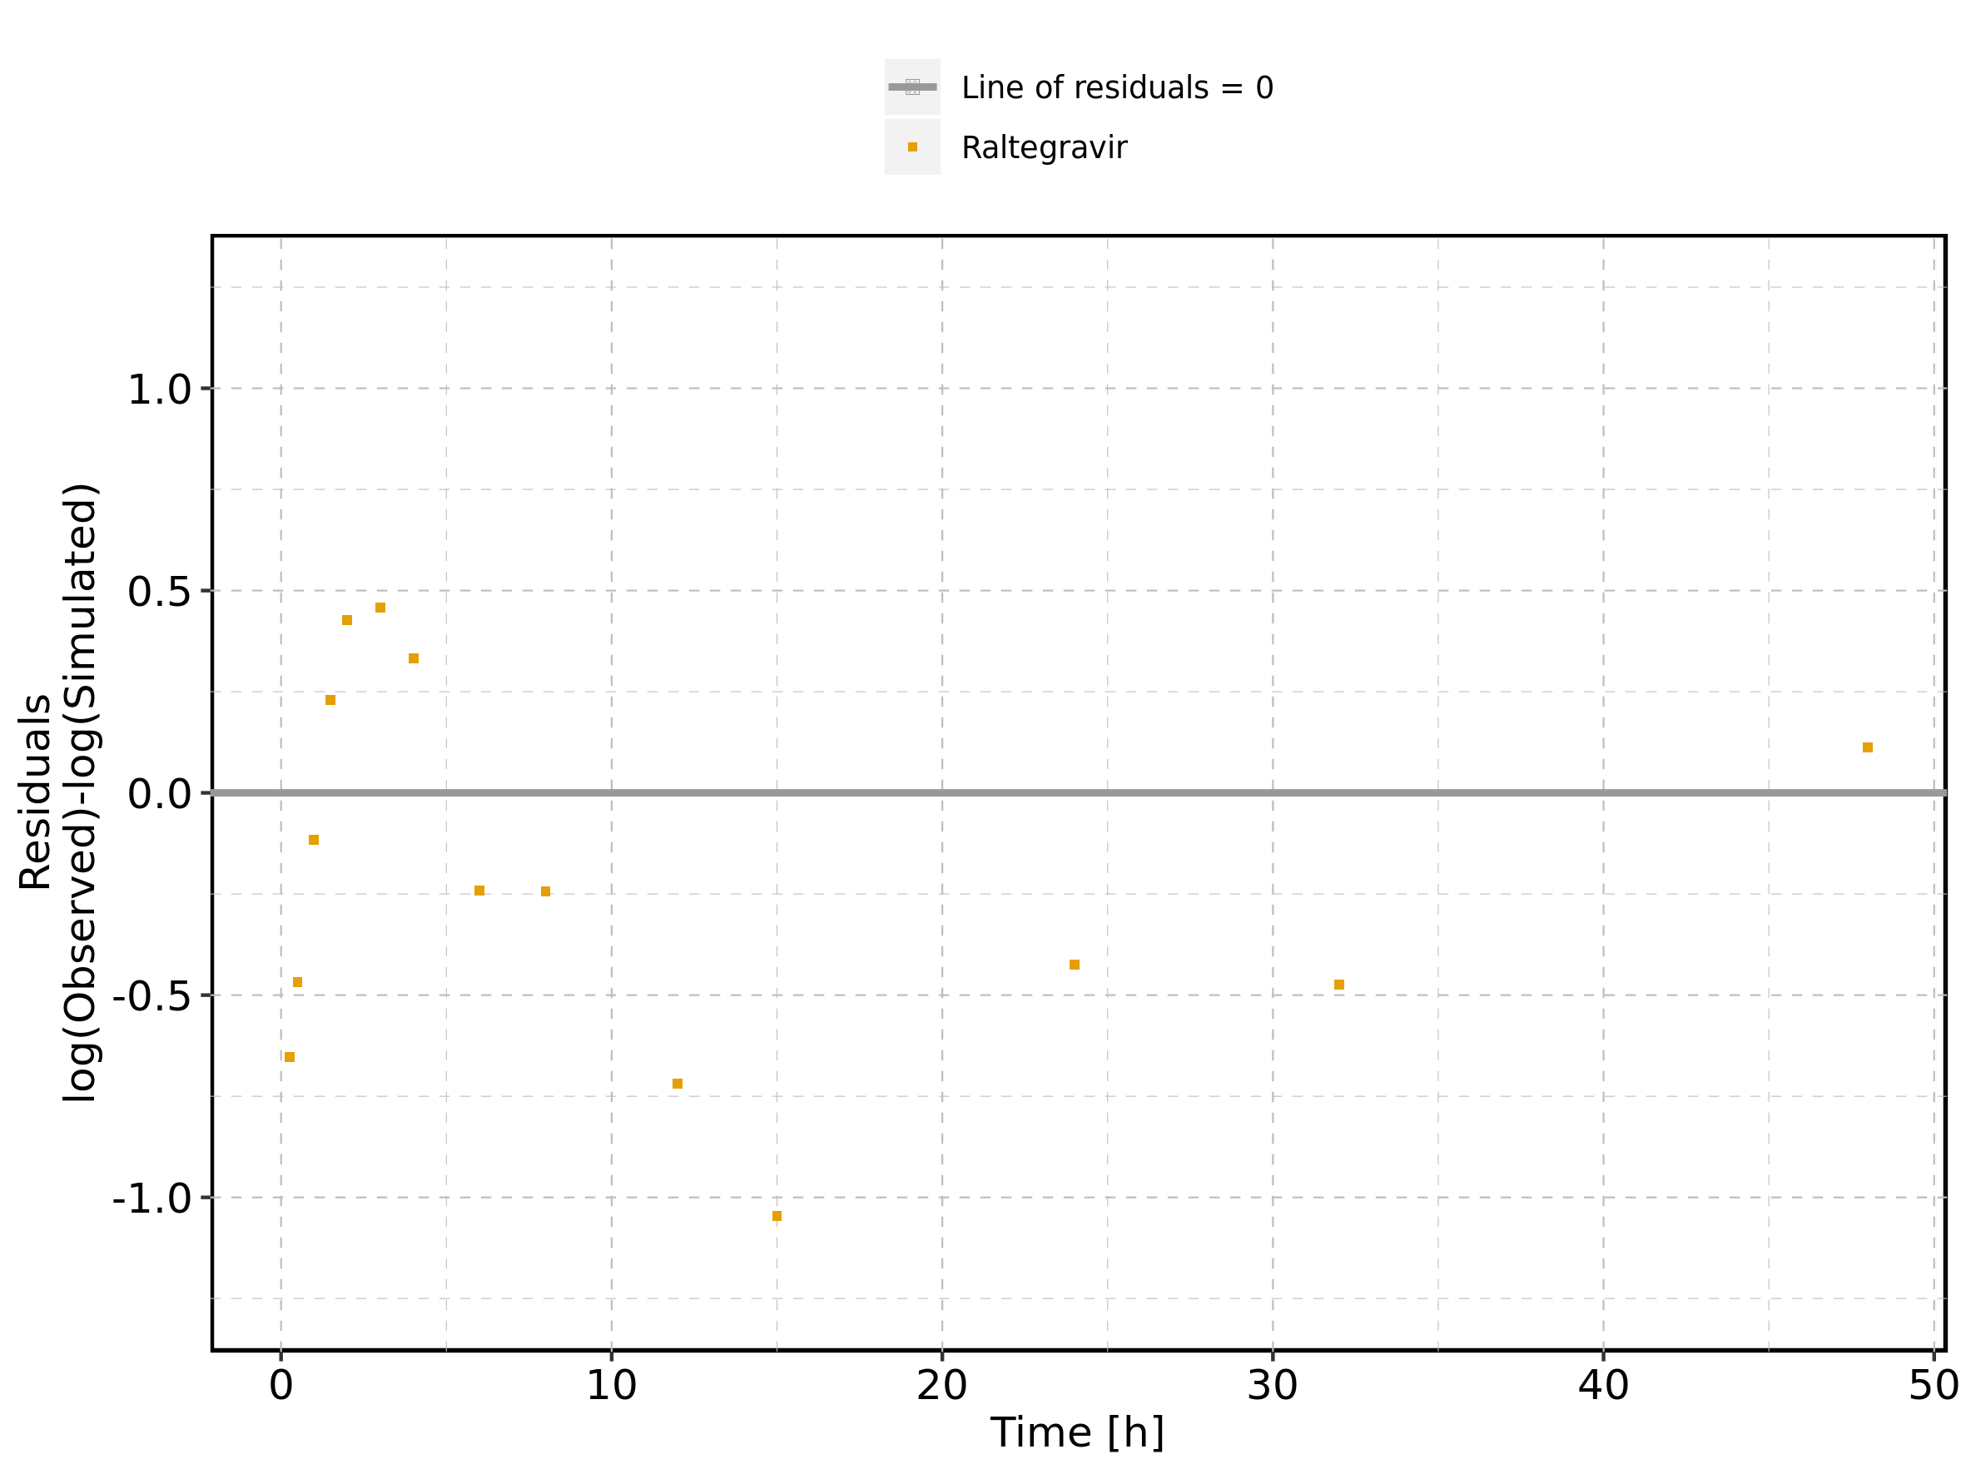

Figure 143: Logarithmic residuals distribution of Raltegravir 400mg (lactose formulation) for Raltegravir 400mg (lactose formulation). Data source: Data/Raltegravir_PK.txt.

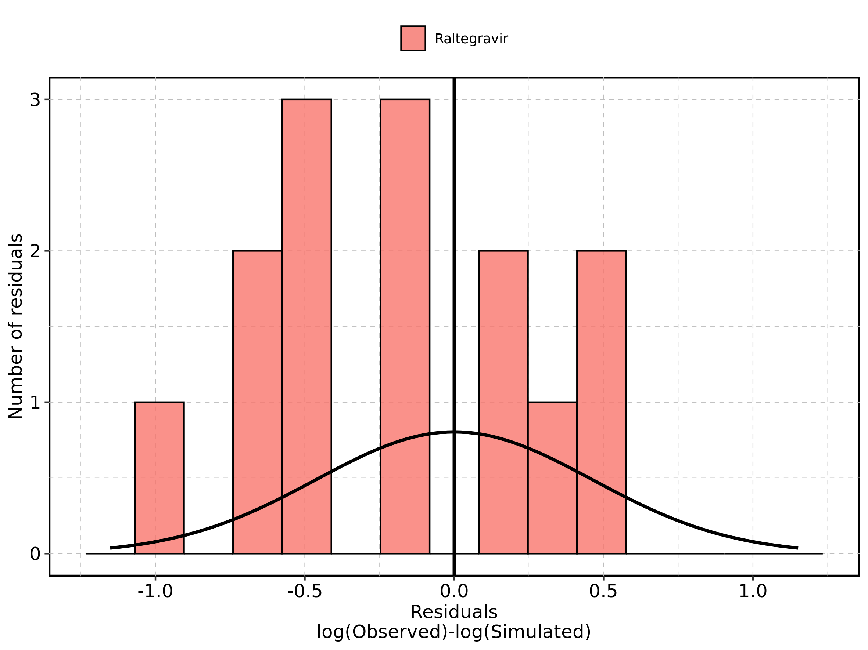

Figure 144: Logarithmic residuals of Raltegravir 400mg (lactose formulation) for Raltegravir 400mg (lactose formulation) as quantile-quantile plot. Data source: Data/Raltegravir_PK.txt.

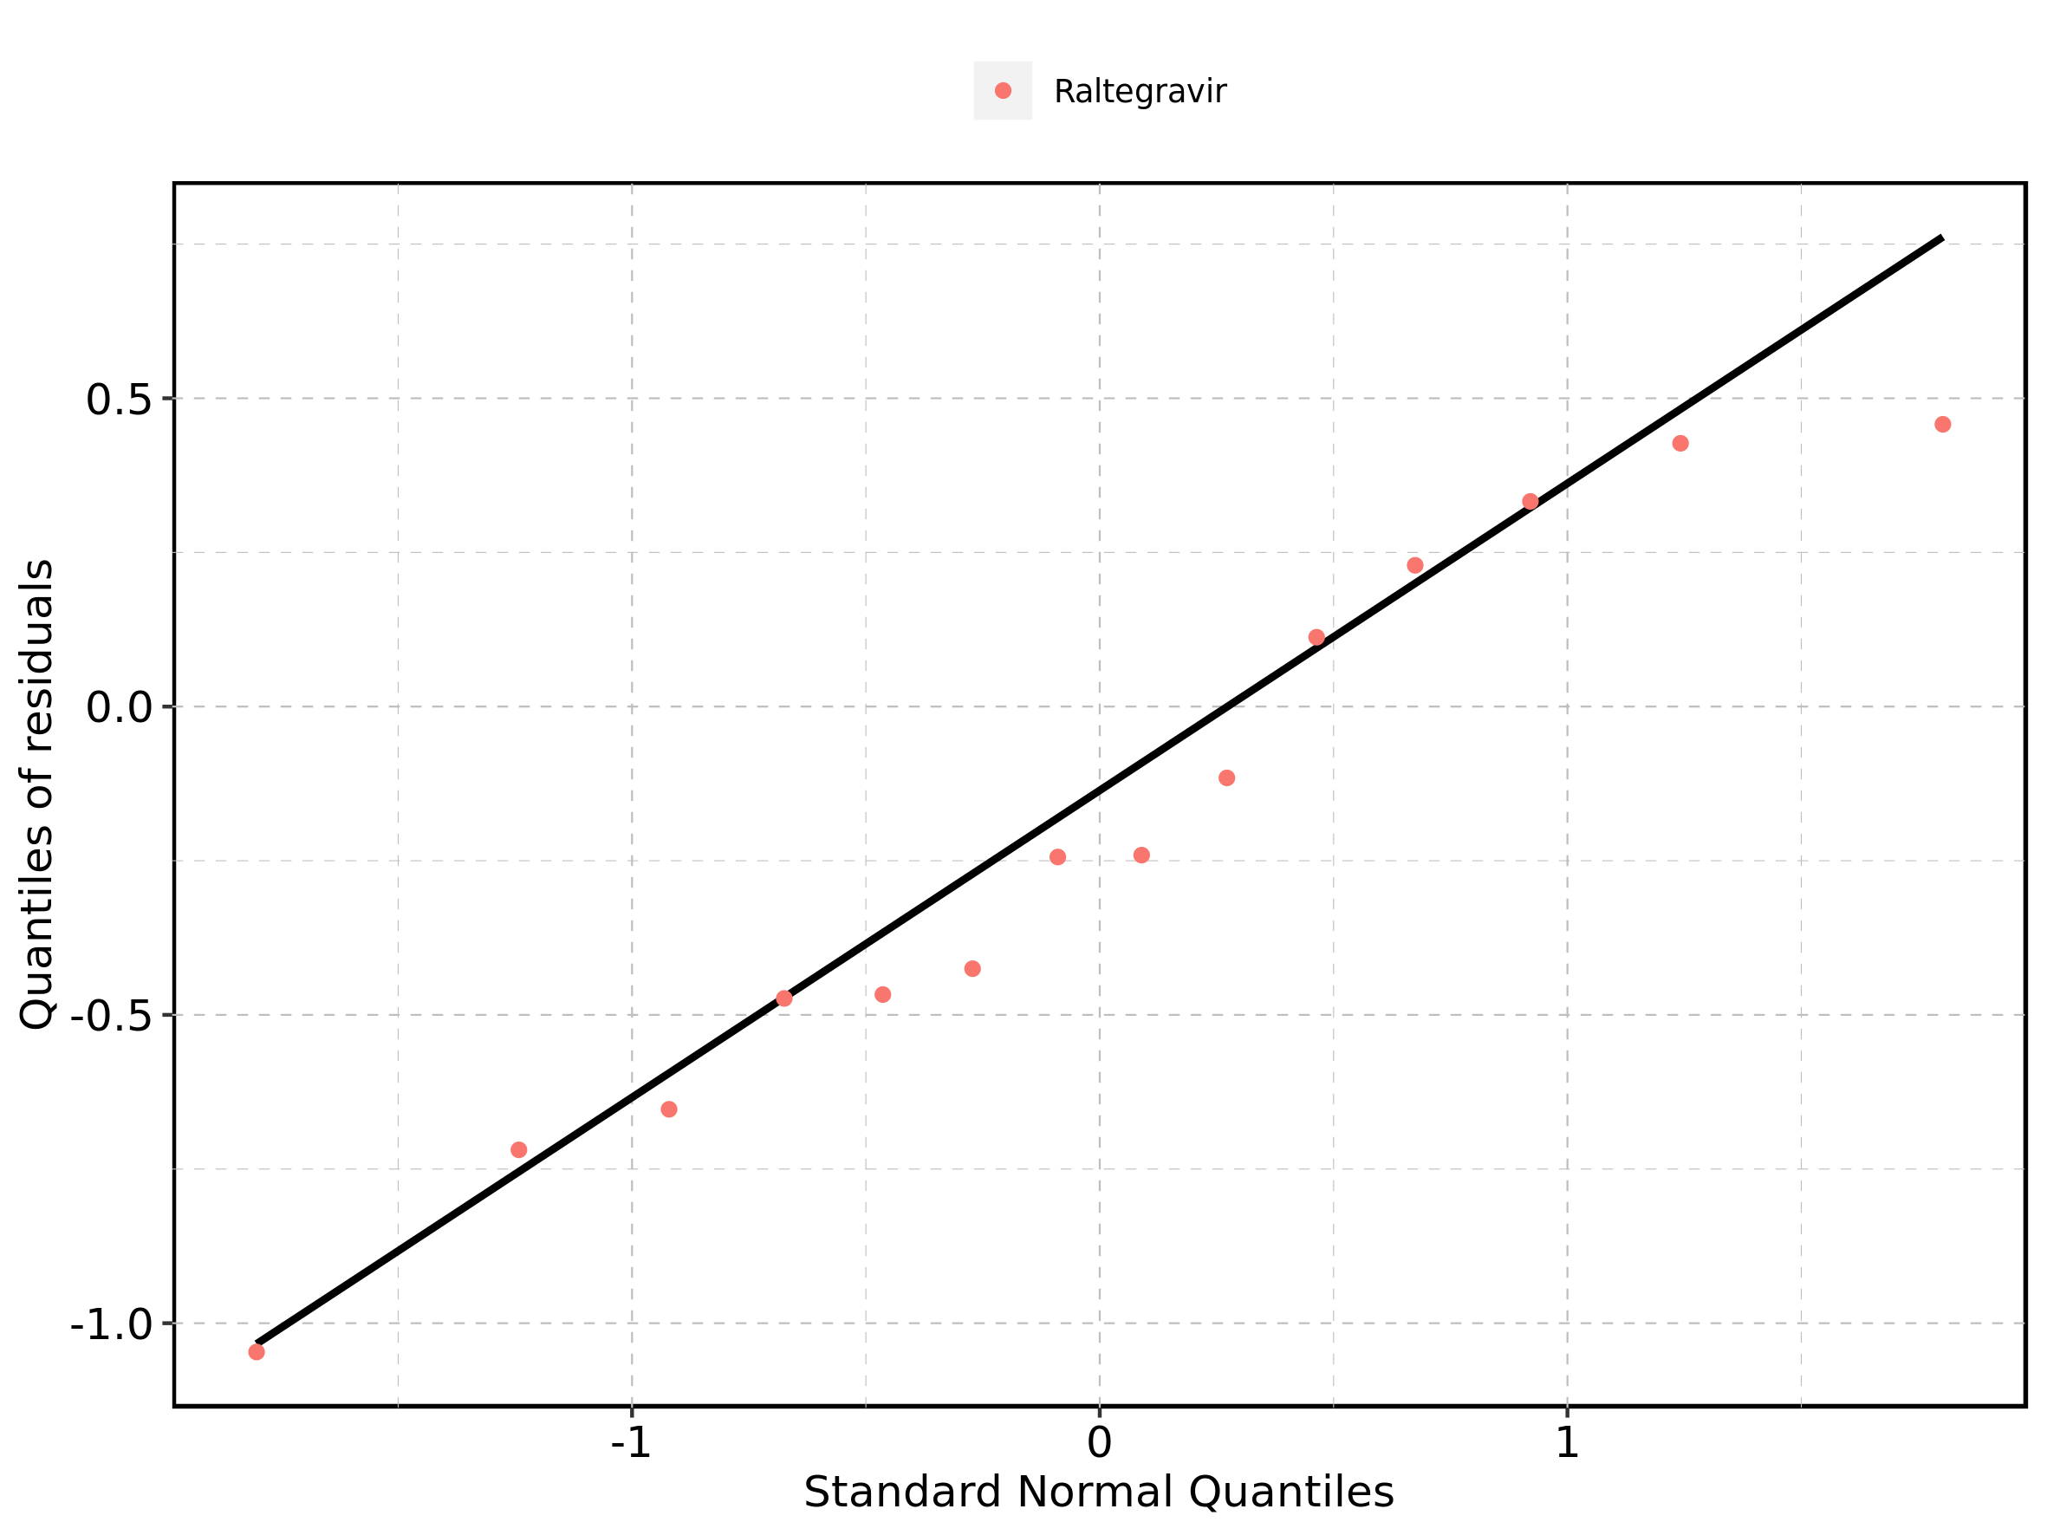

## 4.7. Time profiles and residual plots for Raltegravir 800 mg (lactose formulation)

Figure 145: Time profiles of Raltegravir 800 mg (lactose formulation) for Raltegravir 800 mg (lactose formulation). Data source: Data/Raltegravir_PK.txt. Time profiles are plotted in a linear scale.

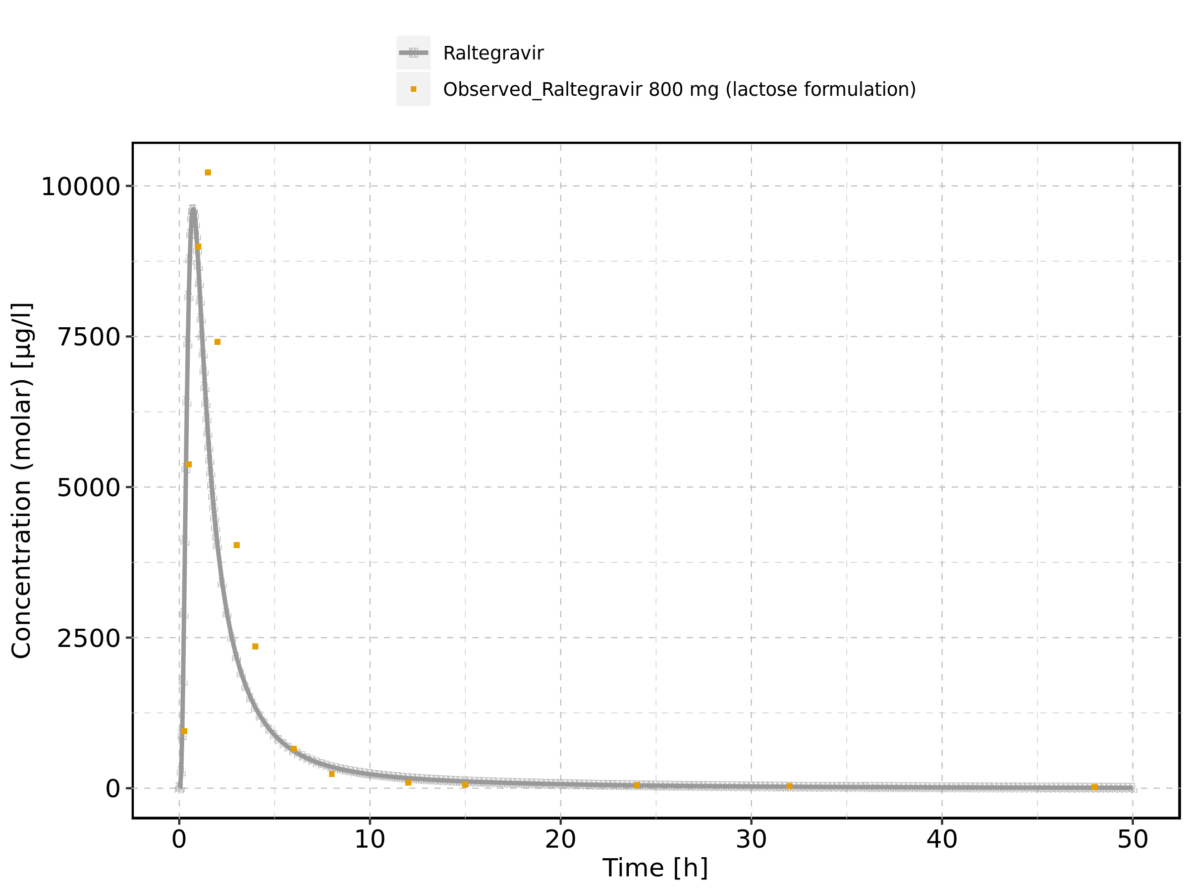

Figure 146: Time profiles of Raltegravir 800 mg (lactose formulation) for Raltegravir 800 mg (lactose formulation). Data source: Data/Raltegravir_PK.txt. Time profiles are plotted in a logarithmic scale.

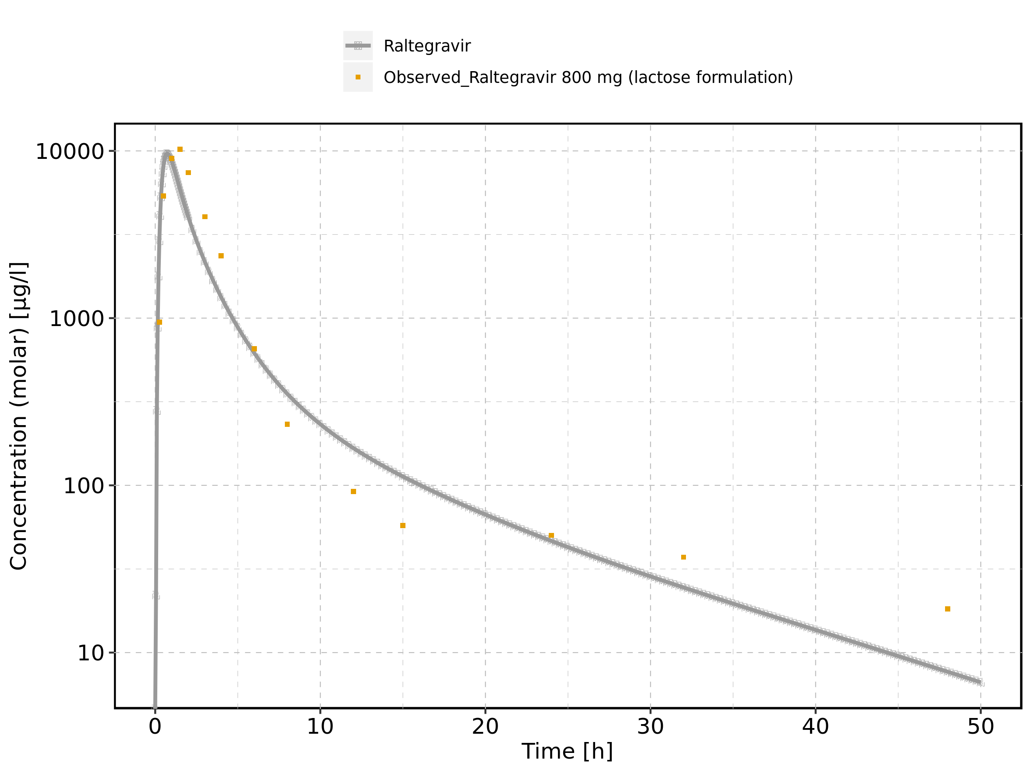

Figure 147: Predicted vs observed of Raltegravir 800 mg (lactose formulation) for Raltegravir 800 mg (lactose formulation). Data source: Data/Raltegravir_PK.txt. Predictions and observations are plotted in a linear scale.

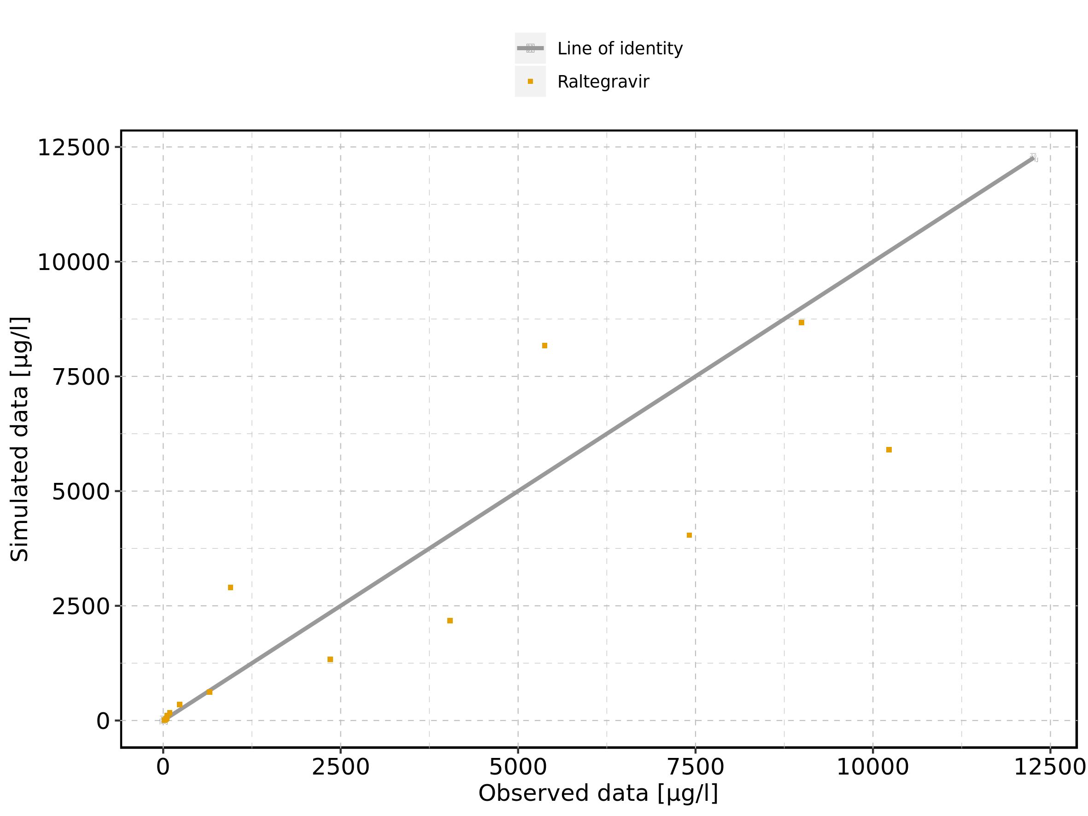

Figure 148: Predicted vs observed of Raltegravir 800 mg (lactose formulation) for Raltegravir 800 mg (lactose formulation). Data source: Data/Raltegravir_PK.txt. Predictions and observations are plotted in a logarithmic scale.

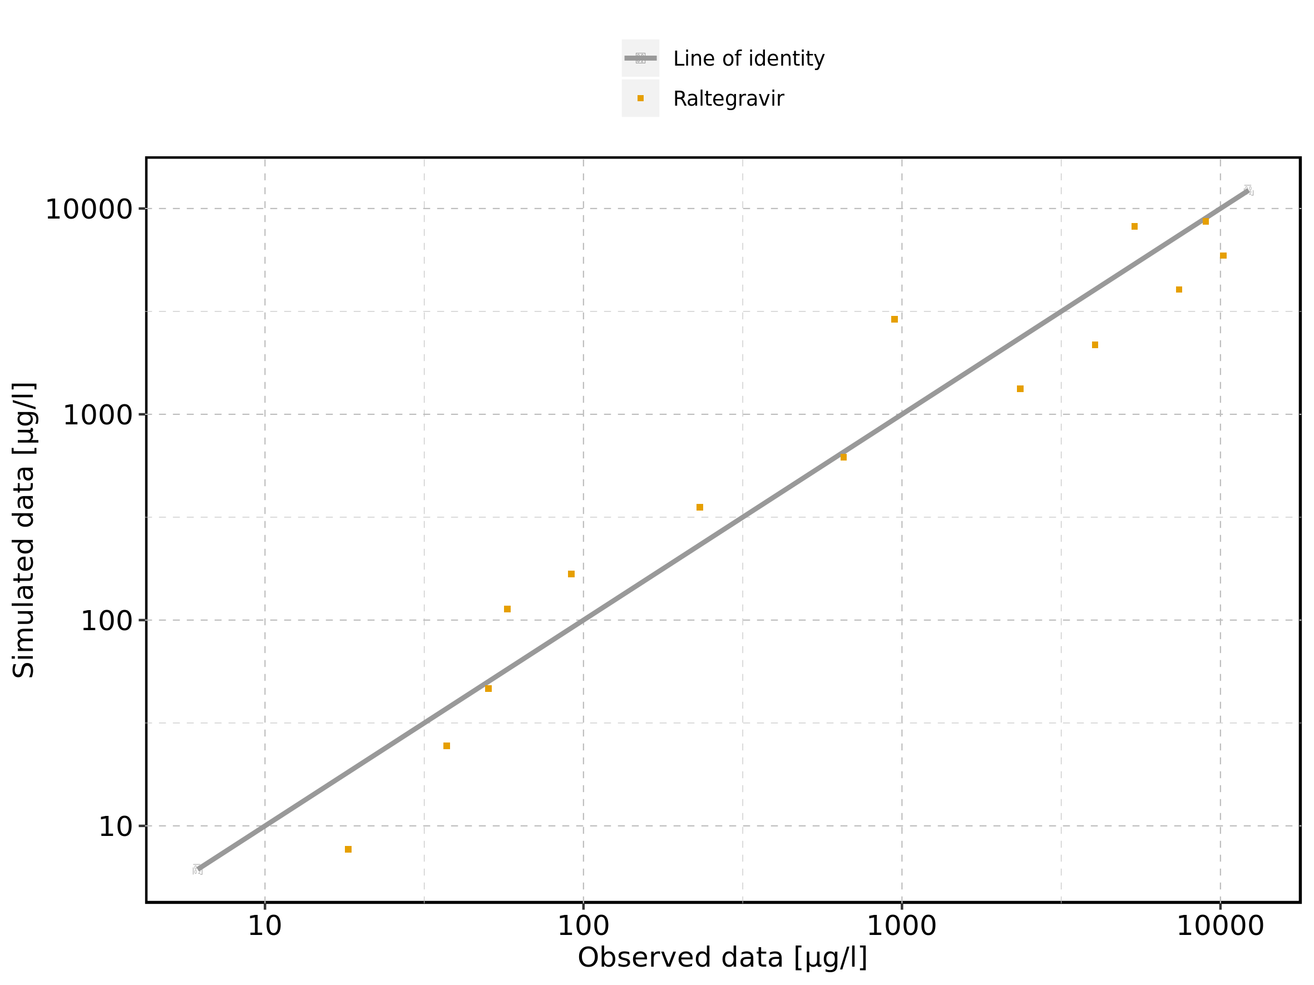

Figure 149: Logarithmic residuals vs predicted values of Raltegravir 800 mg (lactose formulation) for Raltegravir 800 mg (lactose formulation). Data source: Data/Raltegravir_PK.txt.

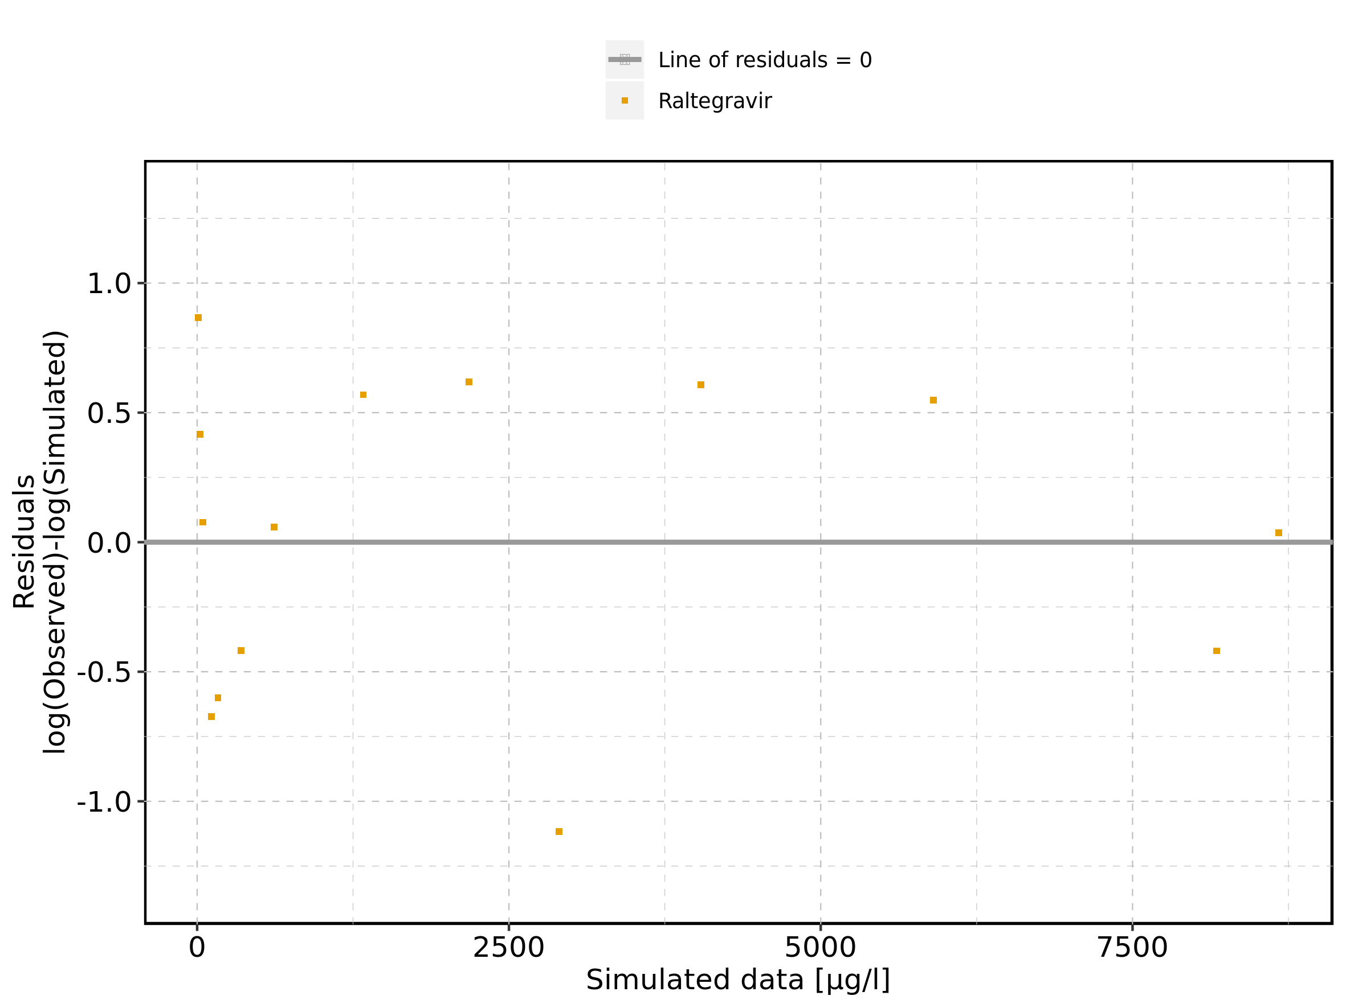

Figure 150: Logarithmic residuals vs time of Raltegravir 800 mg (lactose formulation) for Raltegravir 800 mg (lactose formulation). Data source: Data/Raltegravir_PK.txt.

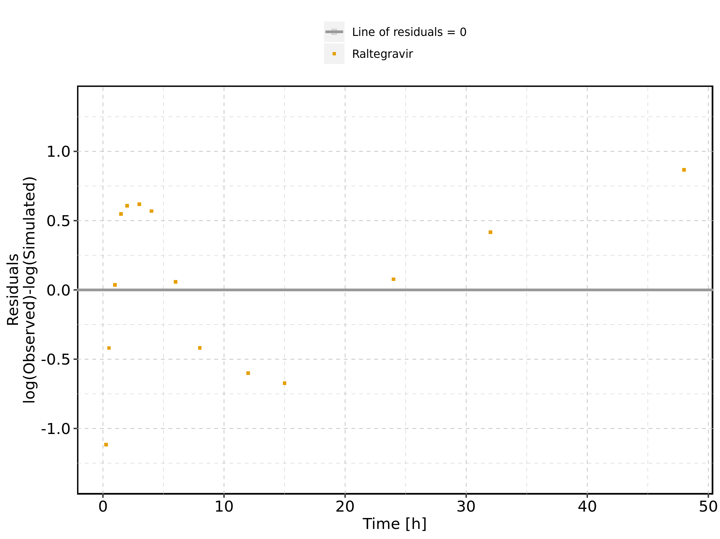

Figure 151: Logarithmic residuals distribution of Raltegravir 800 mg (lactose formulation) for Raltegravir 800 mg (lactose formulation). Data source: Data/Raltegravir_PK.txt.

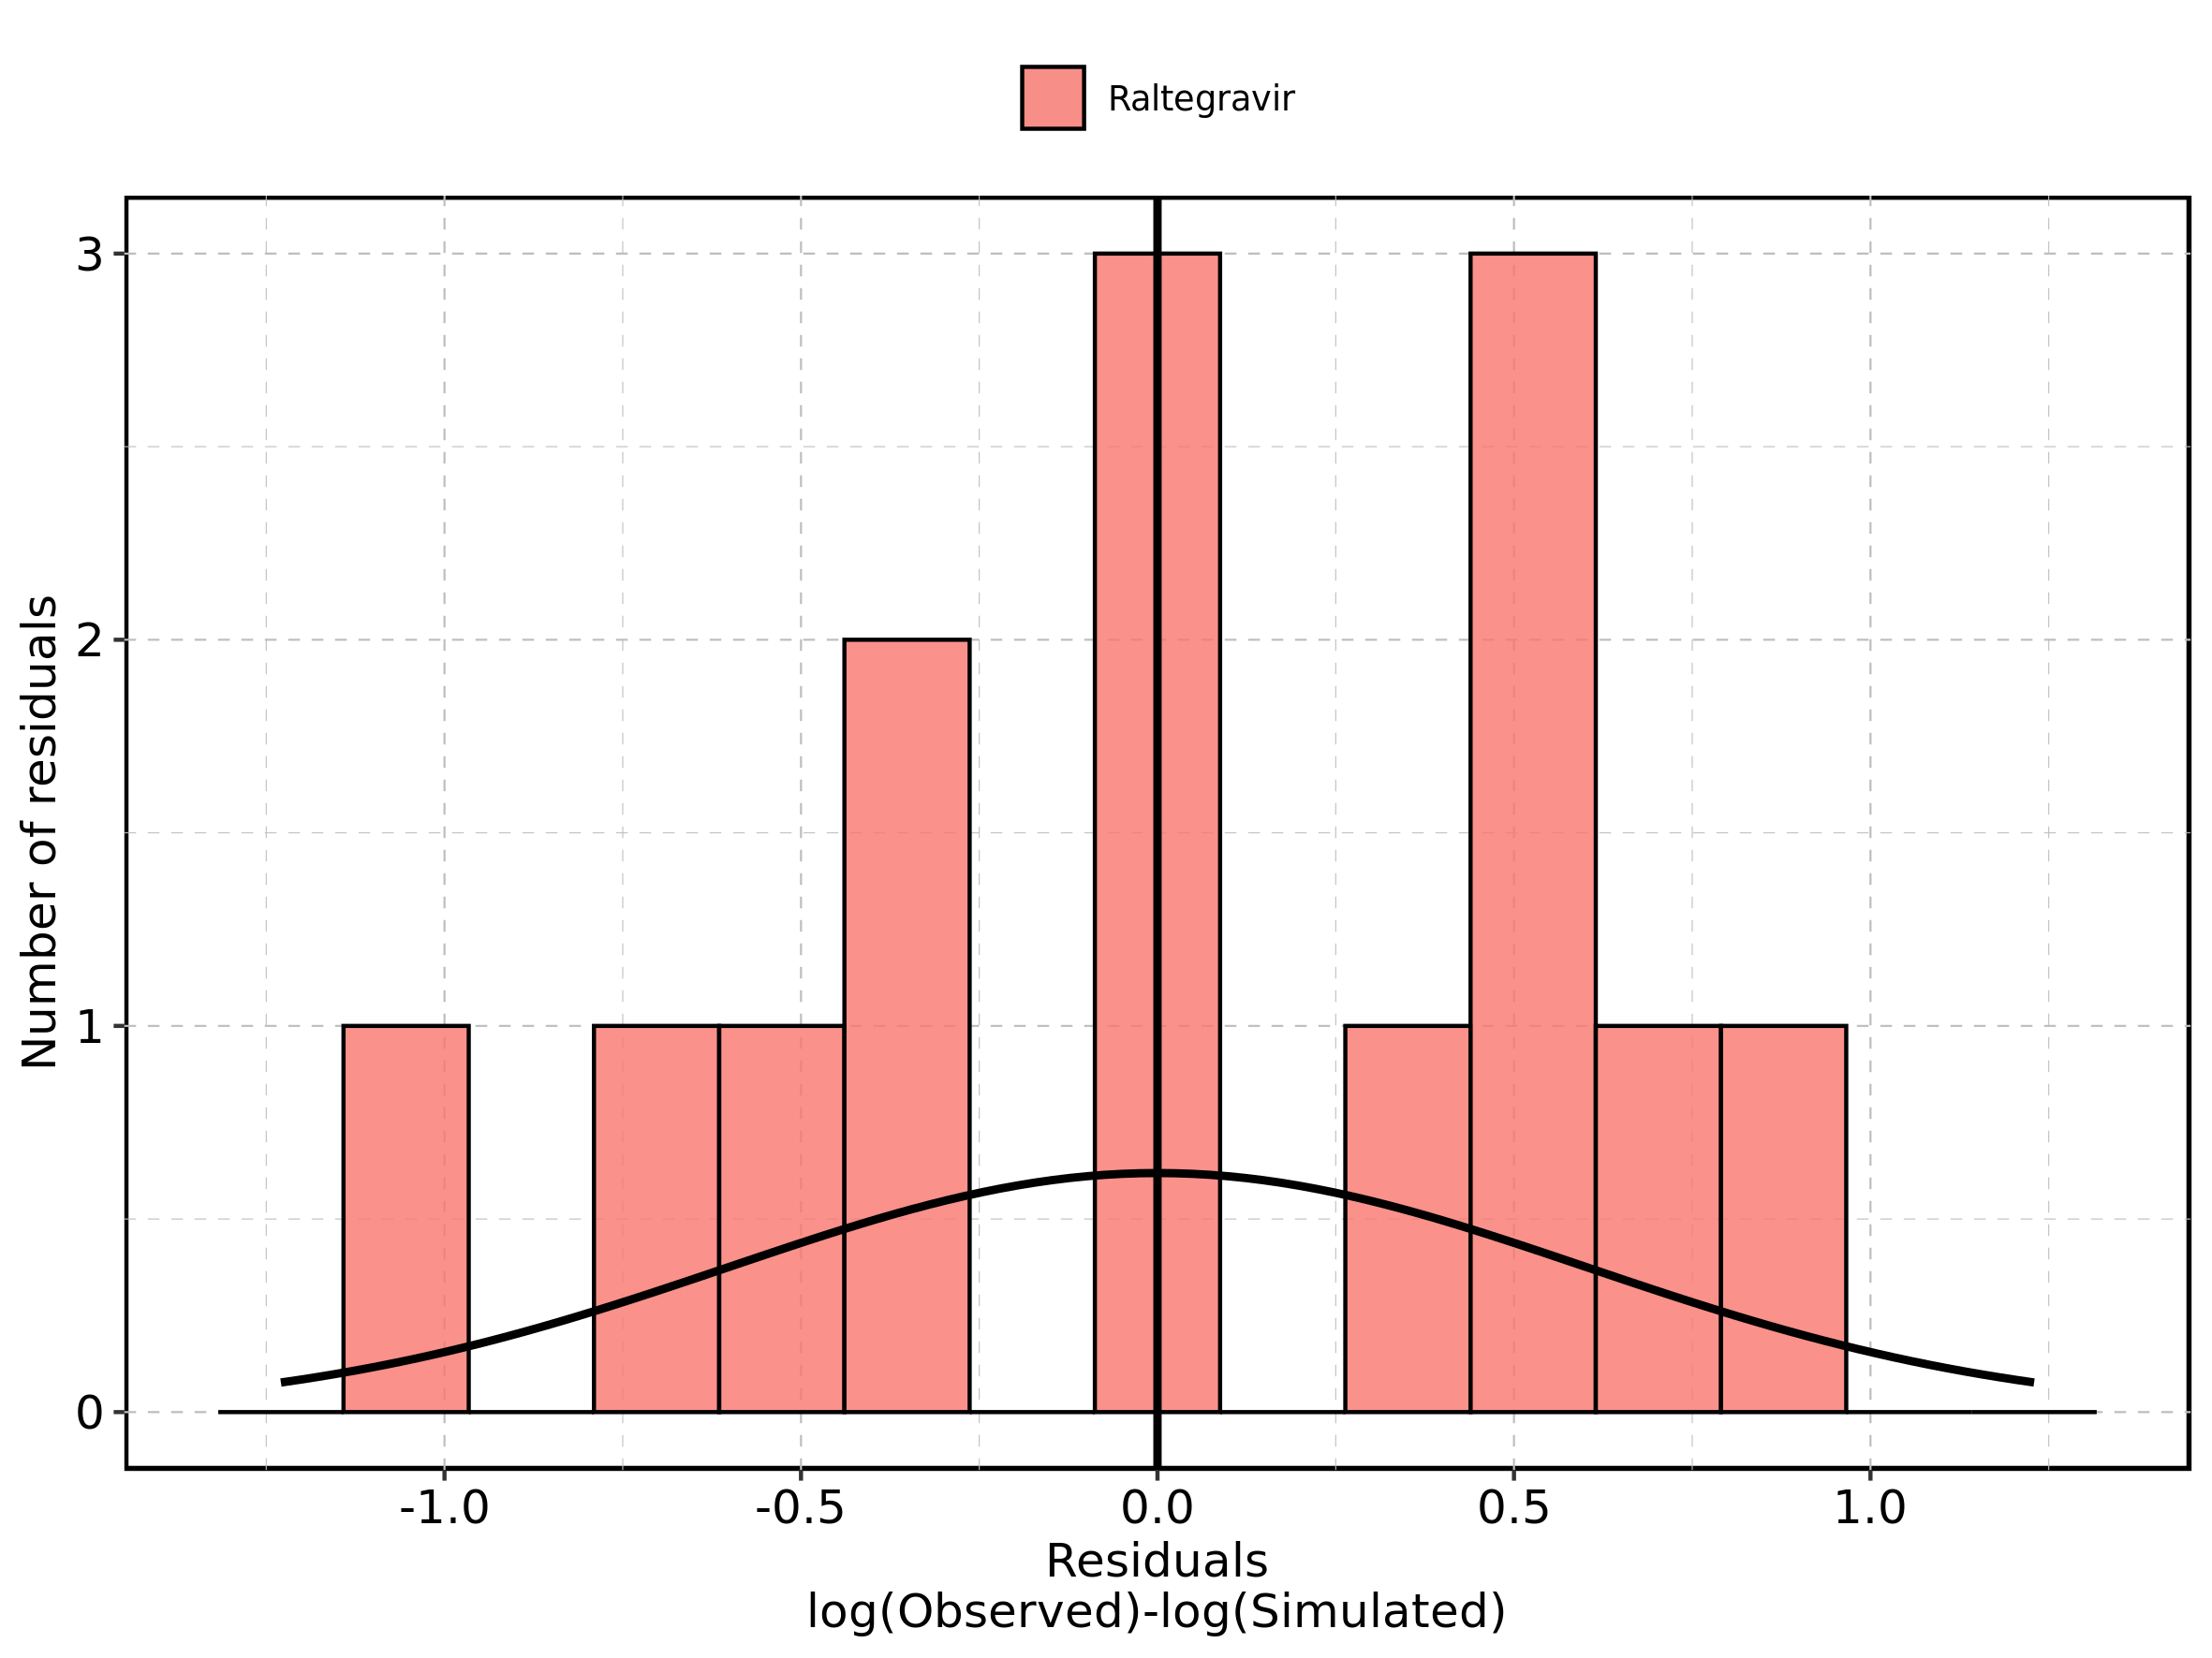

Figure 152: Logarithmic residuals of Raltegravir 800 mg (lactose formulation) for Raltegravir 800 mg (lactose formulation) as quantile-quantile plot. Data source: Data/Raltegravir_PK.txt.

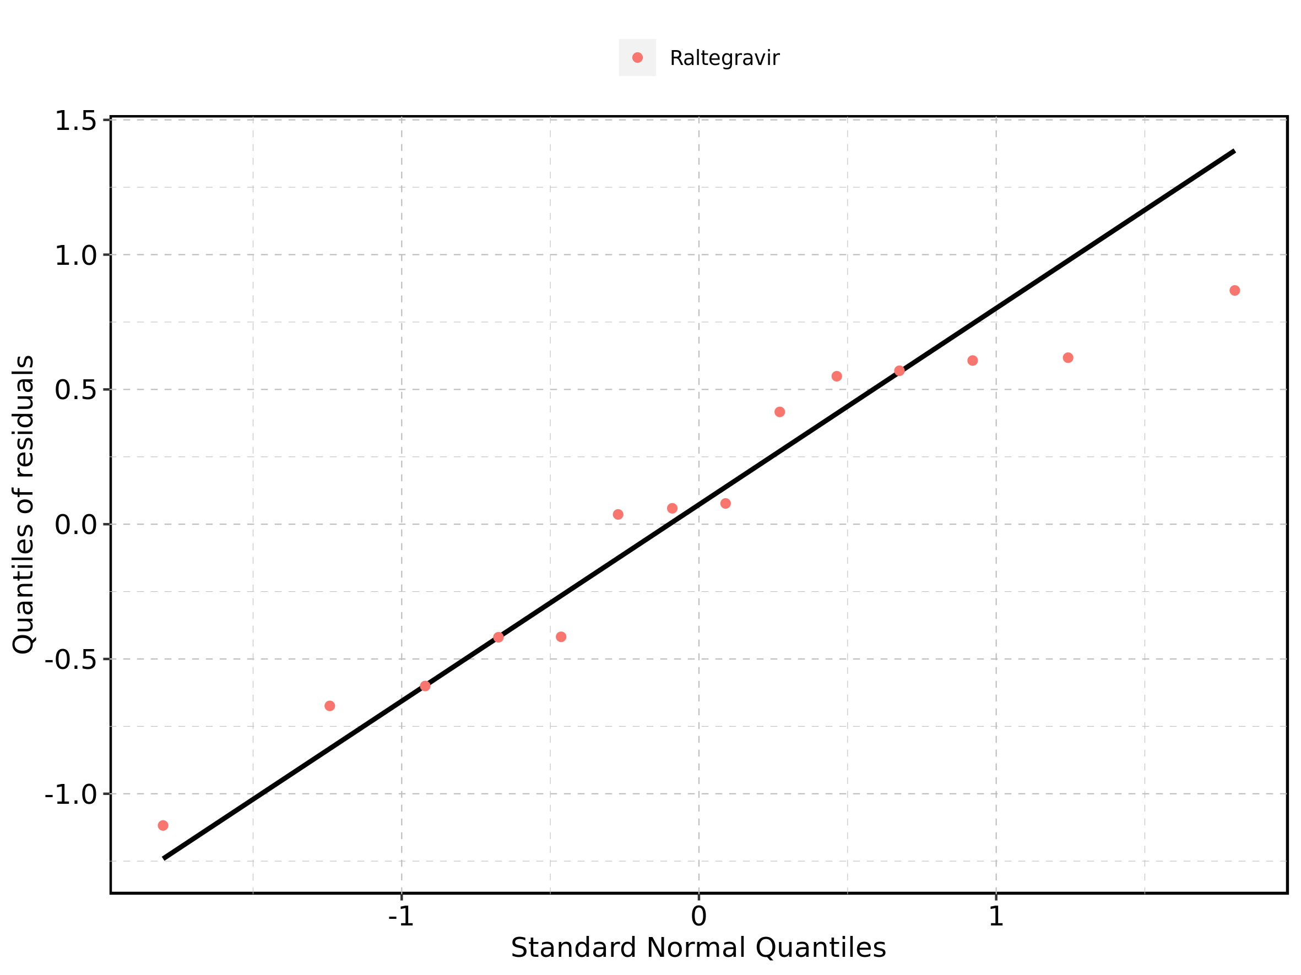

## 4.8. Time profiles and residual plots for Raltegravir 1200 mg (lactose formulation)

Figure 153: Time profiles of Raltegravir 1200 mg (lactose formulation) for Raltegravir 1200 mg (lactose formulation). Data source: Data/Raltegravir_PK.txt. Time profiles are plotted in a linear scale.

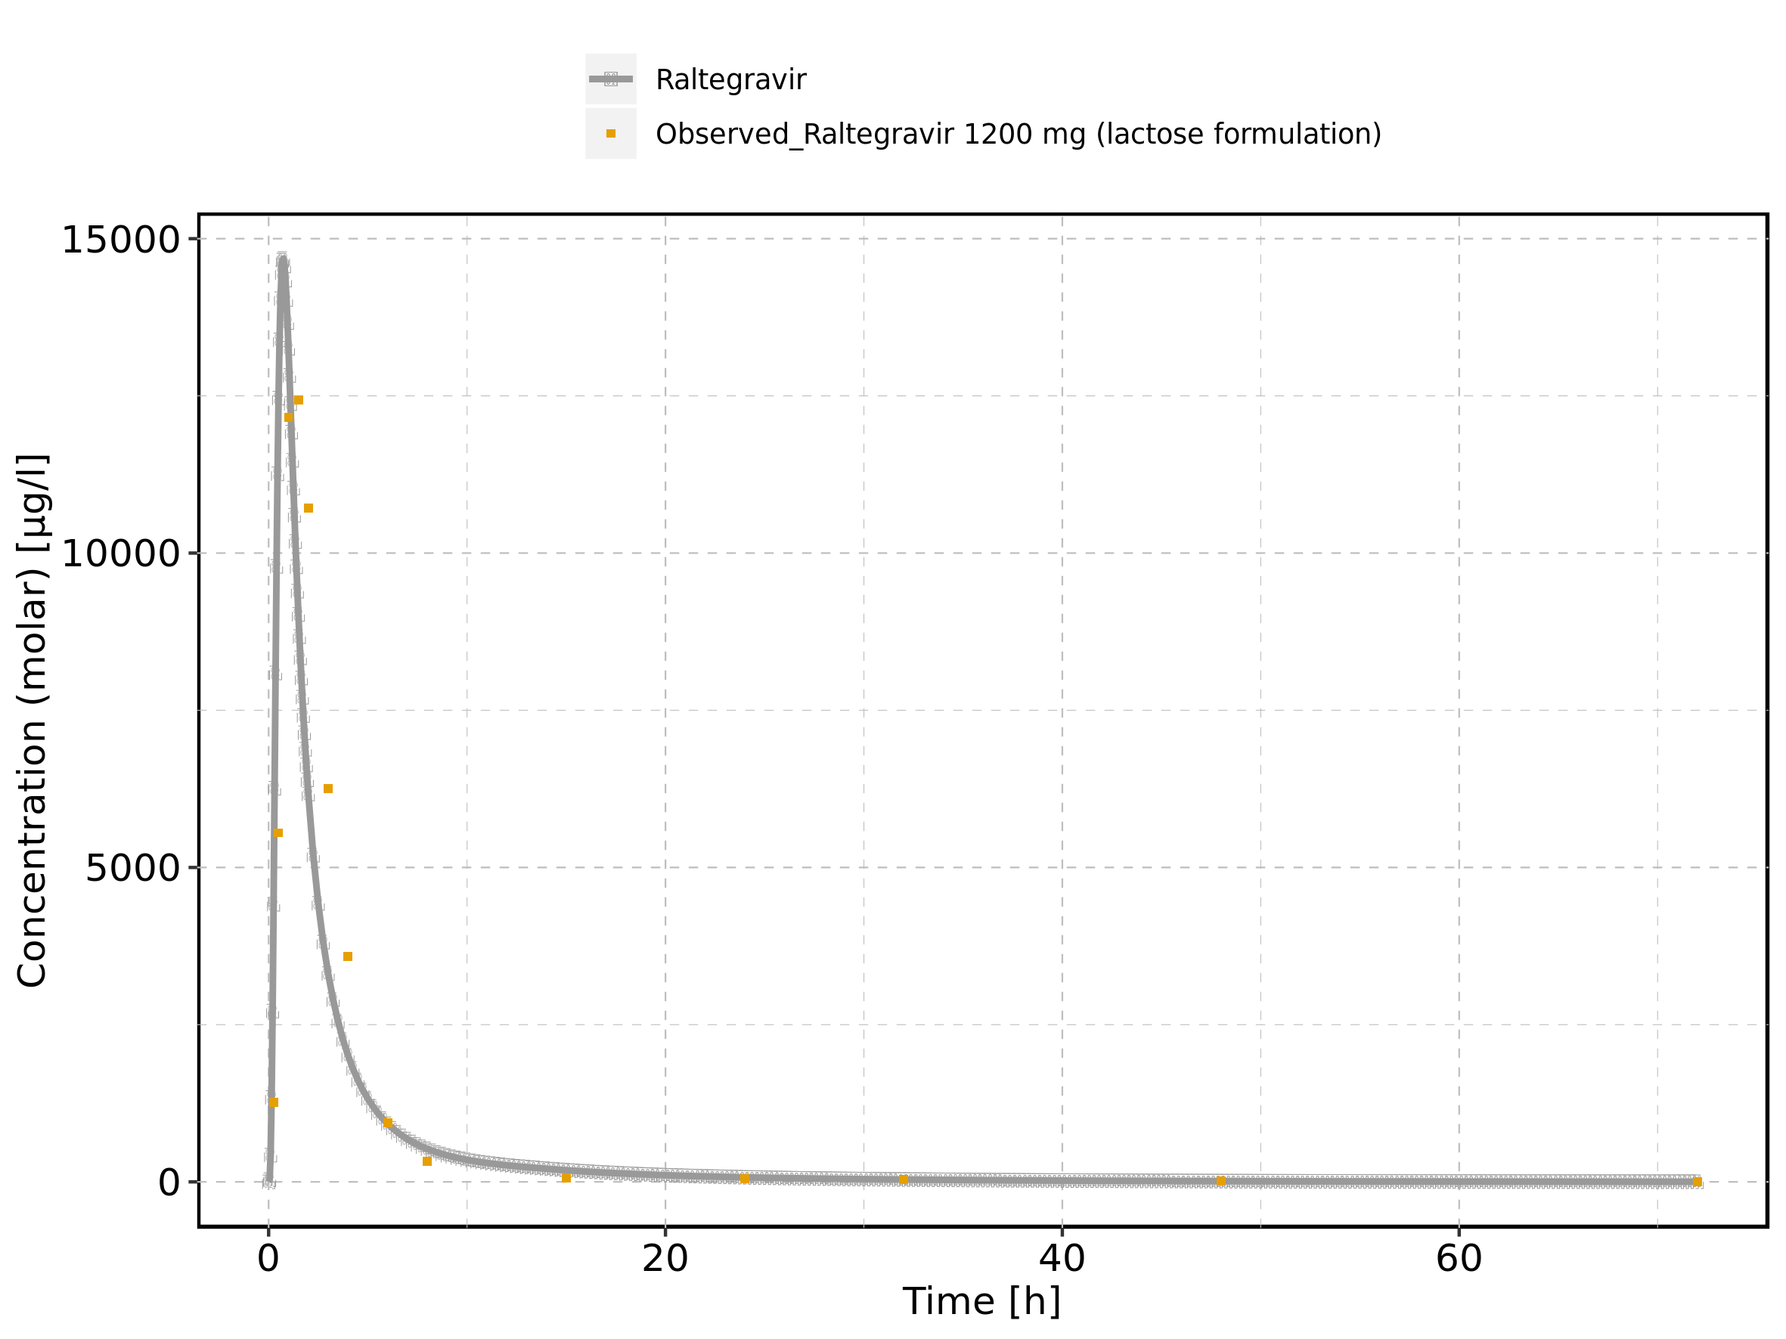

Figure 154: Time profiles of Raltegravir 1200 mg (lactose formulation) for Raltegravir 1200 mg (lactose formulation). Data source: Data/Raltegravir_PK.txt. Time profiles are plotted in a logarithmic scale.

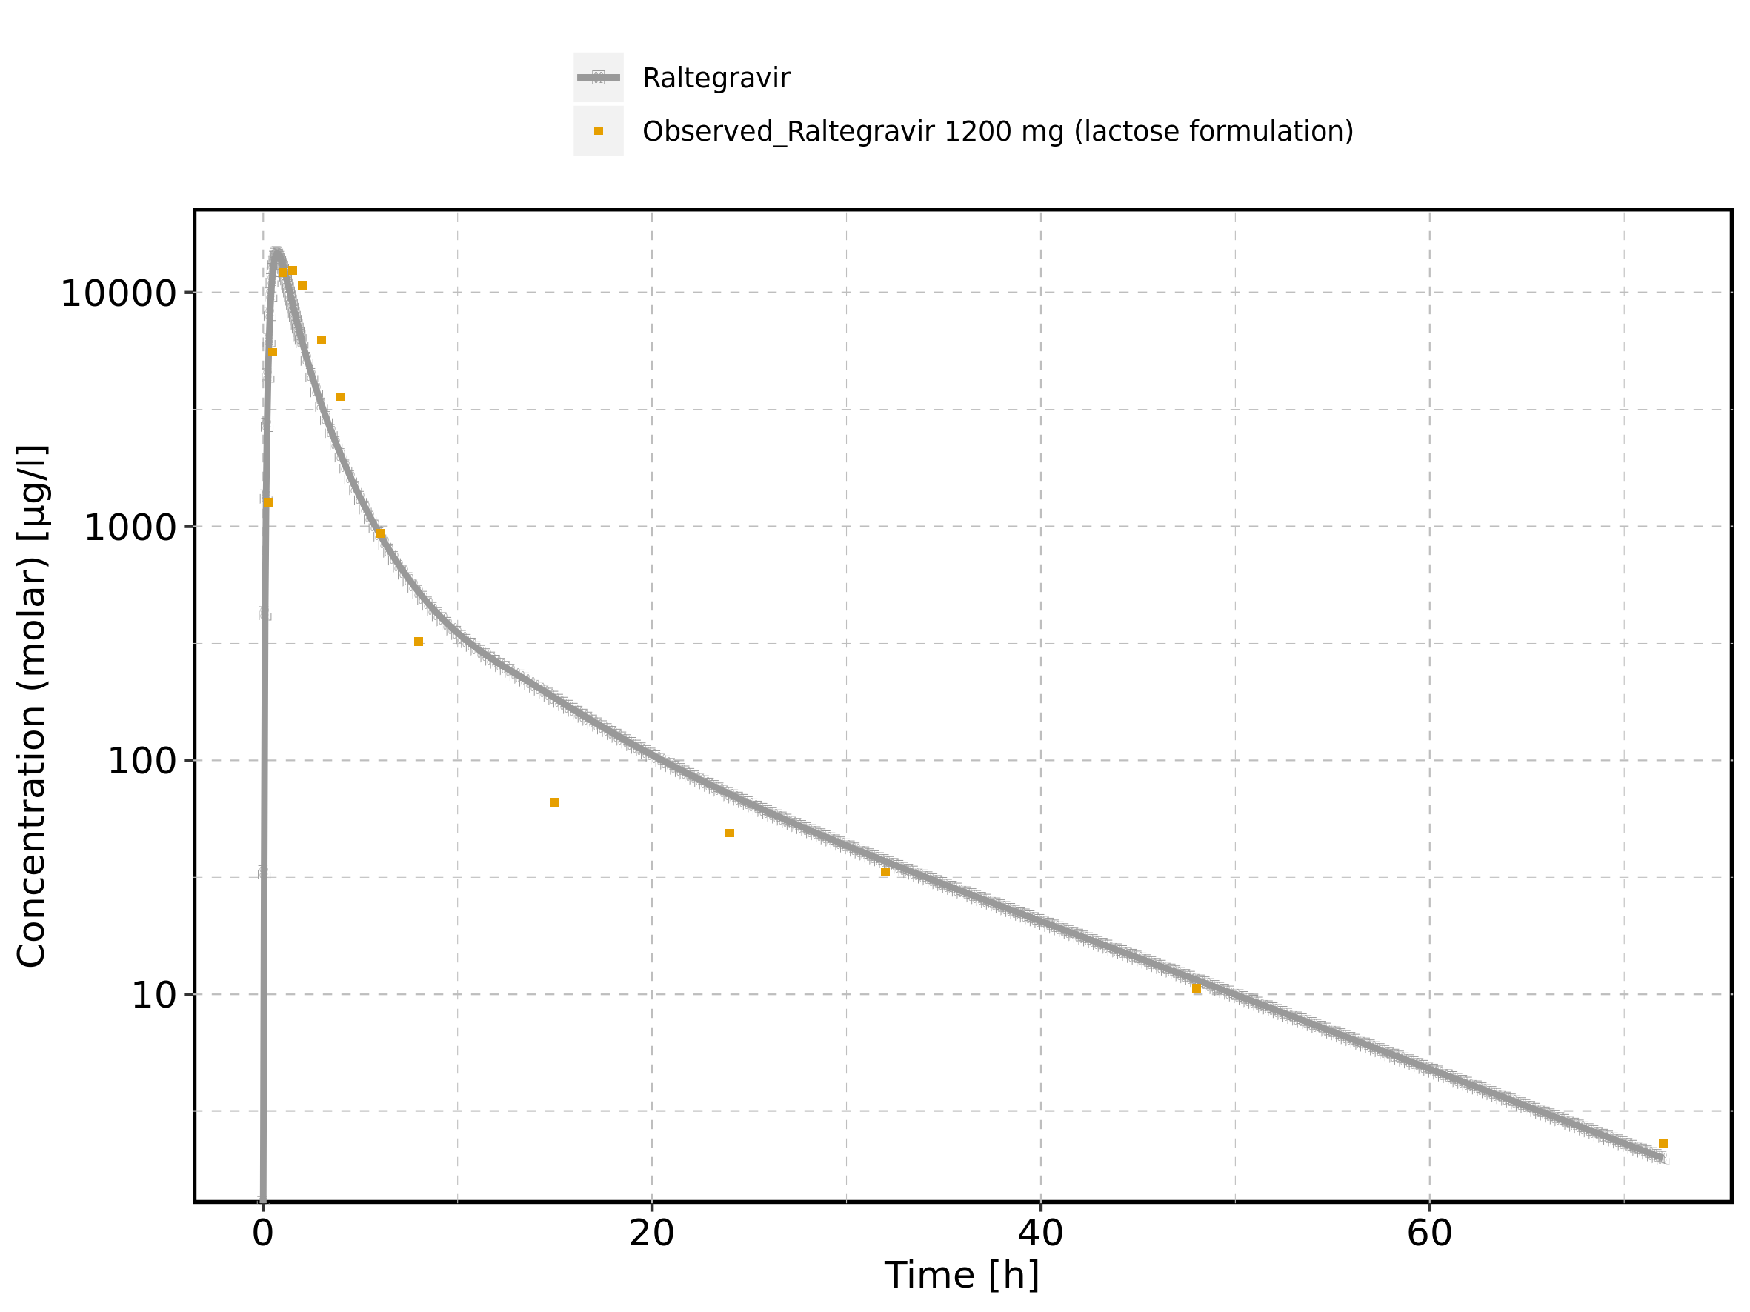

Figure 155: Predicted vs observed of Raltegravir 1200 mg (lactose formulation) for Raltegravir 1200 mg (lactose formulation). Data source: Data/Raltegravir_PK.txt. Predictions and observations are plotted in a linear scale.

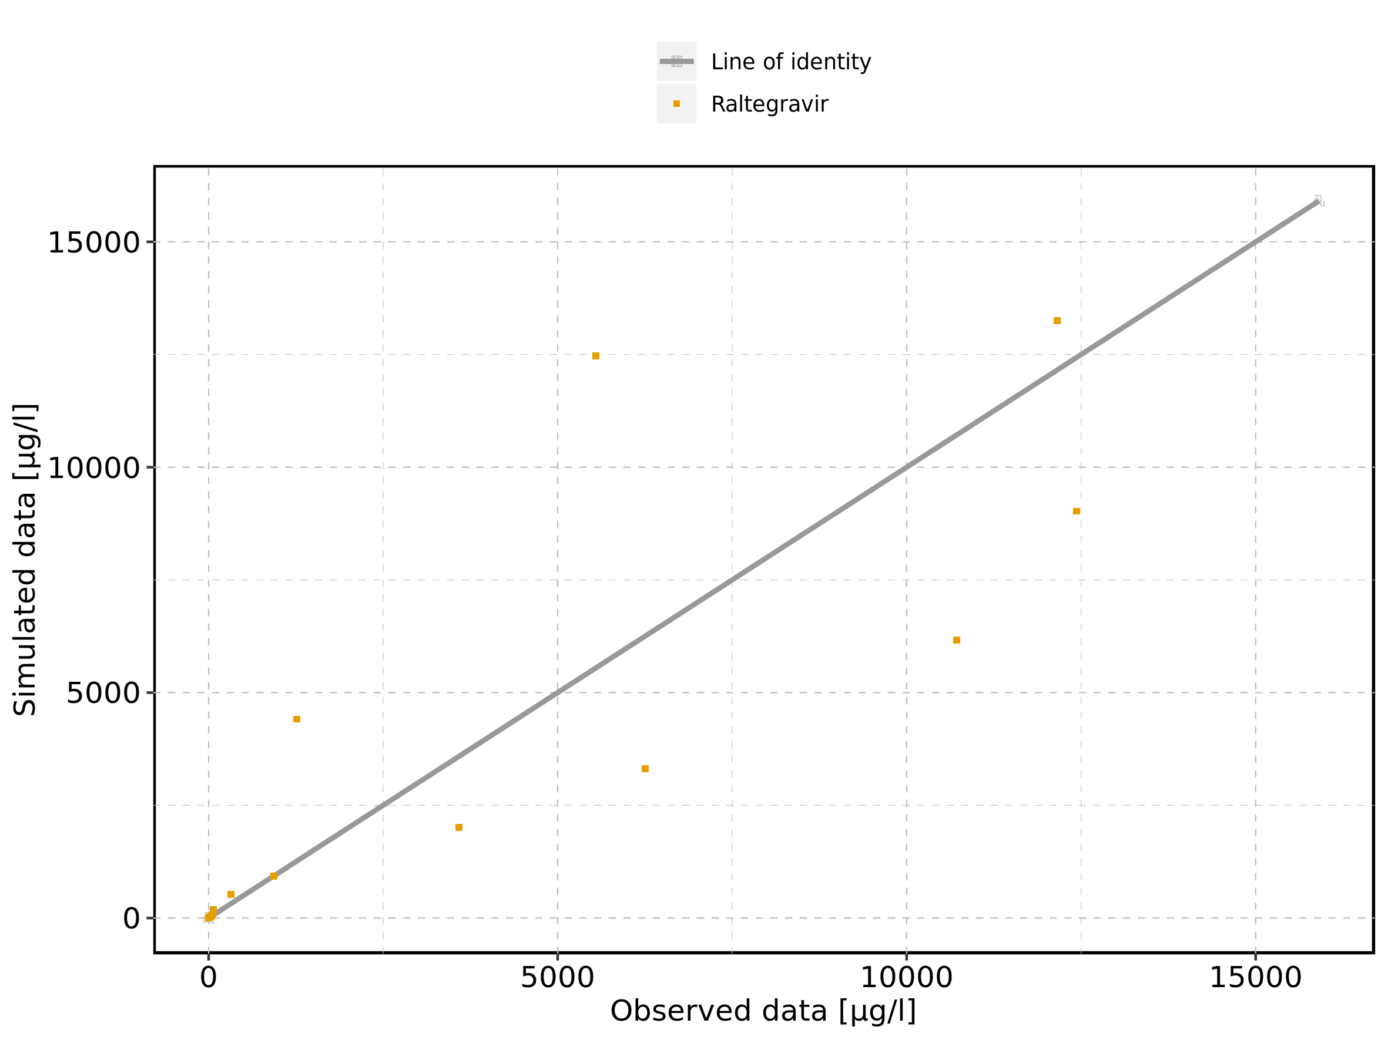

Figure 156: Predicted vs observed of Raltegravir 1200 mg (lactose formulation) for Raltegravir 1200 mg (lactose formulation). Data source: Data/Raltegravir_PK.txt. Predictions and observations are plotted in a logarithmic scale.

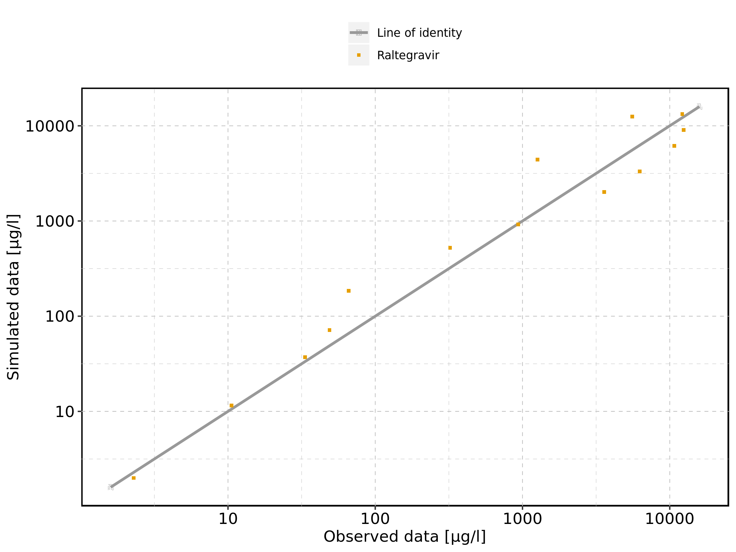

Figure 157: Logarithmic residuals vs predicted values of Raltegravir 1200 mg (lactose formulation) for Raltegravir 1200 mg (lactose formulation). Data source: Data/Raltegravir_PK.txt.

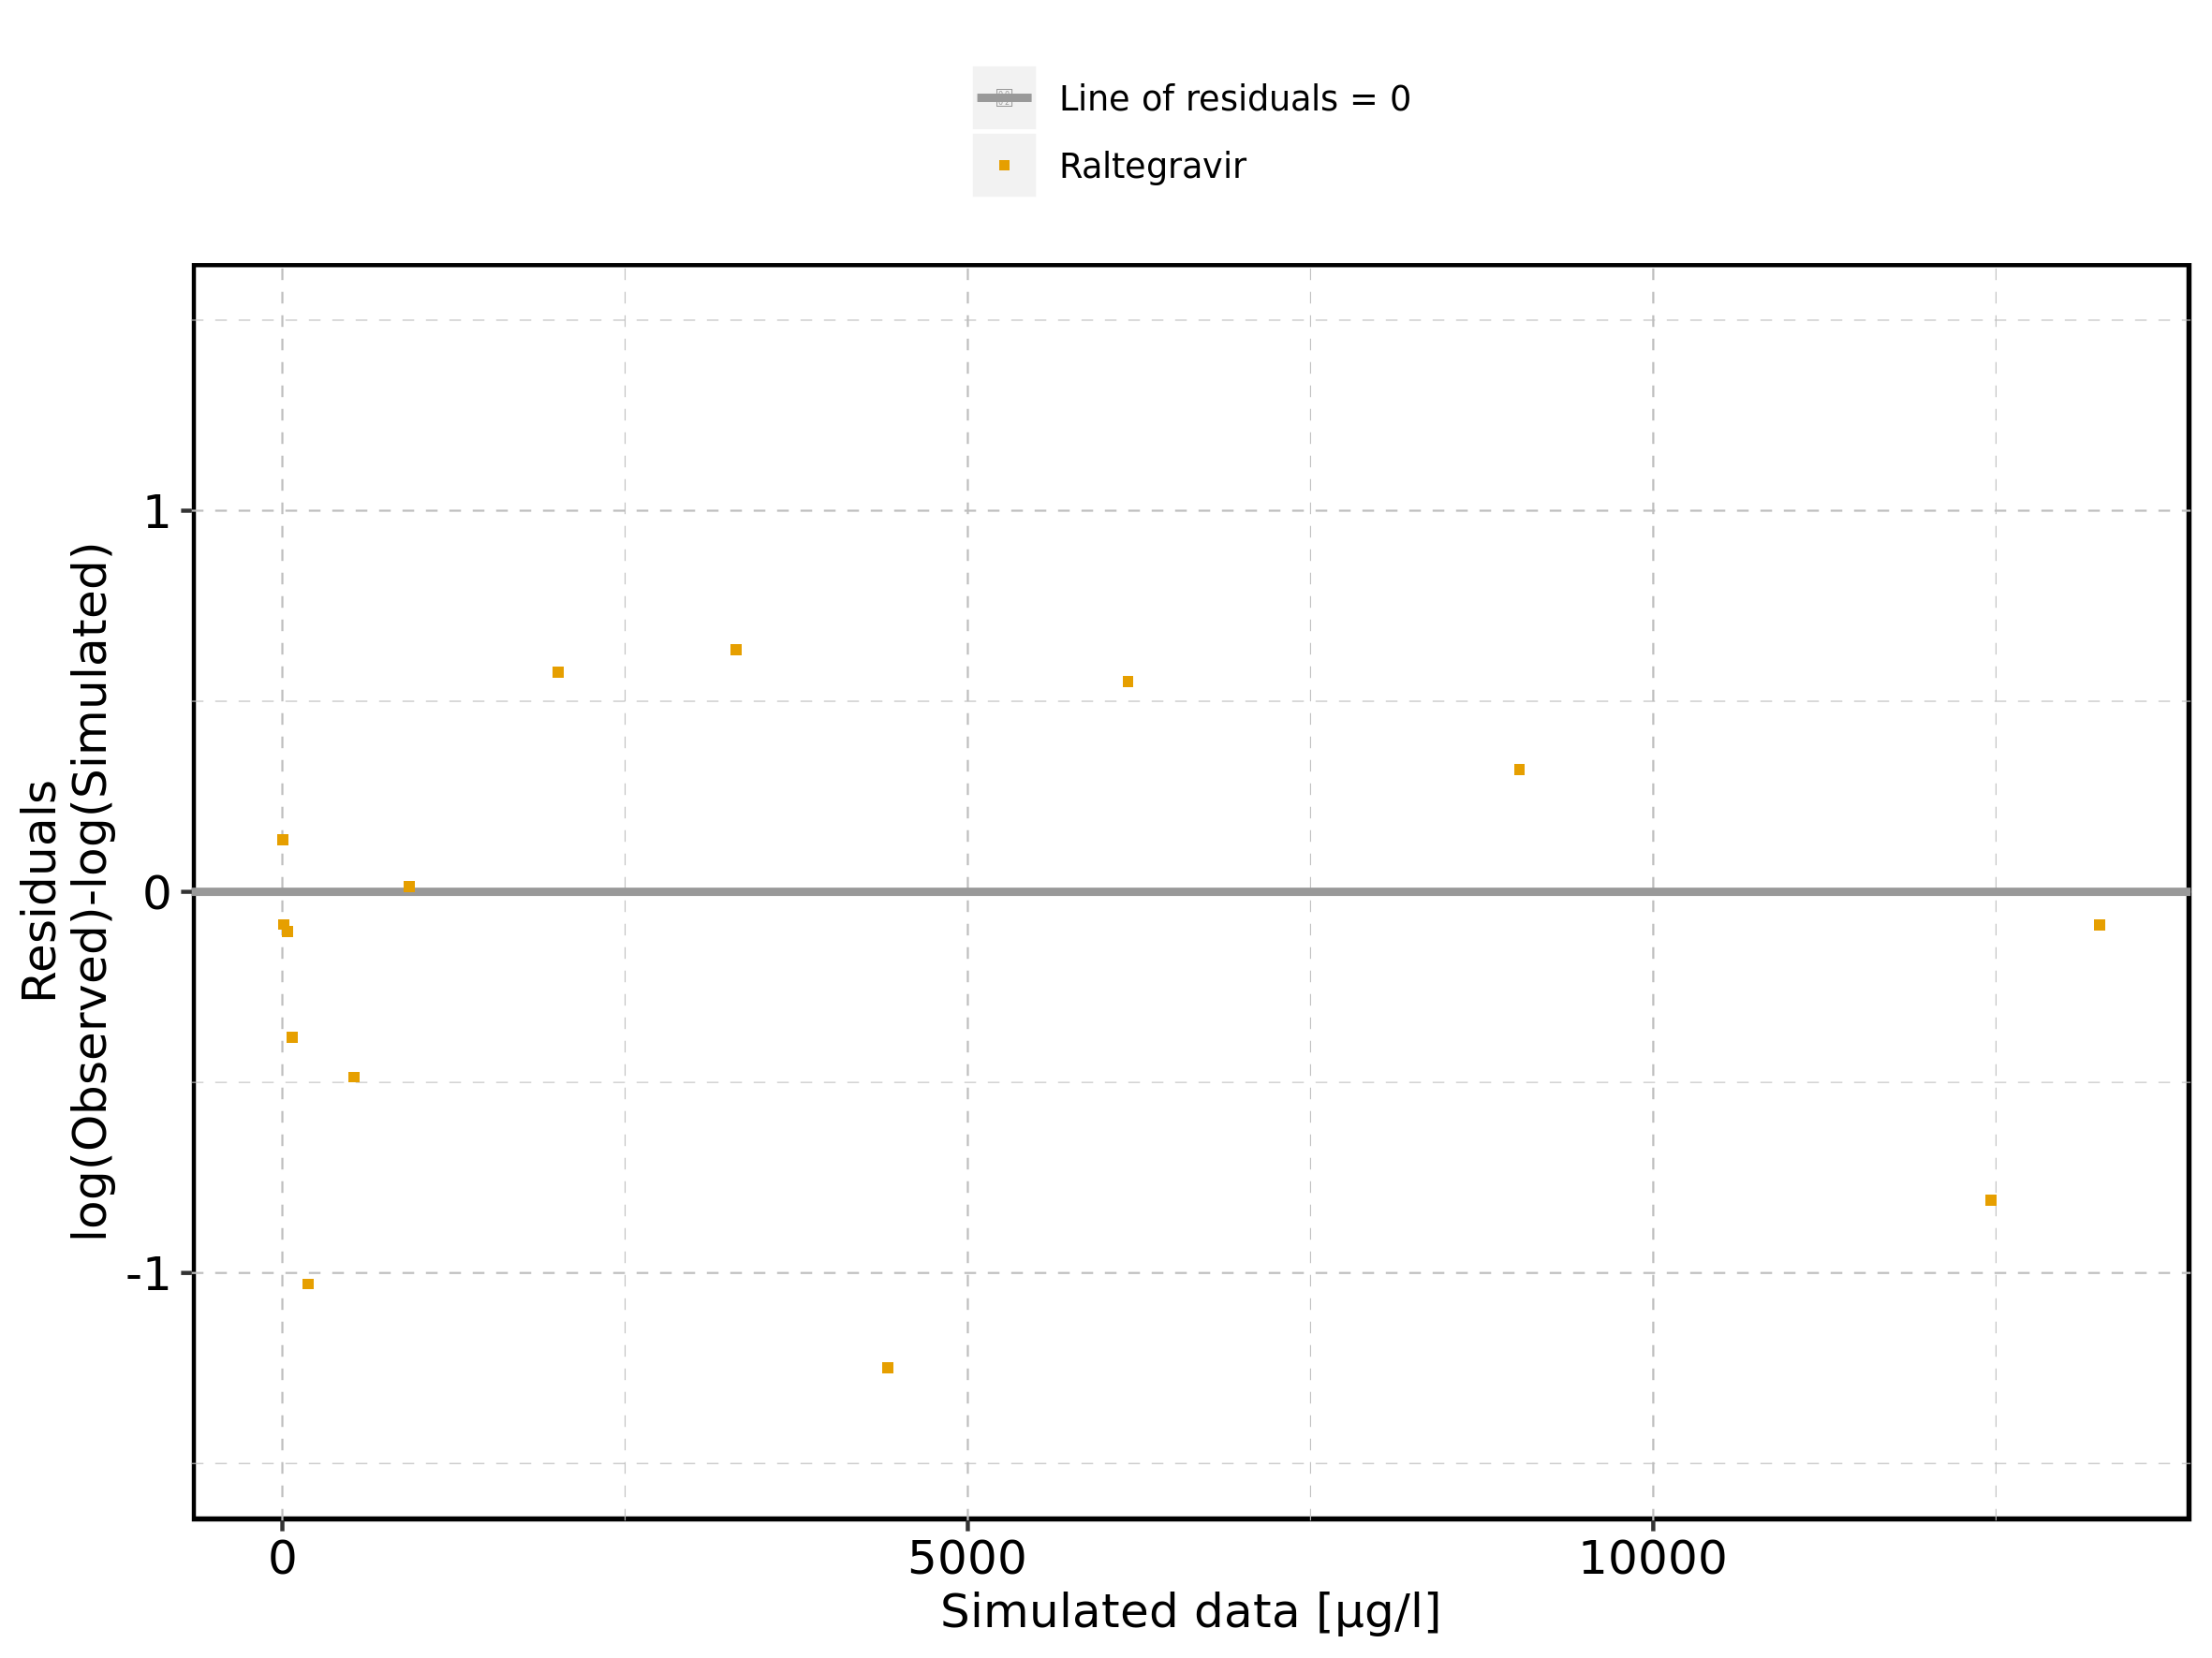

Figure 158: Logarithmic residuals vs time of Raltegravir 1200 mg (lactose formulation) for Raltegravir 1200 mg (lactose formulation). Data source: Data/Raltegravir_PK.txt.

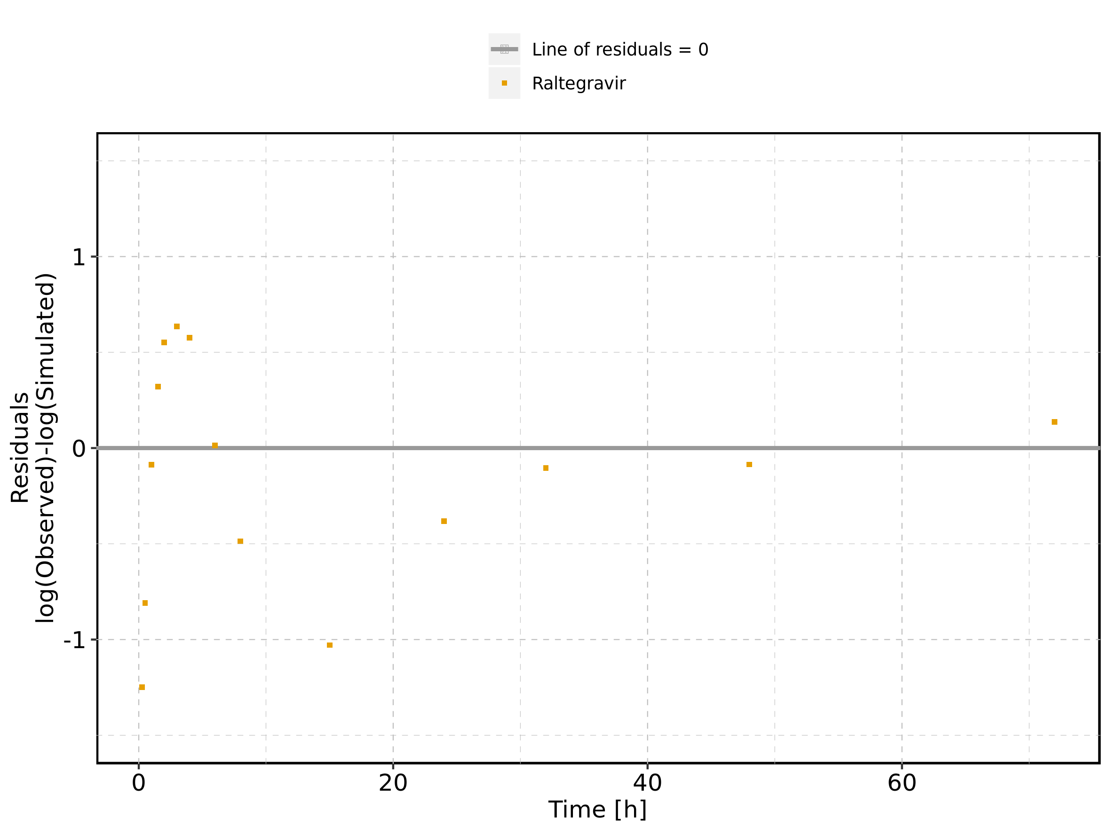

Figure 159: Logarithmic residuals distribution of Raltegravir 1200 mg (lactose formulation) for Raltegravir 1200 mg (lactose formulation). Data source: Data/Raltegravir_PK.txt.

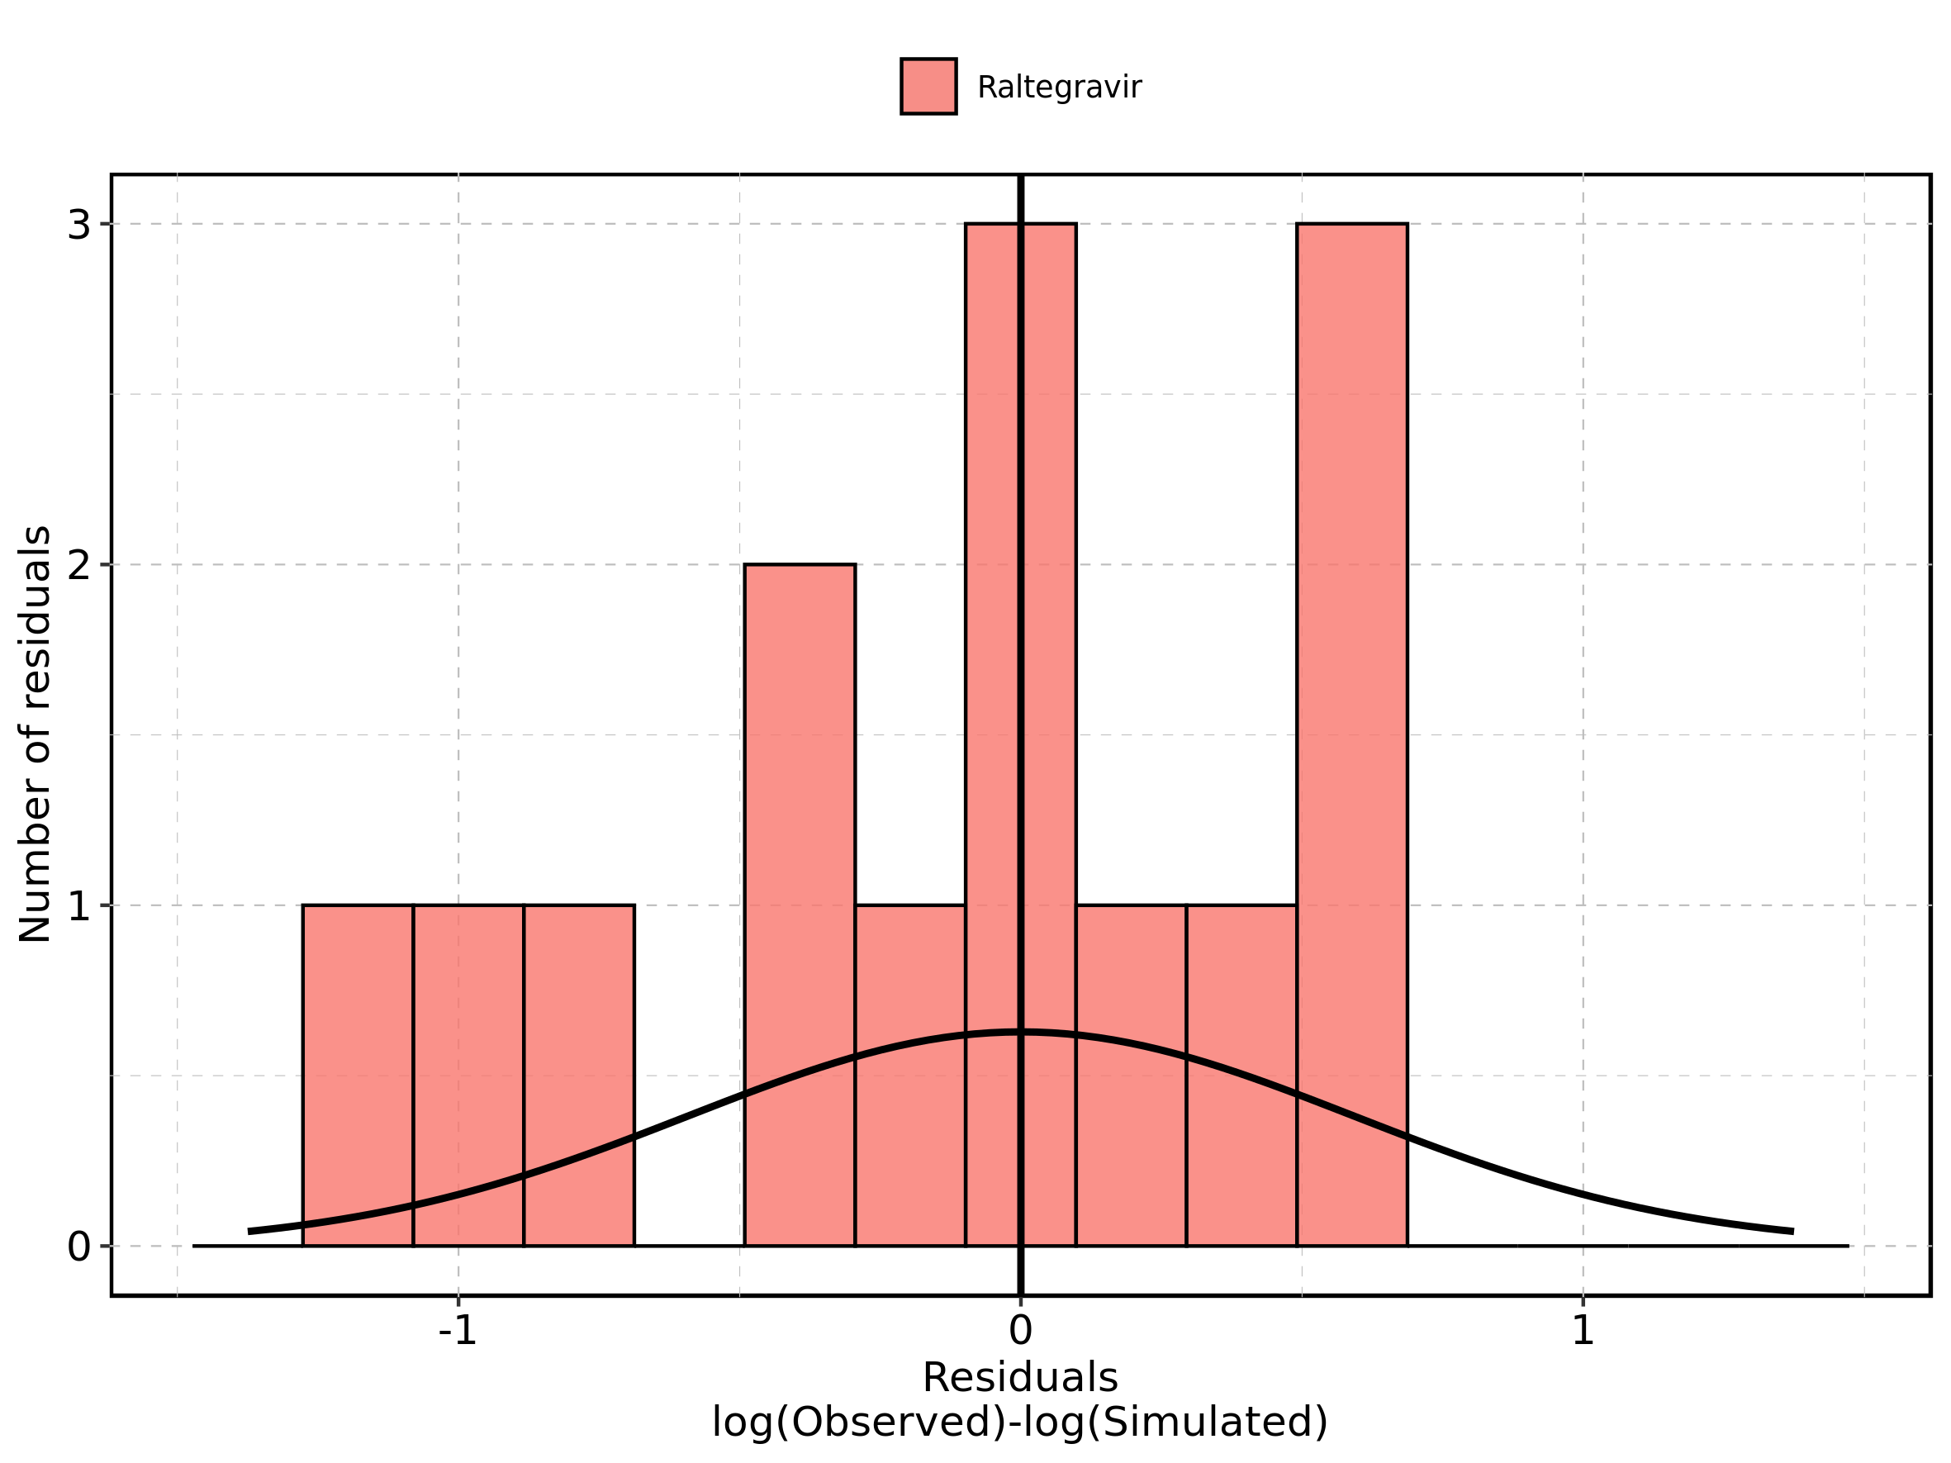

Figure 160: Logarithmic residuals of Raltegravir 1200 mg (lactose formulation) for Raltegravir 1200 mg (lactose formulation) as quantile-quantile plot. Data source: Data/Raltegravir_PK.txt.

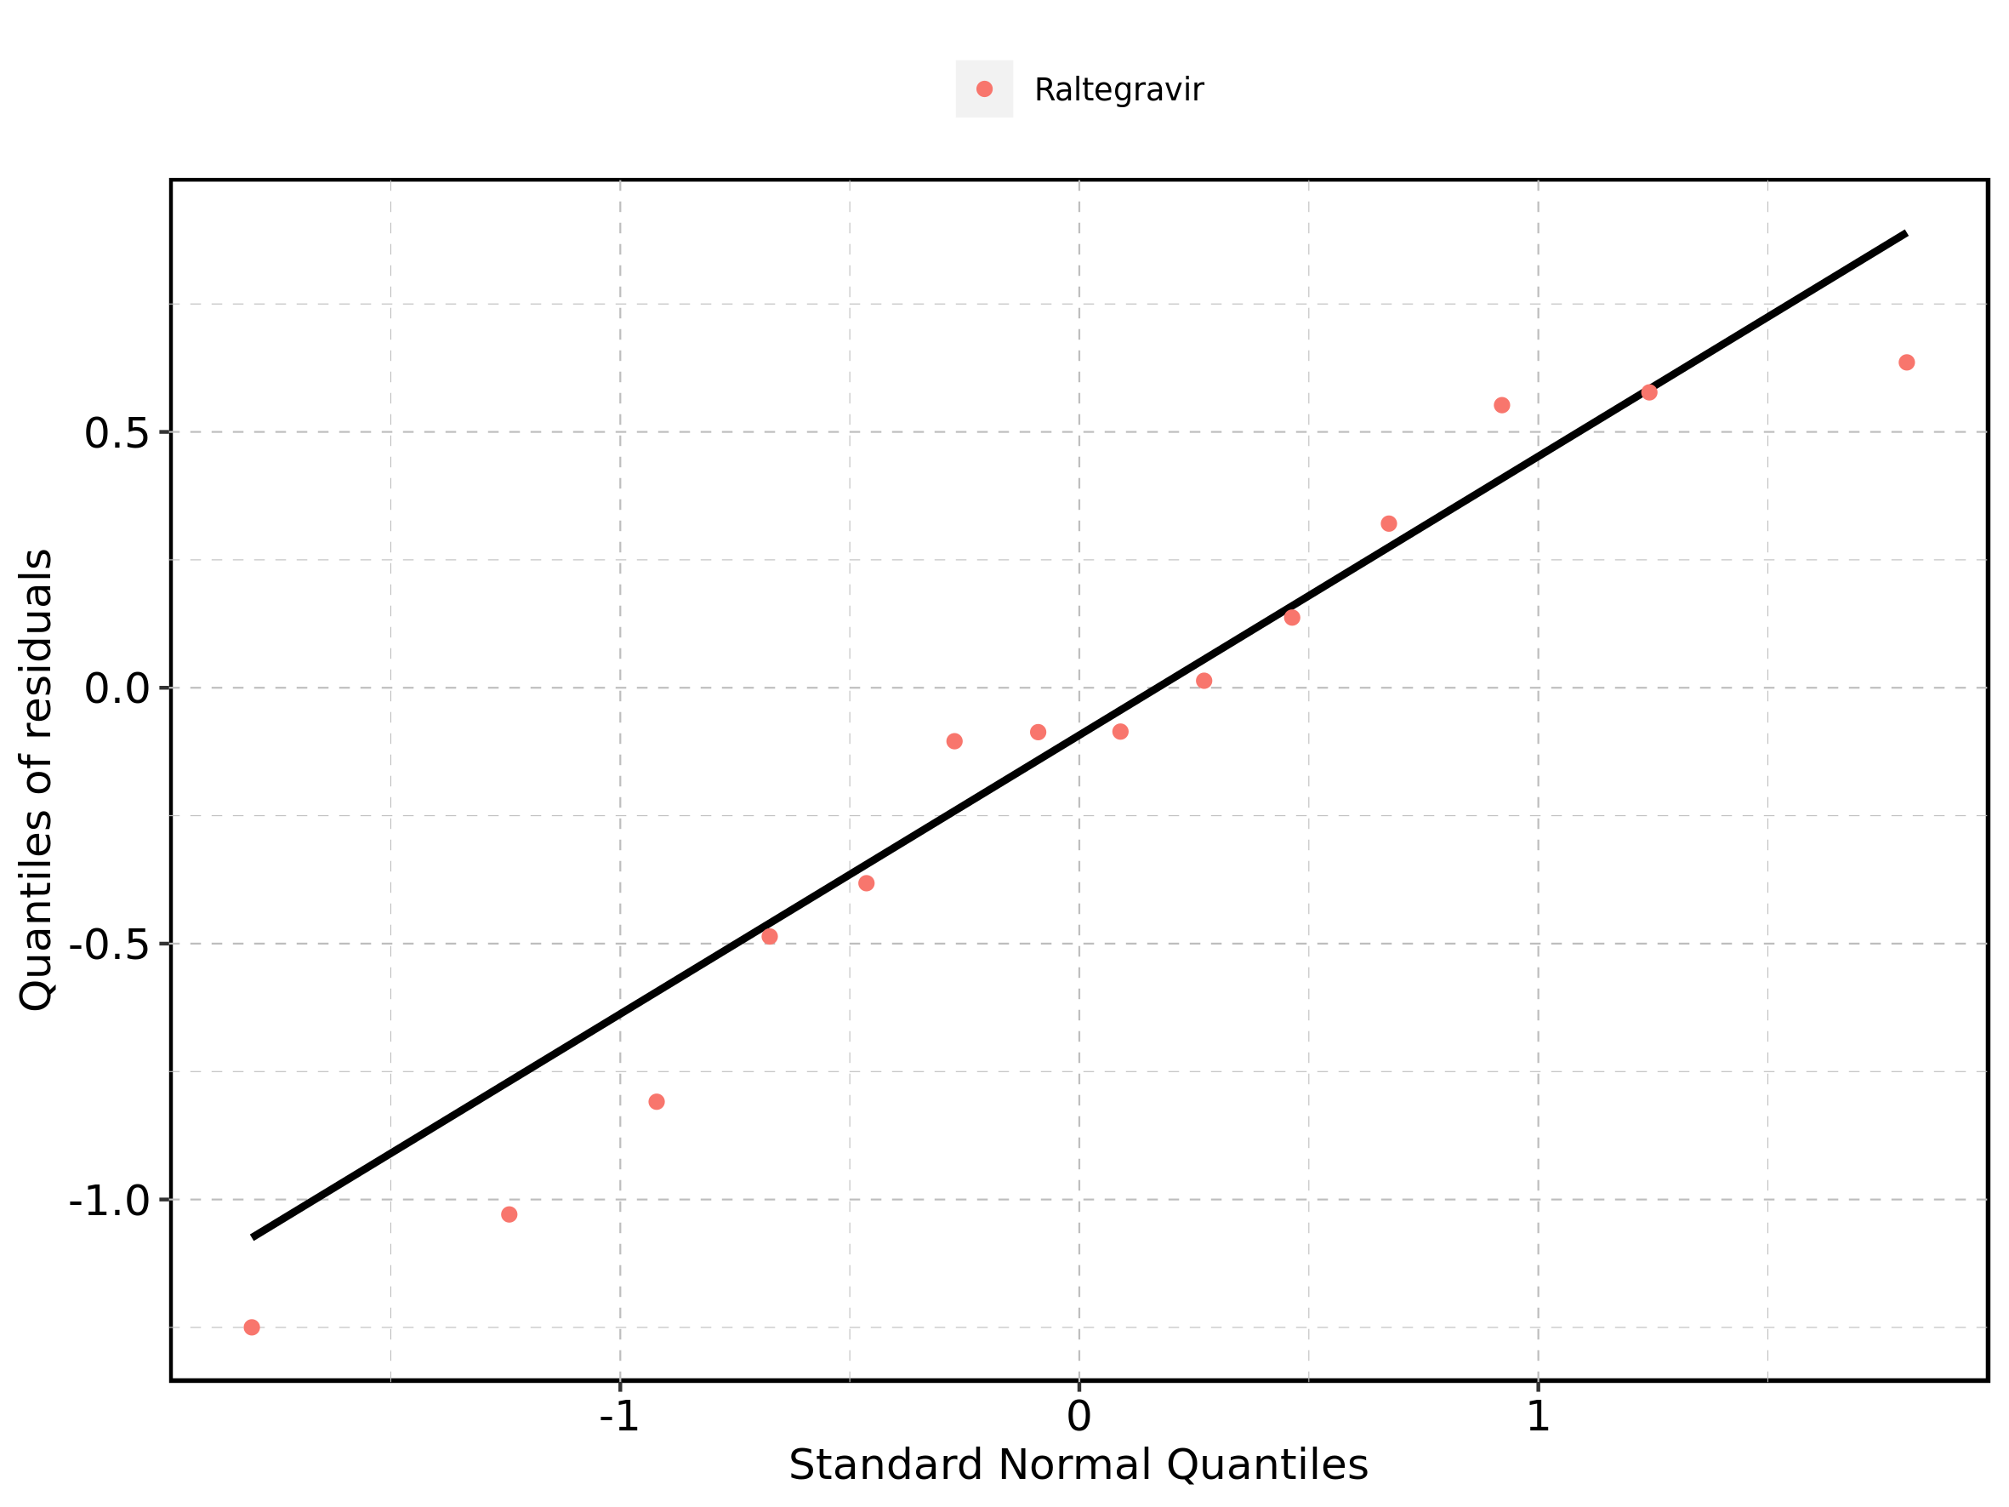

## 4.9. Time profiles and residual plots for Raltegravir 1600 mg (lactose formulation)

Figure 161: Time profiles of Raltegravir 1600 mg (lactose formulation) for Raltegravir 1600 mg (lactose formulation). Data source: Data/Raltegravir_PK.txt. Time profiles are plotted in a linear scale.

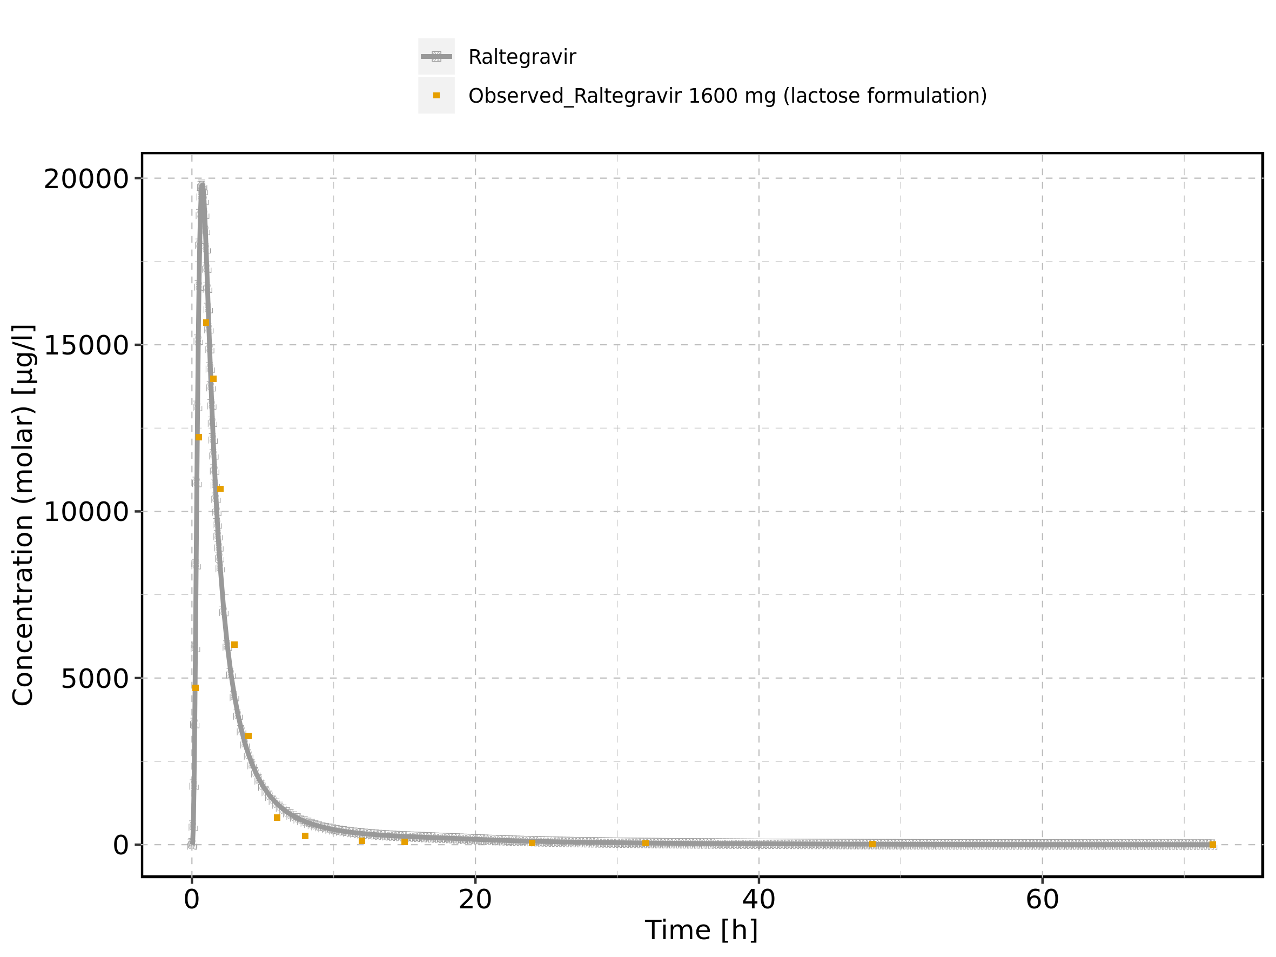

Figure 162: Time profiles of Raltegravir 1600 mg (lactose formulation) for Raltegravir 1600 mg (lactose formulation). Data source: Data/Raltegravir_PK.txt. Time profiles are plotted in a logarithmic scale.

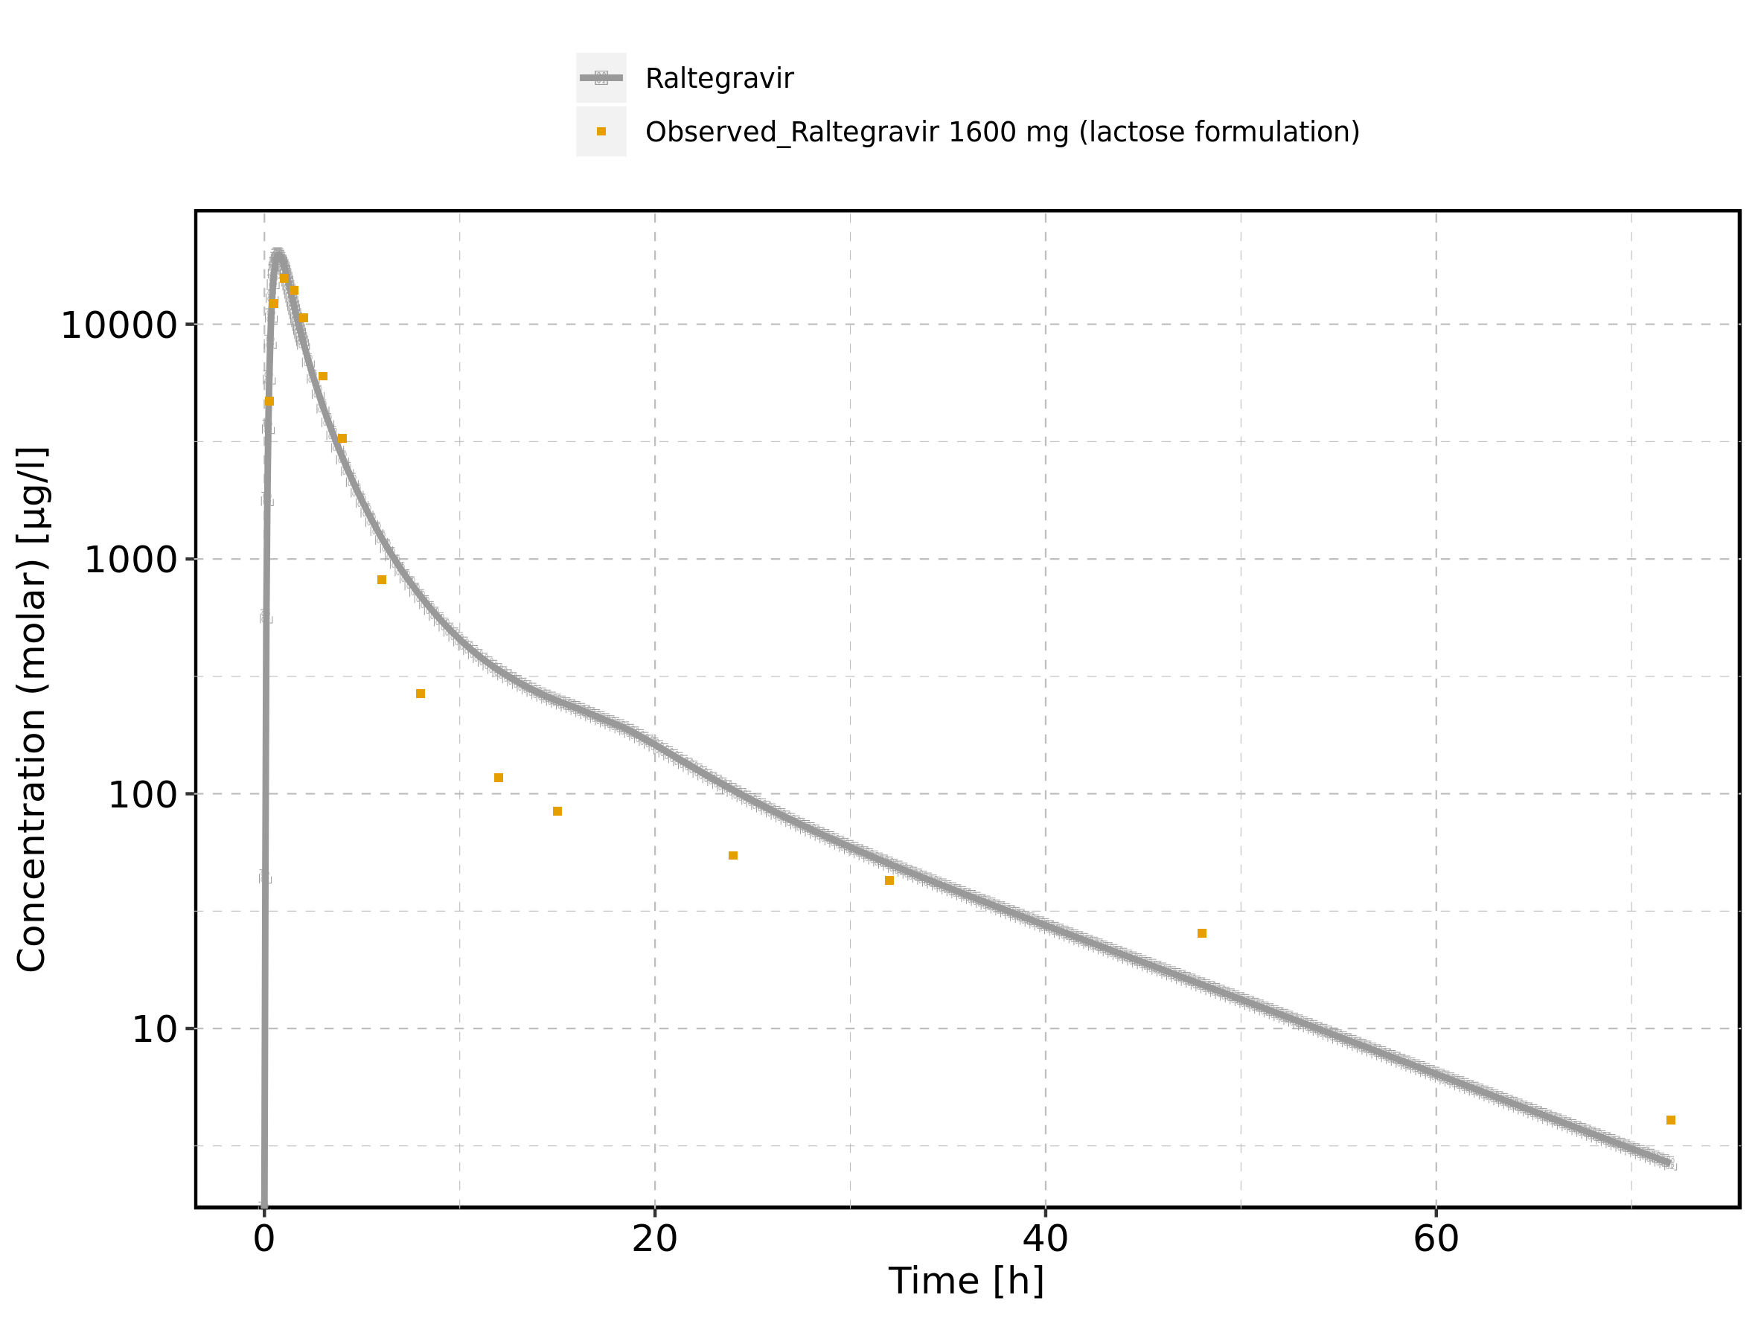

Figure 163: Predicted vs observed of Raltegravir 1600 mg (lactose formulation) for Raltegravir 1600 mg (lactose formulation). Data source: Data/Raltegravir_PK.txt. Predictions and observations are plotted in a linear scale.

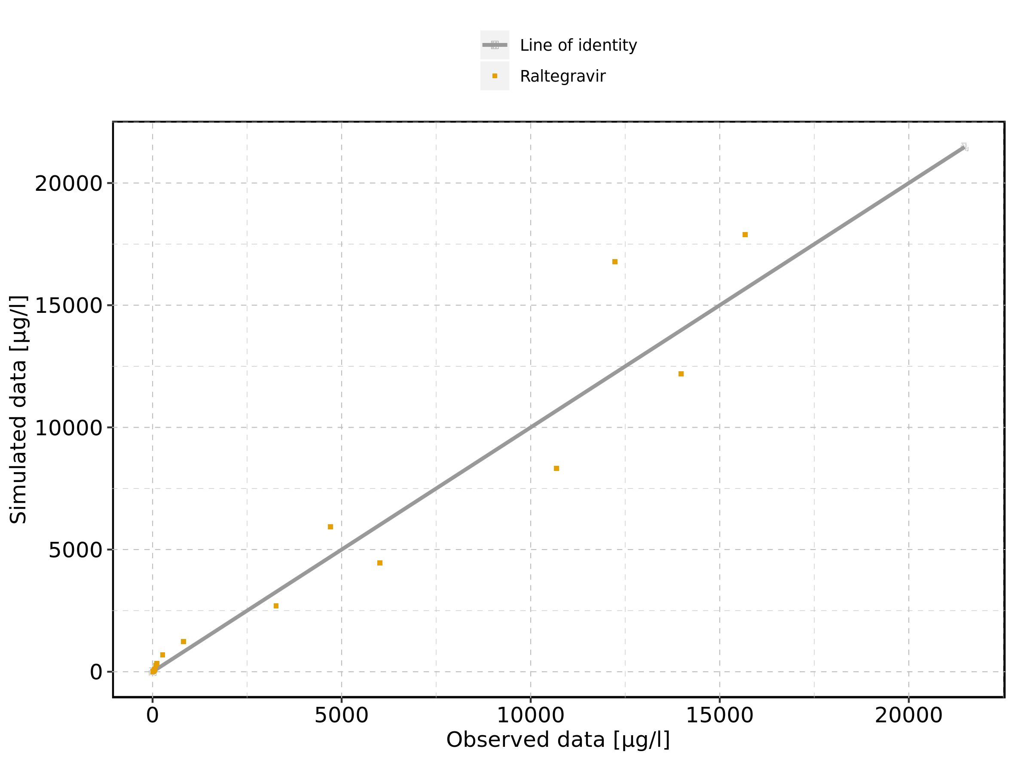

Figure 164: Predicted vs observed of Raltegravir 1600 mg (lactose formulation) for Raltegravir 1600 mg (lactose formulation). Data source: Data/Raltegravir_PK.txt. Predictions and observations are plotted in a logarithmic scale.

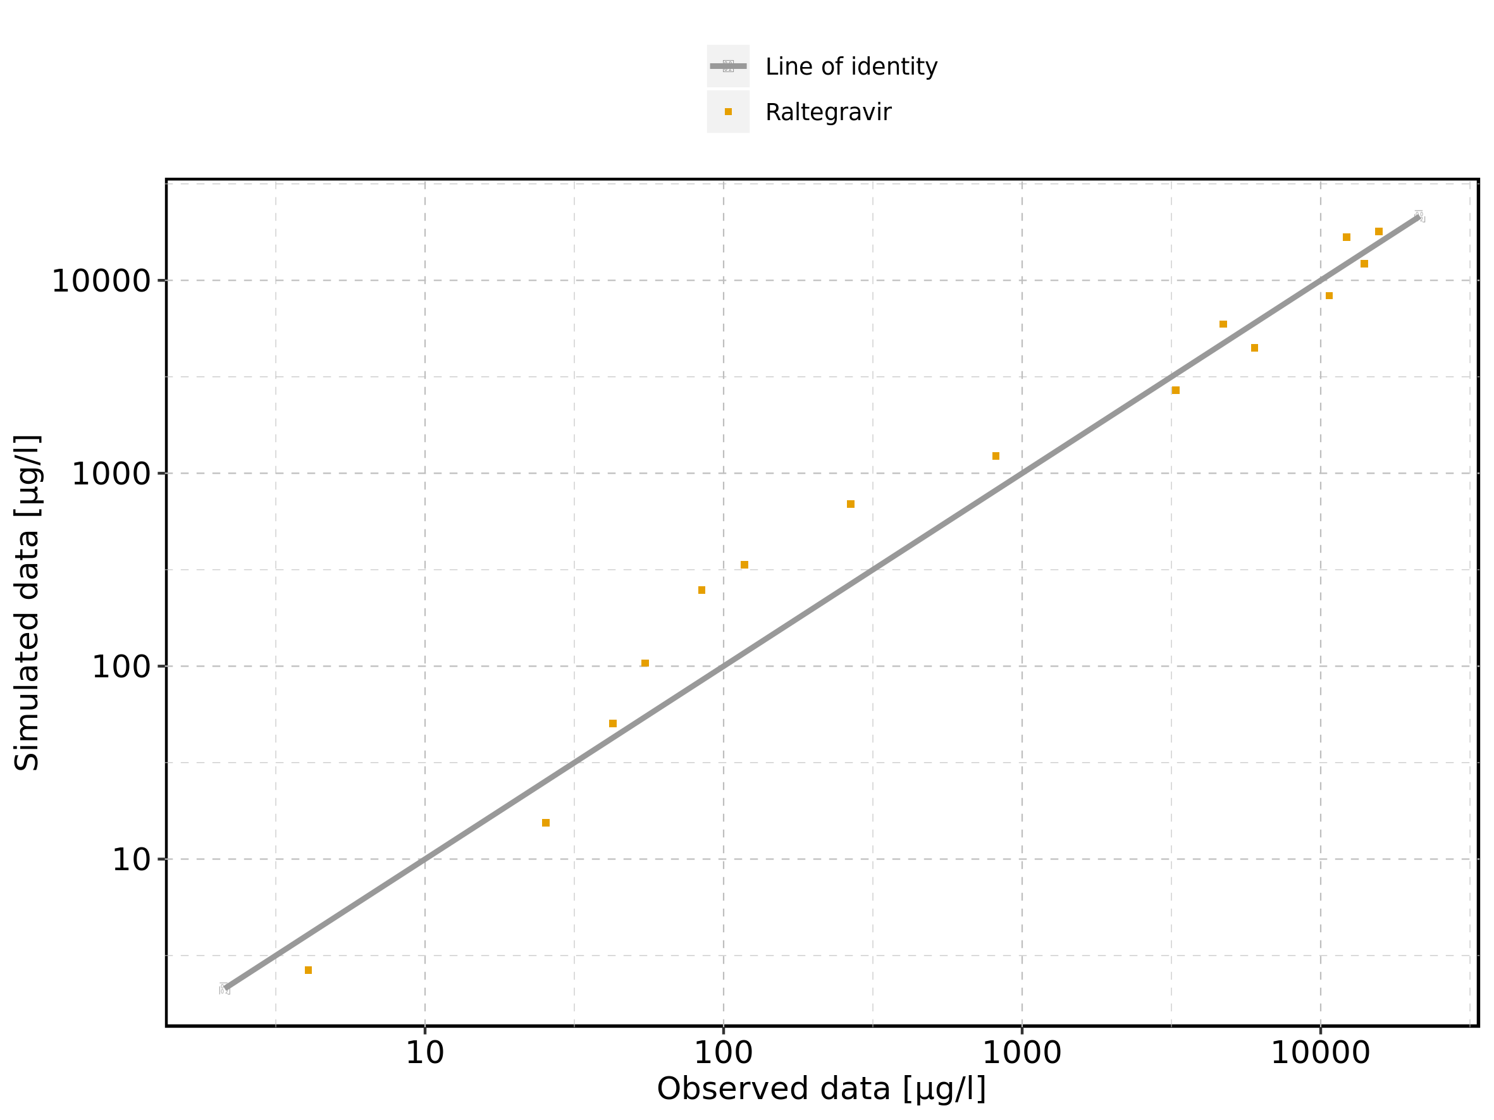

Figure 165: Logarithmic residuals vs predicted values of Raltegravir 1600 mg (lactose formulation) for Raltegravir 1600 mg (lactose formulation). Data source: Data/Raltegravir_PK.txt.

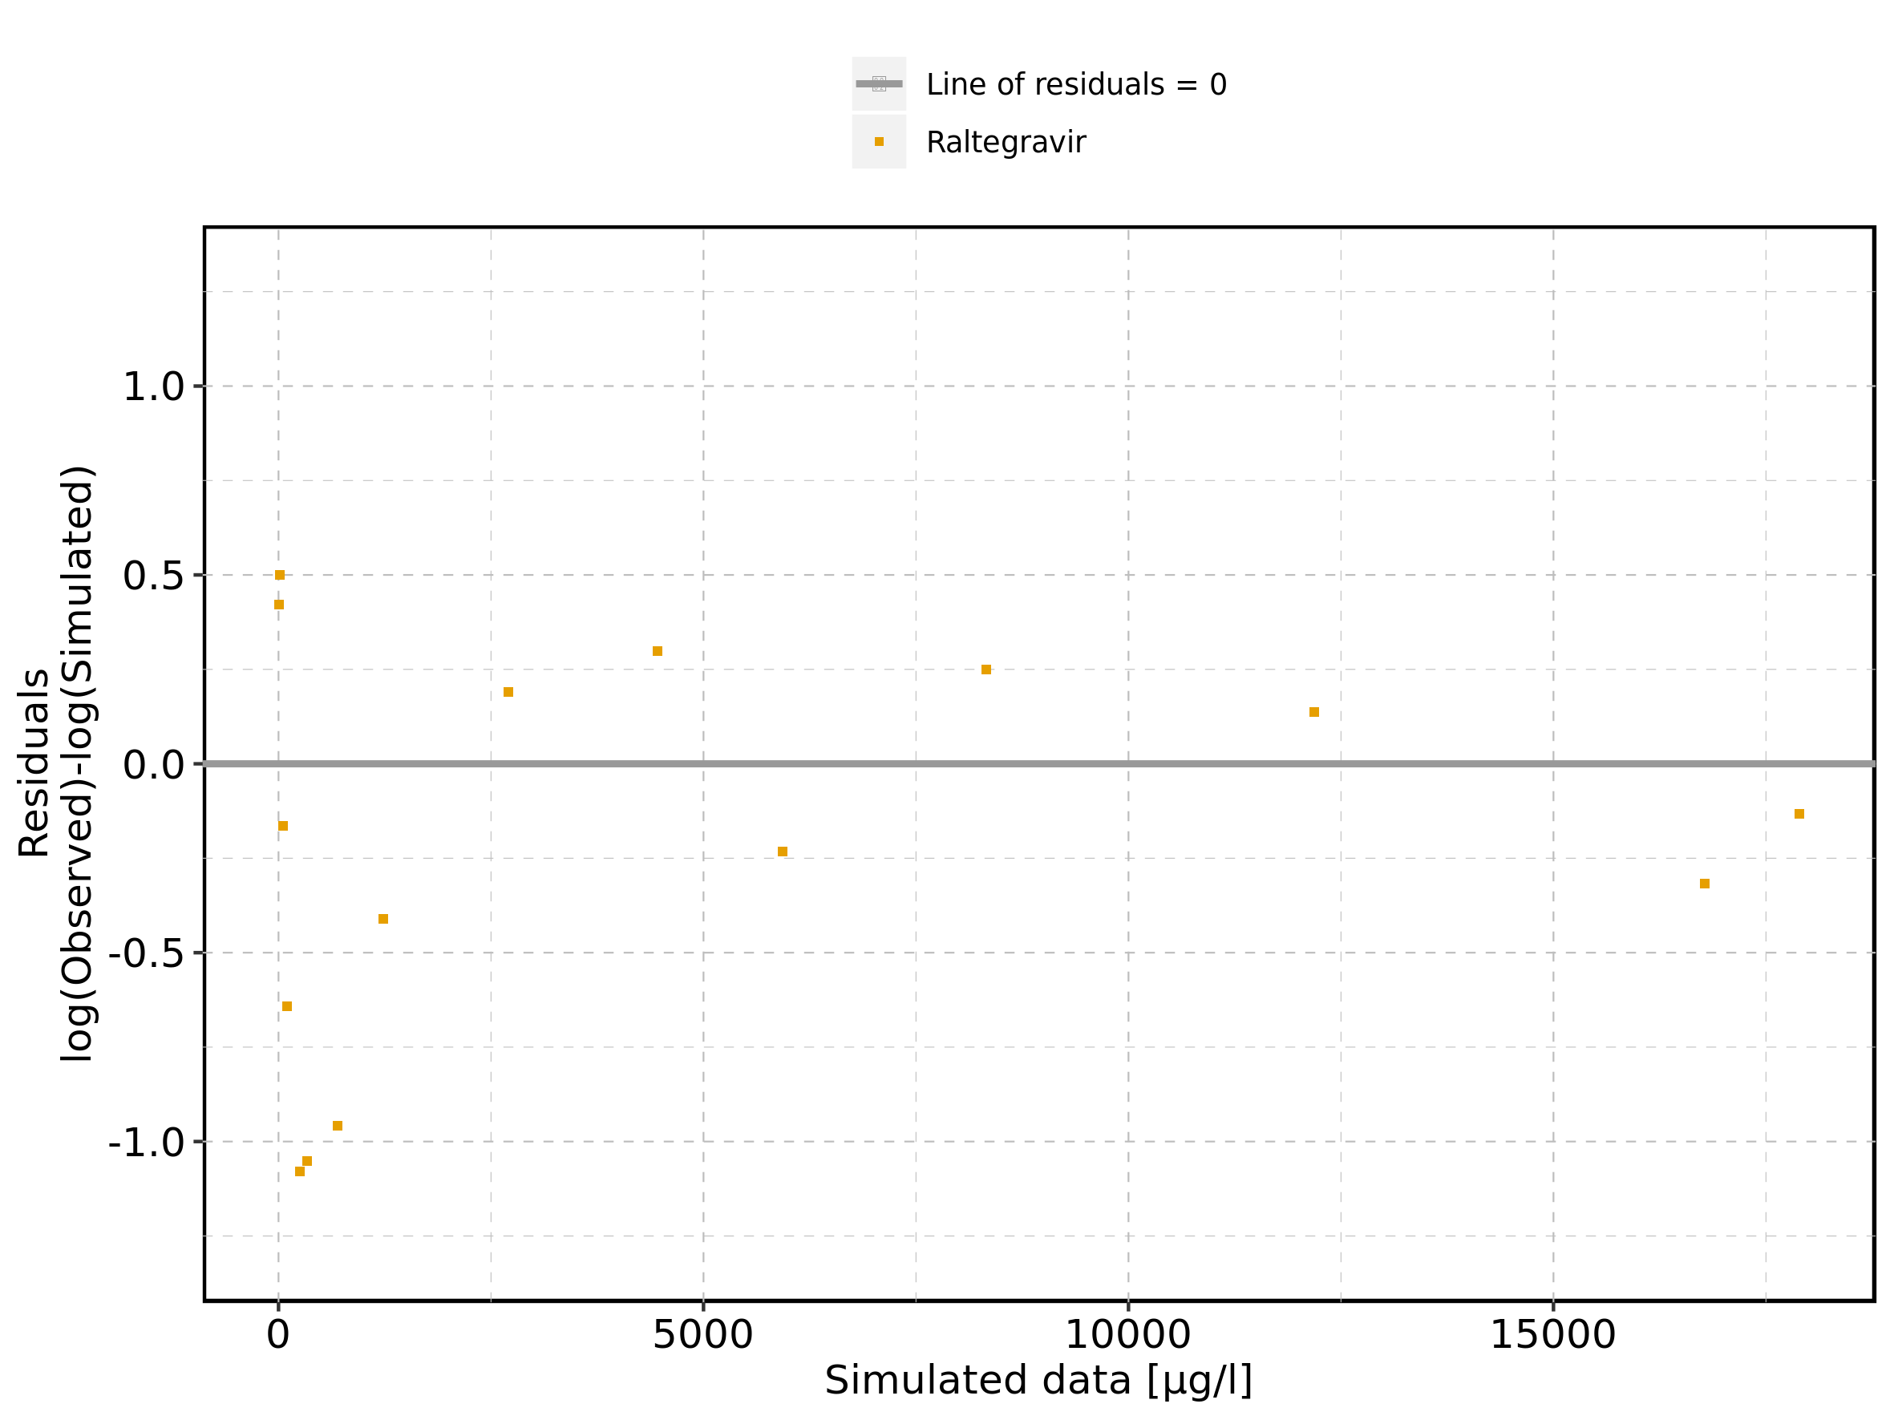

Figure 166: Logarithmic residuals vs time of Raltegravir 1600 mg (lactose formulation) for Raltegravir 1600 mg (lactose formulation). Data source: Data/Raltegravir_PK.txt.

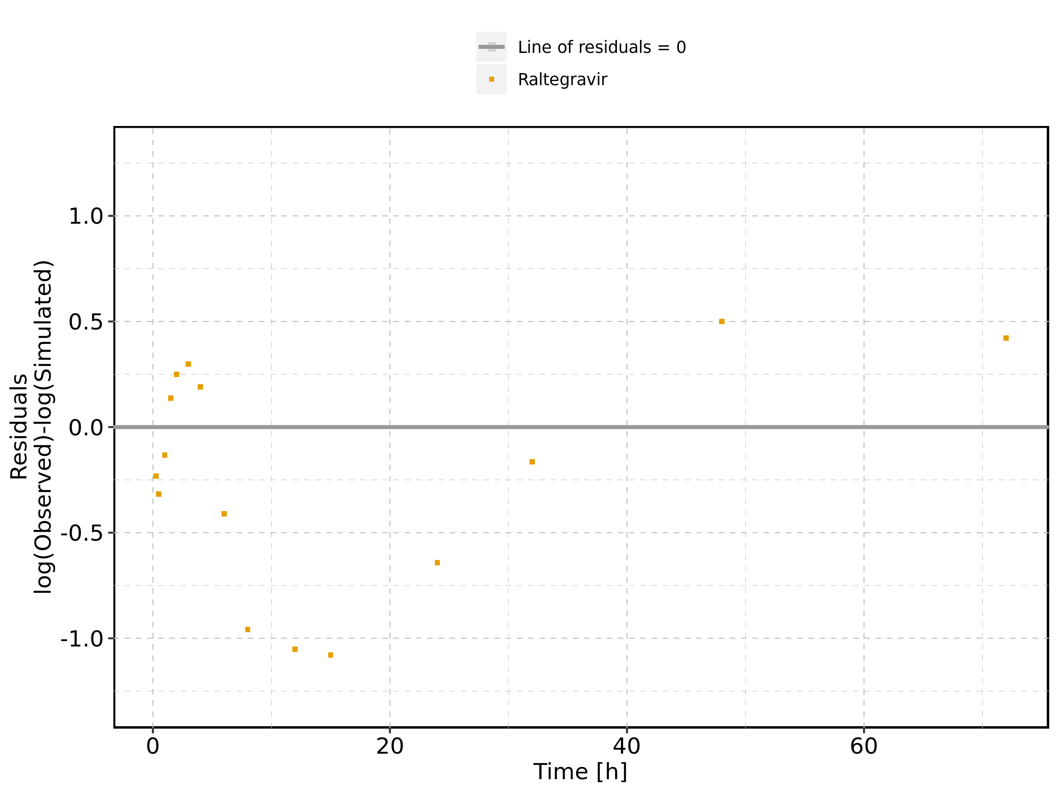

Figure 167: Logarithmic residuals distribution of Raltegravir 1600 mg (lactose formulation) for Raltegravir 1600 mg (lactose formulation). Data source: Data/Raltegravir_PK.txt.

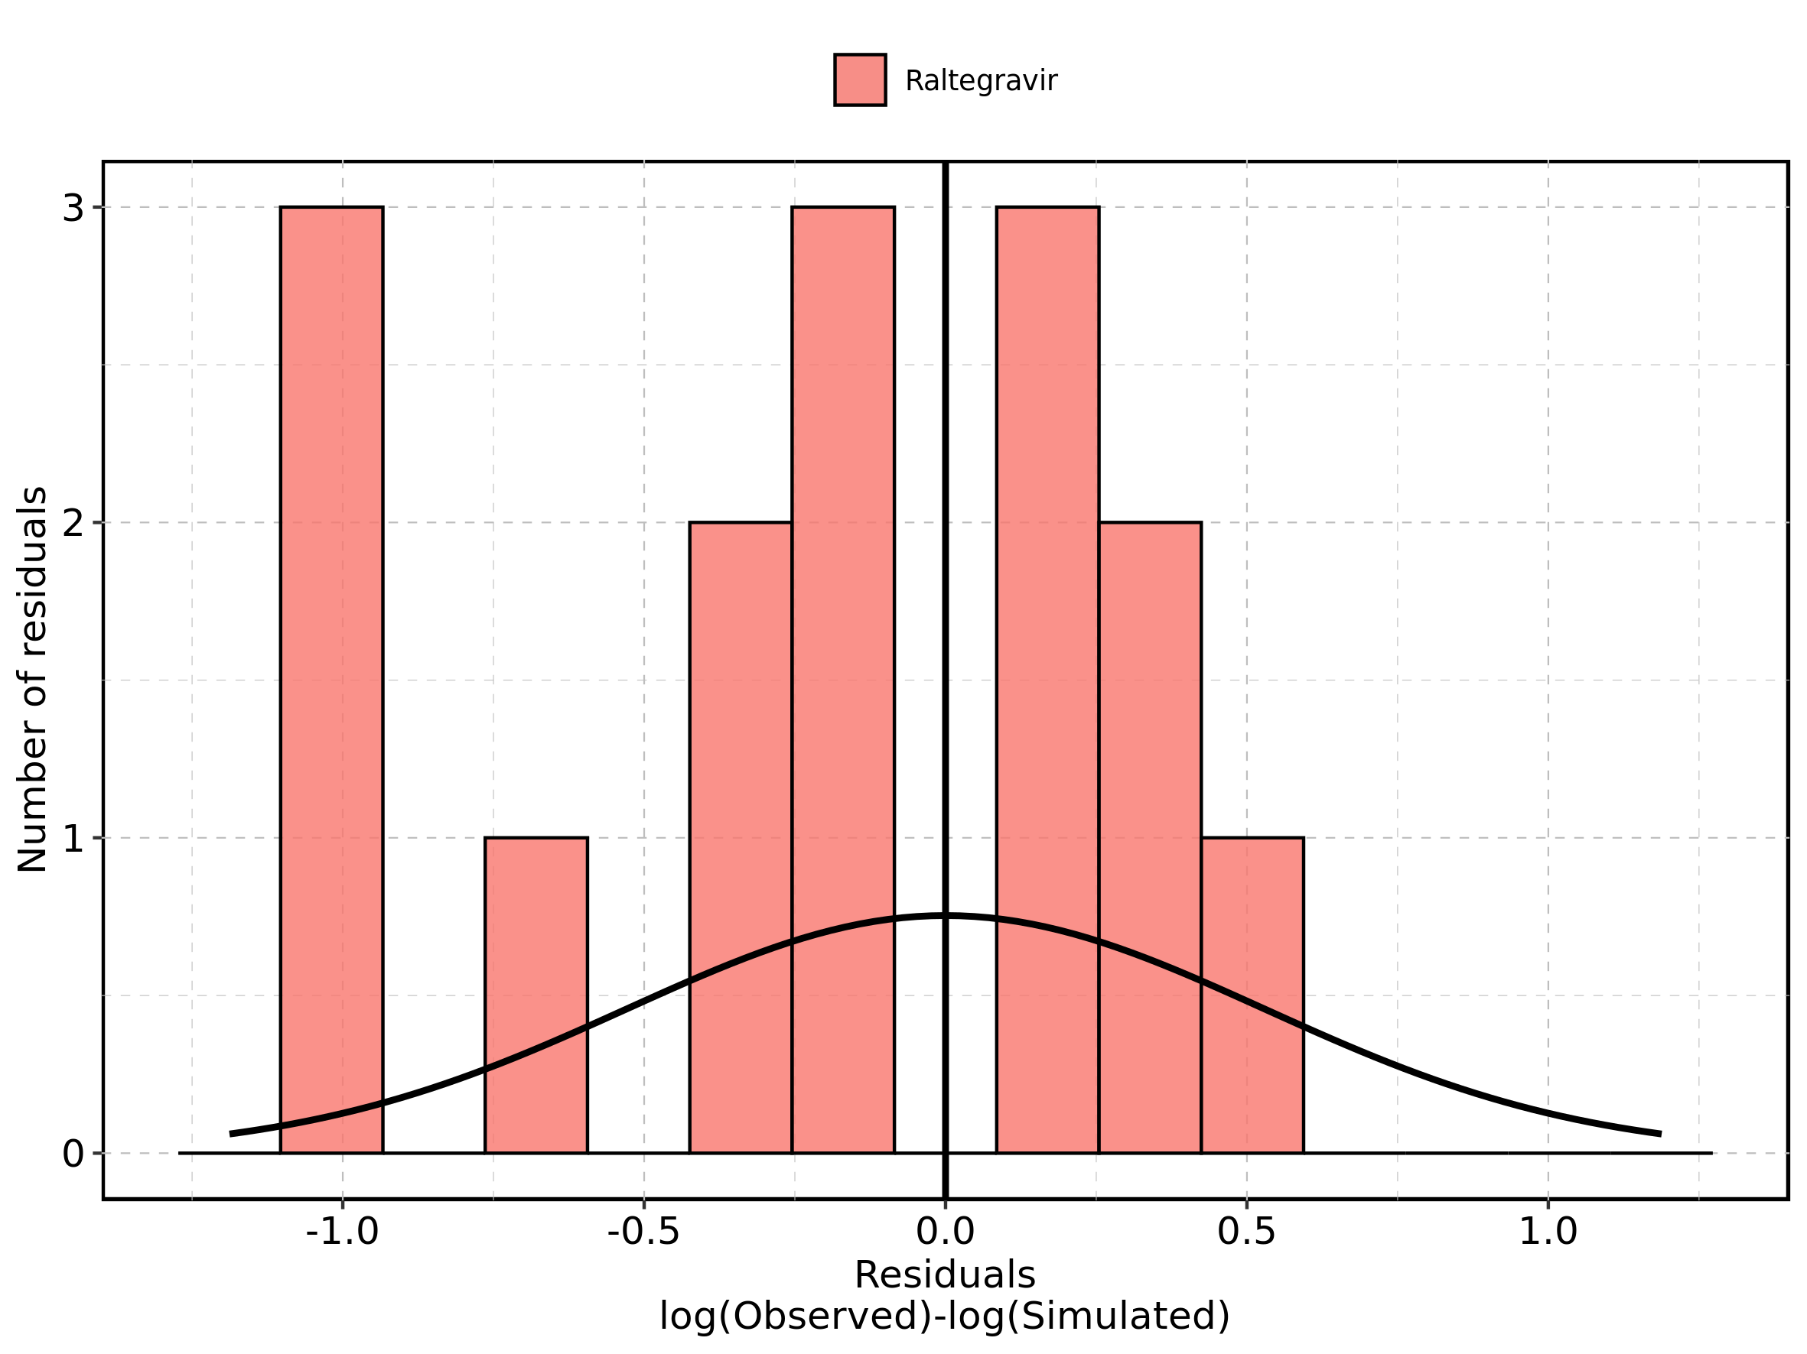

Figure 168: Logarithmic residuals of Raltegravir 1600 mg (lactose formulation) for Raltegravir 1600 mg (lactose formulation) as quantile-quantile plot. Data source: Data/Raltegravir_PK.txt.

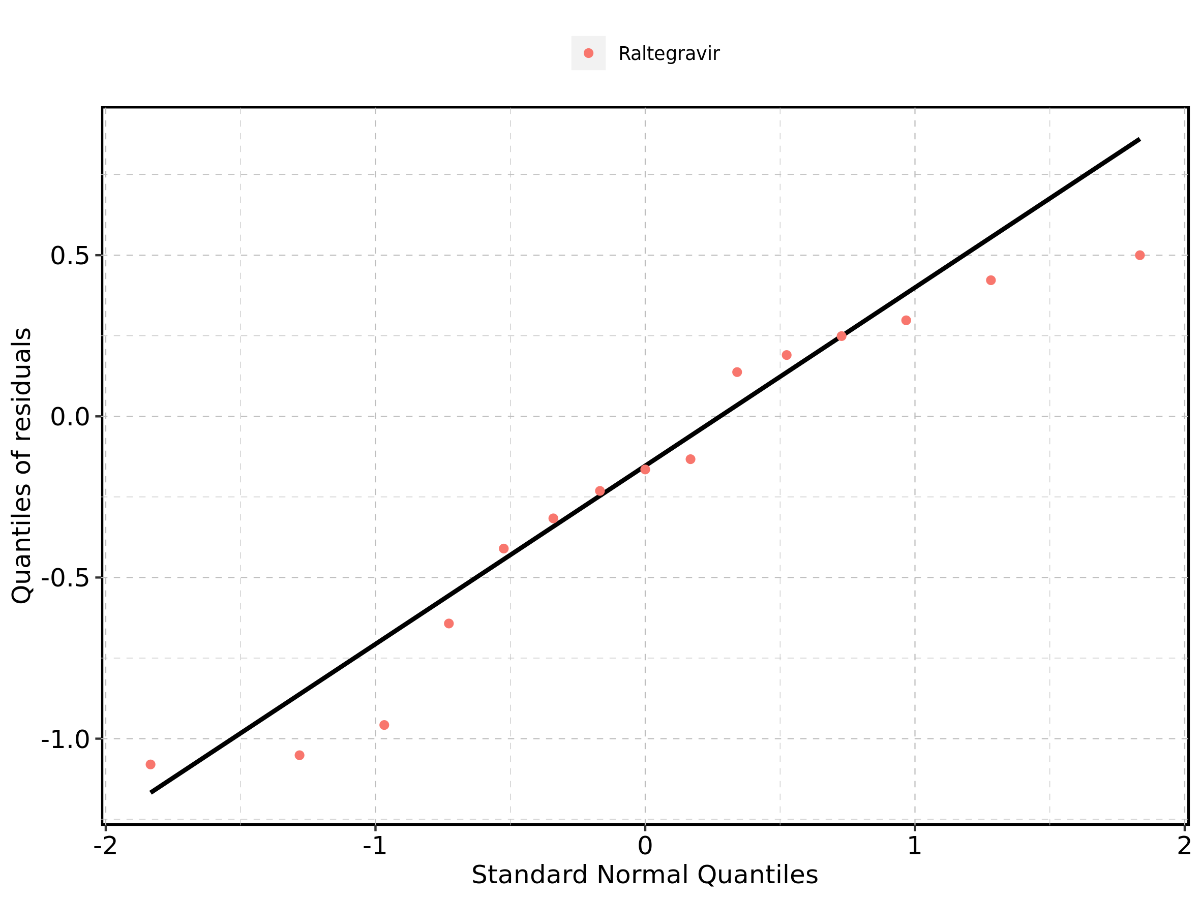

## 4.10. Time profiles and residual plots for Raltegravir 100 mg filmcoated tablet md

### 4.10.1. For total simulation time range

Figure 169: Time profiles of Raltegravir 100 mg filmcoated tablet md for Raltegravir 100 mg filmcoated tablet md. Data source: Data/Raltegravir_PK.txt. Time profiles are plotted in a linear scale.

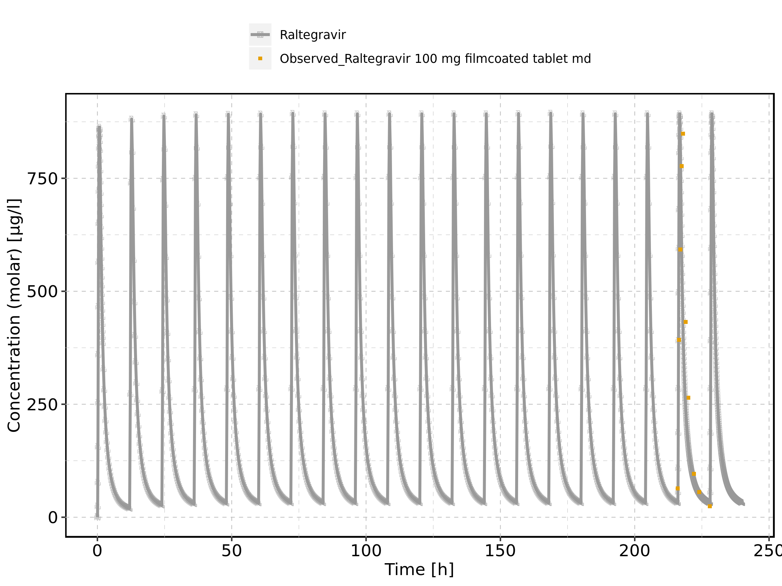

Figure 170: Time profiles of Raltegravir 100 mg filmcoated tablet md for Raltegravir 100 mg filmcoated tablet md. Data source: Data/Raltegravir_PK.txt. Time profiles are plotted in a logarithmic scale.

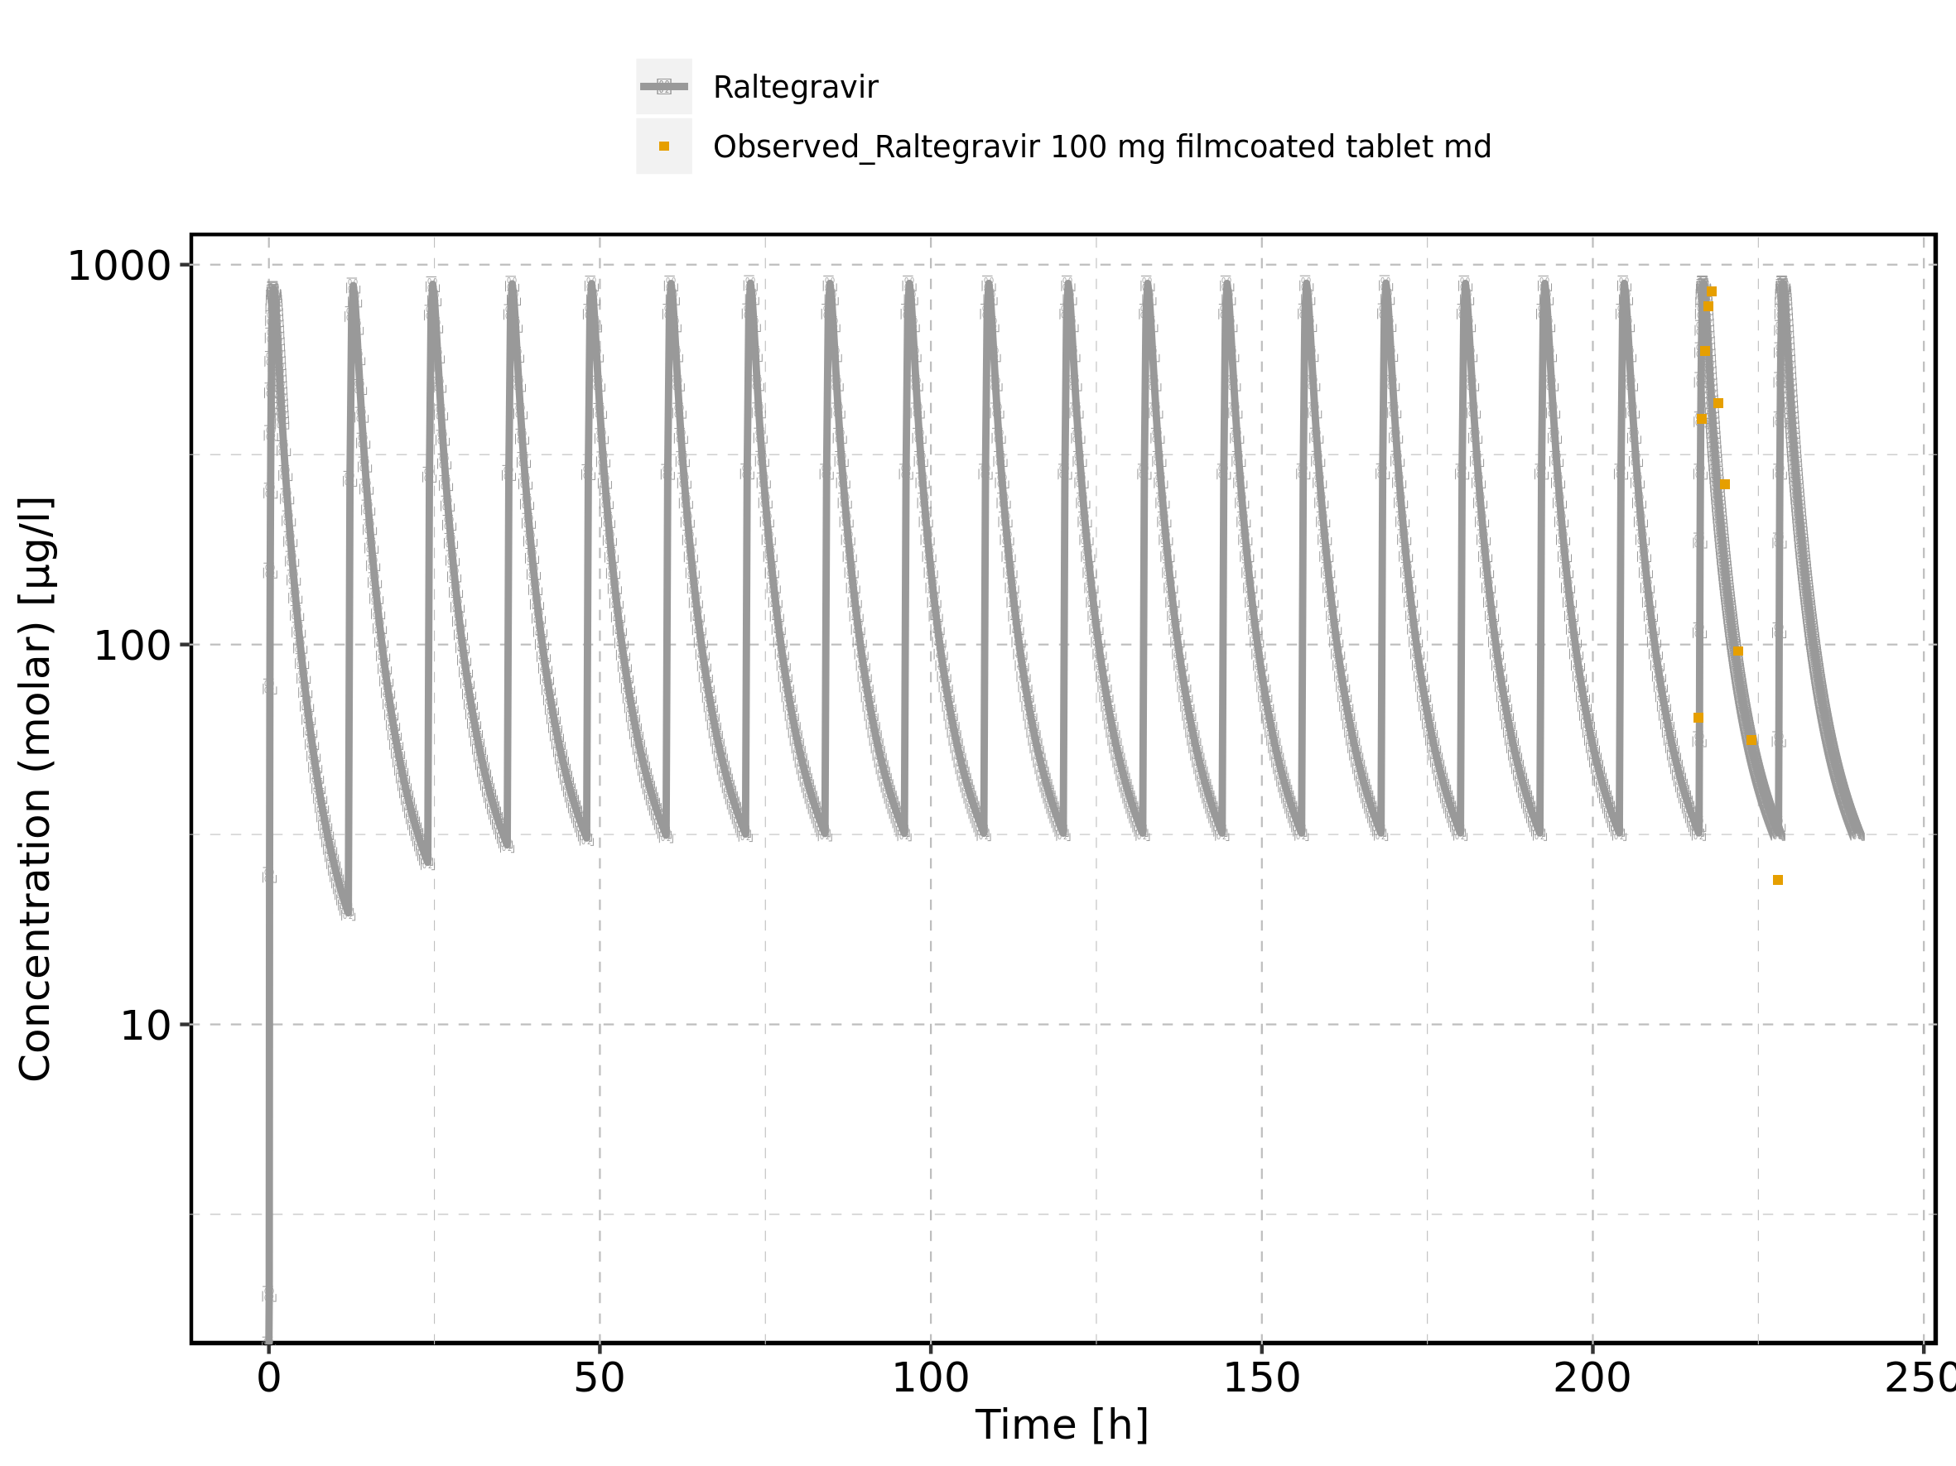

Figure 171: Predicted vs observed of Raltegravir 100 mg filmcoated tablet md for Raltegravir 100 mg filmcoated tablet md. Data source: Data/Raltegravir_PK.txt. Predictions and observations are plotted in a linear scale.

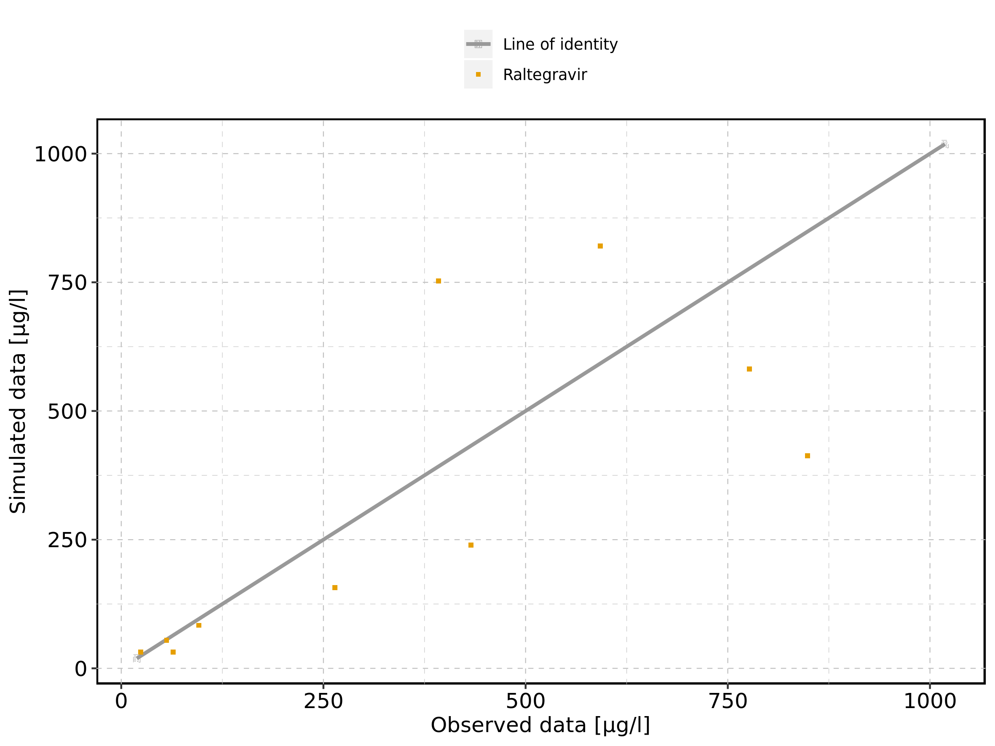

Figure 172: Predicted vs observed of Raltegravir 100 mg filmcoated tablet md for Raltegravir 100 mg filmcoated tablet md. Data source: Data/Raltegravir_PK.txt. Predictions and observations are plotted in a logarithmic scale.

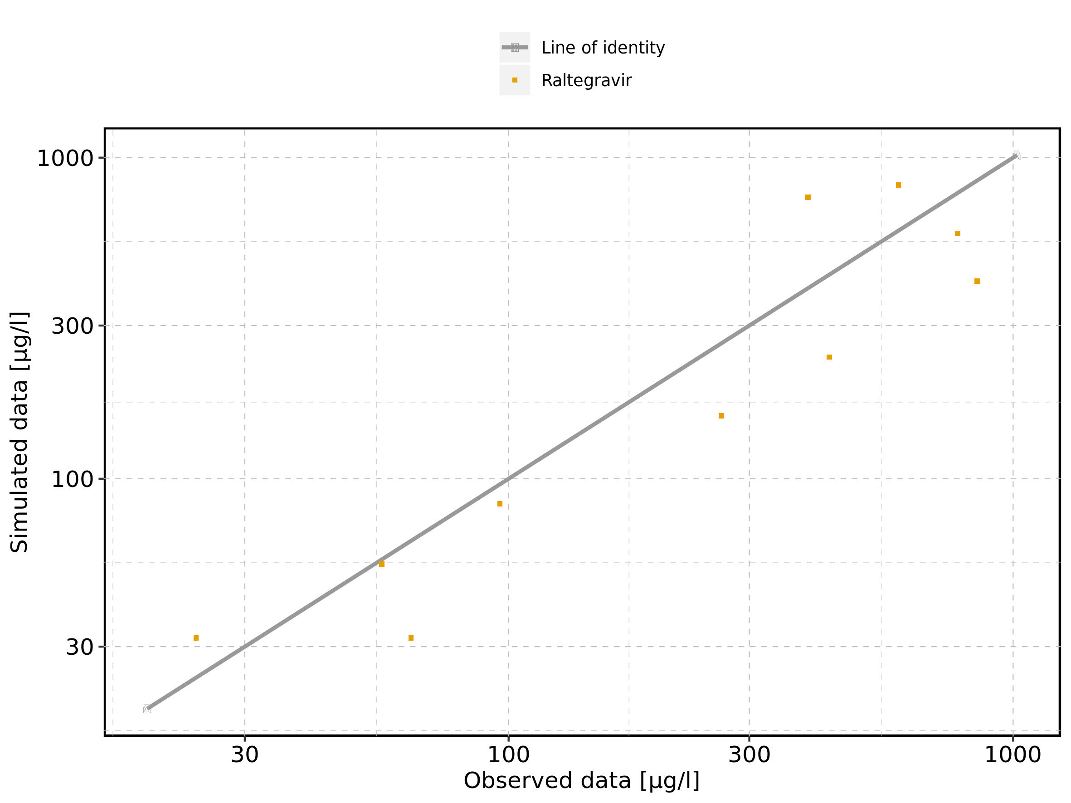

Figure 173: Logarithmic residuals vs predicted values of Raltegravir 100 mg filmcoated tablet md for Raltegravir 100 mg filmcoated tablet md. Data source: Data/Raltegravir_PK.txt.

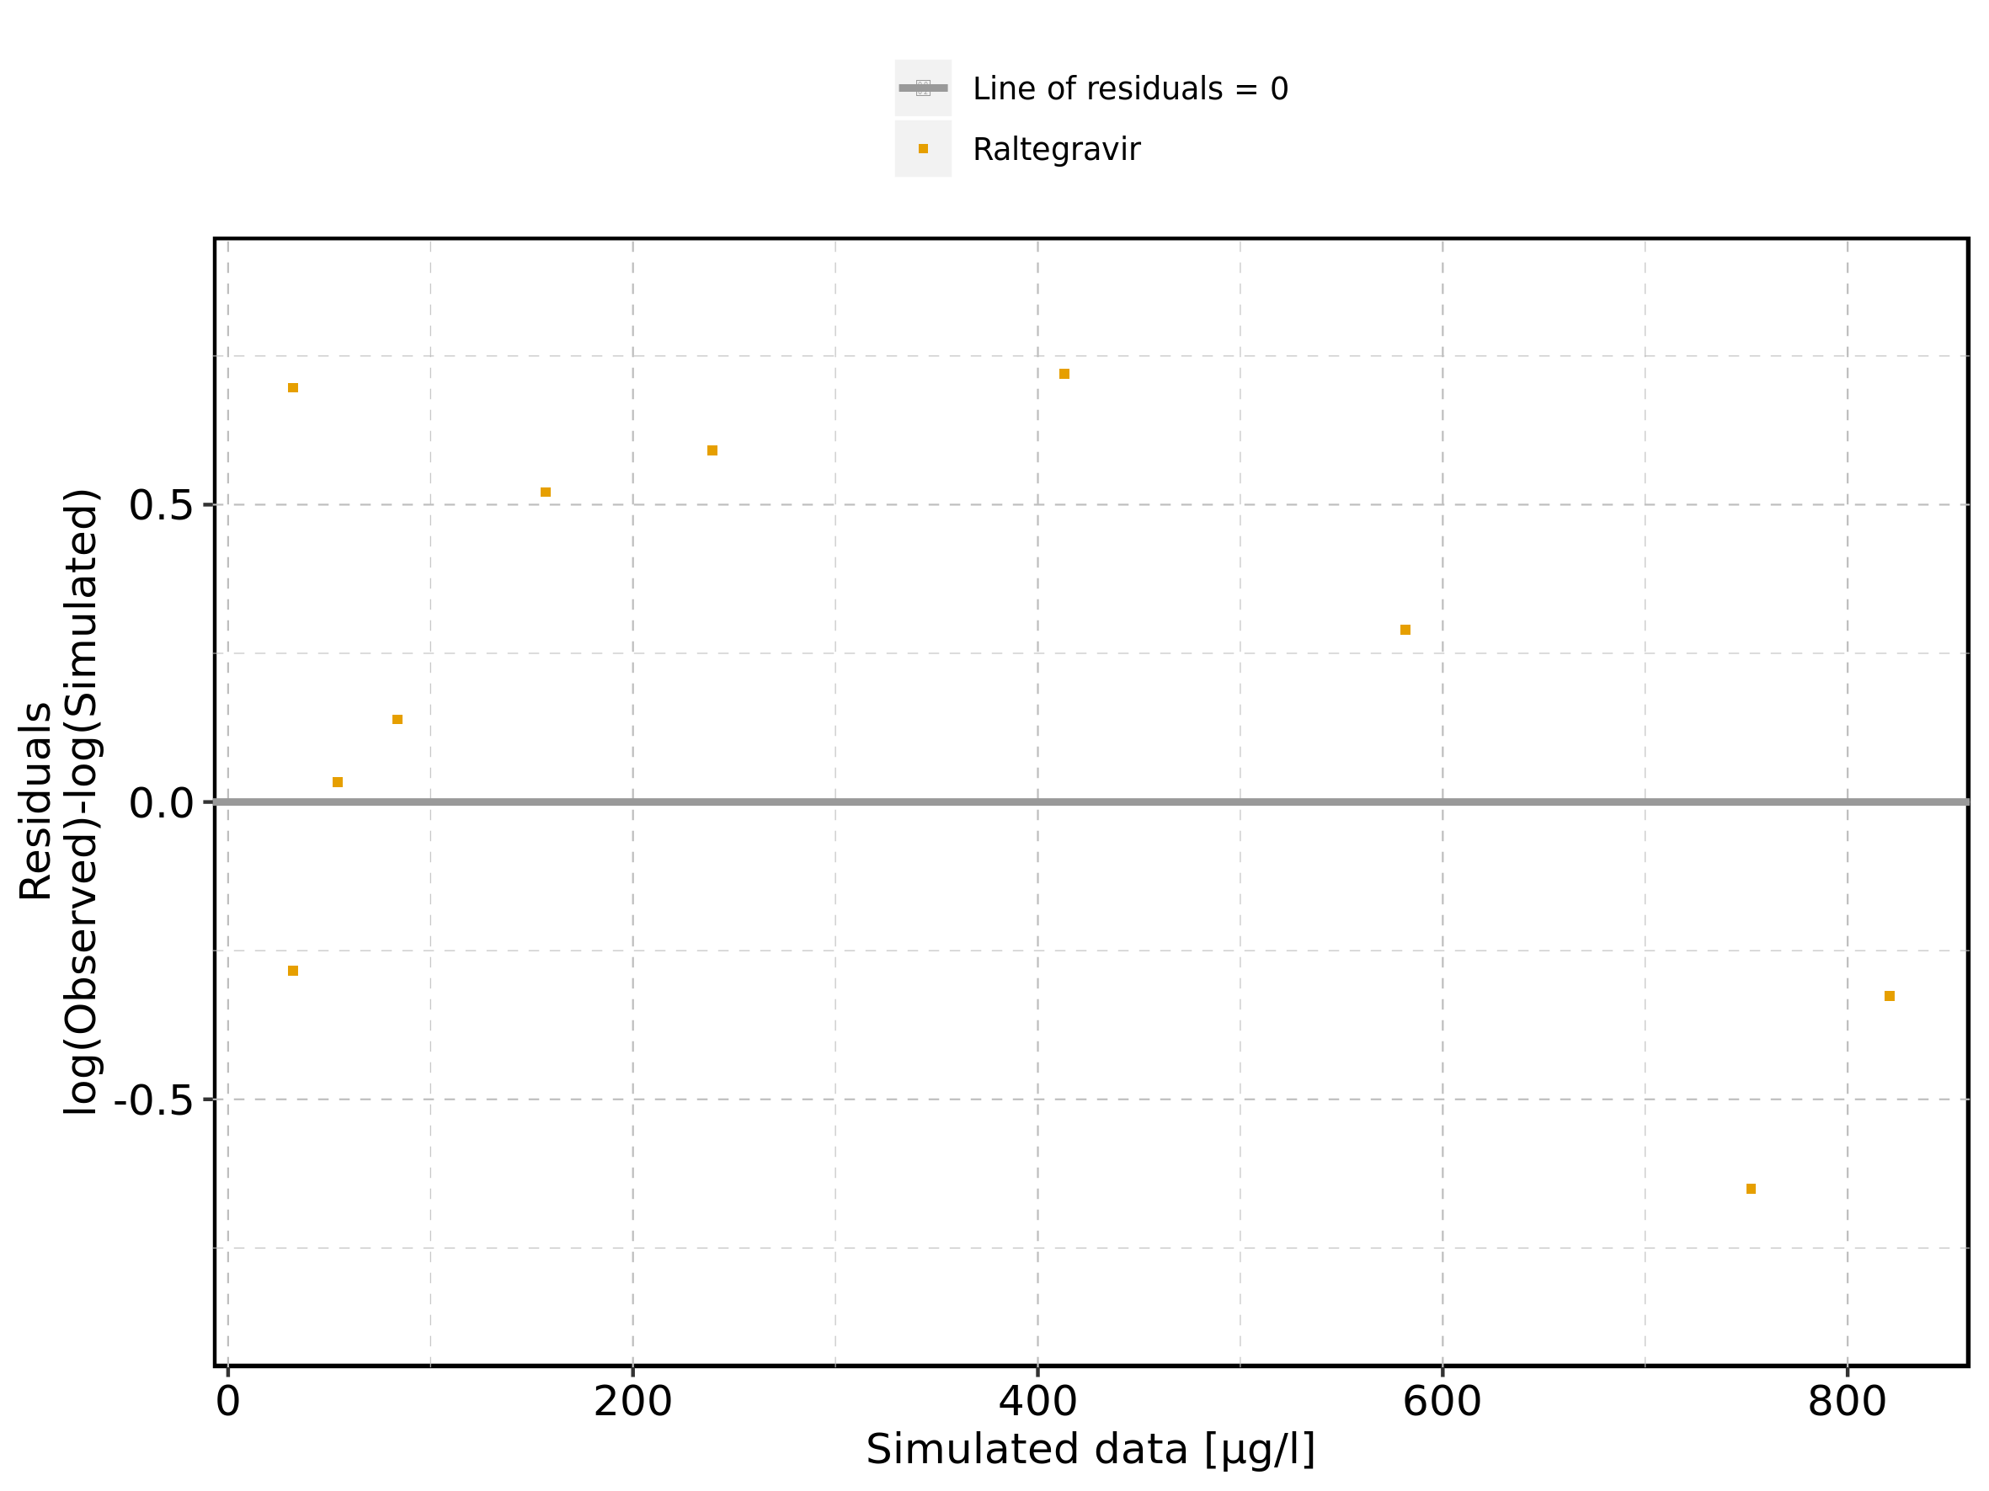

Figure 174: Logarithmic residuals vs time of Raltegravir 100 mg filmcoated tablet md for Raltegravir 100 mg filmcoated tablet md. Data source: Data/Raltegravir_PK.txt.

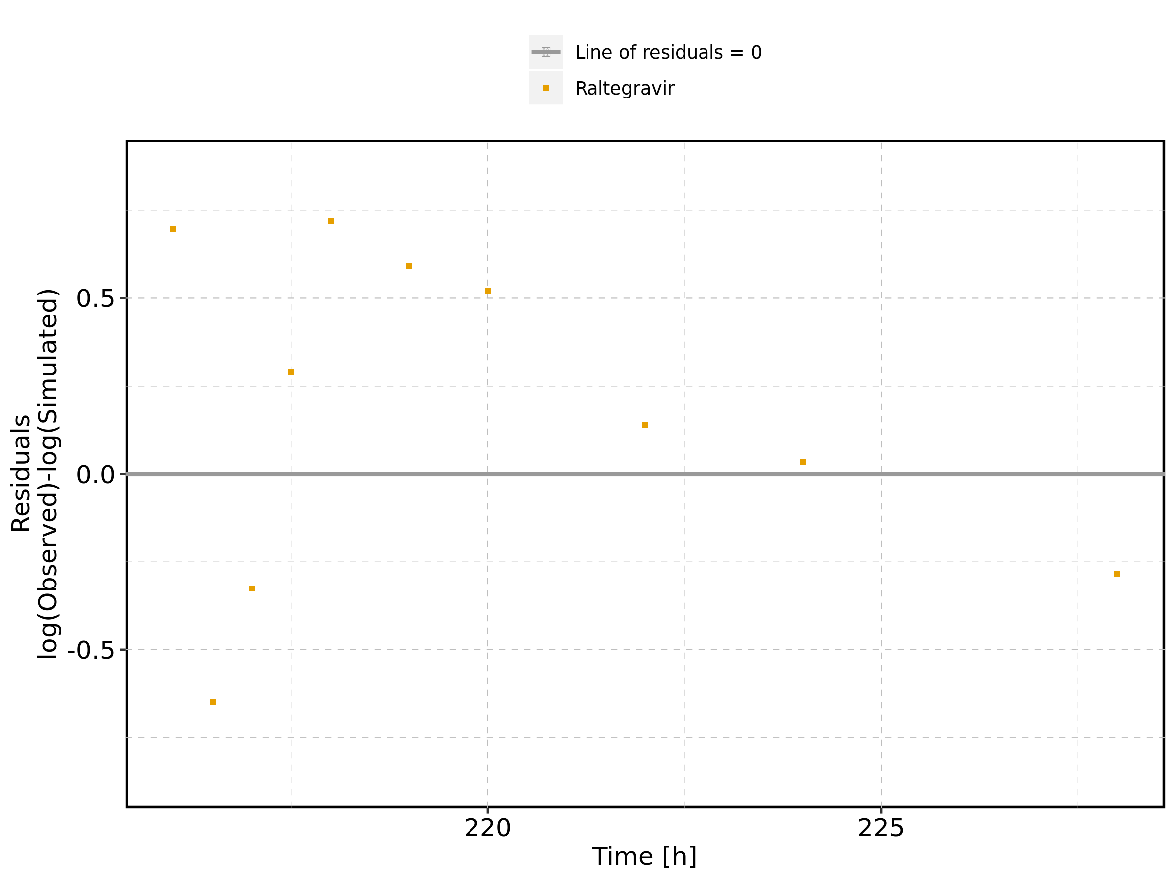

Figure 175: Logarithmic residuals distribution of Raltegravir 100 mg filmcoated tablet md for Raltegravir 100 mg filmcoated tablet md. Data source: Data/Raltegravir_PK.txt.

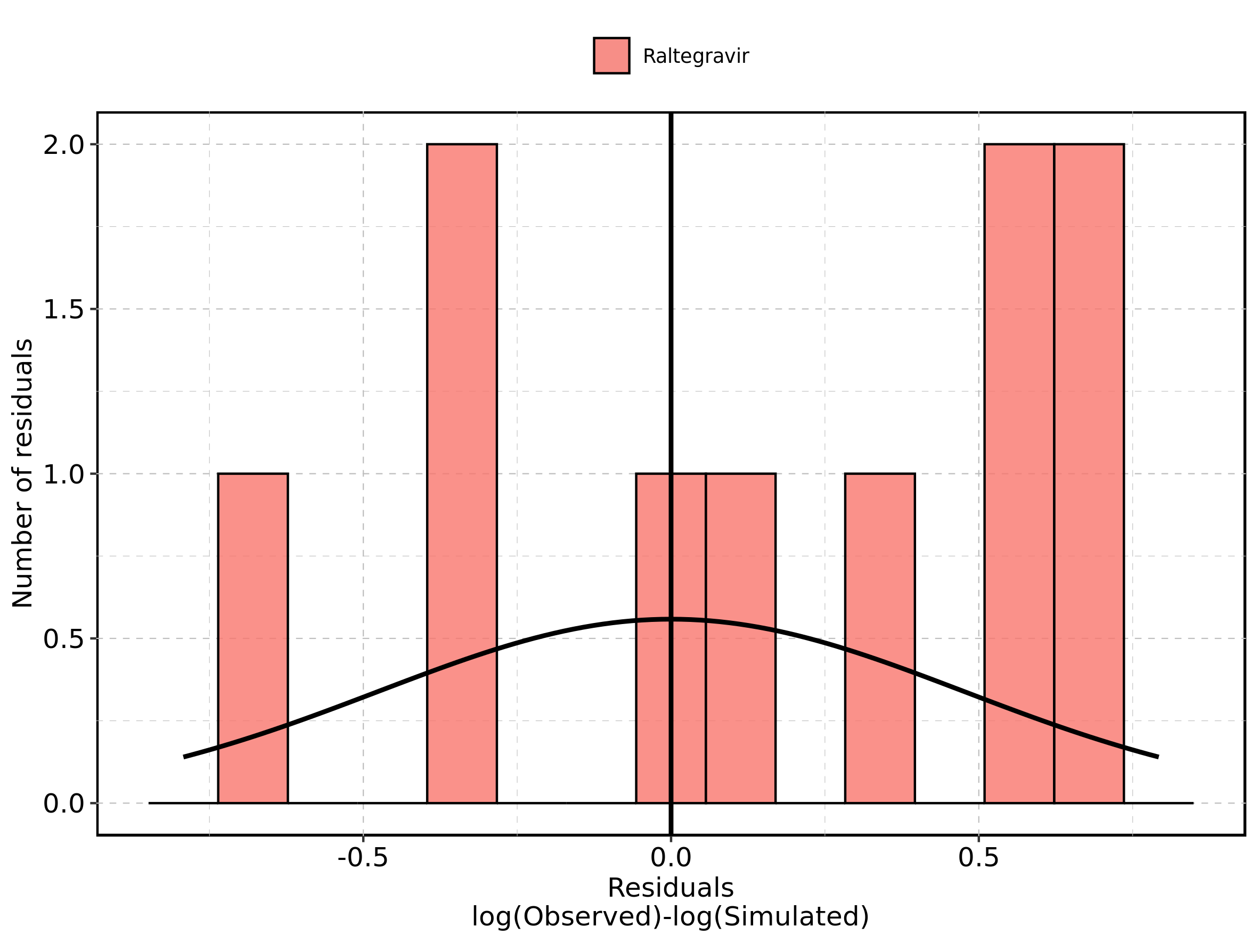

Figure 176: Logarithmic residuals of Raltegravir 100 mg filmcoated tablet md for Raltegravir 100 mg filmcoated tablet md as quantile-quantile plot. Data source: Data/Raltegravir_PK.txt.

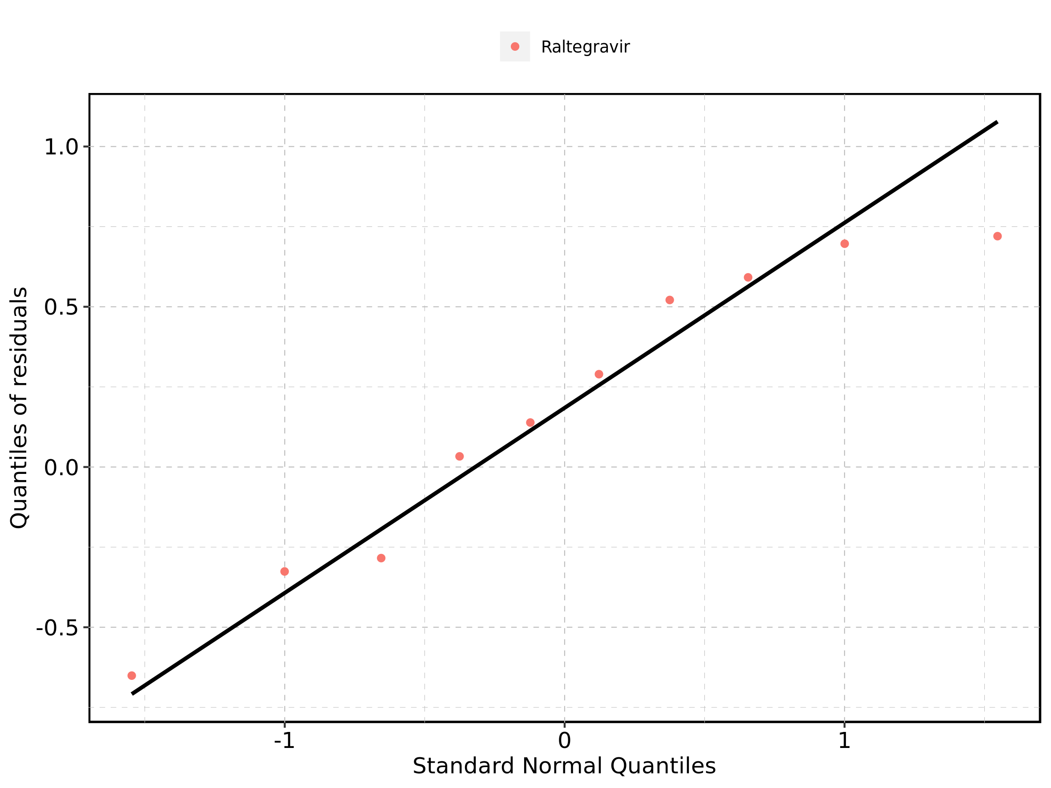

### 4.10.2. For first application range

Figure 177: Time profiles of Raltegravir 100 mg filmcoated tablet md for Raltegravir 100 mg filmcoated tablet md. Data source: Data/Raltegravir_PK.txt. Time profiles are plotted in a linear scale.

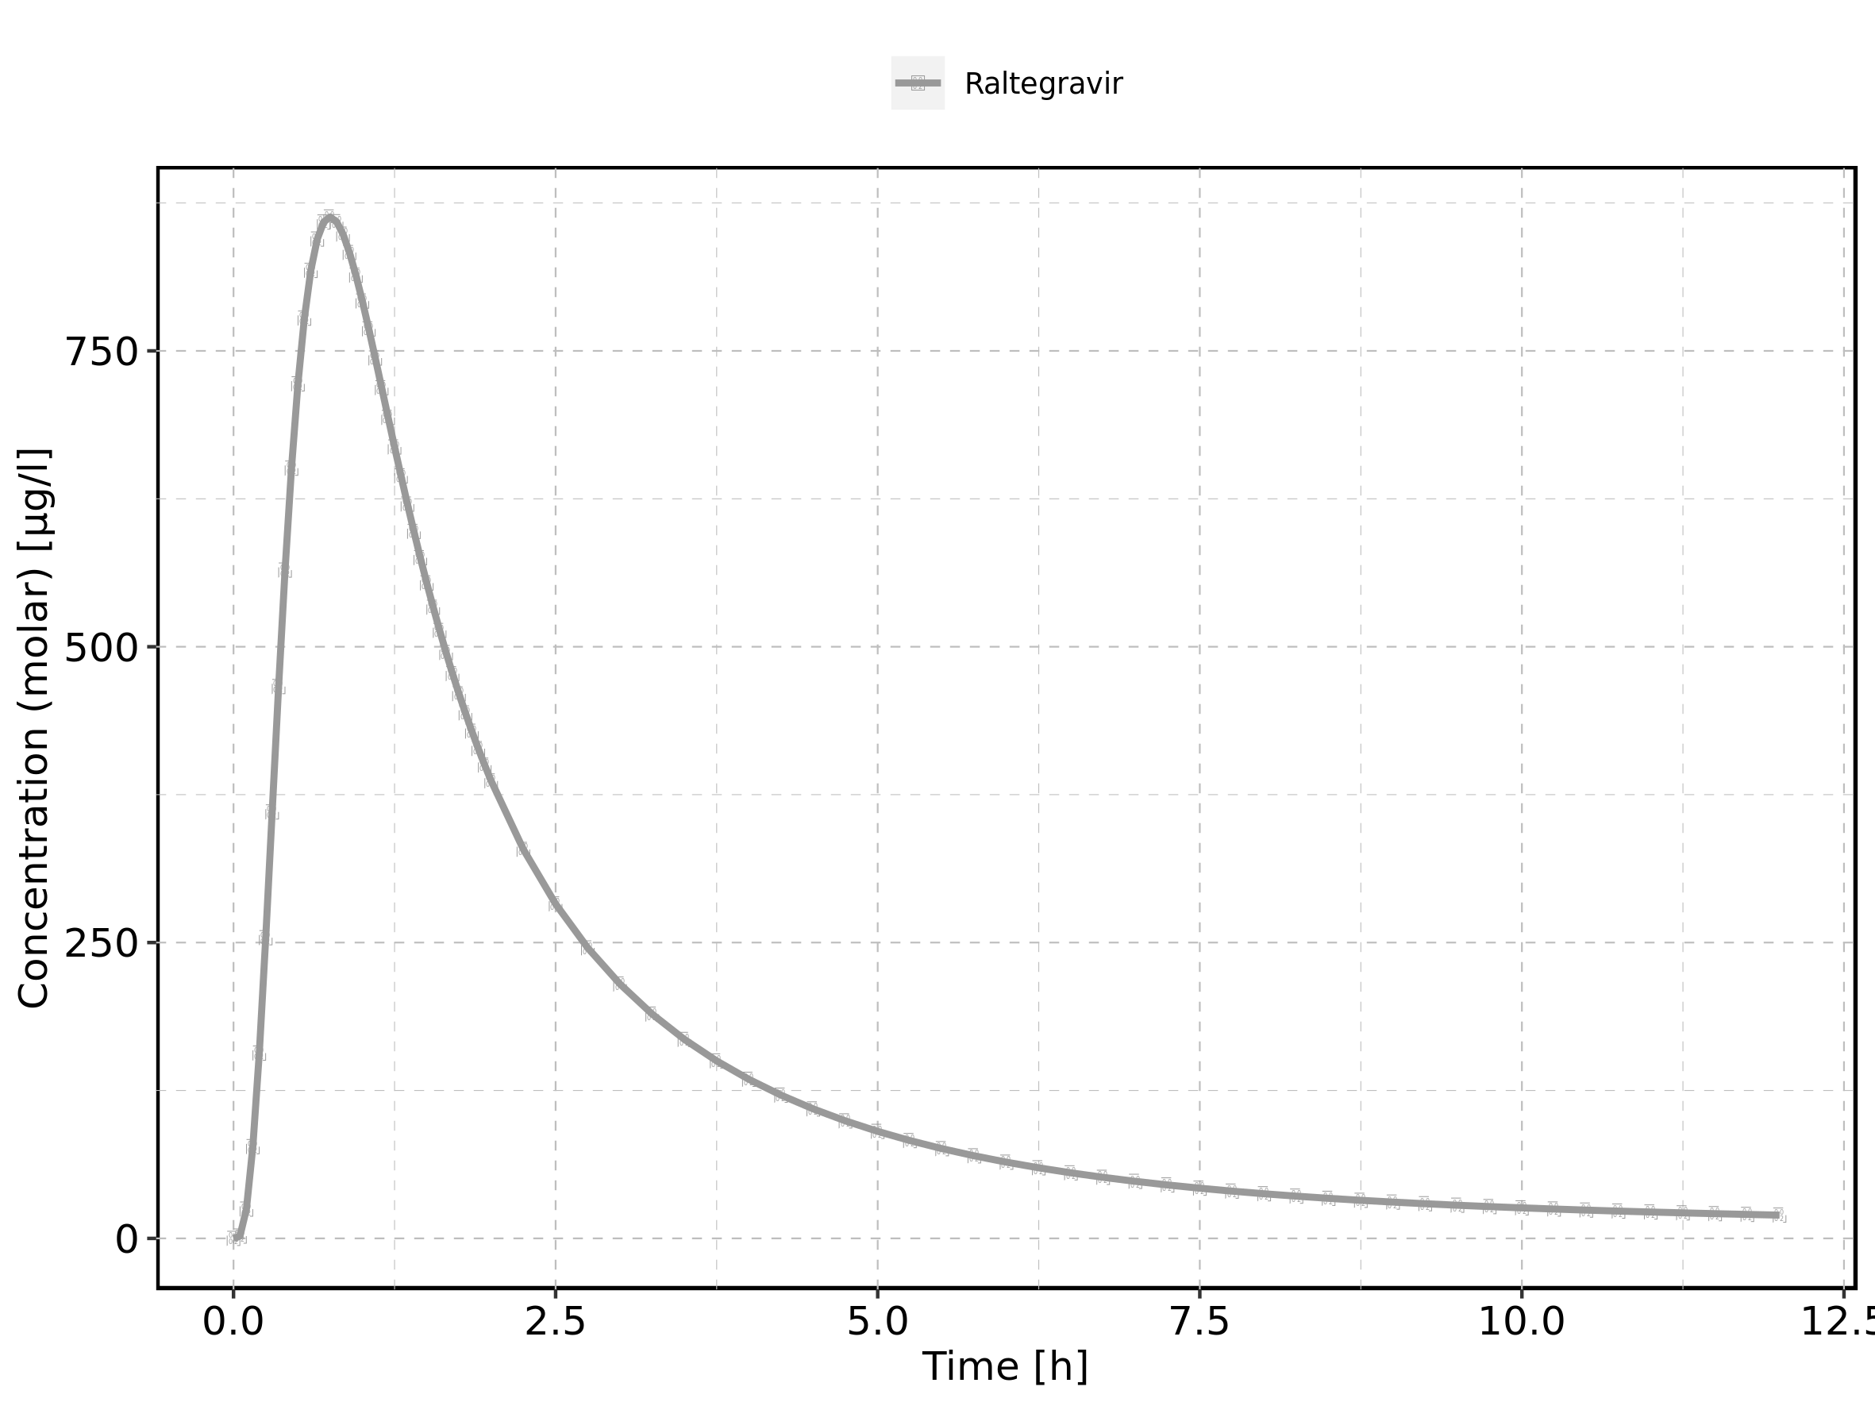

Figure 178: Time profiles of Raltegravir 100 mg filmcoated tablet md for Raltegravir 100 mg filmcoated tablet md. Data source: Data/Raltegravir_PK.txt. Time profiles are plotted in a logarithmic scale.

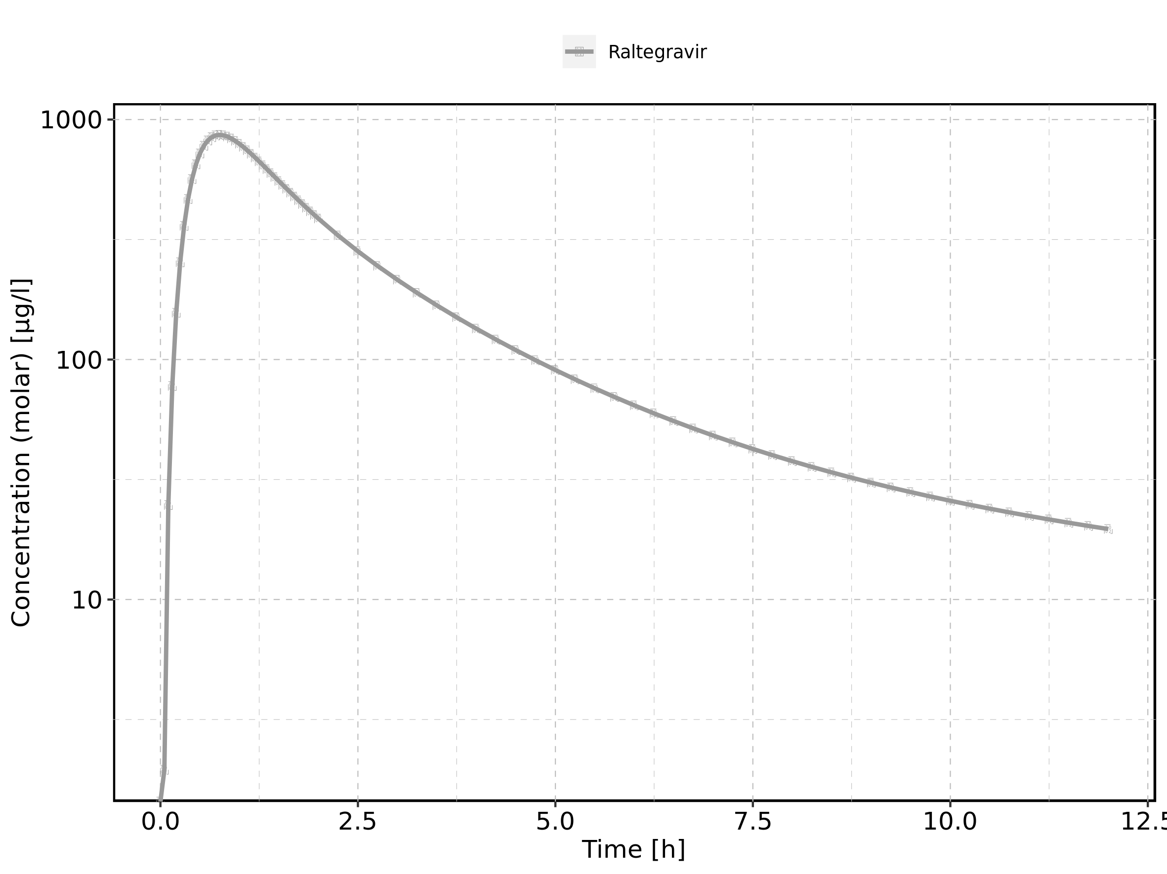

### 4.10.3. For last application range

Figure 179: Time profiles of Raltegravir 100 mg filmcoated tablet md for Raltegravir 100 mg filmcoated tablet md. Data source: Data/Raltegravir_PK.txt. Time profiles are plotted in a linear scale.

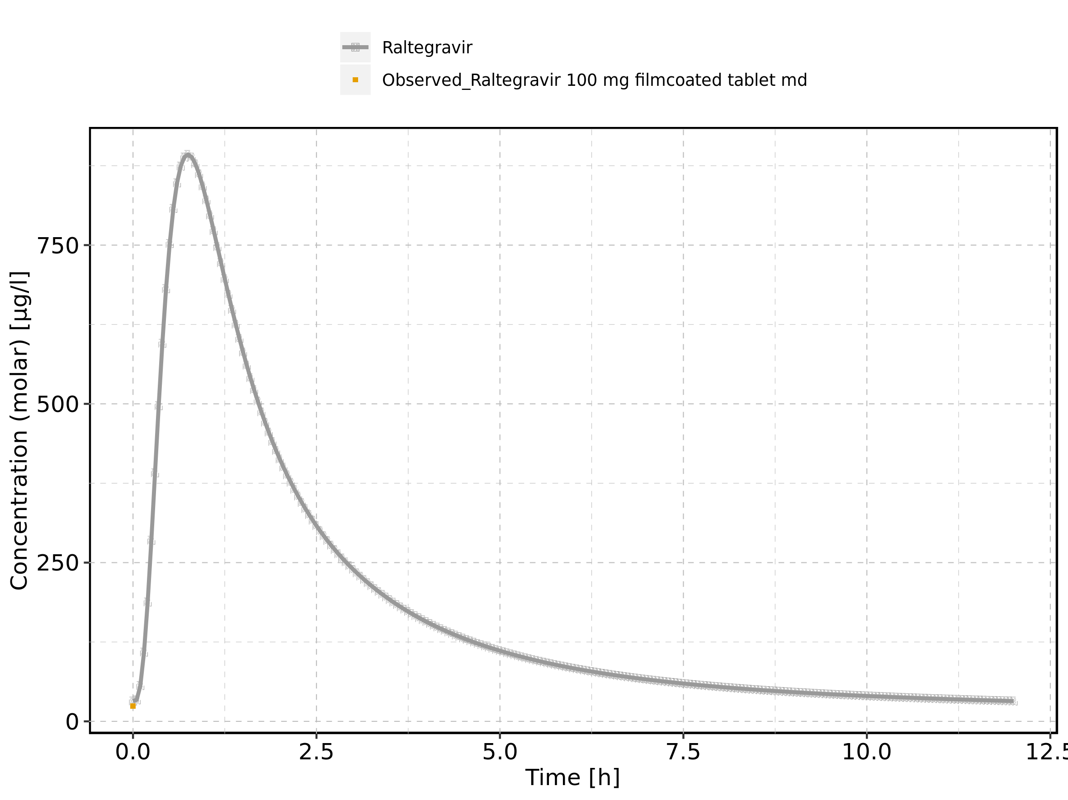

Figure 180: Time profiles of Raltegravir 100 mg filmcoated tablet md for Raltegravir 100 mg filmcoated tablet md. Data source: Data/Raltegravir_PK.txt. Time profiles are plotted in a logarithmic scale.

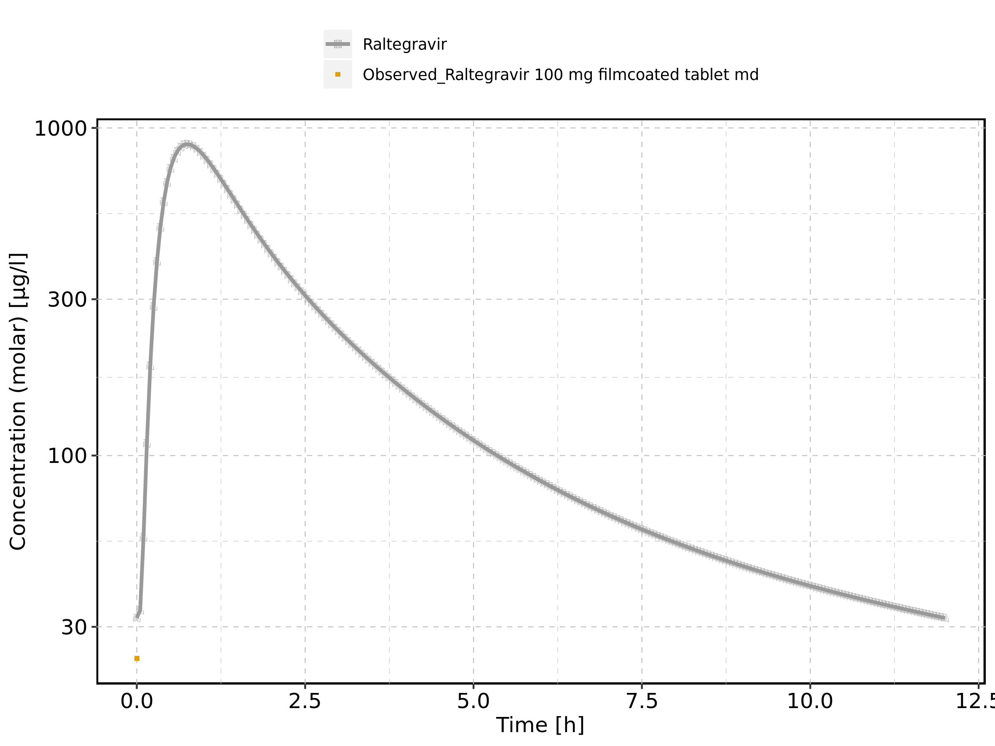

Figure 181: Predicted vs observed of Raltegravir 100 mg filmcoated tablet md for Raltegravir 100 mg filmcoated tablet md. Data source: Data/Raltegravir_PK.txt. Predictions and observations are plotted in a linear scale.

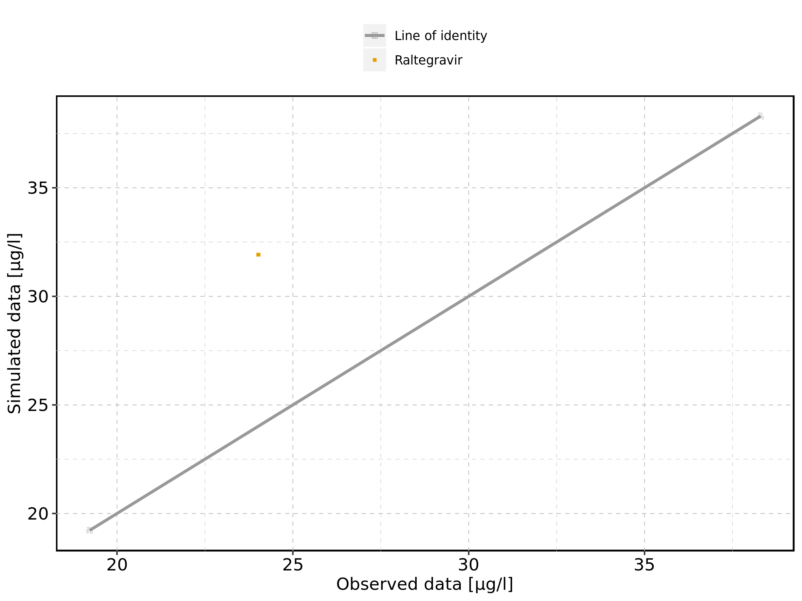

Figure 182: Predicted vs observed of Raltegravir 100 mg filmcoated tablet md for Raltegravir 100 mg filmcoated tablet md. Data source: Data/Raltegravir_PK.txt. Predictions and observations are plotted in a logarithmic scale.

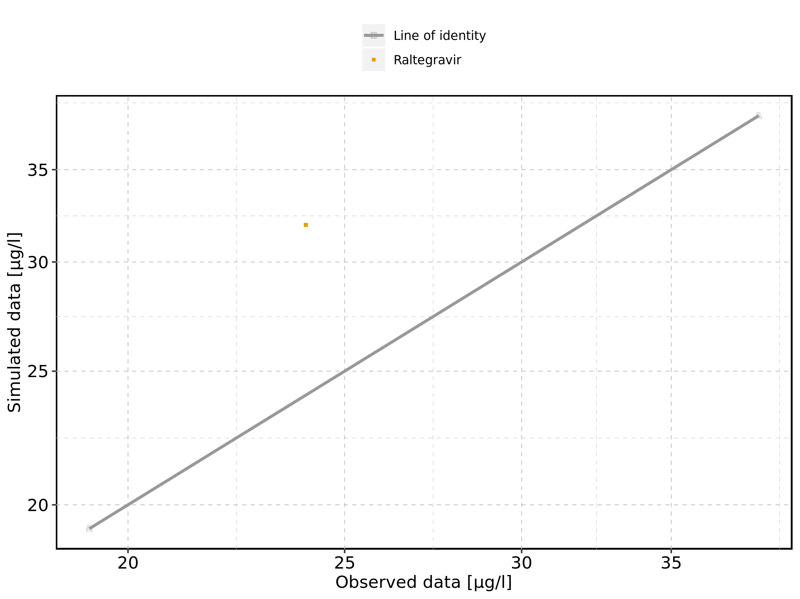

Figure 183: Logarithmic residuals vs predicted values of Raltegravir 100 mg filmcoated tablet md for Raltegravir 100 mg filmcoated tablet md. Data source: Data/Raltegravir_PK.txt.

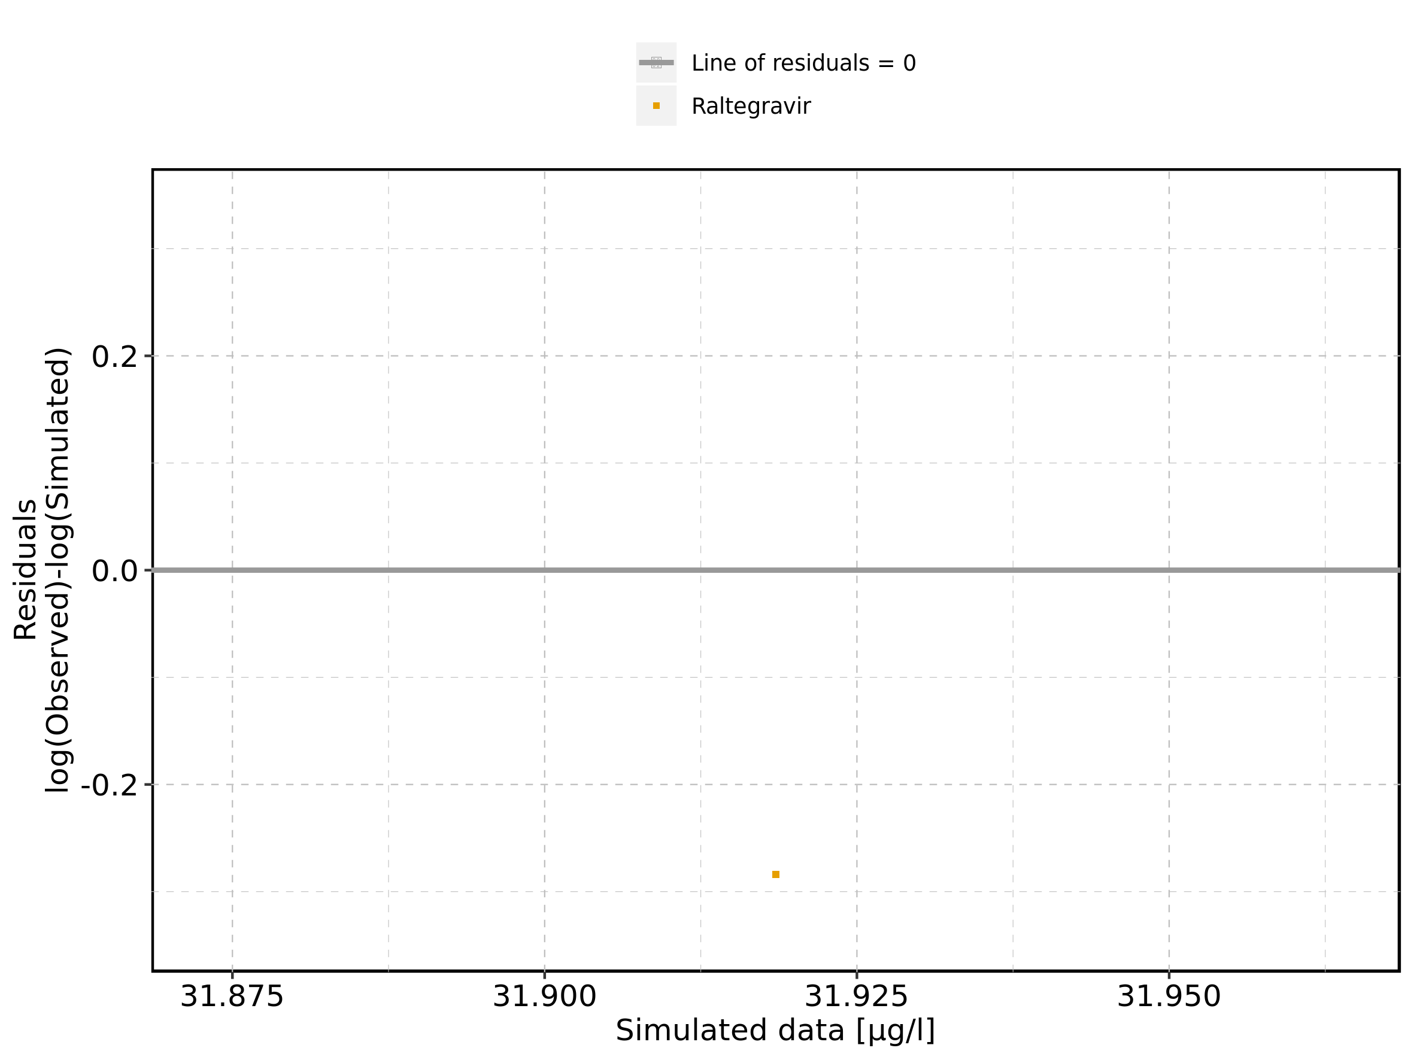

Figure 184: Logarithmic residuals vs time of Raltegravir 100 mg filmcoated tablet md for Raltegravir 100 mg filmcoated tablet md. Data source: Data/Raltegravir_PK.txt.

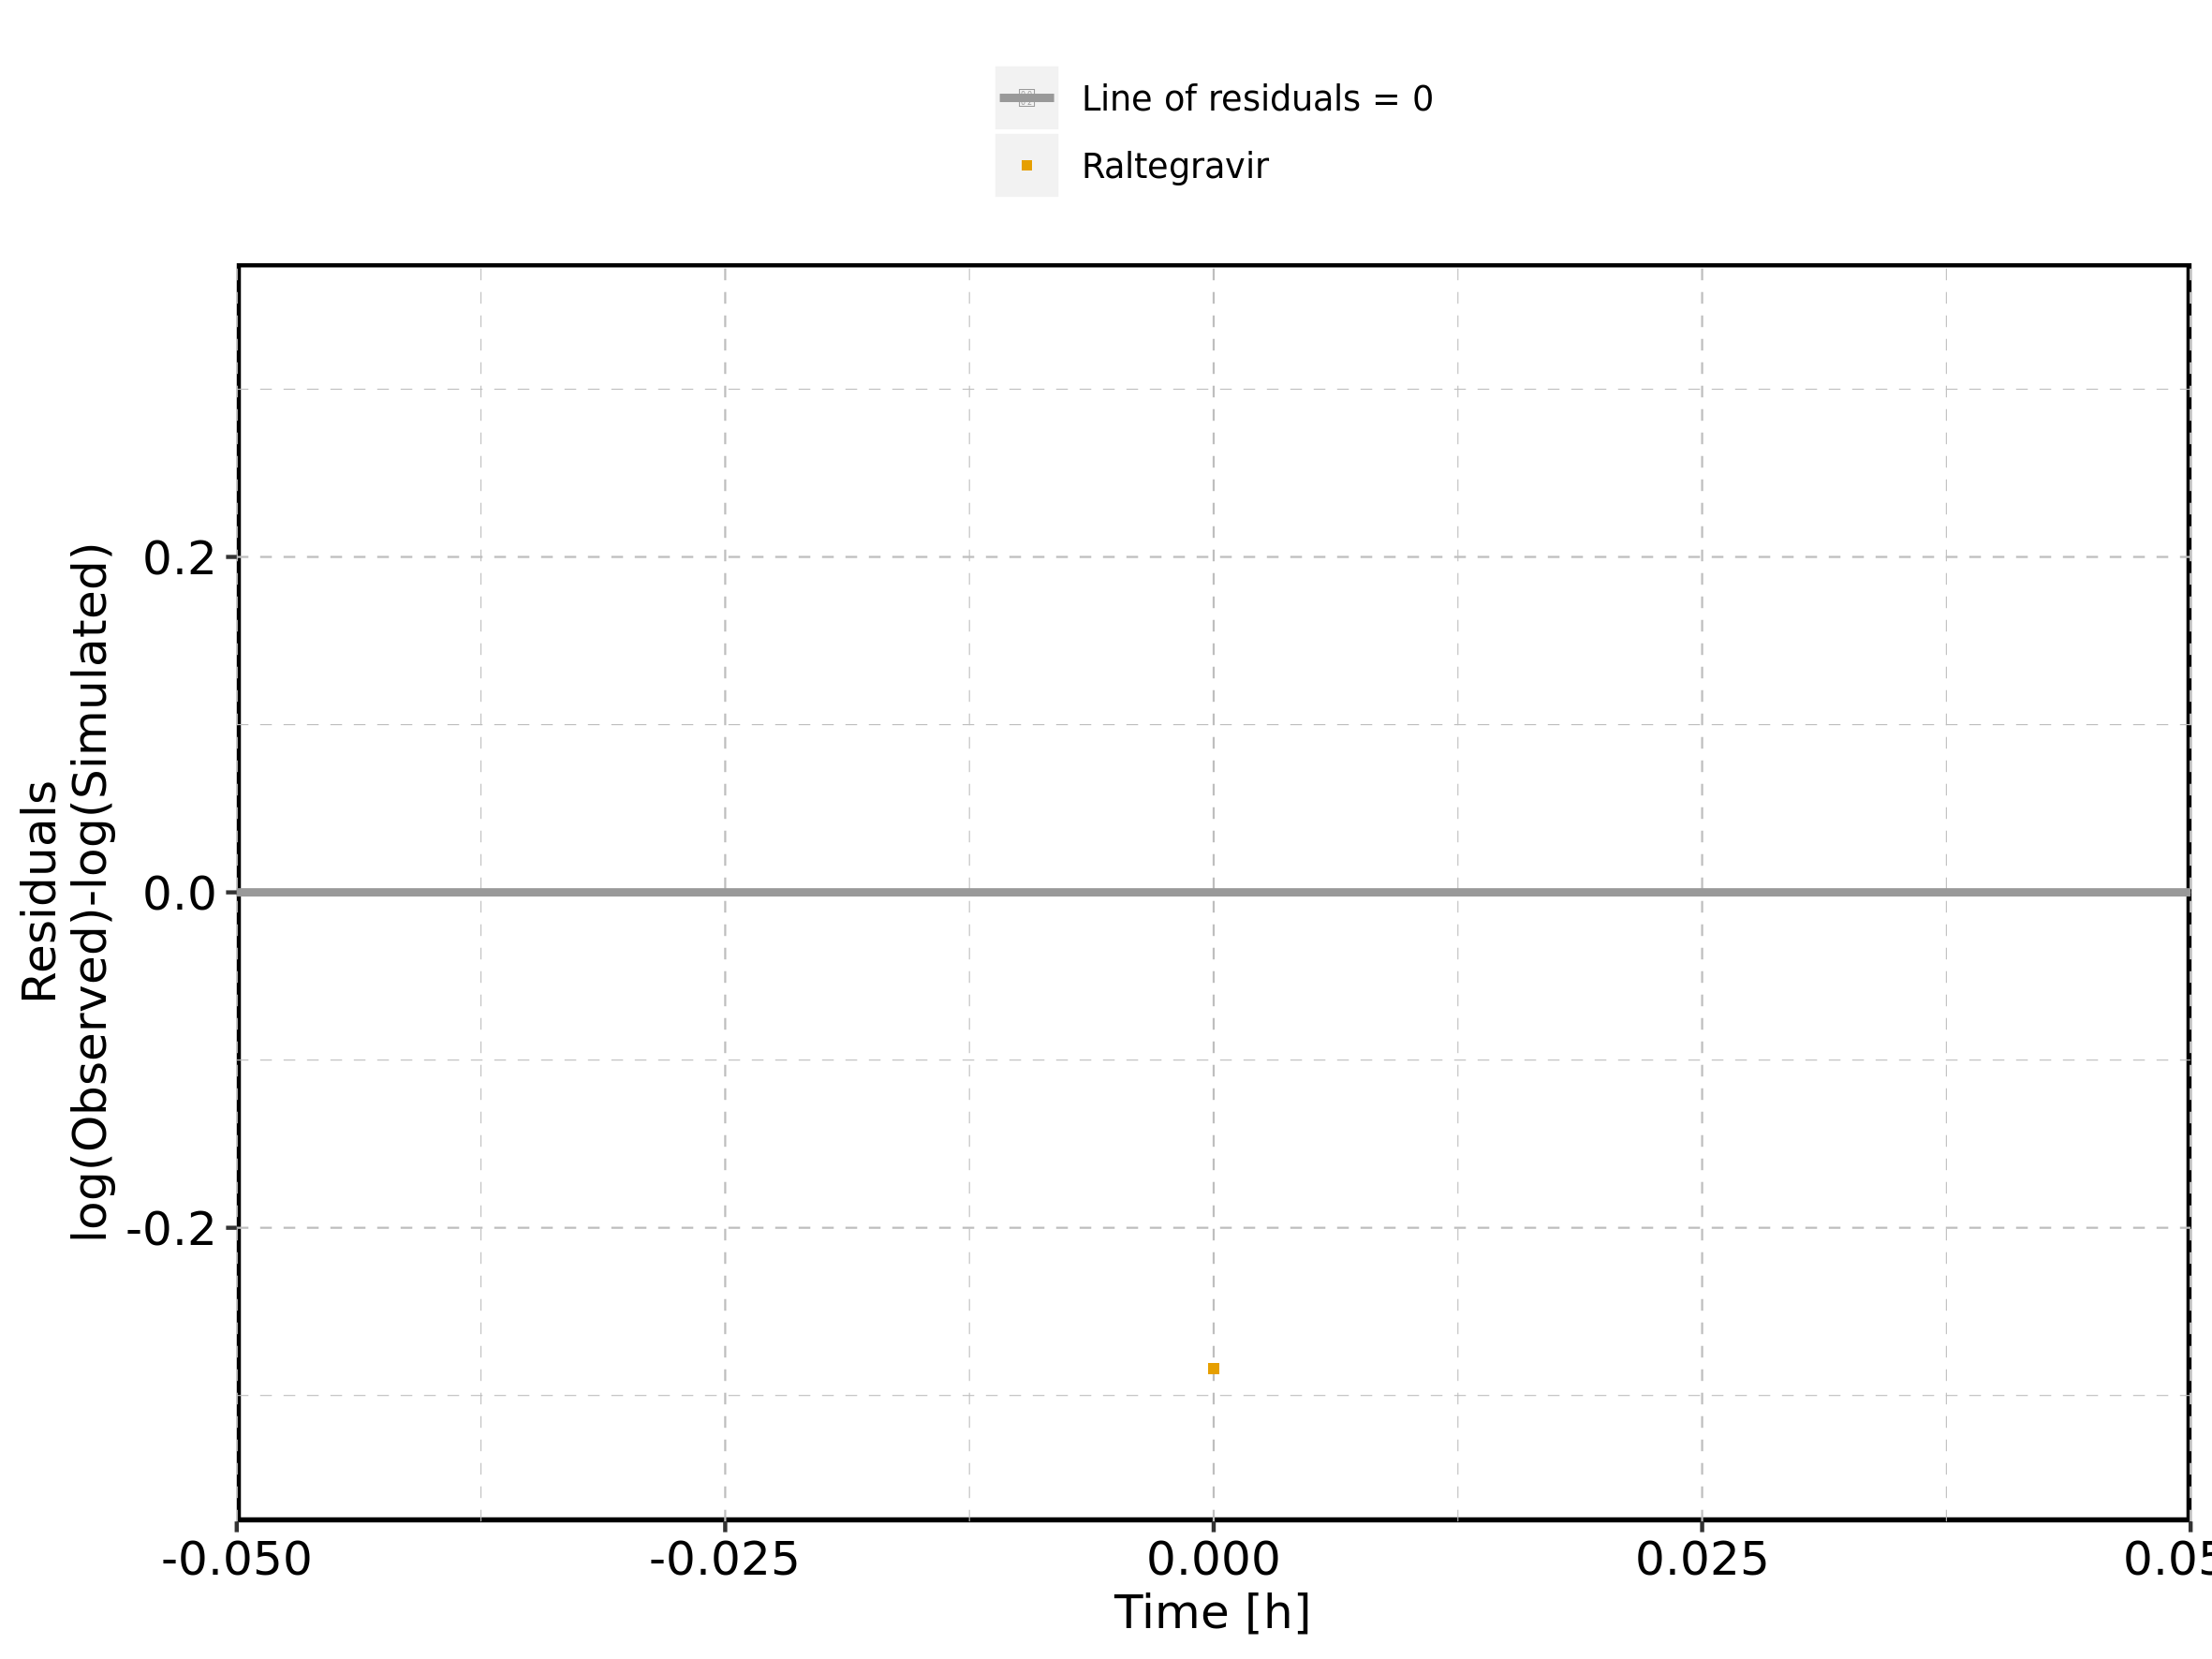

Figure 185: Logarithmic residuals distribution of Raltegravir 100 mg filmcoated tablet md for Raltegravir 100 mg filmcoated tablet md. Data source: Data/Raltegravir_PK.txt.

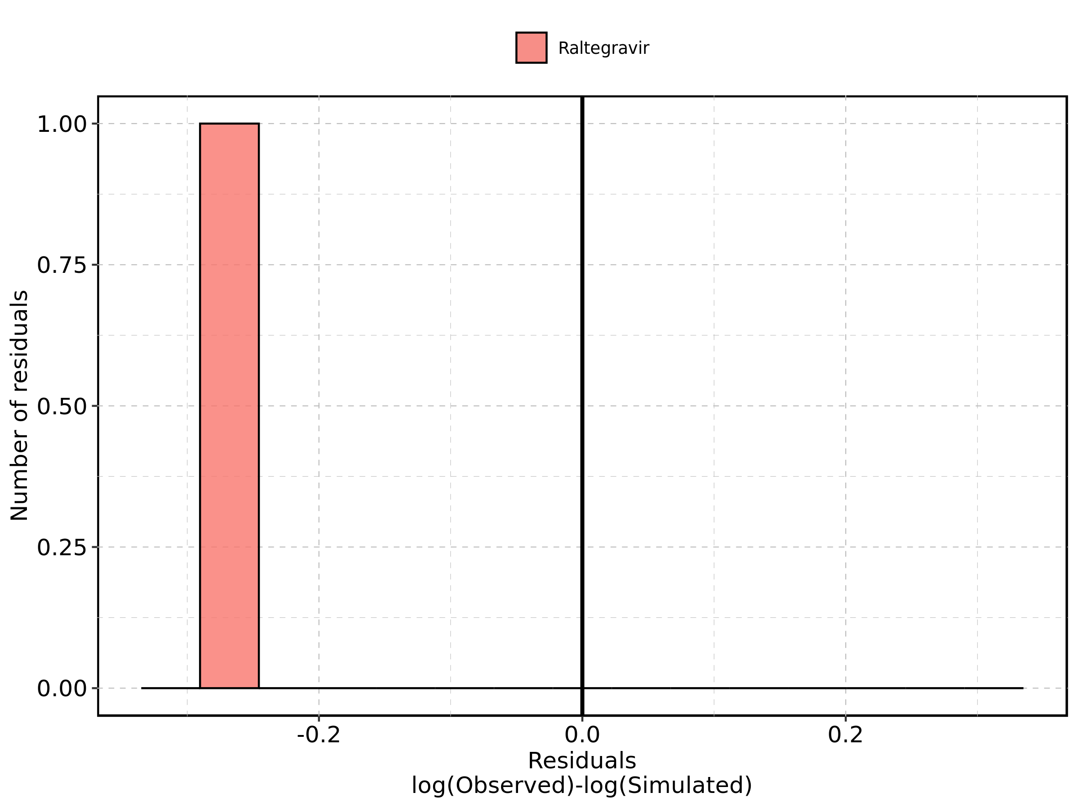

Figure 186: Logarithmic residuals of Raltegravir 100 mg filmcoated tablet md for Raltegravir 100 mg filmcoated tablet md as quantile-quantile plot. Data source: Data/Raltegravir_PK.txt.

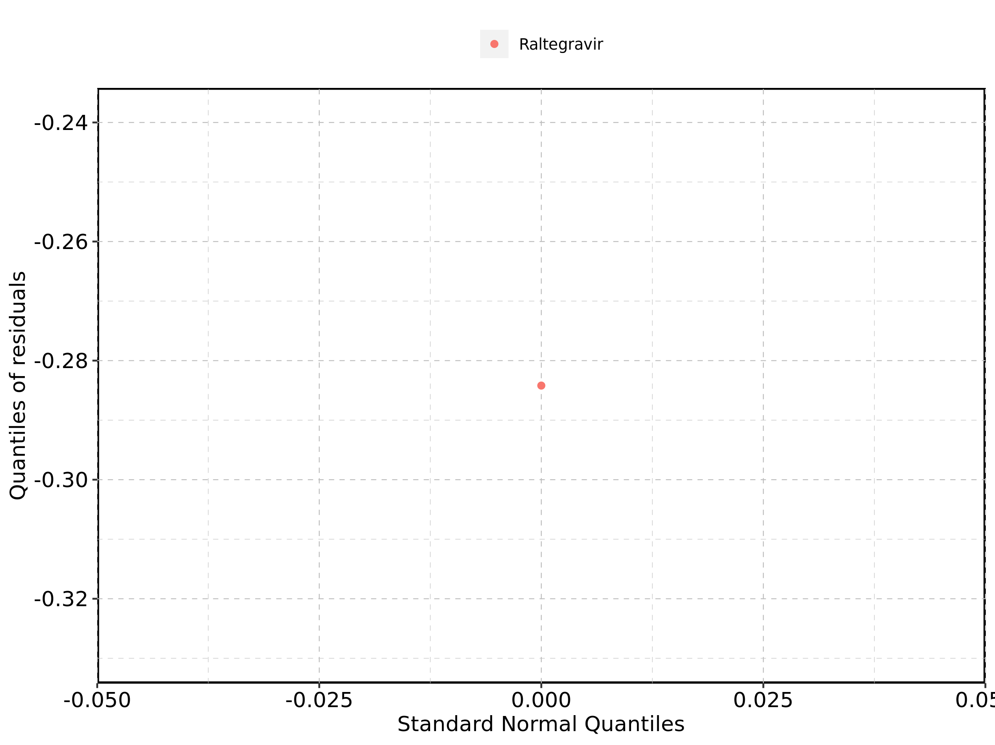

## 4.11. Time profiles and residual plots for Raltegravir 200 mg filmcoated tablet md

### 4.11.1. For total simulation time range

Figure 187: Time profiles of Raltegravir 200 mg filmcoated tablet md for Raltegravir 200 mg filmcoated tablet md. Data source: Data/Raltegravir_PK.txt. Time profiles are plotted in a linear scale.

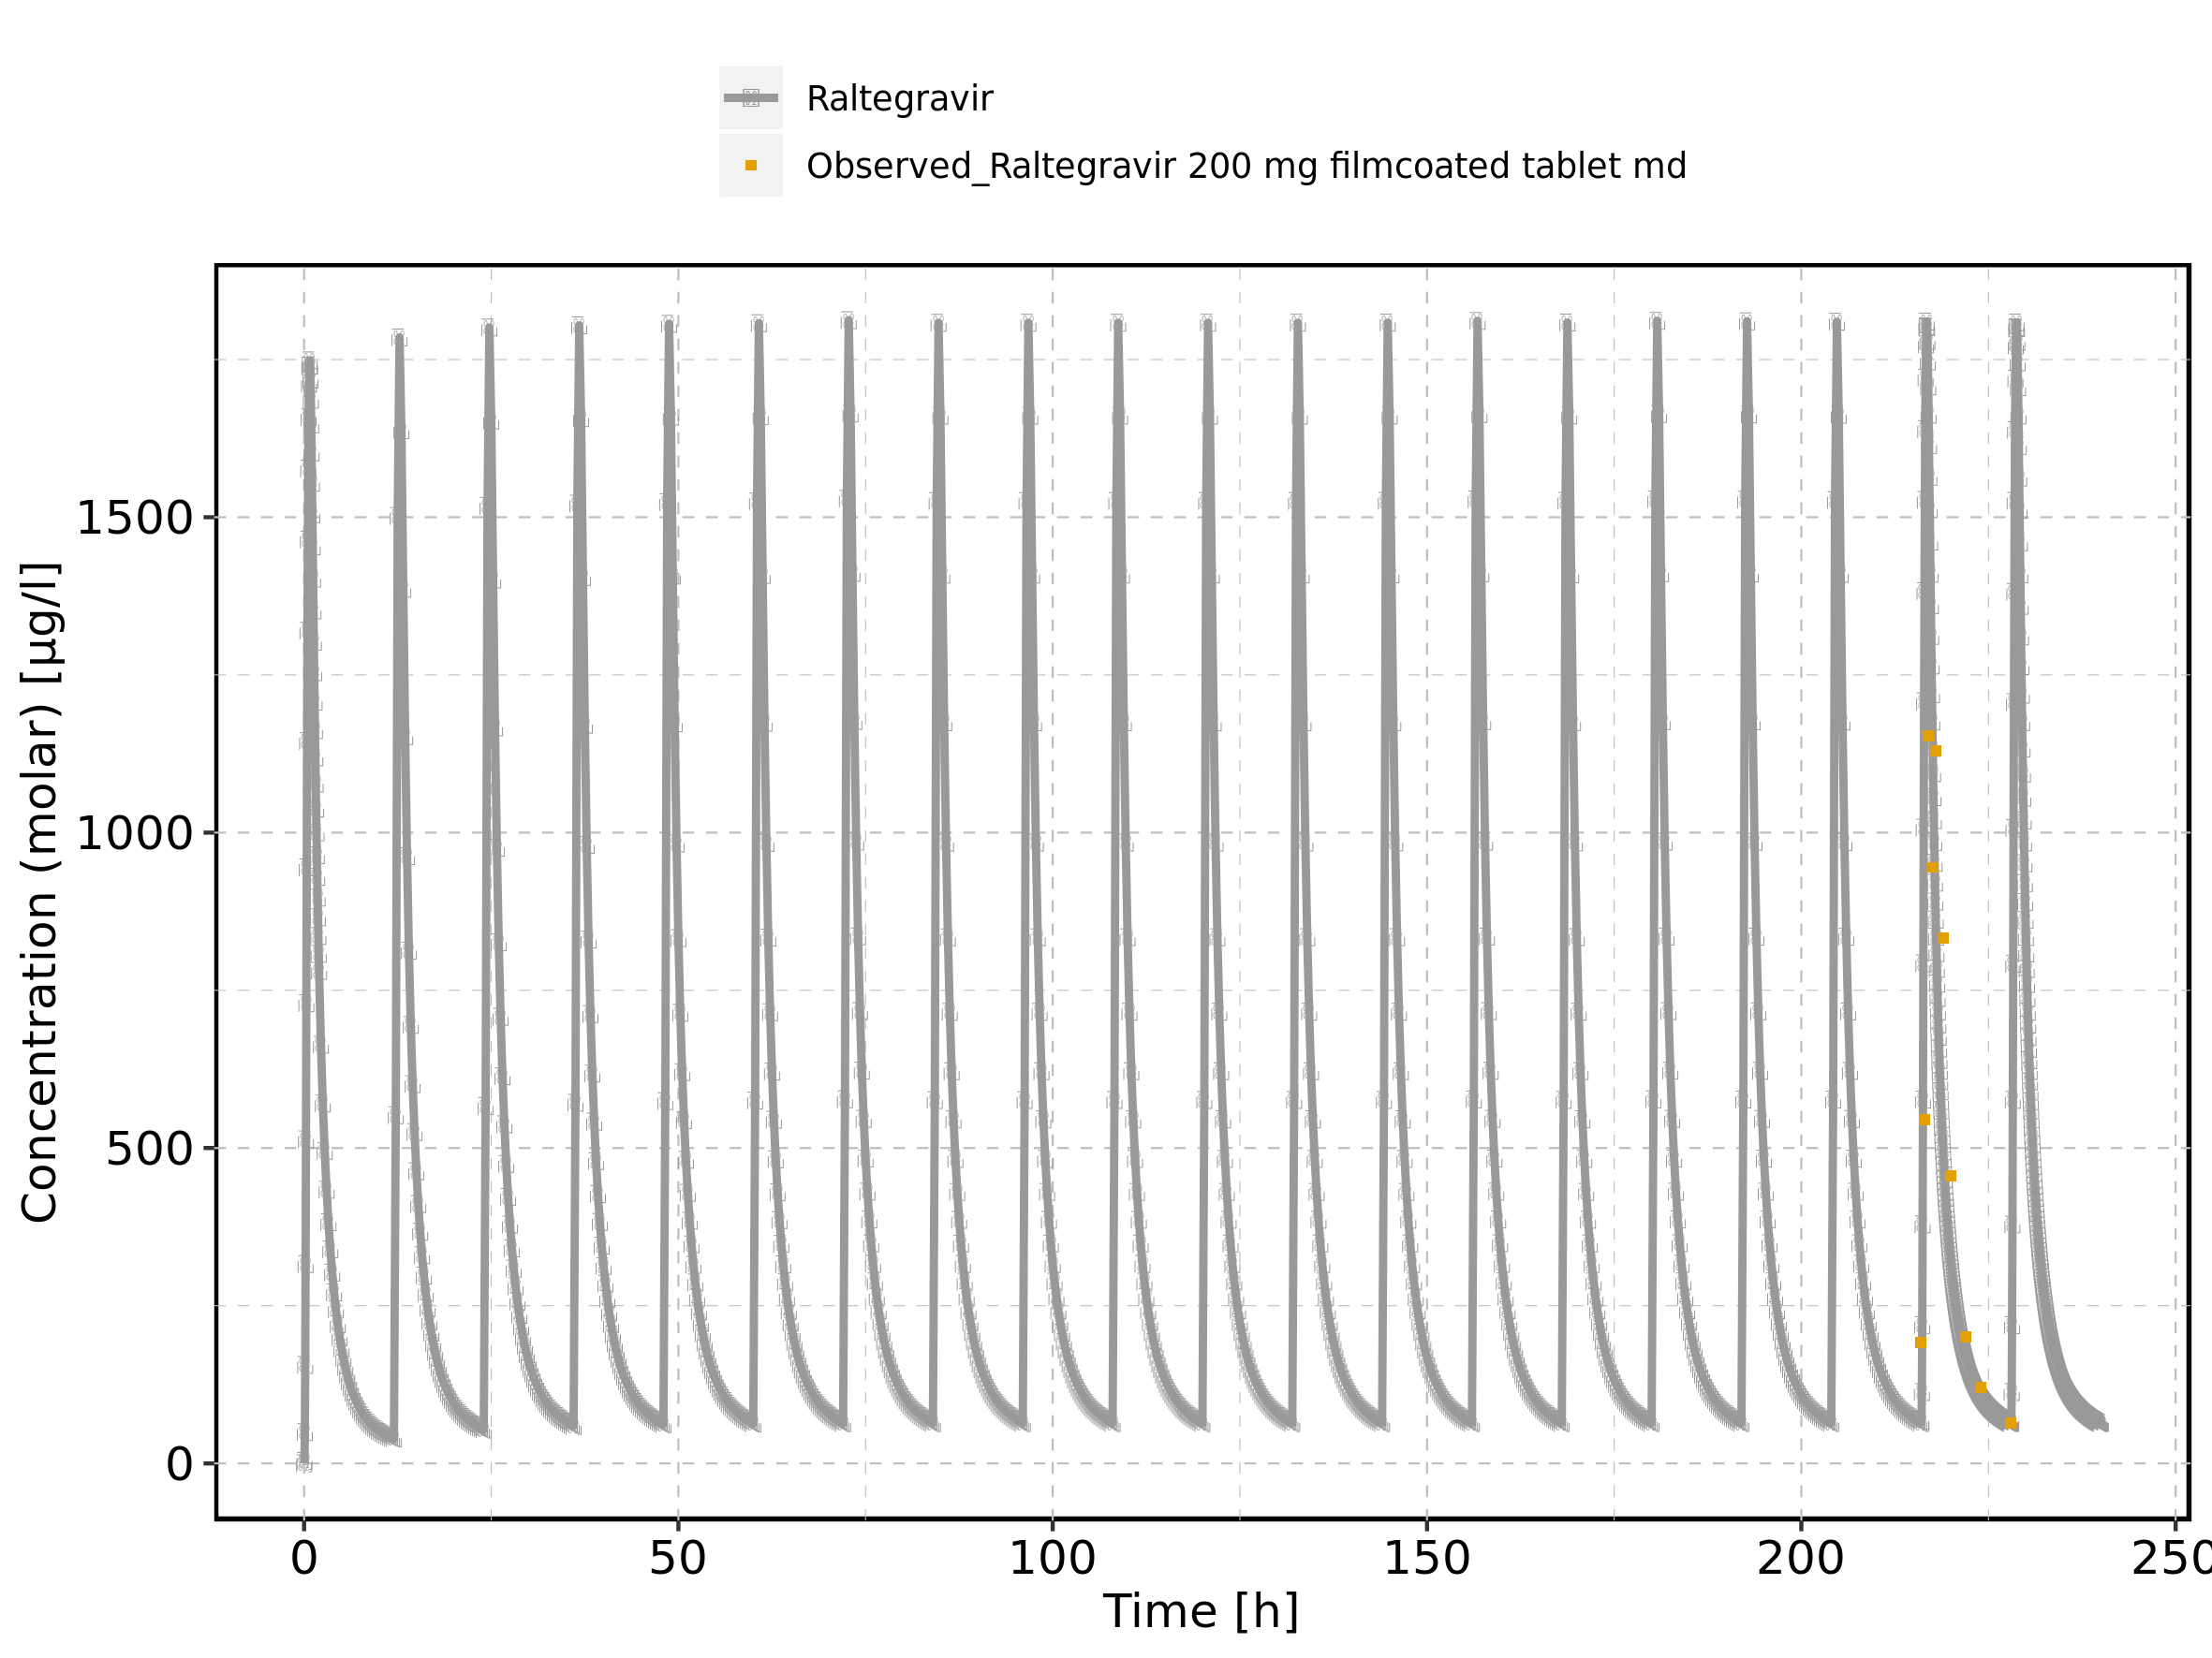

Figure 188: Time profiles of Raltegravir 200 mg filmcoated tablet md for Raltegravir 200 mg filmcoated tablet md. Data source: Data/Raltegravir_PK.txt. Time profiles are plotted in a logarithmic scale.

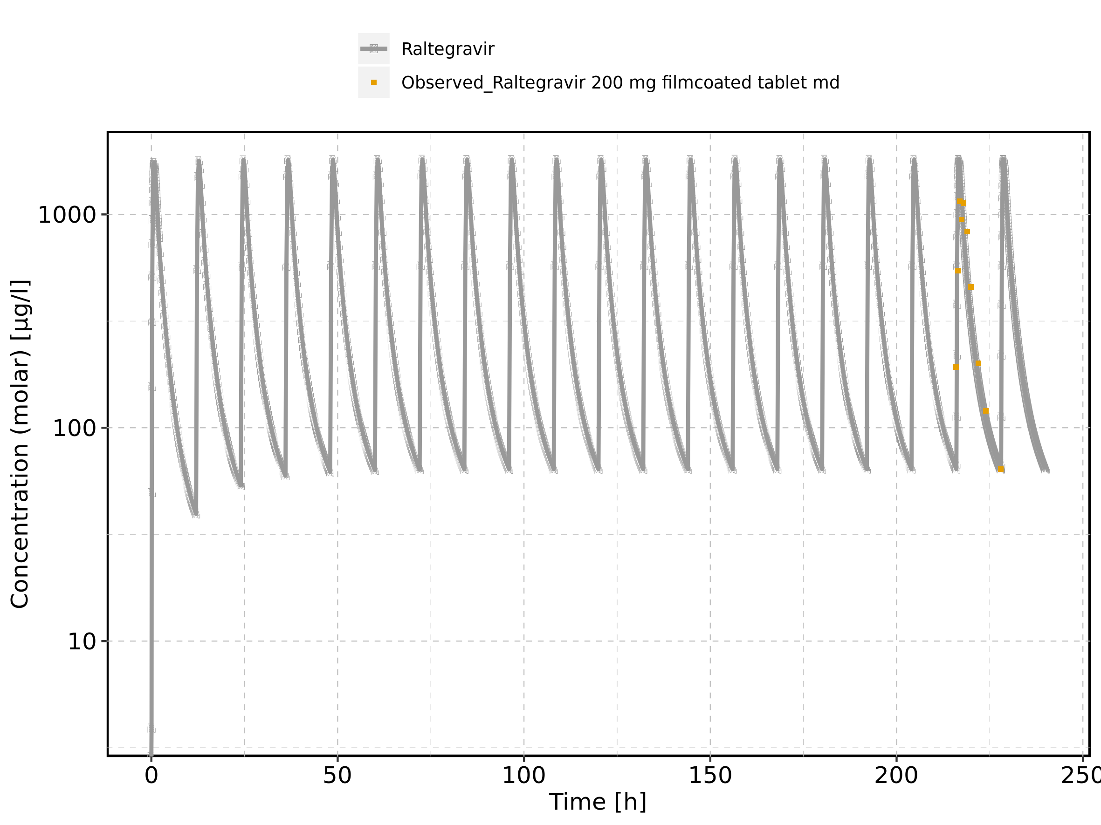

Figure 189: Predicted vs observed of Raltegravir 200 mg filmcoated tablet md for Raltegravir 200 mg filmcoated tablet md. Data source: Data/Raltegravir_PK.txt. Predictions and observations are plotted in a linear scale.

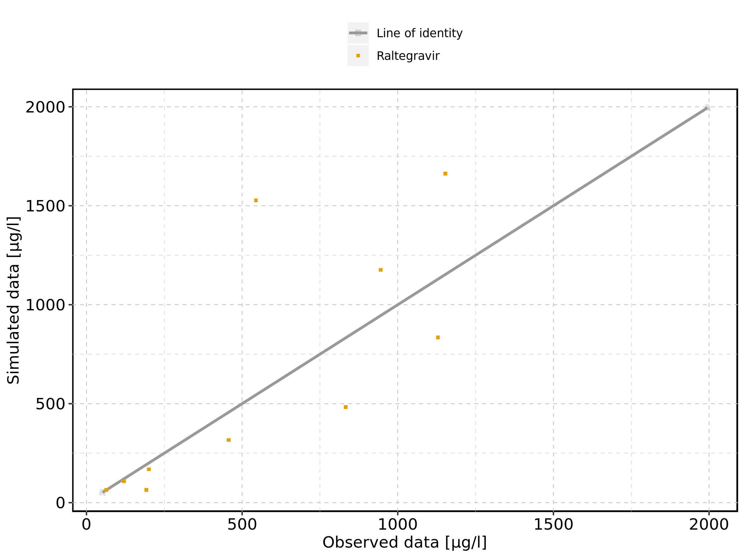

Figure 190: Predicted vs observed of Raltegravir 200 mg filmcoated tablet md for Raltegravir 200 mg filmcoated tablet md. Data source: Data/Raltegravir_PK.txt. Predictions and observations are plotted in a logarithmic scale.

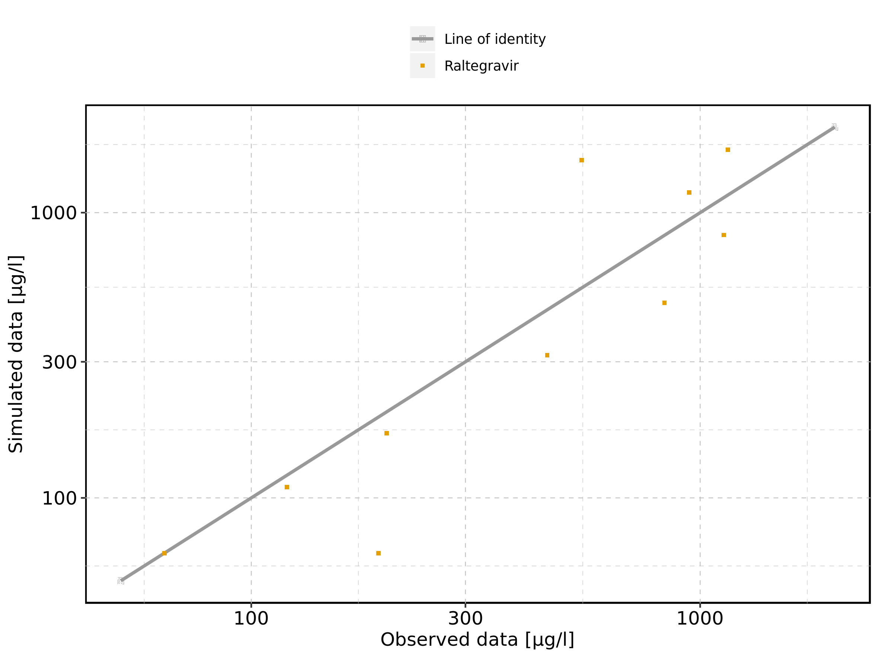

Figure 191: Logarithmic residuals vs predicted values of Raltegravir 200 mg filmcoated tablet md for Raltegravir 200 mg filmcoated tablet md. Data source: Data/Raltegravir_PK.txt.

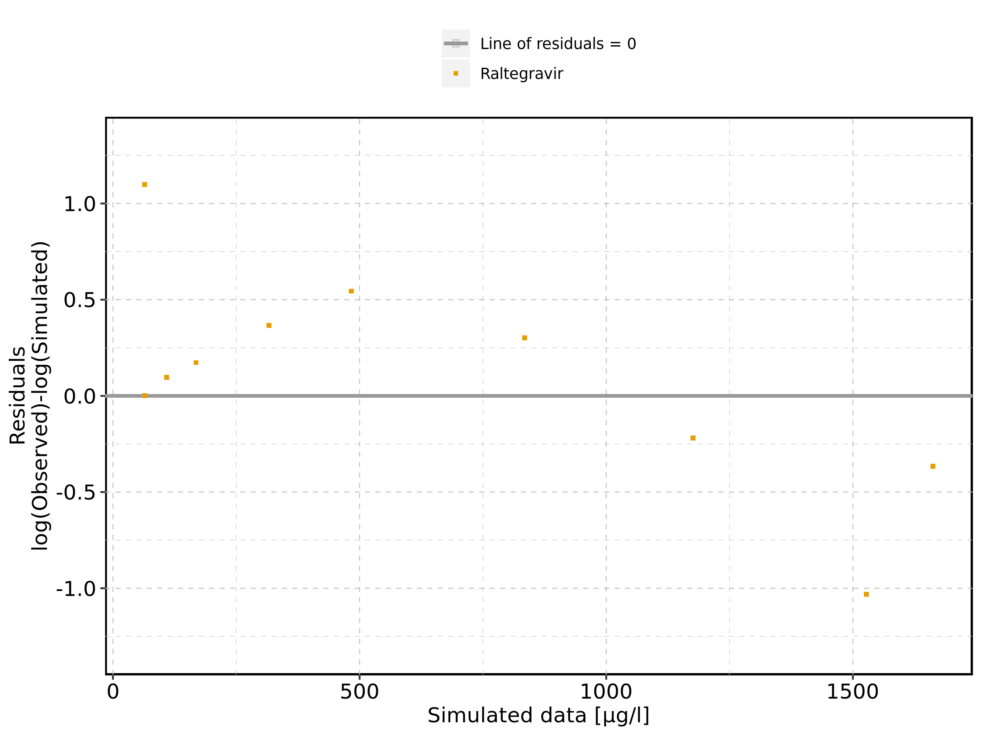

Figure 192: Logarithmic residuals vs time of Raltegravir 200 mg filmcoated tablet md for Raltegravir 200 mg filmcoated tablet md. Data source: Data/Raltegravir_PK.txt.

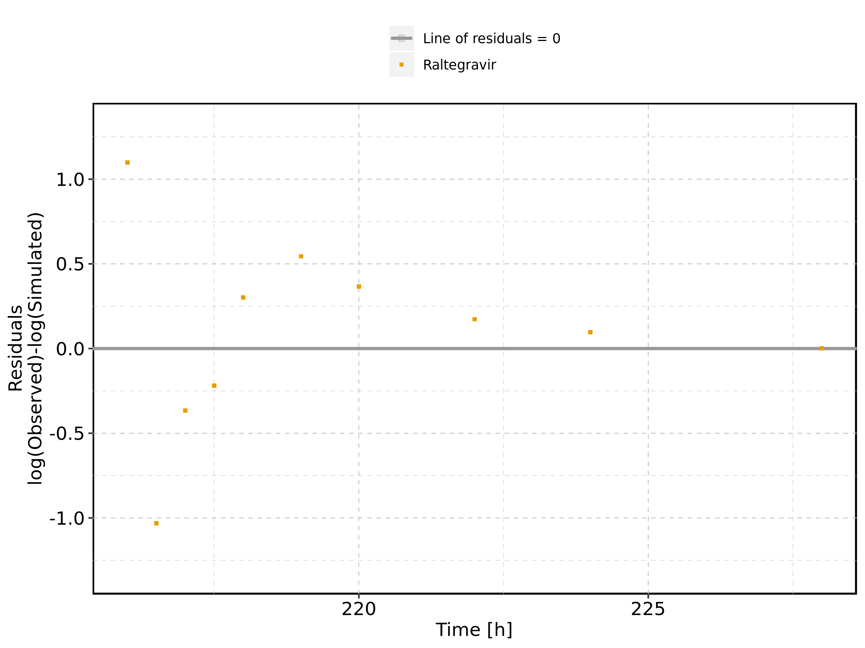

Figure 193: Logarithmic residuals distribution of Raltegravir 200 mg filmcoated tablet md for Raltegravir 200 mg filmcoated tablet md. Data source: Data/Raltegravir_PK.txt.

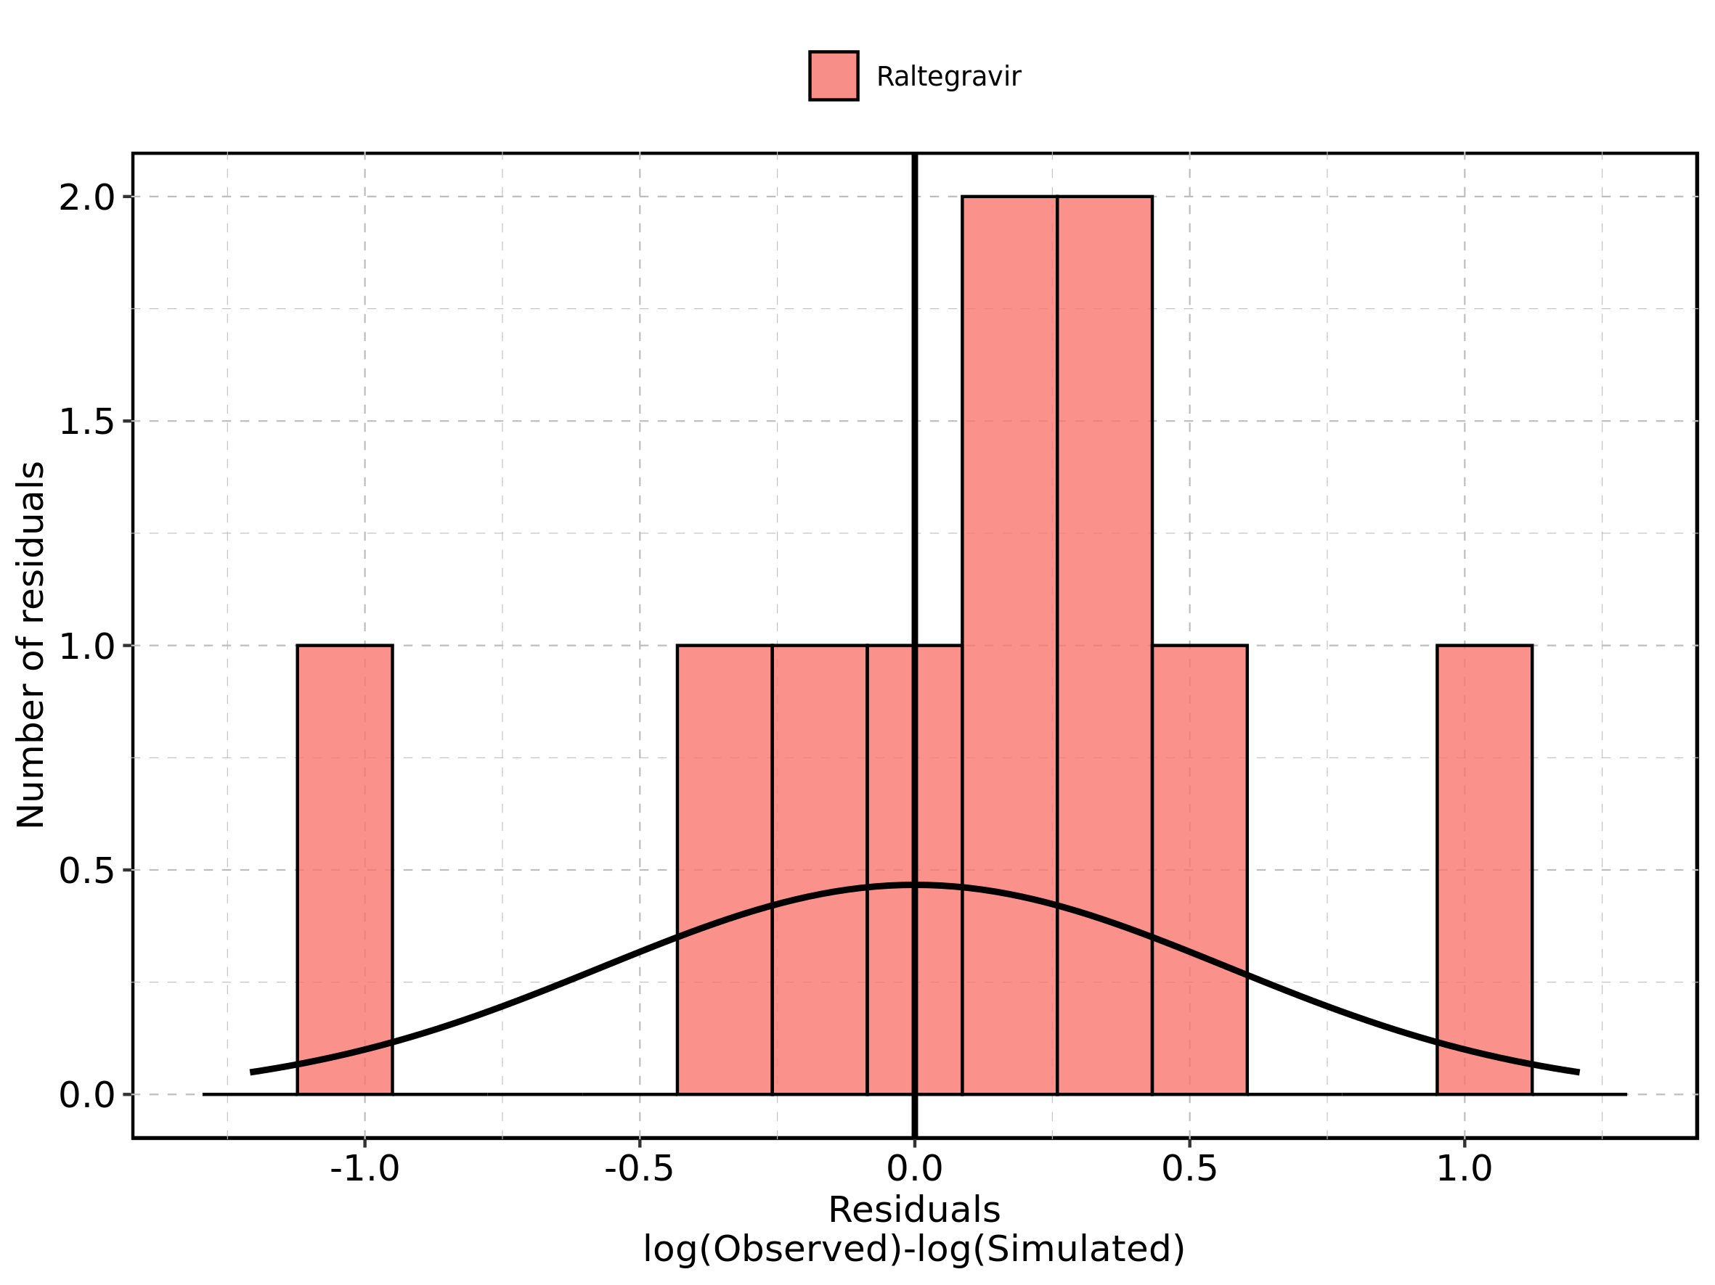

Figure 194: Logarithmic residuals of Raltegravir 200 mg filmcoated tablet md for Raltegravir 200 mg filmcoated tablet md as quantile-quantile plot. Data source: Data/Raltegravir_PK.txt.

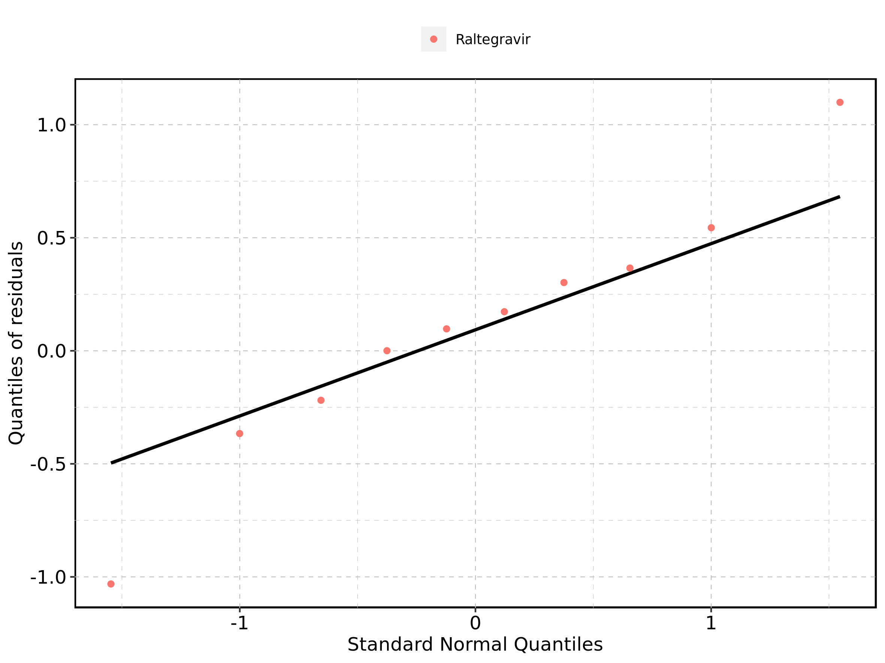

### 4.11.2. For first application range

Figure 195: Time profiles of Raltegravir 200 mg filmcoated tablet md for Raltegravir 200 mg filmcoated tablet md. Data source: Data/Raltegravir_PK.txt. Time profiles are plotted in a linear scale.

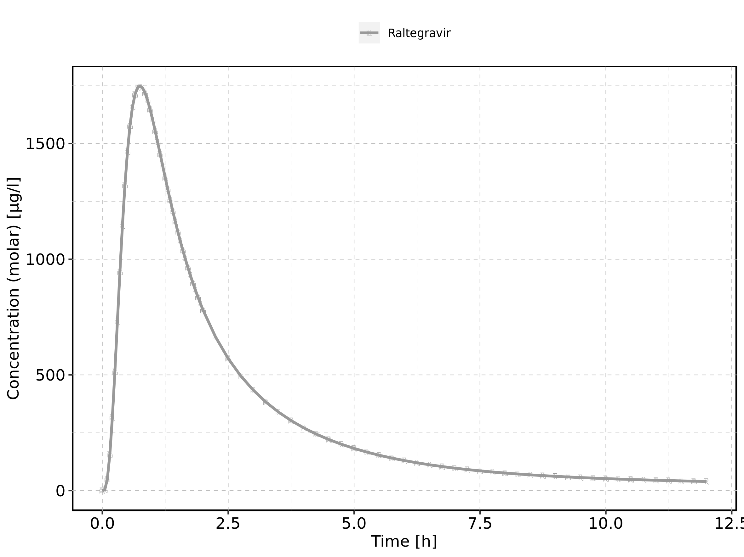

Figure 196: Time profiles of Raltegravir 200 mg filmcoated tablet md for Raltegravir 200 mg filmcoated tablet md. Data source: Data/Raltegravir_PK.txt. Time profiles are plotted in a logarithmic scale.

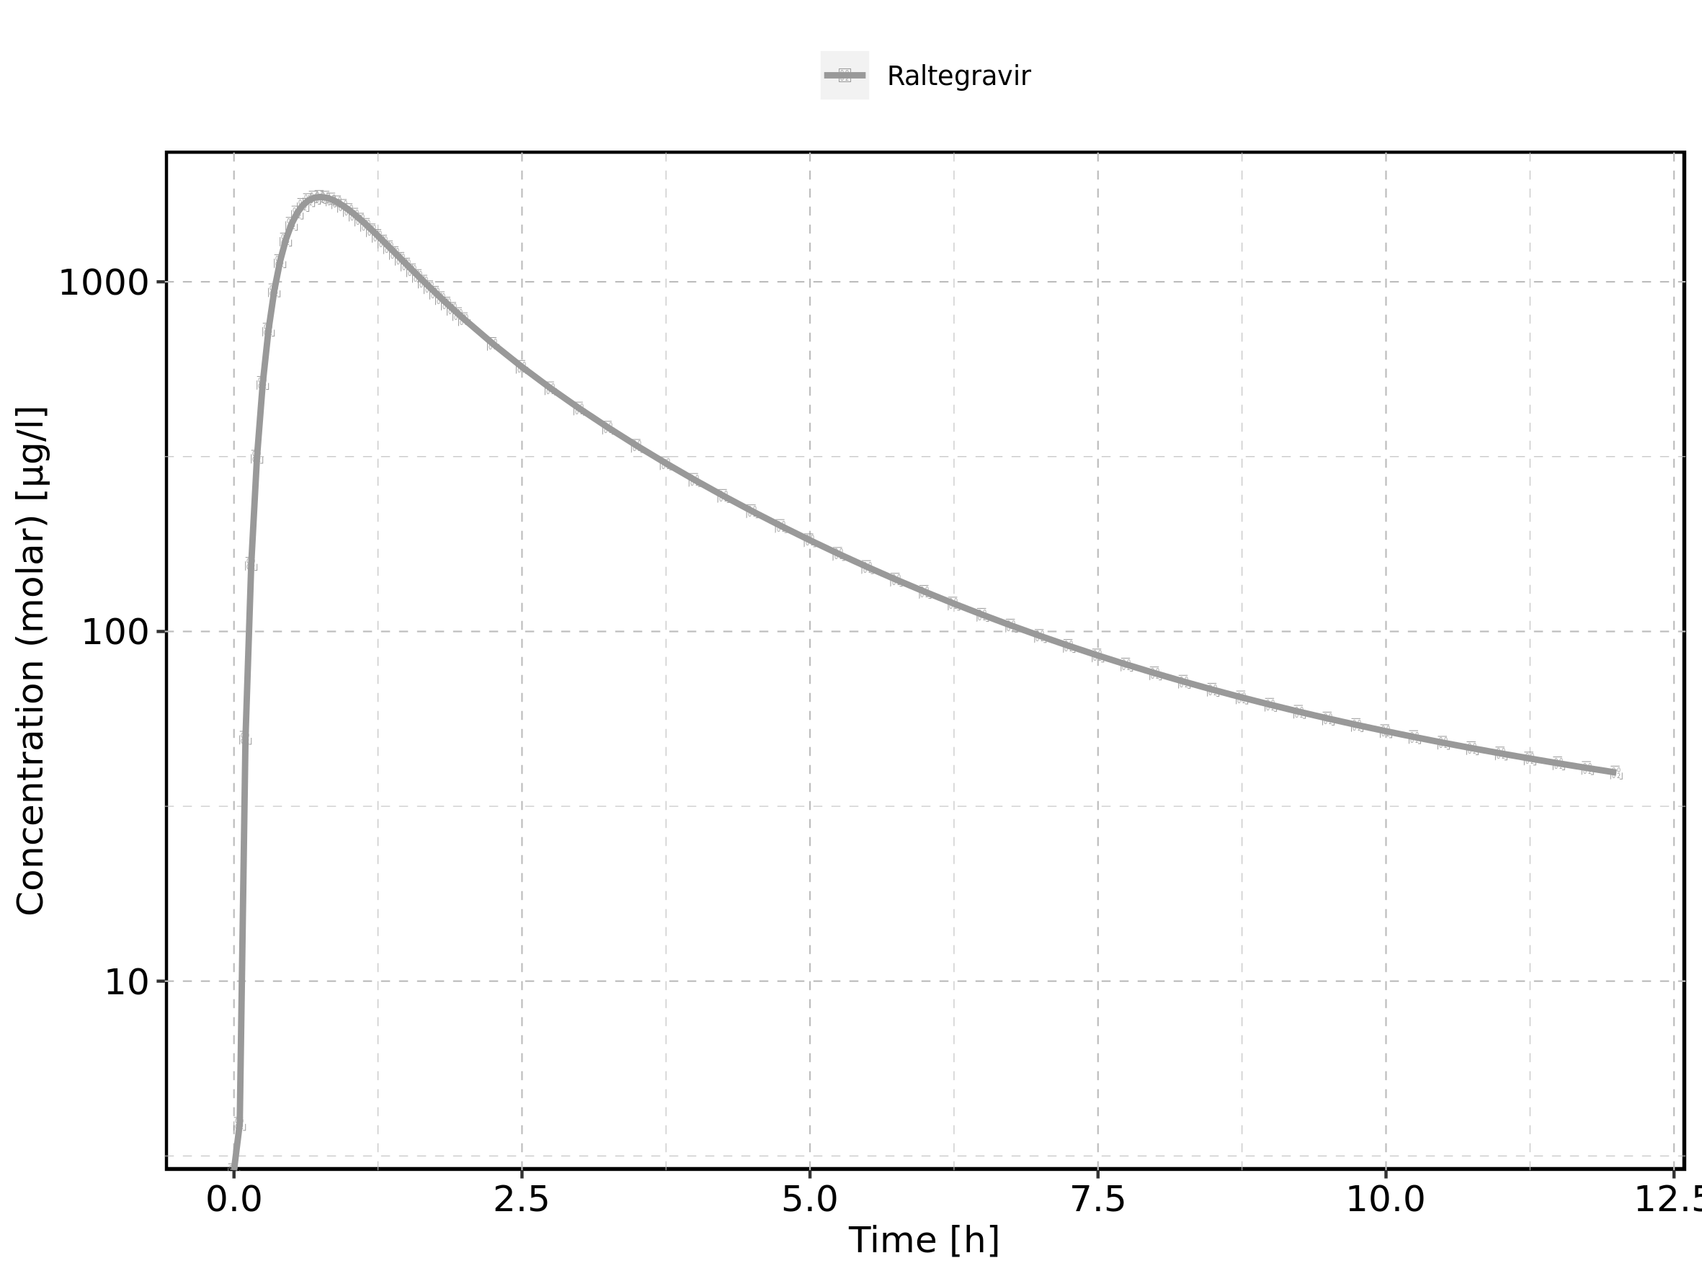

### 4.11.3. For last application range

Figure 197: Time profiles of Raltegravir 200 mg filmcoated tablet md for Raltegravir 200 mg filmcoated tablet md. Data source: Data/Raltegravir_PK.txt. Time profiles are plotted in a linear scale.

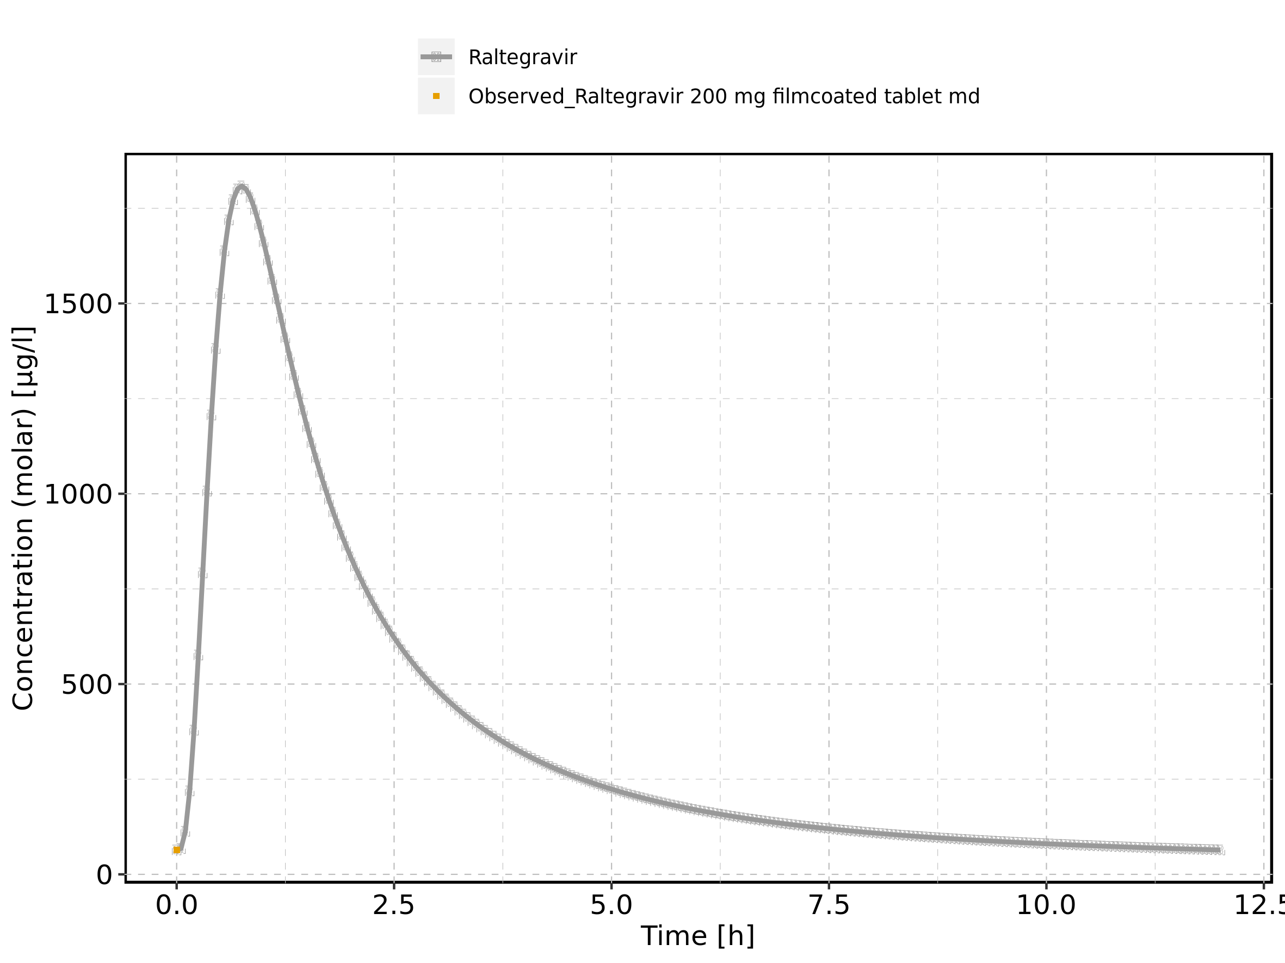

Figure 198: Time profiles of Raltegravir 200 mg filmcoated tablet md for Raltegravir 200 mg filmcoated tablet md. Data source: Data/Raltegravir_PK.txt. Time profiles are plotted in a logarithmic scale.

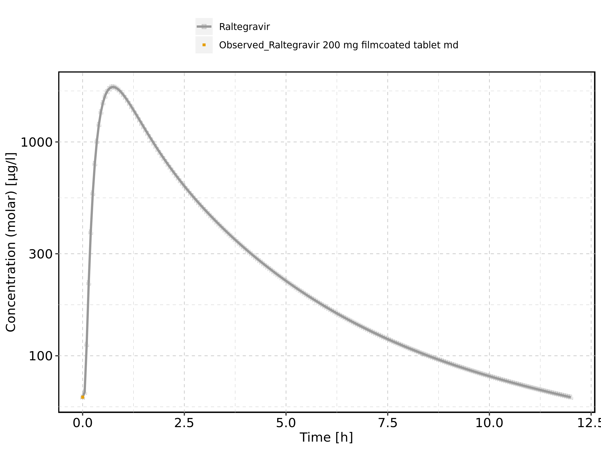

Figure 199: Predicted vs observed of Raltegravir 200 mg filmcoated tablet md for Raltegravir 200 mg filmcoated tablet md. Data source: Data/Raltegravir_PK.txt. Predictions and observations are plotted in a linear scale.

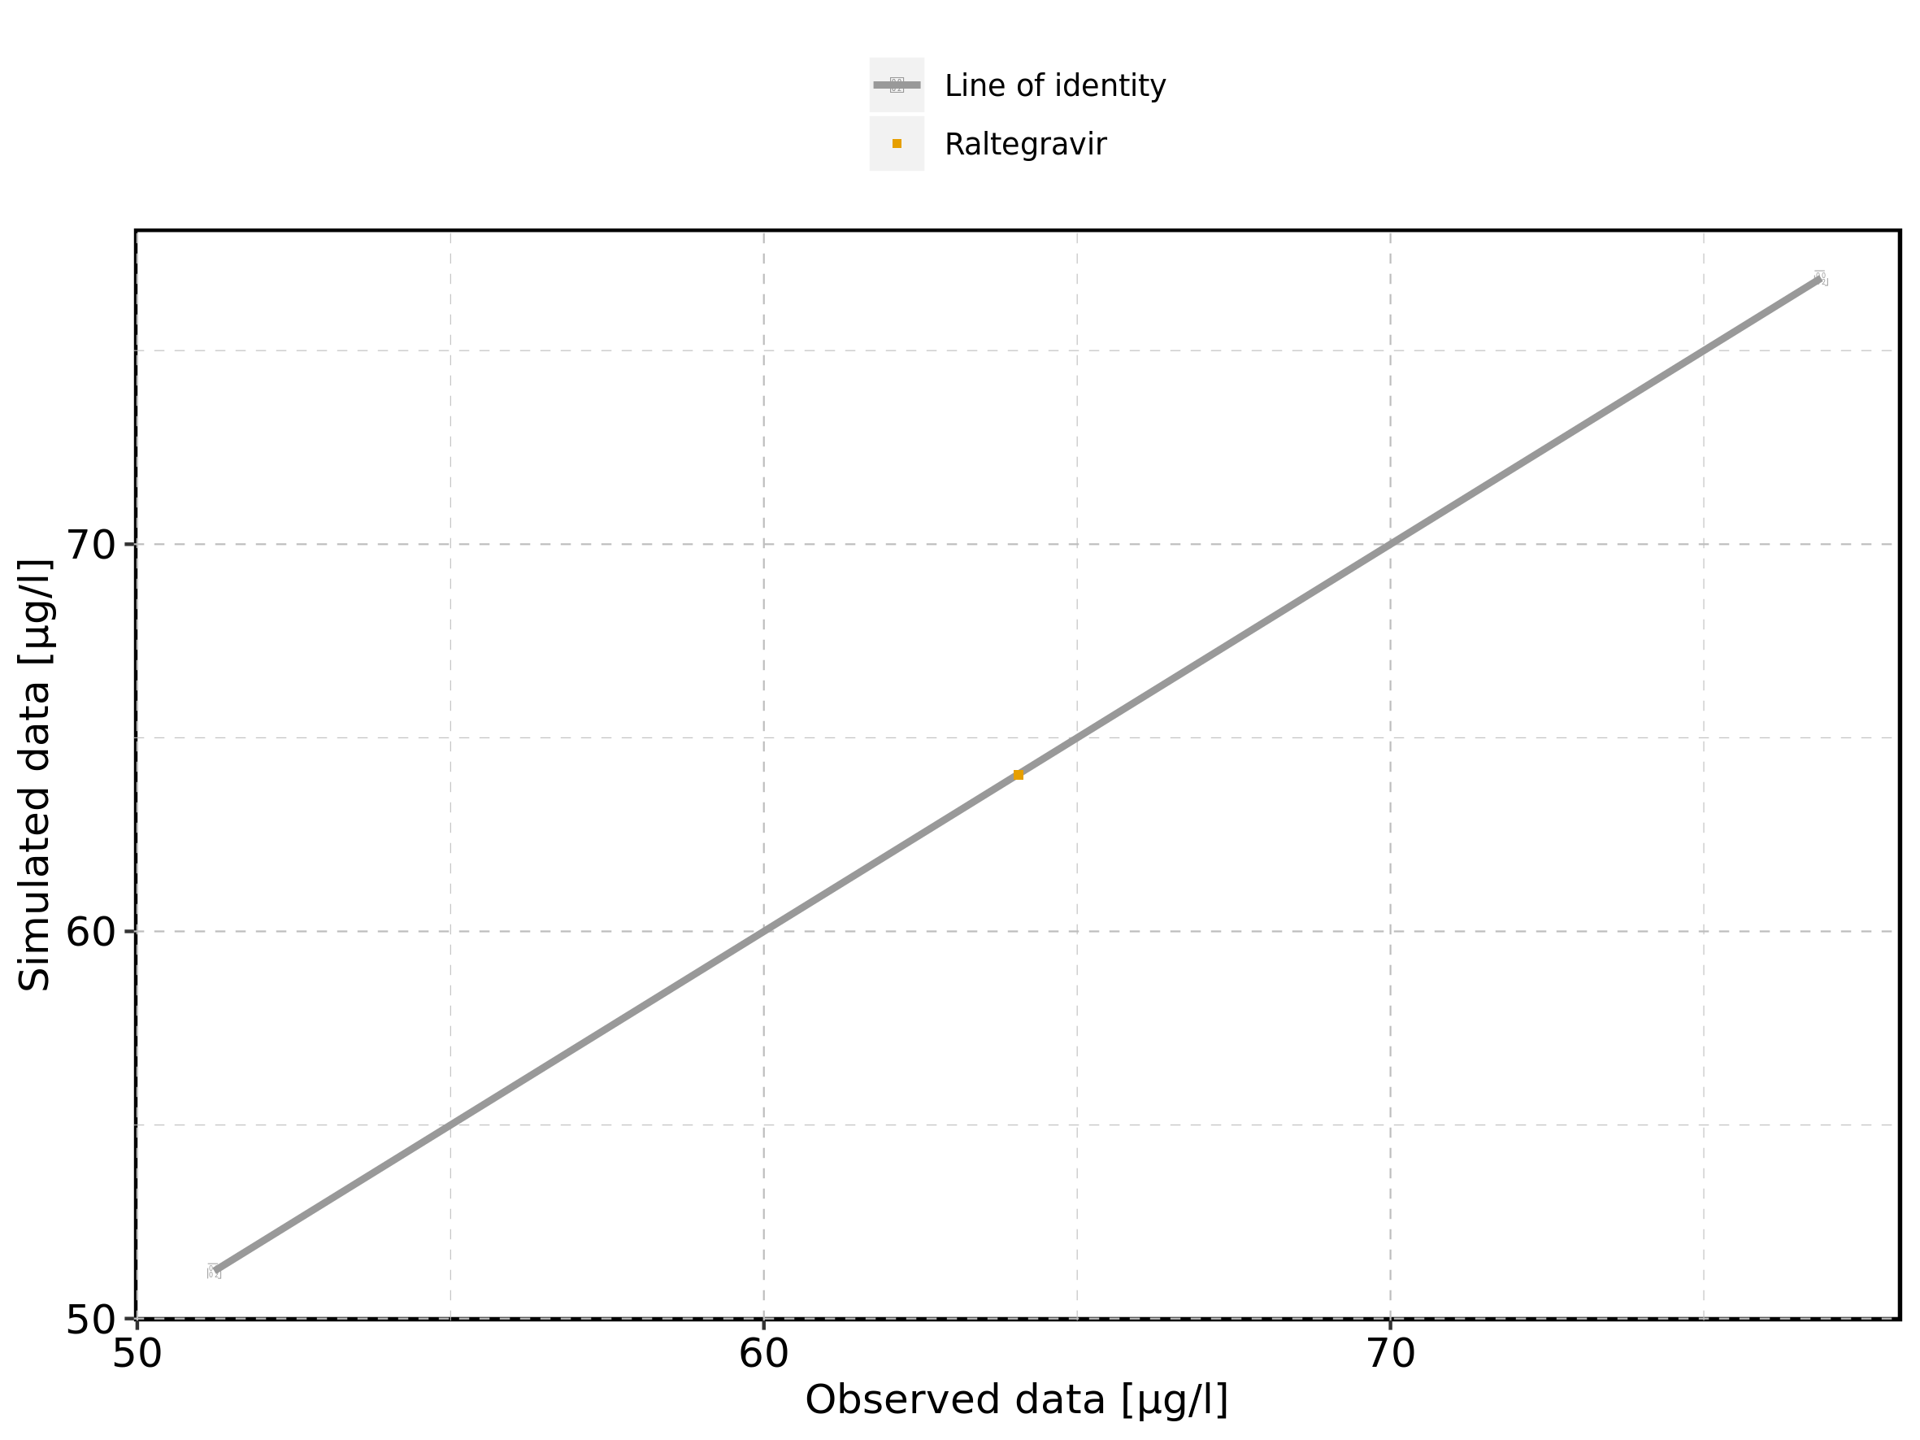

Figure 200: Predicted vs observed of Raltegravir 200 mg filmcoated tablet md for Raltegravir 200 mg filmcoated tablet md. Data source: Data/Raltegravir_PK.txt. Predictions and observations are plotted in a logarithmic scale.

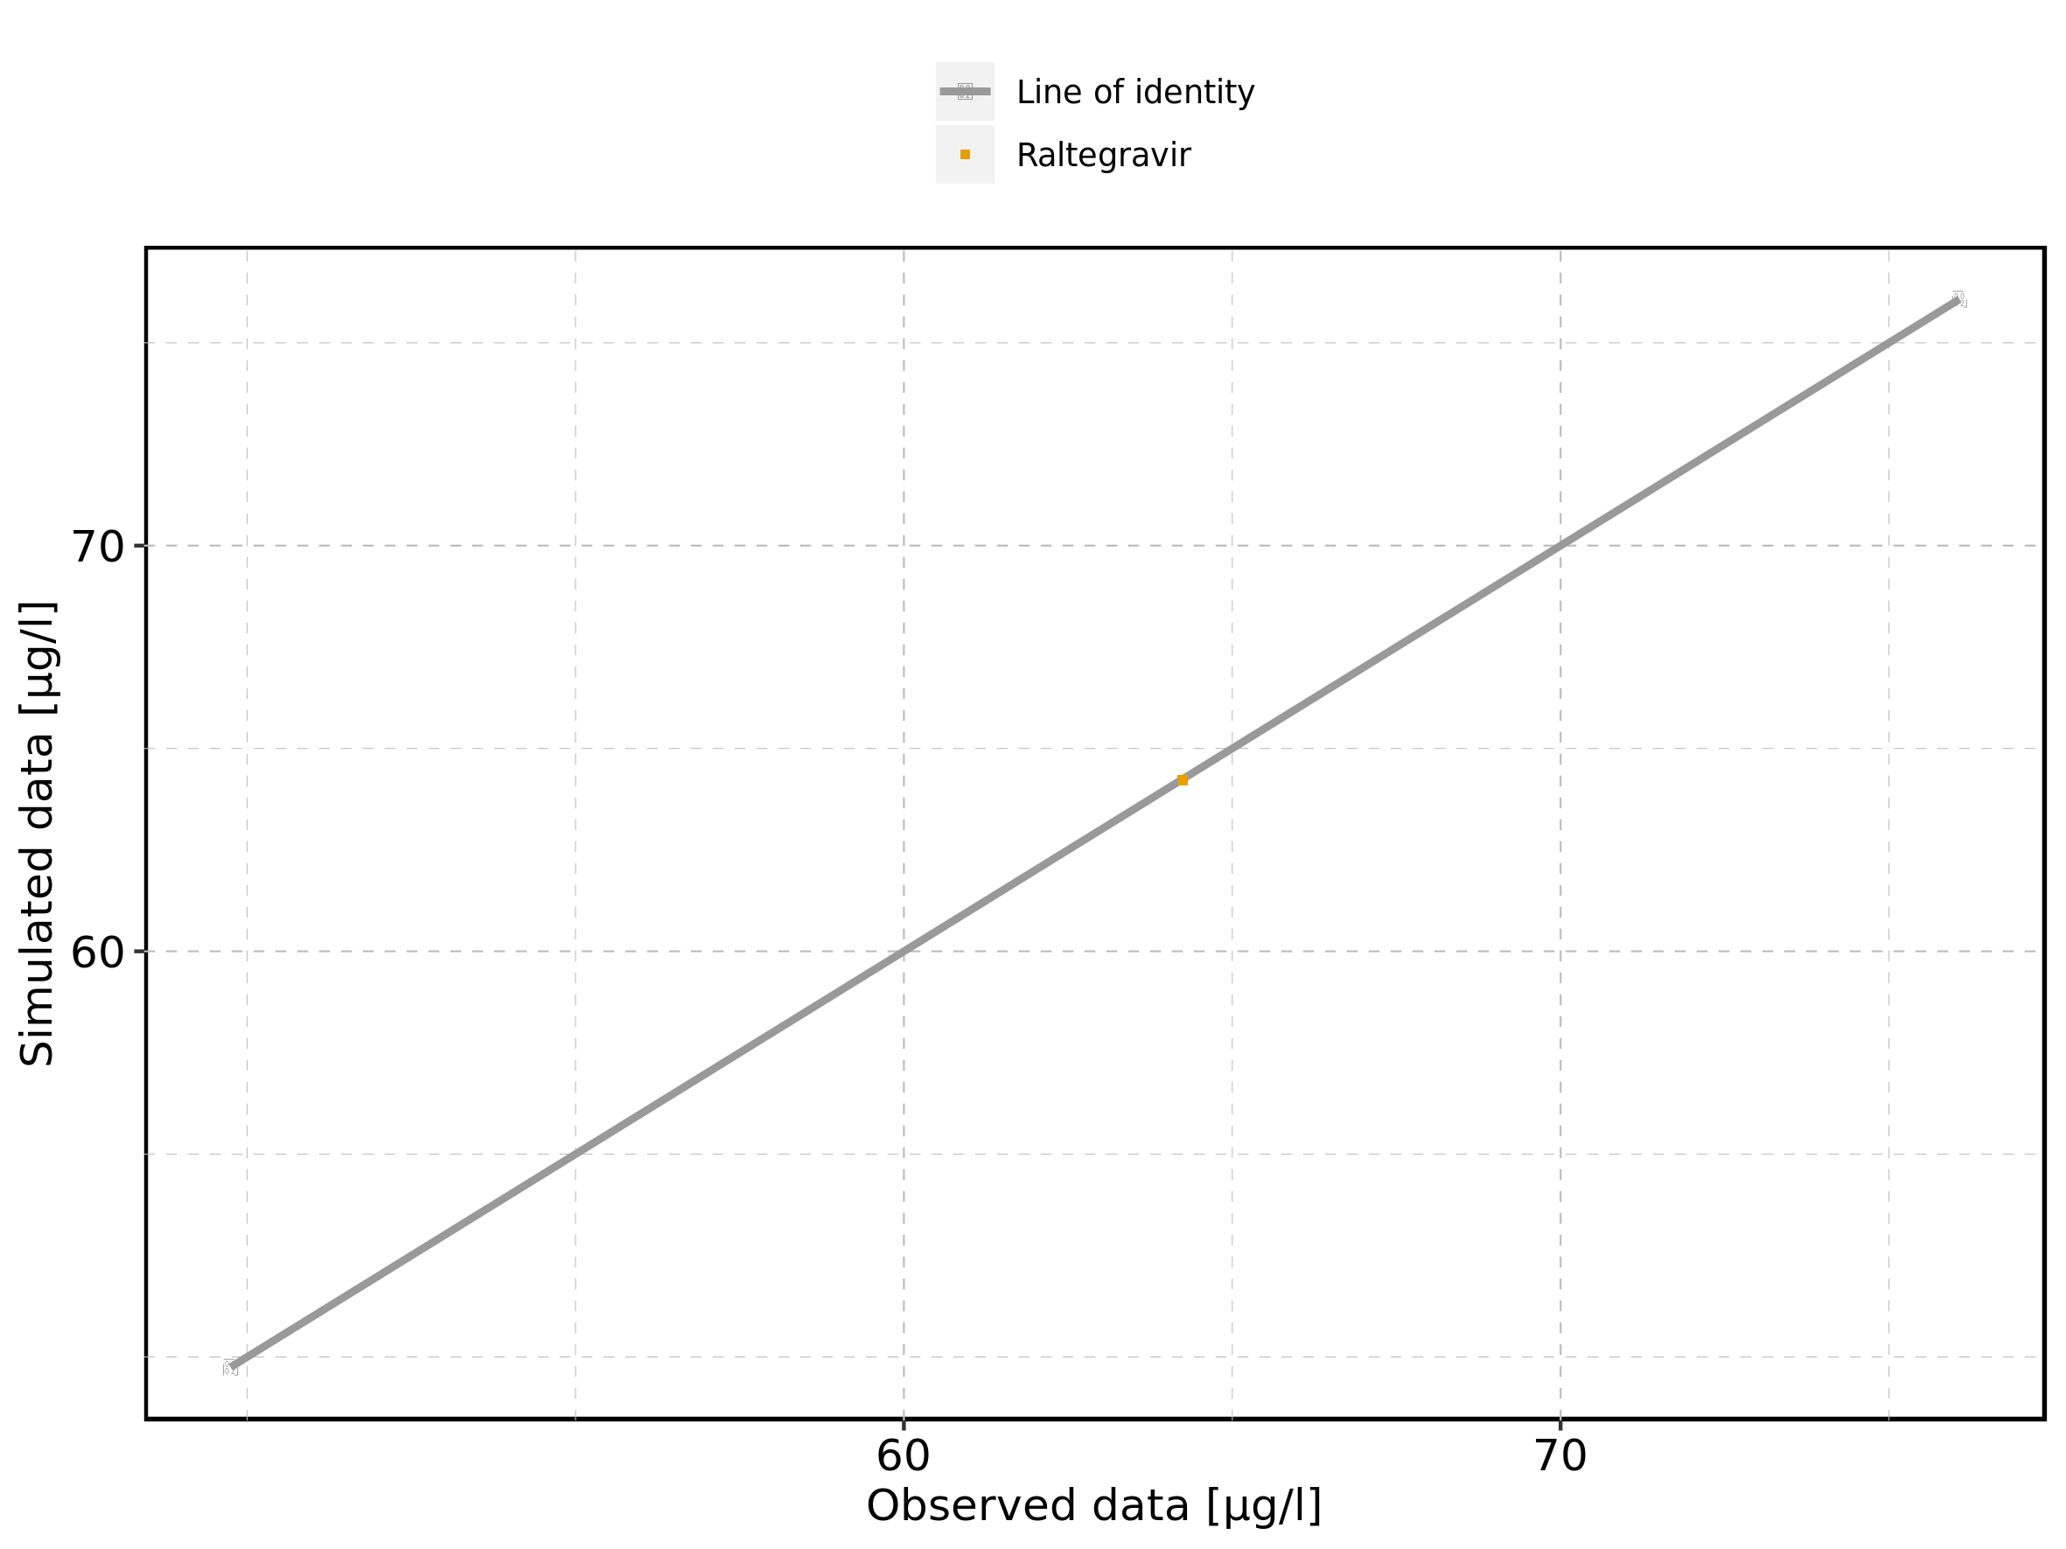

Figure 201: Logarithmic residuals vs predicted values of Raltegravir 200 mg filmcoated tablet md for Raltegravir 200 mg filmcoated tablet md. Data source: Data/Raltegravir_PK.txt.

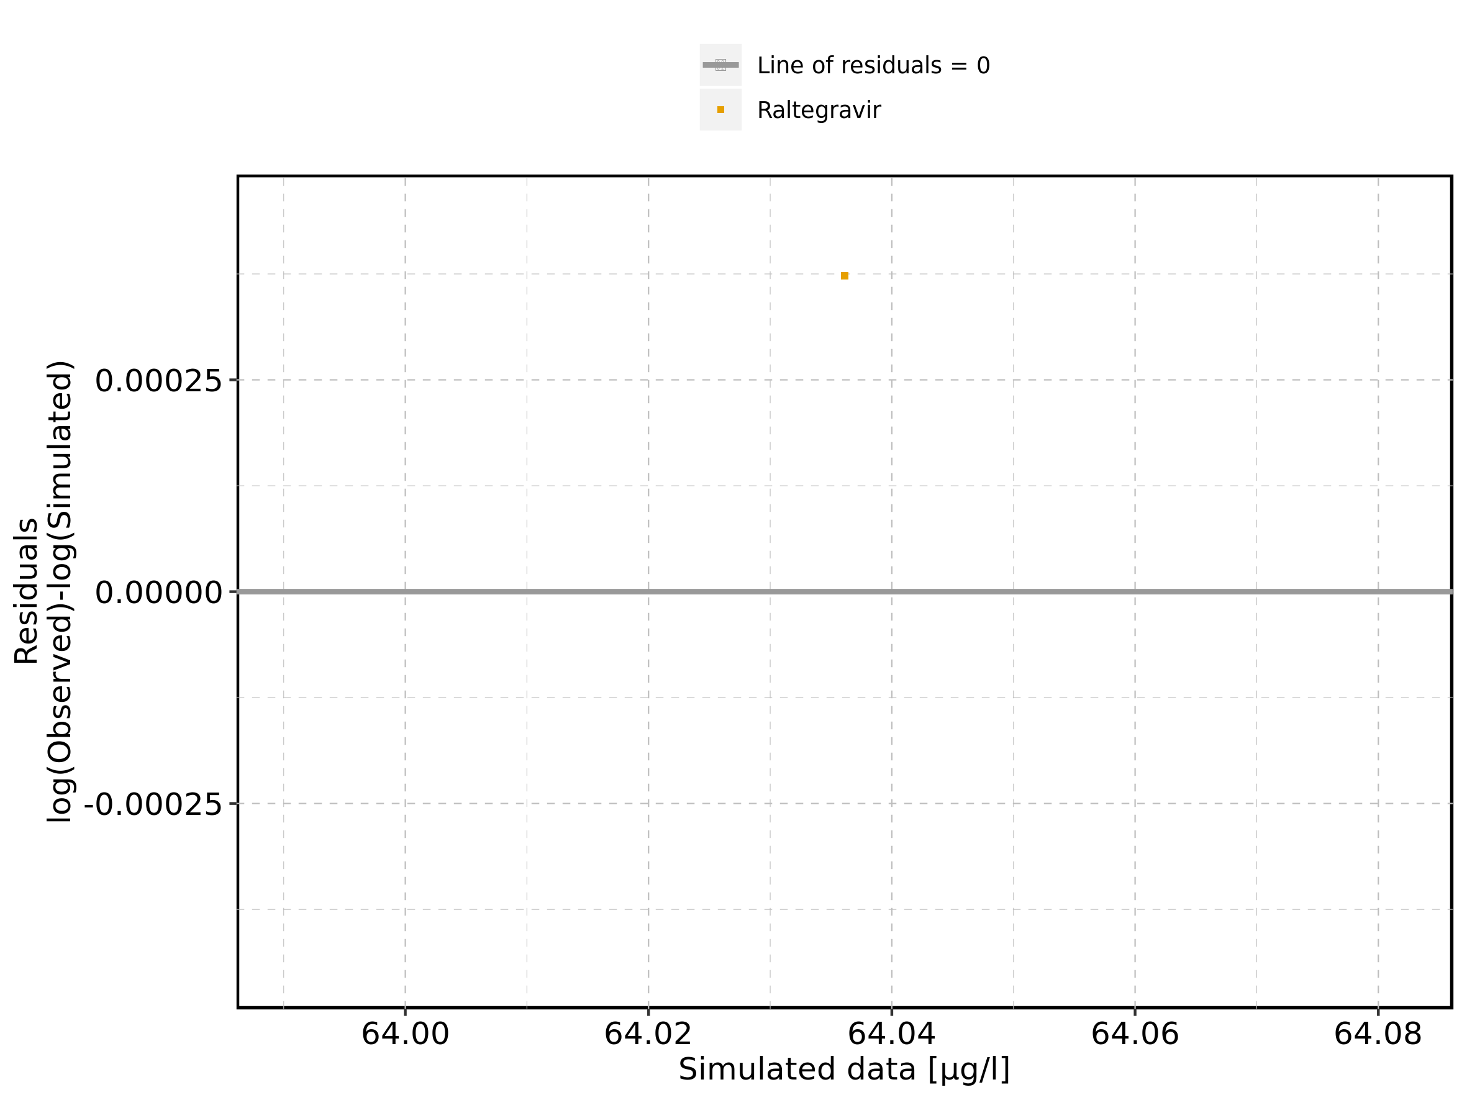

Figure 202: Logarithmic residuals vs time of Raltegravir 200 mg filmcoated tablet md for Raltegravir 200 mg filmcoated tablet md. Data source: Data/Raltegravir_PK.txt.

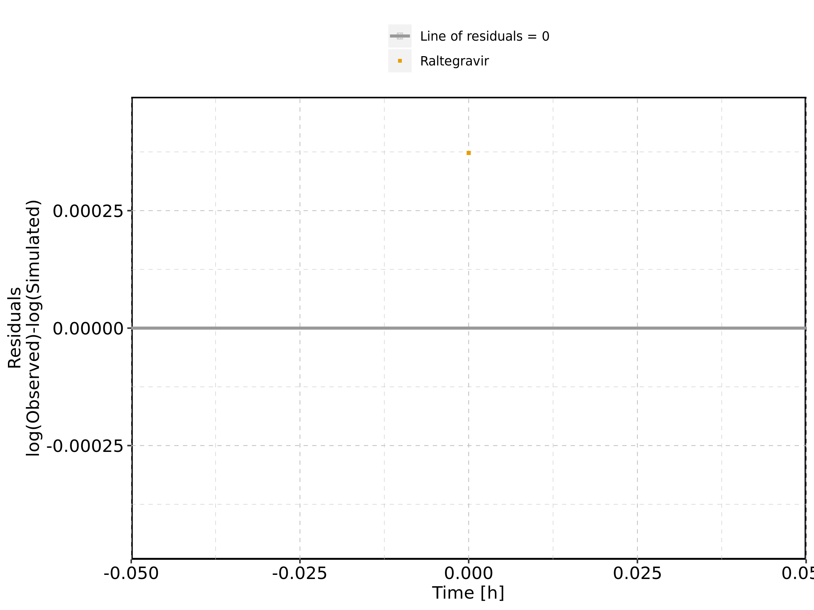

Figure 203: Logarithmic residuals distribution of Raltegravir 200 mg filmcoated tablet md for Raltegravir 200 mg filmcoated tablet md. Data source: Data/Raltegravir_PK.txt.

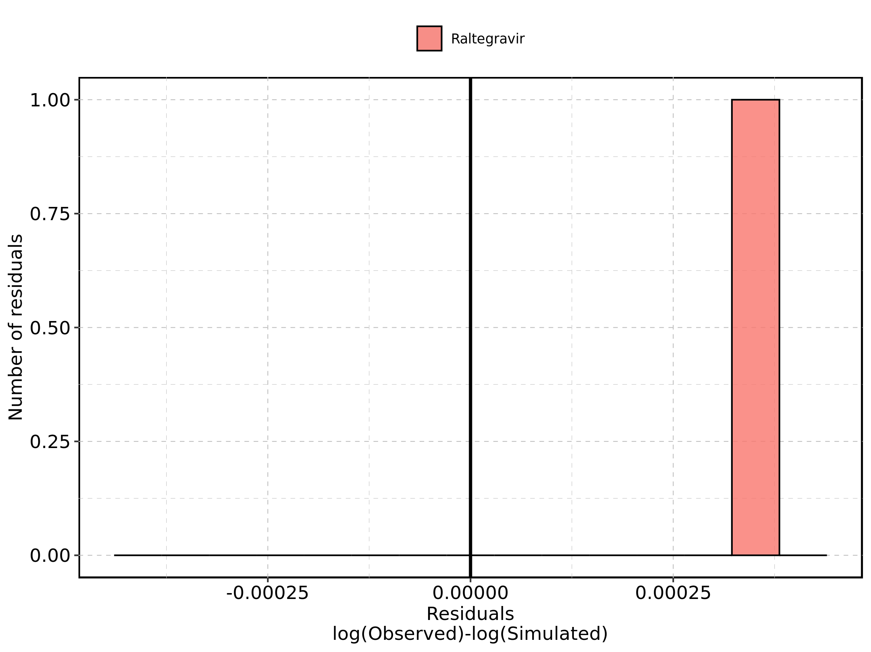

Figure 204: Logarithmic residuals of Raltegravir 200 mg filmcoated tablet md for Raltegravir 200 mg filmcoated tablet md as quantile-quantile plot. Data source: Data/Raltegravir_PK.txt.

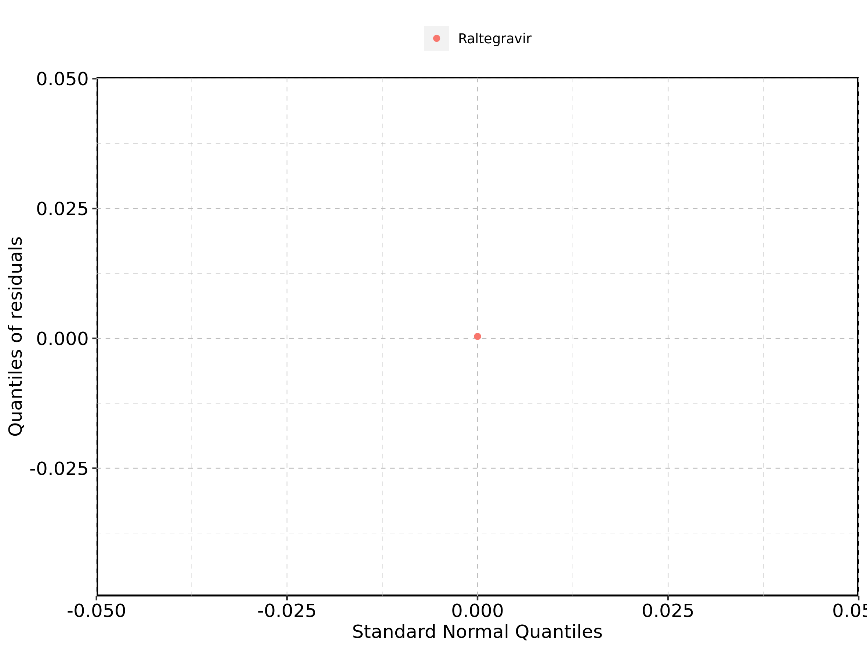

## 4.12. Time profiles and residual plots for Filmcoated_tablet_400mg_sd

Figure 205: Time profiles of Filmcoated_tablet_400mg_sd for Raltegravir 400mg filmcoated tablet. Data source: Data/Raltegravir_PK.txt. Time profiles are plotted in a linear scale.

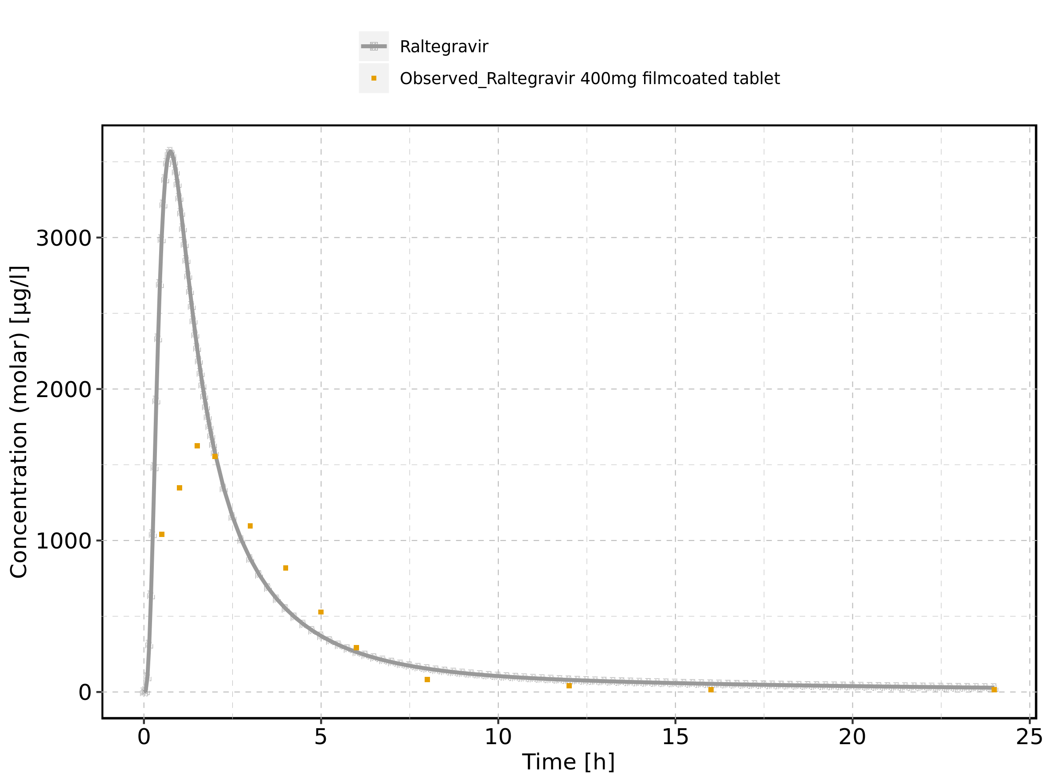

Figure 206: Time profiles of Filmcoated_tablet_400mg_sd for Raltegravir 400mg filmcoated tablet. Data source: Data/Raltegravir_PK.txt. Time profiles are plotted in a logarithmic scale.

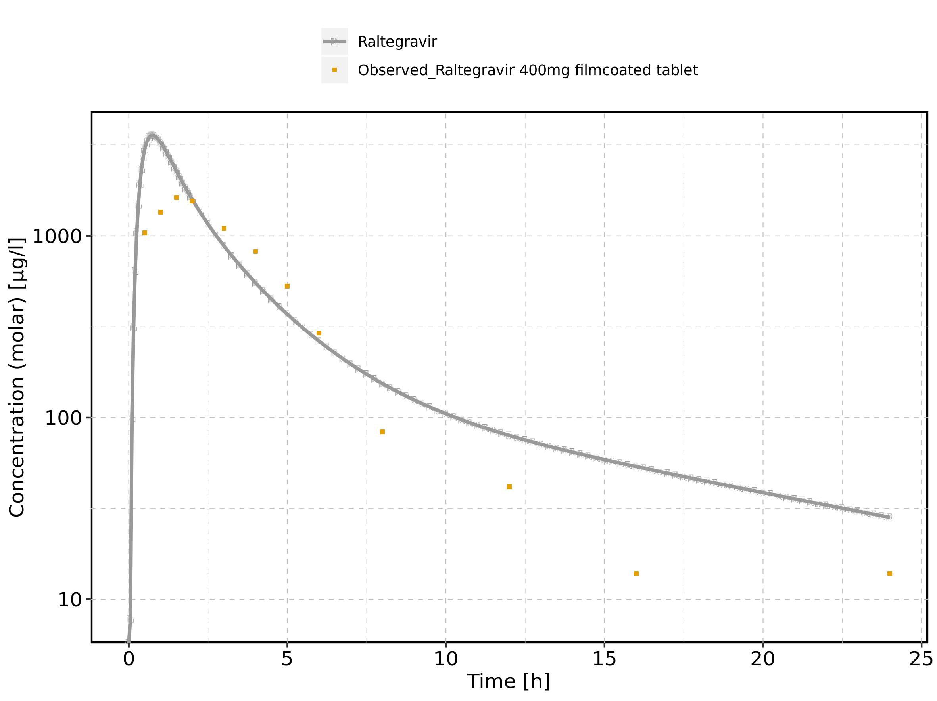

Figure 207: Predicted vs observed of Filmcoated_tablet_400mg_sd for Raltegravir 400mg filmcoated tablet. Data source: Data/Raltegravir_PK.txt. Predictions and observations are plotted in a linear scale.

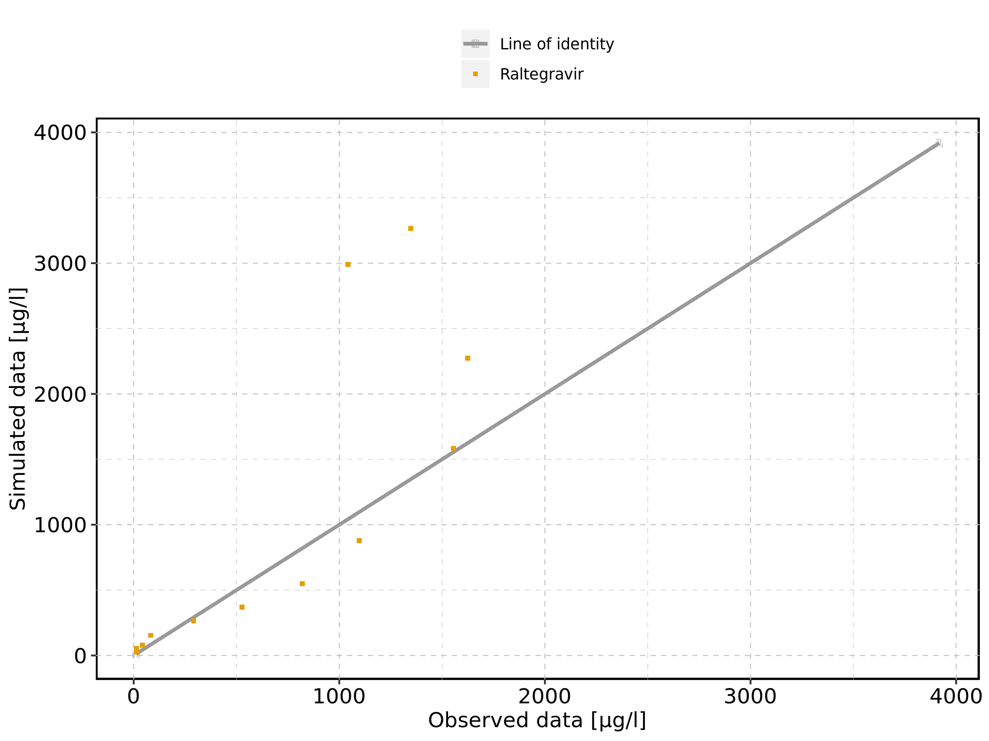

Figure 208: Predicted vs observed of Filmcoated_tablet_400mg_sd for Raltegravir 400mg filmcoated tablet. Data source: Data/Raltegravir_PK.txt. Predictions and observations are plotted in a logarithmic scale.

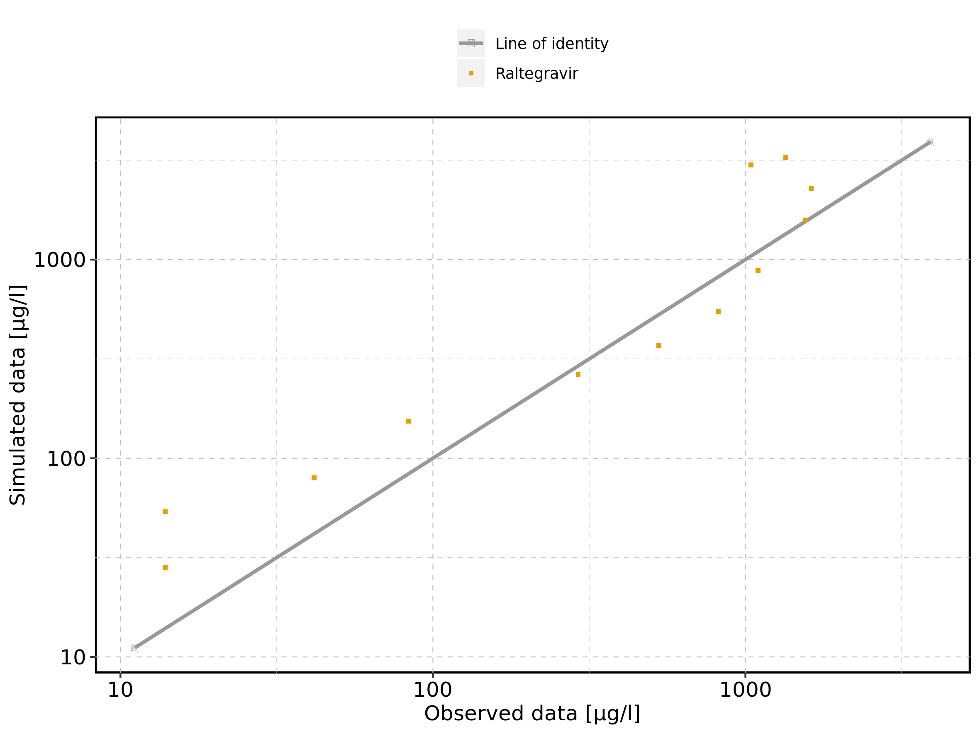

Figure 209: Logarithmic residuals vs predicted values of Filmcoated_tablet_400mg_sd for Raltegravir 400mg filmcoated tablet. Data source: Data/Raltegravir_PK.txt.

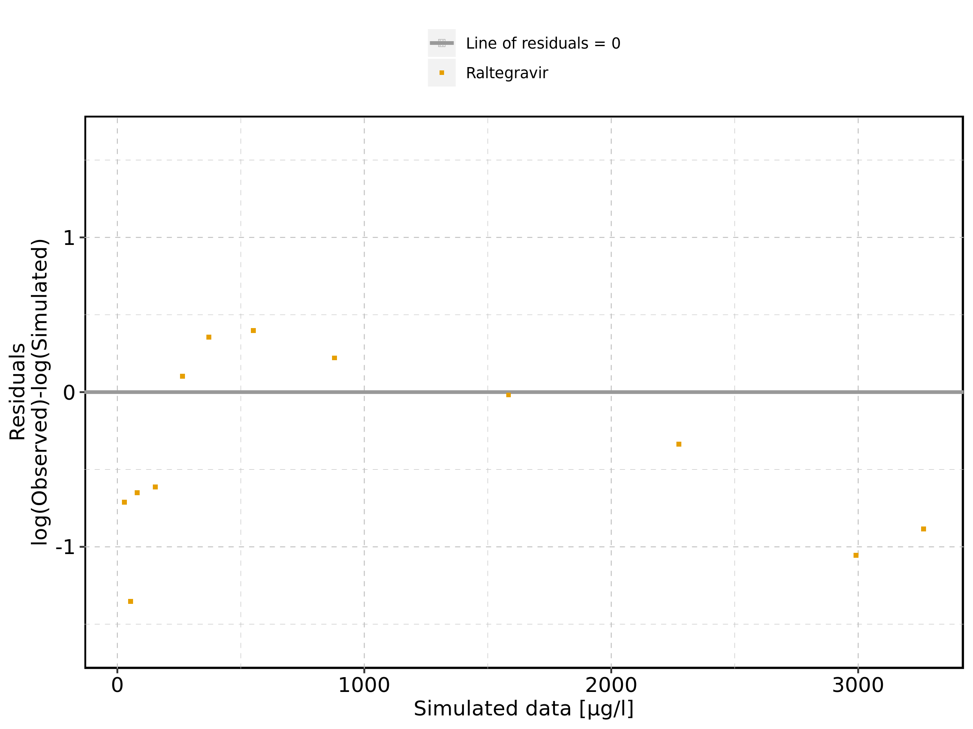

Figure 210: Logarithmic residuals vs time of Filmcoated_tablet_400mg_sd for Raltegravir 400mg filmcoated tablet. Data source: Data/Raltegravir_PK.txt.

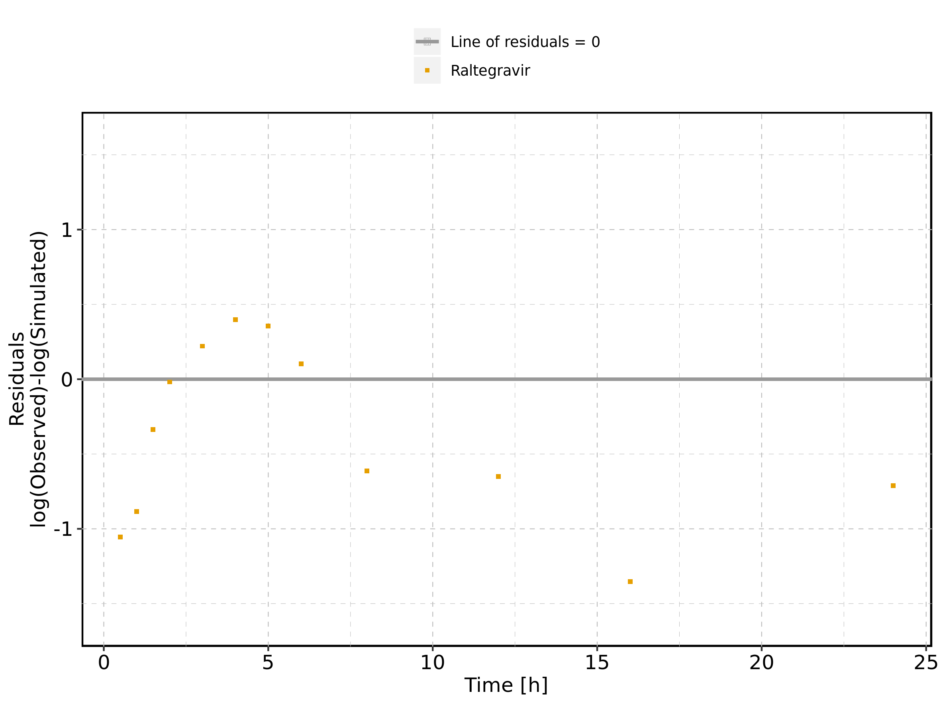

Figure 211: Logarithmic residuals distribution of Filmcoated_tablet_400mg_sd for Raltegravir 400mg filmcoated tablet. Data source: Data/Raltegravir_PK.txt.

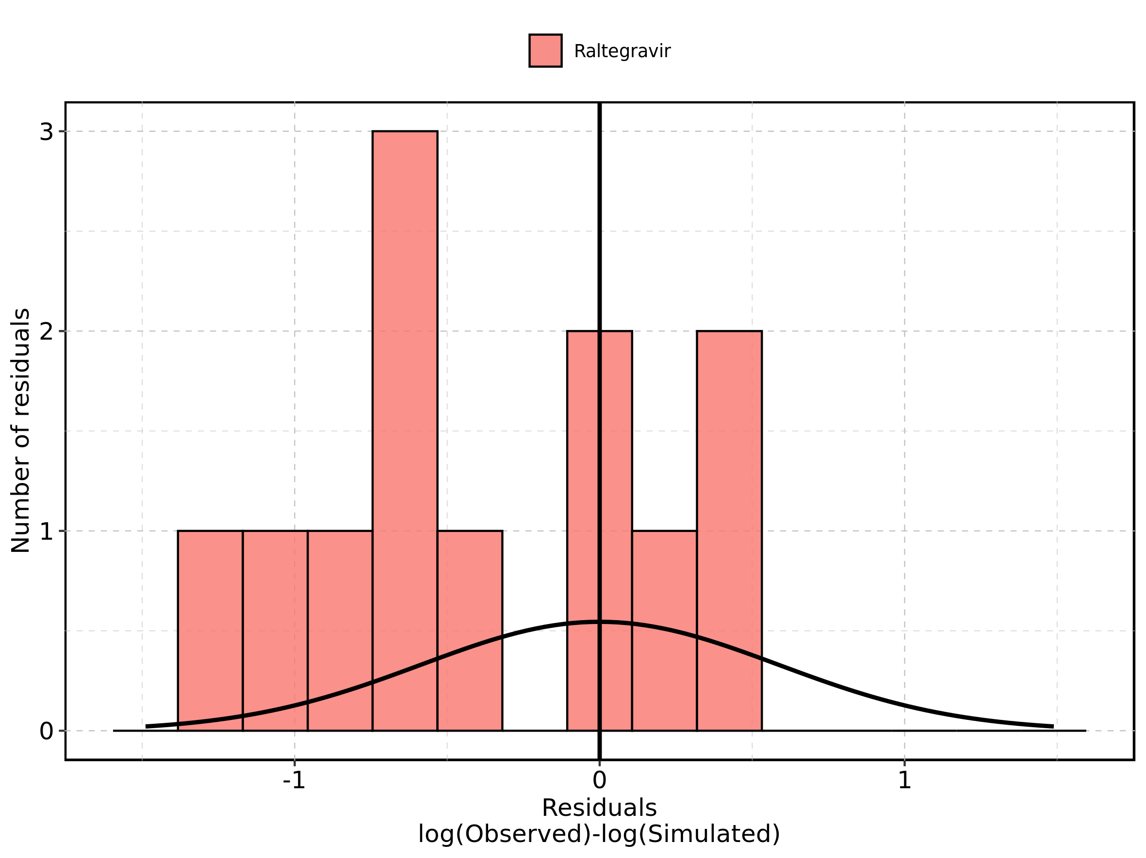

Figure 212: Logarithmic residuals of Filmcoated_tablet_400mg_sd for Raltegravir 400mg filmcoated tablet as quantile-quantile plot. Data source: Data/Raltegravir_PK.txt.

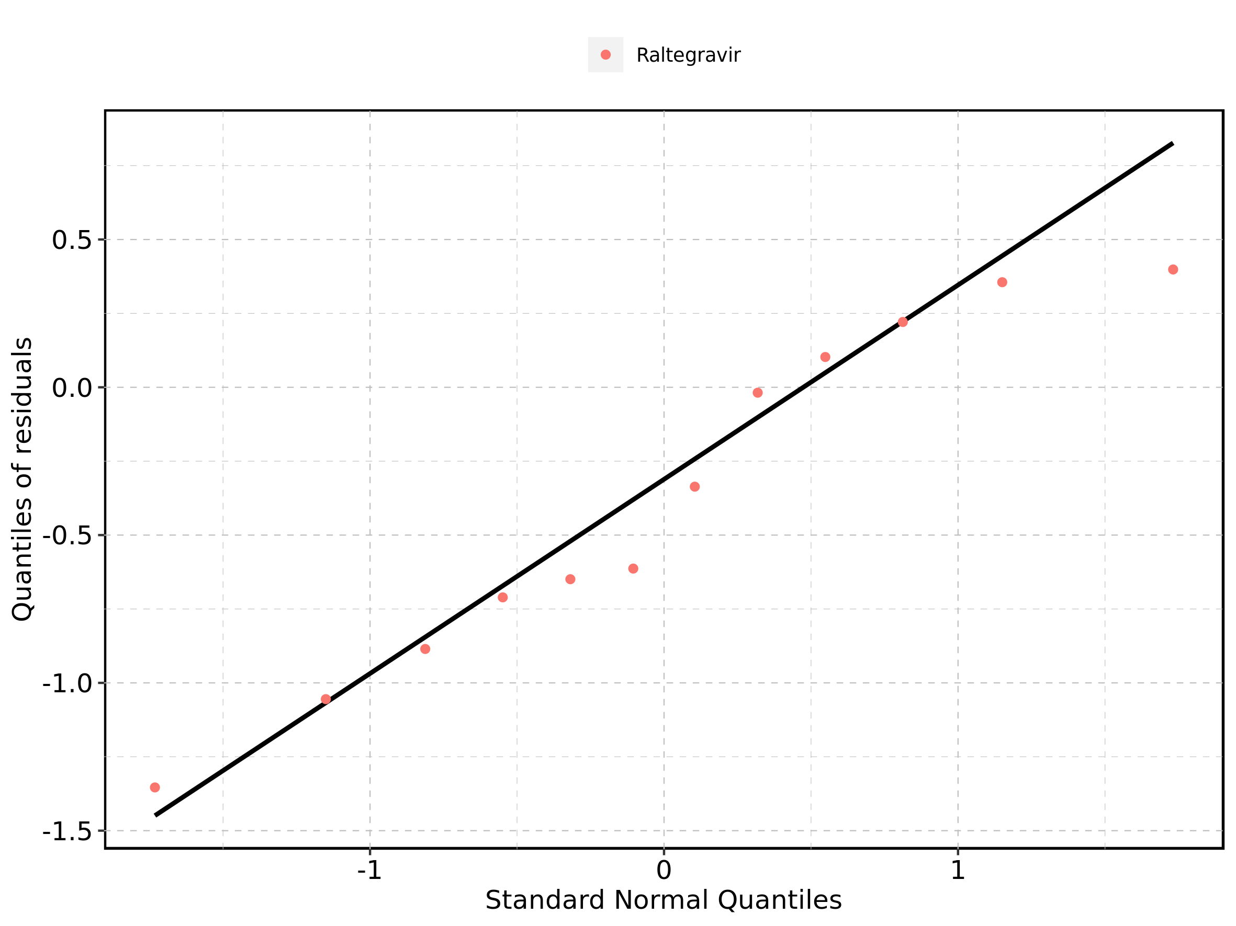

## 4.13. Time profiles and residual plots for Raltegravir 400 mg filmcoated tablet md

### 4.13.1. For total simulation time range

Figure 213: Time profiles of Raltegravir 400 mg filmcoated tablet md for Raltegravir 400 mg filmcoated tablet md. Data source: Data/Raltegravir_PK.txt. Time profiles are plotted in a linear scale.

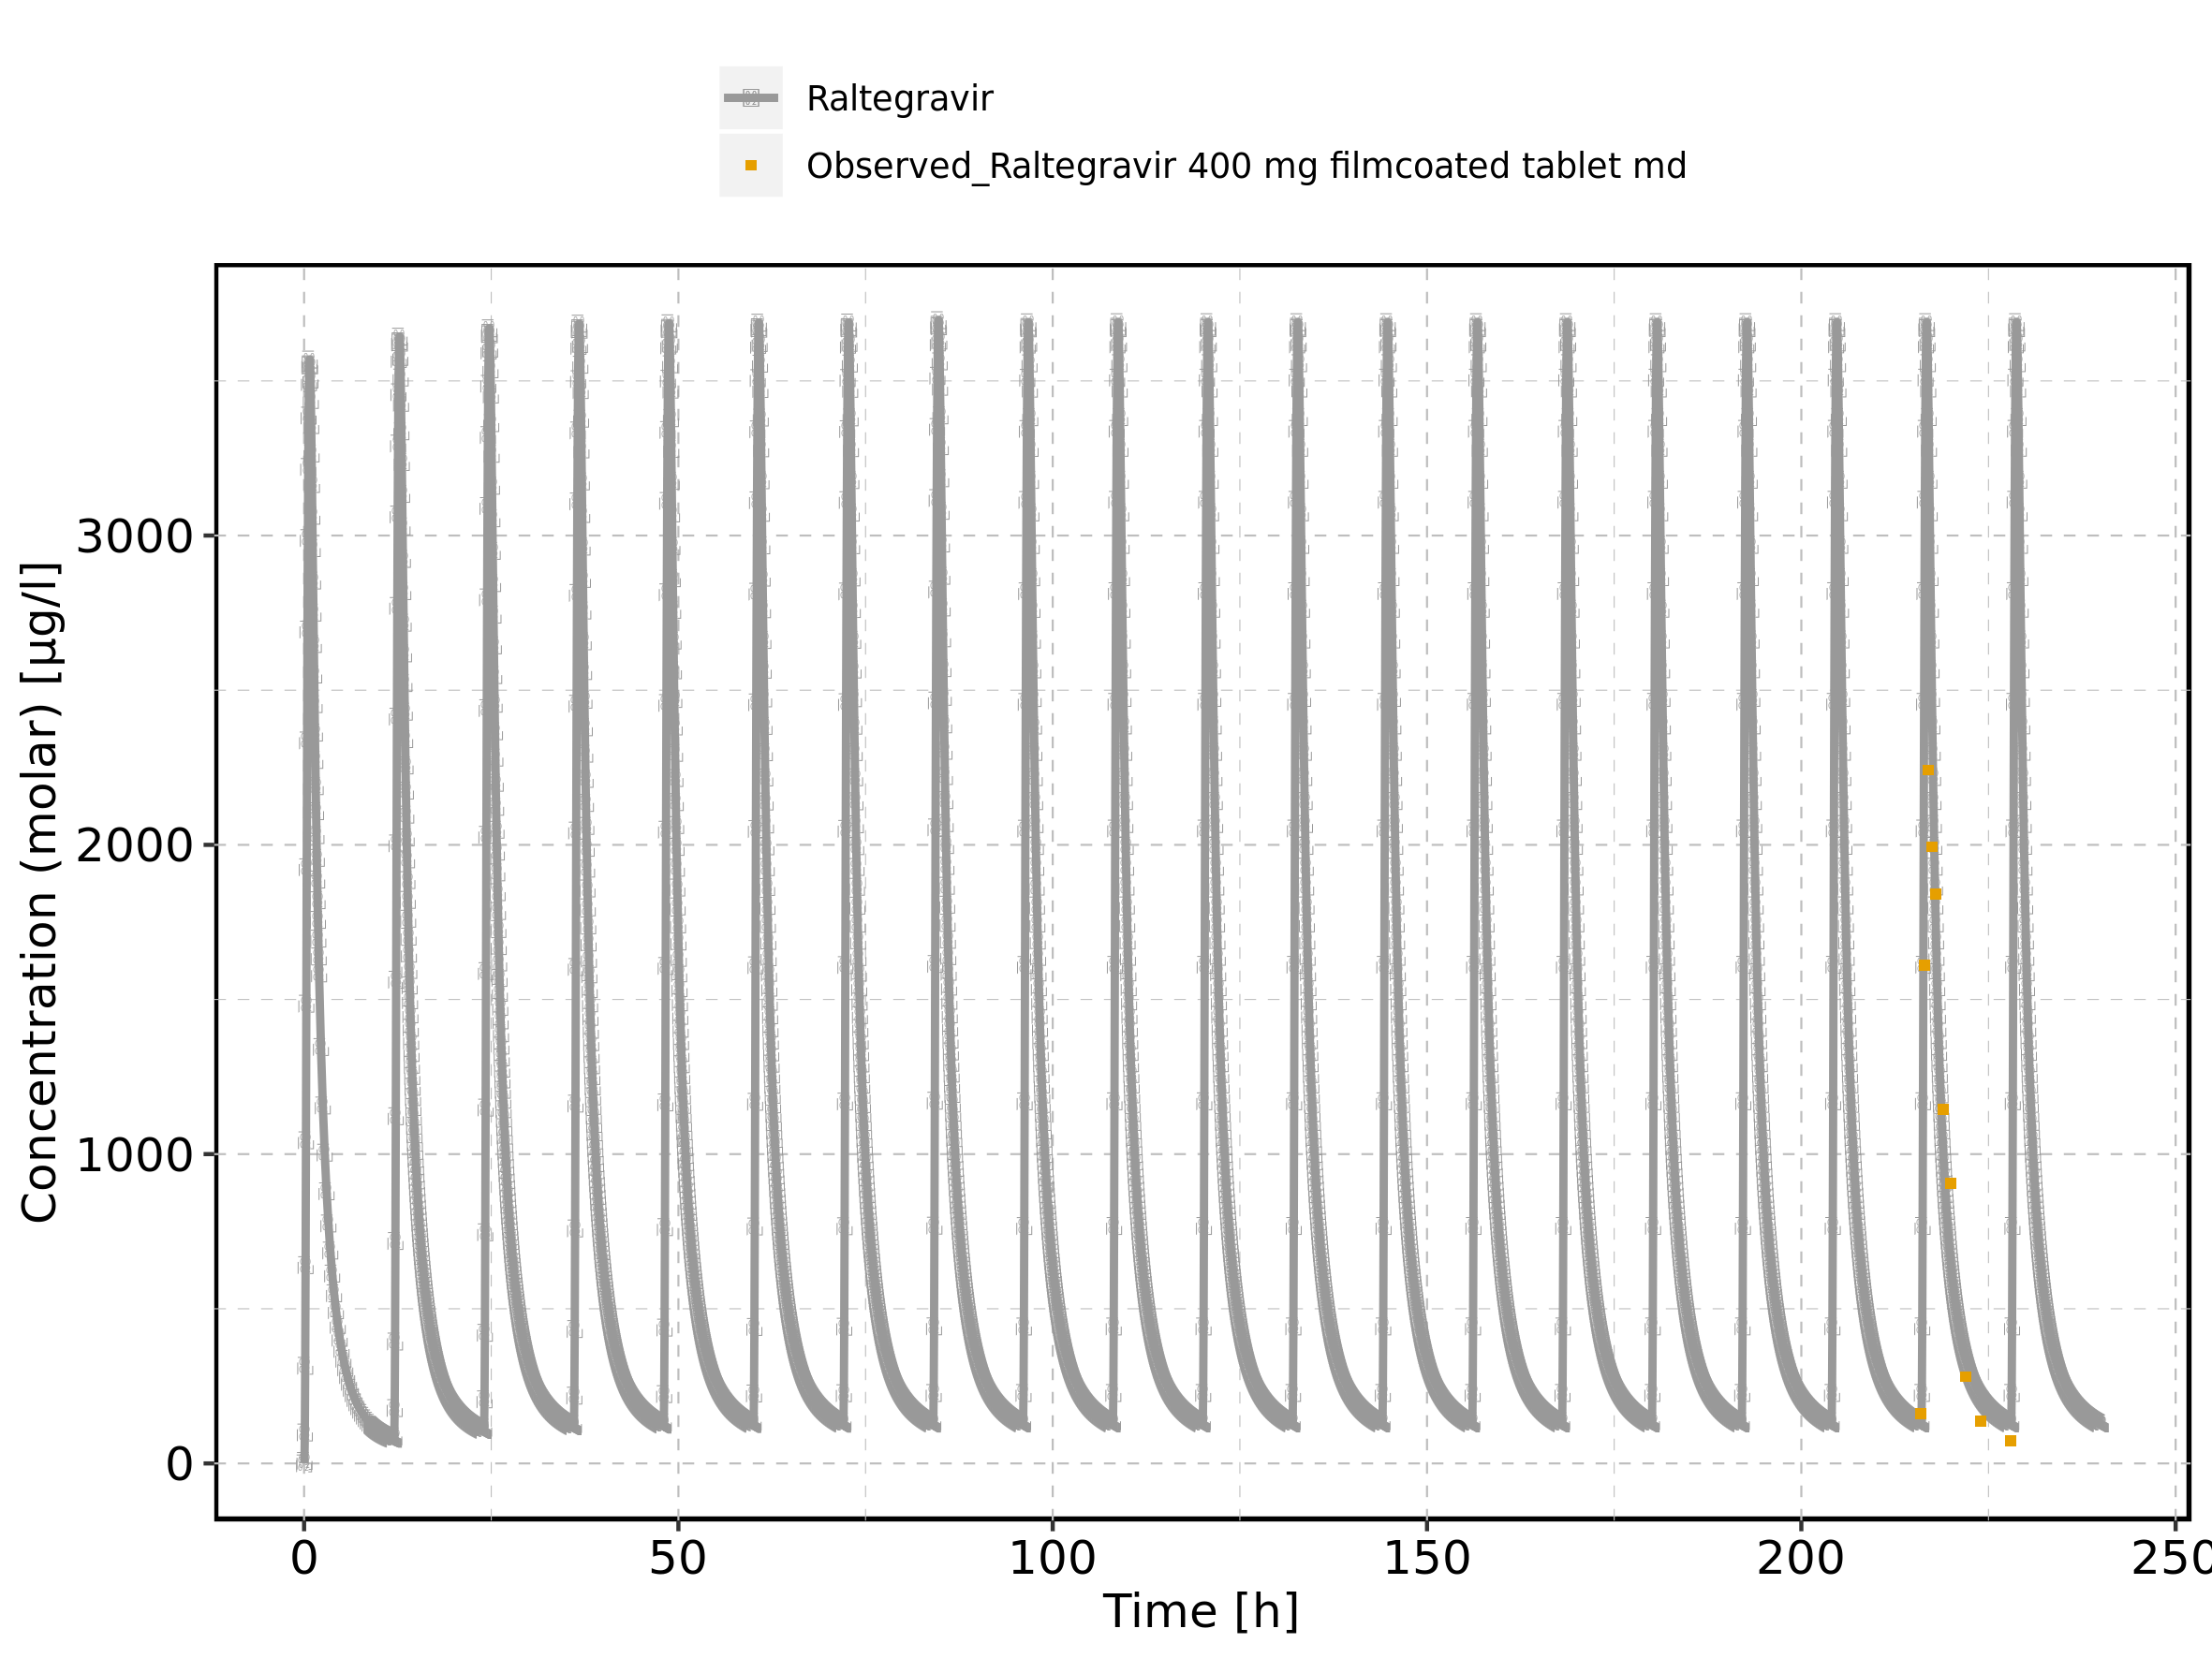

Figure 214: Time profiles of Raltegravir 400 mg filmcoated tablet md for Raltegravir 400 mg filmcoated tablet md. Data source: Data/Raltegravir_PK.txt. Time profiles are plotted in a logarithmic scale.

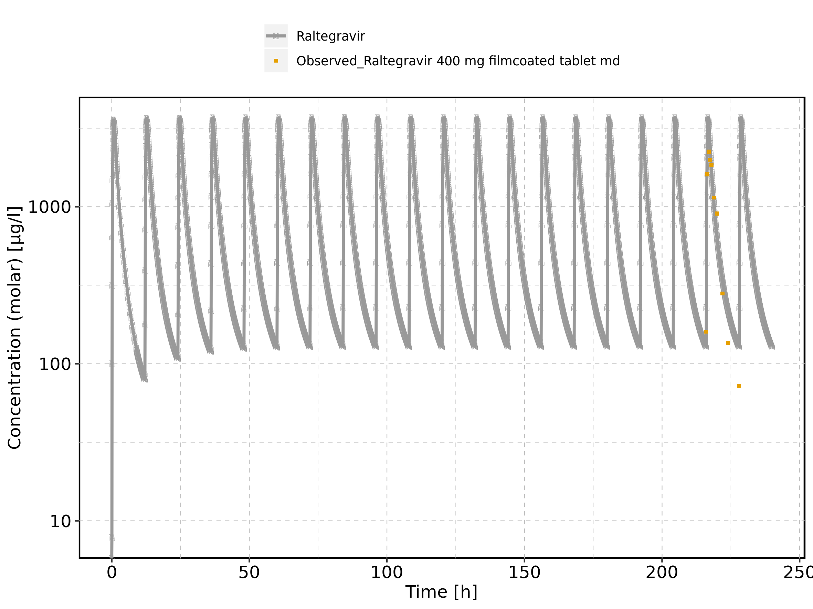

Figure 215: Predicted vs observed of Raltegravir 400 mg filmcoated tablet md for Raltegravir 400 mg filmcoated tablet md. Data source: Data/Raltegravir_PK.txt. Predictions and observations are plotted in a linear scale.

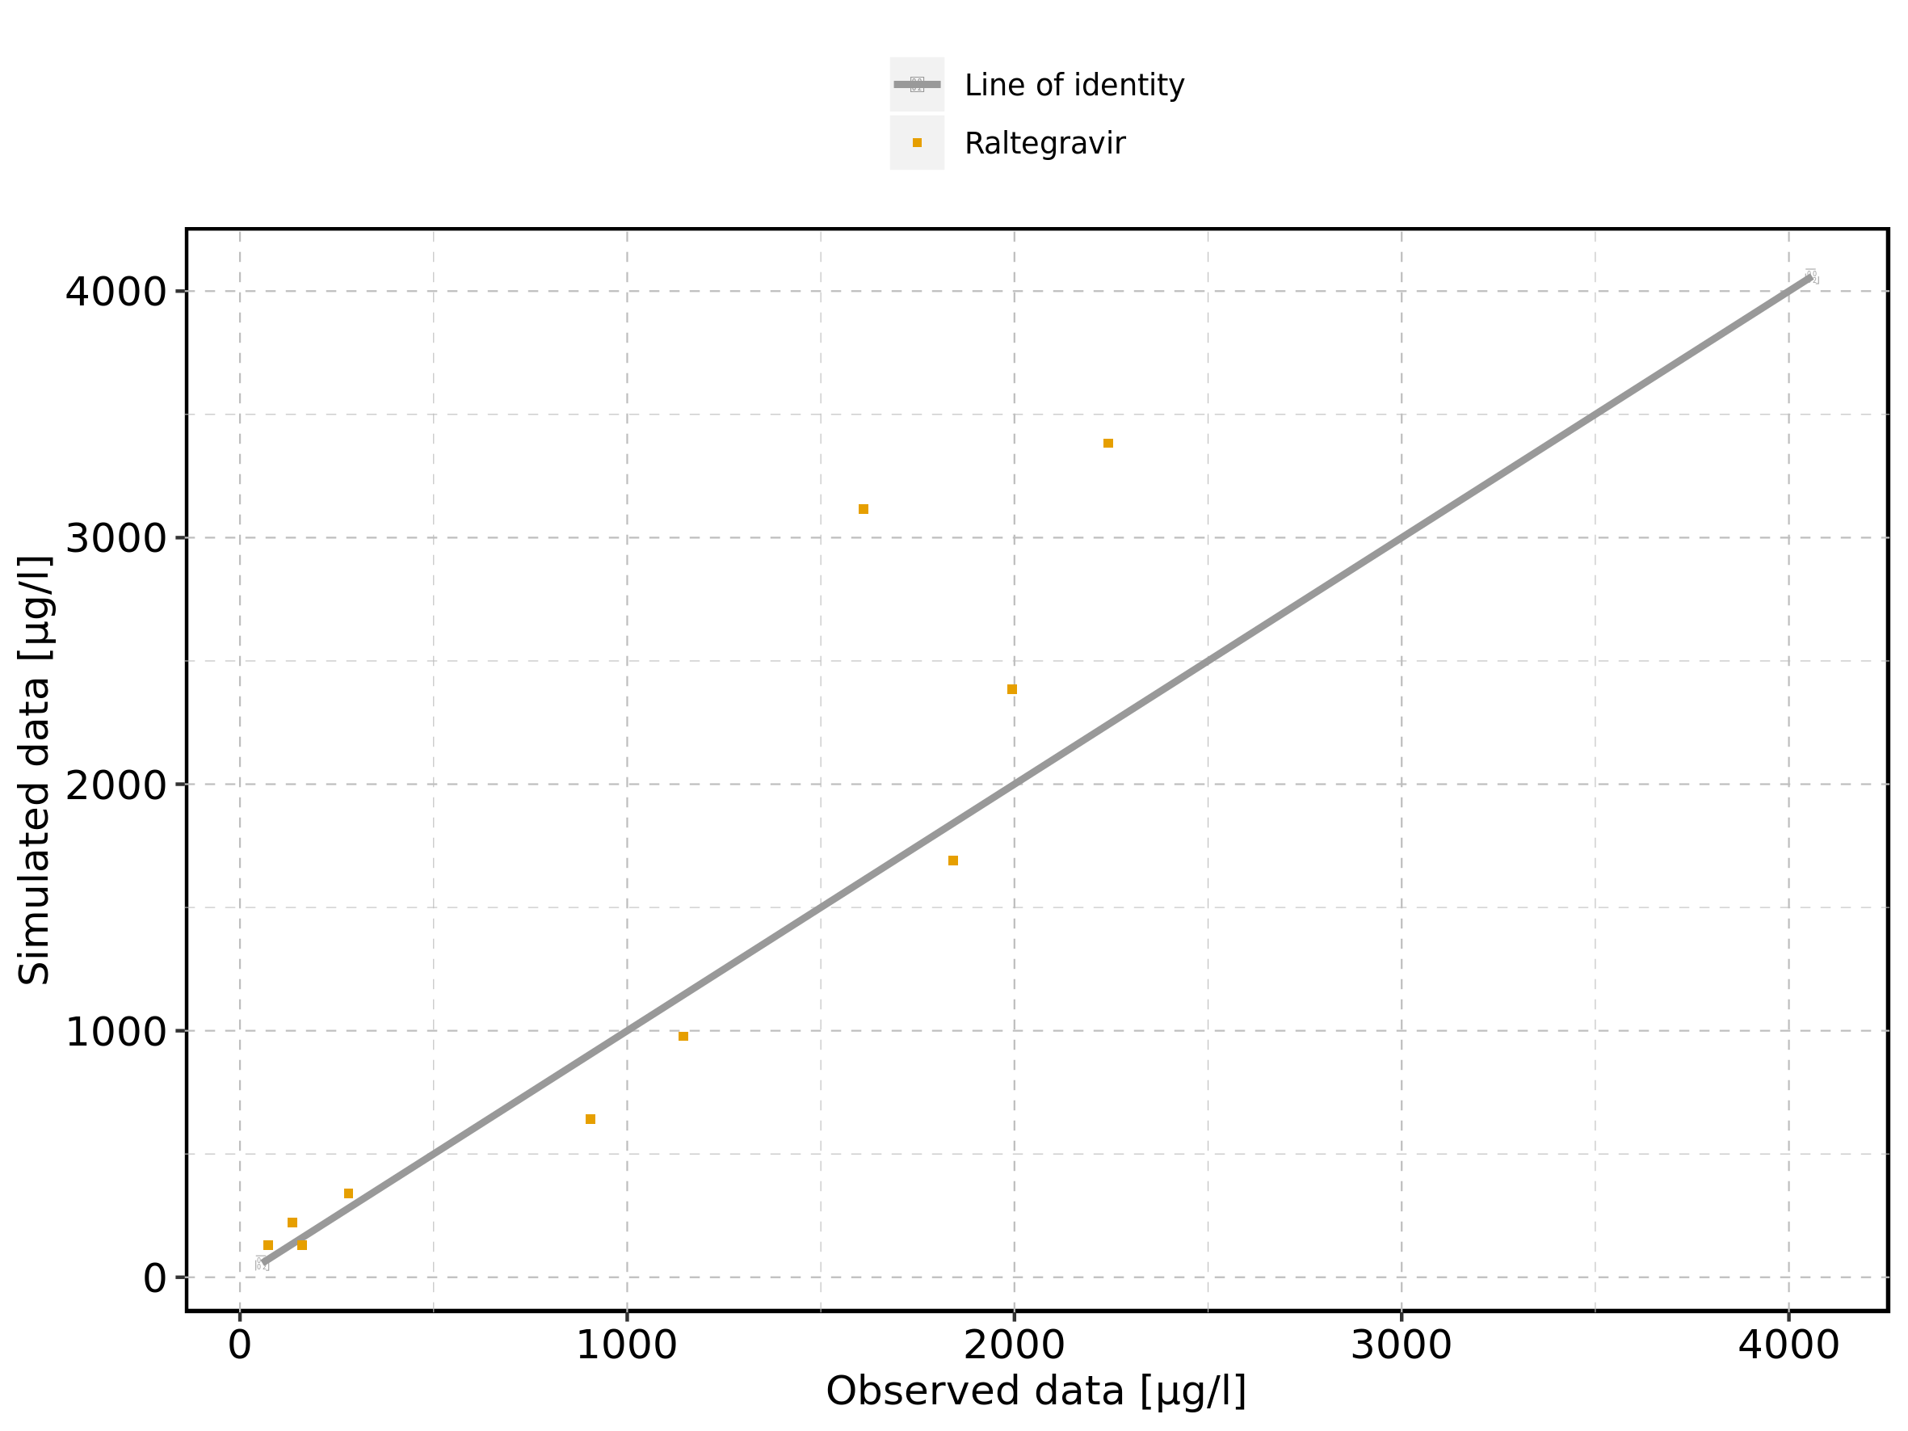

Figure 216: Predicted vs observed of Raltegravir 400 mg filmcoated tablet md for Raltegravir 400 mg filmcoated tablet md. Data source: Data/Raltegravir_PK.txt. Predictions and observations are plotted in a logarithmic scale.

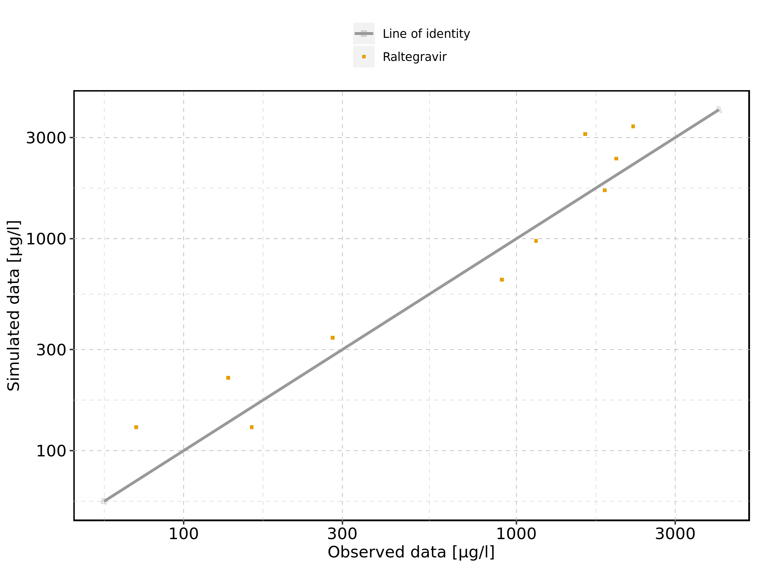

Figure 217: Logarithmic residuals vs predicted values of Raltegravir 400 mg filmcoated tablet md for Raltegravir 400 mg filmcoated tablet md. Data source: Data/Raltegravir_PK.txt.

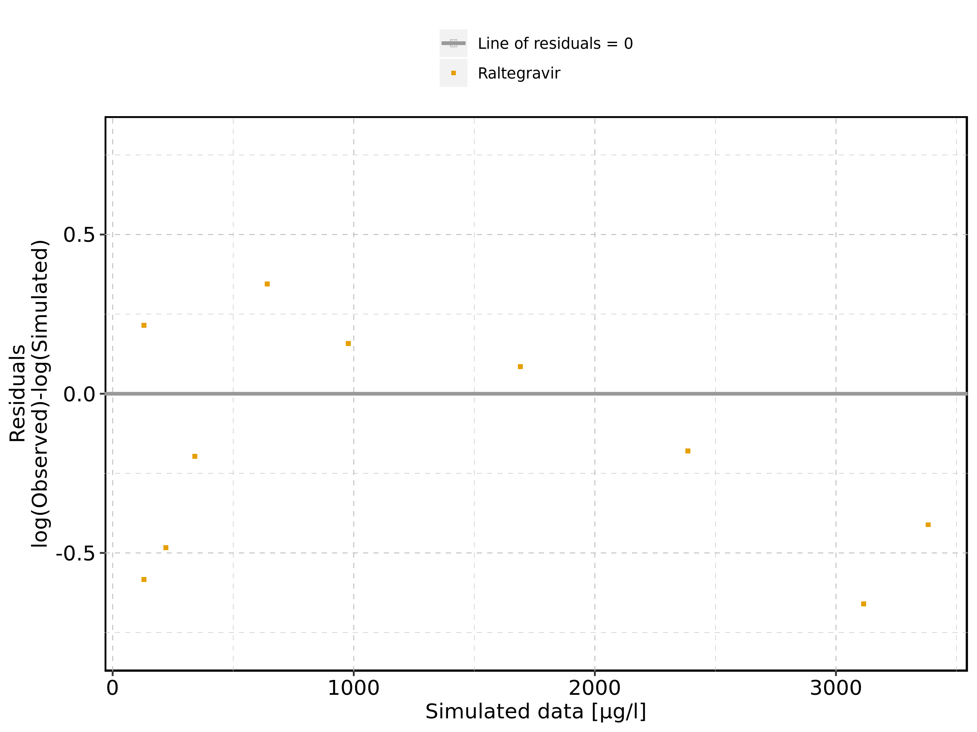

Figure 218: Logarithmic residuals vs time of Raltegravir 400 mg filmcoated tablet md for Raltegravir 400 mg filmcoated tablet md. Data source: Data/Raltegravir_PK.txt.

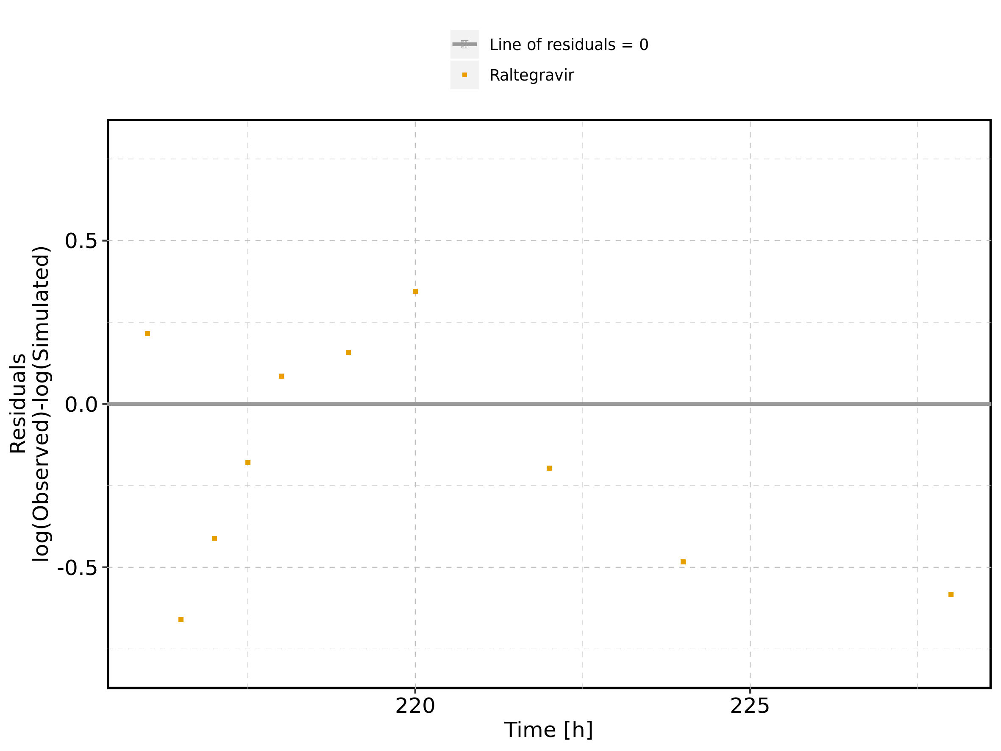

Figure 219: Logarithmic residuals distribution of Raltegravir 400 mg filmcoated tablet md for Raltegravir 400 mg filmcoated tablet md. Data source: Data/Raltegravir_PK.txt.

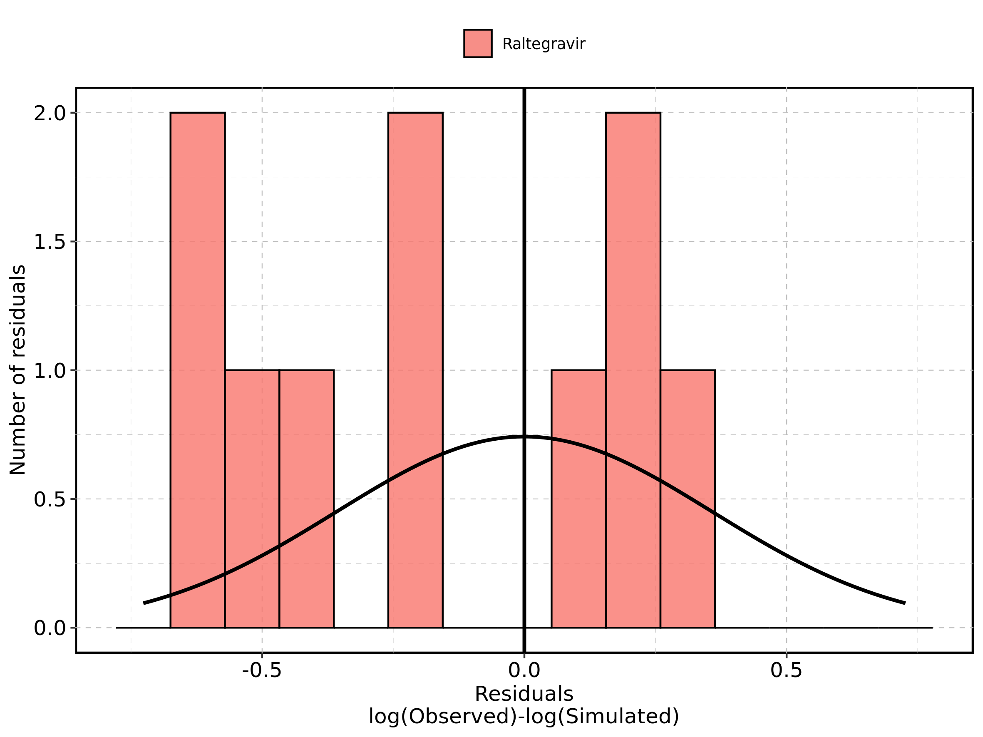

Figure 220: Logarithmic residuals of Raltegravir 400 mg filmcoated tablet md for Raltegravir 400 mg filmcoated tablet md as quantile-quantile plot. Data source: Data/Raltegravir_PK.txt.

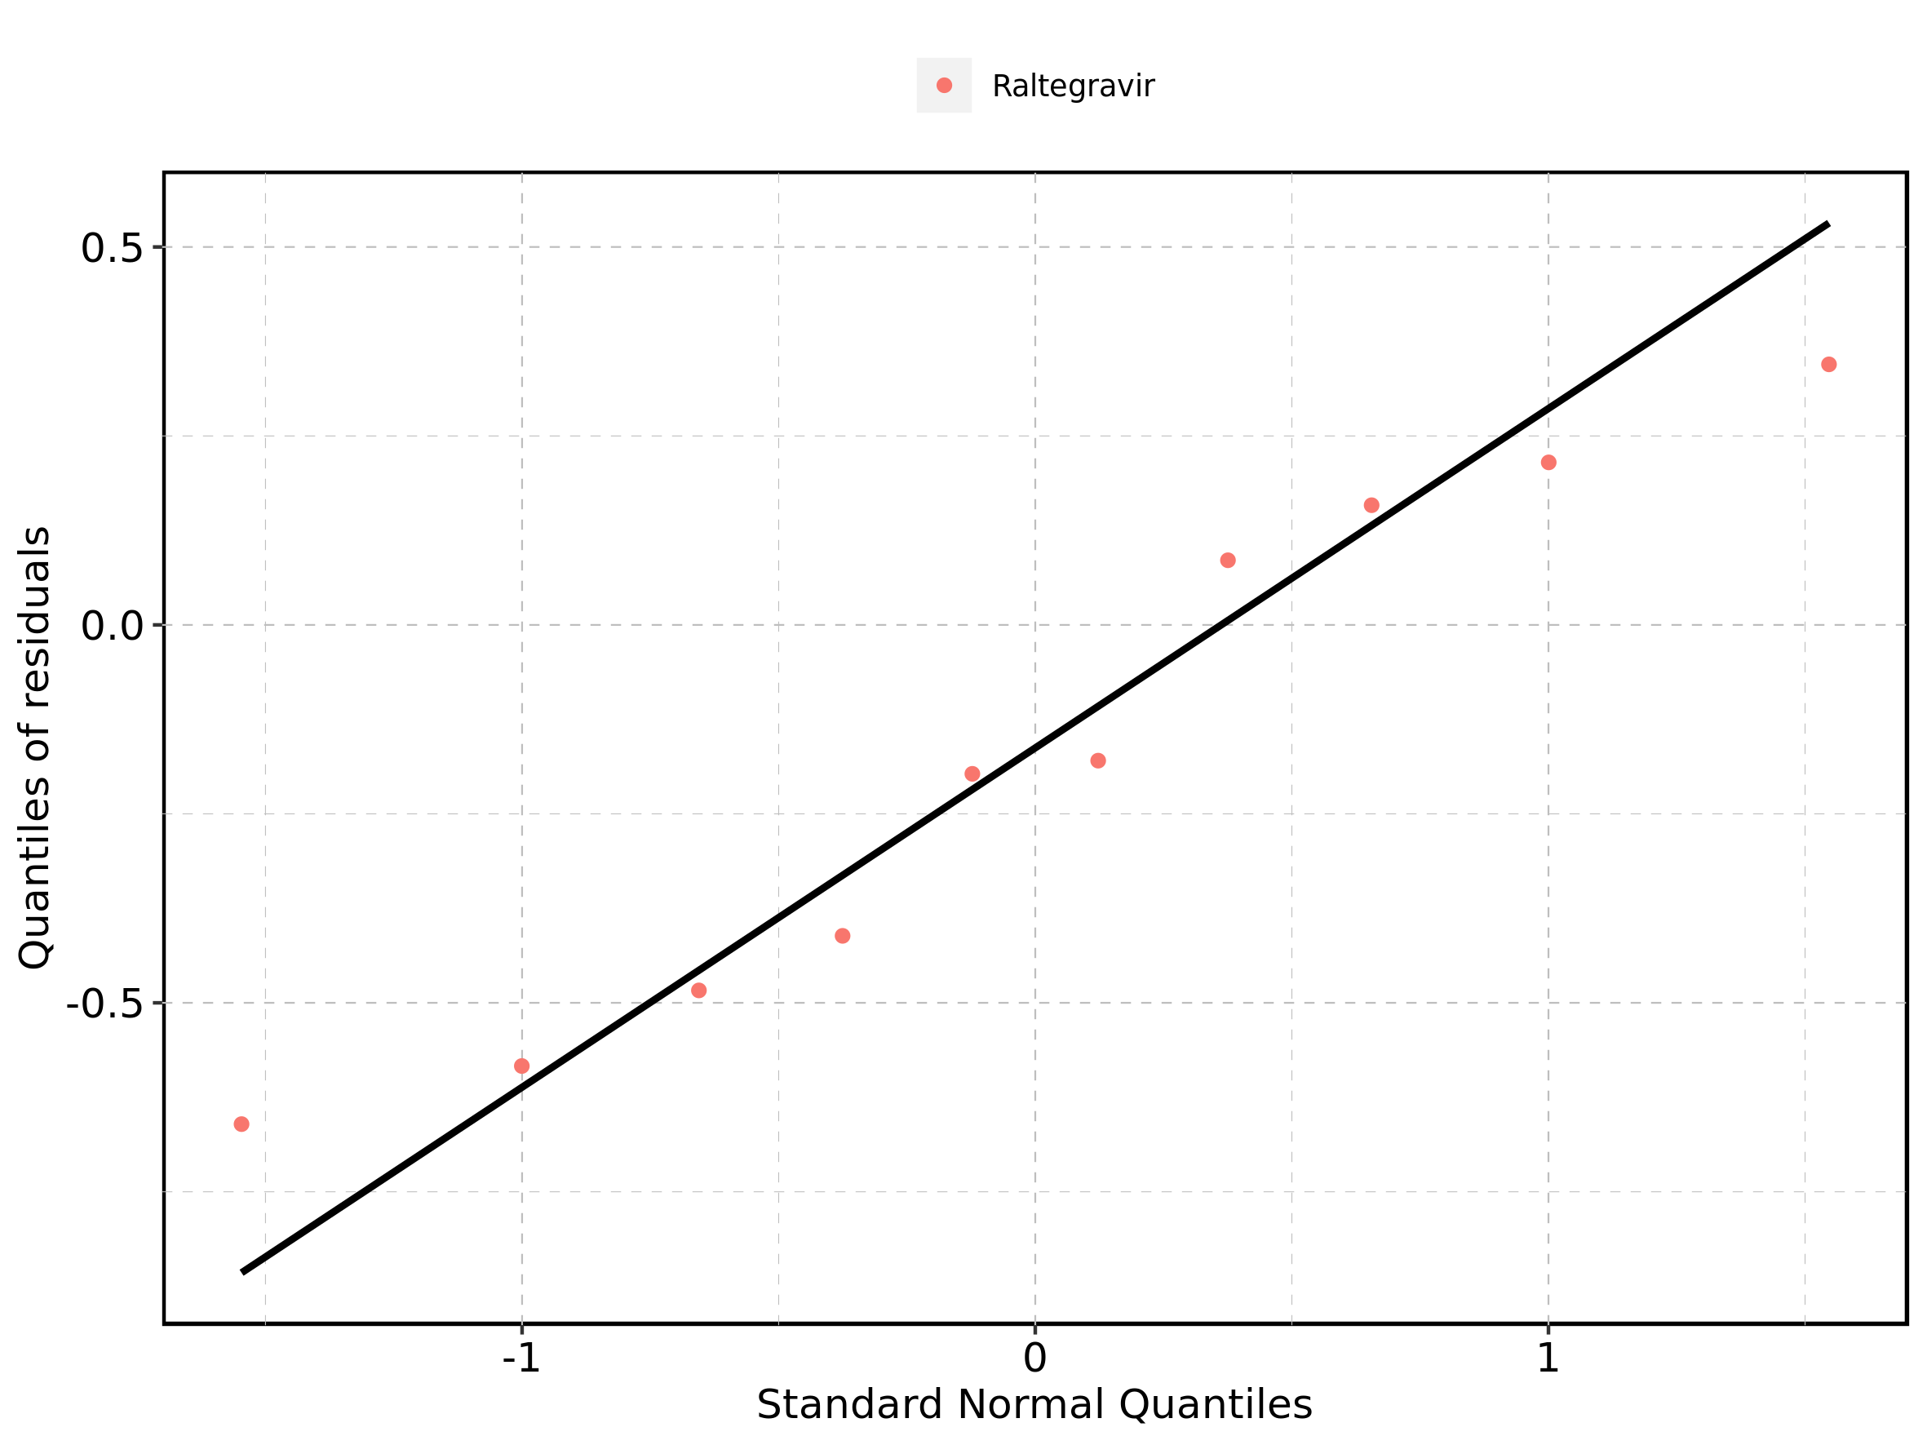

### 4.13.2. For first application range

Figure 221: Time profiles of Raltegravir 400 mg filmcoated tablet md for Raltegravir 400 mg filmcoated tablet md. Data source: Data/Raltegravir_PK.txt. Time profiles are plotted in a linear scale.

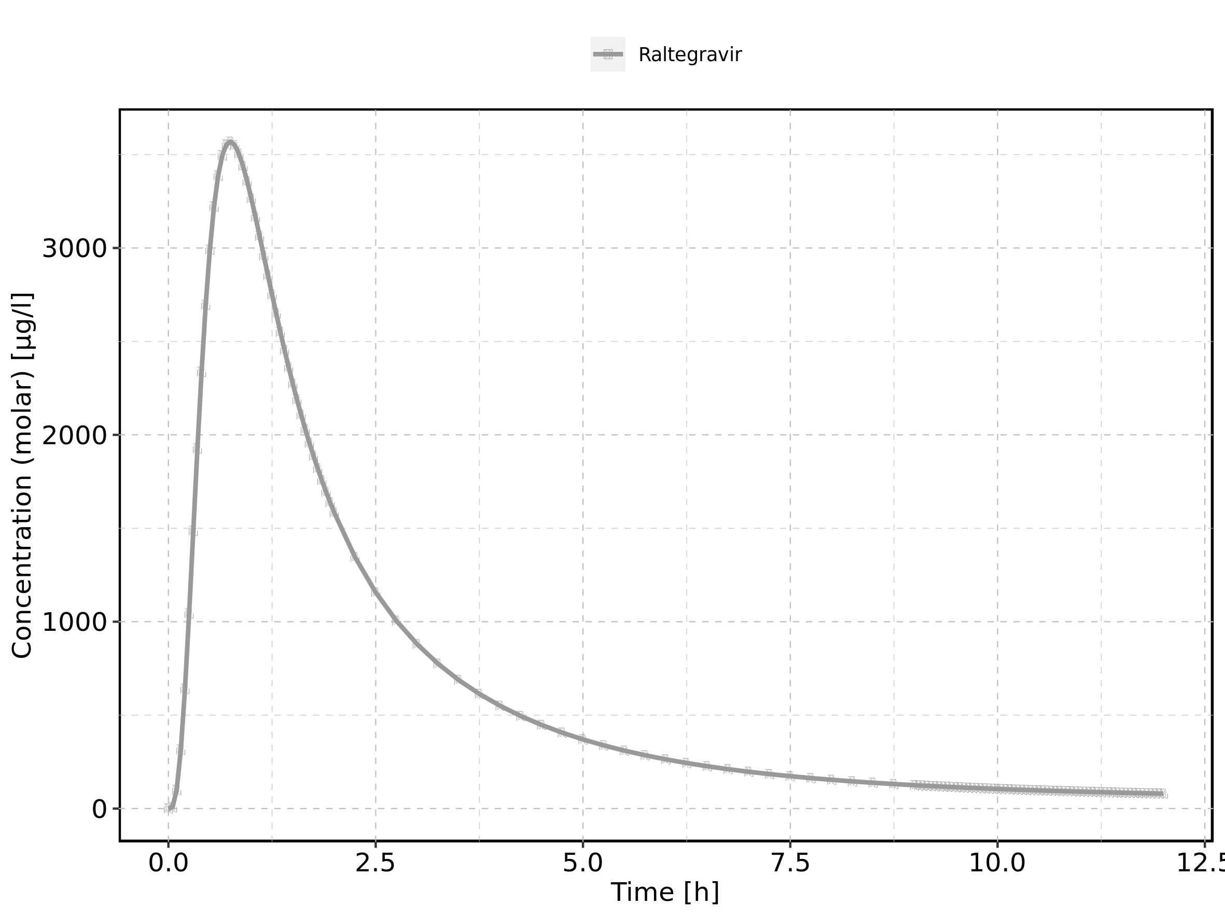

Figure 222: Time profiles of Raltegravir 400 mg filmcoated tablet md for Raltegravir 400 mg filmcoated tablet md. Data source: Data/Raltegravir_PK.txt. Time profiles are plotted in a logarithmic scale.

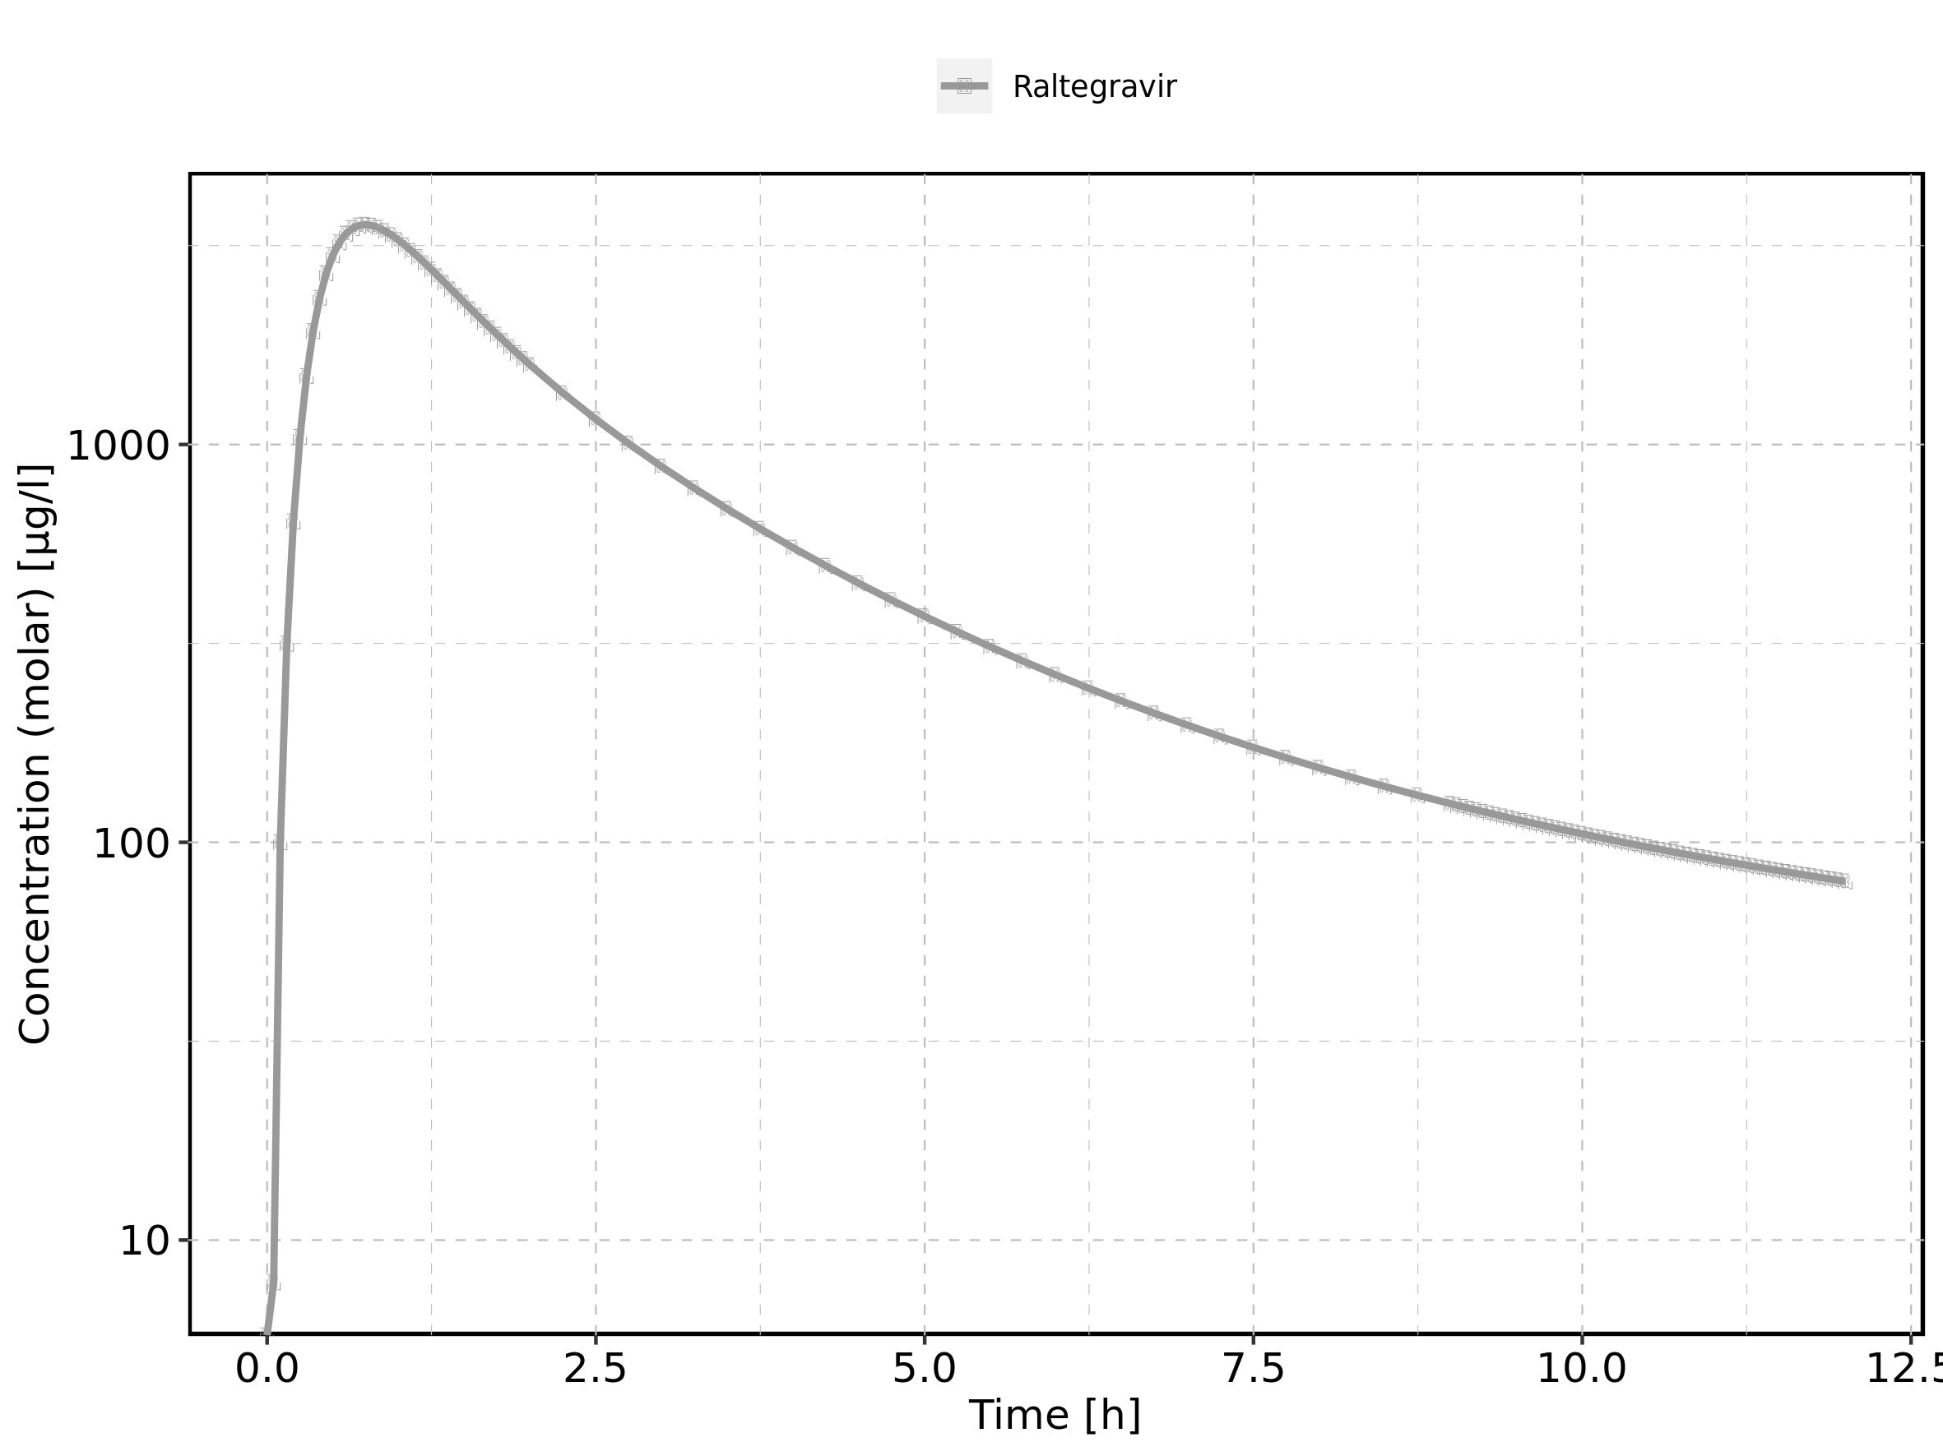

### 4.13.3. For last application range

Figure 223: Time profiles of Raltegravir 400 mg filmcoated tablet md for Raltegravir 400 mg filmcoated tablet md. Data source: Data/Raltegravir_PK.txt. Time profiles are plotted in a linear scale.

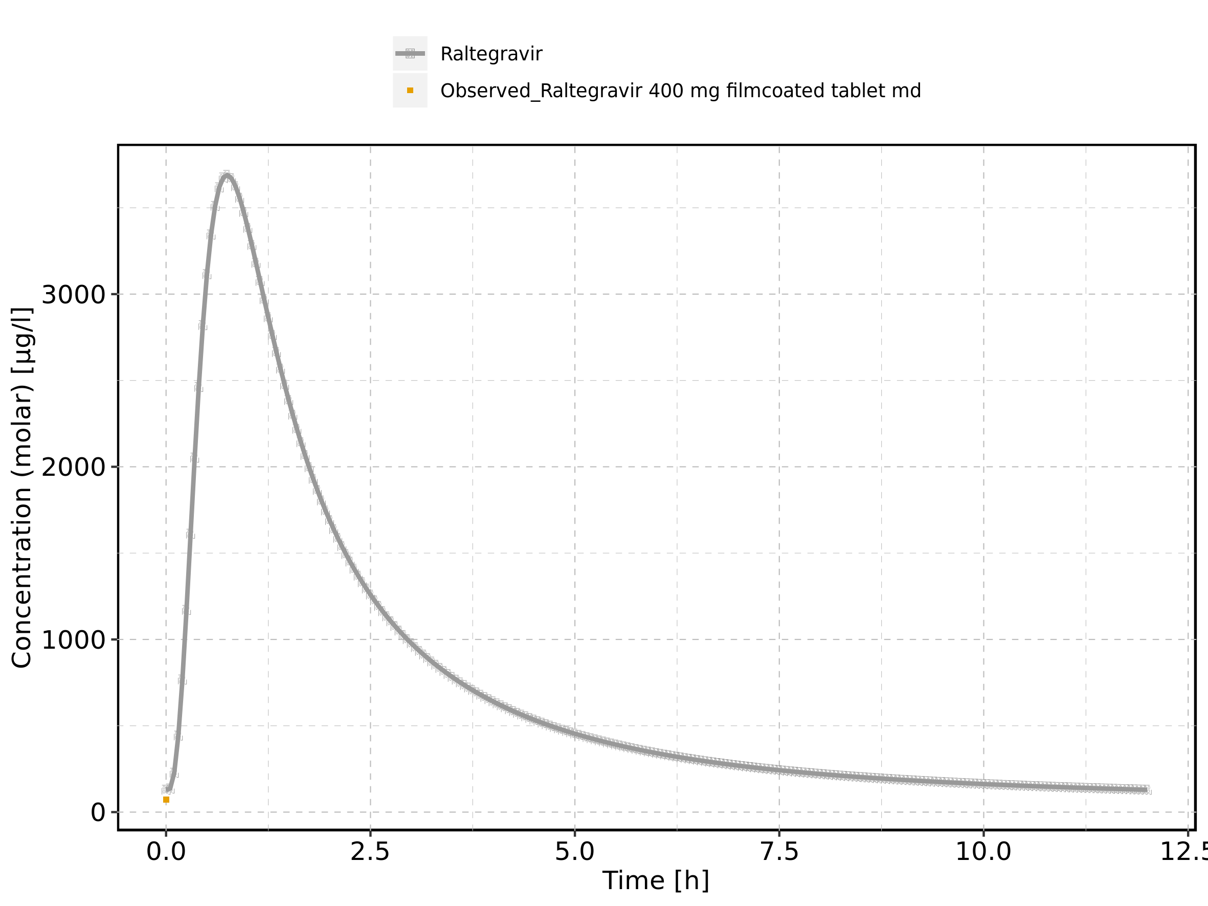

Figure 224: Time profiles of Raltegravir 400 mg filmcoated tablet md for Raltegravir 400 mg filmcoated tablet md. Data source: Data/Raltegravir_PK.txt. Time profiles are plotted in a logarithmic scale.

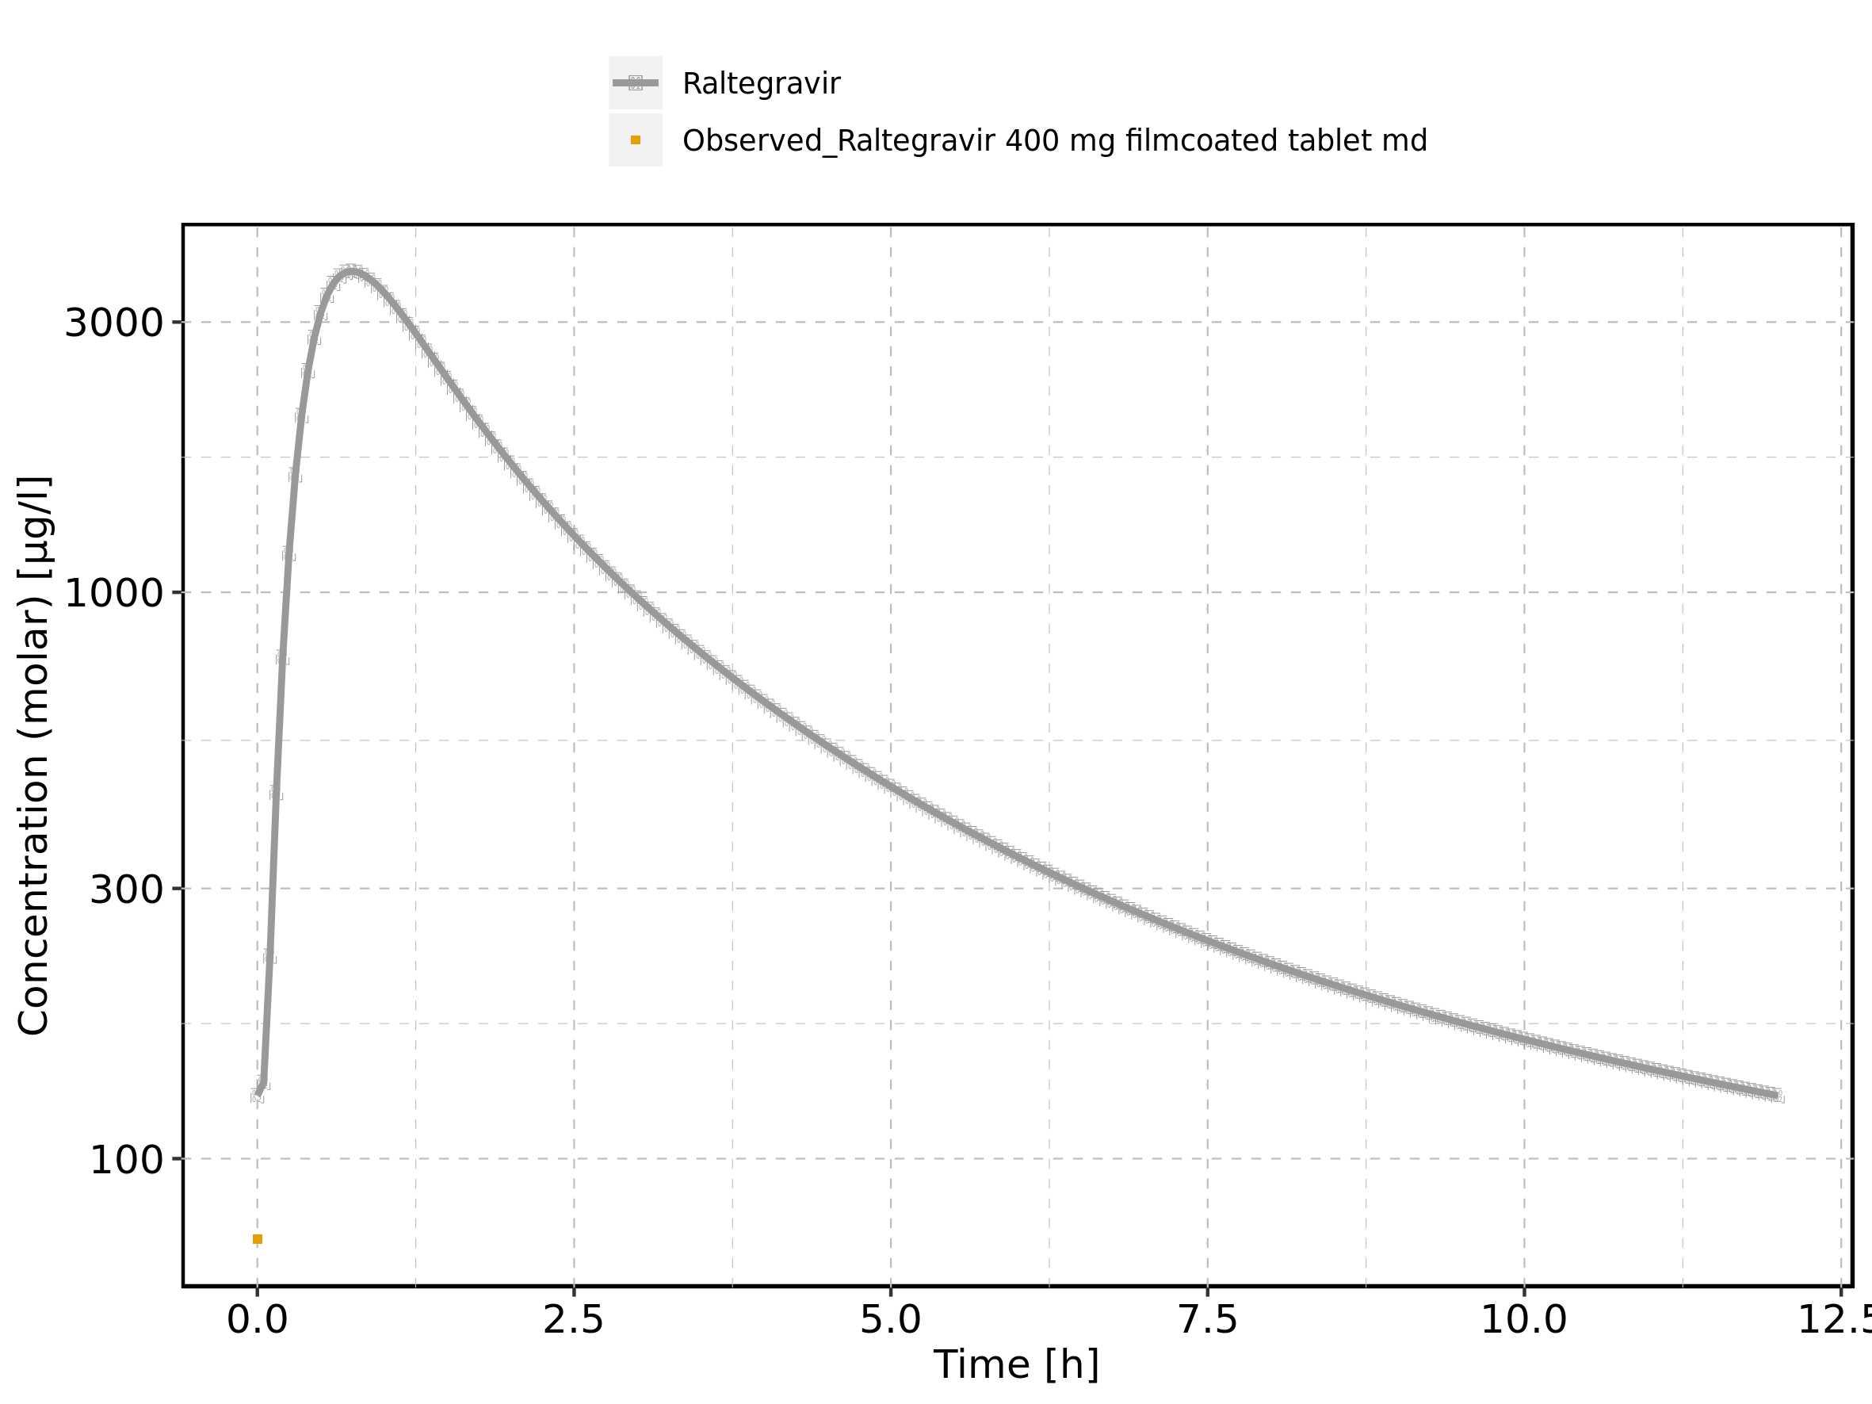

Figure 225: Predicted vs observed of Raltegravir 400 mg filmcoated tablet md for Raltegravir 400 mg filmcoated tablet md. Data source: Data/Raltegravir_PK.txt. Predictions and observations are plotted in a linear scale.

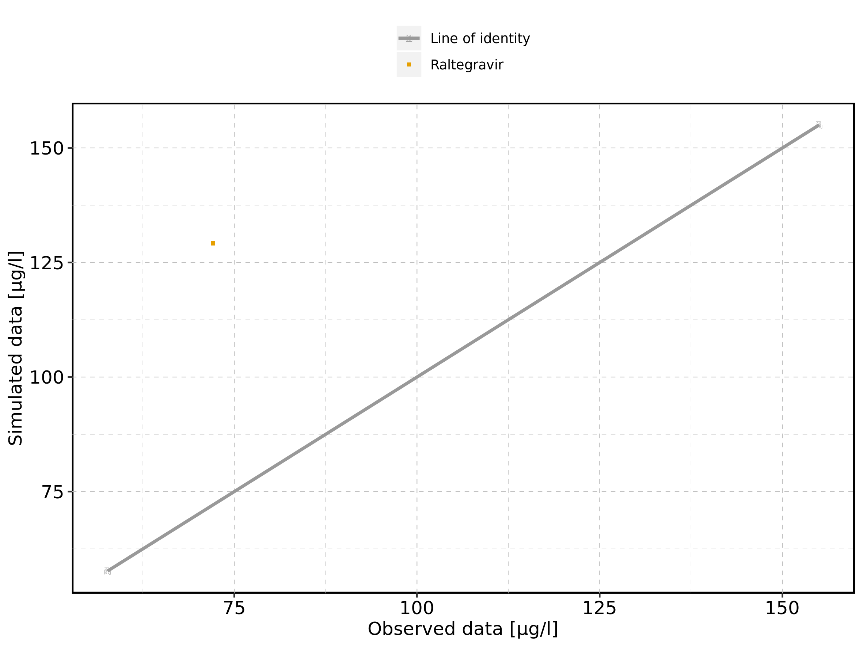

Figure 226: Predicted vs observed of Raltegravir 400 mg filmcoated tablet md for Raltegravir 400 mg filmcoated tablet md. Data source: Data/Raltegravir_PK.txt. Predictions and observations are plotted in a logarithmic scale.

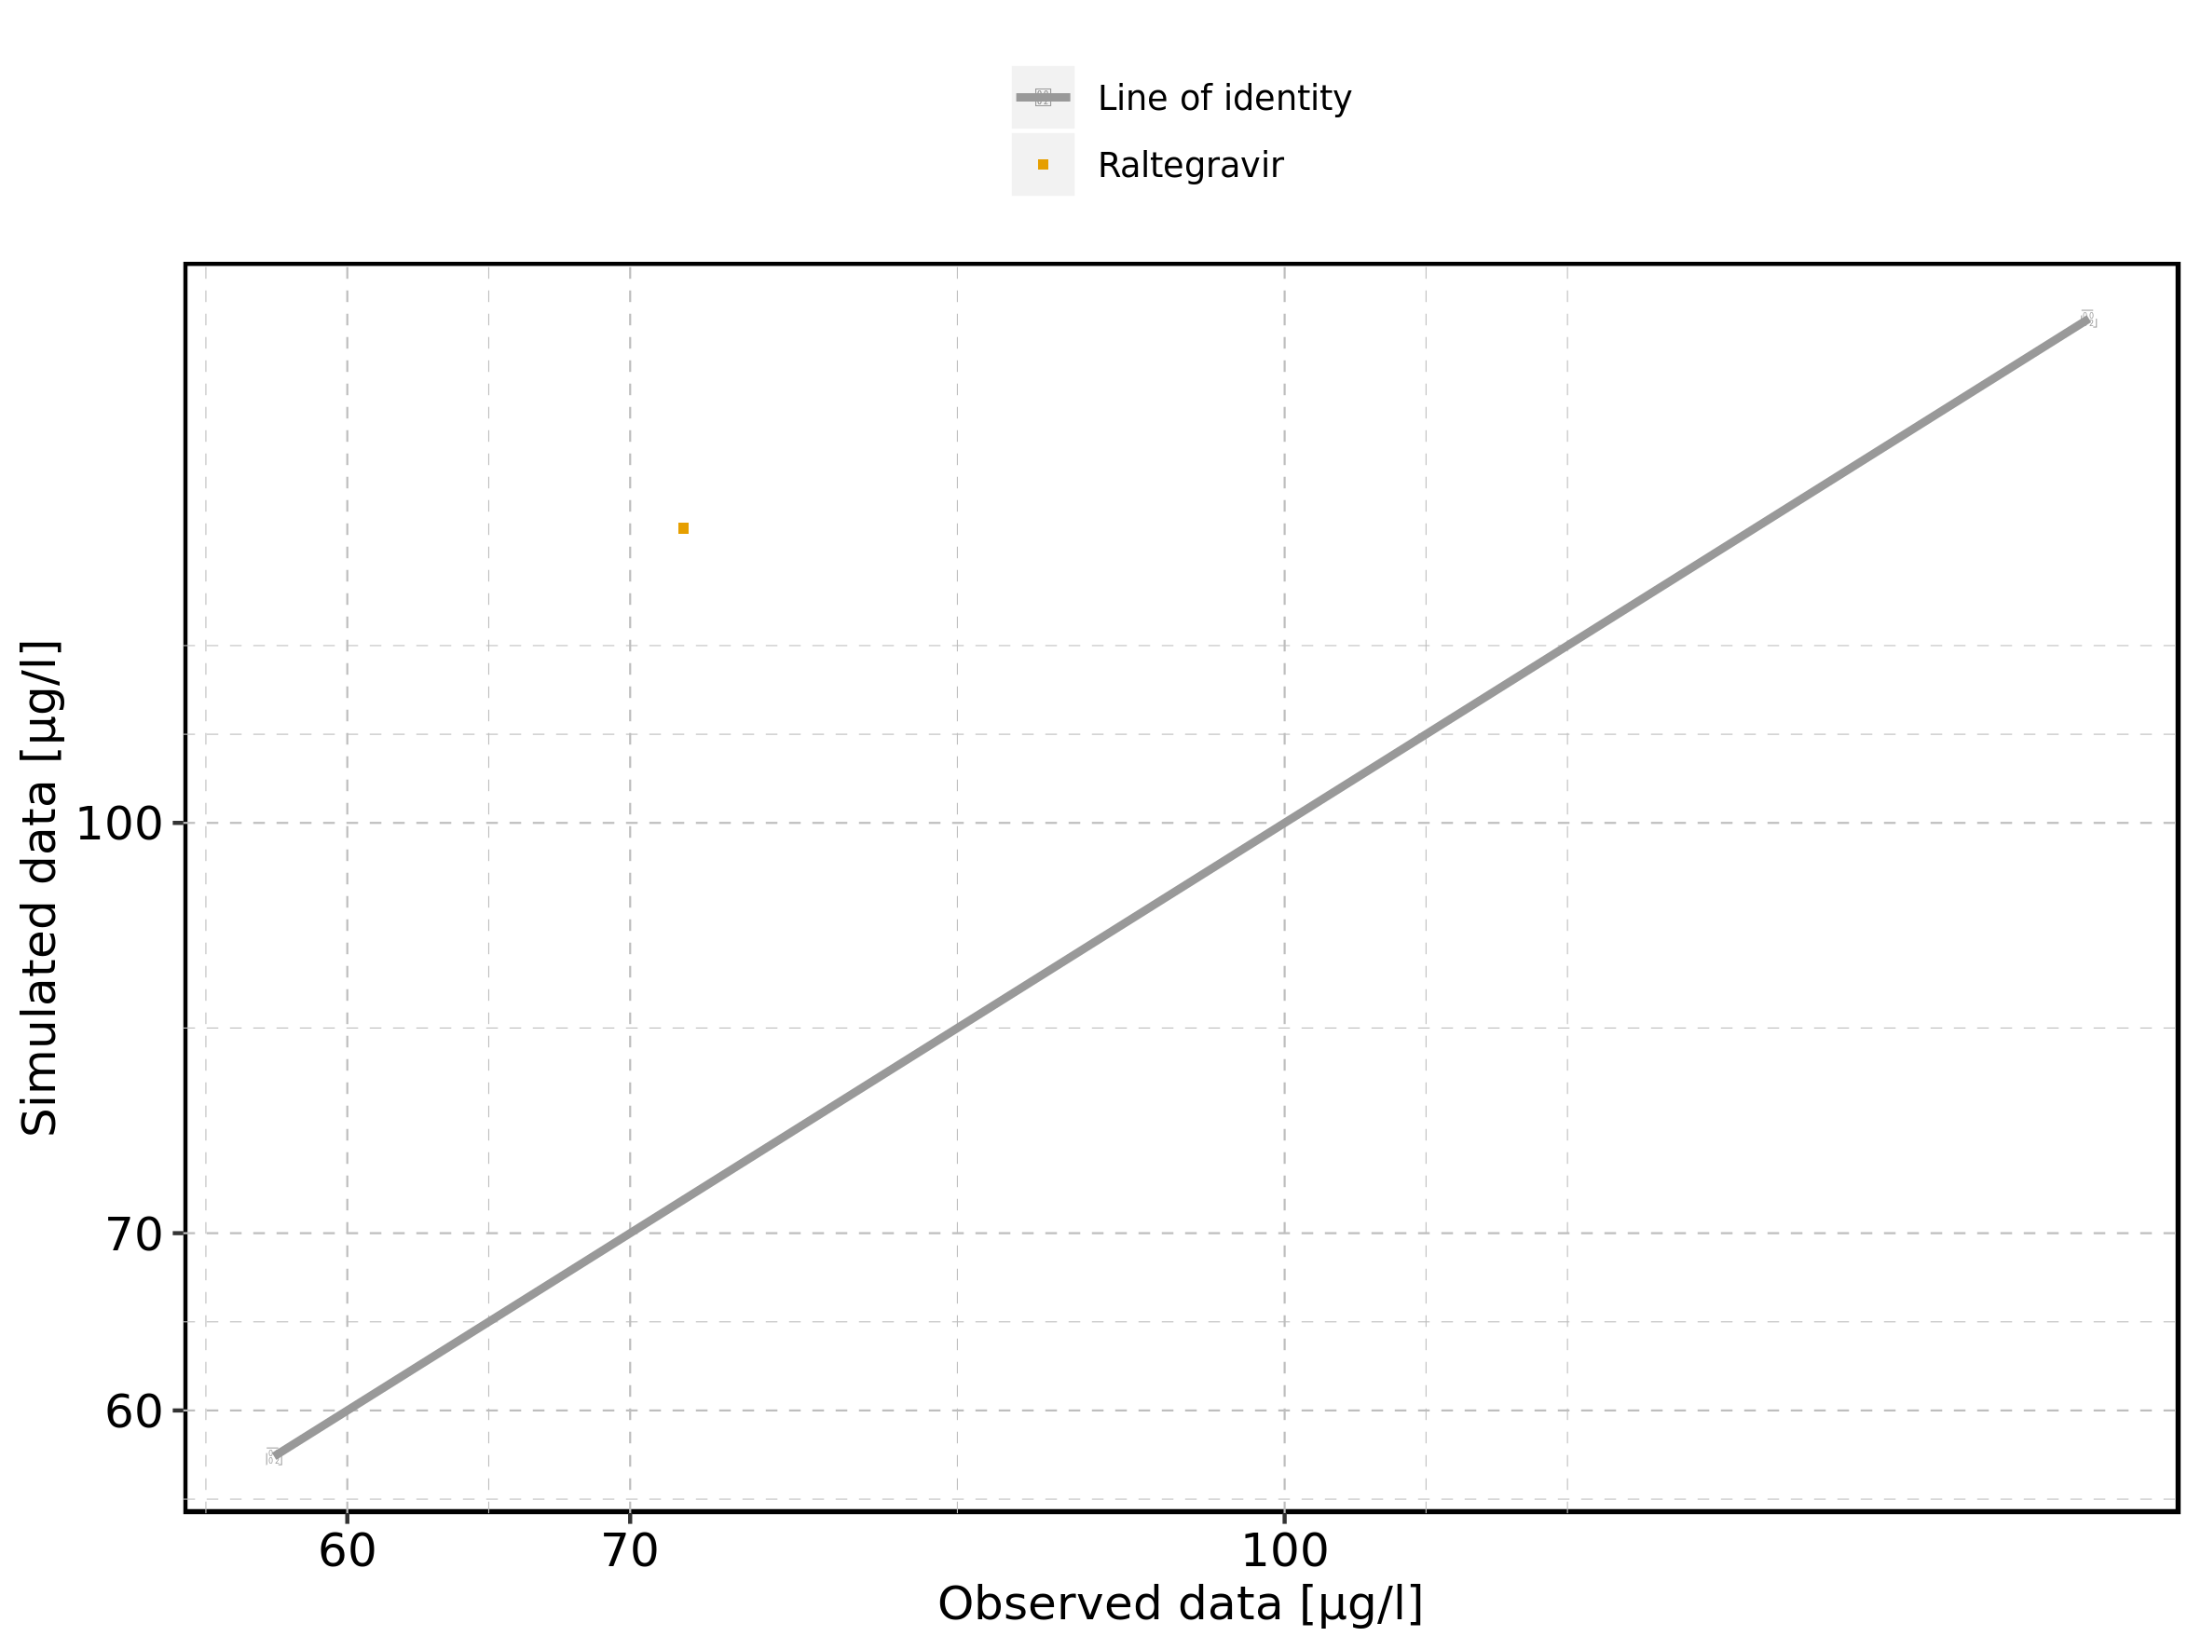

Figure 227: Logarithmic residuals vs predicted values of Raltegravir 400 mg filmcoated tablet md for Raltegravir 400 mg filmcoated tablet md. Data source: Data/Raltegravir_PK.txt.

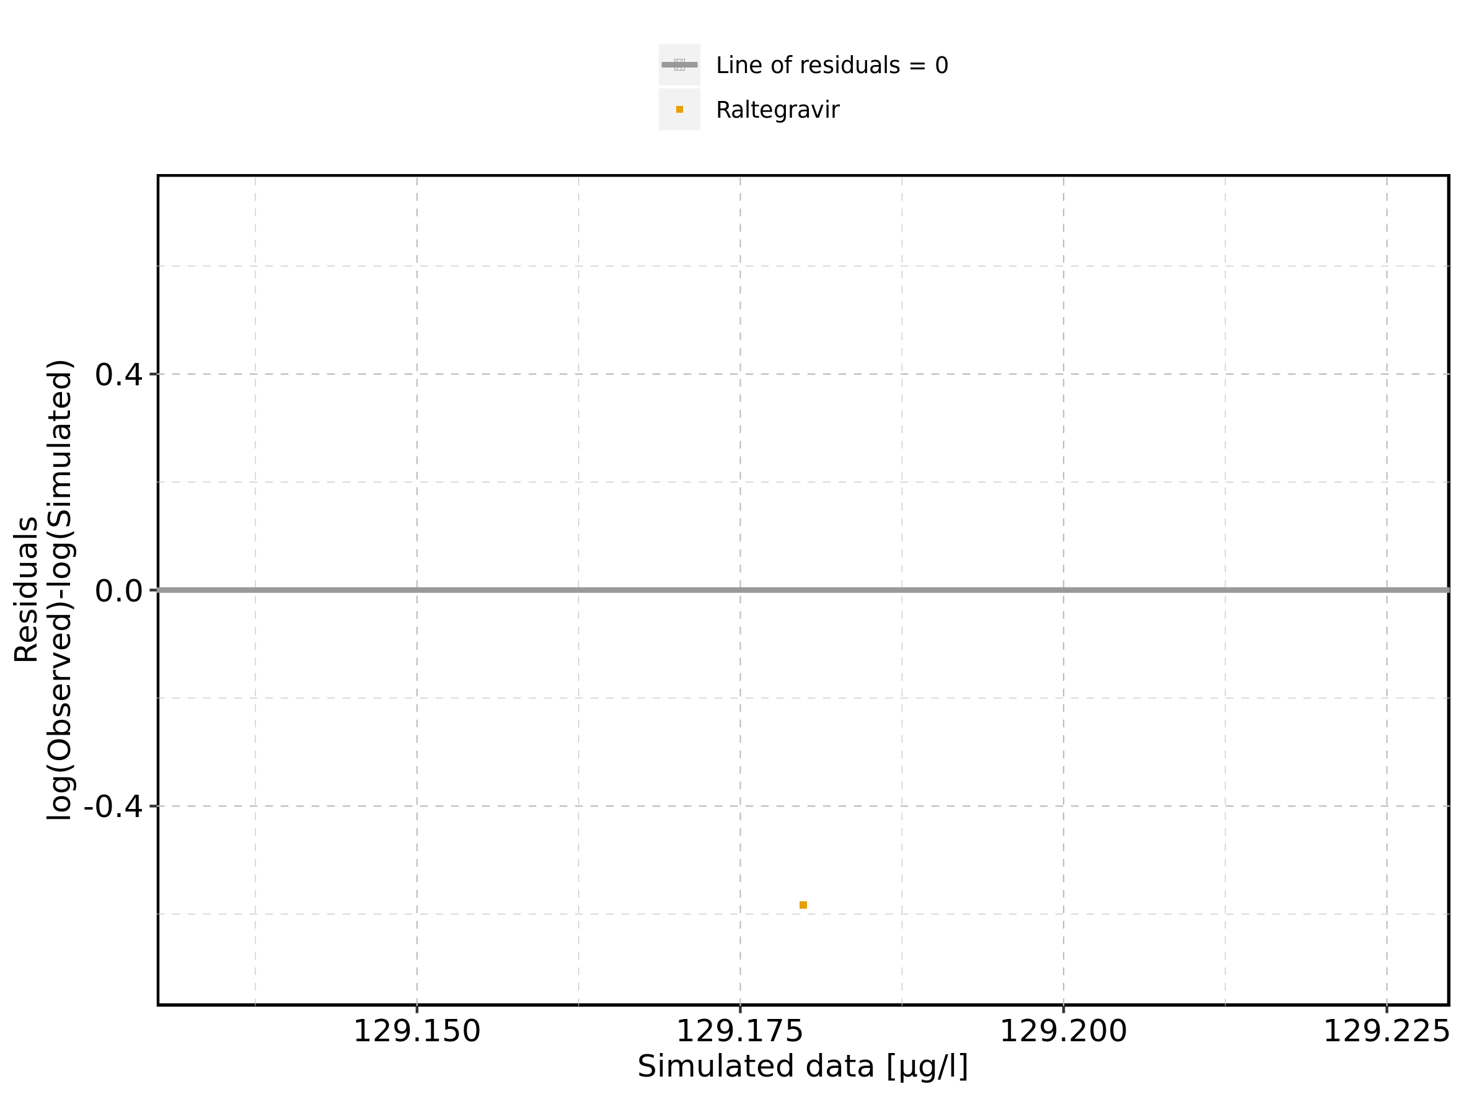

Figure 228: Logarithmic residuals vs time of Raltegravir 400 mg filmcoated tablet md for Raltegravir 400 mg filmcoated tablet md. Data source: Data/Raltegravir_PK.txt.

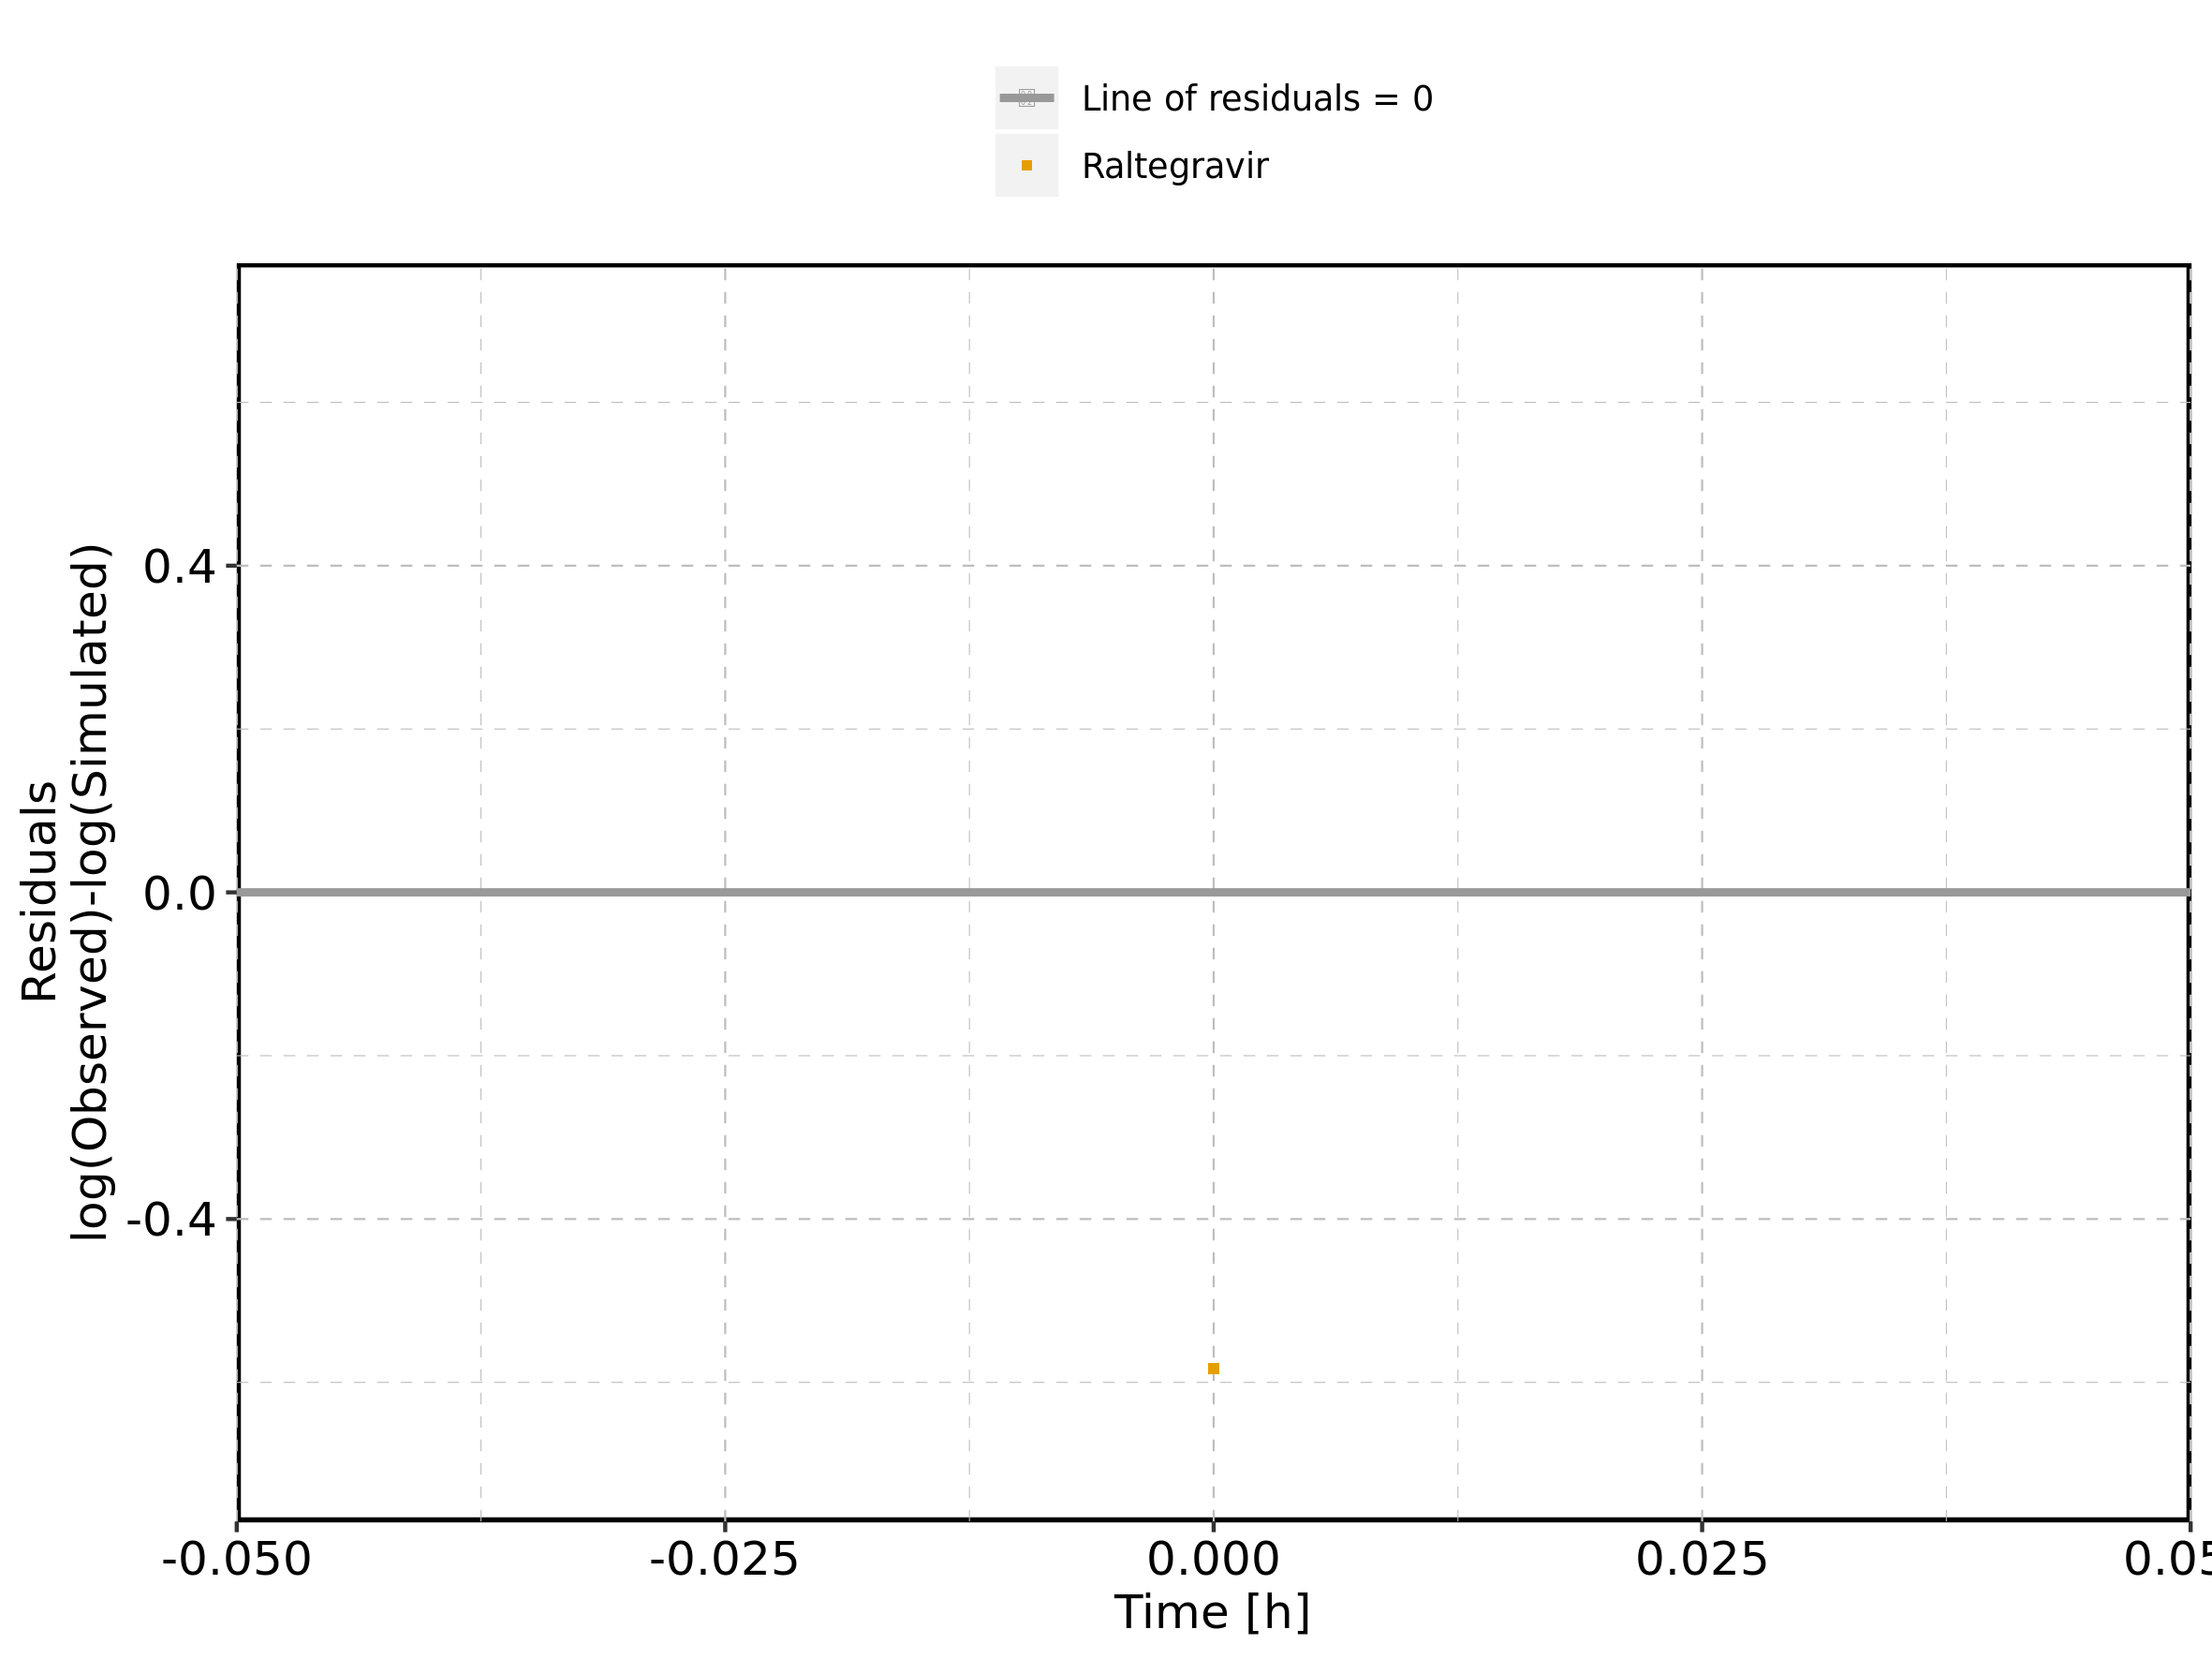

Figure 229: Logarithmic residuals distribution of Raltegravir 400 mg filmcoated tablet md for Raltegravir 400 mg filmcoated tablet md. Data source: Data/Raltegravir_PK.txt.

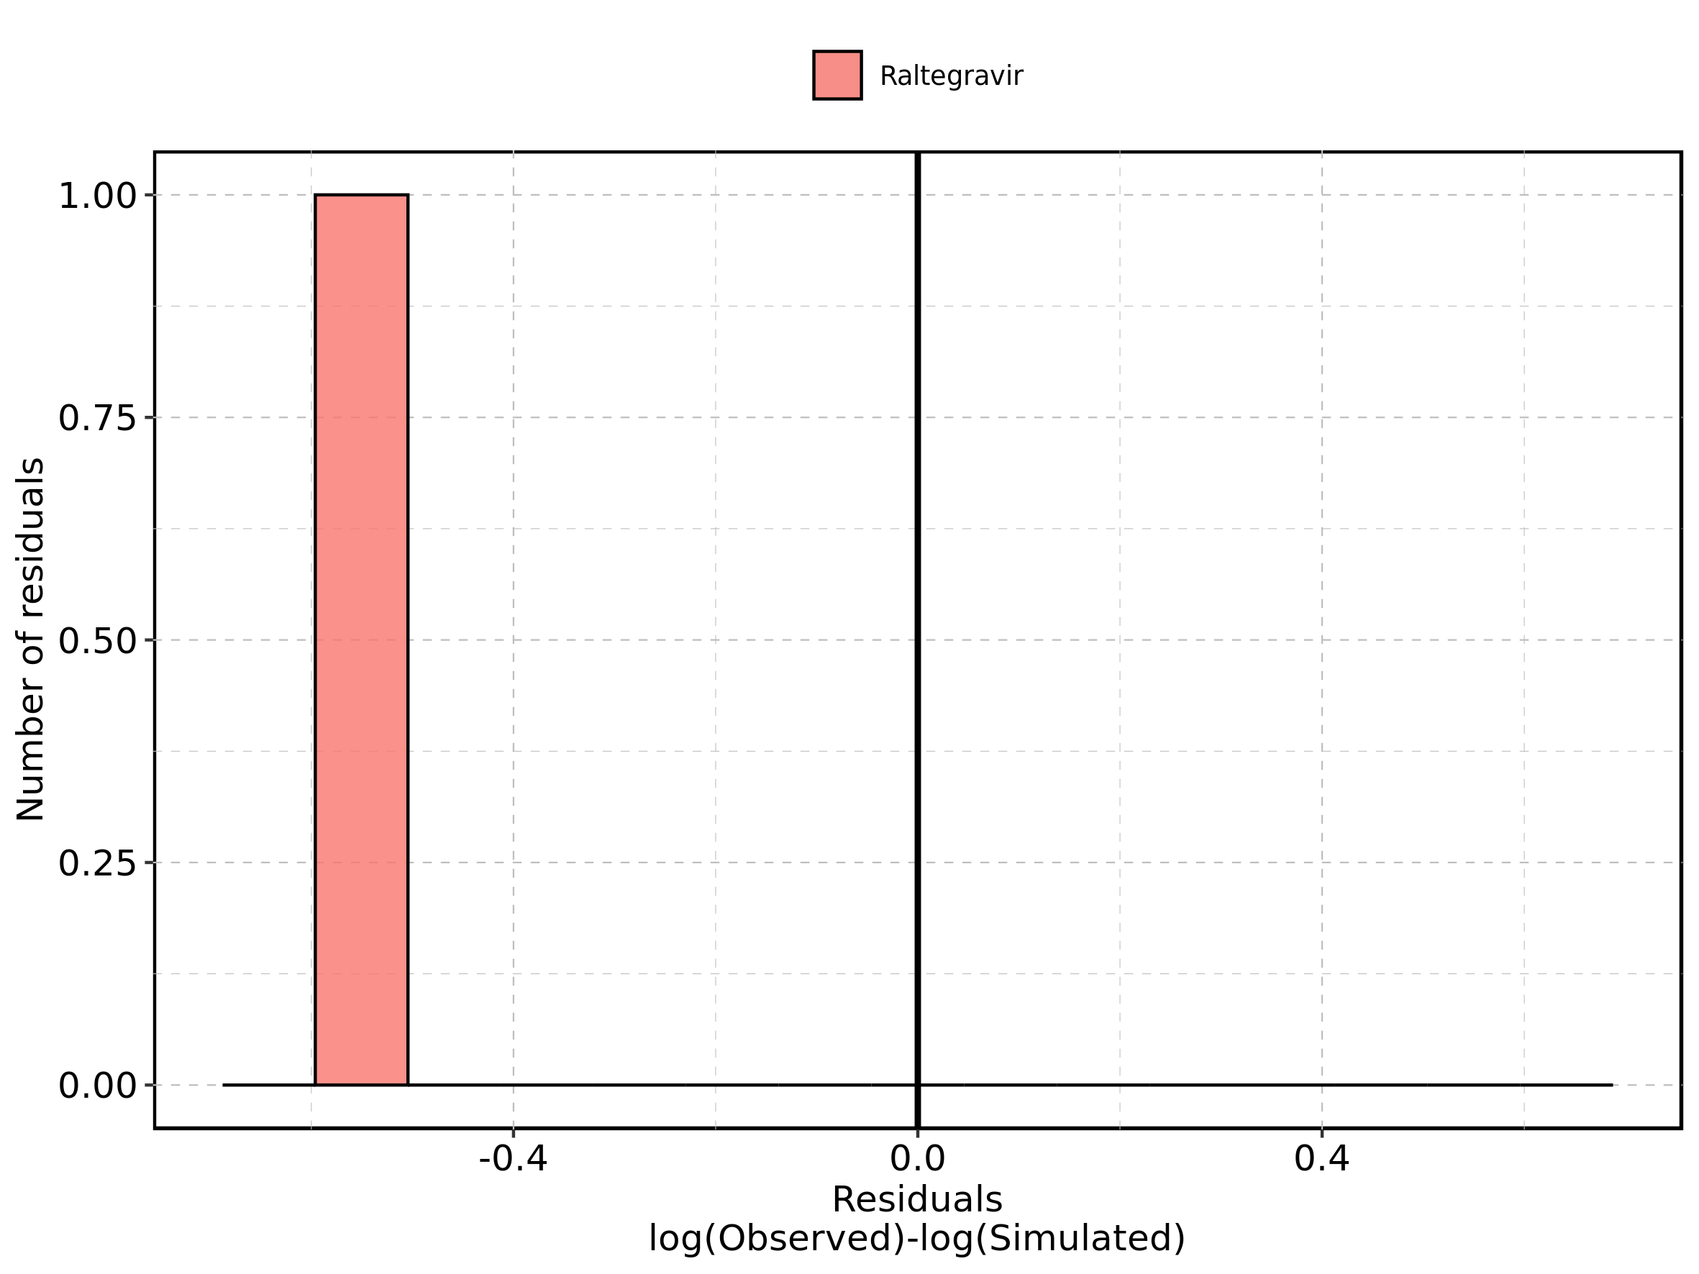

Figure 230: Logarithmic residuals of Raltegravir 400 mg filmcoated tablet md for Raltegravir 400 mg filmcoated tablet md as quantile-quantile plot. Data source: Data/Raltegravir_PK.txt.

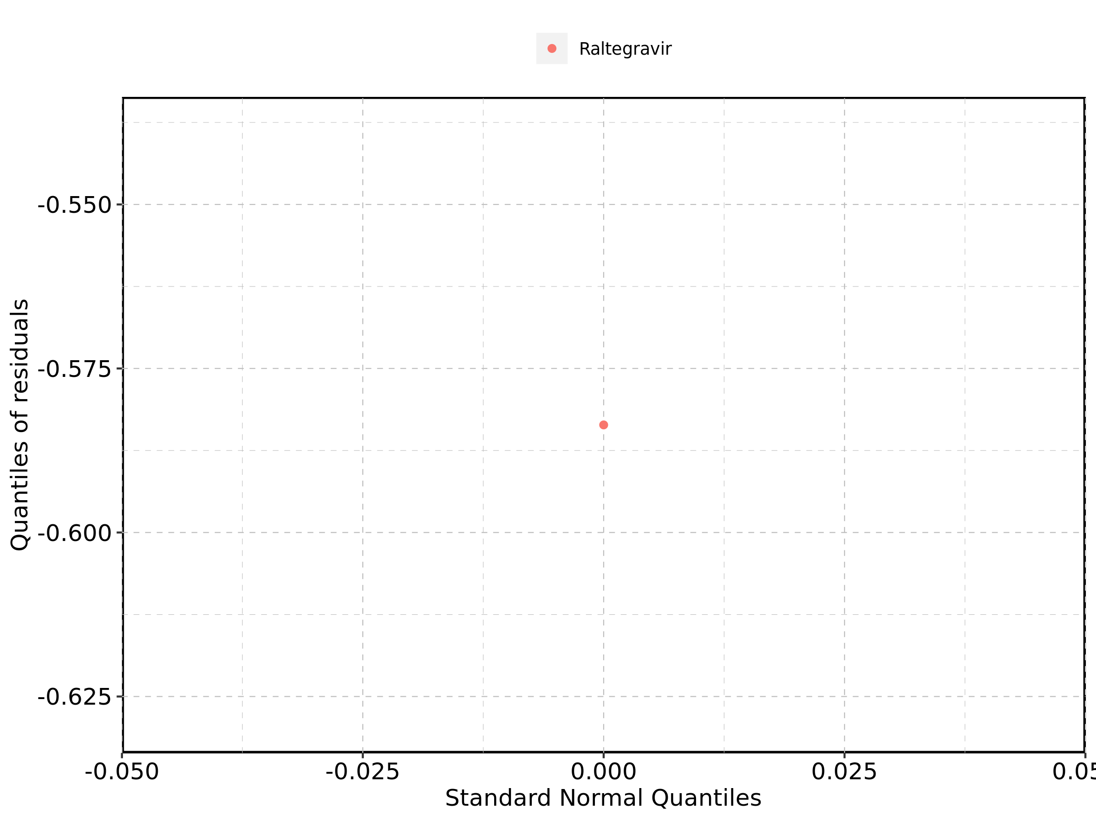

## 4.14. Time profiles and residual plots for Raltegravir 400mg chewable fasted

Figure 231: Time profiles of Raltegravir 400mg chewable fasted for Raltegravir 400mg chewable fasted. Data source: Data/Raltegravir_PK.txt. Time profiles are plotted in a linear scale.

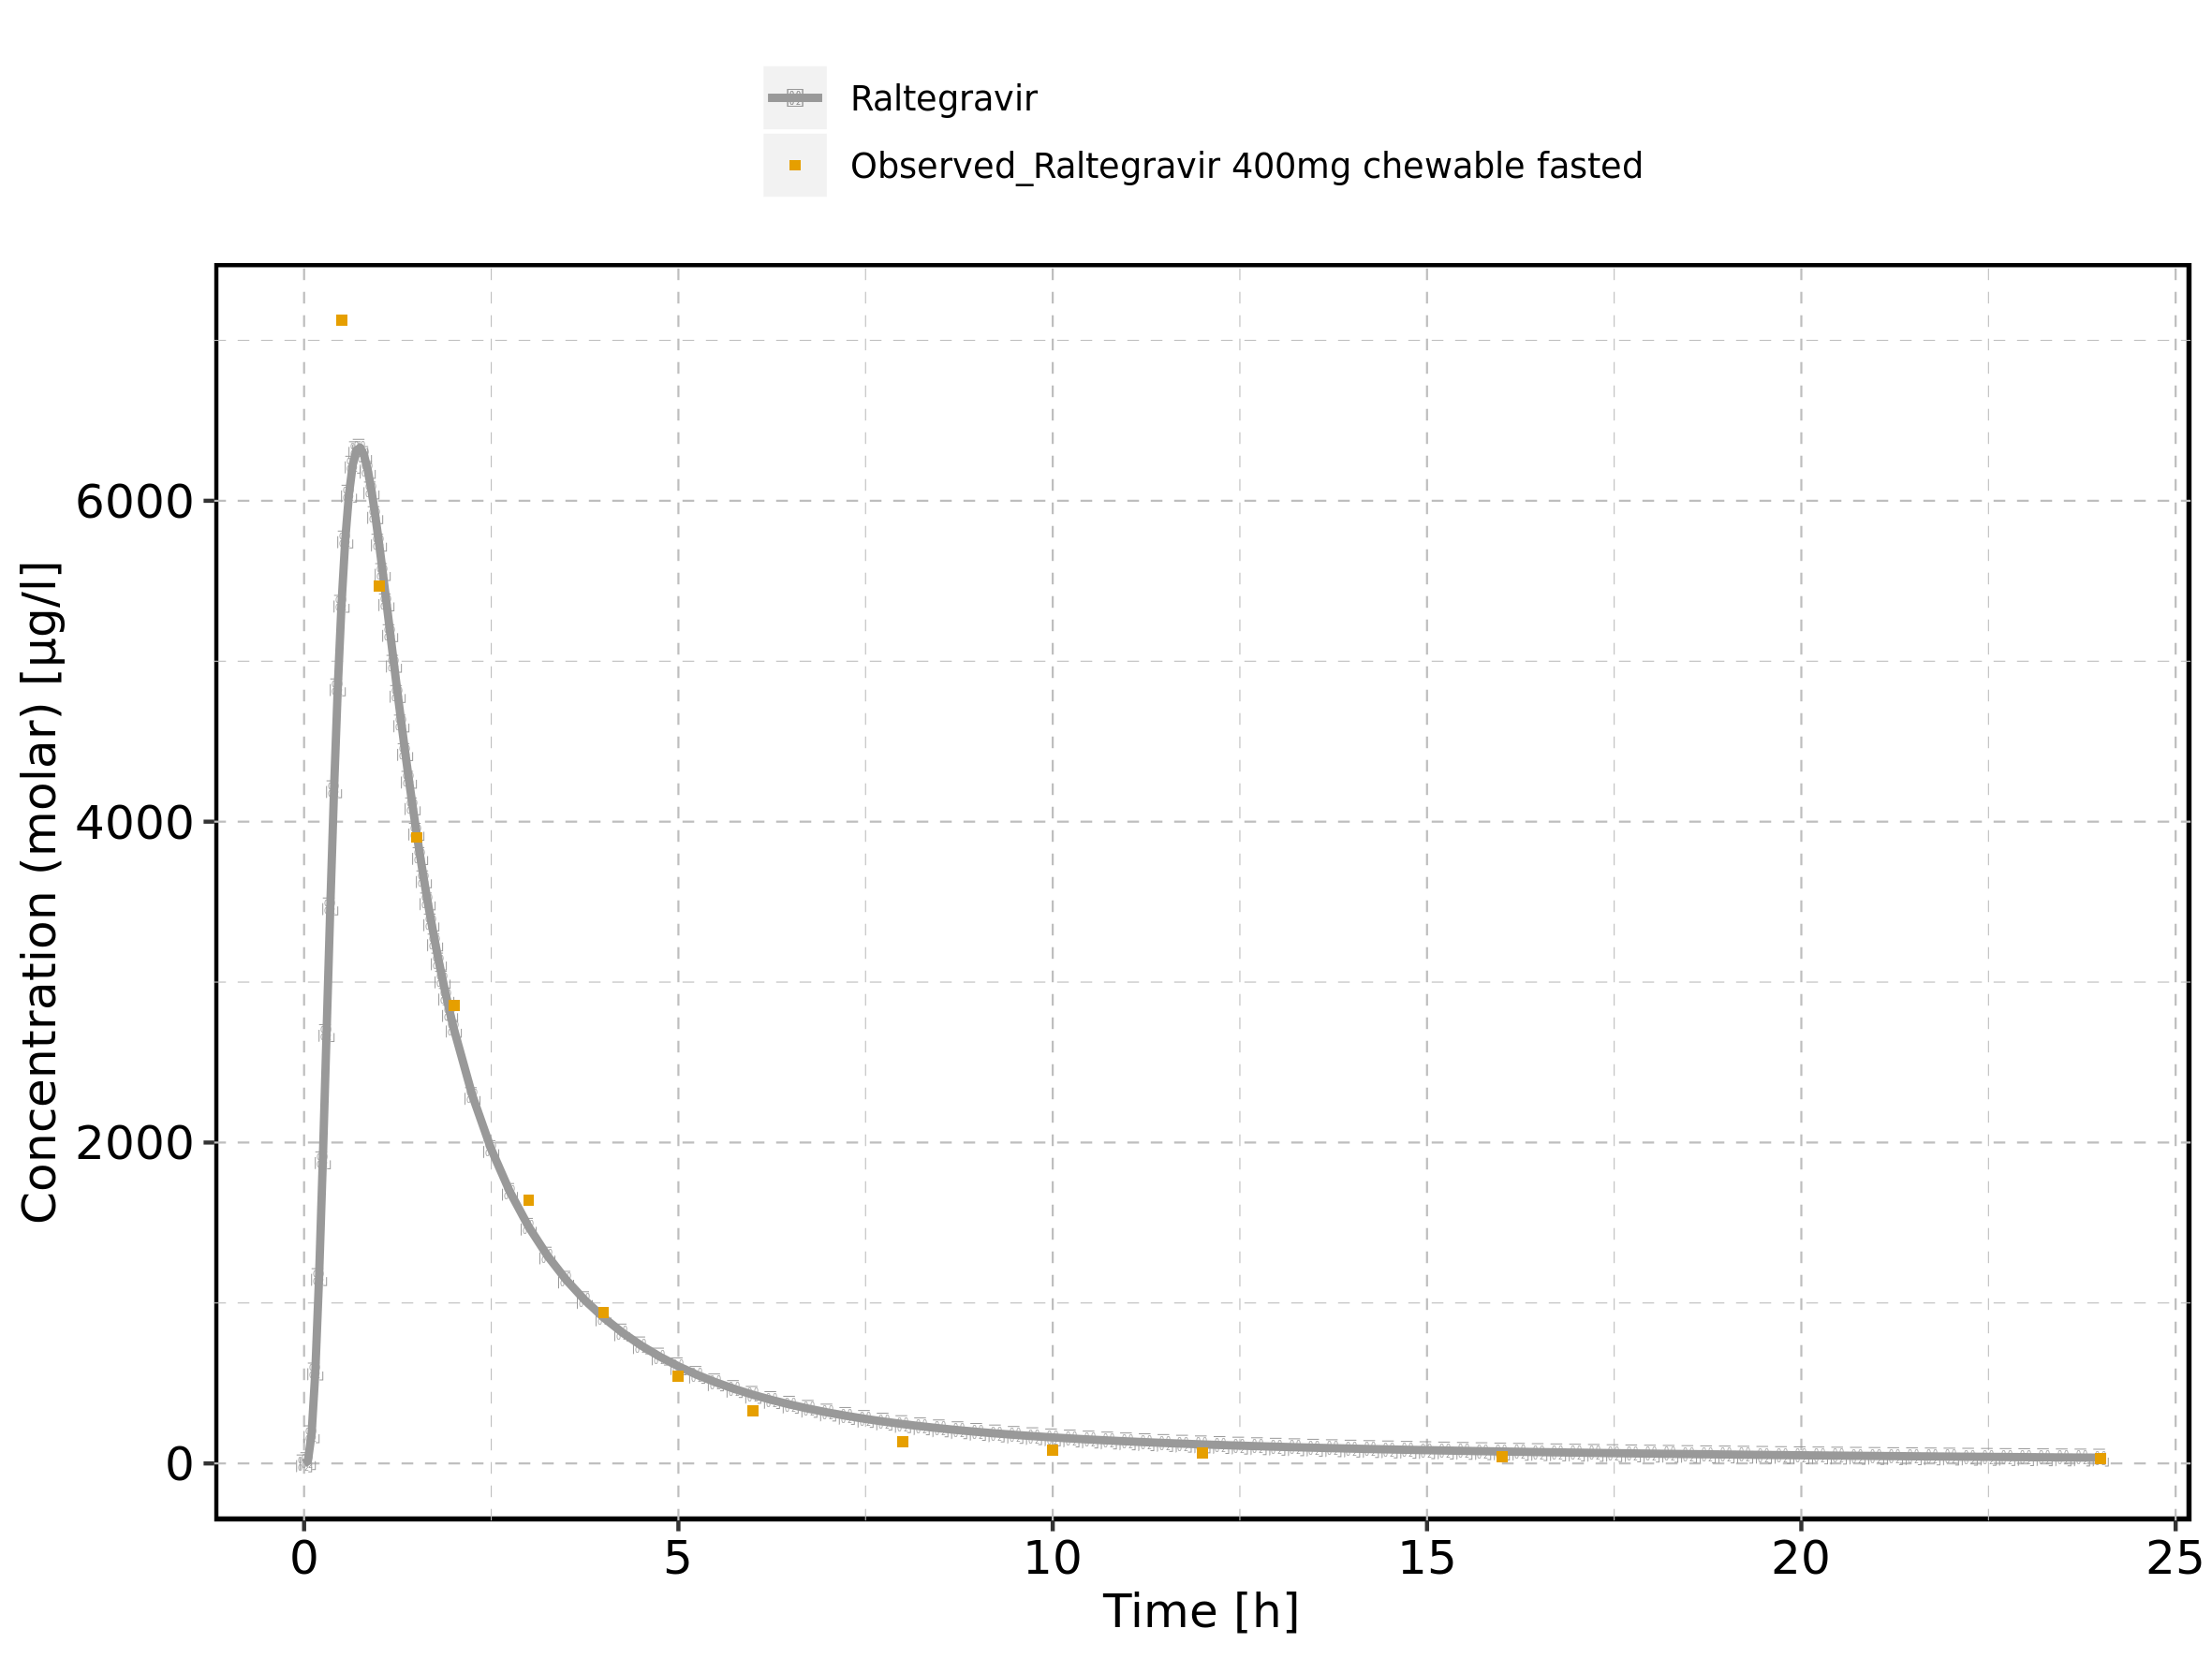

Figure 232: Time profiles of Raltegravir 400mg chewable fasted for Raltegravir 400mg chewable fasted. Data source: Data/Raltegravir_PK.txt. Time profiles are plotted in a logarithmic scale.

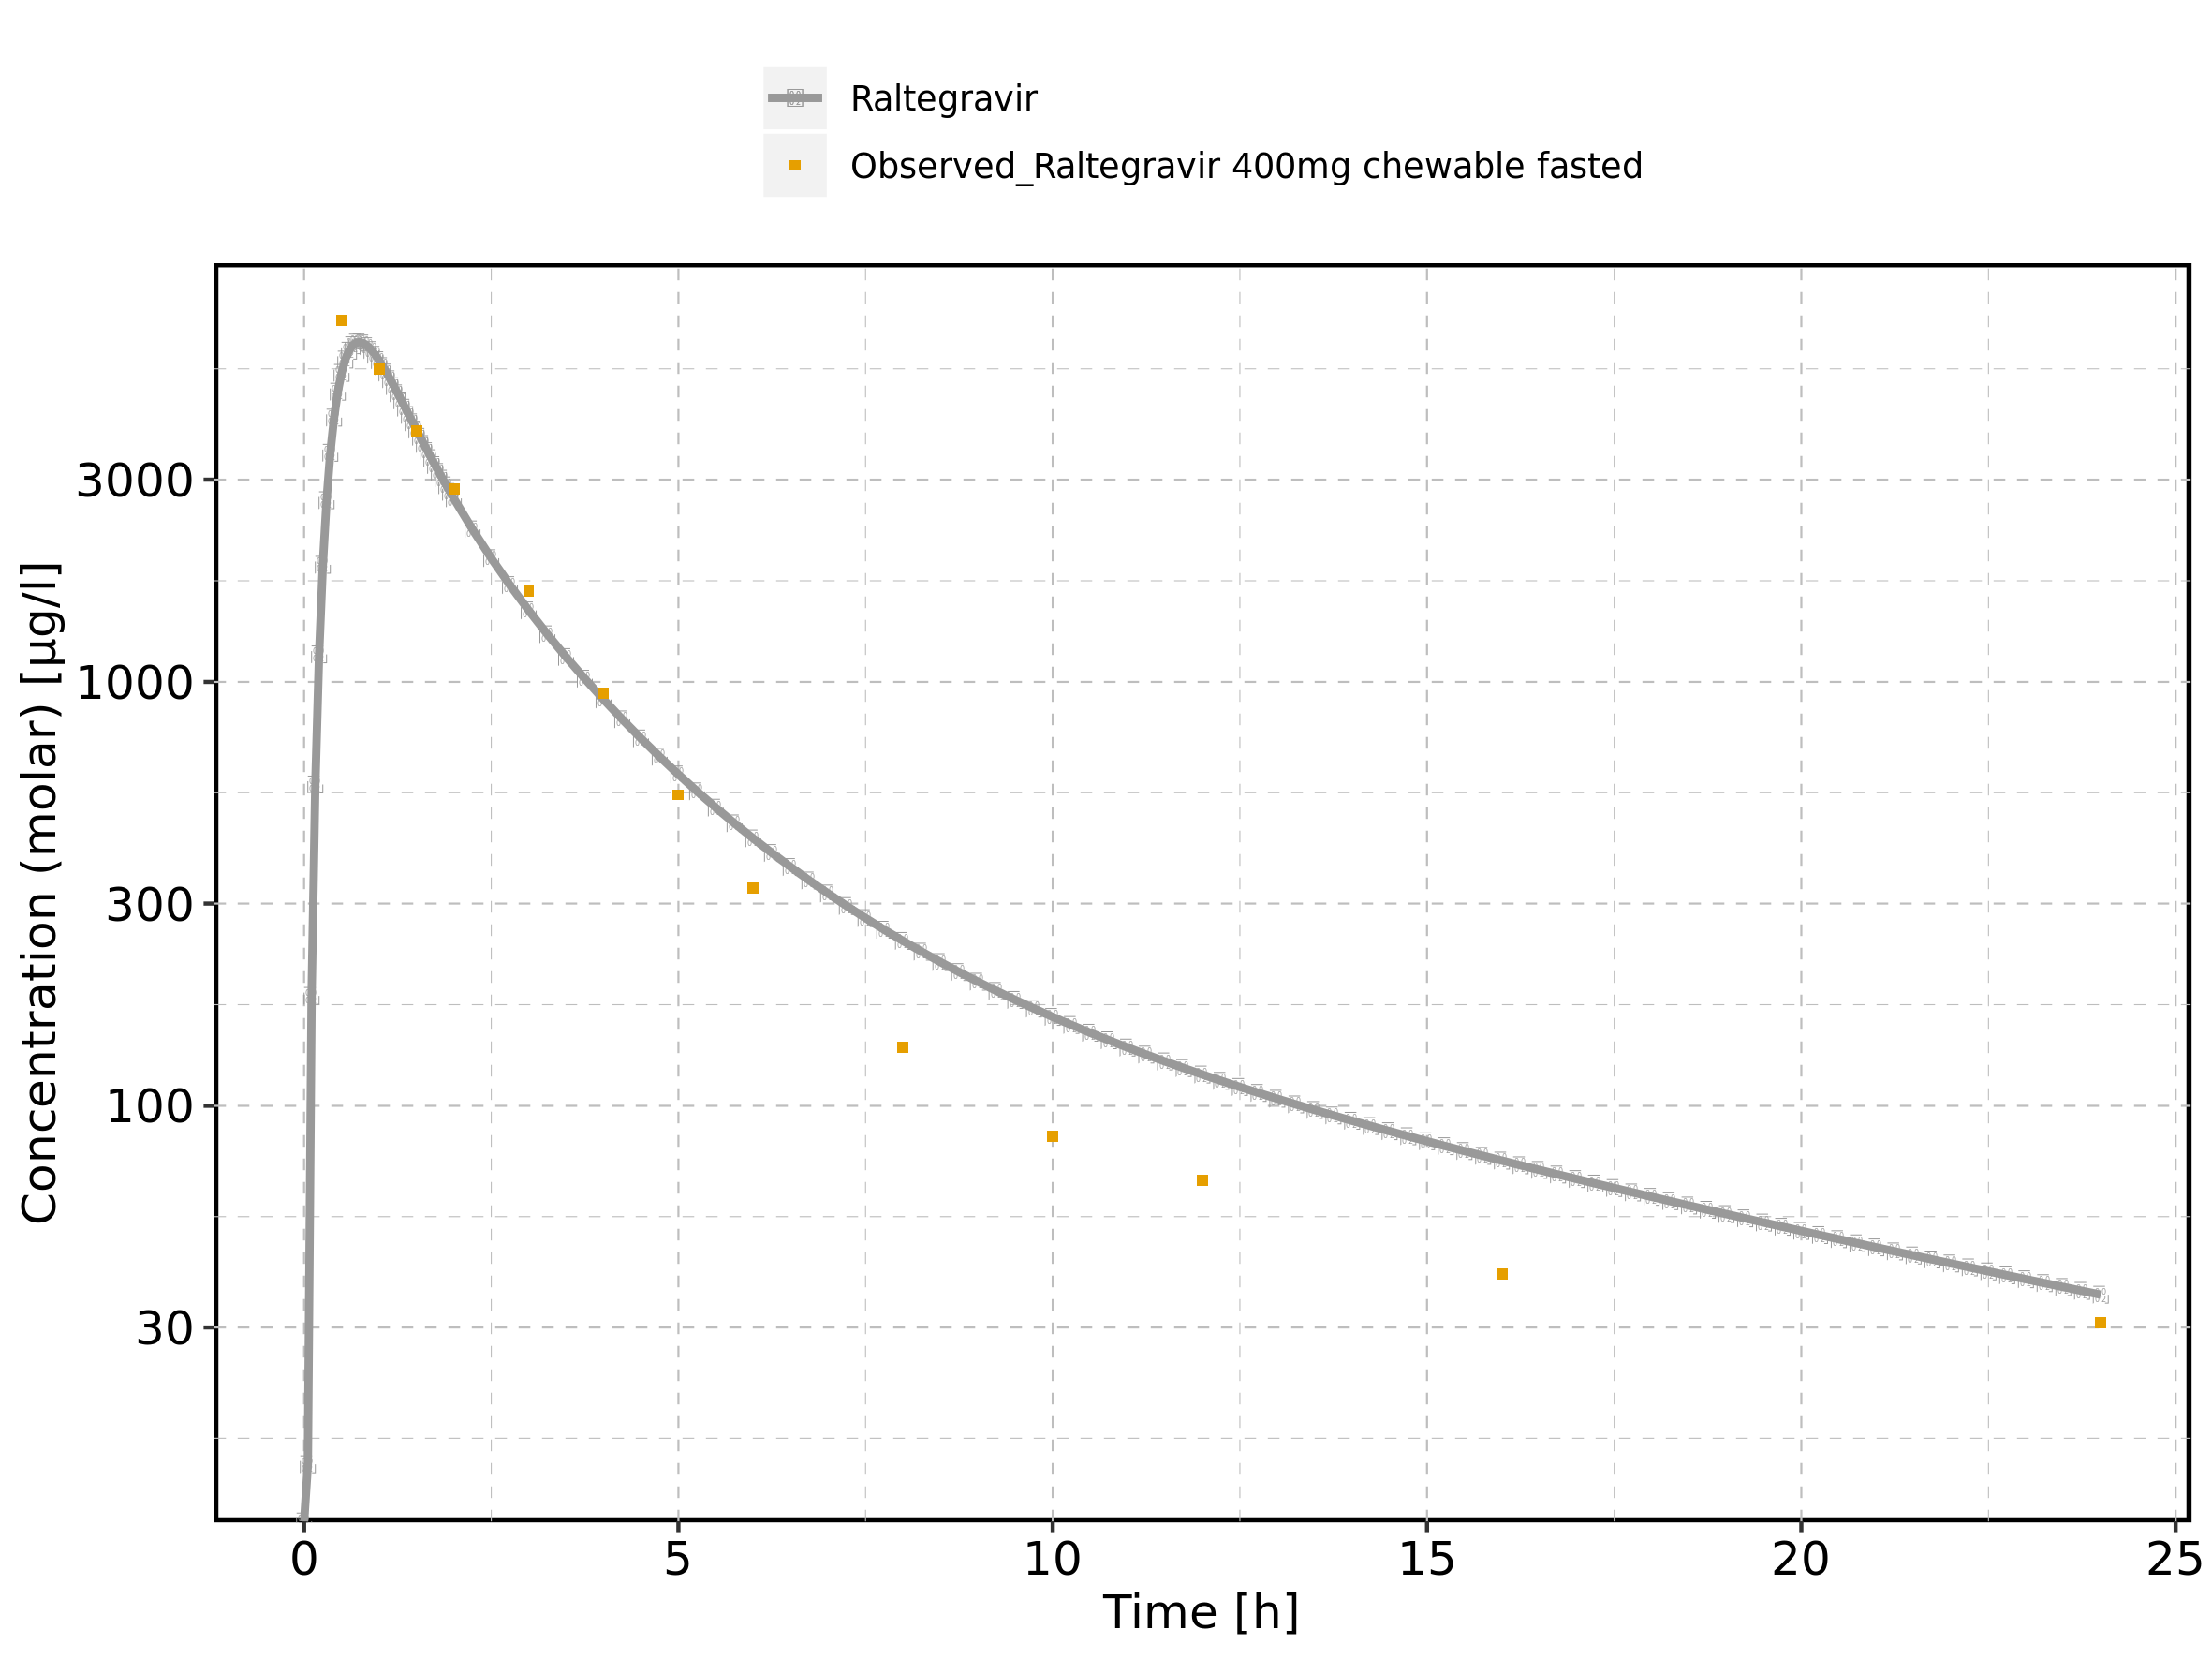

Figure 233: Predicted vs observed of Raltegravir 400mg chewable fasted for Raltegravir 400mg chewable fasted. Data source: Data/Raltegravir_PK.txt. Predictions and observations are plotted in a linear scale.

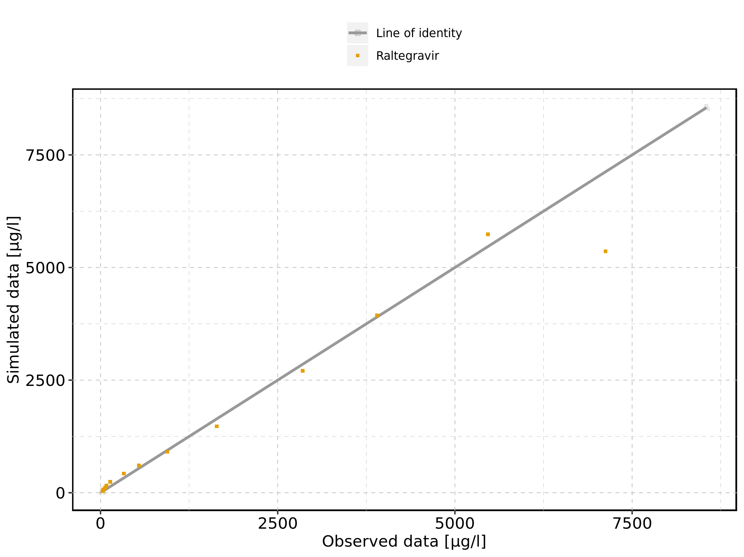

Figure 234: Predicted vs observed of Raltegravir 400mg chewable fasted for Raltegravir 400mg chewable fasted. Data source: Data/Raltegravir_PK.txt. Predictions and observations are plotted in a logarithmic scale.

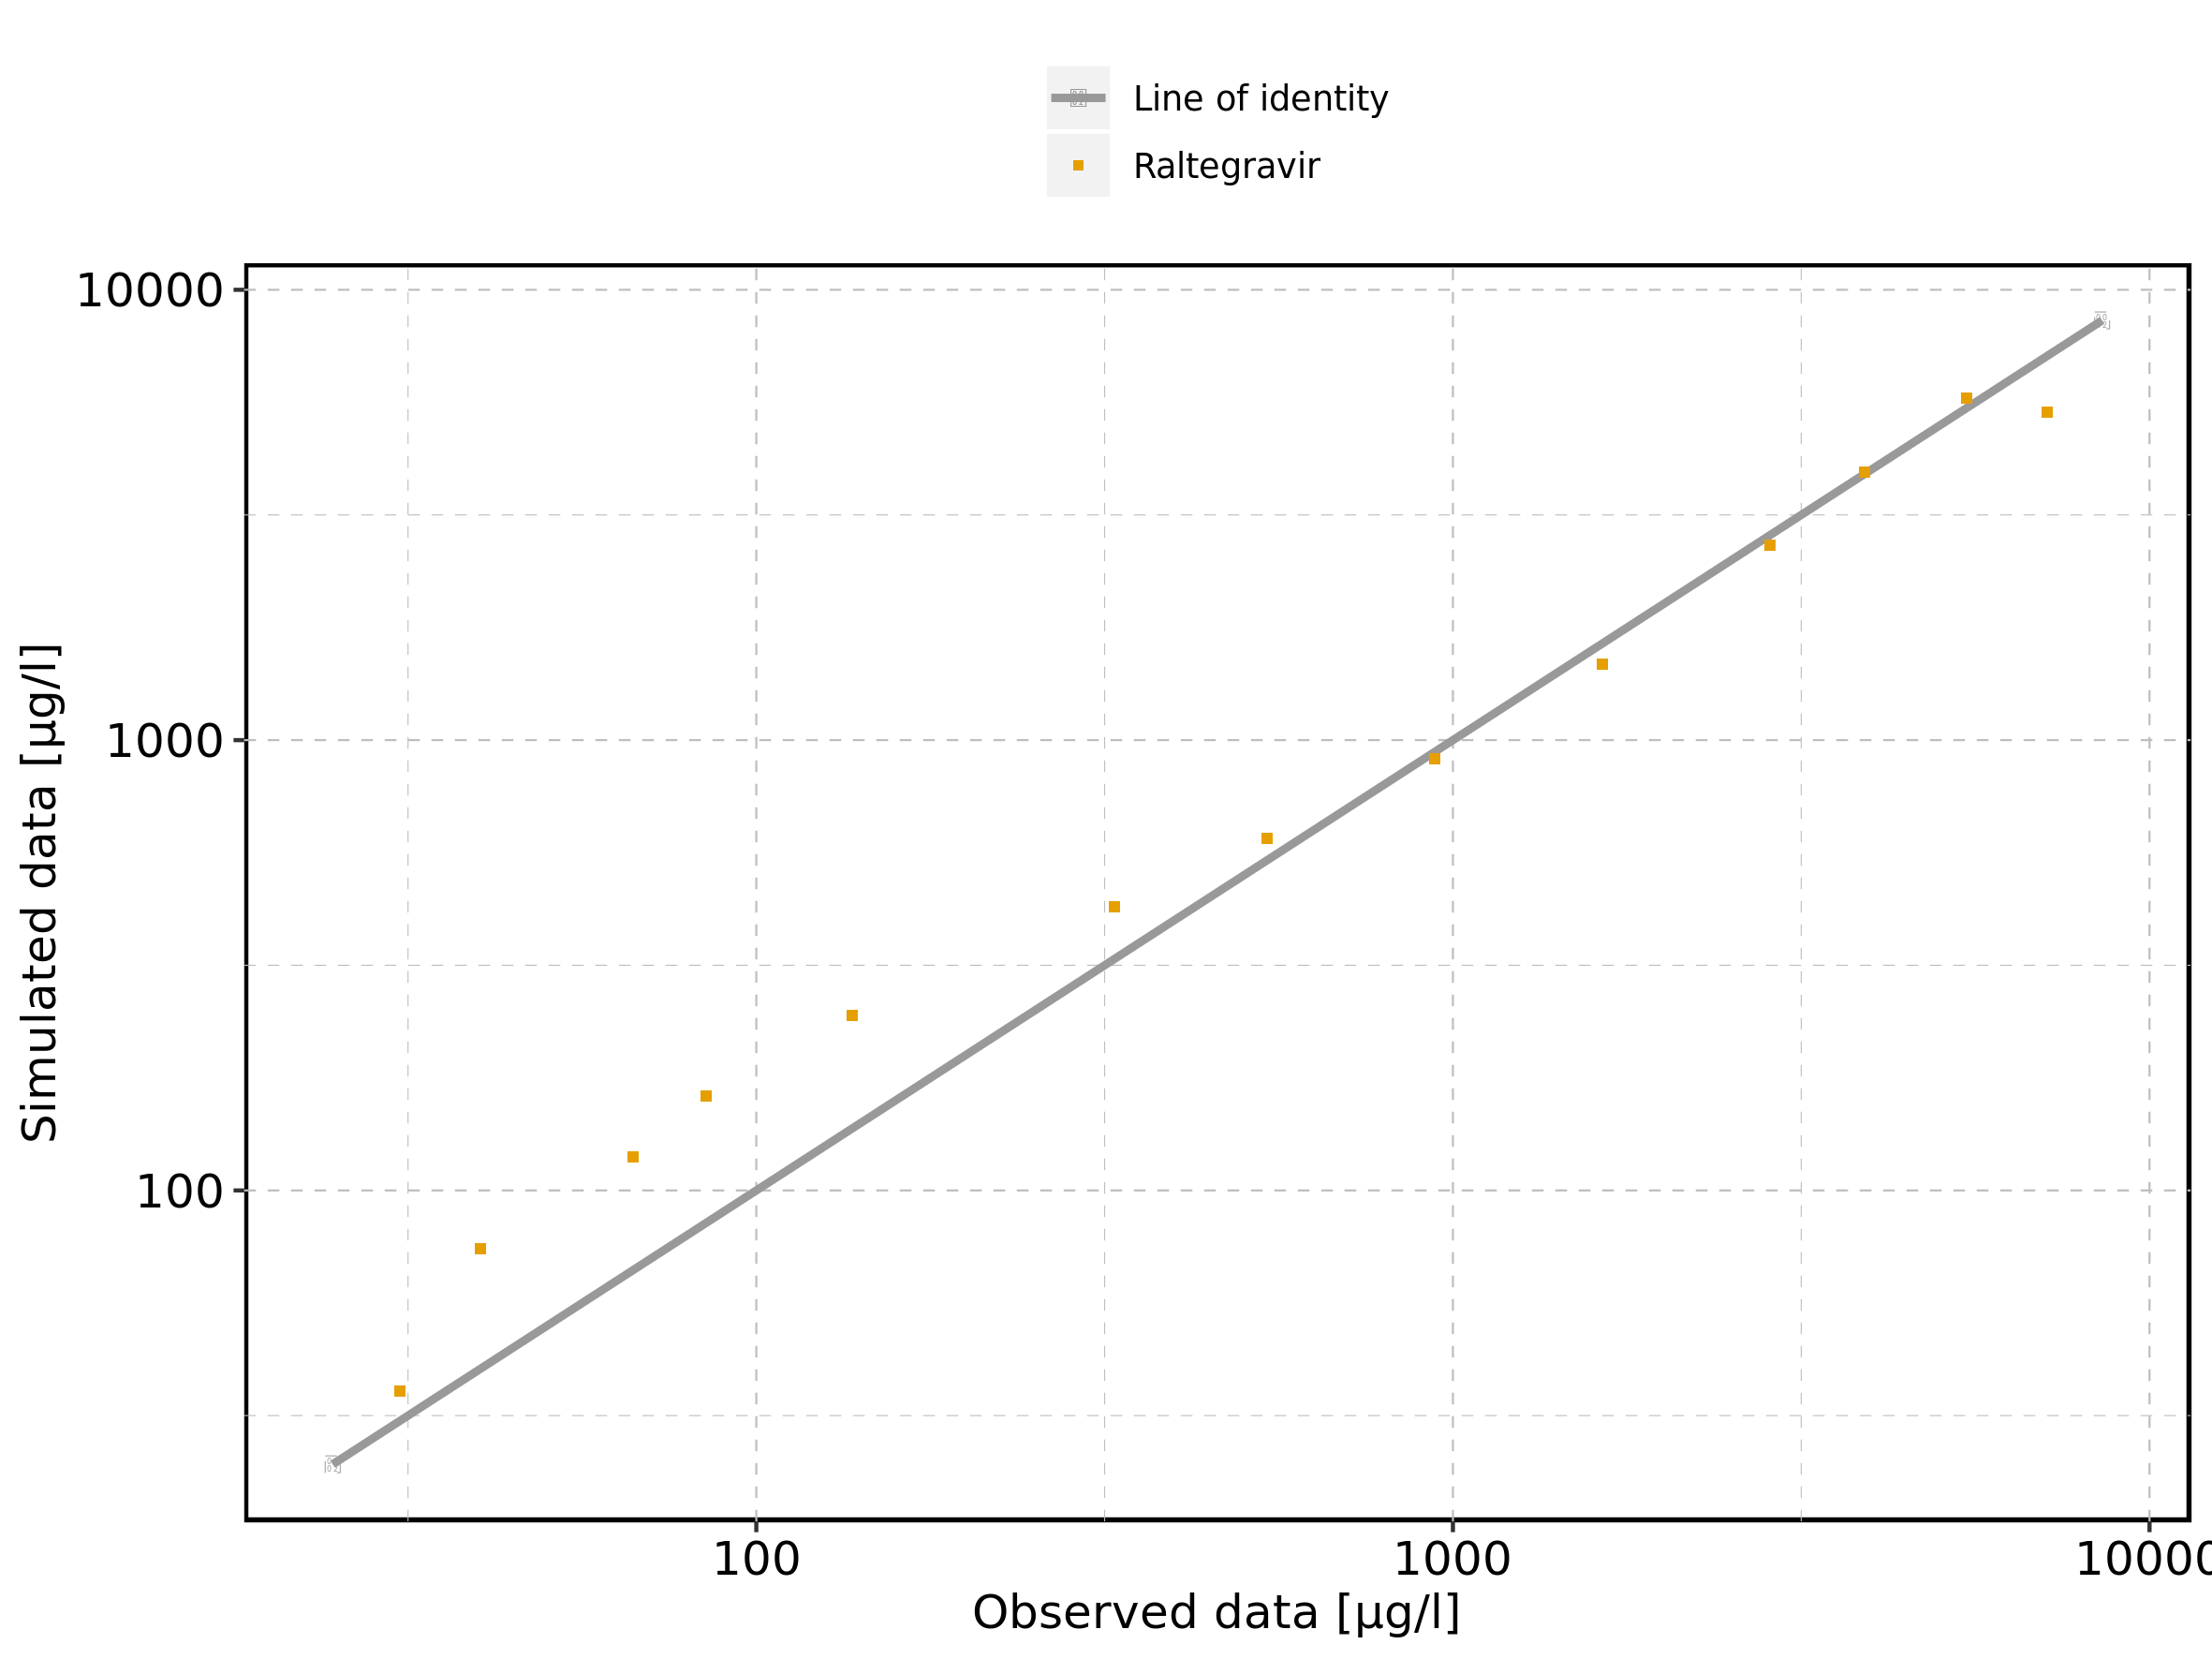

Figure 235: Logarithmic residuals vs predicted values of Raltegravir 400mg chewable fasted for Raltegravir 400mg chewable fasted. Data source: Data/Raltegravir_PK.txt.

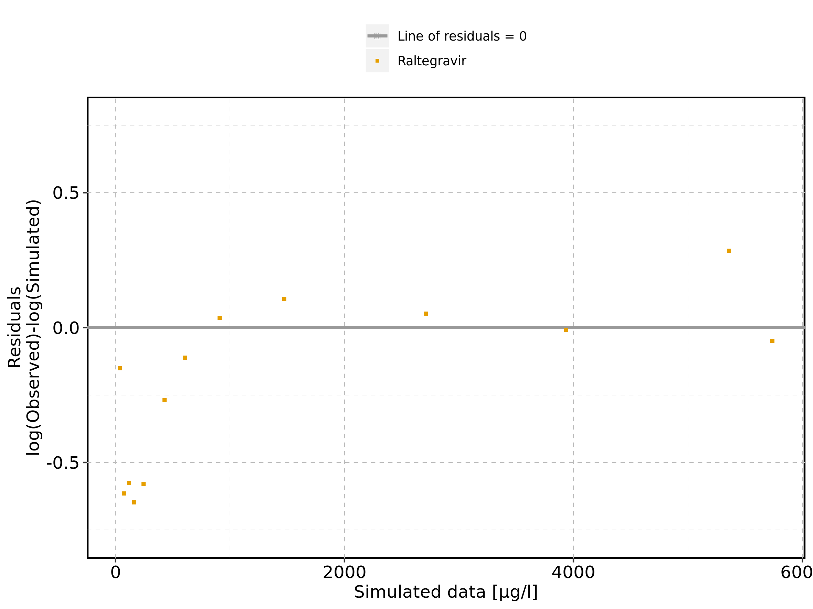

Figure 236: Logarithmic residuals vs time of Raltegravir 400mg chewable fasted for Raltegravir 400mg chewable fasted. Data source: Data/Raltegravir_PK.txt.

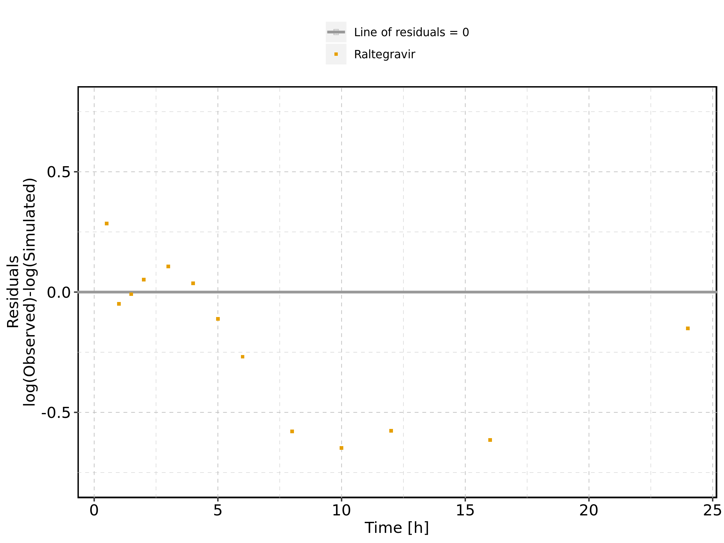

Figure 237: Logarithmic residuals distribution of Raltegravir 400mg chewable fasted for Raltegravir 400mg chewable fasted. Data source: Data/Raltegravir_PK.txt.

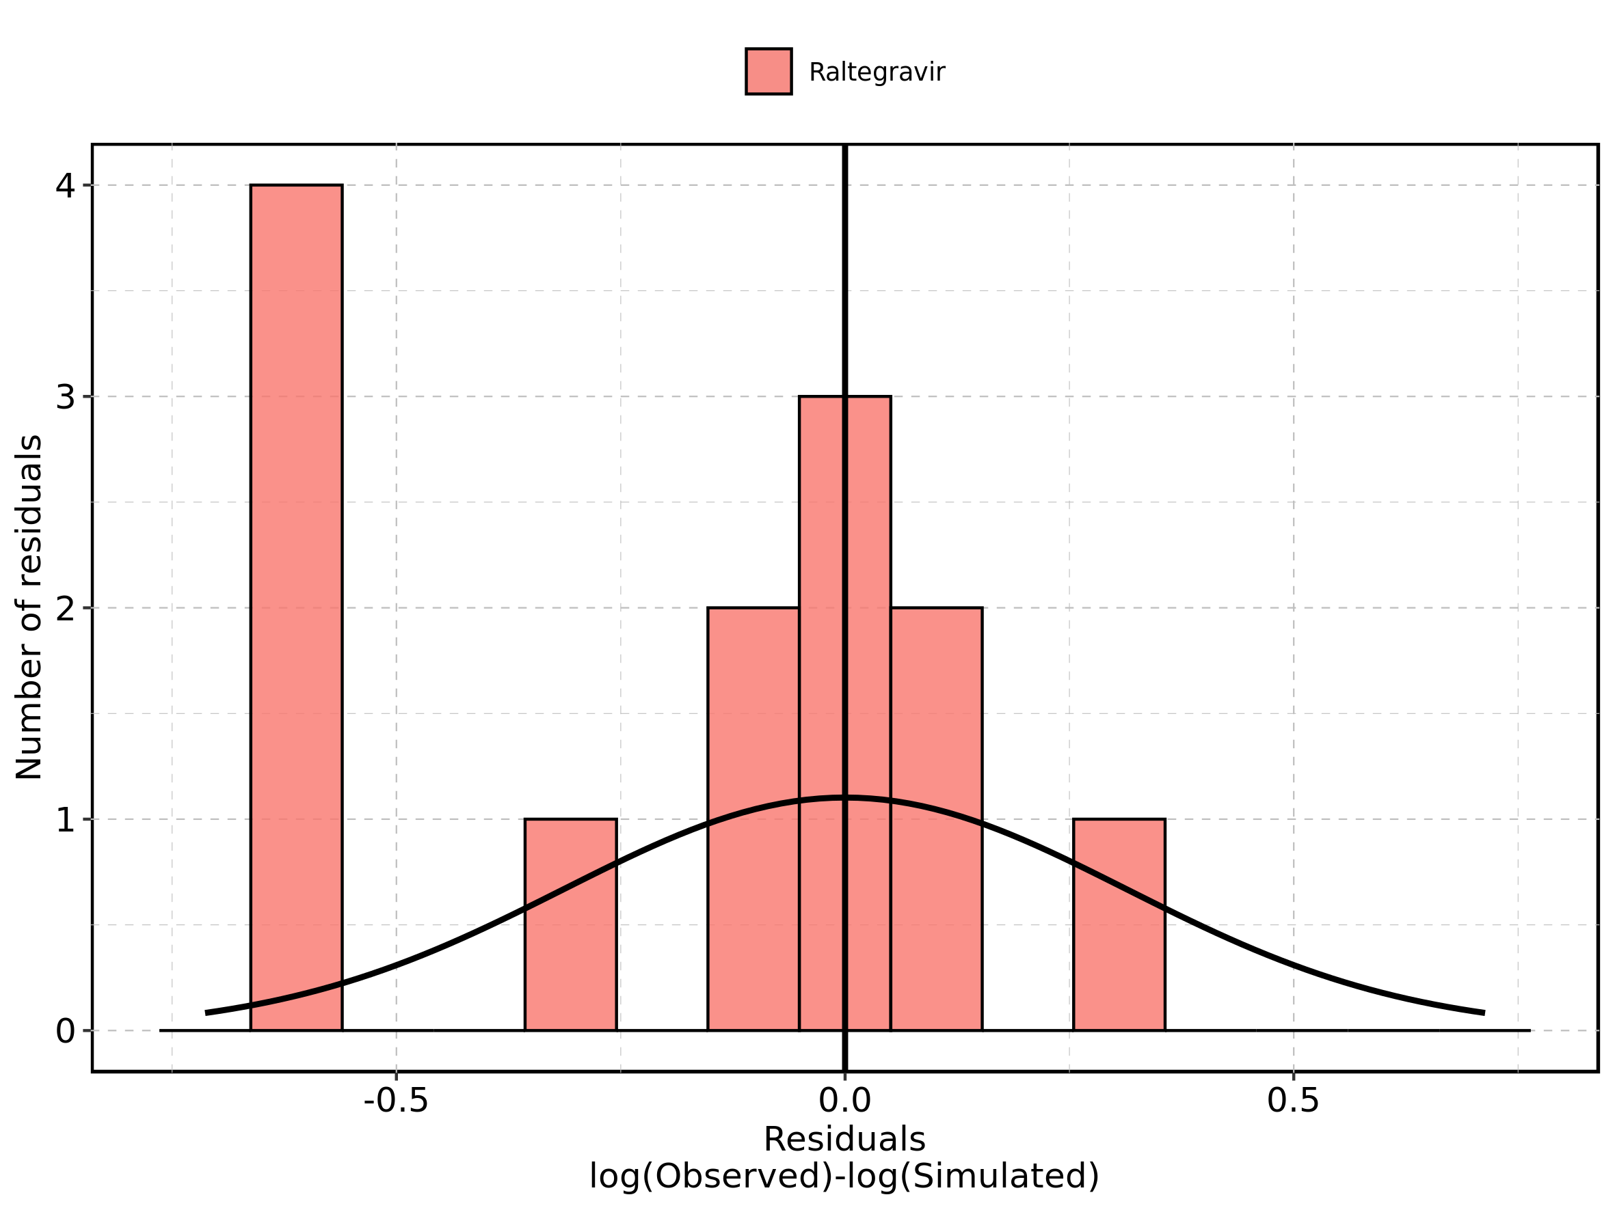

Figure 238: Logarithmic residuals of Raltegravir 400mg chewable fasted for Raltegravir 400mg chewable fasted as quantile-quantile plot. Data source: Data/Raltegravir_PK.txt.

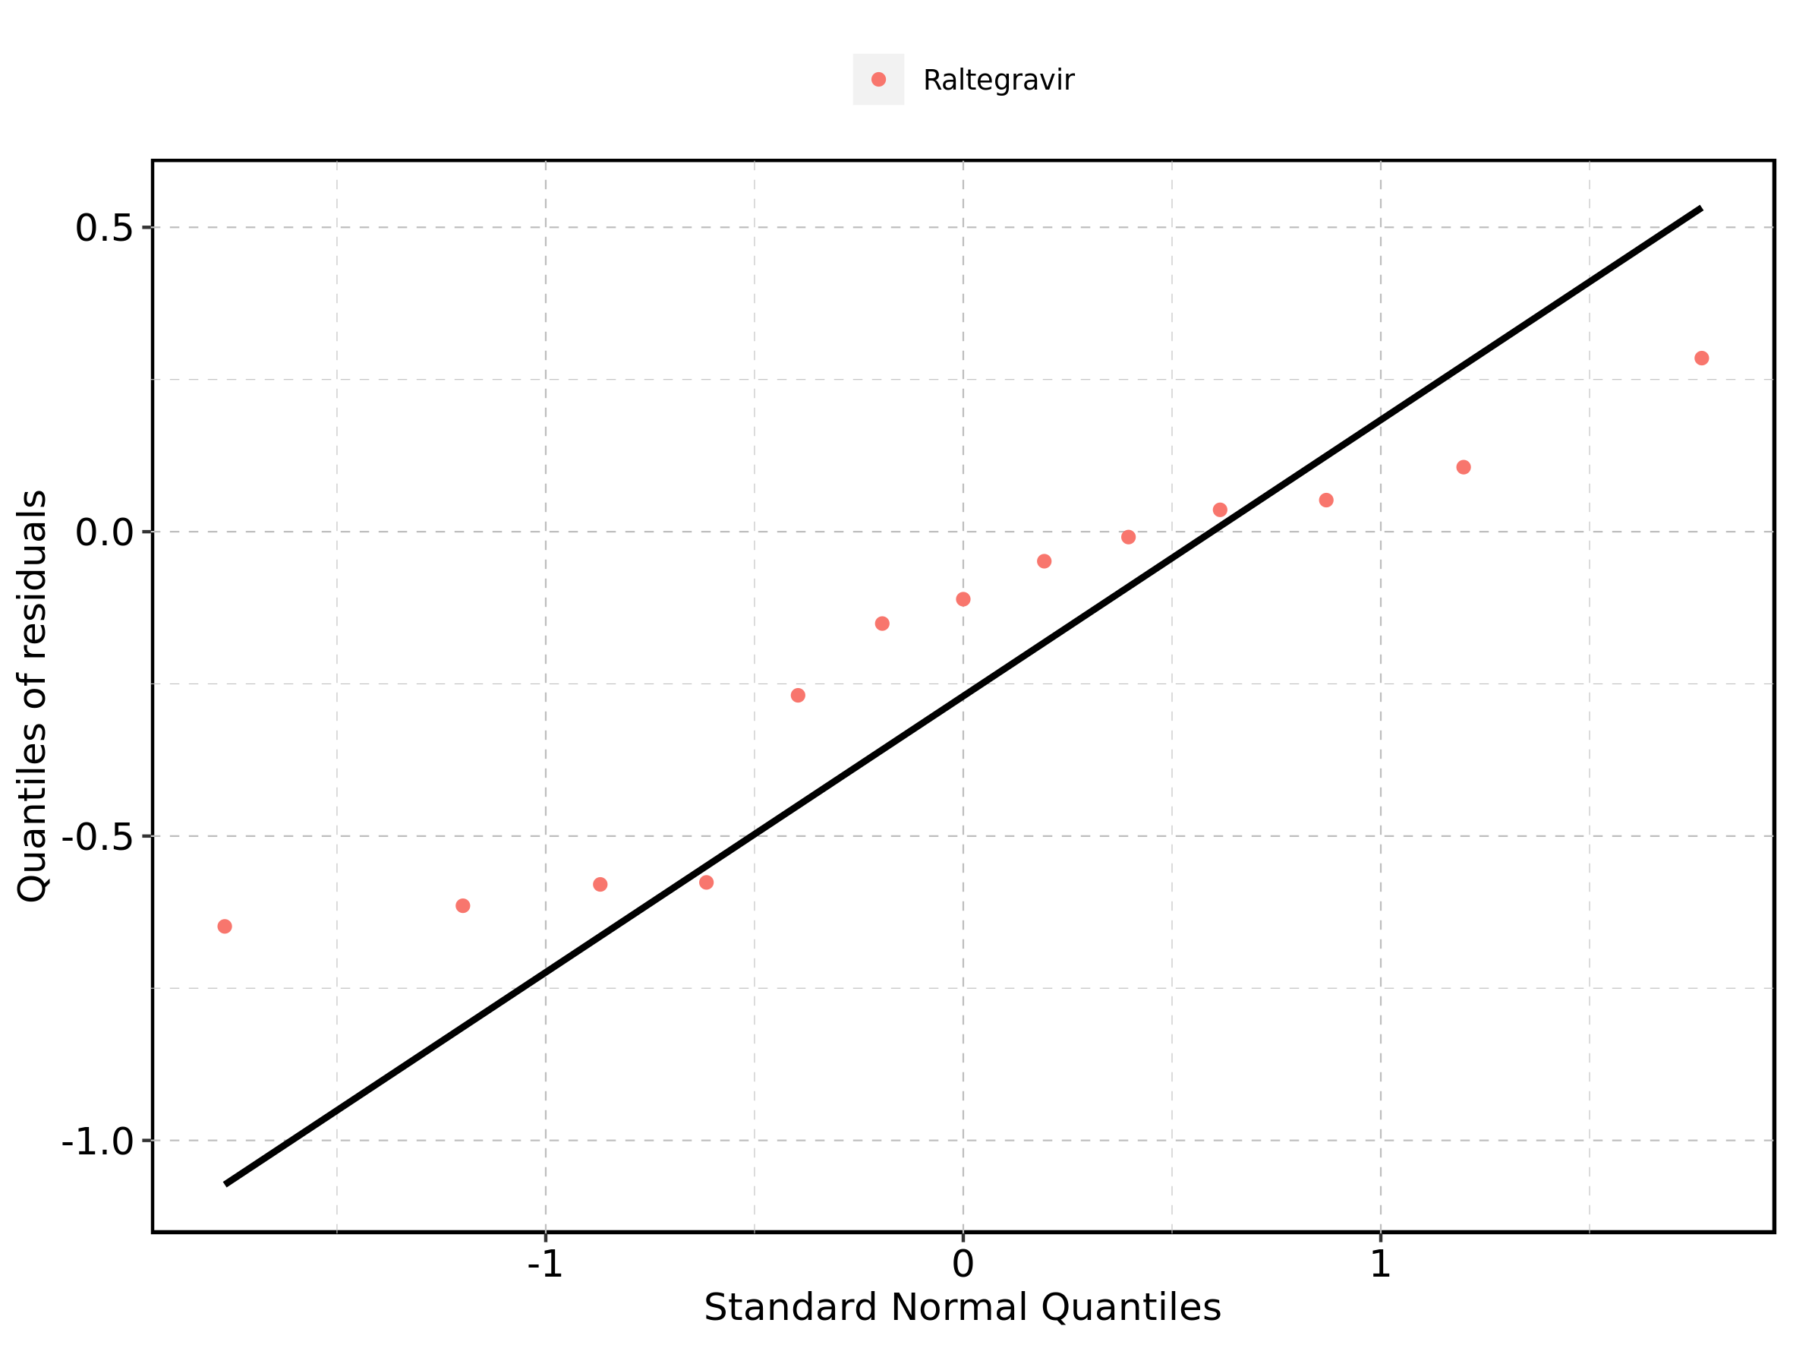

## 4.15. Time profiles and residual plots for Raltegravir 400mg chewable fed

Figure 239: Time profiles of Raltegravir 400mg chewable fed for Raltegravir 400mg chewable fed. Data source: Data/Raltegravir_PK.txt. Time profiles are plotted in a linear scale.

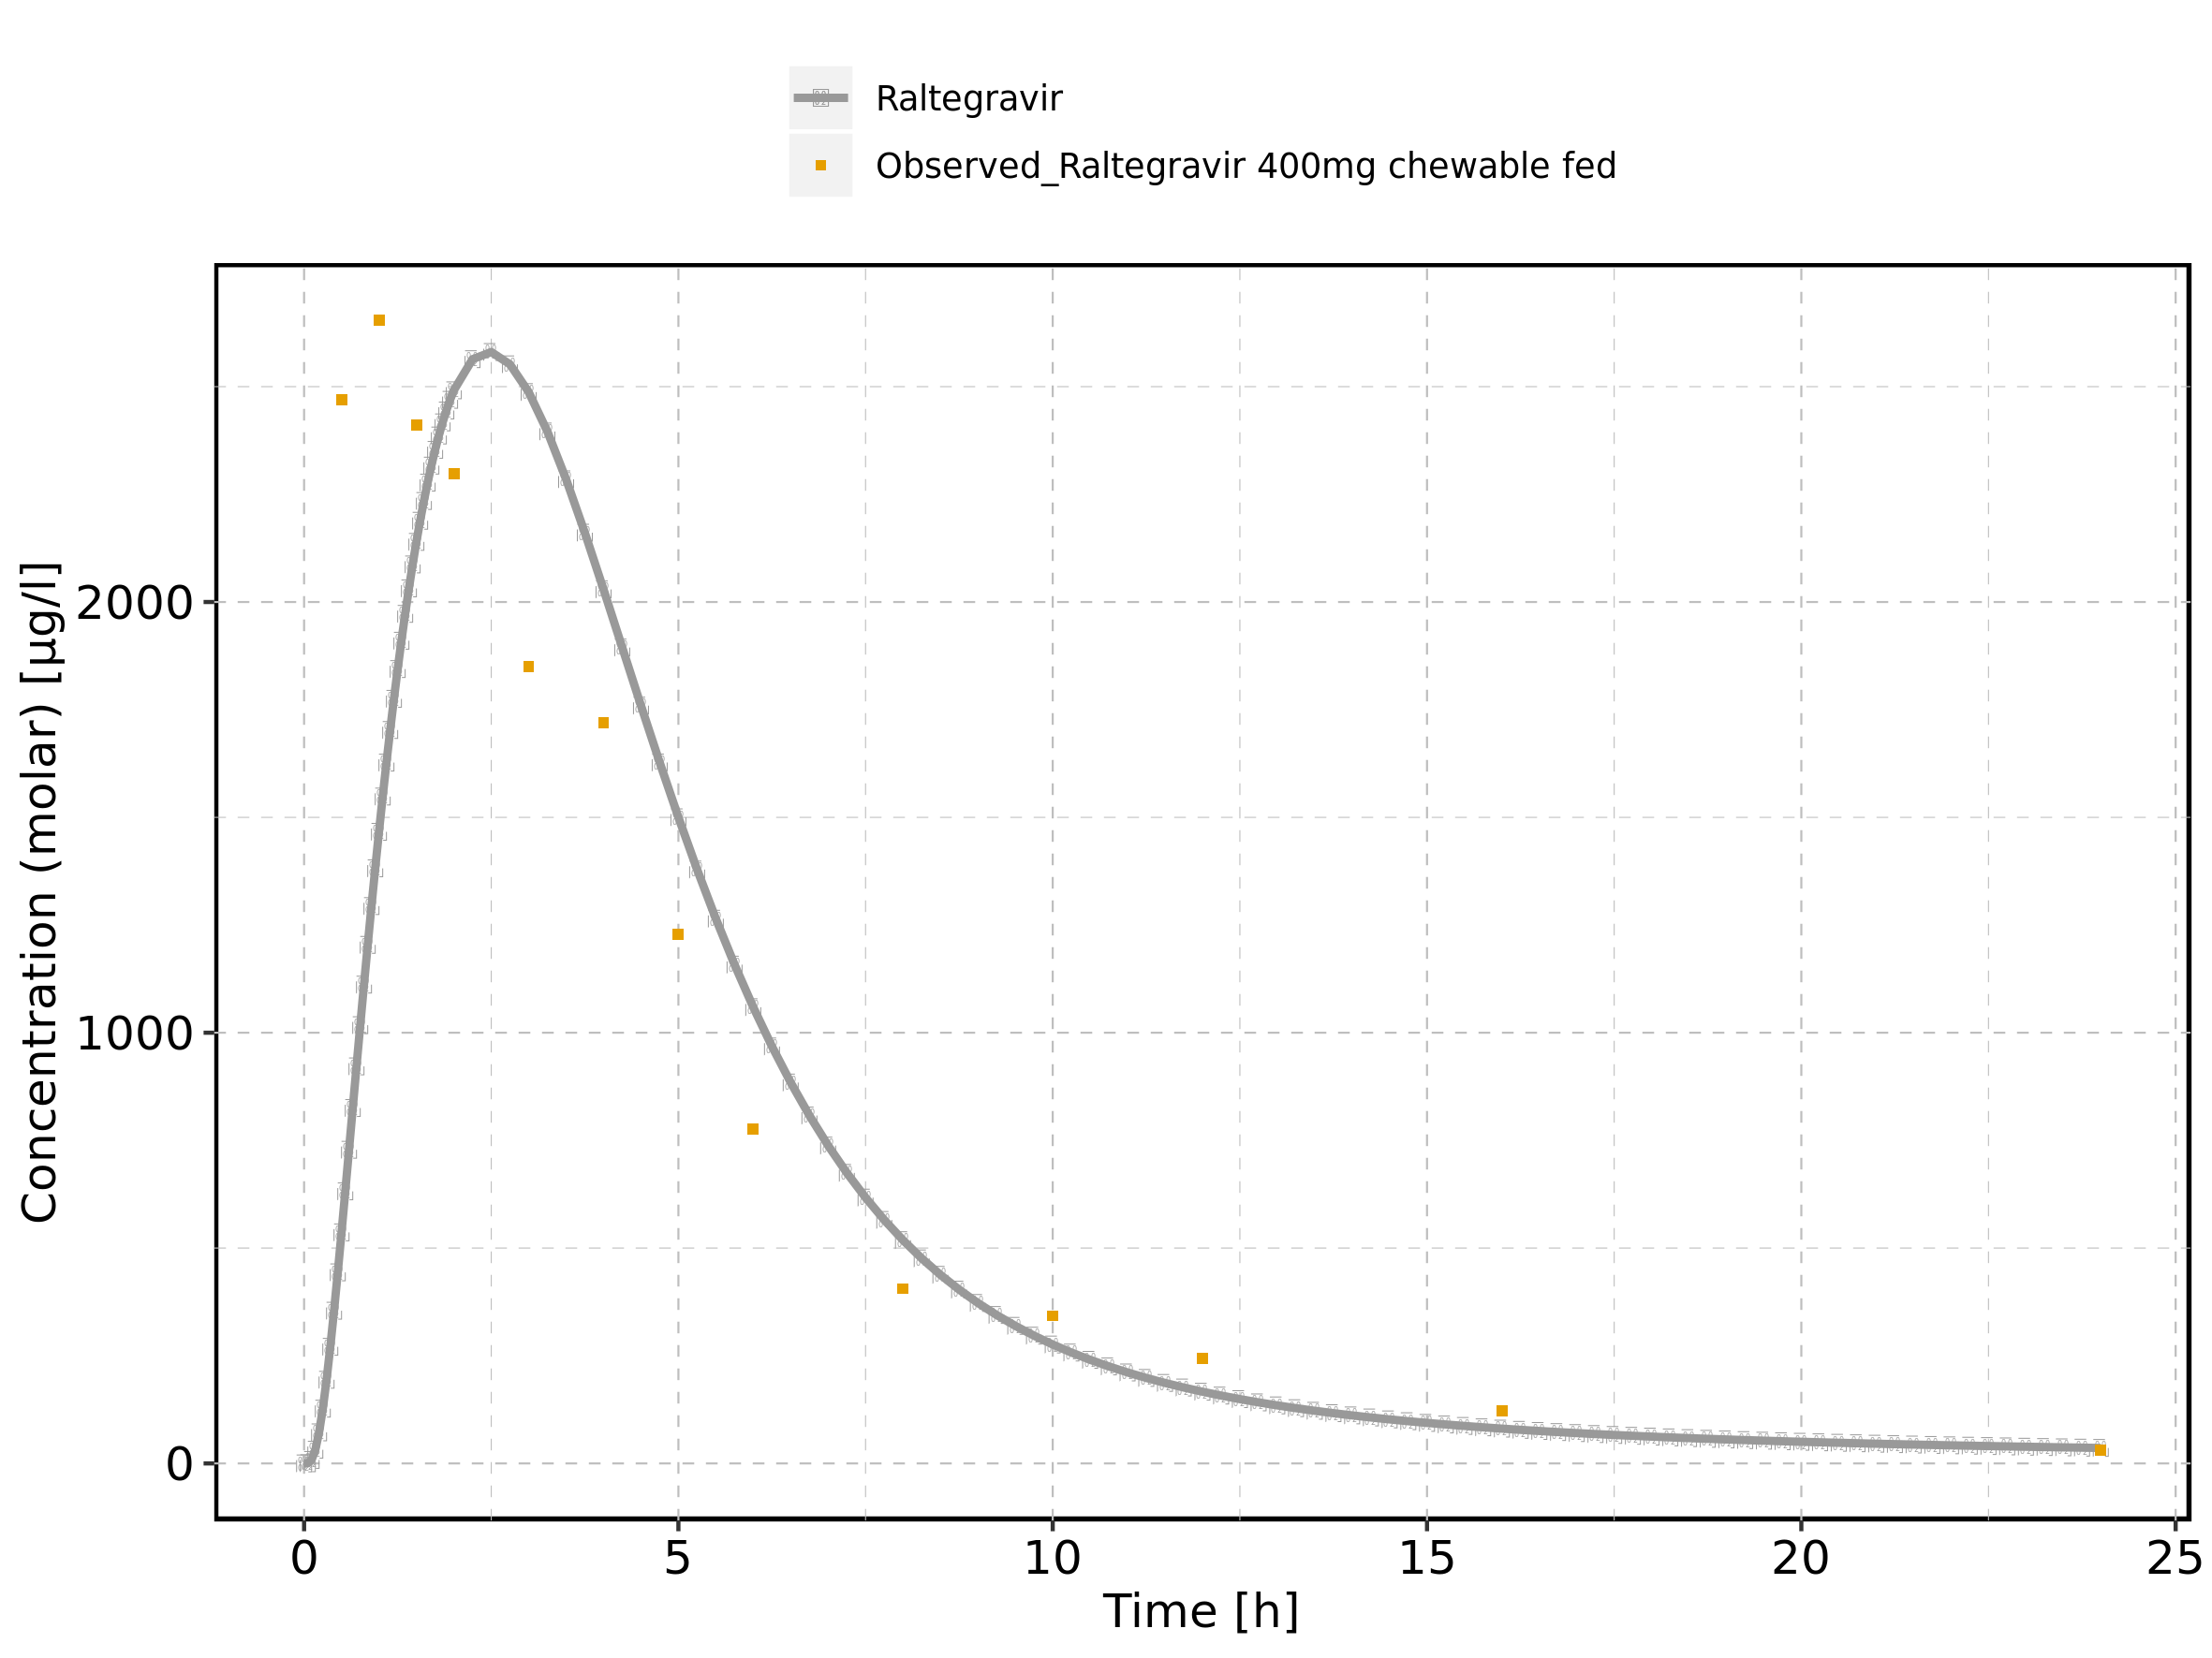

Figure 240: Time profiles of Raltegravir 400mg chewable fed for Raltegravir 400mg chewable fed. Data source: Data/Raltegravir_PK.txt. Time profiles are plotted in a logarithmic scale.

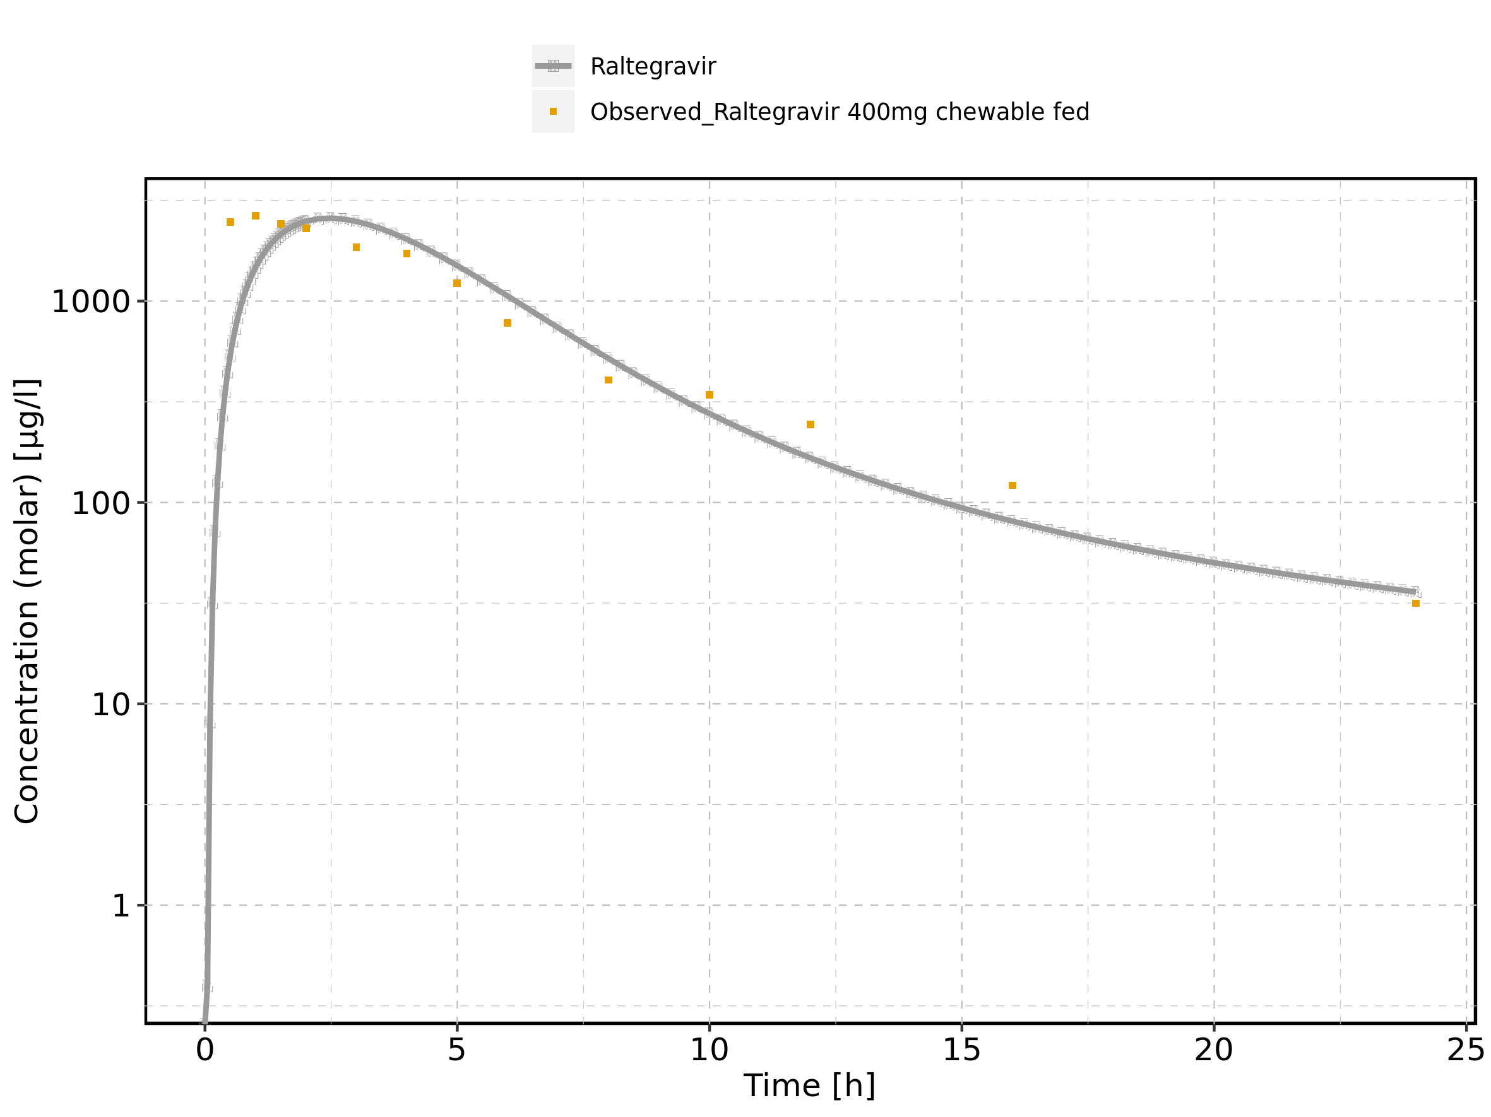

Figure 241: Predicted vs observed of Raltegravir 400mg chewable fed for Raltegravir 400mg chewable fed. Data source: Data/Raltegravir_PK.txt. Predictions and observations are plotted in a linear scale.

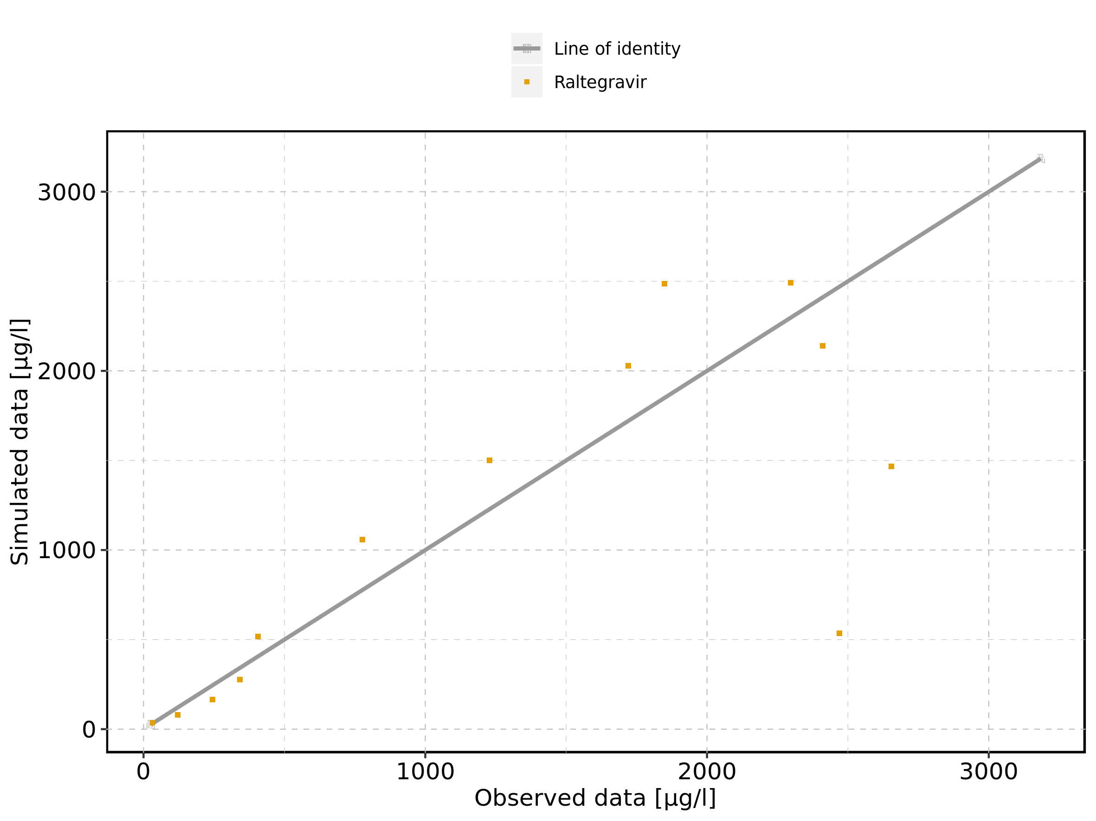

Figure 242: Predicted vs observed of Raltegravir 400mg chewable fed for Raltegravir 400mg chewable fed. Data source: Data/Raltegravir_PK.txt. Predictions and observations are plotted in a logarithmic scale.

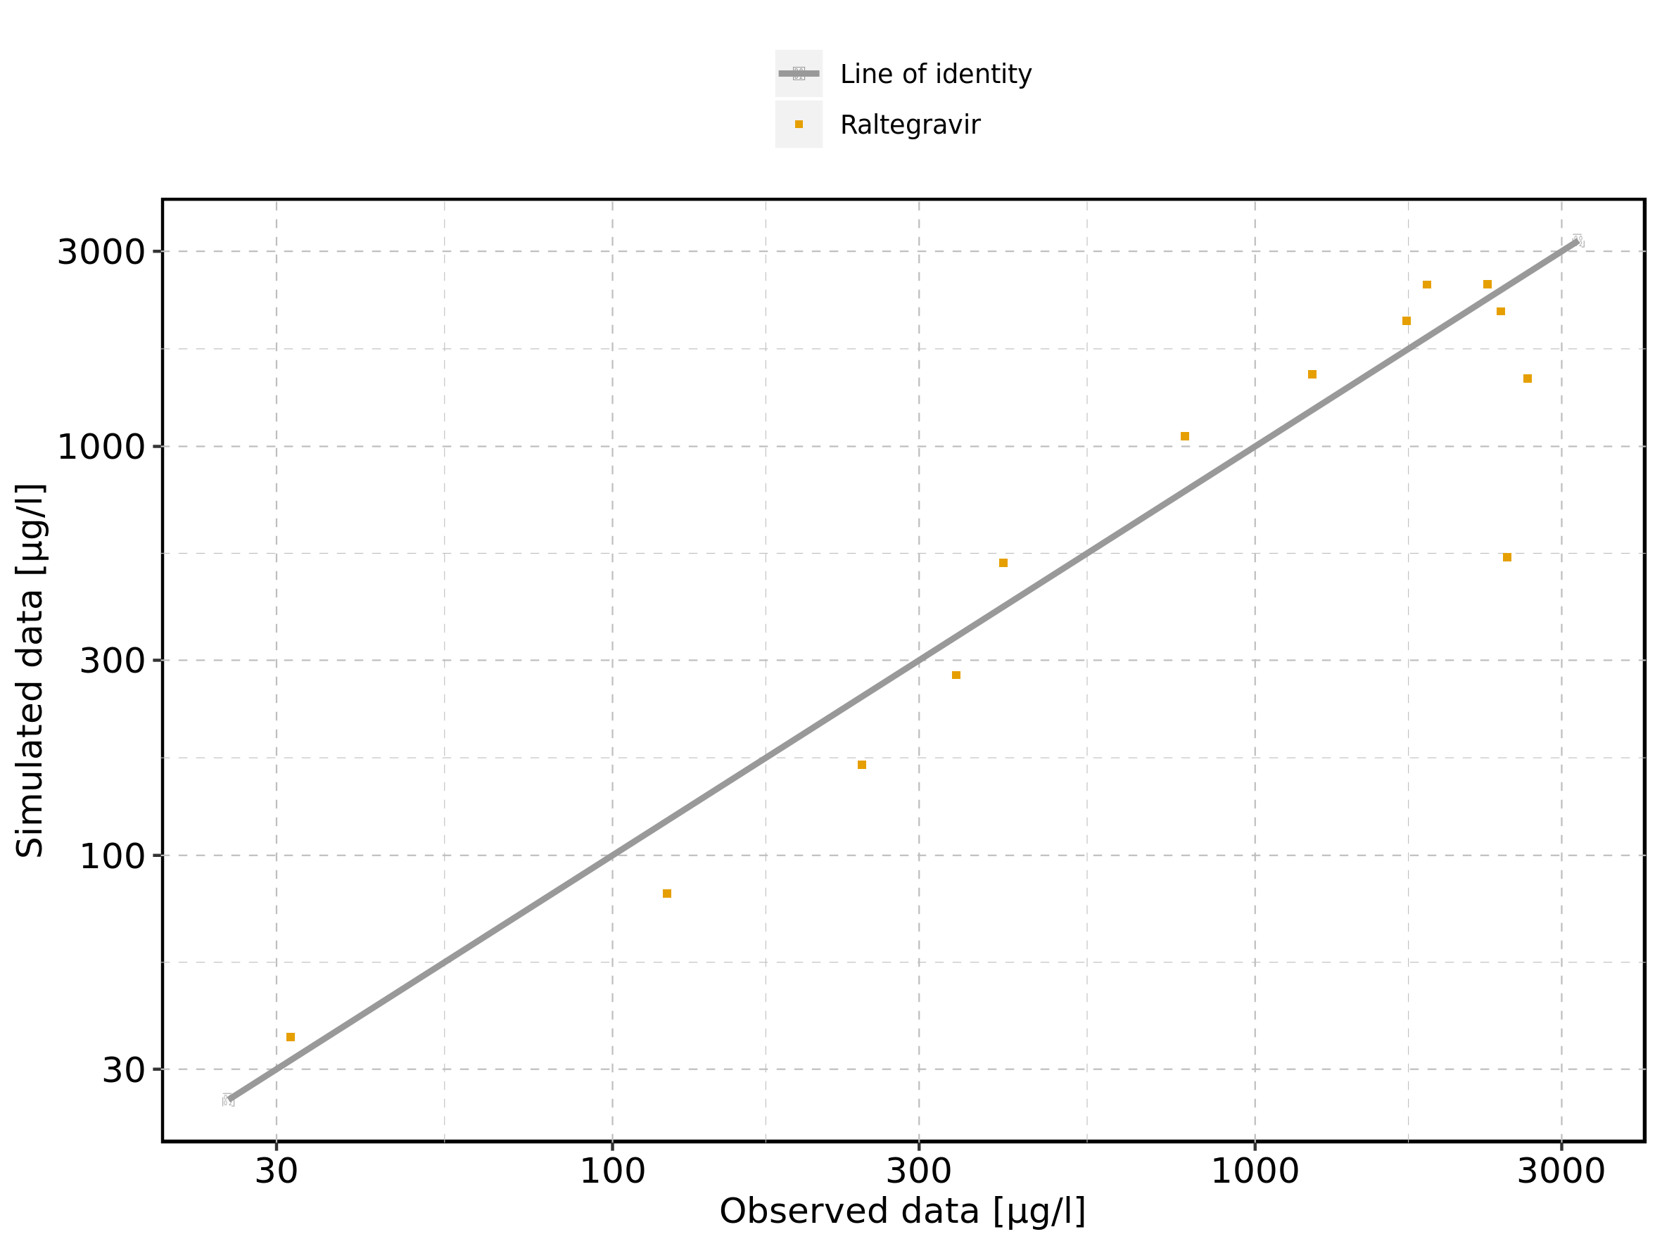

Figure 243: Logarithmic residuals vs predicted values of Raltegravir 400mg chewable fed for Raltegravir 400mg chewable fed. Data source: Data/Raltegravir_PK.txt.

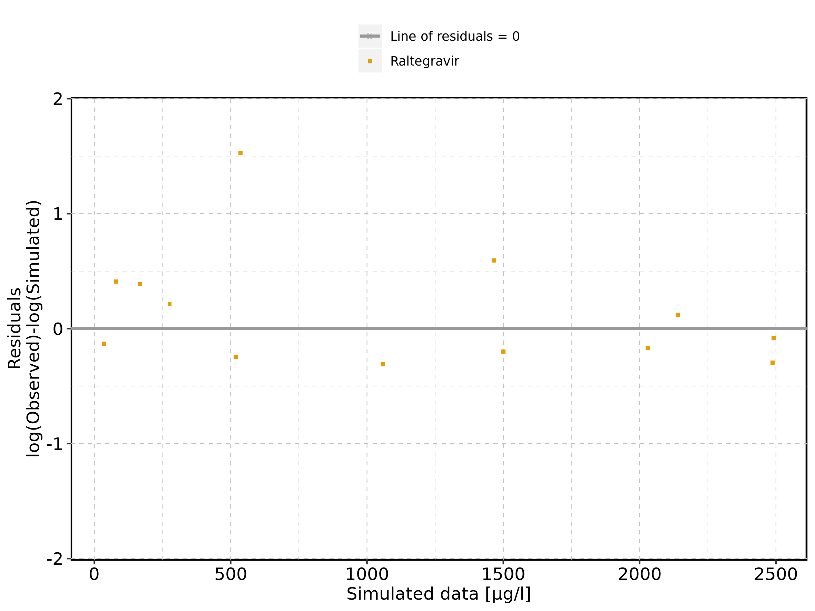

Figure 244: Logarithmic residuals vs time of Raltegravir 400mg chewable fed for Raltegravir 400mg chewable fed. Data source: Data/Raltegravir_PK.txt.

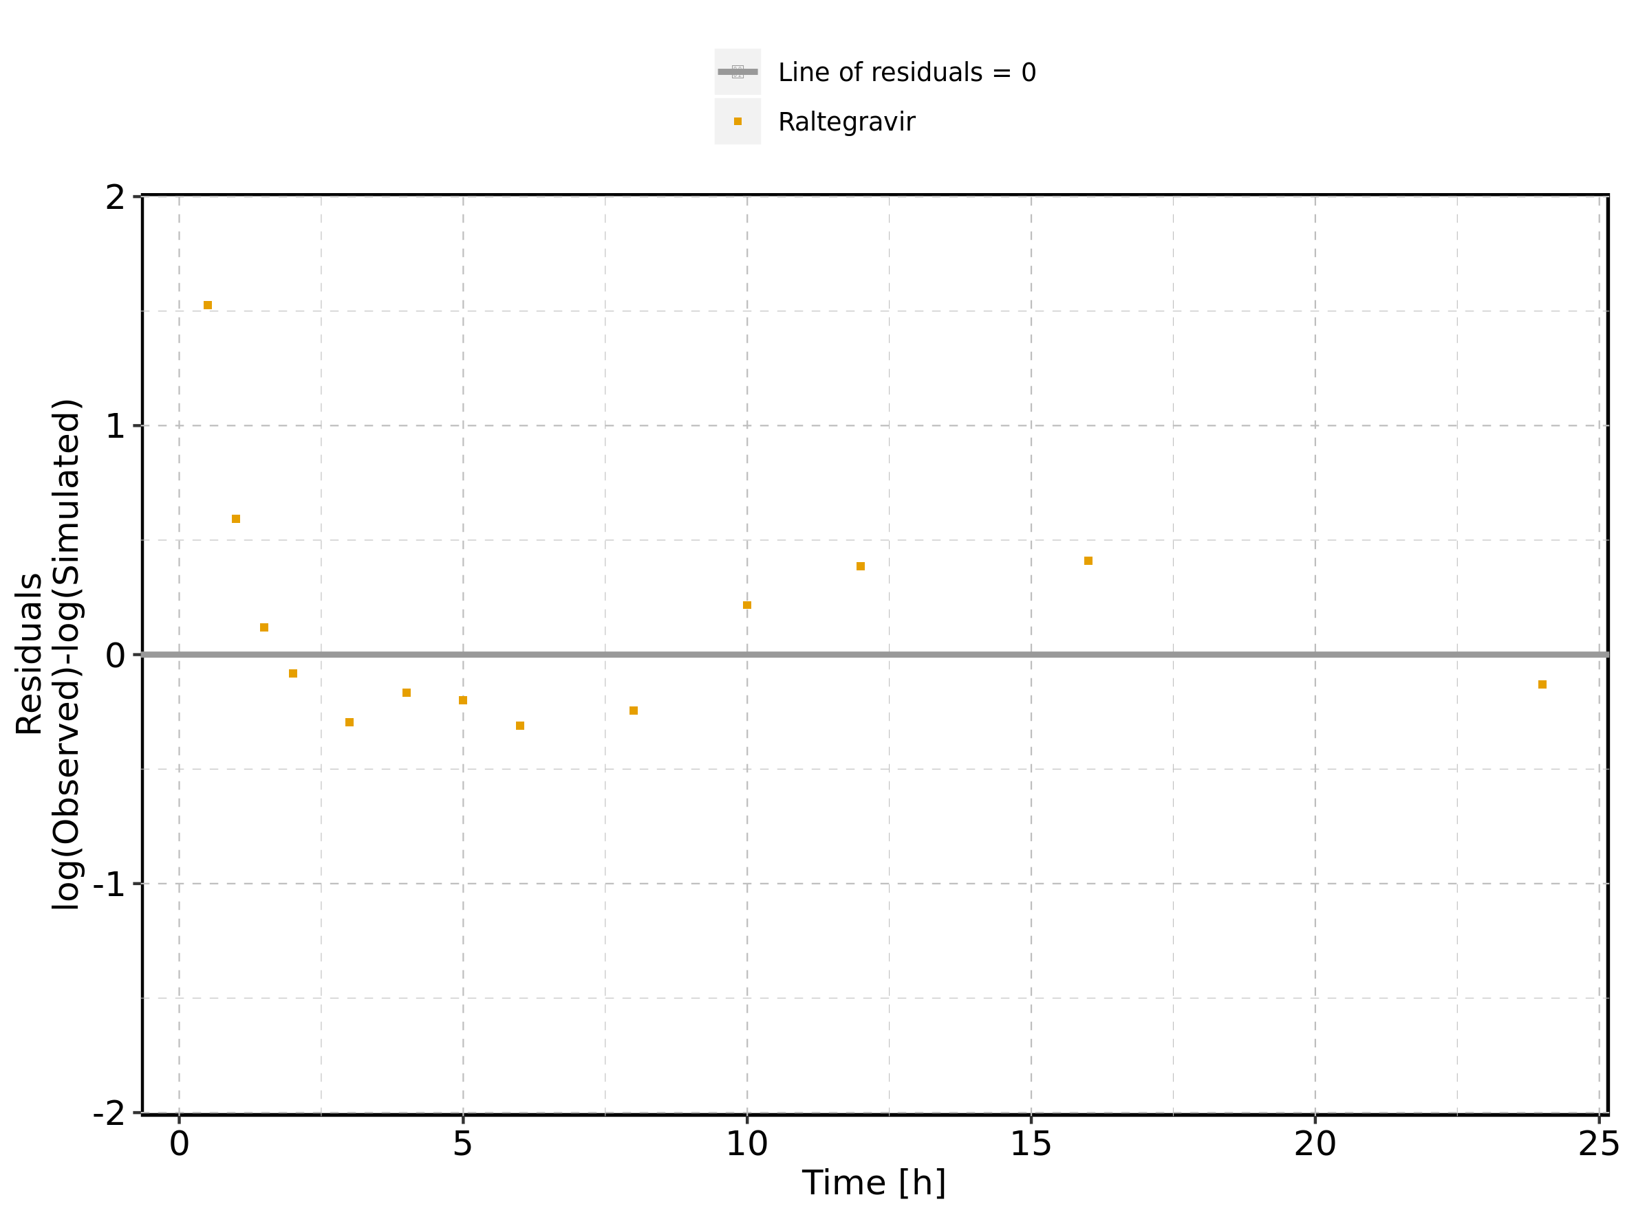

Figure 245: Logarithmic residuals distribution of Raltegravir 400mg chewable fed for Raltegravir 400mg chewable fed. Data source: Data/Raltegravir_PK.txt.

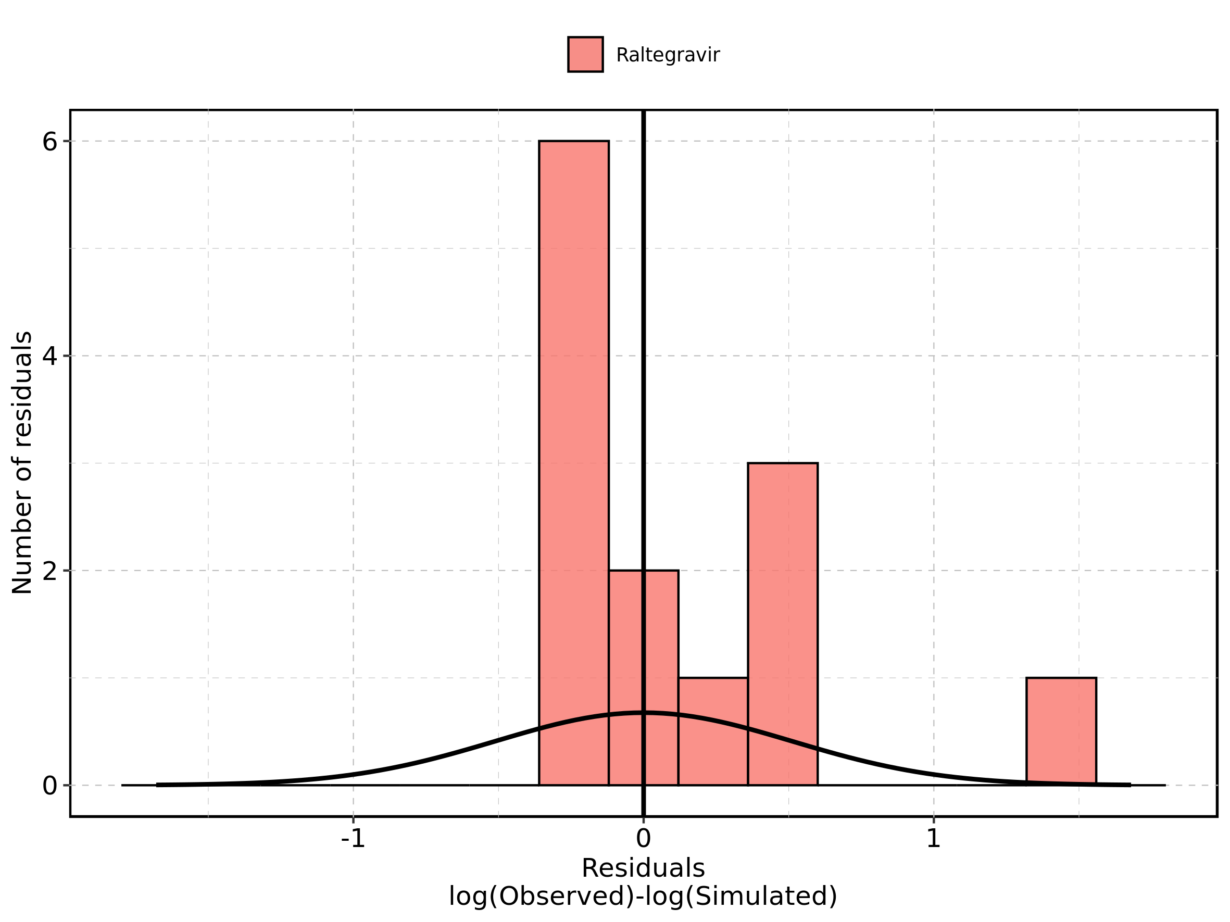

Figure 246: Logarithmic residuals of Raltegravir 400mg chewable fed for Raltegravir 400mg chewable fed as quantile-quantile plot. Data source: Data/Raltegravir_PK.txt.

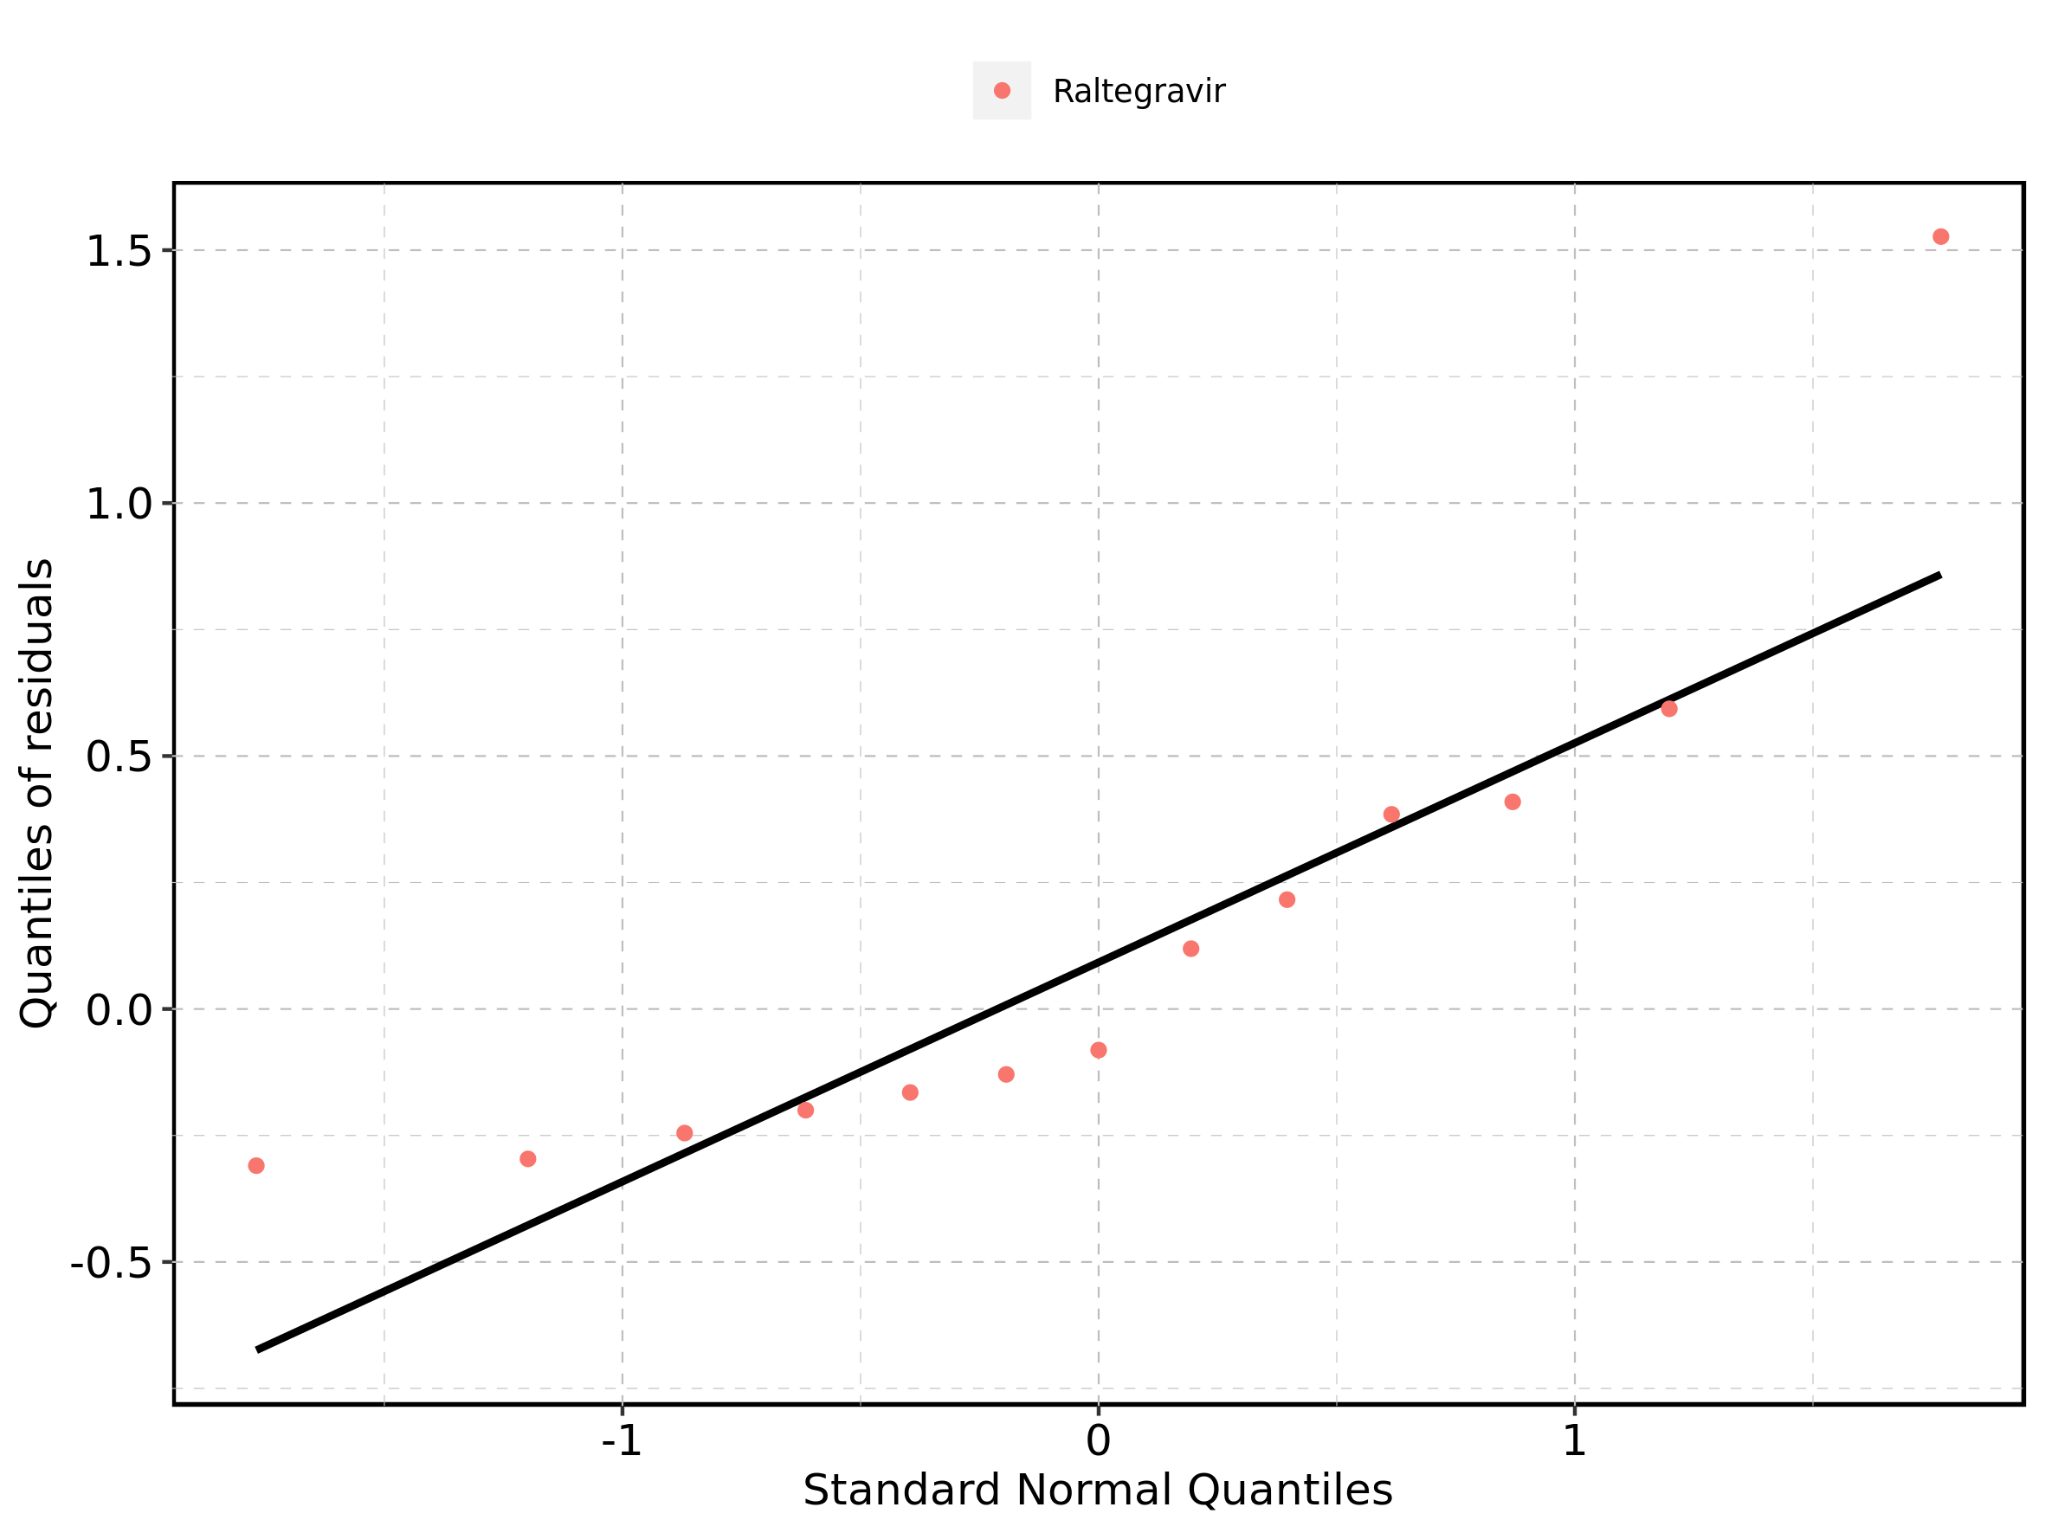

## 4.16. Time profiles and residual plots for Raltegravir 400mg (granules in suspension)

Figure 247: Time profiles of Raltegravir 400mg (granules in suspension) for Raltegravir 400mg (granules in suspension). Data source: Data/Raltegravir_PK.txt. Time profiles are plotted in a linear scale.

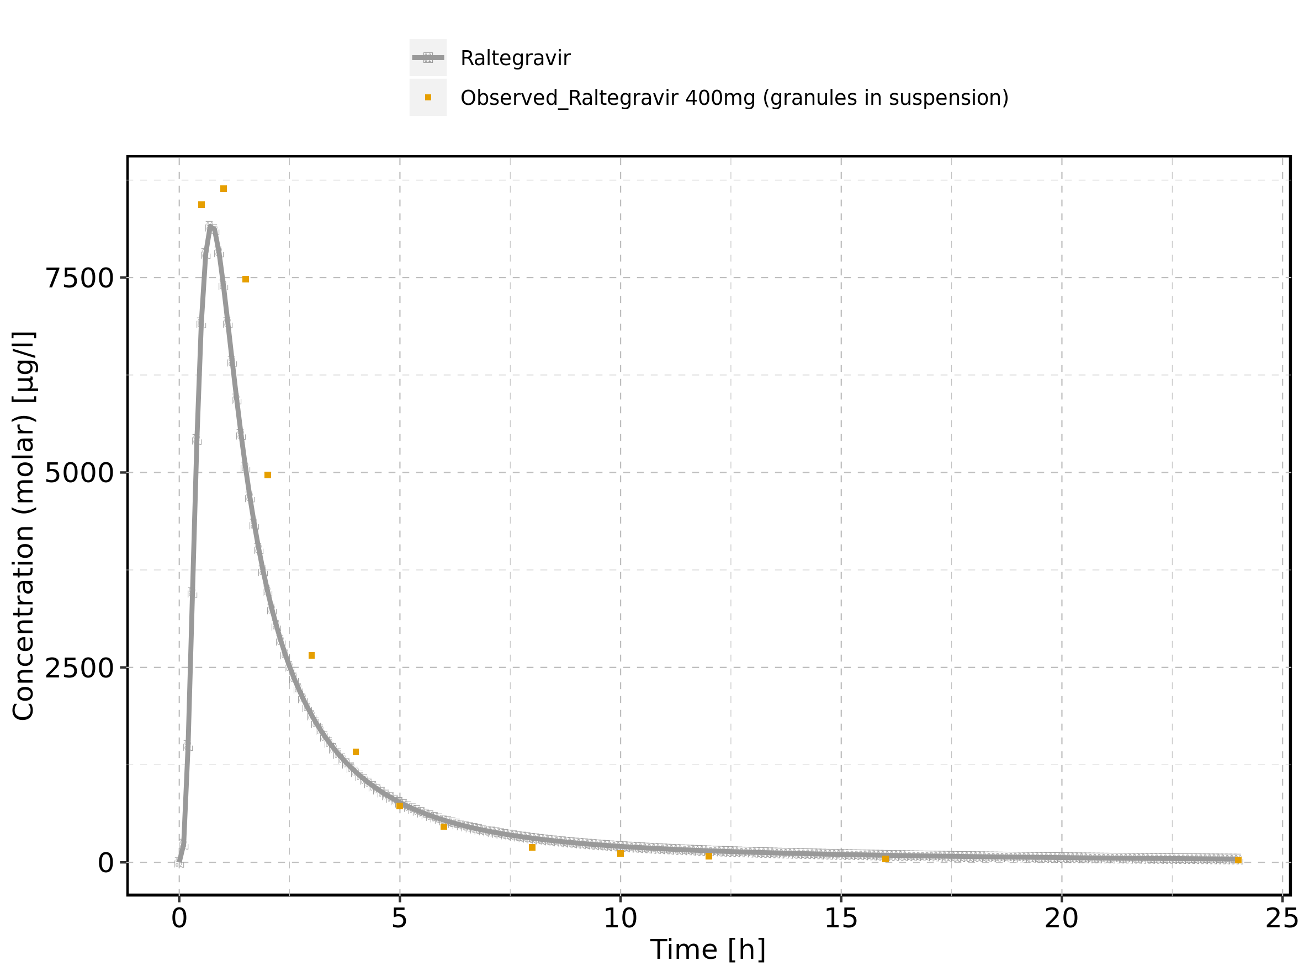

Figure 248: Time profiles of Raltegravir 400mg (granules in suspension) for Raltegravir 400mg (granules in suspension). Data source: Data/Raltegravir_PK.txt. Time profiles are plotted in a logarithmic scale.

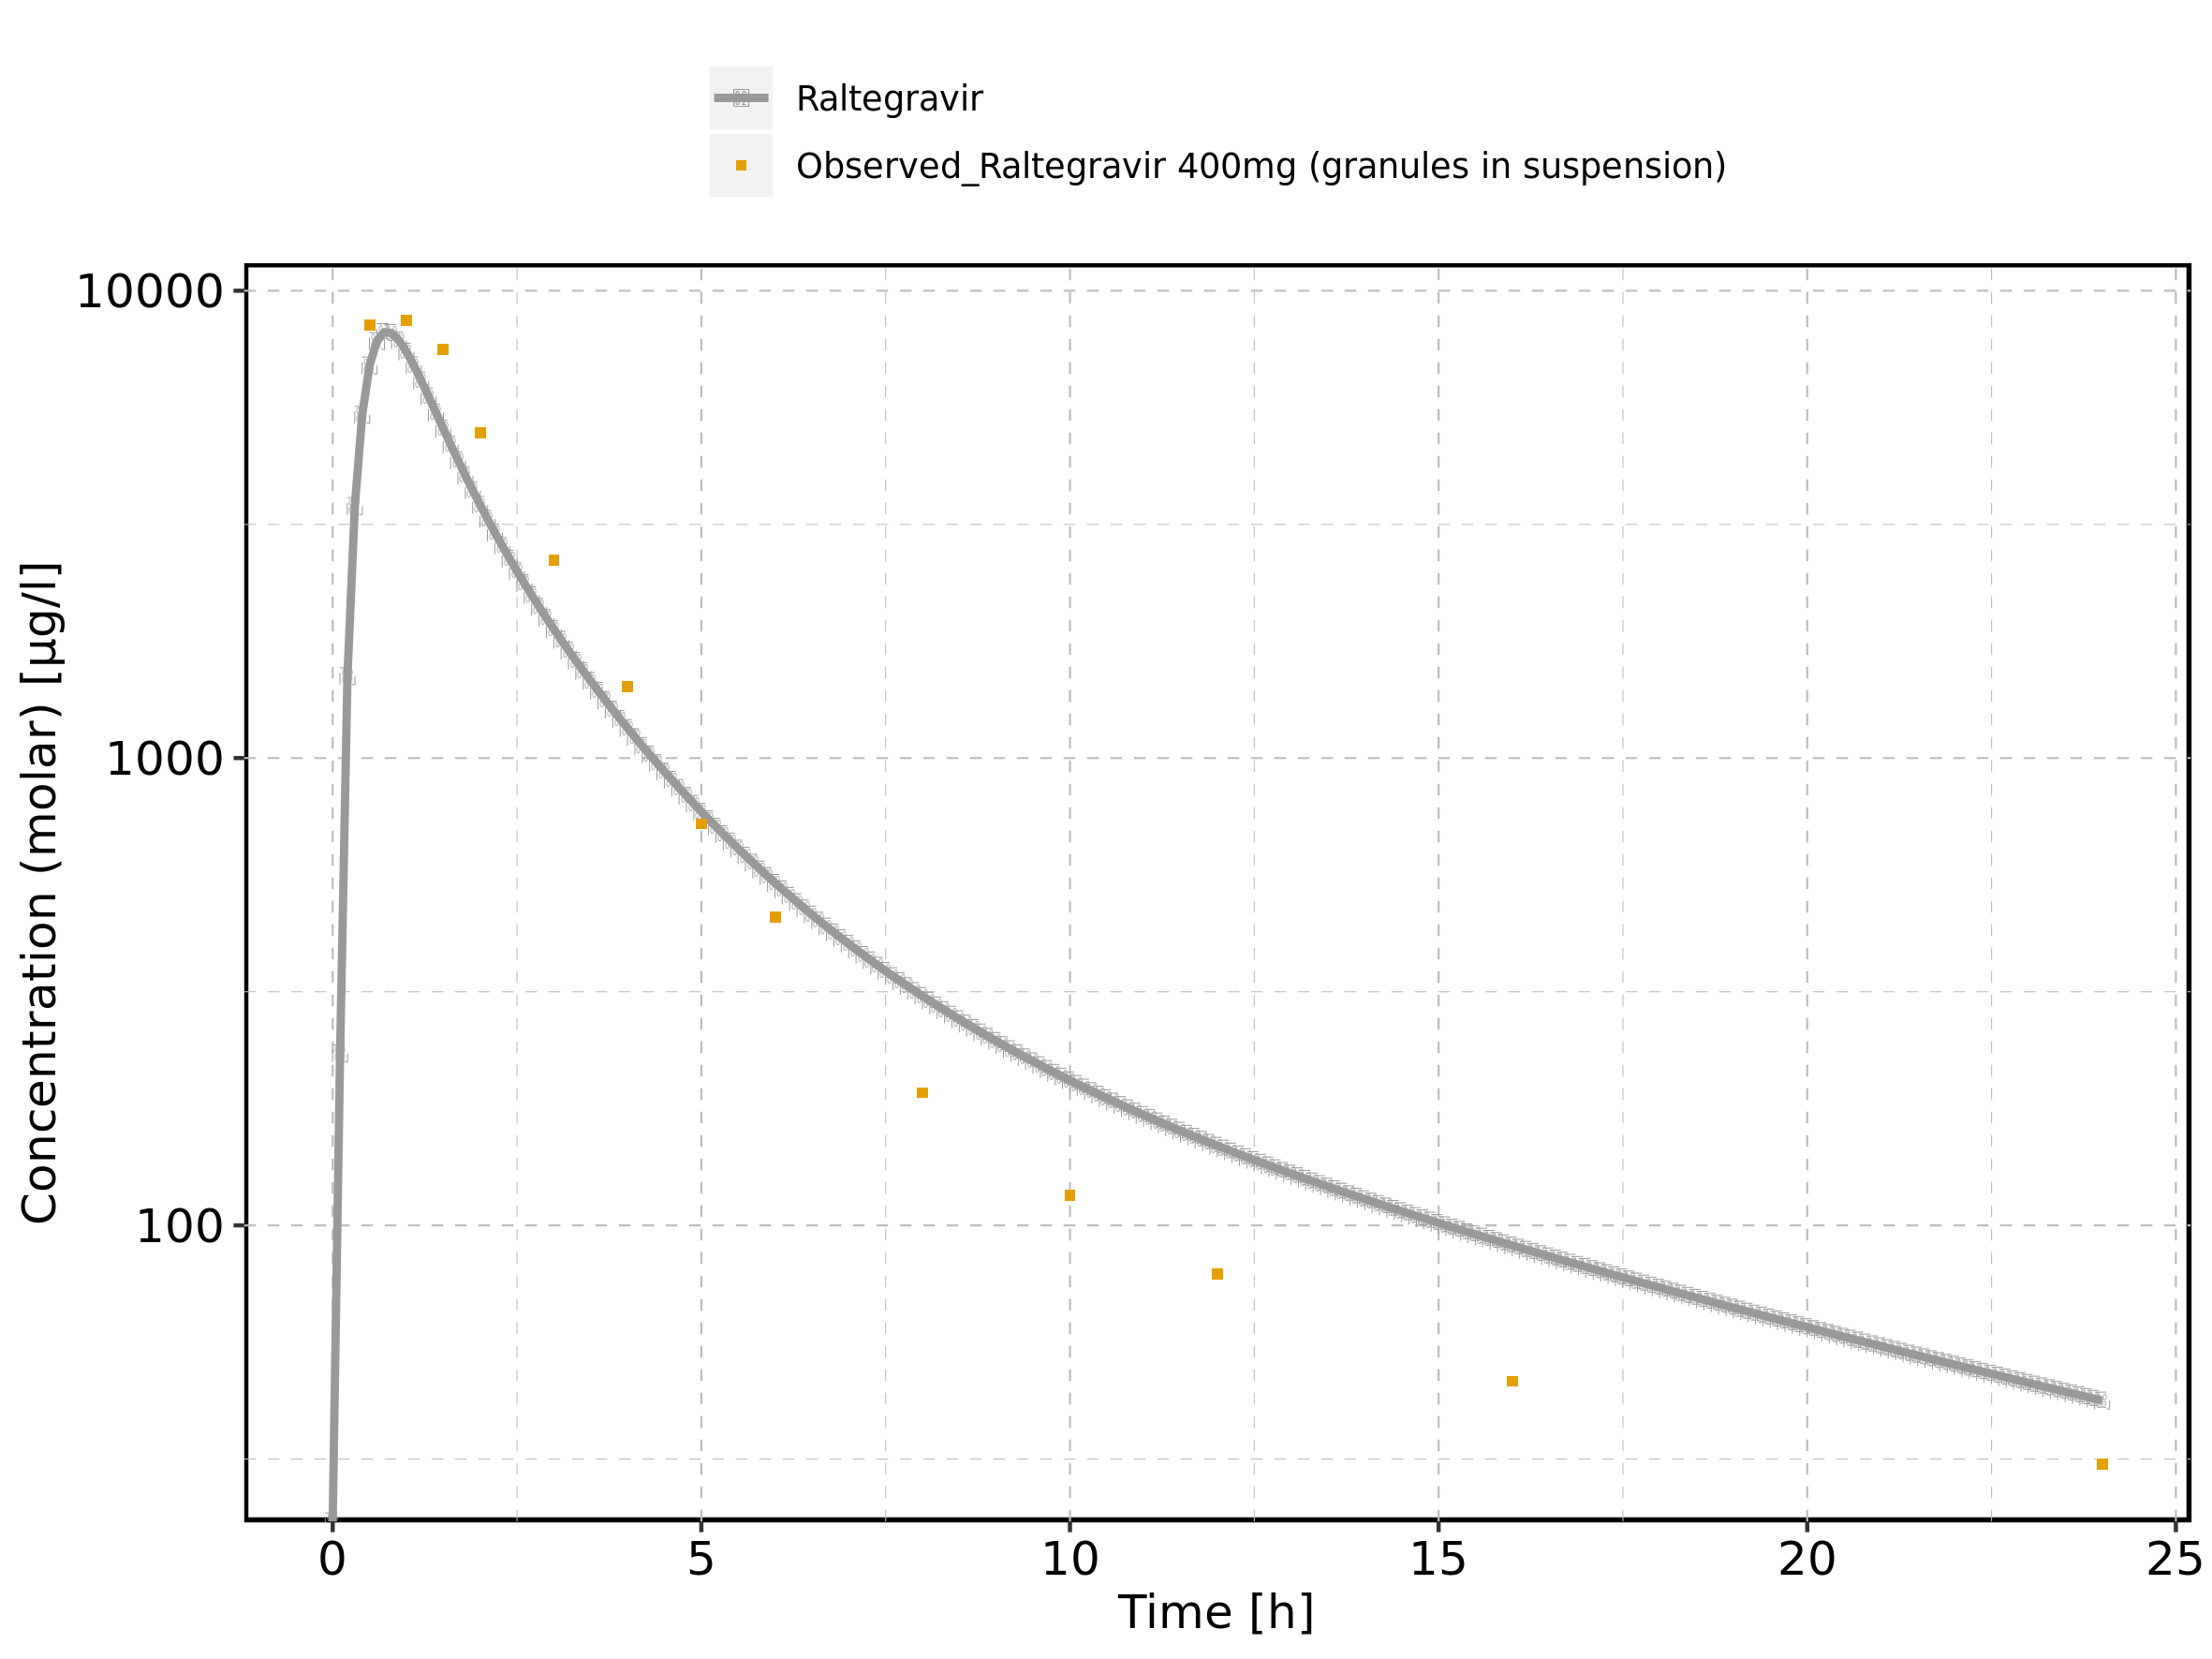

Figure 249: Predicted vs observed of Raltegravir 400mg (granules in suspension) for Raltegravir 400mg (granules in suspension). Data source: Data/Raltegravir_PK.txt. Predictions and observations are plotted in a linear scale.

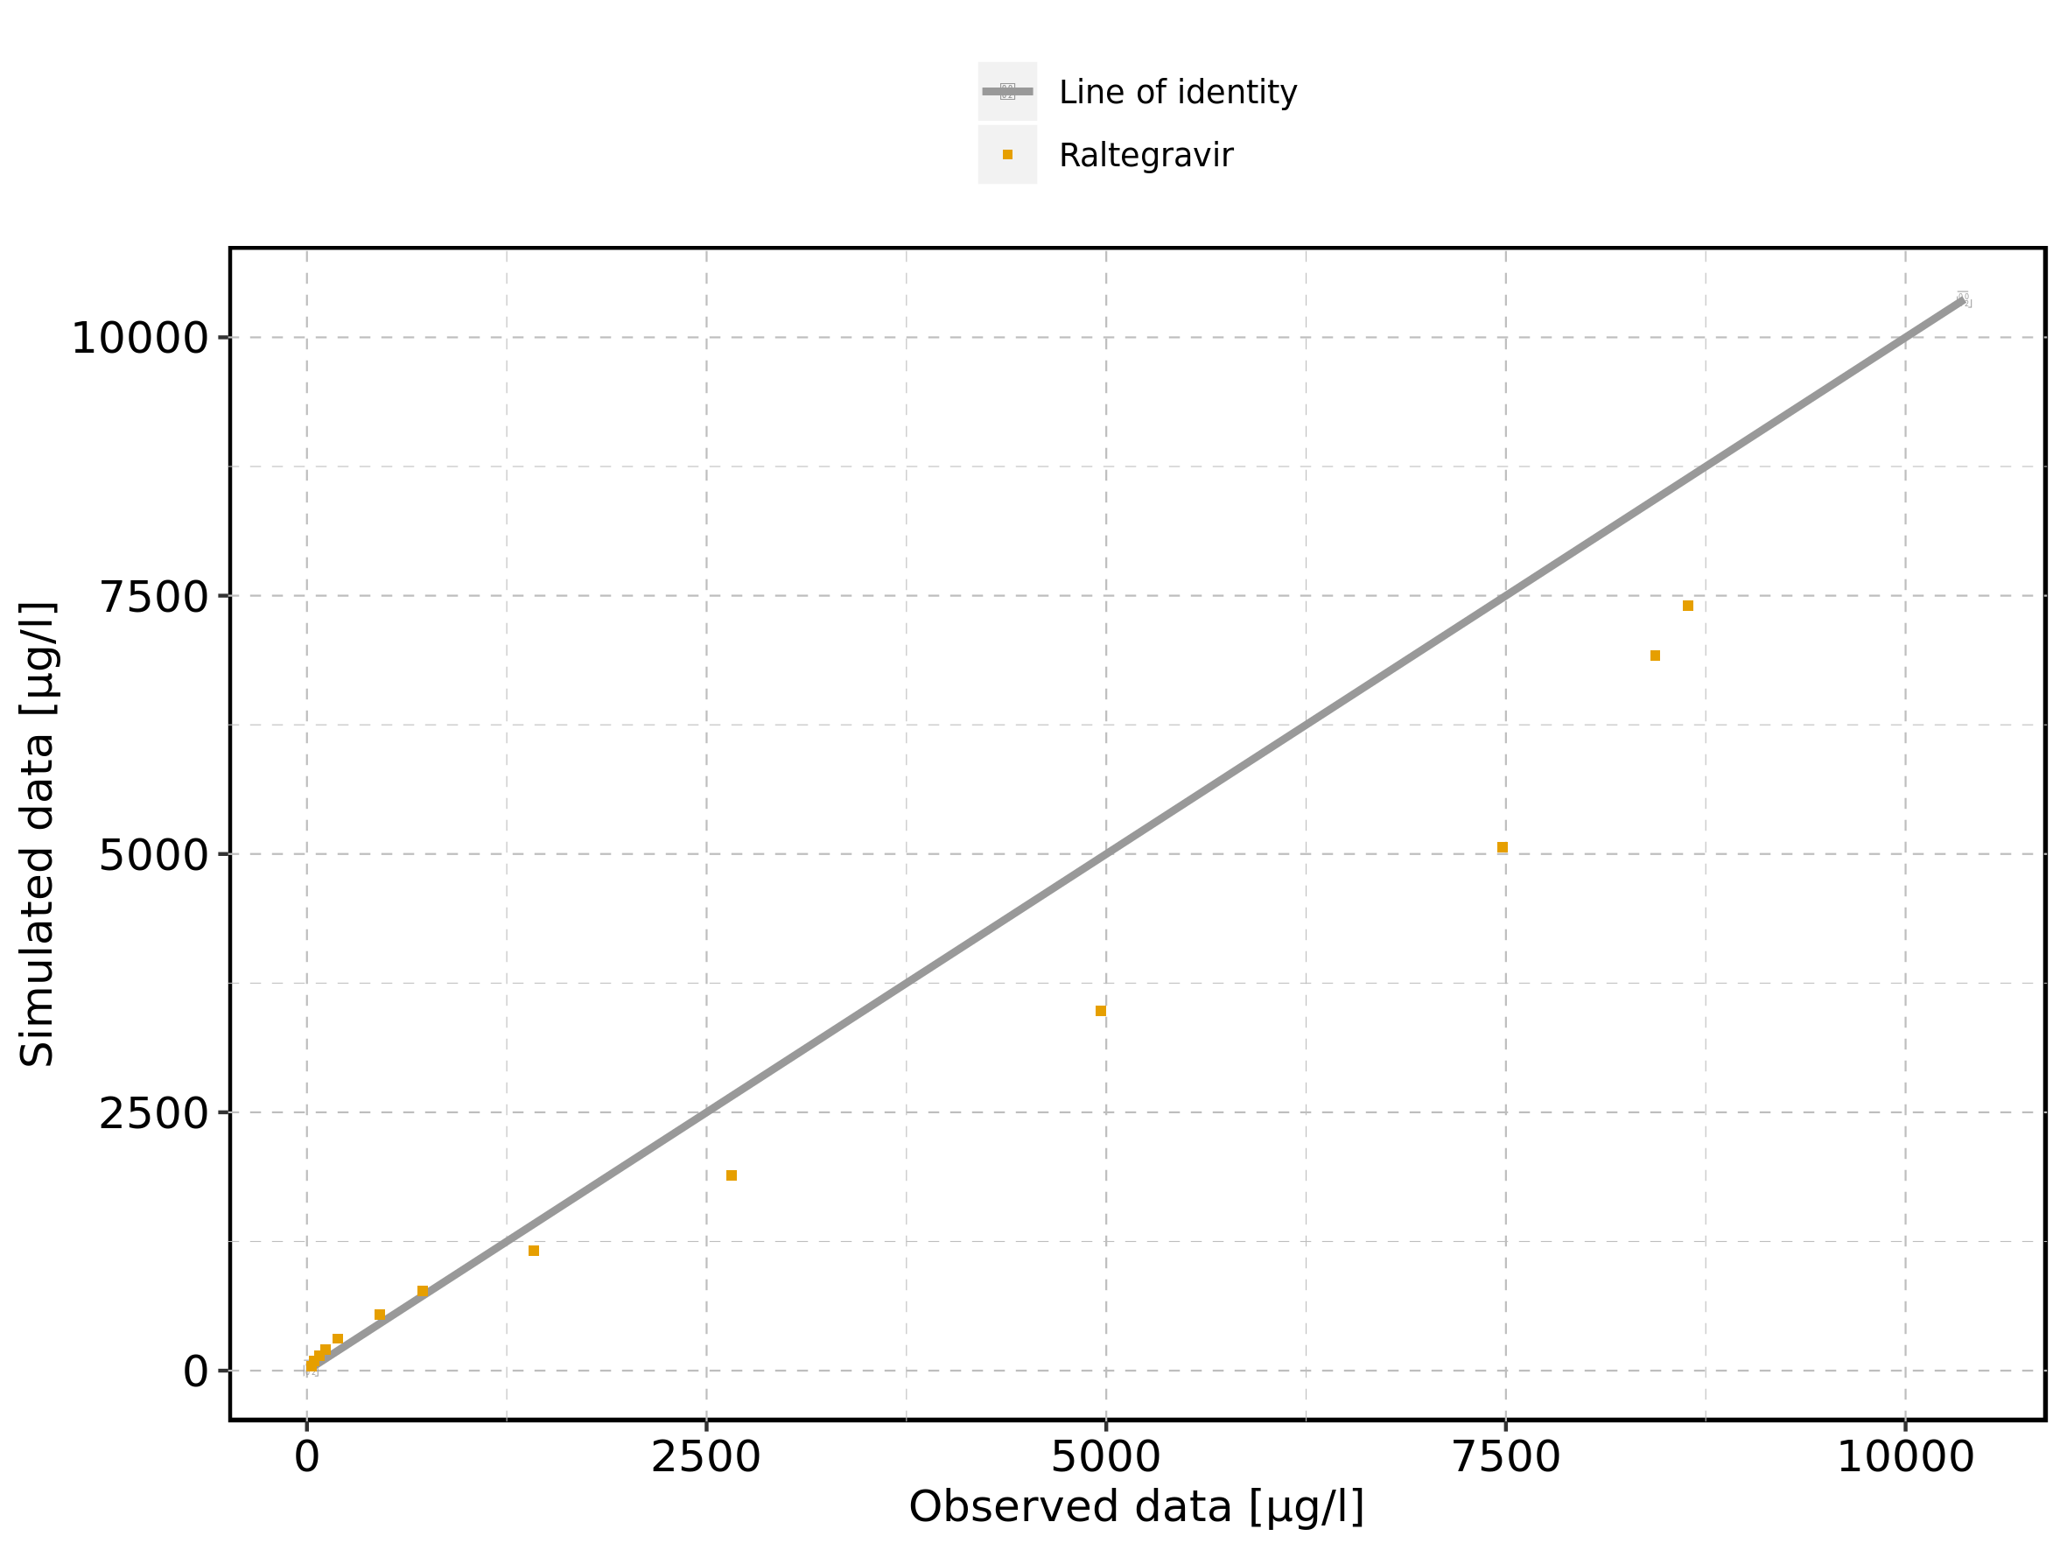

Figure 250: Predicted vs observed of Raltegravir 400mg (granules in suspension) for Raltegravir 400mg (granules in suspension). Data source: Data/Raltegravir_PK.txt. Predictions and observations are plotted in a logarithmic scale.

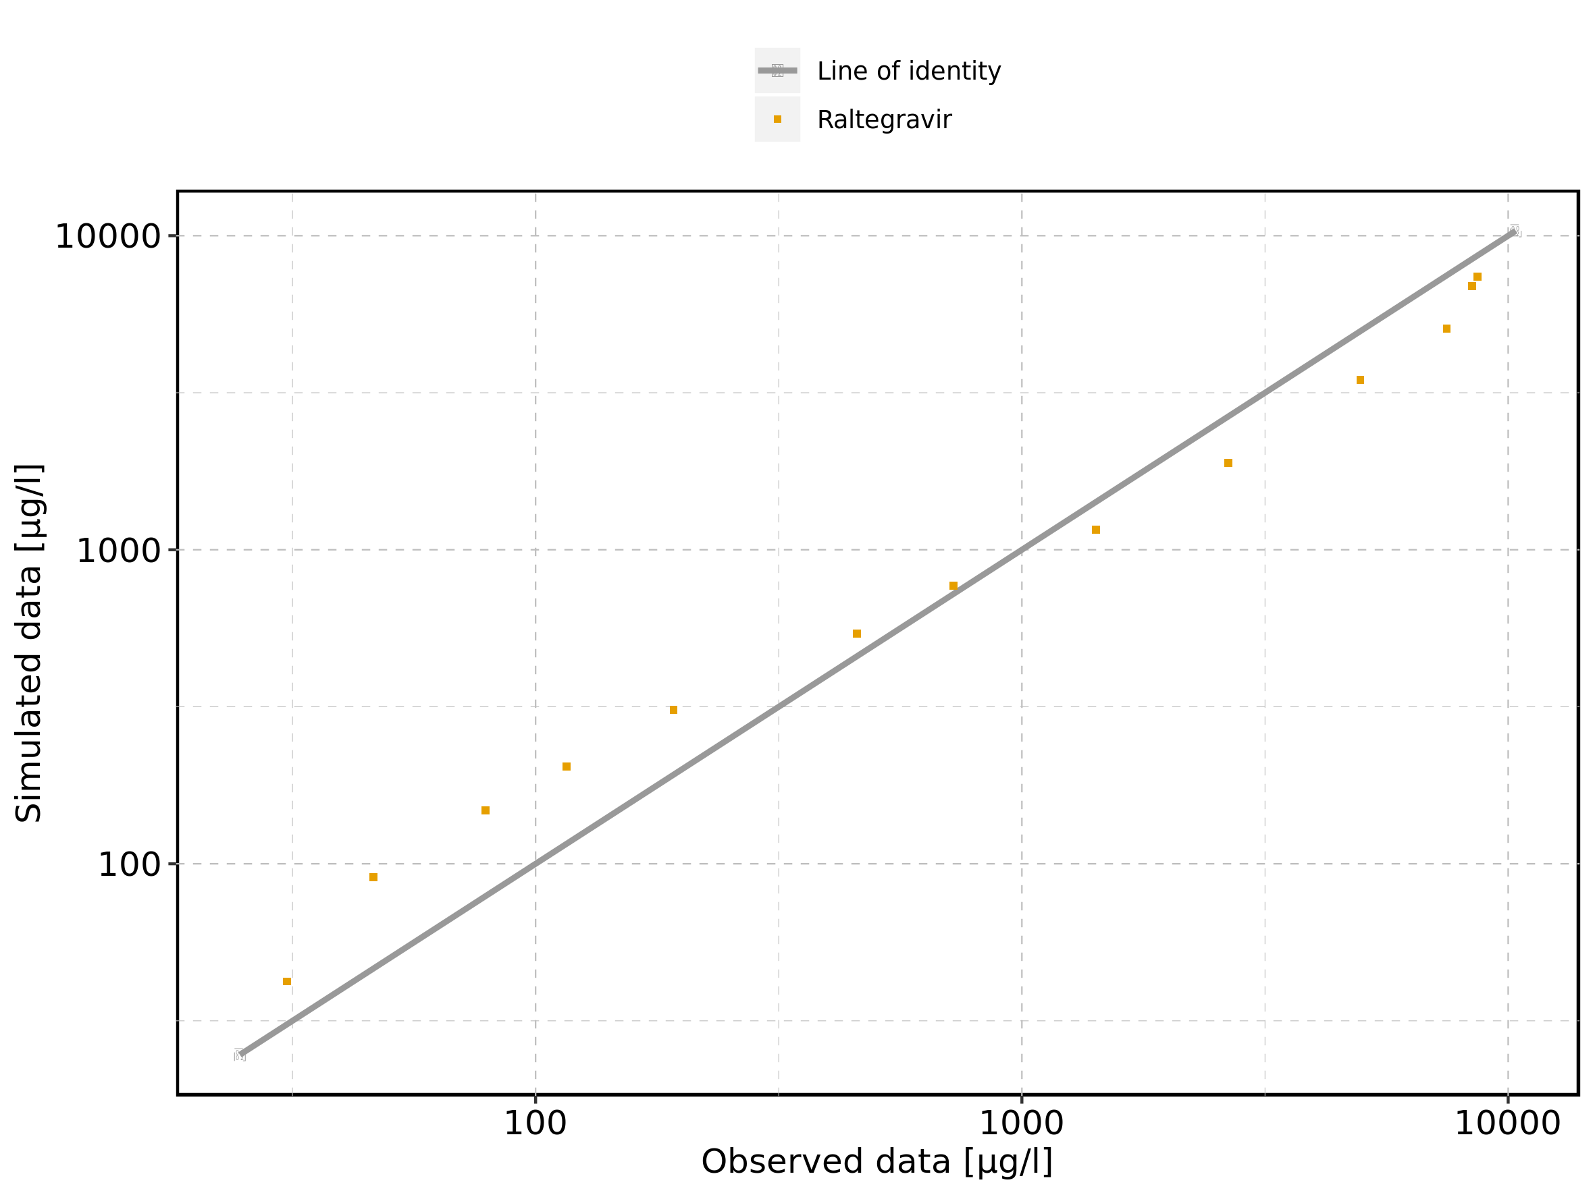

Figure 251: Logarithmic residuals vs predicted values of Raltegravir 400mg (granules in suspension) for Raltegravir 400mg (granules in suspension). Data source: Data/Raltegravir_PK.txt.

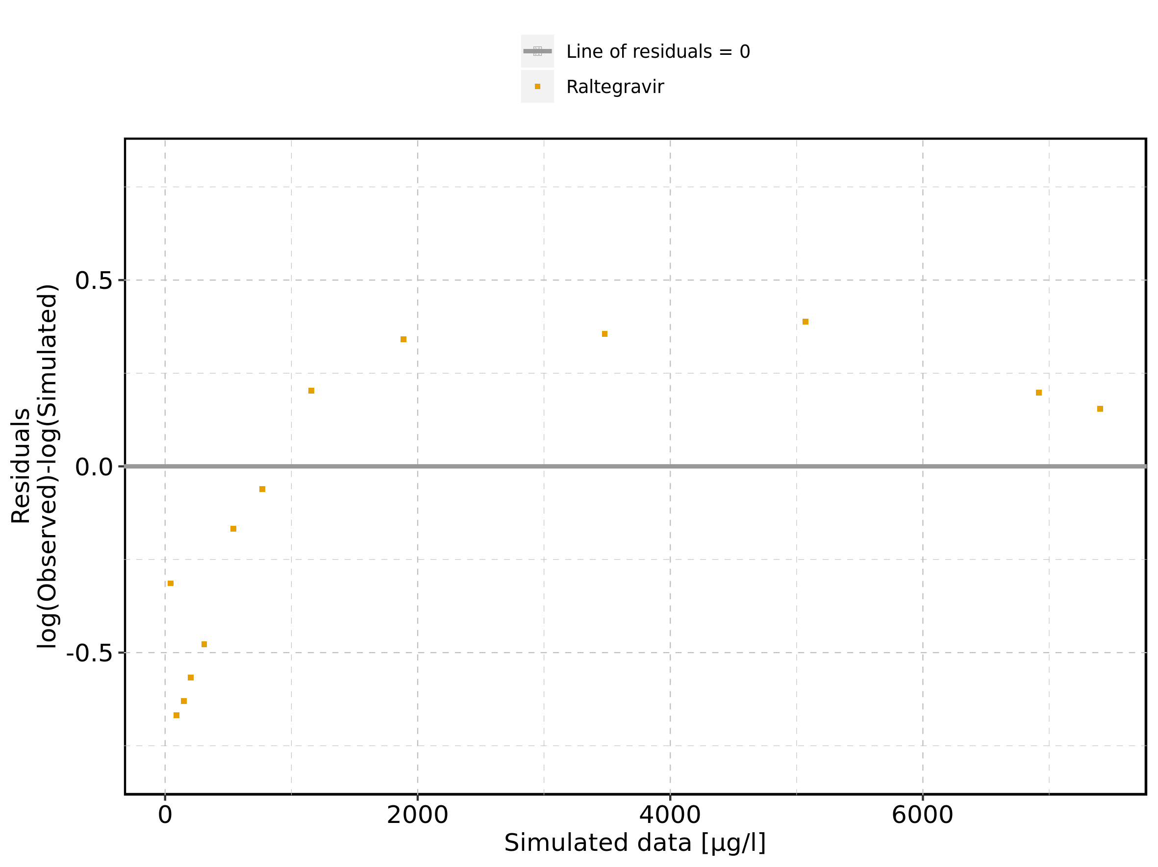

Figure 252: Logarithmic residuals vs time of Raltegravir 400mg (granules in suspension) for Raltegravir 400mg (granules in suspension). Data source: Data/Raltegravir_PK.txt.

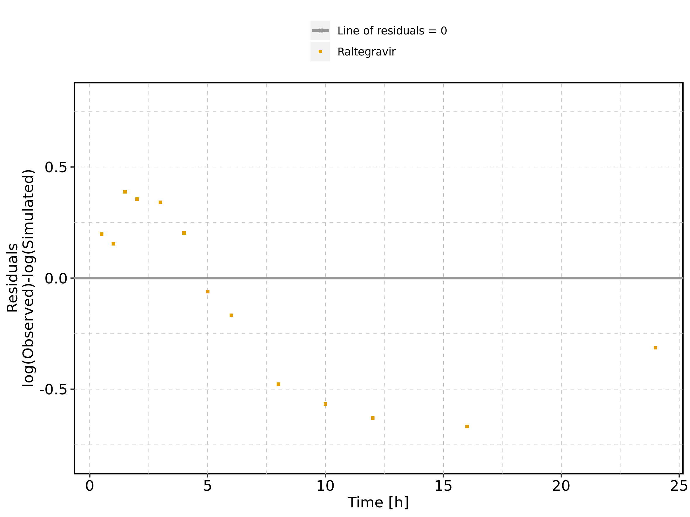

Figure 253: Logarithmic residuals distribution of Raltegravir 400mg (granules in suspension) for Raltegravir 400mg (granules in suspension). Data source: Data/Raltegravir_PK.txt.

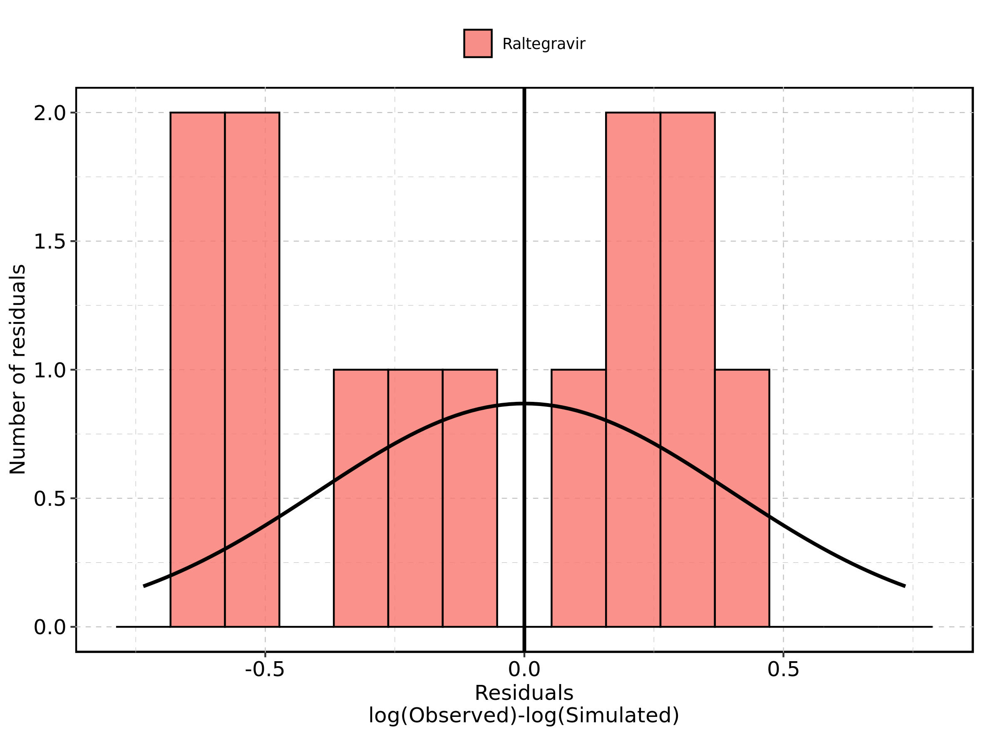

Figure 254: Logarithmic residuals of Raltegravir 400mg (granules in suspension) for Raltegravir 400mg (granules in suspension) as quantile-quantile plot. Data source: Data/Raltegravir_PK.txt.

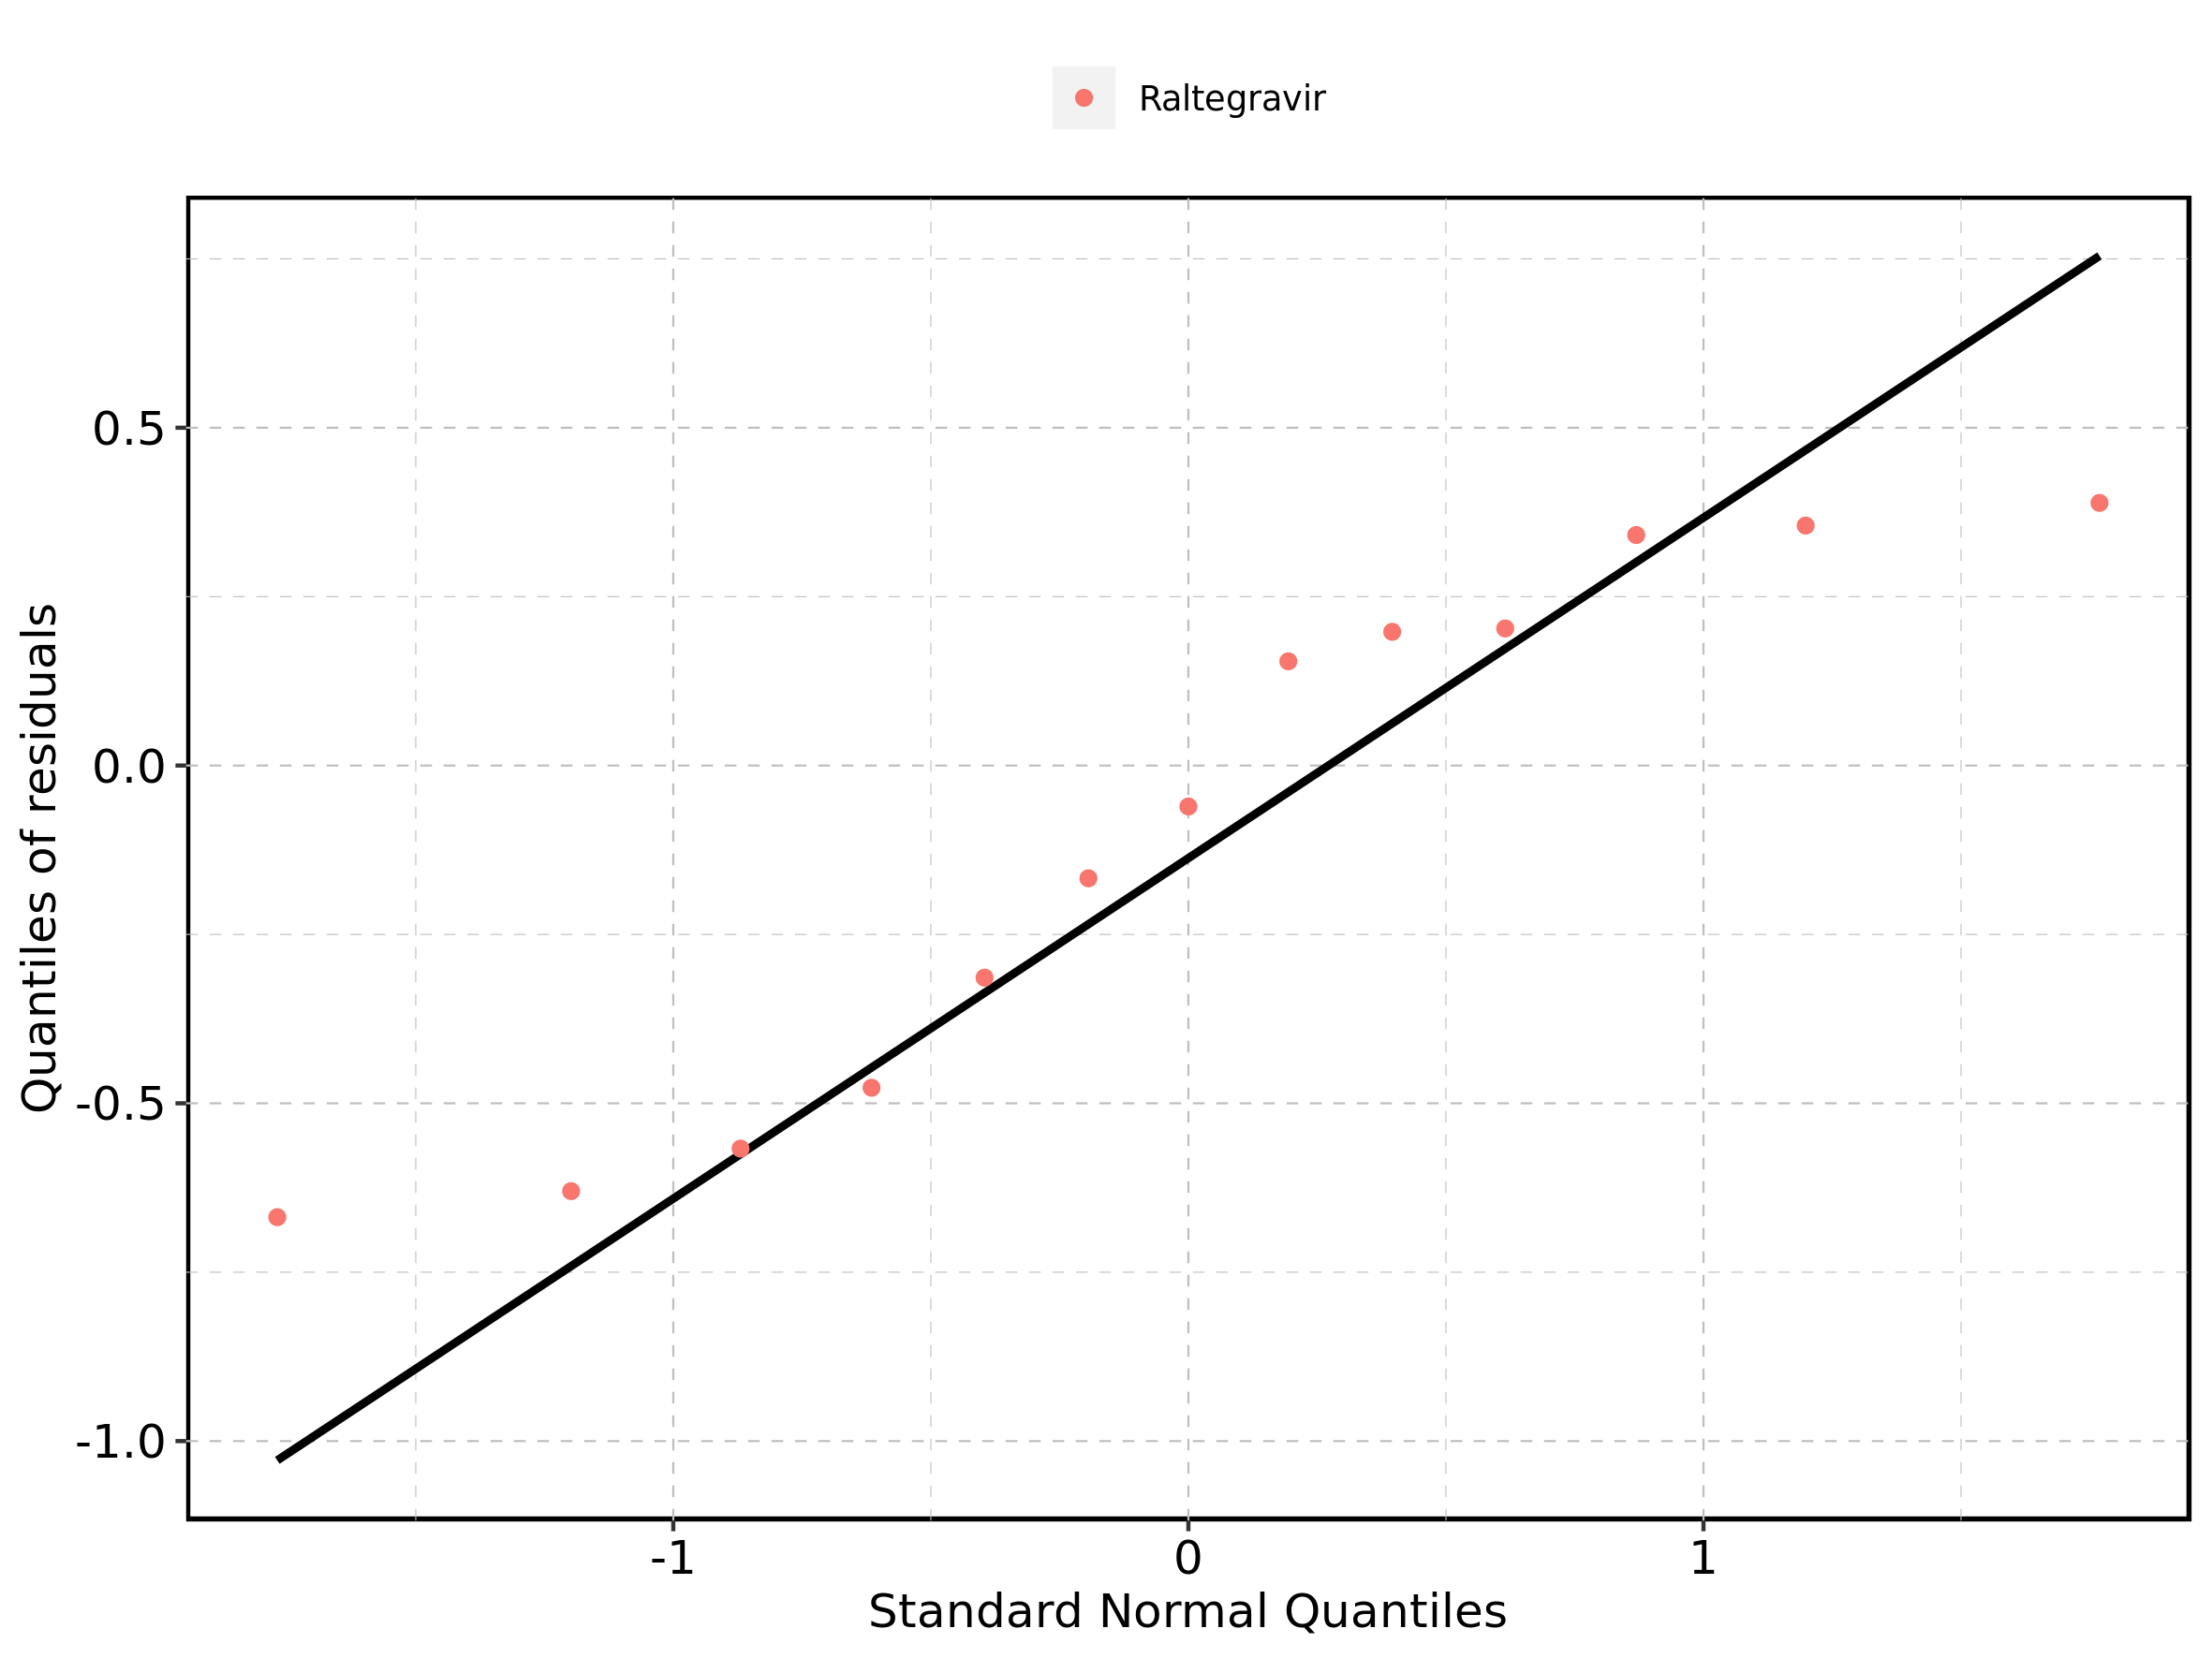

## 4.17. Residuals across all simulations

Figure 255: Distribution of residuals for Raltegravir 10 mg (lactose formulation), Raltegravir 25 mg (lactose formulation), Raltegravir 50 mg (lactose formulation), Raltegravir 100 mg (lactose formulation), Raltegravir 200 mg (lactose formulation), Raltegravir 400mg (lactose formulation), Raltegravir 800 mg (lactose formulation), Raltegravir 1200 mg (lactose formulation), Raltegravir 1600 mg (lactose formulation), Raltegravir 100 mg filmcoated tablet md, Raltegravir 200 mg filmcoated tablet md, Filmcoated_tablet_400mg_sd, Raltegravir 400 mg filmcoated tablet md, Raltegravir 400mg chewable fasted, Raltegravir 400mg chewable fed, Raltegravir 400mg (granules in suspension)

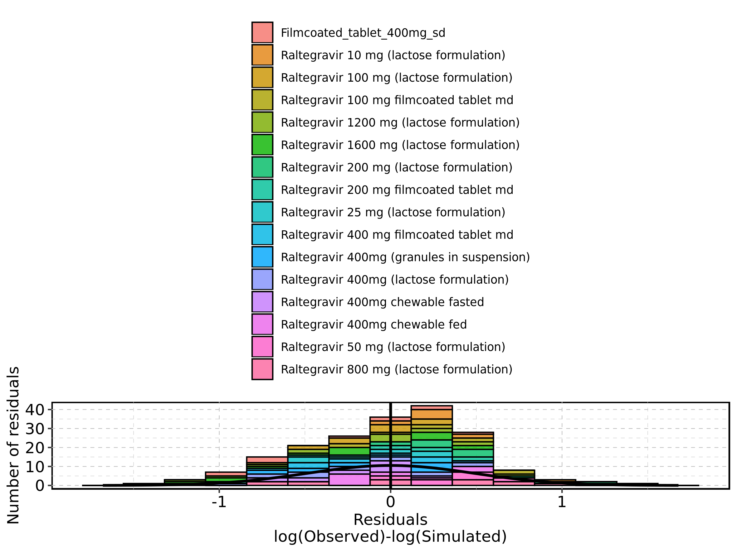

Figure 256: Residuals for Raltegravir 10 mg (lactose formulation), Raltegravir 25 mg (lactose formulation), Raltegravir 50 mg (lactose formulation), Raltegravir 100 mg (lactose formulation), Raltegravir 200 mg (lactose formulation), Raltegravir 400mg (lactose formulation), Raltegravir 800 mg (lactose formulation), Raltegravir 1200 mg (lactose formulation), Raltegravir 1600 mg (lactose formulation), Raltegravir 100 mg filmcoated tablet md, Raltegravir 200 mg filmcoated tablet md, Filmcoated_tablet_400mg_sd, Raltegravir 400 mg filmcoated tablet md, Raltegravir 400mg chewable fasted, Raltegravir 400mg chewable fed, Raltegravir 400mg (granules in suspension) as quantile-quantile plot.

